**Numerical Analysis of Micro Pin Fin Heat Sink Using Nano Fluids as Coolants**

**Pradeepaa*, C.N.Natarajb**

*a M.Tech Scholar, Department of Studies in Mechanical Engineering, University B D T College of Engineering Davanagere, 577004, Karntaka, India.*

*bAssociate Professor, Department of Studies in Mechanical Engineering, University B D T College of Engineering Davanagere, 577004, Karntaka, India.*

*\*Corresponding Author Email:* [*pradeepsompur@gmail.com*](mailto:pradeepsompur@gmail.com)

*Received: Date? Accepted: Date?*

**Abstract:** In this paper a fluid flow and thermal characteristics of micro pin fin heat sink is investigated with the computational fluid dynamics, by this with three fins geometries (square, triangular and circular) and Nano fluids is used as a cooling fluid, since the flow and heat transfer have been studied with two types of Nano fluids (Diamond-water and Alumina-water) in addition to the base fluid water. The comparison of hydrodynamic and thermal characteristics of different fin geometries and cooling fluids has been made under the same value of Reynolds number and the velocity of flow is taken 0.069 m/s throughout, the range of Re used is (100-1000) to ensure that, the flow remains in the laminar region. The results obtained indicated that, using of Nano fluids instead of water as a coolant leads to enhanced heat transfer performance by increasing the amount of heat dissipated but it also leads to increased pressure drop for all fins shapes. Also increasing the fins length will leads the heat carrying capacity more. Here for the analysis of heat sink, the model has been designed in the CATIA V5 software, and for the fluid flow and numerical analysis ANSYS 16.2 software is used.

**Keywords:** Heat sink, Nano fluids, 3D Fins Geometry, Reynolds number.

**1. Introduction:** increasing in the electronic devices in the modern days has the wide range of usages over the other devices with minimizing of time and also increasing the efficiency of work. The microelectronic devices like CPU’s, LED’s and many more dissipates heat from the chips hence inside the devices more heat generation has disadvantages of the devices for that its necessitate to cool the devices by minimizing the heat generated, and increasing the heat removal rate from the chips is only possible by the cooling. For cooling of the electronic devices keeps the components of devices stable and effective. Here liquid cooling is more effective than the air cooling and also the fluids will carry large amount of heat transfer rate. Looking at the background study of the liquid cooling of the microelectronic devices its came to know that the using of Nano fluids instead of base fluid water has the more advantage and also Nano fluids can carry large amount of heat by this usage of Nano fluids in the heat sink is more benefits. Nano fluids is a kind of liquids containing small quantity of Nano sized particles (usually less than 100nm) Micro channel heat sinks due to their small mass and volume as well as larger area to volume ratio are very attractive for cooling of high heat flux chips. To improve the cooling performance and temperature uniformity of these devices, many new innovative ideas have been proposed such as using pin fins with different shapes and different arrangements. Fins as an extended surfaces play an important role in enhancing heat transfer process by increasing the area of heat transfer.There are many researches in literature made to study the micro pin heat sink with different fins geometries and to study the heat transfer rate in Nano fluids. Mustaq Ismael Hasan [1] has studied a micro pin fin heat sink is numerically investigated with three fins geometries (square, triangular and circular) in addition to the un finned micro channel heat sink. Nano fluid is used as a cooling fluid, since the flow and heat transfer have been studied with two types of Nano fluids (Diamond-water and Al2O3-water) in addition to the pure water. S.Subramanian, K.S.Shridhar, C.K.Umesh [2] researched this work is about the investigation for the performance enhancement by modifying the oblique fin geometry. Seven variants of micro channel geometries have been explored using three dimensional numerical simulations. The variants are plate fin, in-line pin fin, staggered pin fin, oblique fin. Piyush Laad, Bhushan Akhare, Praveen Chaurasia[3] studied about The effect of the pin-fin shapes on the overall performance of the heat sink with inline and staggered arrangement is studied in this paper. Six different shapes of fins rectangle, trapezoidal, rectangular interrupted, square, circular inline and staggered are subjected to study in this paper. Ravishankar Prasad Maurya, Ankesh Kumar Pataskar[4] has researched investigation of performance of heat sinkwith variable pin attached along with uniform fin. The present work deals with the computational analysis of flow (CFD analysis) and heat transfer with pin fin. In the present work a diamond shaped pin fin are used and is investigated under constant heat flux condition at the place of plane fin or elliptical pin fin.Asif Afzal*, A.D. Mohammed Samee, R.K. Abdul Razak, M.K. Ramis [5] has worked on experimental comparative thermal analysis of Multi Walled Carbon Nano Tubes (MWCNT) in rectangular mini channels. 0.01% volume concentration of MWCNT nanoparticles were suspended in water as base fluid to obtain MWCNT-water Nano fluid. Venkatesh Saravanan, Chitradurga K Umesh, Doddamani Hithaish,Kanakanahalli Seetharam[6] they investigated comparison of fluid flow and heat transfer characteristics for micro pin fin heat sink and micro channel pin fin heat sink with un finned micro channel heat sink. A Three Dimensional heat sink with water as coolant subjected to constant heat flux 10W/cm2, for Reynolds number ranging between100-900 is considered for study.

After reviewing of all literature surveys its came to know that how to design a model of heat sink should be and how to cool the micro pin fin heat sink by using Nano fluids comparing it to the other fluids.After all surveys its concluded that for effective transfer of heat in the electronic systems it should be based on the how the geometry of the heat sink design made and how much capacity of heat it should withstand. By simulating the designed model in in the ANSYS FLUENT software the variation of velocity, temperature and pressure inside the heat sink pin fin has been estimated and compared. Most of the studies in literature made to investigate heat transfer and flow characteristics in pin fin heat sink with pure fluids and as the author knowledge there are no researches available in which the Nano fluid used as a coolant in mini and micro pin fin heat sink. In this paper two types of Nano fluids were used as a coolant in micro pin fin heat sink and the effect of using these Nano fluids instead of pure water on the thermal and hydrodynamic performance of pin fin heat sink is numerically investigated.

**2. Problem formulation:** Micro pin fin heat sink was designed with different fin geometries and also fins dimension was varied. Velocity of fluid flow is determined by using Reynolds number laminar flow and the heat transfer rate of micro pin heat sink is calculated using CFD.

Also by using different Nano fluids comparing with base fluid as water showing which Nano fluids makes effective cooling of micro pin fin heat sink in the project by ANSYS FLUENT software.

**3. Physical Geometry:**

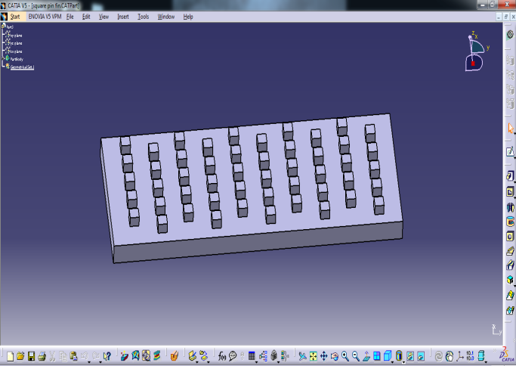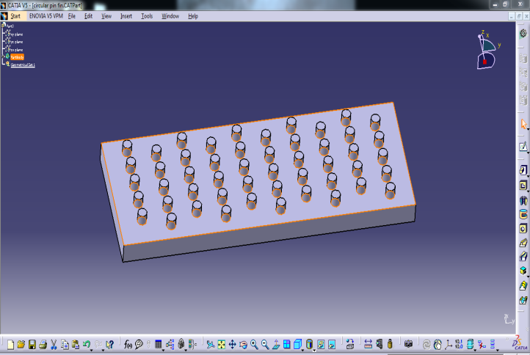The model studied in this paper is 3D micro pin fin heat sink consists of 50 fins with three shapes (square, circular and triangular) fins. The length of heat sink is 16 mm and its width and height are 6 mm and 1 mm respectively. All fins have same height 0.5 mm and base dimensions width of fin =0.5 mm, Depth of fin = 0.5 mm.The physical model represents the studied micro pin fin heat sink with three geometries of fins. The fins are arranged in staggered configuration which is better than inline configuration from the heat transfer point of view as it used by many references the values of fins spacing is 0.5 mm. this geometry is designed in CATIA V5 R20 software.

**Fig 1:** Circular pin fin heat sink. **Fig 2:** Square pin fin heat sink.

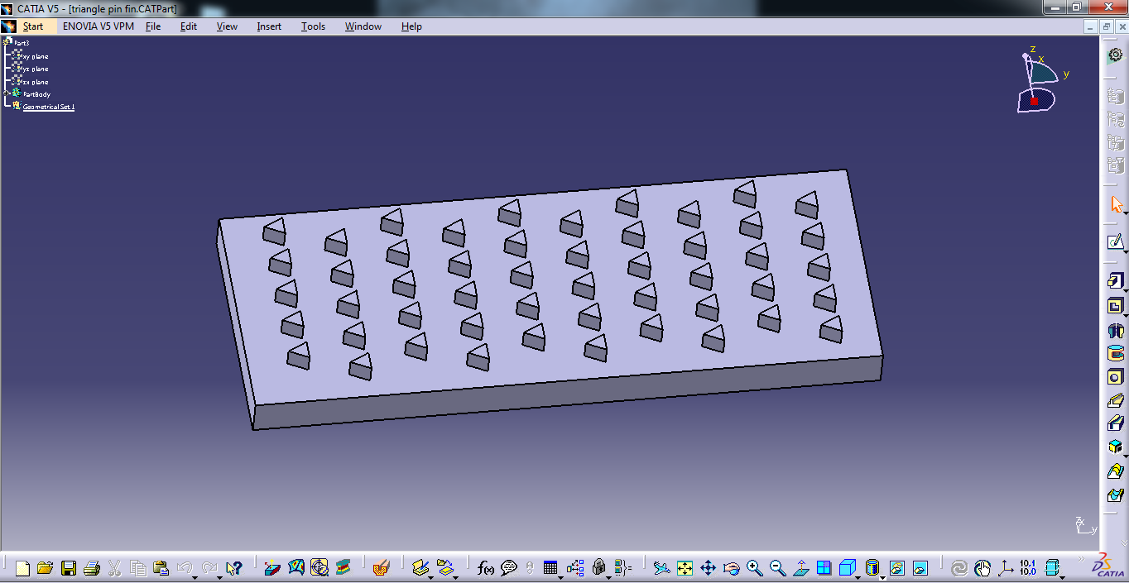

**Fig 3:** Triangular pin fin heat sink.

The base material of heat sink used is Aluminium and the Nano fluids introduced inside the heat sink are Diamond-water and Alumina-water comparing with the water fluid. Velocity of flow is taken 0.069m/s based on Reynolds number at the temperature of 20°c at the inlet of the heat sink. Constant heat flux of 1W is applied on the bottom face, all the fins undergone to convection.

**4. Governing Equations**

For modeling, Nano fluid is treated as a single phase fluid. This assumption can be applicable since the particles are ultra-fine and they are easily fluidized. Moreover, the particle volume fraction in Nano fluid is usually low. Under such assumptions the governing equations for the Nano fluid flow and heat transfer are greatly simplified and local fluid and particles are in thermal equilibrium. For steady state, 3-D, incompressible and laminar flow the following equations are solved to calculate the distributions of velocity and temperature.

Continuity equation: $∇$ V=0 (1)

Momentum equation: $ρ(V∇V)$ = $-∇P+∇(µ∇V)$ (2)

Energy equation: $ρC_{p}\left(V∇T\right)=k∇^{2}T$ (3)

**4.1 Boundary Conditions**

• At the inlet: velocity inlet taken ranges from 0.069 m/s at ambient temperature 20˚C.

• At the outlet: pressure outlet is taken (flow assumed to be fully developed).

• At the lower surfaces of the heat sink constant wall temperature is applied (T=100°C).

• For the Bottom side of the heat sink: heat flux = 1W.

• No-slip boundary condition is applied to all fluid-solid interfaces.

Outer surface of the heat sink model (right, left, and top) are assumed to be adiabatic walls.

The hydraulic diameter is calculated by using Equation (11).

Dh = (4)

Reynolds number is calculated using Equation (5).

Re= (5)

Heat transfer co-efficient is calculated using the relation (6).

Q = hA $∆T$ (6)

**5. Results and Discussion**

**5.1 Validation**

The results obtained from the present work is validated with the investigated Model [1] of the paper, and the below Fig 4 validates the results hence the present thesis are in good agreement.

**Fig 4:** Variation of Pressure Drop with the Different Reynolds Number.

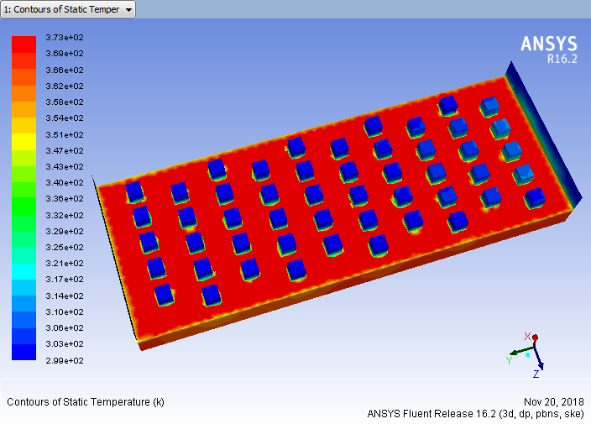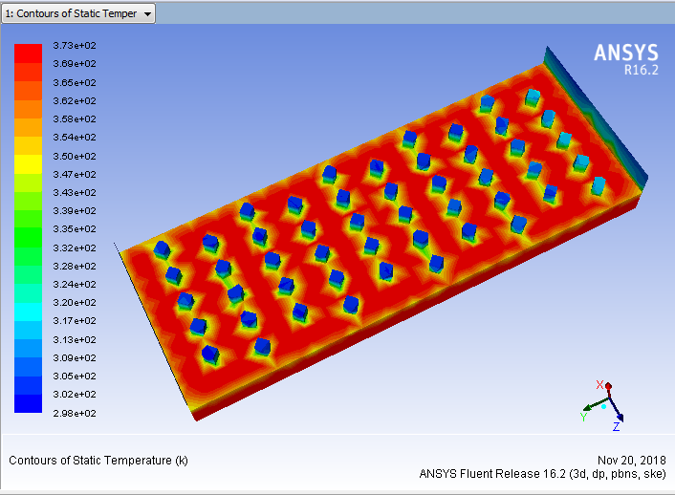**5.2 Numerical results**

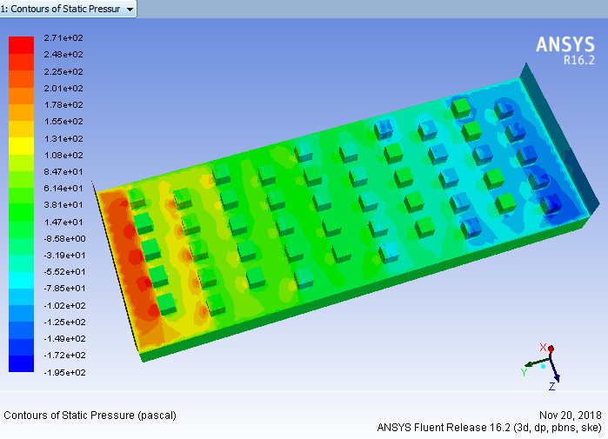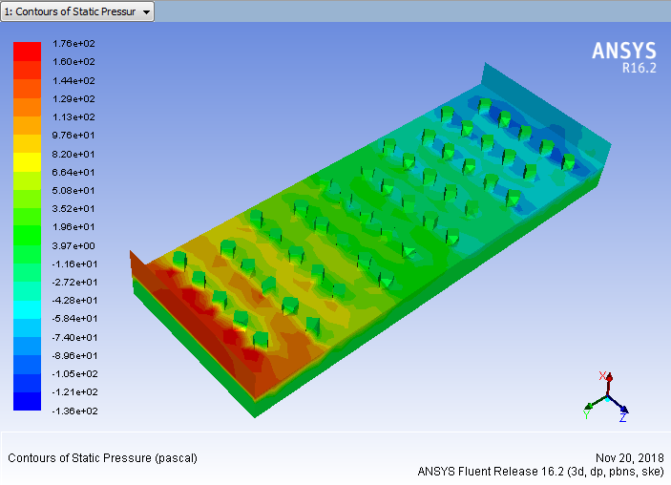In the above figures Fig- 5 and Fig- 6 shows that the temperature distribution at the Reynolds number Re=1000, in the laminar flow region.

Fig 6: Temperature contours of square pin fins.

Fig 5: Temperature contours of circular pin fins.

Fig 8: Pressure contours of square pin fin.

Fig 7: Pressure contours of circular pin fin.

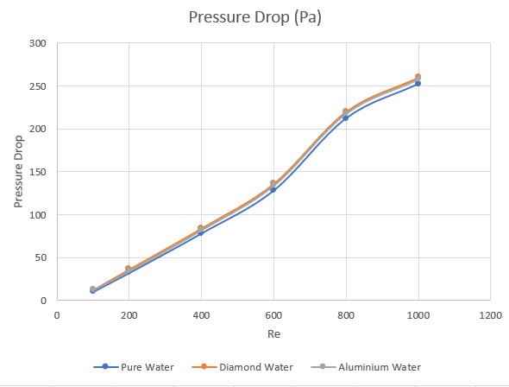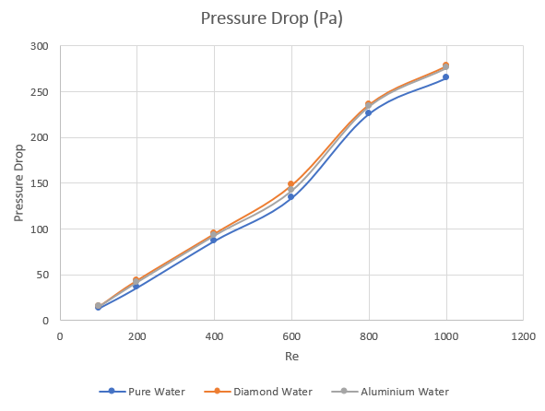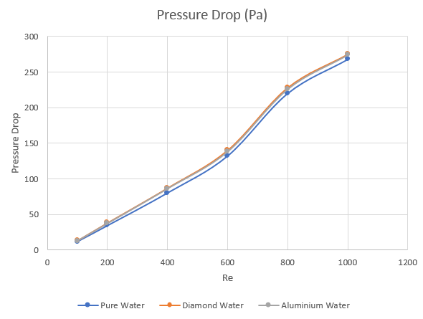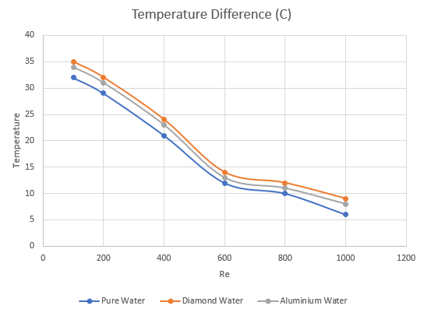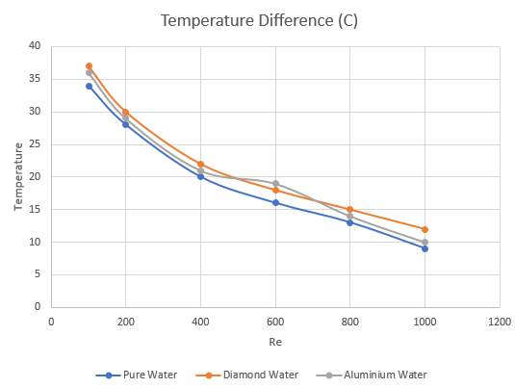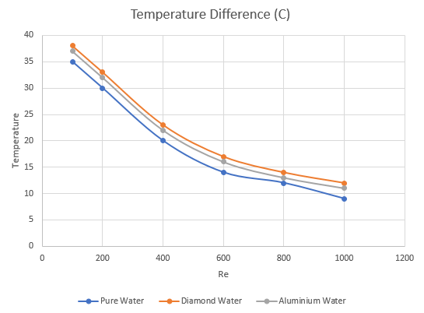From the Fig-7 and Fig-8 which shows the pressure distributions in the micro pin fin heat sink i.e. the static pressure contours occurs in the circular and square fin pin geometry. And the Figures 9, 10 and 11, which explained about the temperature difference inside the micro pin fin heat sink varied with the Reynolds number using different Nano fluids like Diamond-water, and Alumina-water compared with the water fluid in the circular, square and triangular geometries. Here the circular geometry has the more temperature difference also diamond water has the more heat carrying capacity than the other fluids.

Fig 12: Pressure drop v/s Re in circular pin fins.

Fig 9: Temperature difference v/s Re in circular pin fins

Fig 10: Temperature difference v/s Re in square pin fins

Fig 13: Pressure drop v/s Re in square pin fins.

Fig 14: Pressure drop v/s Re in triangular pin fins.

Fig 11: Temperature difference v/s Re in triangular pin fins.

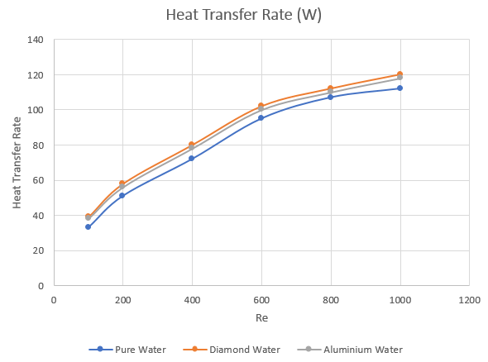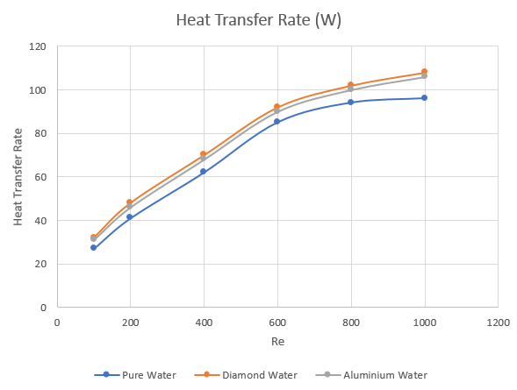From the Figures 12, 13, and 14 it is observed that the pressure drop inside the square pin fin heat sink geometry has found to be more compared to the other geometries hence diamond-water Nano fluid which can be effectively cools the heat sink.

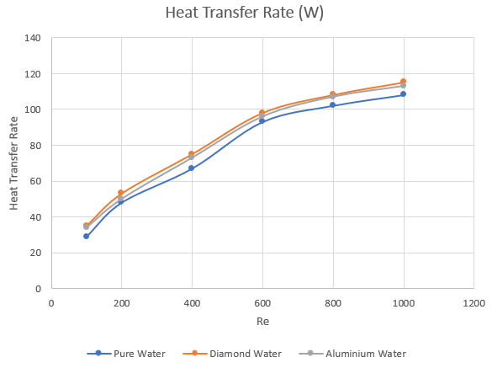

Figure 16: Heat transfer rate v/s Re in square pin fins.

Figure 15: Heat transfer rate v/s Re in circular pin fins.

Figure 17: Heat transfer rate v/s Re in square pin fins.

From the Figures 15, 16, and 17 it is observed that the heat transfer rate from the micro pin fin heat sink using Nano fluids with different fin geometry shapes, the circular pin fins geometry has the more heat removal rate from the heat sink than the other geometries also Nano fluids used i.e. Diamond-water and Alumina-water has the effective cooling characteristics over the base fluid water.

**6. Conclusion**

Three types of fluids are used by varying the Reynolds number in different fin geometries like circular, square and triangular.

* For all fins geometries using of Nano fluid as a coolant lead to enhanced cooling process by increasing the temperature of outlet fluid and the amount of heat that can be removed. From the other hand using of Nano fluid cause increase in pressure drop.
* Diamond-water Nano fluid is better than Al2O3-water from heat transfer point of view since it can carry larger amount of heat transfer rate for all types of fins studied.
* By increasing the volumetric concentration of Nano fluids both heat transfer rate and pressure drop have been increased dramatically.
* At constant temperature as a thermal boundary condition and for all values of Re and for both Nano fluids studied, the circular fins give higher heat transfer rate compared with other fins. And the square fins caused higher pressure drop.

In future scope of the analysis of heat sink, removing of heat generated can be increased by increasing the fins geometry i.e. varying the fins length, width and depth.

**Nomenclature**

a- length of heat sink,mm. Re- Reynolds number.

b-width of heat sink, mm.CPU-Control Processing Unit.

Cp-Specific heat Jkg-1k-1. LED-Light Emitting Diode.

K - Thermal Conductivity Wm-1K-1. 2D- Two Dimensional.

q - Heat flux input, Wm-2. 3D- Three Dimensional.

Q -Total heat Transfer, W. Al2O3-Aluminium Oxide.

P- Pressure, Pa. Greek symbols

v -Velocity of liquid flow, ms-1. -differnce in value.

Dh- Hydraulic diameter mm. ρ Density, Kgm-3.

T -Temperature ºC.

**REFERENCES**

[1] Mustaq Ismael Hasan Applied thermal Engineering Edition 2013, 63 (2014)598-607.  
 “Investigation of flow and heat transfer characteristics in micro pin fin heat sink with

Nano fluid”.

[2] S.Subramanian, K.S.Shridhar, C.K.Umesh-“Comparative study for Improving the Thermal

and fluid flow Performance of micro channel fin geometries using numerical simulation”.

(AJER)- e-ISSN:2320-0847 p-ISSN:2320-0936

[3] Piyush Laad, Bhushan Akhare, Praveen Chaurasia. “Thermal analysis of heat sinks with

fins of different configuration using ansys workbench 14.0” ISSN:2277-9655, Impact

Factor:4.116

[4] Ravishankar Prasad Maurya, Ankesh Kumar Pataskar “Investigation of thermal resistance of

Diamond shaped pin fin by CFD”. ISSN 2250-2459, ISO 9001:2008 Certified Journal,

Volume 4, Issue 2, February 2014.

[5] Asif Afzal*, A.D. Mohammed Samee, R.K. Abdul Razak, M.K. Ramis “Heat transfer

Characteristics of MWCNT Nano fluid in rectangular mini channels”.Volume.36, No.1,

March, 2018, pp. 222-228.

[6] Venkatesh Saravanan, Chitradurga K Umesh, Doddamani Hithaish,Kanakanahalli Seetharam

“Numerical investigation of pressure drop and heat transfer in pin fin heat sink and micro

channel pin fin heat sink”. Vol. 36, No. 1, March, 2018. Pp. 267-276.

[7]Deepak Gupta1, Vignesh Venkataraman2, Rakesh Nimje3. “CFD & Thermal Analysis of

Heat Sink and its Application in CPU”. (ISSN 2250-2459, ISO 9001:2008 Certified Journal,

Volume 4, Issue 8, August 2014).

[8] Asif Afzal*, Mohammed Samee A.D, Abdul Razak R.K. “Experimental Thermal

Investigation of CuO-W Nano fluid in Circular Mini channel.” AMSE IIETA publication

2017-series: Modeling B; Vol. 86; No 2; pp 335-344.