Vibration based condition monitoring of rotating shaft with crack

Lavoori Ramesh a*, ArunValabhojub, Dr.Amitkumarsingha

*aDepartment of Mechanical Engineering, MNIT Jaipur, Rajasthan, India.*

*bDepartment of Mechanical Engineering, NIT Warangal, Telangana, India.*

*Corresponding author Email: [2014pde5153@mnit.ac.in](mailto:2014pde5153@mnit.ac.in)

____________________________________________________________________________________

**ABSTRACT**

Signal is the most important element in implementation of Condition Based Monitoring(CBM). The present health condition of machine can be understanding by collecting the data from machine as signal and the analysis can be done through interpolation. Using algorithms remaining useful life of the machine could be estimate.

In this work, the vibration based fault detection of the rotating shaft with crack is developed for vibration signal analysis. The major components of vibration based monitoring system are accelerometer transducer, data acquisition card (DAQ). Data acquisition system, signal analysis and LabVIEW software are used to detect various defects which occur in the rotating machinery. Fast Fourier Transform (FFT) is simulated for the rotor health conditions and crack case at two different speeds 1200 rev/min and 1450 rev/min at bearing-1 and bearing-2. All three transforms provides much better diagnosis compared to the raw signature. FFT signature analysis is performed at both bearings at 1200 rev/min and 1450 rev/min. It has been observed that FFT provides a clear increase in its harmonic signatures almost double at 1st harmonic frequency for each case.

***Keywords*:** Condition Monitoring, Fault detection, Vibration.

1. **Introduction**

As rotating machinery is designed to run at higher efficiency, power, speed, and load the result is a significantly increased level of operating stress in modern rotating machinery. As a consequence, many practical rotor dynamic systems contain shaft/rotor elements that are highly susceptible to transverse cross-sectional cracks due to fatigue. To accurately predict the response of a system to the presence of a transverse crack, an appropriate crack model is essential. Once the crack is included in the system model, unique characteristics of the system response can be identified and attributed directly to the presence of the crack. These predicted indicators then serve as target observations for monitoring systems.

Machine condition monitoring is an important part of condition-based-maintenance, which recognized as the most useful strategy for carrying out maintenance in a wide variety of industries. To base maintenance on the understanding condition of working machines (many of machines are required to run continuously) requires that methods are available to determine their internal state while they are in operation. The two main ways of getting data from the inside to outside of operating machines are lubricant analysis and vibration analysis even though a few other techniques are also useful.

1. **LITERATURE REVIEW**

(Keri Elbhbah & Jyoti K. Sinha, 2013) a comparison between the composite spectrum without and with coherence has been investigated for the simulated fault in the test rig. It has been observed that the non-coherent composite spectrum provides poor diagnosis compared to coherent composite spectrum.(Akilu Yunusa-Kaltungo, Sinha, & Nembhard, 2015)it isplanned to apply the proposed method to different experimental rigs with two different foundations and possibly on industrial rotating machines with different foundations, so as to further enhance the confidence level of the proposed diagnosis method. Also, further analysis on the sensitivity of the proposed technique to different defects severities and variations in data availability are scheduled for future studies.

1. **EXPERIMENTAL SETUP**

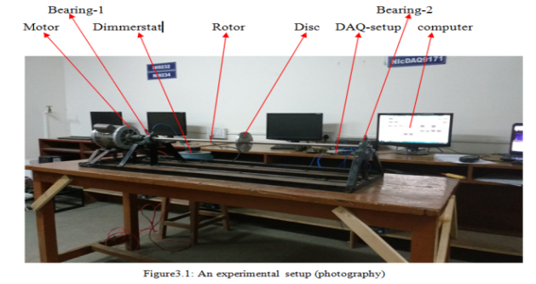

The experimental setup as shown in figure 3.1, which is located in product design and development lab at malaviya national institute of technology Jaipur. It consists of one steel shaft connected by jaw type shaft coupling and supported through two ball bearings which are mounted on frame as shown in figure 3.1. The shaft length is 1 m and diameter is 16 mm. the 1 m shaft is connected to electric motor through jaw type shaft coupling with spider. There is one balancing disc made of steel dimensions 114 mm (OD) x 11 mm thickness. The model testing has been carried on the test rig with healthy and crack shaft case at two different speeds 1200 rev/min and 1450 rev/min on the bearing-1 and bearing-2.The first natural frequency of the rig is 21Hz (1260 rev/min) my speed range (max.1450 rev/min).

3.1 **Accelerometer**

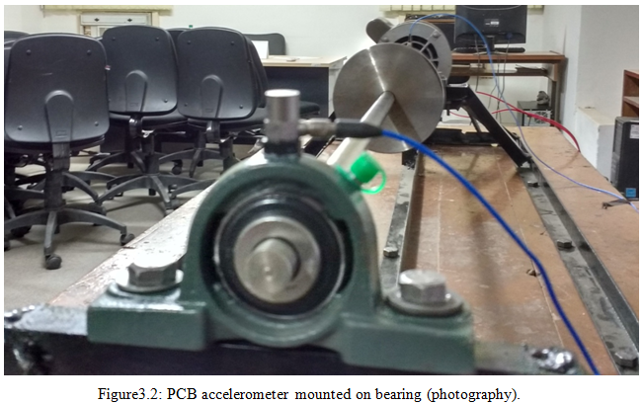

The transducer which produces a signalproportional to acceleration is called accelerometer. The mostcommon type transducers for use in machinevibration based condition monitoringare piezoelectric-accelerometers. Accelerometer transducer is used for this research work, an accelerometer has mounted on the bearings, the wax used as a mounting material as shown in figure 3.2.

## NI-DAQ

NI Compact DAQ is aportable, rugged dataacquisition (DAQ) platform thatintegrates connectivity and signature conditioninginto modular input/output for directly interfacing to any sensor orsignal. Using NI CompactDAQ withLabVIEW, youcan easily customizehow you acquire, analyze, present, and manageyour measurement data.

**4. METHODOLOGY**

**4.1 signal processing methods**

SignalProcessing is the Science and art of adjusting acquiredtime-series datafor analysis orenhancement. Examples includespectral analysis (usingthe FFT orother transforms)

**4.2Fourier analysis**

The fundamental idea of Fourier analysisis to expresssignals as a summationof sinusoidal components, andwith few exceptionsvirtually all signalscan be decomposedin this way. Fourier’soriginal analysis was appliedto finite lengthsignals. In machine vibrationanalysis it is usedprimarily for periodicsignals, as produced by amachine rotating atconstant speed. Thus, forany periodic signalg(t) of period T for which

|  |  |
| --- | --- |
|  |  |

Where*n* is any integer, it can be shown that

|  |  |
| --- | --- |
|  |  |

Whereis the fundamental angular frequency in (). The fundamental frequencyin Hz ( ) equals. The coefficientsof the cosine and sineterms can be obtained bycorrelating the latterwith *g*(*t*), as follows:

|  |  |
| --- | --- |
|  |  |
|  |  |

For a givenperiodic signal, the divisioninto sine and cosinecomponents dependsonan arbitraryassignment of zero time, but the totalcomponent at frequency (=) isgiven by

|  |  |
| --- | --- |
|  |  |

This can alternatively be written as

|  |  |
| --- | --- |
|  |  |

Where

And

This makes itclearer that the sinusoid has aconstantamplitude, with the phase anglebeing that existing atthe arbitrarily defined timezero. A different time zerowould only affect the initialphase

## 4.3 Fast Fourier Transform (FFT)

Fast Fourier Transform (FFT) is one efficient way to Discrete Fourier Transform (DFT) implementation as it utilizes less number of arithmetic units. DFT is one of primary tool to convert discrete time sequence into frequency domain and frequency analysis of discrete time signals.A typical utilization of FFT's is to find the frequency components of a signal buried in a noisy time domain signal.Fast Fourier Transform is the technique to perform DFT with less complexity. Different FFT algorithms like radix-2, radix-4, and split radix, mixed radix butterfly algorithms are available.The Fast Fourier Transform (FFT) is powerful tool foranalyzing and measuringsignals from plug-indataacquisition (DAQ) devices. For example, youcan effectively acquire time-domainsignals, measure thefrequency content, andconvert the resultsto real-world unitsand displays as shownon traditional benchtop spectrum andnetwork analyzers.

The Fourier transform isdefined by the following equation

Where is the time domainsignal, is the FFT, and is the frequency to analyze.

**5. Results**

vibration experimentshave been carried out ata rotor speed of and for the two differentcases(a) healthy condition, (b) a crackdepth was created on the shaft from Bearing-2 (far from electric motor) inorder to study the crackshaft case. The crack was sharpcut with crack width created by using hacksaw blade as shown in figure 5.1 The photographof crack shaft simulator in the rig is shown in figure 5.1.

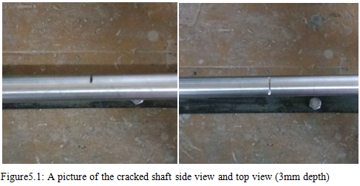

## 5.1 Signal analysis at bearing-1

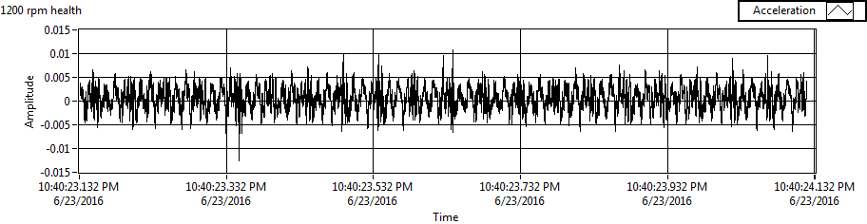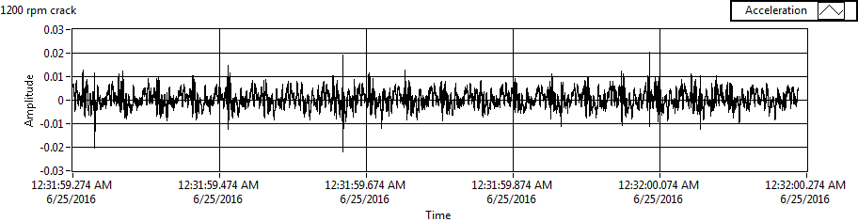

**Figure5.2: Typical signature in time domain for healthy and crack shaft case at 1200 Rev/min (bering-1)**

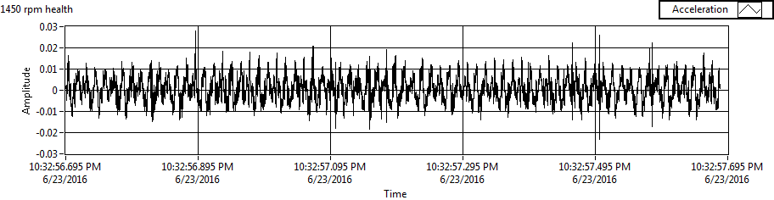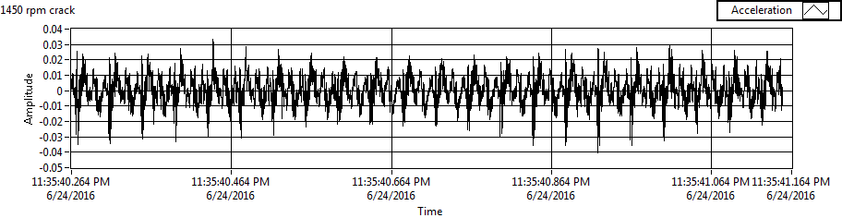

**Figure5.3: Typical signature in time domain for healthy and crack shaft case at 1450 rev/min (bering-1)**

From the figure 5.2 and figure 5.3, it is seenthat the waveforms intime domain reflect alittle abnormal characteristicsin crack shaft case, suchas the amplitudeof vibration signalunder fault state andthe normal conditionis different, and verylittle waveform andspectrum changes hasappeared. But it is notenough to accuratelyreveal the fault featureof each state.It is possiblethat an advanced signalprocessing approach isdemanded to extract fault features or anintelligent fault diagnosismethod is required to deal withthe problem.

**5.2 FFT analysis**

Typical FFT signature at bearing-1 are shown in figure 5.4 and figure 5.5 for the two cases healthy and crack case at the rotorspeeds of 1200 rev/min (20Hz) and 1450 rev/min (24.17Hz). For the rotorspeed 1200 rev/min (20Hz), The FFT at bearing-1 shows peak at 1x harmonic and a few higherharmonics with increasing amplitudefor the healthy casepossibly due to small residualmisalignment between motor and the rotor near bearing-1 which is expectedfor any healthymachine. Peaks are obtained multiple of 1st harmonic (20Hz, 42Hz, 62Hz, 82Hz, 104Hz ... so on). Crack case shows the same harmonicswith increase in theiramplitude value at 1x (20Hz), 3x (62Hz), 5x (104Hz) harmonics and with decrease in their amplitude value 2x (42Hz) and 4x (82Hz) at 1200 rev/min. Crack shaft case shows peaks at 1x (20Hz), 2x (42Hz), 3x (62Hz), 4x (82Hz), 5x (102Hz), 6x (120Hz) and 7x (144Hz) as shown in figure 5.4.

At 1450 rev/min crack shaft caseshows the same harmonicswith increase intheir amplitude value at 1x (20Hz), 3x (62Hz), harmonics and with decrease in their amplitude value 2x (42Hz) and 4x (82Hz), 5x (102Hz) and so on as shown in figure 5.5.

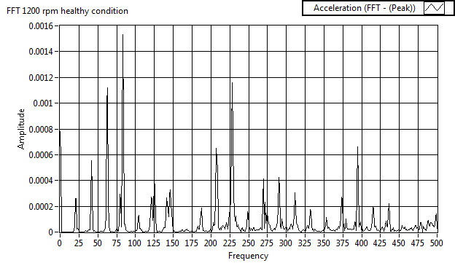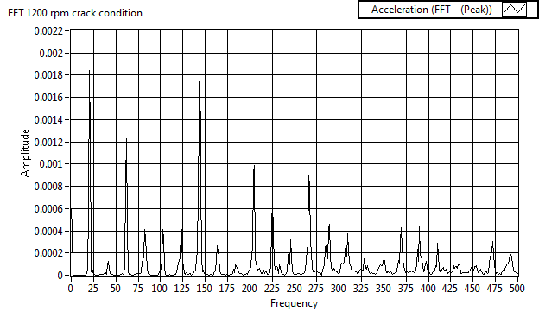

**Figure5.4: Typical FFT spectra of healthy and crack shaftAt bearing one at 1200 rev/min**

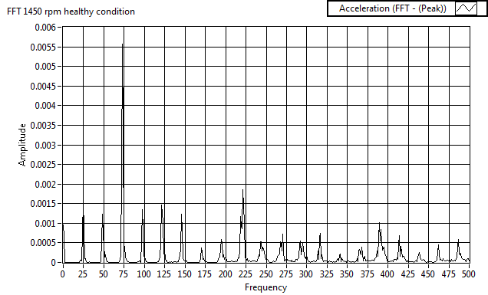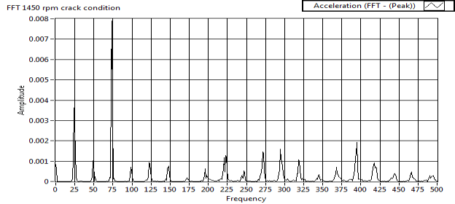

**Figure5.5: Typical FFT spectra of healthy and crack shaft at bearing one at 1450 rev/min**

## 5.3 Signal analysis at Bearing-2

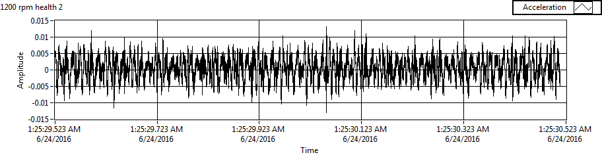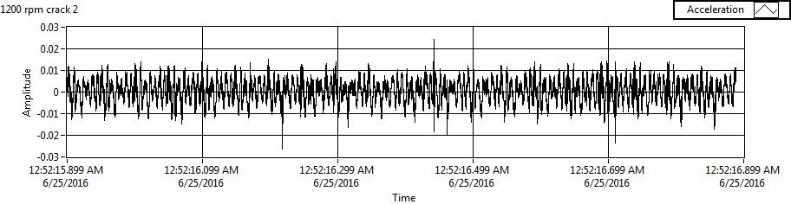

**Figure5.6: Typical signature in time domain for healthy and crack shaft case at 1200 rev/min (bering-2)**

From the figure 5.6 and figure 5.7, it is seen thatthe waveforms in time domain reflecta little abnormal characteristicsin crack shaft case, such as theamplitude of vibration signalunder fault state and the normalcondition is different, and verylittle waveform and spectrum changeshas appeared. But it is notenough to accuratelyreveal the fault feature ofeach state.It is possible thatan advanced signalprocessing approach isdemanded to extractfault features or anintelligent fault diagnosismethod is required to deal with theproblem.

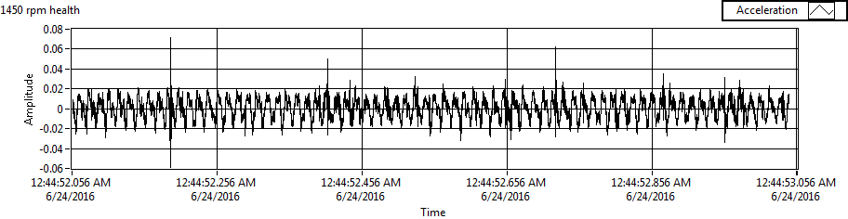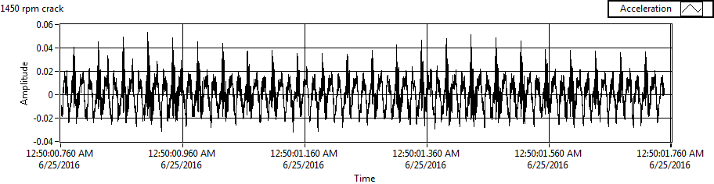

Figure5.7: Typical signature in time domain for healthy and crack shaft case at 1450 rev/min (bering-2)

### 5.4 FFTanalysis

Typicalamplitude spectra of FFT atibearing-2 is shown in figure 5.8 and figure 5.9 for two cases atrotor speedsof 1200 rev/min (20 Hz) and 1450 rpm (24.17 Hz) respectively. For therotor speed 1200 rev/min (20Hz), The FFT at bearing-2 shows peak at 1xiharmonic and a fewhigher harmonics with increasingamplitude for the healthy casepossibly due to smallresidual misalignment betweenmotor and the rotor near bearing-1 which is expectedfor any healthy machine. Peaks are obtained multiple of 1st harmonic (20Hz, 42Hz, 62Hz, 82Hz, 104Hz ... so on). Crackcase shows the sameharmonics with increasein their amplitudevalue at 1x (20Hz), 3x (62Hz), 4x (82Hz), 5x (104Hz) harmonics and with decrease in their amplitude value 2x (42Hz) at 1200 rev/min. Crack shaft case shows peaks at 1x (20Hz), 2x (42Hz), 3x (62Hz), 4x (82Hz), 5x (102Hz), 6x (120Hz) and 7x (144Hz) as shown in figure 5.8.

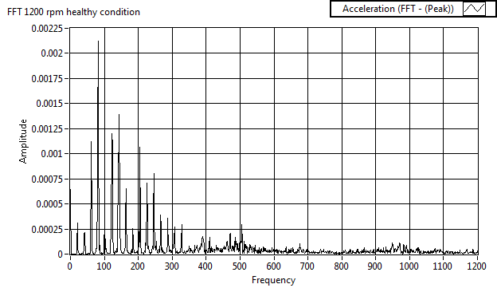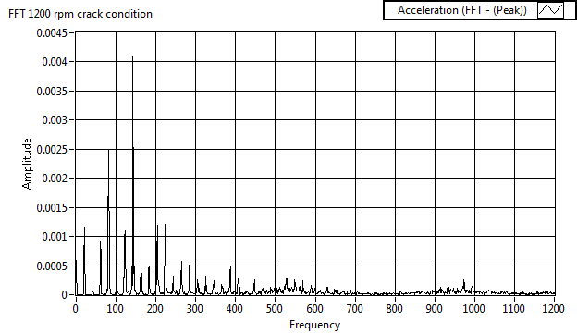

**Figure5.8: Typical FFT signature of healthy and crack shaft at bearing two at 1200 rev/min**

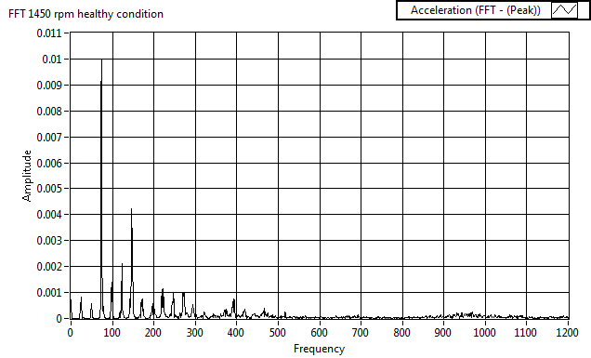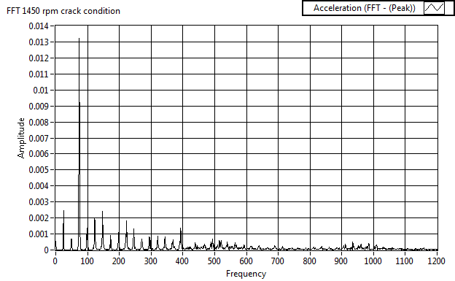

**Figure5.9: Typical FFT signature of healthy and crack shaft at bearing two at 1450 rev/min**

At 1450 rev/min crack shaft showsthe same harmonicswith increase in theiramplitude value at 1x (20Hz), 2x (42Hz), 3x (62Hz), harmonics and with decrease in their amplitude value 4x (82Hz), 5x (102Hz), and so on as shown in figure 5.9.

Although the signature shown in figure 5.8 and figure 5.9 shows the different features for crack case at 1200 rev/min and 1450 rev/min compared to healthy case. The featuresof the FFT observedchanging at differentspeeds for crack case shaft. This is clearlyevident from the measured vibration signal for the casesat Bearing-2 at 1200 rev/min and 1450 rev/min which are shown in figure 5.8 and figure 5.9. As can be observed from the FFT atiBearing-2 that the healthy case shows prominent 1x peak at the speed 1200 rev/min but increase in 1x amplitude at 1450 rev/min. Crack case shows significantincrease in amplitudeat 1x harmonic and 3x harmonic at 1450 rev/min compared to 1200 rev/min. Crack feature haschanged significantlybetween the two speeds, prominentpeak at 3x in addition to 1x at 1200 rev/min.

**6. Conclusion**

The proposed methods FFT on vibration based condition monitoring for rotating shaft with crack are applied at both bearing-1 and bearing-2 at two different speeds 1200 rev/min and 1450 rev/min. the experimental results are encouraging and certainly highlight the potential of the proposed methods for signature analysis.

It has been observed that FFT provides a clear increase in acceleration at its harmonic signals at both speeds.

**Reffrences**

1. Mohamed, A. A., R. Neilson, P. MacConnell, N. C. Renton, and W. Deans. "Monitoring of fatigue crack stages in a high carbon steel rotating shaft using vibration." *Procedia Engineering* 10 (2011): 130-135.
2. Lees, A. W., J. K. Sinha, and M. I. Friswell. "Model-based identification of rotating machines." *Mechanical Systems and Signal Processing* 23, no. 6 (2009): 1884-1893.
3. Adams, Maurice L. *Rotating machinery vibration: from analysis to troubleshooting*. CRC Press, 2009.
4. Akar, Mehmet. "Detection of a static eccentricity fault in a closed loop driven induction motor by using the angular domain order tracking analysis method." *Mechanical Systems and Signal Processing* 34, no. 1 (2013): 173-182.
5. Yunusa-Kaltungo, Akilu, Jyoti K. Sinha, and Keri Elbhbah. "An improved data fusion technique for faults diagnosis in rotating machines."*Measurement* 58 (2014): 27-32.
6. Yunusa-Kaltungo, Akilu, Jyoti K. Sinha, and Adrian D. Nembhard. "Use of composite higher order spectra for faults diagnosis of rotating machines with different foundation flexibilities." *Measurement* 70 (2015): 47-61.
7. Yen, Chia-Liang, Ming-Chyuan Lu, and Jau-Liang Chen. "Applying the self-organization feature map (SOM) algorithm to AE-based tool wear monitoring in micro-cutting." *Mechanical Systems and Signal Processing* 34, no. 1 (2013): 353-366.
8. Mohamed, A. A., R. Neilson, P. MacConnell, N. C. Renton, and W. Deans. "Monitoring of fatigue crack stages in a high carbon steel rotating shaft using vibration." *Procedia Engineering* 10 (2011): 130-135.
9. Lees, A. W., J. K. Sinha, and M. I. Friswell. "Model-based identification of rotating machines." *Mechanical Systems and Signal Processing* 23, no. 6 (2009): 1884-1893.
10. Adams, Maurice L. *Rotating machinery vibration: from analysis to troubleshooting*. CRC Press, 2009.
11. Akar, Mehmet. "Detection of a static eccentricity fault in a closed loop driven induction motor by using the angular domain order tracking analysis method." *Mechanical Systems and Signal Processing* 34, no. 1 (2013): 173-182.
12. Yunusa-Kaltungo, Akilu, Jyoti K. Sinha, and Keri Elbhbah. "An improved data fusion technique for faults diagnosis in rotating machines."*Measurement* 58 (2014): 27-32.
13. Yunusa-Kaltungo, Akilu, Jyoti K. Sinha, and Adrian D. Nembhard. "Use of composite higher order spectra for faults diagnosis of rotating machines with different foundationflexibilities." *Measurement* 70 (2015): 47-61.
14. Yen, Chia-Liang, Ming-Chyuan Lu, and Jau-Liang Chen. "Applying the self-organization feature map (SOM) algorithm to AE-based tool wear monitoring in micro-cutting." *Mechanical Systems and Signal Processing* 34, no. 1 (2013): 353-366.
15. Al-Badour, F., M. Sunar, and L. Cheded. "Vibration analysis of rotating machinery using time–frequency analysis and wavelet techniques."*Mechanical Systems and Signal Processing* 25, no. 6 (2011): 2083-2101.
16. Khelf, Ilyes, LakhdarLaouar, Abdelaziz M. Bouchelaghem, Didier Rémond, and Salah Saad. "Adaptive fault diagnosis in rotating machines using indicators selection." *Mechanical Systems and Signal Processing* 40, no. 2 (2013): 452-468.
17. Lin, Jinshan, and Chunhong Dou. "The diagnostic line: A novel criterion for condition monitoring of rotating machinery." *ISA transactions* 59 (2015): 232-242.
18. Sinha, Jyoti K., and Keri Elbhbah. "A future possibility of vibration based condition monitoring of rotating machines." *Mechanical Systems and Signal Processing* 34, no. 1 (2013): 231-240.
19. Mustapha, K. B., and Z. W. Zhong. "A hybrid analytical model for the transverse vibration response of a micro-end mill." *Mechanical Systems and Signal Processing* 34, no. 1 (2013): 321-339.
20. Elbhbah, Keri, and Jyoti K. Sinha. "Vibration-based condition monitoring of rotating machines using a machine composite spectrum." *Journal of Sound and Vibration* 332, no. 11 (2013): 2831-2845.
21. Gómez, M. J., C. Castejón, and J. C. García-Prada. "Crack detection in rotating shafts based on 3× energy: Analytical and experimental analyses."*Mechanism and Machine Theory* 96 (2016): 94-106.
22. Rao, J. S. *Rotor dynamics*. New Age International, 1996.
23. Randall, Robert Bond. *Vibration-based condition monitoring: industrial, aerospace and automotive applications*. John Wiley & Sons, 2011.