**Power-law nanofluid on Mixed Convection with Influence of Double Dispersion effect Saturated with non-Darcy Porous Medium**

J. Pranitha a, Om Prakash Meenab,*

*a,b Department of Mathematics, National Institute of Technology, Warangal - 506004, Telangana, India.*

*Corresponding author Email: [pranitha@nitw.ac.in](mailto:pranitha@nitw.ac.in)

**Abstract:**

In this article we present numerical solutions of power-law nanofluid on mixed convection with influence of double dispersion effect in presence of non-Darcy porous medium. The flow model represented by governing highly non-linear partial differential equations using the similarity variables. We obtain the required similarity equations which is explained by shooting method. The obtained results for temperature , velocity , and nanoparticle volume fraction  profiles varying for values of thermal dispersion (), solutal dispersion (), buoyancy ratio (), modified darcy(), power law index () and mixed convection () parameters have shown graphically and the local heat and mass transfer coefficients have presented in table. The obtained results found in good consent in comparison of previously published results.

***Keywords*:** non-darcy,Double Dispersion effect, shooting technique.

1. **Introduction**

As seen in literature the study of heat transfer in non-Newtonian fluid flow become a much interested due to wide use of its applications in petroleum production, power engineering industry, food production and many other industries. Many researchers have been studied non-Newtonian fluid behaviors in different geometries, channels and models with different effects, some of them are such as new mass flux condition, thermal radiations effect, non-Darcy porous media, wall heat flux, dispersion, double dispersion, thermal and solutal dispersion etc using the suitable numerical technique.

The power-law model is one of well-recognized non-Newtonian fluid model. Schowalter et al. [1] is one who introduced the boundary layer concept on power-law fluid. Later several researchers have studied its behavior, few of them are listed as [2] to [15].

The analysis of numerical solution of power-law nanofluid on mixed convection with influence of double dispersion effect saturated non-Darcy porous medium have not been studied yet by any researchers. Hence, through this article we aim to analyze the different types of effects.

1. **Mathematical Formulation**

In mixed convection embedded in non-Newtonian nanofluid, let us consider a vertical plate in presence of porous medium. The direction of x-axis aligned vertically, and y-axis is normal to the plate. The flow is laminar and steady 2D flow. At the wall, temperature T and nanoparticle fraction *ϕ* assume constant values  and  and free stream region  and  are the values respectively.

The flow model governing equations are given as

 (1)

 (2)

 (3)

 (4)

The subjective boundary conditions are

v = 0, T = Tw, C = Cw at y = 0

u = Uꝏ, T = Tꝏ, C = Cꝏ as  (5)

Where *u* and *v* are representing the velocity components in *x* and *y* directions, respectively, *K* represents the permeability of the porous medium, *β* represents the volumetric expansion coefficient of the fluid and density of the nanoparticle, *g* represents acceleration due to gravity, *µ* represents the viscosity, &represents thermophoretic diffusion and Brownian diffusion coefficients, respectively and  represents the free stream velocity. *α* and *D* are the thermal diffusivity and solutal diffusivity respectively and written as , respectively. αm and Dm are the molecular thermal and solutal diffusivities, respectively. ζ and γ are the coefficients of solutal and thermal dispersion, respectively. and  represents nano-particle mass density and fluid density respectively. The ratio between effective heat capacity of the nano-particle material and heat capacity of the fluid is represented by, *n* represents as index for power-law fluid.

Stream function is defined as which satisfies the continuity equation.

 and  (6)

We introduce similarity transformations

,    (7)

Using the similarity transformations Eqs. (1)-(4) reduced as

 (8)

 (9)

 (10)

The subjective boundary conditions are

   at η = 0

   as  (11)

Where  represents the Peclet number,  represents the Lewis number,  represents solutal dispersion parameter,  represents the mixed convection parameter,  represents the modified non-Darcy parameter,  represents the buoyancy ratio,  represents the Rayleigh number,  represents the Brownian motion parameter,  represents the thermal dispersion parameter,  represents the thermophoresis parameter.

**Heat and Mass transfer:**

The terms in Sherwood number (Sh) in presence of solutal and thermal dispersion and Nusselt number (Nu), the heat and mass transfer coefficients and can be represented as

 and 

The Nusselt number is representing by  and Sherwood number is representing by  are given by  (12)  (13)

**3. Numerical Method**

The equations from (8) – (10) along with boundary conditions (11) have been explained by shooting technique. The equations (8) – (10) transformed to a scheme of first order differential equations, by assuming the following

 (14)

the coupled differential equations of second order changes to three differential equations of first order;

 (15)

 (16)

 (17)

The boundary conditions are

 (18)

The values for  are assumed which are not stated at initial location and next set of equations from (15) - (17) are integrated utilizing fourth order Runge-kutta technique from  to  for step sizes of 0.01, where  is  at  and selected sufficiently vast with the goal that the arrangement indicates minimal more variation for  greater than . Here utilization of ODE45 solver in MATLAB a built-in code is used to solve these three coupled differential equations of first order.

The precision for the values which were assumed for  are tested by comparing the considered values  at with their given value at. If a differential occurs, another set of initial values for  are presumed and the procedure is repeated. In principle, to determine these initial values a trial and error method can be adopted, but it is tedious.

Instead, we utilize Newton-Raphson technique to get the initial values of  accurately and we integrate the eqs. (15) - (17) by utilizing fourth order Runge-kutta technique. The method prescribed is continuous until the agreement between the calculated and the given condition at  is within specified degree of precision.

**4. Results and Discussions**

The results have been displayed in this section. Fig. (a) & (b) is representing ,  and profiles for fixed values of *n = 0.5, Nb = 0.3, Le = 10.0, λ = 1.0, G = 0.5, Nr = 0.1, Nt = 0.1, Peζ = 0.5* and for varying values of *Peγ* and *Peζ* for the values [0.0, 0.5, 1.0, 1.5] where *Peζ* is fix as 0.5 in Fig(a) and *Peγ* is fix as 0.5 in Fig(b).

In Fig (a) varying the values of *Peγ* andother values fixed one can observe that velocity and temperature is increasing but reverse trend can be observed in Fig(b). Nanoparticle volume fraction is decreased while increasing the values of *Peγ* but a reverse trend can be seen in Fig(b) for varying values of *Peζ*.

Fig. (c) & (d) depicts,  and profiles, in Fig (c) we vary the values of *Nr = [0.1, 0.2, 0.3, 0.4]* for fixed values of *n = 0.5, Nb = 0.3, Le = 10.0, λ = 1.0, G = 0.5, Nt = 0.1, Peζ = 0.5*, Fig (d) is for varying of *G* = [0.1, 0.2, 0.3, 0.4] and keeping other values fixed with Nr =0.1. If we observe the velocity and temperature profiles are decreasing in Fig(c) for increasing values of buoyancy ratio and the same can be seen in Fig(d) for varying values of non-Darcy parameter. An expansion in buoyancy has the impact of expanding the initiated flow along the surface causing a decrease in the temperature. For nano particle volume fraction profile is decreasing in Fig(c) but opposite can be seen in Fig (d) for changing values of non-Darcy parameter.

Fig. (e)& (f) is depicts,  and profiles, in Fig (e) we vary the values of *n* = [0.5, 1.0, 1.5, 2.0] with *Nb = 0.3, Le = 10.0, λ = 1.0, G = 0.5, Nr = 0.1, Nt = 0.1, Peζ = 0.5, Peγ=0.5* and in Fig (f) vary for *λ* =[0.1, 0.5, 1.0,1.5] keeping other values fixed and *n* = 0.5. Fig (e) we can see that velocity is decreasing with increasing values of power-law index (for n < 1, n = 1, n > 1), but a converse trend can be perceived in Fig (f) for varying values of mixed convection parameter. Temperature profile in Fig(e)is increased with varying values of power-law index but opposite trend can be observed in Fig(f) for changing values of mixed convection parameter. For increasing values of power-law index decreases the nano volume fraction profile and the same can be seen in Fig(f) for changing values of mixed convection parameter.

The Table 1 designates the heat and mass transfer for changing values of non-Darcy parameter (G), thermophoretic parameter (Nt), thermal dispersion (Peγ), power law index (n), Brownian motion parameter (Nb), solutal dispersion (Peζ) parameter. From the table we can perceive that by changing the power law index number and keeping other values as constant the mass and heat transfer coefficient are diminishing. By varying of thermal dispersion parameter and keeping other values as constant, we observe that heat transfer coefficient is increasing, and mass transfer coefficient is decreasing. Varying the values of solutal dispersion parameter and fixing the other values we can see that the mass transfer coefficient is decreasing, and heat transfer coefficient is increasing. Higher varied values of thermophoretic parameter we can see that the mass and heat transfer coefficient are lowered. Brownian motion parameter is varied keeping other values fixed, we can witness that heat transfer coefficient is diminishing and mass transfer coefficient is growing. Increasing the values of non-Darcy parameter decreases the mass and heat transfer coefficients. Varying of mixed convection parameter lower the heat transfer coefficient but rises the mass transfer coefficient.

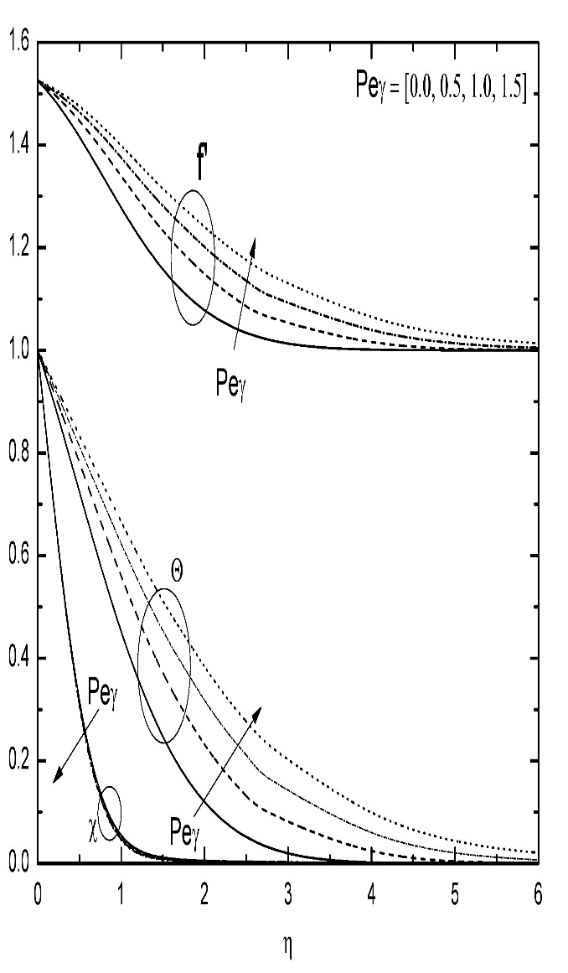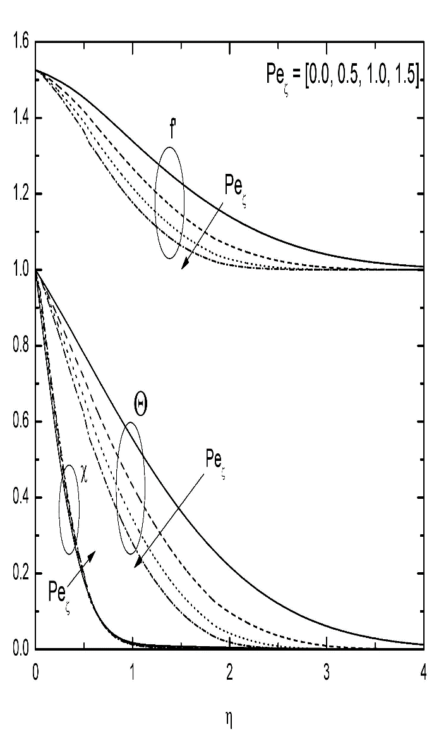

Fig. (a)& (b): ,  and profiles for varying of  and .

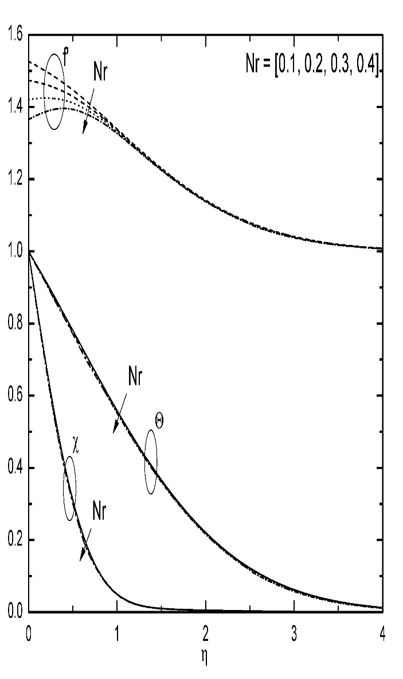 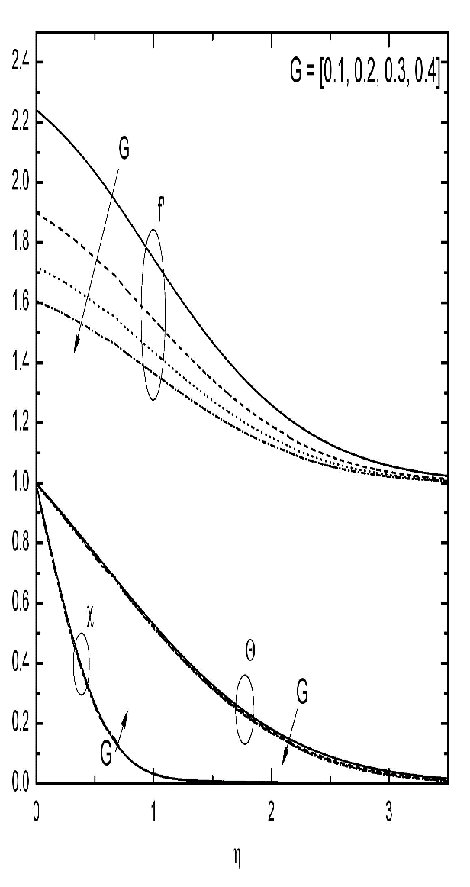

Fig. (c) & (d): ,  and profiles for varying of  and .

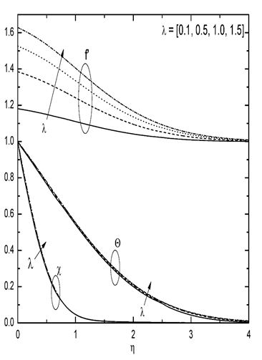

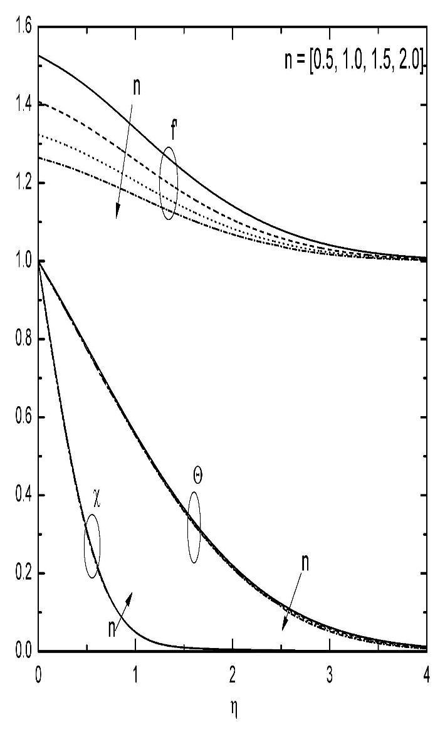

Fig. (e) & (f): ,  and profiles for varying of  and .

|  |  |  |
| --- | --- | --- |
|  |  |  |
| 0.5 0.5 0.5 0.5 0.3 0.5 1.0  1.0 0.5 0.5 0.5 0.3 0.5 1.0  1.5 0.5 0.5 0.5 0.3 0.5 1.0 | 1.616660  1.583596  1.558773 | 0.411151  0.404548  0.399991 |
| 0.5 0.0 0.5 0.5 0.3 0.5 1.0  0.5 1.0 0.5 0.5 0.3 0.5 1.0  0.5 1.5 0.5 0.5 0.3 0.5 1.0 | 1.599546  1.626136  1.632297 | 0.501478  0.356895  0.319723 |
| 0.5 0.5 0.0 0.5 0.3 0.5 1.0  0.5 0.5 1.0 0.5 0.3 0.5 1.0  0.5 0.5 1.5 0.5 0.3 0.5 1.0 | 2.172287  1.338262  1.163831 | 0.408914  0.412926  0.414432 |
| 0.5 0.5 0.5 0.0 0.3 0.5 1.0  0.5 0.5 0.5 0.2 0.3 0.5 1.0  0.5 0.5 0.5 0.3 0.3 0.5 1.0 | 1.627811  1.607716  1.600803 | 0.422466  0.400241  0.389721 |
| 0.5 0.5 0.5 0.5 0.1 0.5 1.0  0.5 0.5 0.5 0.5 0.5 0.5 1.0  0.5 0.5 0.5 0.5 0.7 0.5 1.0 | 1.573038  1.627107  1.632699 | 0.450817  0.374548  0.340919 |
| 0.5 0.5 0.5 0.5 0.3 0.0 1.0  0.5 0.5 0.5 0.5 0.3 0.1 1.0  0.5 0.5 0.5 0.5 0.3 0.2 1.0 | 1.901118  1.763882  1.702824 | 0.452868  0.438606  0.427647 |
| 0.5 0.5 0.5 0.5 0.3 0.5 0.0  0.5 0.5 0.5 0.5 0.3 0.5 0.5  0.5 0.5 0.5 0.5 0.3 0.5 1.5 | 1.564289  1.576985  1.643189 | 0.379328  0.403331  0.416553 |

**Table.1** The mass and heat transfer coefficients for varying values of *n,,, Nt, Nb, *and**.

**5. Conclusions**

In this paper we have considered mixed convection in a vertical plate saturated in porous medium with a power-law nanofluid. The following conclusions are drawn:

1. An Increment in  decreases the  profile but raise in  and  profiles and heat transfer coefficient decreases but mass transfer coefficient increases.
2. An increment in  raises the  profile but decrease in  and  profiles and heat transfer coefficient increases but mass transfer coefficient decreases.
3. An increment in  decrease all profiles.
4. An increment in increases the  profile but decrease in  and  profiles and mass and heat transfer coefficients decrease.
5. An increment in  increases the  profile but decrease in  and  profiles and mass and heat transfer coefficients decrease.
6. An increment in  increase all profiles and mass and heat transfer coefficients.
7. An increment in *Nt* decrease in mass and heat transfer coefficients.
8. An increment in *Nb* decreases heat transfer coefficient but mass transfer coefficient increases.

**Acknowledgements**

Authors are exceptionally appreciative to the DST-SERB for supporting ﬁnancially as a Research Project (EEQ/2016/000777), Government of India.

**References**

[1] W. R. Schowalter, The application of boundary layer theory to power-law pseudoplastic fluid: similar solutions, AIChE J., 24-28, 6(2004).

[2] Masood Khan and Waqar Azeem Khan, MHD boundary layer flow of a power-law nanofluid with new mass flux condition, AIP Advances, 6, 025211(2016).

[3] Macha Madhu and Naikoti Kisan, Finite element analysis of heat and mass transfer by MHD mixed convection stagnation-point flow of a non-newtonian power-law nanofluid towards a stretching surface with radiation, Journal of the Egyptian Mathematical Society, 458-470, 24(2016).

[4] S.U.S. Choi, Enhancing thermal conductivity of fluids with nanoparticles, in: D.A. Singer, H.P. Wang (Eds.), Developments and Applications of Non-Newtonian Flows, ASME, New York, Vol. 231, 99-105, 1995.

[5] Palani Sudhagar, Peri Kameswara Kameswaran and B. Rushi Kumar, Non-Darcy effects on mixed convection nanofluid over a wedge in a porous medium, Journal of Porous Media, 781-791, 21, 2018.

[6] J Pranitha, G Venkata Suman and D Srinivasacharya,Influence of variable properties and double dispersion on mixed convection in a power-law fluid-saturated non-darcy porous medium, Special Topics and Reviews in Porous Media, 177-195, 3, 2017.

[7] A. Subba Rao, V. Ramachandra Prasad, O. Anwar Beg and M. Rashidi, Free convection heat and mass transfer of a nanofluid past a horizontal cylinder embedded in a non-darcy porous medium, Journal of Porous Media, 279-294, Vol. 3, 2018.

[8] A. Abdullah, Fouad S. Ibrahim and Ali J. Chamkha, Non-similar solution of unsteady mixed convection flow near the stagnation point of a heated vertical plate in a porous medium saturated with a nanofluid, Journal of Porous Media, 363-388, Vol. 21, 2018.

[9] P. Cheng, Thermal dispersion effects on non-darcy convection flows in a saturated porous medium, Lett. Heat Mass Trans., 267-270, 8 (1981).

[10] O. Plumb, The effect of thermal dispersion on heat transfer in packed bed boundary layers, in: Proceedings of the 1st ASME/JSME Thermal Engineering Joint Conference, 17-21, 2, 1983.

[11] J Pranitha, G Venkata Suman and D Srinivasacharya, Mixed Convection in a Power-law Fluid Saturated Non-Darcy Porous Medium with Influence of Variable Properties, MHD and Thermophoresis “International Journal of Pure and Applied Mechanics”,113,160-168,2017.

[12] P. V. S. N. Murthy and P. Singh, Thermal dispersion effects on non-darcy natural convection over horizontal plate with surface mass flux, Archive of Applied Mechanics, 487-495, 67(1997).

[13] G. Dagan, Some aspects of heat and mass transfer in porous media, Fundamentals of Transport Phenomena in Porous Media, 55-64, 1972.

[14] D. Srinivasacharya, J. Pranitha and Ch. Ramreddy, Magnetic and double dispersion effects on free convection in a non-darcy porous medium saturated with power-law fluid, International Journal for Computational Methods in Engineering Science and Mechanics, 13, 210-218, 2012.

[15] Pooja Thakur, Naveen Tiwari and R. P. Chhabra, Flow of a power-law fluid across a rotating cylinder in a confinement, Journal of Non-Newtonian Fluid Mechanics, 145-161, 251(2018).