**Power-law nanofluid on Mixed Convection with Influence of Double Dispersion effect Saturated with non-Darcy Porous Medium**

J. Pranitha, Om Prakash Meena

Email: [pranitha@nitw.ac.in](mailto:pranitha@nitw.ac.in)

Department of Mathematics, National Institute of Technology Warangal – 506004, India.

**Abstract:**

The aim of this article is to present numerical solutions of power-law nanofluid on mixed convection with influence of double dispersion effect in presence of non-Darcy porous medium. The flow model represented by governing highly non-linear partial differential equations using the similarity variables. We obtain the required similarity equations which is explained by shooting method. The obtained results for velocity , temperature  and nanoparticle volume fraction  profiles for varying values of thermal dispersion (), solutal dispersion (), buoyancy ratio (), modified darcy (), power law index () and mixed convection () parameters have shown graphically and the local heat and mass transfer coefficients have shown in table. The obtained results found in good consent in comparison of previously published results.

**Key Words:** non-darcy,Double Dispersion effect, shooting technique.

**Introduction:**

As seen in literature the study of heat transfer in non-Newtonian fluid flow become a much interested due to wide use of its applications in petroleum production, power engineering industry, food production and many other industries. Many researchers have been studied non-Newtonian fluid behaviors in different geometries, channels and models with different effects, some of them are such as new mass flux condition, thermal radiations effect, non-Darcy porous media, wall heat flux, dispersion, double dispersion, thermal and solutal dispersion…etc using the suitable numerical technique.

The power-law model is one of well-recognized non-Newtonian fluid model. Schowalter et al. [1] is one who introduced the boundary layer concept on power-law fluid. Later many other researchers have studied its behavior, few of them are listed as [2] to [15].

The study of numerical solutions of power-law nanofluid on mixed convection with influence of double dispersion effect saturated non-Darcy porous medium have not been studied yet by any researchers. Hence, through this article we aim to analyze the effects.

**Mathematical Formulation:**

In mixed convection embedded in non-newtonian nanofluid, let us consider a vertical plate in presence of porous medium. In upward direction x-axis aligned vertically and y-axis aligned normally. The flow is steady and laminar 2D flow. At the wall, temperature T and nanoparticle fraction *ϕ* assume constant values  and  and In free stream region  and  are the values respectively.

The flow model governing equations are given as

 (1)

 (2)

 (3)

 (4)

The subjective boundary conditions are

v = 0, T = Tw, C = Cw at y = 0

u = Uꝏ, T = Tꝏ, C = Cꝏ as  (5)

Where *u* and *v* are representing the velocity components in *x* and *y* directions, respectively, *g* represents acceleration due to gravity, *K* represents the permeability of the porous medium, *β* represents the volumetric expansion coefficient of the fluid and density of the nanoparticle, *µ* represents the viscosity,  and represents the thermophoretic diffusion and Brownian diffusion coefficients, respectively and  represents the free stream velocity of *u* as *y* tends to infinity. *D* and *α* are the effective solutal and thermal diffusivities respectively and written as  and  Dm and αm are the molecular solutal and thermal diffusivities, respectively. ζ and γ are the coefficients of solutal and thermal dispersion, respectively. ζ and γ are the coefficients of solutal and thermal dispersion, respectively.  and  represents density of the fluid and nano-particle mass density respectively. The ratio between effective heat capacity of the nano-particle material and heat capacity of the fluid is represented by  and *n* represents the power-law index.

The stream function defined as which satisfies the continuity equation.

 and  (6)

We introduce similarity transformations

,    (7)

Using the similarity transformations Eqs. (1)-(4) reduced as

 (8)

 (9)

 (10)

The subjective boundary conditions are

   at η = 0

   as  (11)

Where  represents the peclet number,  represents the Lewis number,  represents solutal dispersion parameter,  represents the mixed convection parameter,  represents the modified non-darcy parameter,  represents the buoyancy ratio,  represents the Rayleigh number,  represents the brownian motion parameter,  represents the thermal dispersion parameter,  represents the thermophoresis parameter,.

**Heat and Mass transfer:**

In Nusselt number (Nu) term the heat and mass transfer coefficients and Sherwood number (Sh) in presence of solutal and thermal dispersion can be represented as

 and 

The Nusselt number is representing by  and Sherwood number is representing by  are given by  (12)  (13)

**Results and Discussions:**

The results have been displayed in this section. Fig. (a) & (b) is representing,  and profiles for fixed values of *n = 0.5, Nb = 0.3, Le = 10.0, λ = 1.0, G = 0.5, Nr = 0.1, Nt = 0.1, Peζ = 0.5* and for varying values of *Peγ* and *Peζ* [0.0, 0.5, 1.0, 1.5] where *Peγ* is fix as 0.5.

In Fig (a) varying the values of *Peγ* andother values fixed one can observe that velocity and temperature is increasing but reverse trend can be observed in Fig (b). Nanoparticle volume fraction is decreased while increasing the values of *Peγ* but a reverse trend can be seen in Fig(b) for varying values of *Peζ* and keeping other values fixed.

Fig. (c)& (d) depicts ,  and profiles for varying of *Nr = [0.1, 0.2, 0.3, 0.4]; Peγ* and *Peζ* fix as 0.5, for varying of *G* = 0.1, 0.2, 0.3, 0.4; Nr fix as 0.1. If we observe the velocity and temperature profiles is decreasing in Fig(c) for increasing values of buoyancy ratio and keeping other fixed values and the same can be seen in Fig(d) for varying values of non-darcy parameter and keeping others constant. For nano particle volume fraction profile is decreasing in Fig(c) but opposite can be seen in Fig(d).

Fig. (e)& (f) is depicts,  and profiles for varying of *n* = 0.5, 1.0, 1.5, 2.0; *Nr, G* and *λ* fix as 0.1, 0.5, 0.5, respectively; for varying of *λ* = 0.5, 1.0, 1.5, 2.0; *n* fix as 0.5. In Fig (e) we can see that velocity is decreasing with increasing values of power-law index, but a reverse trend can be observed in Fig(f) for varying values of mixed convection parameter. Temperature profile in Fig(e)is increased with varying values of Power-law index but opposite trend can be observed in Fig(f). For increasing values of power-law index decreases the nano volume fraction profile and the same can be seen in Fig(f) for varying values of mixed convection parameter.

The Table 1 designates the heat and mass transfer for varying values of non-Darcy parameter (G), thermophoretic parameter (Nt), thermal dispersion (Peγ), power law index (n), , Brownian motion parameter (Nb), solutal dispersion (Peζ) parameter.

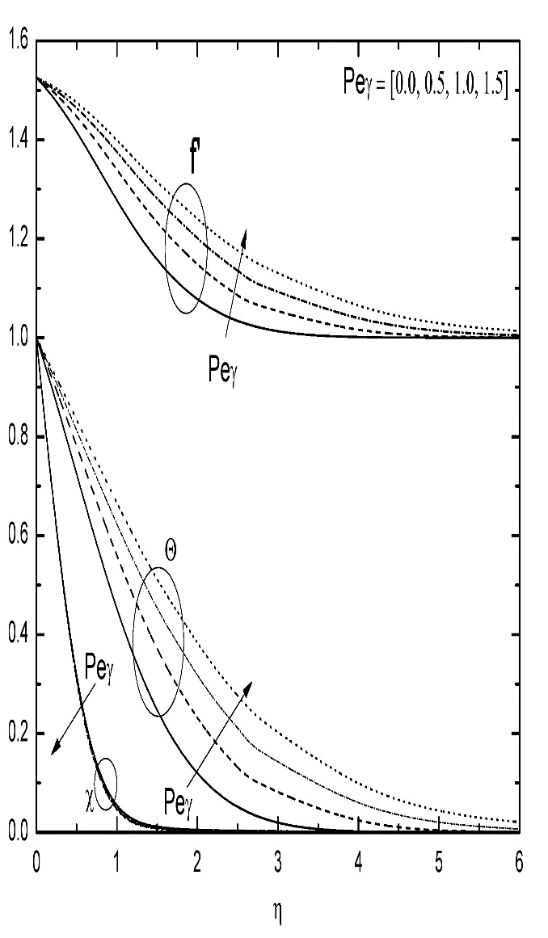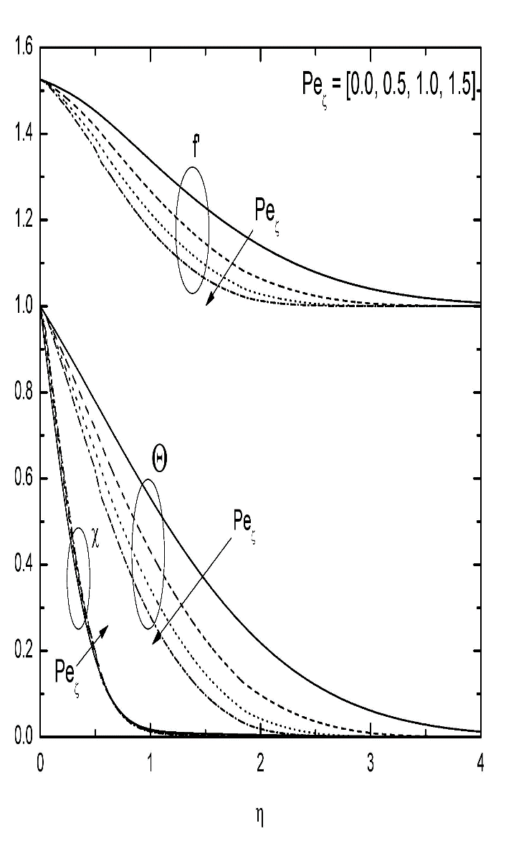

Fig. (a & b): ,  and profiles for varying of  and .

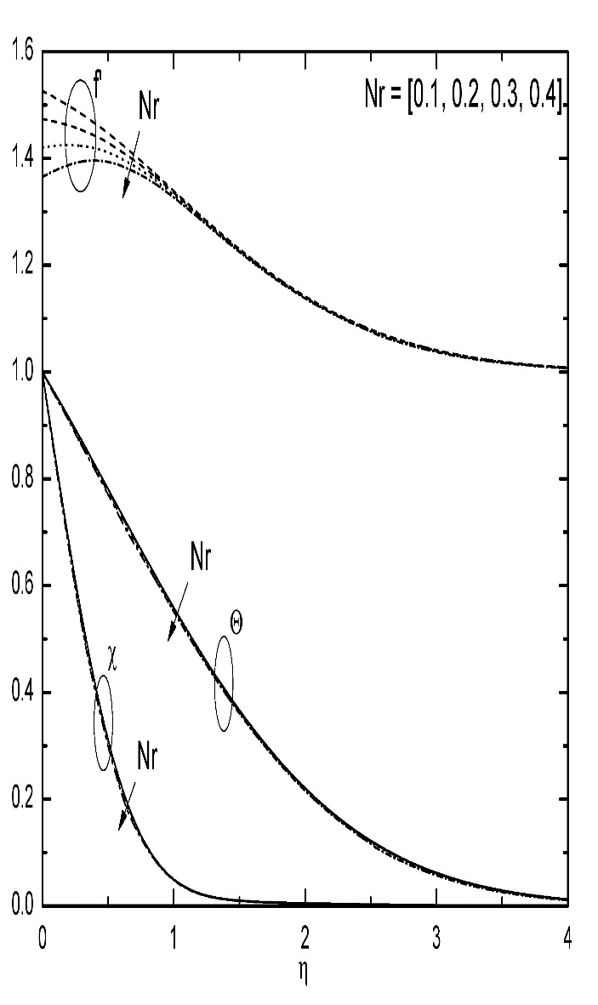 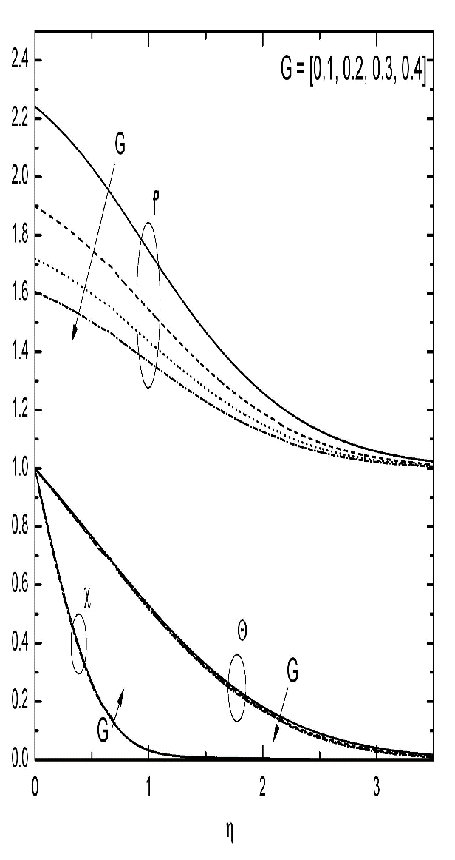

Fig. (c & d): ,  and profiles for varying of  and .

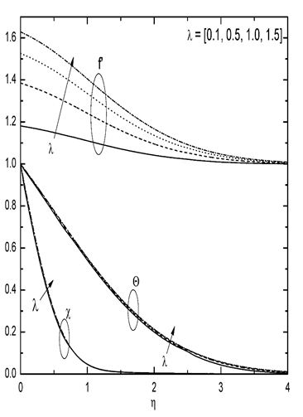

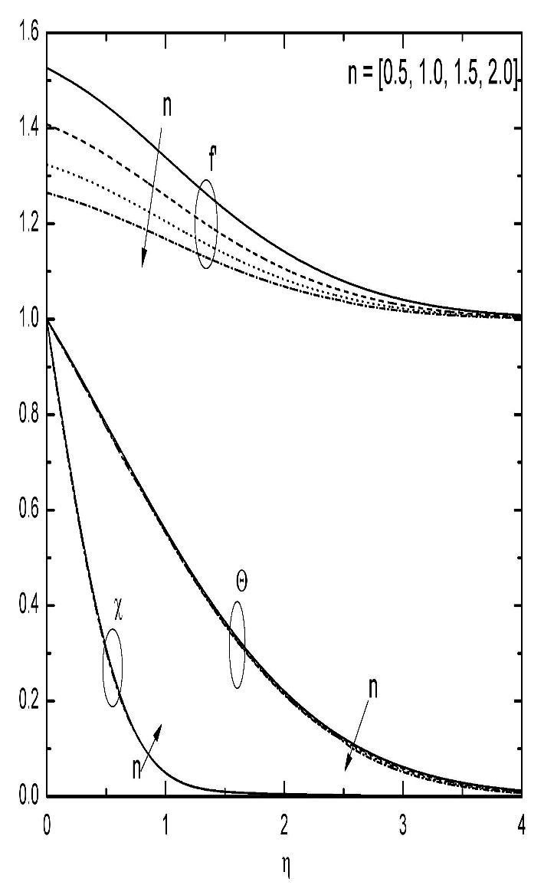

Fig. (e & f): ,  and profiles for varying of  and .

|  |  |  |
| --- | --- | --- |
|  |  |  |
| 0.5 0.5 0.5 0.5 0.3 0.5 1.0  1.0 0.5 0.5 0.5 0.3 0.5 1.0  1.5 0.5 0.5 0.5 0.3 0.5 1.0 | 0.411151  0.404548  0.399991 | 1.616660  1.583596  1.558773 |
| 0.5 0.0 0.5 0.5 0.3 0.5 1.0  0.5 1.0 0.5 0.5 0.3 0.5 1.0  0.5 1.5 0.5 0.5 0.3 0.5 1.0 | 0.501478  0.356895  0.319723 | 1.599546  1.626136  1.632297 |
| 0.5 0.5 0.0 0.5 0.3 0.5 1.0  0.5 0.5 1.0 0.5 0.3 0.5 1.0  0.5 0.5 1.5 0.5 0.3 0.5 1.0 | 0.408914  0.412926  0.414432 | 2.172287  1.338262  1.163831 |
| 0.5 0.5 0.5 0.0 0.3 0.5 1.0  0.5 0.5 0.5 0.2 0.3 0.5 1.0  0.5 0.5 0.5 0.3 0.3 0.5 1.0 | 0.422466  0.400241  0.389721 | 1.627811  1.607716  1.600803 |
| 0.5 0.5 0.5 0.5 0.1 0.5 1.0  0.5 0.5 0.5 0.5 0.5 0.5 1.0  0.5 0.5 0.5 0.5 0.7 0.5 1.0 | 0.450817  0.374548  0.340919 | 1.573038  1.627107  1.632699 |
| 0.5 0.5 0.5 0.5 0.3 0.0 1.0  0.5 0.5 0.5 0.5 0.3 0.1 1.0  0.5 0.5 0.5 0.5 0.3 0.2 1.0 | 0.452868  0.438606  0.427647 | 1.901118  1.763882  1.702824 |
| 0.5 0.5 0.5 0.5 0.3 0.5 0.0  0.5 0.5 0.5 0.5 0.3 0.5 0.5  0.5 0.5 0.5 0.5 0.3 0.5 1.5 | 0.379328  0.403331  0.416553 | 1.564289  1.576985  1.643189 |

**Table.1** The heat and mass transfer coefficients for varying values of *n, , , Nt, Nb, *and **.

**Conclusions**

From above results we reach on following conclusions:

1. An Increment in  decreases the  profile but raise in  and  profiles and heat transfer coefficient decreases but mass transfer coefficient increases.
2. An increment in  raises the  profile but decrease in  and  profiles and heat transfer coefficient increases but mass transfer coefficient decreases.
3. An increment in  decrease all profiles.
4. An increment in increases the  profile but decrease in  and  profiles and heat and mass transfer coefficients decrease.
5. An increment in  increases the  profile but decrease in  and  profiles and heat and mass transfer coefficients decrease.
6. An increment in  increase all profiles and heat and mass transfer coefficients.
7. An increment in *Nt* decrease in heat and mass transfer coefficients.
8. An increment in *Nb* decreases heat transfer coefficient but mass transfer coefficient increases.

**References**

[1] W. R. Schowalter, The application of boundary layer theory to power-law pseudoplastic fluid: similar solutions, AIChE J., 24-28, 6(2004).

[2] Pooja Thakur, Naveen Tiwari and R. P. Chhabra, Flow of a power-law fluid across a rotating cylinder in a confinement, Journal of Non-Newtonian Fluid Mechanics, 145-161, 251(2018).

[3] Masood Khan and Waqar Azeem Khan, MHD boundary layer flow of a power-law nanofluid with new mass flux condition, AIP Advances, 6, 025211(2016).

[4] Macha Madhu and Naikoti Kisan, Finite element analysis of heat and mass transfer by MHD mixed convection stagnation-point flow of a non-newtonian power-law nanofluid towards a stretching surface with radiation, Journal of the Egyptian Mathematical Society, 458-470, 24(2016).

[5] S.U.S. Choi, Enhancing thermal conductivity of fluids with nanoparticles, in: D.A. Singer, H.P. Wang (Eds.), Developments and Applications of Non-Newtonian Flows, ASME, New York, Vol. 231, 99-105, 1995.

[6] Palani Sudhagar, Peri Kameswara Kameswaran and B. Rushi Kumar, Non-Darcy effects on mixed convection nanofluid over a wedge in a porous medium, Journal of Porous Media, 781-791, 21, 2018.

[7] J Pranitha, G Venkata Suman and D Srinivasacharya,Influence of variable properties and double dispersion on mixed convection in a power-law fluid-saturated non-darcy porous medium, Special Topics and Reviews in Porous Media, 177-195, 3, 2017.

[8] A. Subba Rao, V. Ramachandra Prasad, O. Anwar Beg and M. Rashidi, Free convection heat and mass transfer of a nanofluid past a horizontal cylinder embedded in a non-darcy porous medium, Journal of Porous Media, 279-294, Vol. 3, 2018.

[9] A. Abdullah, Fouad S. Ibrahim and Ali J. Chamkha, Non-similar solution of unsteady mixed convection flow near the stagnation point of a heated vertical plate in a porous medium saturated with a nanofluid, Journal of Porous Media, 363-388, Vol. 21, 2018.

[10] P. Cheng, Thermal dispersion effects on non-darcy convection flows in a saturated porous medium, Lett. Heat Mass Trans., 267-270, 8 (1981).

[11] O. Plumb, The effect of thermal dispersion on heat transfer in packed bed boundary layers, in: Proceedings of the 1st ASME/JSME Thermal Engineering Joint Conference, 17-21, 2, 1983.

[12] J Pranitha, G Venkata Suman and D Srinivasacharya, Mixed Convection in a Power-law Fluid Saturated Non-Darcy Porous Medium with Influence of Variable Properties, MHD and Thermophoresis “International Journal of Pure and Applied Mechanics”,113,160-168,2017.

[13] P. V. S. N. Murthy and P. Singh, Thermal dispersion effects on non-darcy natural convection over horizontal plate with surface mass flux, Archive of Applied Mechanics, 487-495, 67(1997).

[14] G. Dagan, Some aspects of heat and mass transfer in porous media, Fundamentals of Transport Phenomena in Porous Media, 55-64, 1972.

[15] D. Srinivasacharya, J. Pranitha and Ch. Ramreddy, Magnetic and double dispersion effects on free convection in a non-darcy porous medium saturated with power-law fluid, International Journal for Computational Methods in Engineering Science and Mechanics, 13, 210-218, 2012.