**Computational Fluid Dynamics Analysis in a Ribbed Tube with Different Twisted Tape Inserts To Enhance The Heat Transfer**

Dr.S.K.Gugulothua, B.Ravinder nayakb, V.V.PhaniBabuc

aDepartment Of Mechanical Engineering, N.I.T, Hamirpur.

b & c Department of Mechanical Engineering, MLR Institute of Technology

Corresponding author mail: santoshgk1988@nith.ac.in

**Abstract:**

Computational Fluid Dynamics analysis has been carried out to investigate on plain tube with different twisted tapes inserts with uniform heat flux condition to study the performance characteristics on thermal efficiency, friction factor and mean Nusselt number. Treating the working fluid (i.e., air), experiments was carried out in a turbulent region by choosing suitable Reynolds number. A plain tube with full length twisted tape is tested and compared with short length twisted tapes to avoid the decaying along the tube half-length twisted tape was introduced to produce a strong swirl flow, whereas in the case of full length twisted tape stronger swirling flow is observed along the complete length of tube. The variation of reduction in pressure along the length of tube and heat flux in the form of the friction factor and Nusselt number are represented graphically. The numerical results indicate that when compared to half-length twisted tape (i.e., λ =0.14, 0.27 &0.36), fully length twisted tape show better heat transfer, friction factor and improvement in the enhancement efficiency. It is also observed that numerical results are in good agreement with the experimental & correlated values of the mean Nusselt number in the order of ±10% in the range of Reynolds number 25000 to 110000.

**Keywords:** CFD, inserts, Nusselt number, friction factor and heat transfer rate**.**

**1. INTRODUCTION:**

In many applications, heat has to be transferred from one flowing fluid to another through a solid barrier separating these fluids which are at different temperature, which can be achieved by using heat exchangers. From last decade with increased the usage of the heat exchanger for an industrial and domestic purpose, such as powerplant, processing plant makes use of refrigeration and air conditioning equipment, opens up the door for necessary improvement to be made in order to minimize the cost and at the same time increase the efficiency of the heat exchanger. Till date, exhaustive research techniques are considered to enhance the heat transfer rates, which are generally referred to as an augmentation technique.

Sedong Kim has done the analysis to study characteristics of fluid flow and heat transfer coefficient of nano fluids consisting of distilled H2O by using laminar model experimentally and them validated numerically using computational fluid dynamics 0.25, 0.5 wt.% & 1 wt.% AL2O3 nano particles. At each phase of concentration with different pressure drop, convective heat transfer characteristics were studied. Results showed that, with an increase in Reynolds Number, heat transfer coefficient & Nusselt Number also increases and also observed that with the enlargement in concentration of nano fluids, prandtl number reduces. Ozden Agra et .al has done the analysis on passive heat transfer enhancement techniques numerically and then validated experimentally i.e.; zdaniuk et al by considering following parameters i.e.; temperature & pressure distribution inside the tubes, pressure drop along the length of the tube, losses due to friction and convective heat transfer coefficient. Various friction factor correlations obtained by Blassius & Zdaniuk are in good agreement with the numerical results obtained. Results found that by using CFD, mean deviation was less than 5% for the friction factor where as Blassius correlation has the deviation of less than 10%. A study has been done on laminar forced convection of flow, with the concentration of AL2O3/water as the nano fluid at a Reynolds Number of 1600 in a tube by using different models numerically. It was observed that the Nusselt Number was more accurate in time independent fluids than time dependent fluids, with an average deviation of 5.98% & 4.84% respectively.

Sogol pirbastami Samir et.al has done the analysis in a plain tube to improve the rate of heat flow when compared with different helically grooved tubes with different twisted ratios by using computational fluid dynamics code, and AnsysFluent. The analysis was done with heat flow rate of 3150 W/m2,  of length 2m and diameter of 7.1 mm with a Reynolds number range of 4000-20000. From the results it was noted that with constant Reynolds Number, and reducing the twisted ratio, both the Nusselt Number & the friction factor increase. At the expense of pressure energy, increase in Nusselt Number was obtained for a pitch size of 7.1 mm. Investigations were carried out numerically by using CFD in a straight micro channel with water/Alumina nano fluids as a working fluid to enhance the heat transfer phenomena. In order to predict the heat flow and hydrodynamics parameter of nano fluids, different phase mixtures (i.e., single & two phases) models are considered. It was found that single phase approach gives lesser prediction compared to two phase model numerically and was in good agreement with the experimental results.

M.Haghshenas has done the CFD analysis on a smooth tube with uniform wall temperature distribution with laminar convective heat transfer of nano fluids. For calculation of convective heat transfer, temperature & flow field a single phase & two-phase model approaches were considered. Simultaneously other parameters like nano fluid Peclet Number, Volume fraction effect on rate of heat flow were examined. It showed that with an increase in the nano fluid Concentration heat transfer enhancement also increases. Simulated results are in good agreement with experimental results, in the case Cu/water Nano fluid with 0.2% concentration when compared to single phase model.

Majid Hejazian et.al has done the experimental investigations to enhance the heat transfer by creating a non-uniform magnetic field with different working fluids to measure the convective heat transfer coefficient. From the results it was observed that convective heat transfer was higher in the case of diluted ferro fluid. However, due to the existence of non-uniform magnetic field, decrease in the Nusselt number and exit temperature is observed. Atul Bhattad et.al has done experimental & analytical analysis to study the effect of heat transfer and reduce in the pressure characteristics by using hybrid nano fluid with variable concentration on a heat exchanger. From the result it was observed that, by using hybrid Nano fluid improvement in the convective coefficient by 39.16% It is observed that when compared to base fluid, in case of hybrid nano fluid effectiveness increased, and improvement of heat transfer & pressure drop characteristics. Adnan M Hussain et.al has carried out the computational fluid dynamics with different nano fluids, geometries and loss of friction characteristics. In this analysis water is chosen as a base fluid with TiO2 as a nano particle with vol. fraction (1%, 1.5%, 2%) is considered. Results are shown that when compared to base fluid, improvement in the heat transfer, fluid flow characteristics & volume fraction are observed in the case of hybrid nano fluid.

To study the effect of momentum and thermal diffusivity when compared with the thermal conductivity of nano fluids on disorganized convective heat transfer was studied experimentally & numerically by H. Abdel razek et.al. Experimental results are in good agreement with simulated results for the average Nusselt Number & pressure drop in a given length with the same concentration , better enhancement was observed in the case of Al2O3 – DW nano fluids where compared with other Nano fluids .It was also observed that even though Cu-DW Nano fluids has higher thermal conductivity lower enhancement is observed. Paisan Naphon et.al studied the effect of flow phenomena and heat transfer characteristics on horizontal spiral coil tube numerically & validated with the literature available. Non-uniform unstructured grid system is considered in finite volume method for solving the conservation principles. To analyze the disorganized, K-є turbulence model is employed. From the results, it is observed that when compared to plain tube, pressure gradient along the axial path & Nusselt Number are 1.49 &1.50 times lesser than that of spiral – coil tube. To study the hydrodynamic & thermal behavior on a trapezoidal tube consisting of nine circular cylinders subjected to forced convection heat transfers. The following parameters are considered i.e., fluctuating velocity, trapezoidal factor & longitudinal & transverse pitches to study the effect of pressure drop & Nusselt Number simultaneously, by evaluating the production of entropy which is a function of trapezoidal factor, second law analysis was performed. Results showed that in the tube tank, development of entropy is very sophisticated to the trapezoidal factor.

Vamsi Mokkapati et.al investigated the enhancement of the concentric tube heat exchanger by considering two thermal fluids to assess the effect on engine performance through heat recovery system when compared to plain tubes without twisted tape inserts, enhancement of 235.3% & 67.2% is observed in the case of annually corrugated tube heat exchanger. H.Demir has done the numerical investigation with uniform wall temperature in a horizontal cross-section with combination of TiO2 and Al2O3 with water as the working fluid. Nano fluids are chosen based on palm et.al correlations. From the above literature it could be derived that, to improve the heat transfer in flow through pipe with twisted tape inserts in a full length tube is one of the most attractive method because of its simplicity and effectiveness.

**3. Numerical Simulation**

Numerical analysis has been carried out to investigate the pain tube by using Ansys as the CFD tool by considering discretization techniques. Geometrical domain was created with air as a working fluid flowing in a stainless steel tube which is electrically heated with a length of 1980 mm approximately and diameter of 22mm similar to the physical domain as shown in the figure 1. The computational domain has been created in CATIA. In the present research work, analysis was carried out on plain tube with different twisted tape inserts (λ=d/H=0.14, 0.27, 0.38) with uniform heat flux condition of 2300 W/m2  to study the performance characteristics on thermal efficiency, friction factor and mean Nusselt number.

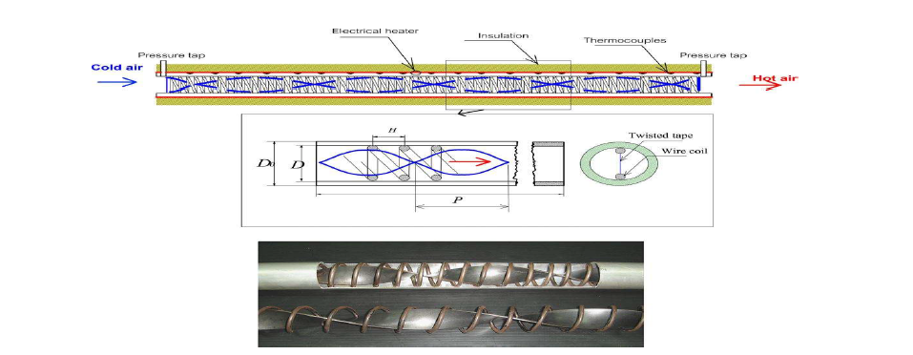

Figure 1. Test Section with twisted tape (geometrical domain)

Following are the various twisted tape configurations considered for the analysis:

A) Ribbed Tube (PT) condition: Analysis of convective heat transfer along the axial length of tube without any inserts.

B) Full Length (FLTT): Distorted tapes are occupied completely along the length of heating section.

C)Down Stream condition (HLDTT): Twisted tapes are occupied along the second half of the heating section (partial swirl flow)

D) Upstream condition (HLUTT): Twisted tapes are occupied along the first half of the test section leading to improvement in the swirl flow.

**3.1 Numerical Method:**

To do the analysis on swirl flow finite difference method is employed and for solving the governing partial differential equations Prandtl theory is chosen. In order to make the analysis easier, some assumptions are considered to simplify the complex energy and flow equations to enhance the heat transfer phenomena in a tube with twisted tape. Considering three dimensional fluid flow phenomena by neglecting radiation and convective heat transfer for solving three conservation principles (i.e. continuity momentum, Energy) by choosing suitable thermo physical characteristics and assuming the flow to be Incompressible, uniform, turbulent and steady flow.

Following are the equations given below:

In order to relate the mean velocity difference with Reynolds shear stress, Boussinesq hypothesis method has been employed to model the Reynolds stresses accurately in turbulence modelling.





To simplify the turbulent viscosity suitable turbulence model is chosen. To discretize the convective term second order upwind scheme was considered. A SIMPLE algorithm method was employed to enhance the relation between the velocity &pressure quantities. To study the behaviour of the fluid flow near to the surface of the tube wall, a standard wall treatment model.



Grid Independence analysis was carried out to validate the accuracy of computational results on the computational domain. Finer mesh was chosen with different structured nodes (i.e;1,30,000,3,00,000,6,00,000,12,00,000cells) at the vicinity of the wall surface and around the twisted tapes, by comparing the friction factor with meshed configuration. From the analysis obtained, the numerical mesh considered to study was about 700000 cells incorporated with tetrahedral grid. To validate with the experimental result, similar dimensions are chosen for numerical study by considering the length of the test section to be 2000mm, equipped with twisted tape insert of 22 mm diameter incorporated with a twist angle of 0.14. Further, the convergence criteria 10-3 for the continuity & 10-6 were used for energy of the calculated parameters. Entrance of the computational domain the working fluid (i.e. air) temperature is considered to be 300k and following are the assumptions considered before initialising the numerical solver.

1) Heat flux is uniformly distributed along the computational domain.

2) Wall surface are assumed to be perfectly insulated

**3.2 Data Processing Technique:** In order to obtain the experimental results in a more effective manner, data reduction technique has been employed. To determine the loss of friction, conductive rate of heat flow, and improvement in the heat transfer enhancement.

The friction factor (f) is calculated considering pressure drop along the length (∆p), using the following equation

A Non- dimensional parameter i.e.; Reynolds number is expressed as Nu= h.D/K

To determine the fluid flow characteristics Nusselt number and the Reynolds number are based on the surface temperature and the average of the tube wall. To determine the rate of heat flow of the heated tube with different inserts the parameters like velocity, wall temperature, inlet and outlet air temperature, the pressure drop across the test section are measured.

**4. Results & Discussion:**

**4.1 Verification of setup**

Experimental and CFD results are validated by considering the plain tube without a twisted tape insert as shown in the figure 2 &3. For validating the analytical with the simulated results, empirical correlation is given by Boelter et.al equation is applied for finding the heat transfer and the Blassius equation is used for solving the friction factor. Analytical results are in good agreement with the simulated results, with 12 %in the case of rate of heat flow and 8% loss in the friction.

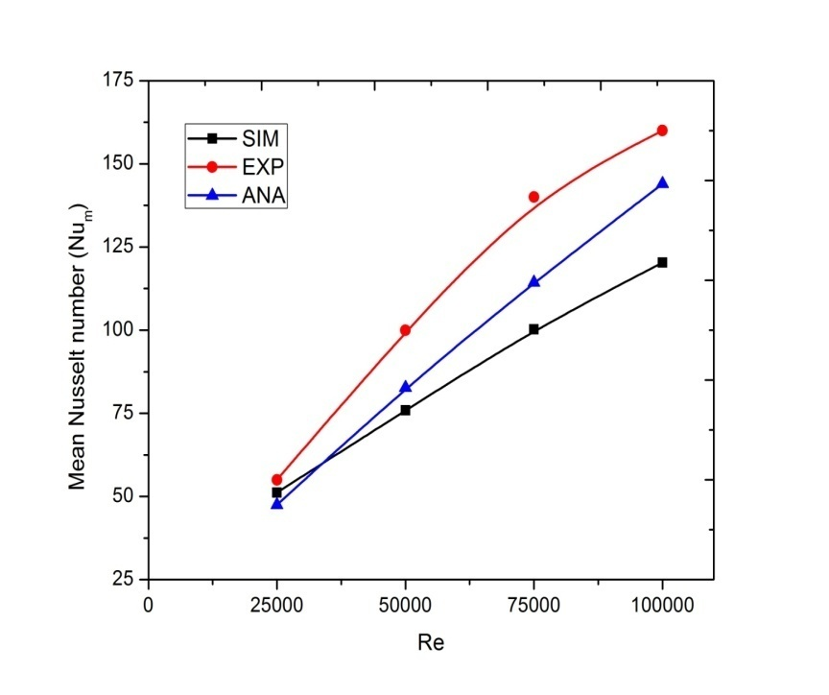

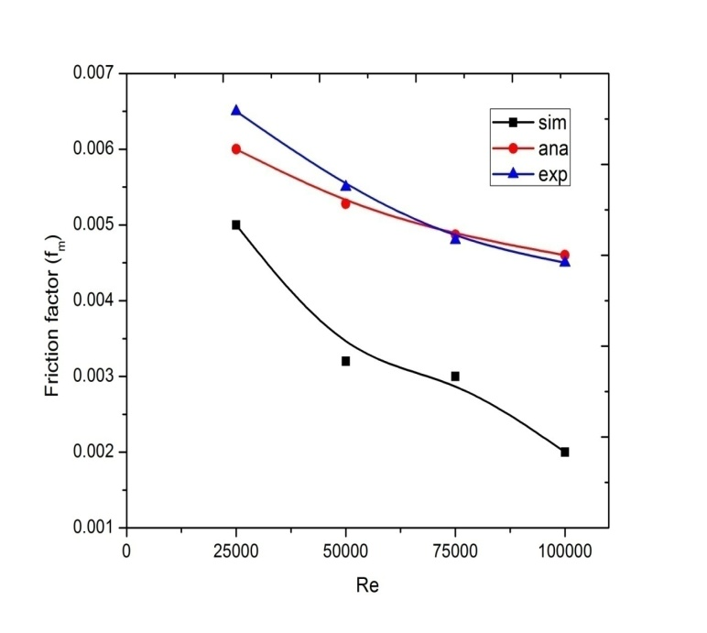

Figure 2 & 3: Validation of simulated results with experimental and analytical correlations

**4.2 Heat Transfer**

From the figure 4, it is noted that the significance of different twisted tape inserts on the heat transfer mechanism with increase in Reynolds Number are studied. When compared to ribbed tube, improvement in the heat transfer is observed in the case of inserts with different ratios, due to the production of strong swirl flow along the interference of boundary layers.

From the graphs it is noted that as the Reynolds number, the convection heat transfer coefficient also increases for different tubes when compared to plain tubes, the convective heat transfer of 30-85% is observed in the full length twisted tape(FLTT) without inserts. Whereas in the case of HLUTT with the twisted tape insert, a heat transfer coefficient of 10-35% higher than those of plain tubes are observed. Even though there is an increase in heat transfer coefficient in the case of HLUTT & HLDTT but when compared to FLTT reduction of 20-80% is observed.

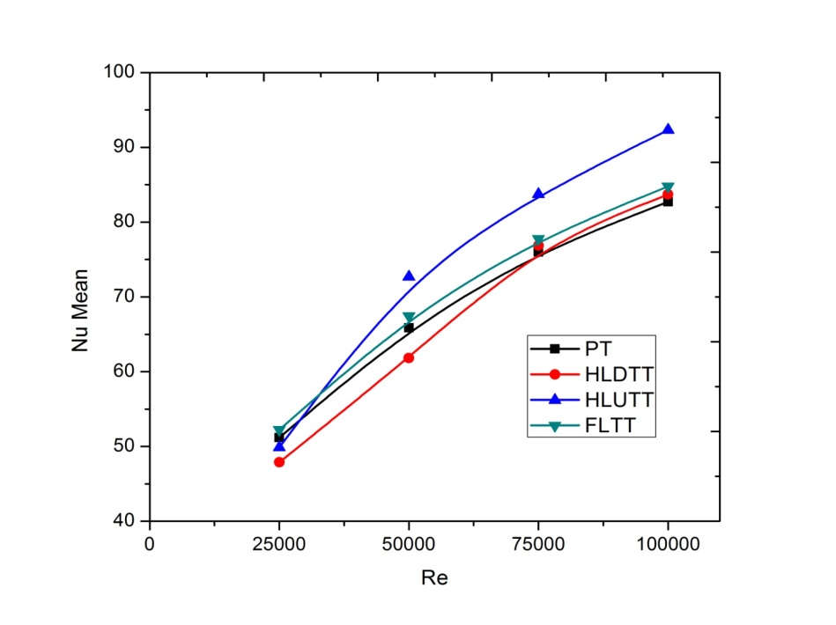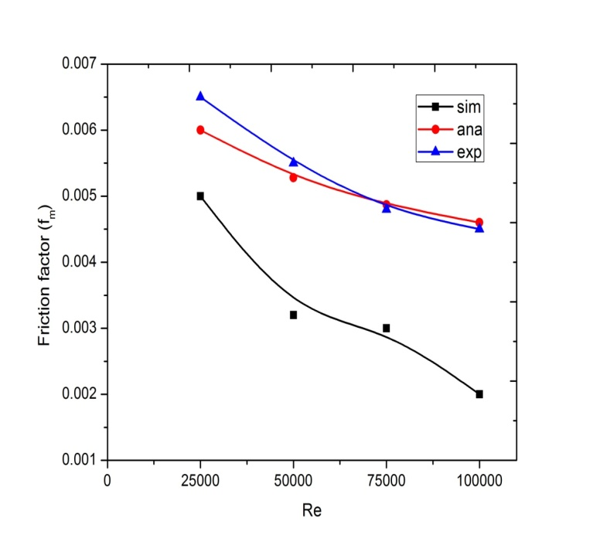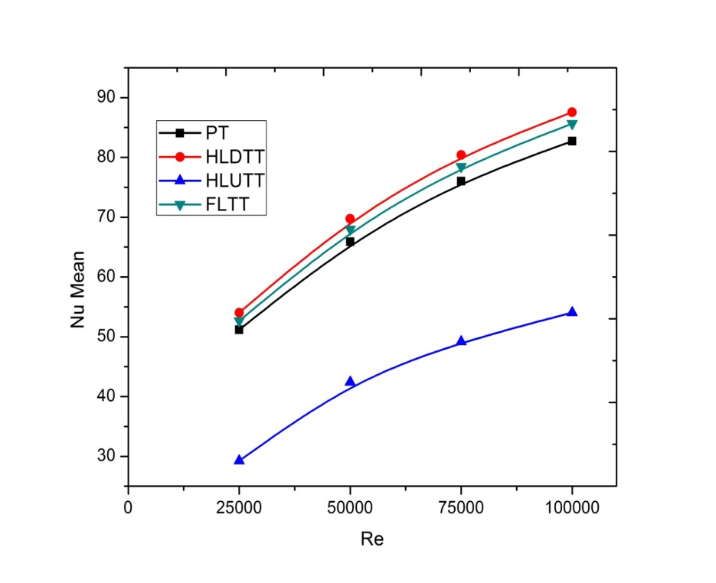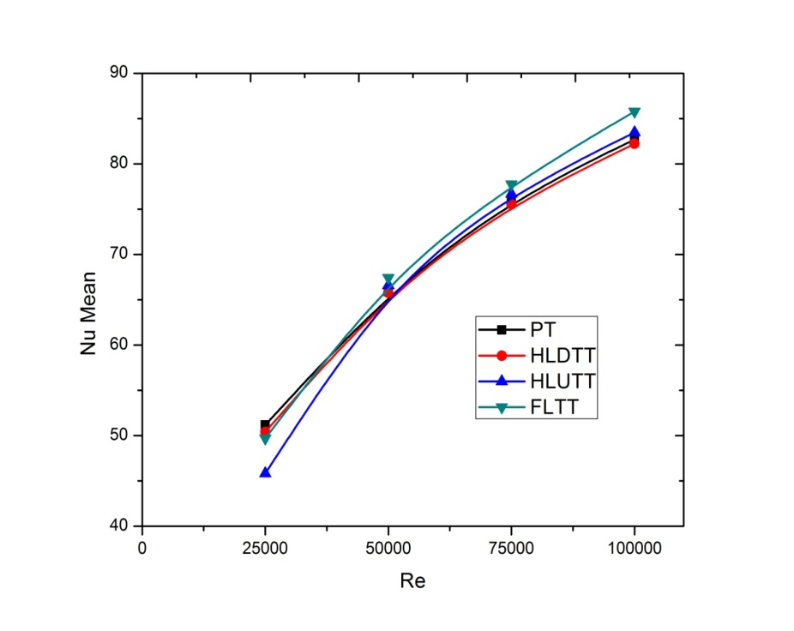

Figure 4: Variation of Re with mean Nu for different ratios (i.e., λ =0.14, 0.27 &0.36)

**4.3 Friction factor**

The variation of pressure gradient for different twisted tape inserts are analyzed by plotting the friction factor with Reynolds number. From the graphs it is observed that with an increase in Reynolds number there is a decrease in the friction factor and the different configuration are followed with a similar trend. When compared to axial flow, the combination of increase in friction factor with swirl flow showed better efficiency. From the analysis it was observed that when compared to HLDTT(30-150%) &HLUTT(30-128%) the pressure drop in the case of FLTT(200-610%)is larger than that for the plain tubes. With a twist ratio of λ=0.38,larger is the pressure drop observed on the different twisted tape inserts.

**4.4 Thermal performance factor**

It is observed that in the case of HLUTT & HLDTT tapes, there is a decrease in the thermal performance factor with an increase in Reynolds number and twisted ratios. Where as in the case of FLTT, thermal performance factor tends to increase with different twisted ratios and improvement in Reynolds number.

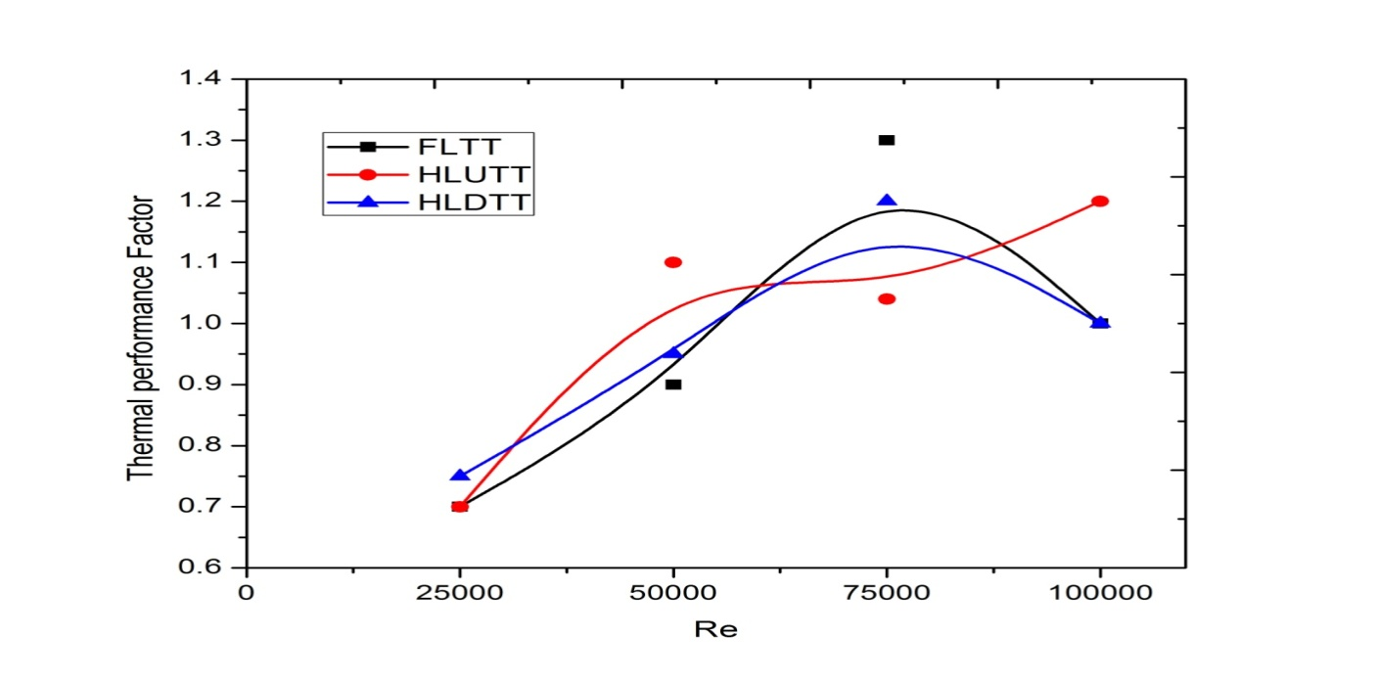

Figure 5: Variation of Re with thermal performance factor for a twist ratio of λ=0.14 with Q=2300 W/m2

**4.5 Stream lines & path lines**

**4.5.1 Velocity vector plots**

From the fig.6, the velocity vector plots of different configurations (i.e; PT, FLTT, HLUTT, HLDTT) are depicted. It is observed that in core flow area two longitudinal vertices are generated leading to the disturbance of boundary layers around the cross-section, because of which a uniform temperature gradient is observed in the core area of flow. Simultaneously, along the length of tube the vortex tends to deteriorate due to unavailabity of twisted tapes in other of cross section (i,e.,HLUTT & HLDTT).In the case of Plain tube, to different Reynolds number the tangential velocity is observed to be Zen, where as in the case of twisted tapes, tangential velocity gradually increases.

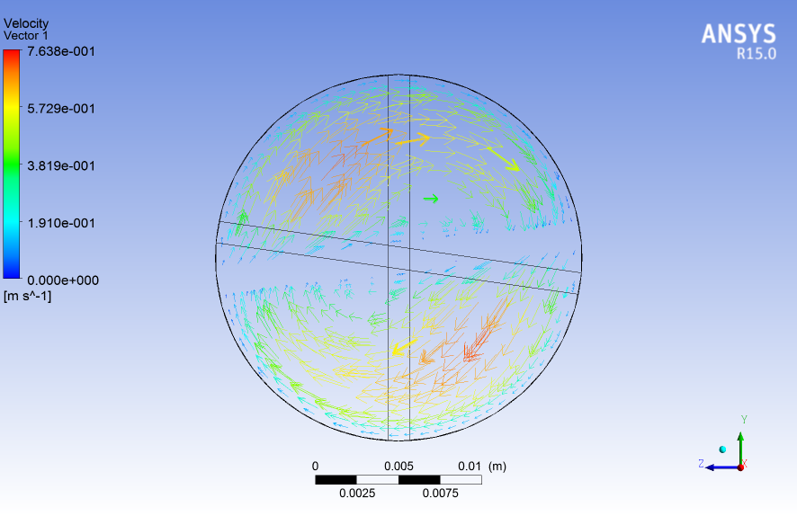 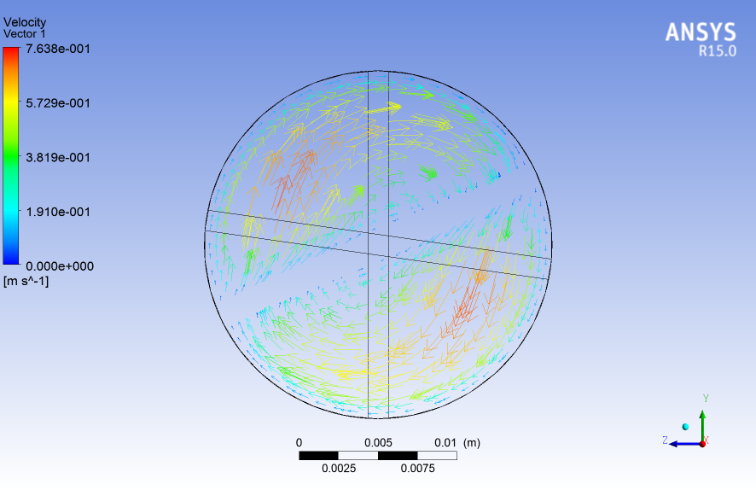

1. Vector plots for FLTT with Re=50,000 and λ=0.14

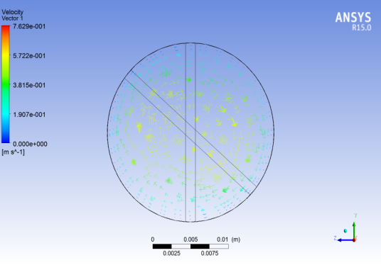

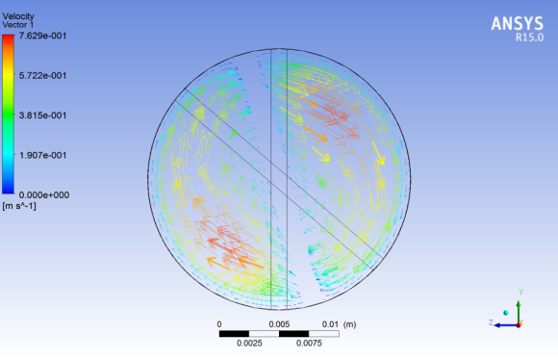

1. Vector plots for HLUTT with Re=50,000 and λ=0.14

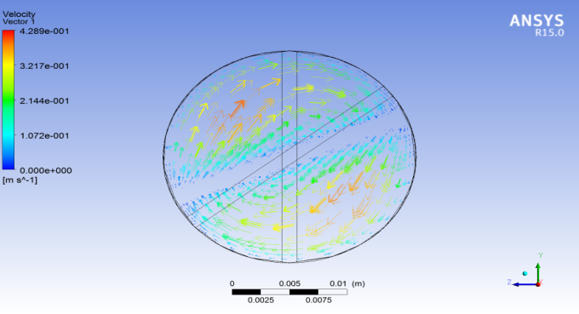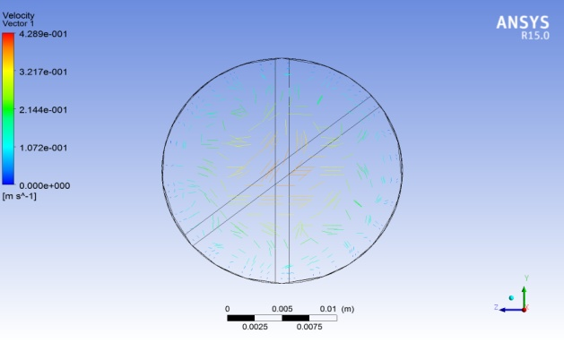

1. Velocity Vector plots for HLDTT with Re=50,000 and λ=0.14

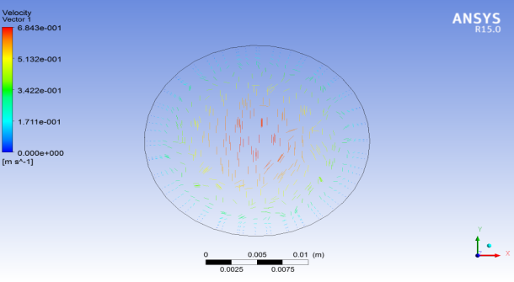 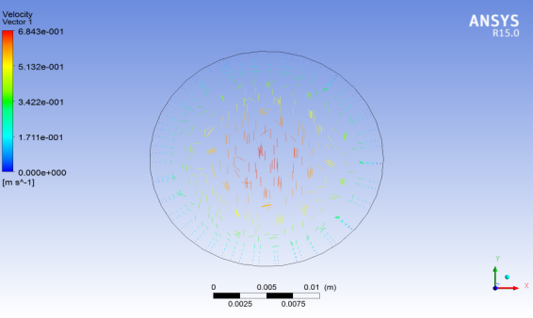

1. Velocity Vector plots for Ribbed Tube with Re=50,000 and λ=0.14

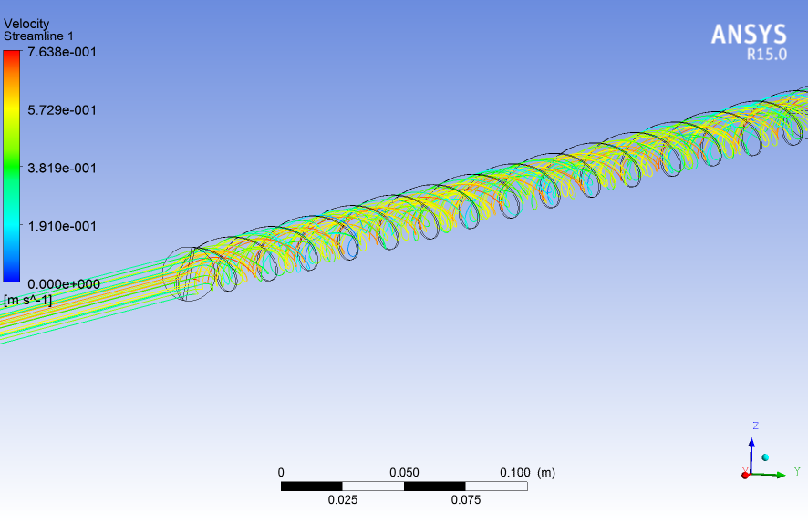

1. Stream line for velocity magnitude for FLTT

Figure 6. Velocity contour plots across the tube with uniform cross section

**4.5.2 Temperature profile Analysis:-**

A) Plain tube data: From the figure 7, it is observed that in the case of Plain tube, maximum temp is observed near to the wall ( range from 50 to 2000C) of the test section , and the maximum temperature gradient between wall & the working fluid is at X/D =86.The wall temp distribution is completely observed at approximately 17 diameters from the entry length in the direction of flow, based on the Claussius statement of Second law of thermodynamics, in the direction of flow temperature decreases with the reduction in the Reynolds number.

B). Twisted tape inserts:-

I). Effect on wall temperatures with Reynolds number:-

It is observed that with an increase in Reynolds number the wall temp decreases along the axial direction of the flow. This is due to fact as the heat transfer coefficient increases due to Reynolds number lewd8ng to reduce the wall to fluid temp difference.

II) Effect of local wall temperature (Twx) on heat flux :

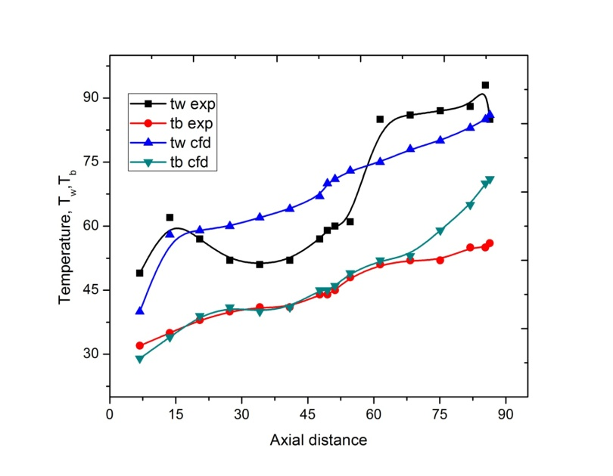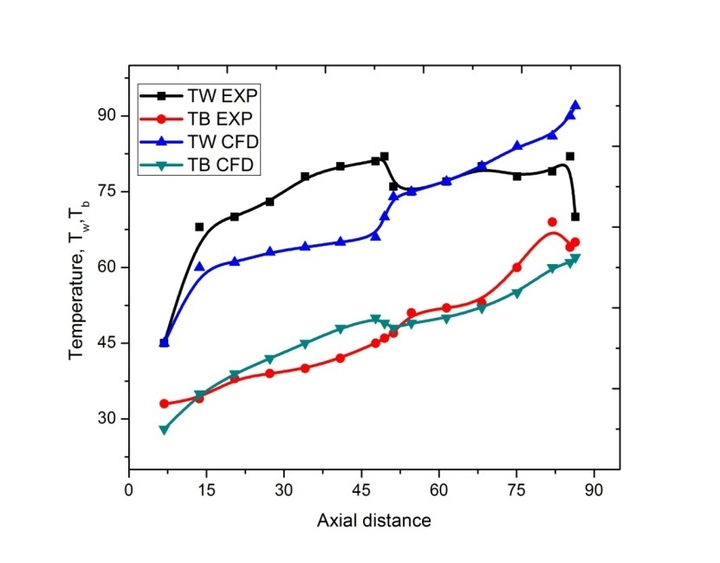It is observed that in all the geometries in the direction of the heat flow the wall temperature increases with an enhancement of heat flux. In the case of twisted tape inserts with upstream condition, with an increase of heat flow, in addition to an increase in the local wall temperature at location of X/D=38 to X/D=46.

Figure 7. Simulated and experimental wall temperature along the axial path for q=2300W/m2 with λ=0.14

**5. Conclusion**

The present research works has been done on pipe with uniform cross section and then with different twisted (i.e., FLTT, HLUTT & HLDTT) for fully, partially decaying swirl flows for understanding the rate of heat flow and temperature distribution along with length of pipe.

* It was absorbed that when compared to plain tube without inserts pressure drop along the given length (202-623%) & heat transfer coefficient (29-84) was greater in the case of FLTT.
* When compared to plain tube with inserts pressure drop along the given length, (34-170%) & the heat transfer coefficient (8-36%)was estimated to be higher in the case of HLUTT.
* It was also found that, when compared to plain tube with twisted tube inserts pressure gradient along the given (30-140%) and convective HT coefficient (8-46%) was estimated to be higher in the case of HLDTT.
* It was observed that the thermal performance factor decreases with an increase in Reynolds number and twist ratio in the case of HLUTT&HLDTT twisted tapes.
* It was observed that maximum temperature was near to the wall surface and decreases in the direction of the flow.

**Reference:**

1.Sedong Kim, HeegeunSong, KitaeYu, BaasandulamTserengombo,Soon-HoChoi, HanshikChung, JunhyoKim,HyominJeong “Comparison of CFD simulations to experiment for heat transfer characteristics with aqueous A*l*2*O*3 nanofluid in heat exchanger tube”[International Communications in Heat and Mass Transfer](https://www.sciencedirect.com/science/journal/07351933)[Volume 95](https://www.sciencedirect.com/science/journal/07351933/95/supp/C), July 2018, Pages 123-131.

2.[ÖzdenAğra](https://www.sciencedirect.com/science/article/pii/S0735193311001710" \l "!)[HakanDemir](https://www.sciencedirect.com/science/article/pii/S0735193311001710" \l "!)[Ş.ÖzgürAtayılmaz](https://www.sciencedirect.com/science/article/pii/S0735193311001710" \l "!)[FatihKantaş](https://www.sciencedirect.com/science/article/pii/S0735193311001710" \l "!)[AhmetSelimDalkılıç](https://www.sciencedirect.com/science/article/pii/S0735193311001710" \l "!)“Numerical investigation of heat transfer and pressure drop in enhanced tubes ”[International Communications in Heat and Mass Transfer](https://www.sciencedirect.com/science/journal/07351933) [Volume 38, Issue 10](https://www.sciencedirect.com/science/journal/07351933/38/10), December 2011, Pages 1384-1391.

3. **“**A comprehensive comparison of various CFD models for convective heat transfer of Al2O3 nanofluid inside a heated tube**”**[International Communications in Heat and Mass Transfer](https://www.sciencedirect.com/science/journal/07351933)

[Volume 70](https://www.sciencedirect.com/science/journal/07351933/70/supp/C), January 2016, Pages 27-37

4.[SogolPirbastamiSamirF.MoujaesSamadGharehdaghiMol](https://www.sciencedirect.com/science/article/pii/S0735193316300446#!) “Computational fluid dynamics simulation of heat enhancement in internally helical grooved tubes”[International Communications in Heat and Mass Transfer](https://www.sciencedirect.com/science/journal/07351933)[Volume 73](https://www.sciencedirect.com/science/journal/07351933/73/supp/C), April 2016, Pages 25-32.

5.**“**Investigation of nanofluids heat transfer in a ribbed microchannel heat sink using single-phase and multiphase CFD models”[International Communications in Heat and Mass Transfer](https://www.sciencedirect.com/science/journal/07351933)

[Volume 68](https://www.sciencedirect.com/science/journal/07351933/68/supp/C), November 2015, Pages 122-129.

6.M.HaghshenasFard,M. NasrEsfahany,M.R.Talaie“Numerical study of convective heat transfer of nanofluids in a circular tube two-phase model versus single-phase model”[International Communications in Heat and Mass Transfer](https://www.sciencedirect.com/science/journal/07351933)[Volume 37, Issue 1](https://www.sciencedirect.com/science/journal/07351933/37/1), January 2010, Pages 91-97

7. S.K.Gugulothu ,**“**Numerical analysis of laminar flow heat transfer of nanofluids in a flattened tube**”**[International Communications in Heat and Mass Transfer](https://www.sciencedirect.com/science/journal/07351933)[Volume 44](https://www.sciencedirect.com/science/journal/07351933/44/supp/C), May 2013, Pages 52-57

8.[MajidHejazian](https://www.sciencedirect.com/science/article/pii/S073519331630361X#!), [Nam-TrungNguyen](https://www.sciencedirect.com/science/article/pii/S073519331630361X#!) “Magnetofluidics for manipulation of convective heat transfer”[International Communications in Heat and Mass Transfer](https://www.sciencedirect.com/science/journal/07351933)[Volume 81](https://www.sciencedirect.com/science/journal/07351933/81/supp/C), February 2017, Pages 149-154.

9.[AtulBhattad](https://www.sciencedirect.com/science/article/pii/S0735193317303500#!), [JaharSarkar](https://www.sciencedirect.com/science/article/pii/S0735193317303500#!), [PradyumnaGhosh](https://www.sciencedirect.com/science/article/pii/S0735193317303500#!) “Discrete phase numerical model and experimental study of hybrid nanofluid heat transfer and pressure drop in plate heat exchanger” [International Communications in Heat and Mass Transfer](https://www.sciencedirect.com/science/journal/07351933)[Volume 91](https://www.sciencedirect.com/science/journal/07351933/91/supp/C), February 2018, Pages 262-273.

10.Adnan M.Hussein,K.V.Sharma,R.A.Bakar,[K.Kadirgama](https://www.sciencedirect.com/science/article/pii/S0735193313001322#!) “The effect of cross sectional area of tube on friction factor and heat transfer nanofluid turbulent flow” [International Communications in Heat and Mass Transfer](https://www.sciencedirect.com/science/journal/07351933)[Volume 47](https://www.sciencedirect.com/science/journal/07351933/47/supp/C), October 2013, Pages 49-55.

11.Ali H.Abdelrazek,Omer A.Alawi, S.N.Kazi,NukmanYusoff,ZairaChowdhury,Ahmed A.D.Sarhan“A new approach to evaluate the impact of thermophysical properties of nanofluids on heat transfer and pressure drop” [International Communications in Heat and Mass Transfer](https://www.sciencedirect.com/science/journal/07351933)[Volume 95](https://www.sciencedirect.com/science/journal/07351933/95/supp/C), July 2018, Pages 161-170.

12.[PaisarnNaphon](https://www.sciencedirect.com/science/article/pii/S0735193310002502#!) “Study on the heat transfer and flow characteristics in a spiral-coil tube”[International Communications in Heat and Mass Transfer](https://www.sciencedirect.com/science/journal/07351933)[Volume 38, Issue 1](https://www.sciencedirect.com/science/journal/07351933/38/1), January 2011, Pages 69-74.

13. [A.Bender](https://www.sciencedirect.com/science/article/pii/S073519331730324X#!), [A.M.Meier](https://www.sciencedirect.com/science/article/pii/S073519331730324X#!), [M.Vaz, Jr.P.S.B.Zdanski](https://www.sciencedirect.com/science/article/pii/S073519331730324X#!) “A numerical study of forced convection in a new trapezoidal tube bank arrangement” [International Communications in Heat and Mass Transfer](https://www.sciencedirect.com/science/journal/07351933)[Volume 91](https://www.sciencedirect.com/science/journal/07351933/91/supp/C), February 2018, Pages 117-124.

14.[VamsiMokkapatiChuen-SenLin](https://www.sciencedirect.com/science/article/pii/S0735193314001596#!) “Numerical study of an exhaust heat recovery system using corrugated tube heat exchanger with twisted tape inserts”[International Communications in Heat and Mass Transfer](https://www.sciencedirect.com/science/journal/07351933)[Volume 57](https://www.sciencedirect.com/science/journal/07351933/57/supp/C), October 2014, Pages 53-64.

15.[Yue-TzuYangYi-HsienWangPo-KaiTseng](https://www.sciencedirect.com/science/article/pii/S073519331300239X#!) “Numerical optimization of heat transfer enhancement in a wavy channel using nanofluids”[International Communications in Heat and Mass Transfer](https://www.sciencedirect.com/science/journal/07351933)[Volume 51](https://www.sciencedirect.com/science/journal/07351933/51/supp/C), February 2014, Pages 9-17.

16.H.Demir,A.S.Dalkilic,N.A.Kürekci,W.Duangthongsuk,S.Wongwises “Numerical investigation on the single phase forced convection heat transfer characteristics of TiO2 nanofluids in a double-tube counter flow heat exchanger”[International Communications in Heat and Mass Transfer](https://www.sciencedirect.com/science/journal/07351933)[Volume 38, Issue 2](https://www.sciencedirect.com/science/journal/07351933/38/2), February 2011, Pages 218-228.

17.[Pongjet,Promvonge](https://www.sciencedirect.com/science/article/pii/S0735193312001145" \l "!),[SomsakPethkool](https://www.sciencedirect.com/science/article/pii/S0735193312001145#!), [MonsakPimsarn](https://www.sciencedirect.com/science/article/pii/S0735193312001145#!),[ChinarukThianpong](https://www.sciencedirect.com/science/article/pii/S0735193312001145#!) “Heat transfer augmentation in a helical-ribbed tube with double twisted tape inserts”[International Communications in Heat and Mass Transfer](https://www.sciencedirect.com/science/journal/07351933)[Volume 39, Issue 7](https://www.sciencedirect.com/science/journal/07351933/39/7), August 2012, Pages 953-959.

18.S.Eiamsa-ard,K.Wongcharee,P.Eiamsa-ard,C.Thianpong “Heat transfer enhancement in a tube using delta-winglet twisted tape inserts”[Applied Thermal Engineering](https://www.sciencedirect.com/science/journal/13594311)[Volume 30, Issue 4](https://www.sciencedirect.com/science/journal/13594311/30/4), March 2010, Pages 310-318.

19.S.Jaisankar,T.K.Radhakrishnan,K.N.Sheeba “Experimental studies on heat transfer and thermal performance characteristics of thermosyphon solar water heating system with helical and Left–Right twisted tapes**”**[Energy Conversion and Management](https://www.sciencedirect.com/science/journal/01968904)[Volume 52, Issue 5](https://www.sciencedirect.com/science/journal/01968904/52/5), May 2011, Pages 2048-2055.

20.SmithEiamsa-ard,ChinarukThianpong,PetpicesEiamsa-ard,PongjetPromvonge “Convective heat transfer in a circular tube with short-length twisted tape insert”[International Communications in Heat and Mass Transfer](https://www.sciencedirect.com/science/journal/07351933)[Volume 36, Issue 4](https://www.sciencedirect.com/science/journal/07351933/36/4), April 2009, Pages 365-371.

21.K.Nanan,K.Yongsiri,K.Wongcharee,C.Thianpong,S.Eiamsa-ard “Heat transfer enhancement by helically twisted tapes inducing co- and counter-swirl flows”[International Communications in Heat and Mass Transfer](https://www.sciencedirect.com/science/journal/07351933)[Volume 46](https://www.sciencedirect.com/science/journal/07351933/46/supp/C), August 2013, Pages 67-73.