**Computational Fluid Dynamics Analysis on Plate-fin Heat Sink with Piezoelectric Fan to Enhance the Heat Transfer Phenomena**

Dr.S.K.Gugulothua, V.V.Phani babub

aDepartment Of Mechanical Engineering, National Institute of Technology, Hamirpur.

Corresponding author mail: santoshgk1988@nith.ac.in

**Abstract**

This study applied the computational fluid dynamic code, Ansys Fluent for simulating the effect a piezoelectric fan installed inside rectangular channel by numerical simulation method for transient flow field and investigating the influence of each parameter. To remove the disorganized form of energy from the electronic components, reversible piezoelectric effect is employed to energize the piezoelectric fan. To observe the variation of fan characteristics and to predict the convective heat transfer coefficient, CFD code Ansys Fluent 15.0 is used. The numerical simulation parameters included are Nusselt number (Nu), number of fins (n = 12, 14) and counter-shift (inward and outward-phase), and distance between upper portion of the fan tip to the front part of the low thermal reservoir. Numerical analysis was carried out evaluate the effect of thermal flow fields on heat sink and piezoelectric fan employed in a flow domain. the results showed that by varying the height from channel bottom to the centre of piezoelectric fan improves the performance of piezoelectric fan, piezoelectric fan swinging in an transient phenomena and also simultaneously influences fluid flow behavior on the heat source surface, the fan vibration at counter phase has better rate of heat transfer than vibration in in-phase.

**Keywords**: CFD, Fins, Piezoelectric cooling, plate-fin heat sink

1. **Introduction**

The demand of growth in science and technology enhances the electronic industry to develop efficient electronic components with high functionality and portability. The demand for smaller, more functional and portable electronic devices has resulted in large number of powerful electronic components being packed in to smaller spaces. The resulting reduction in size and mass density of electronics components has improved the rate of heat generation and wall heat fluxes over their components. The heat generated in the electronic devices is gradually increasing which affects the efficiency and lifetime of devices. Hence the necessity of implementing the sophisticated cooling techniques to improve performance of electronic components is increasing significantly. Piezoelectric fans considered as an alternative cooling mechanism for electronic components. In this study, piezoelectric fans are investigated as an active cooling technique for the thermal management of portable electronics.

Various investigations have been done to improve the cooling of electronic components. Sheny-Fu-Liu et.al[1] has studied the influence of geometric parameters, location of piezo-fan etc. Results found that in vertical arrangement the heat transfer enhancement is gradually increasing and reaches the maximum at the centre and gradually decreases whereas in the horizontal retarded peaks are observed at the inception stage.. Chein-Nan-Lin et.al[2] has done the numerical and experimental analysis on vibrating fan by considering a three dimensional fluid domain. From the analysis, it was observed that experimental and numerical results indicate that fan improves the rate of heat transfer by 25 to 50% and simultaneously local heat transfer coefficient can be achieved by 2.85 times. H.K.Ma et.al [3] has established a driving source to drive multistage fan by cooling system that uses a piezo-electric magnetic force. The results has shown that MPMF system is efficient consuming low power with an improved thermal resistance performance compared with natural convection. Z.M.Fairuz [4] has done numerical analysis on the effect of differnt piezoelectric fan shapes driven at the frequency and the tip amplitude of first mode to investigate their effects on the performance of heat transfer characteristics. The results showed that the increase in mode number decreased the induced air flow velocity on the top of heating surface, thus impeding the cooling capabilities at higher mode number. Jin-Cheng Shyu et.al [5] has investigated the enhancement of a piezoelectric fan-cooled plate fin array by varying fan position, height of the fan, fan material. From the results it was observed that the fin heat transfer with aluminum fan at x = 0 was higher than that of x = 0.25L. S.F.Sufian et.al [6] has done the analysis of the influence of dual vibrating fans on flow and thermal fields by conducting numerical and experimental investigations. Good comparison results were achieved by accurate modeling of the salient features of the fan. M.K.Abdullah et.al [7] has investigated the cooling capability for possible use in electronic devices by using piezoelectric fan. By using PIV, measurements are carried out for fluid flow at different heights.The results shows that the fan height of ${h_{p}}/{l_{p}}$ =0.23 can reduce the temperature of the heat source surface as much 68.9 $℃$. In this analysis, we intended to enhance the heat transfer effect by utilizing piezoelectric fan which is set in front of the radiator to mix the air surrounding radiator and the fins.

1. **Geometric model**

The model used in this simulation consists of an rectangular channel in which piezoelectric fans is installed in front of the heat sink attached with the extended surfaces known as “FINS”. Numerical Simulation parameters are the size of the rectangular channel is 320mm*45mm*100mm, the size of the heat sink is 31mm*31mm, and number of fins (n) are 12,14. Dimensions of piezoelectric fan is 65mm length and width of 12mm, distance between two fans is 30 mm. vibrations phase: In-phase and counter-phase.

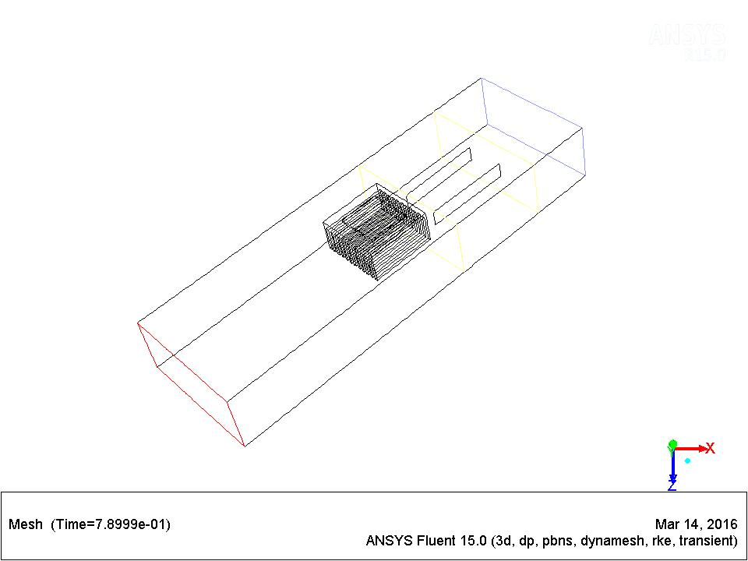

Fig 1. Schematic diagram of the experimental setup

In order to carry out the process, the thermodynamic system is assumed to be a steady state, flow as incompressible, gravity forces and effects of thermal radiation are neglected. Following are the boundary conditions are considered.

**Inlet:** U = $U_{φ}$, V = W = 0, T = $T_{φ}$ = 293K; **Wall:** U = V = W = $\frac{∂T}{∂n}$ = 0; **Outlet: $\frac{∂∅}{∂n}$**  = 0, $∅$ = ( U,V,W,K $,∈$,T )

The heat sink is thermally isolated at the bottom except the surface of heat. The heat transfer coefficient of heat sink is 168 w/m²k and it is kept at a operating temperature of 350K. Approximately 2.5 m/s maximum flow velocity produced by a single fan is considered, other parameters included are fan length of 65 mm, breadth of 12 mm and amplitude vibration of 23 mm.

**3 Numerical method**

The numerical analysis is done by using Ansysfluent 15.0 with 3D computational model. To predict the flow fields, dynamic mesh is used where shape of the domain is changing with time due to motion of the domain boundaries. For maintaining the movement of fan, smoothing and re-meshing is done. Hybrid mesh is used in which mesh is constructed by tetrahedral and hexahedral mesh. For reducing the number of elements, coarse mesh i.e., hexahedral mesh is chosen for piezoelectric fan and for flow domain flow along with heat sink hexahedral mesh is chosen.

The governing equation applied in this simulation is the conservation of energy. The equation can be written as

$\iiint{ρc_{p}}{∂T}/{∂t}$ dxdydz + $h_{c}A_{t}$ ($T_{ave}$- $T_{∞}$) = $Ė_{in}$ (1)

The first and second terms on the left side are the change in internal energy with respect to time and convective energy. The term on the right is energy conducted into the system. Where $ρ$ is density, $C_{p}$ is specific heat, $\frac{∂T}{∂t}$ is the energy per unit volume with rate of change of time, dxdydz represents the control volume, $h_{c}$ is proportionality constant, ($T_{ave}$- $T_{∞}$) is the temperature gradient of the wall surface and fluid particles. The assumption in the 3D computational model includes turbulent flow, incompressible flow with buoyant forces and radiation phenomena are neglected. Energy equations are solved by using differential equations, pressure forces by using simple mechanism Although a second-order would yield better accuracy. To capture the flow domain precisely , lesser time gap is required. The time step taken in this simulation is 0.001 seconds.

**4 Results & Discussions**

In the present study, numerical analysis was carried out to evaluate the effect of thermal flow fields on plated heat sink and piezoelectric fan installed in a rectangular channel. To investigate the performance of the thermal flow efficiency of heat sink under operating conditions with various parameters. From the present analysis it is assumed that temperature gradient in plate-fin heat sinks are neglected, and simultaneously defines distribution of unsteady temperature per energy balance as the objective.

|  |  |  |  |  |
| --- | --- | --- | --- | --- |
| **fins** | **Phase** | **Time Step** | **Heat transfer coefficient(w/m²K)** | **Nusselt number** |
| 12 | In-Phase | 1.875 | 2.8 | 117.82 |
|  | Counter-phase | 1.84 | 4.46 | 184.66 |
| 14 | In-Phase | 0.76 | 1.06 | 43.92 |
|  |  | 1.2 | 1.17 | 48.3 |
|  |  | 2.5 | 1.24 | 51.3 |
|  |  | 3.6 | 1.28 | 52.85 |
|  | Counter-Phase | 1.25 | 1.4 | 57.93 |
|  |  | 1.6 | 1.38 | 57.1 |

**Table 1**. Simulated data & Calculations

**4.1 Fin Number**

For doing the analysis on heat sink under natural convection, to assess the performance coefficient of performance (COP) is considered. Using COP the thermal resistance provided by piezoelectric fan and the convective resistance of the thermal reservoir under natural convection with different fins (n=12 &14) are considered. The result has shown that COP at n=12 is greater than that of n=14 at a given distance Lg = -45. From the graph, it is observed that for both the fins (n =12 & 14) at a distance of Lg =5, similar COP is identified i.e., length between thermal reservoir to piezoelectric fan tip.

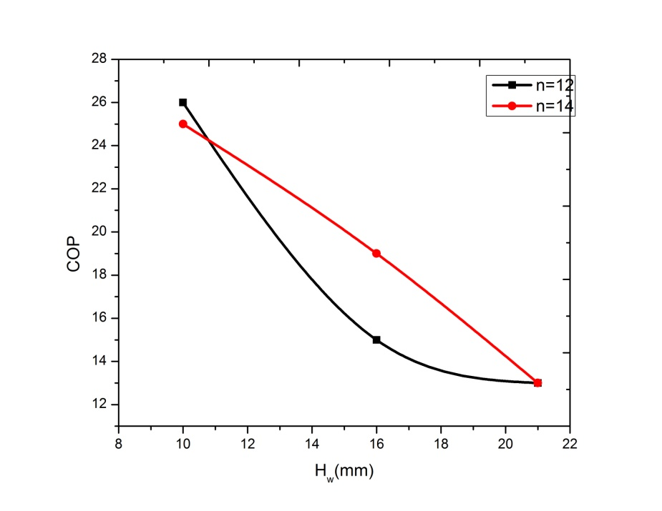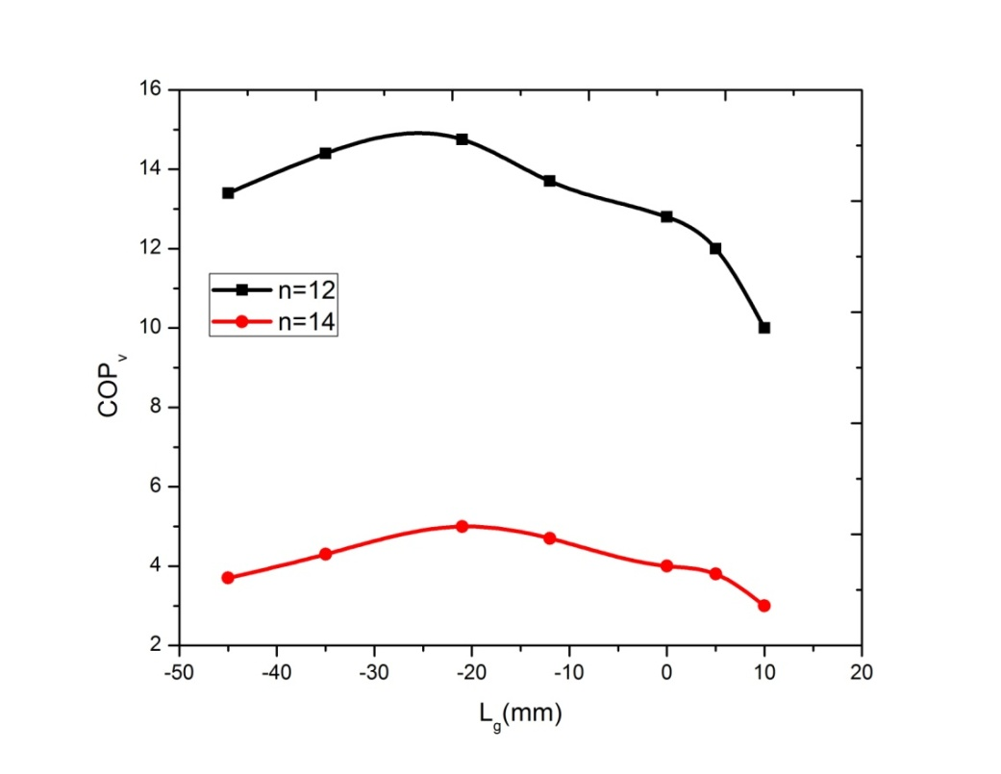

Fig 2. Effects of the COP on Hw Fig 3. Effects of the COP on Hw

Figure 2 represents the comparison plot between the effect of COP and length between piezoelectric fan to flow. It is observed that the distance from fan tip to heat sink(Hw) is reducing, the COP is observed to be higher. It is also observed from the figure that there is no significant influence of increasing both cop and number of fins at HW=10. Even though twin fan has effective performance on the rate of heat transfer on thermal reservoir but due to its higher maintenance cost it may not be considered to helpful in electronic cooling system.

**4.2 Compare with In-phase and Counter-phase**

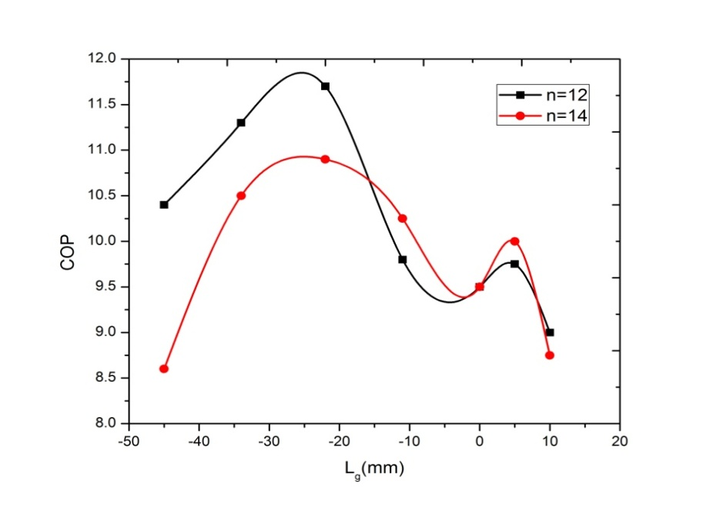From the analysis it was observed that the thermal efficiency of single piezoelectric fan is lesser than that of counter phase twin fan, even though the velocity of fan tip is observed to be similar for both twin and single piezoelectric fan, but mass flow rate of twin fan is higher than single fan. In this analysis, investigation has been carried out to draw the comparison between counter and in-phase with different Lg, which convective heat transfer phenomena occurred on the surface which gives greater scope to compare the relative fluid flow.

Figure 5 compares Nu at different distance for the vibration of fan at opposite phase and in-phase. In counter phase the convective performance of flow is greater than in-phase of heat sink surface. For Lg = 0, the convective flow drops away from heat sink at in-phase vibration and there is no effect when compared to counter phase vibration.

**5. Conclusions**

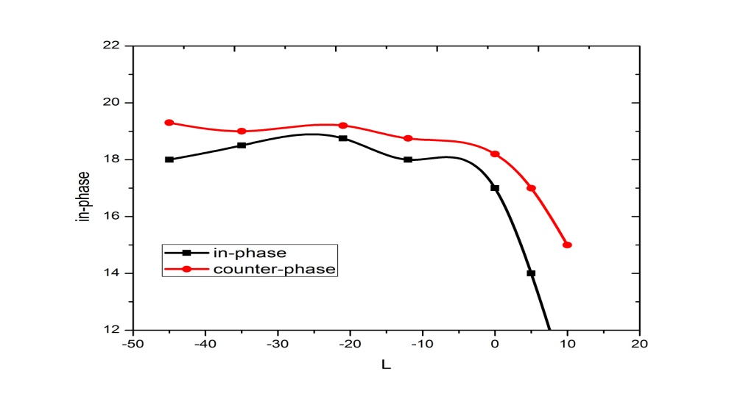Based on the numerical analysis following are the observations drawn on the performance of the piezoelectric fan associated with different angle of inclinations, with extended surfaces on the low temperature reservoir with perpendicular flow evaluated heat capacitance and fluid efficiency. If fins are placed below the center of the piezoelectric fan center, entrained flow area is prioritized of consideration in study the most effect of entrained flow is at Lg =-0.5 and Hw =21. With the increase in the distance between the thermal reservoir and fan is increasing, it is observed that there is decrease in the flow efficiency. From the observation it is evident that only advantage of inward flow, twin-fan is that convective flow is developed only around the fan with better performance away from the fan gradually reduced.

Fig 5 The effects of the Nu number on Lg.

**References**

1. [ShengFuLiu](http://www.sciencedirect.com/science/article/pii/S0017931009000623#!) [Ren-TsungHuang](http://www.sciencedirect.com/science/article/pii/S0017931009000623#!)**.,**  [Wen-JennSheu](http://www.sciencedirect.com/science/article/pii/S0017931009000623#!)[Chi-ChuanWang](http://www.sciencedirect.com/science/article/pii/S0017931009000623#!). 2009."Heat transfer by a piezoelectric fan on a flat surface subject to the influence of horizontal/vertical arrangement", International Journal of Heat and Mass Transfer, [Volume 52, Issues 11–12](http://www.sciencedirect.com/science/journal/00179310/52/11),  2565-2570.
2. [Chien-NanLin](http://www.sciencedirect.com/science/article/pii/S1359431112005054#!).2013. "Heat transfer enhancement analysis of a cylindrical surface by a piezoelectric fan", Applied Thermal Engineering, Volume.10, Pages 693-703.
3. [H.K.Ma](http://www.sciencedirect.com/science/article/pii/S0735193314001109#!)[L., K.Tan](http://www.sciencedirect.com/science/article/pii/S0735193314001109" \l "!)[Y., T.Li](http://www.sciencedirect.com/science/article/pii/S0735193314001109" \l "!)[C, .L.Liu](http://www.sciencedirect.com/science/article/pii/S0735193314001109" \l "!), 2014. "Optimum thermal resistance of the multiple piezoelectric–magnetic fan system", International Communications in Heat and Mass Transfer, Volume 55, 77-83.
4. [Z.M.FairuzS .F.Sufian](http://www.sciencedirect.com/science/article/pii/S0735193313002339#!) [M.Z.Abdullah](http://www.sciencedirect.com/science/article/pii/S0735193313002339#!) [M.Zubair](http://www.sciencedirect.com/science/article/pii/S0735193313002339#!)[M.S.Abdul Aziz](http://www.sciencedirect.com/science/article/pii/S0735193313002339" \l "!). 2014." Effect of piezoelectric fan mode shape on the heat transfer characteristics", Transfer, Volume 12, 140-151.
5. Jin-Cherng Shyu, Jhih-Zong Syu, 2014. "[Plate-fin array cooling using a finger-like piezoelectric fan](http://www.sciencedirect.com/science/article/pii/S1359431113007308)", Applied Thermal Engineering, Volume 62, Issue 2( 25) ,  573-580.
6. [S.F.Sufiana](http://www.sciencedirect.com/science/article/pii/S0735193313000419#!) [M.Z.Abdullaha](http://www.sciencedirect.com/science/article/pii/S0735193313000419#!) [J.J.Mohamedb](http://www.sciencedirect.com/science/article/pii/S0735193313000419#!) 2013 ,"Effect of synchronized piezoelectric fans on microelectronic cooling performance", International Communications in Heat and Mass Transfer, [Volume 43](http://www.sciencedirect.com/science/journal/07351933/43/supp/C), 81-89.
7. [M.K.Abdullah](http://www.sciencedirect.com/science/article/pii/S0735193308001930#!) M.Z.Abdullah [M.V.Ramana](http://www.sciencedirect.com/science/article/pii/S0735193308001930#!)[C .Y.Khor](http://www.sciencedirect.com/science/article/pii/S0735193308001930" \l "!)[K.A.Ahmad](http://www.sciencedirect.com/science/article/pii/S0735193308001930" \l "!) [M.A.Mujeebu](http://www.sciencedirect.com/science/article/pii/S0735193308001930#!) [Y.Ooi](http://www.sciencedirect.com/science/article/pii/S0735193308001930#!)[Z.Mohdipin](http://www.sciencedirect.com/science/article/pii/S0735193308001930" \l "!) 2009,"Numerical and experimental investigations on effect of fan height on the performance of piezoelectric fan in microelectronic cooling", [International Communications in Heat and Mass Transfer](http://www.sciencedirect.com/science/journal/07351933), [Volume 36, Issue 1](http://www.sciencedirect.com/science/journal/07351933/36/1), Pages 51-58.