**Effectiveness of Yoga on Stress level among Adolescent Students**

B. Ravi Prasad* Prof. K. Deepla** *\*Junior Research Fellow & Ph.D. Scholar,  
Department of Physical Education, Osmania University, Hyderabad.  
**Chairman BoS, Department of Physical Education, Osmania University, Hyderabad. e-mail:*[*kdeepla.ou@gmail.com*](mailto:kdeepla.ou@gmail.com)

**ABSTRACT**

This research paper is an attempt to study the effect of Yogasanas training on the Stress level of Adolescent students. To achieve this purpose 60 subjects, whose age was ranged between 17 to 19 years were selected from the Gurukrupa Junior College, Siddipet District, Telangana. The subjects were randomly assigned to Two equal groups (Control Group & Experimental Group) of 30 men each. The Descriptive Survey Method was used for the data collection and for assessing the variables of the study. The Pre-test was conducted on the selected variable for both the Control and Experimental Groups. The subjects of the Experimental Group then participated in a Six-weeks Yogasanas training programme, whereas the subjects of the Control Group were not given any kind of training. The Post-test was conducted for all the subjects of both the Control and Experimental Groups. The level of Stress was measured by Anxiety, Depression and Stress Scale (ADSS) developed by Pallavi Bhatnagar et al., Department of Psychology Lucknow University. The data so collected was analyzed statistically by employing Mean, S.D and t-test. The level of significance was kept at 0.05 level. The results reveals that there was a significant difference on Stress level in Experimental Group than the Control Group.

**Key Words:** Yogasanas, Adolescence, Stress.

**1. INTRODUCTION**

**1.1. Adolescence** (meaning 'to grow up') is a transitional stage of physical and psychological development that generally occurs during the period from puberty to legal adulthood (age of majority). Adolescence is usually associated with the teenage years, but its physical, psychological or cultural expressions may begin earlier and end later. For example, puberty now typically begins during [preadolescence](https://en.wikipedia.org/wiki/Preadolescence), particularly in females. Physical growth (particularly in males) and cognitive development can extend into the early twenties. Thus, age provides only a rough marker of adolescence, and scholars have found it difficult to agree upon a precise definition of adolescence.

A thorough understanding of adolescence in society depends on information from various perspectives, including Psychology, Biology, History, Sociology, Education, and Anthropology. Within all of these perspectives, adolescence is viewed as a transitional period between childhood and adulthood, whose cultural purpose is the preparation of children for adult roles. It is a period of multiple transitions involving education, training, employment, and unemployment, as well as transitions from one living circumstance to another.

Adolescence is usually accompanied by an increased independence allowed by the parents or legal guardians, including less supervision as compared to preadolescence.

**1.2. Stress** is the state of mental or emotional strain or tension resulting from adverse or very demanding circumstances. Stress differs from person to person. The signs of stress can be physical; they can also be emotional or behavioural. Physical signs of stress can vary, including “knots,” “butterflies,” or pain in the stomach; a rapid, pounding heart beat; cold, clammy hands; headache, hyperventilation; tightness in the neck or shoulders; tightness in the chest; lower back pain; and a tendency toward illness such as colds or flu (Burka, 1983). Emotional or behavioural signs of stress include irritability; fatigue and exhaustion; trouble concentrating; mood swings; increased alcohol or drug use; changes in sleep, appetite, or sexual interest; inability to relax; inability to enjoy the things that once brought you pleasure; apathy or lethargy; and forgetfulness (Burka, 1983). Knowing yourself well enough to identify your own signs of stress is vital as you work to manage stress.

Teen stress is an important health issue. The early teen years are marked by rapid changes — physical, cognitive, and emotional. Young people also face changing relationships with peers, new demands at school, family tensions, and safety issues in their communities. The ways in which teens cope with these stressors can have significant short-and long-term consequences on their physical and emotional health.

**1.3. Some causes of Stress in Teens and Adolescents:**

* School pressure and career decisions.
* After-school or summer jobs.
* Dating and friendships.
* Pressure to wear certain types of clothing, jewellery or hairstyles.
* Pressure to experiment with drugs, alcohol or sex.
* Pressure to be a particular size or body shape (with girls, the focus is often weight; with boys, it is usually a certain muscular or athletic physique).
* Dealing with the physical and cognitive changes of puberty.
* Family and peer conflicts.
* Being bullied or exposed to violence or sexual harassment.
* Crammed schedules, juggling school, sports, after-school activities, social life and family obligations.

**1.4. Some signs that a Teen or Adolescent is suffering from Stress:**

* Increased complaints of headache, stomach-ache, muscle pain and/or tiredness.
* Shutting down and withdrawing from people and activities.
* Increased anger or irritability (i.e., lashing out at people and situations).
* Crying more often and appearing teary-eyed.
* Feelings of hopelessness.
* Chronic anxiety and nervousness.
* Changes in sleeping and eating habits (i.e., insomnia, nightmares, or being “too busy” to eat).
* Difficulty concentrating.
* Experimentation with drugs or alcohol.

**1.5. Strategies for coping with Stress:**

* Talk about problems with others.
* Take deep breaths, accompanied by thinking or saying aloud, “I can handle this”.
* Perform progressive muscle relaxation, which involves repeatedly tensing and relaxing large muscles of the body.
* Set small goals and break tasks into smaller, manageable chunks.
* Exercise and eat regular meals.
* Get proper sleep.
* Practice consistent, positive discipline.
* Visualize and practice feared situations.
* Focus on what you can control (your reactions, your actions) and let go of what you cannot (other people’s opinions and expectations).
* Work through worst-case scenarios until they seem amusing or absurd.
* Lower unrealistic expectations.
* Schedule breaks and enjoyable activities.
* Accept yourself as you are; identify your unique strengths and build on them.
* Give up on the idea of perfection, both in yourself and in others. Give yourself permission and cultivate the ability to learn from mistakes.

|  |
| --- |
|  |

**2. Statement of the Problem:**

The purpose of the present study was to study the effect of Six-weeks Yogasanas training programme on the Stress level of Adolescent students of the Gurukrupa Junior College, Siddipet District, Telangana.

**3. Hypothesis:**

It was hypothesized that the Six-weeks Yogasanas training programme may show significant difference on the Stress level of Adolescent students.

**4. Methodology:**

The Descriptive Survey Method was used for the data collection and for assessing the Stress level of the subjects.

**5. Sample:**

The study was conducted on a sample of 60 randomly selected subjects of Gurukrupa Junior College, Siddipet District, Telangana. The age of the samples was between 17-19 years. The subjects were divided into Two equal groups (Control Group & Experimental Group) of 30 men each. The subjects generally hail from the different socio-economic status, different dietary habits, mode of living, etc., Hence certain factors like daily routine life-style, environmental conditions and food habits were not taken into consideration.

**6. Variables**:

Yogasanas training was considered as Independent Variable and Stress level was considered as Dependent variable.

**7. Tools Used for Data collection:**

The Anxiety, Depression and Stress Scale (ADSS) developed by Pallavi Bhatnagar et al., Department of Psychology Lucknow University was used to collect the data. The scale consisted a total of 48 items divided into Three subscales which are:

Anxiety subscale consists of 19 items covering various symptoms that are the manifestation of Anxiety. Depression subscale consists of 15 items representing the different symptoms of Depression.

Stress subscale consists of 14 items which cover the symptoms that people experience in the state of Stress.

The response categories are “True” and “False”. Each item is scored ‘1’ for ‘Yes’ and ‘0’ for ‘No’. Higher score indicates experiencing greater Anxiety, Depression and Stress level and vice-versa. Here only the Stress subscale was selected for this study.

**8. Training protocol:**

The subjects of the Experimental Group had 30 minutes of practice of the Yogasanas (Padmasana, Vajrasana, Halasana, Chekrasana, Salabhasana, Dhanurasana, Bhujagasana and Shavasana) in the initial days, but the total time was increased up to an hour gradually by increasing the number of repetitions and time duration in a progressive load method. The subjects practiced the Yogasanas Six-days a week for a total of Six-weeks in a common room selected for the purpose. The scheduled time of the practice lasted for one hour between 6.00 am to 7.00 am and was conducted instead of the student’s regular conditioning period. Each and every practice session was concluded with five minutes of Shavasana. The subjects of the Control Group were not given any kind of training.

**9. Data Collection Procedure:**

The Subjects were met personally and explained clearly the purpose of the study, process of the data collection and gave instructions regarding the method for answering the questions. Then the questionnaires were distributed to the subjects. The subjects went through the instructions, read each statement carefully and indicated their responses. All the filled-in questionnaires were collected from the subjects and scoring was done. The test was administrated for both Experimental and Control Groups before and after Six-weeks yogasanas training and the scores were recorded as Pre-test and Post-test values respectively. The subjects of the Control Group were not given any kind of training. The investigator explained to the subjects in the Experimental Group about the benefits of performing Yogasanas.

**10. Statistical tools used:**

With respect to the type of study, the data collected was statistically analyzed through Mean, Standard Deviation(SD) and t-ratio was applied. The level of significance was fixed at 0.05 level of confidence.

Table-1: Showing the results of Effectiveness of Yoga on Stress level among Adolescent Students.

|  |  |  |  |  |  |  |
| --- | --- | --- | --- | --- | --- | --- |
| **Group** | **N** | **Pre-test** | | **Post-test** | | **t-ratio** |
| **Mean** | **SD** | **Mean** | **SD** |
| **Experimental Group** | 30 | 51.70 | 6.35 | 63.70 | 6.30 | 4.824 |
| **Control Group** | 30 | 55.10 | 5.41 | 52.46 | 4.46 | 0.774 |

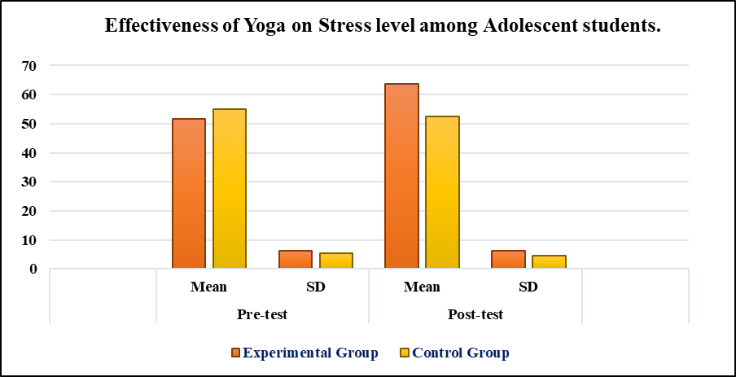Graphical Illustration showing the Mean & SD values of both the Experimental and Control Groups of Adolescent students.

**11. Discussion:**

The Experimental Groups Mean value of Stress level of Pre-test is 51.70 and Post-test is 63.70. The Post-test Stress level performance is less than Pre-test Stress level performance. The t-ratio (4.824) is also more than the table value (2.00). Hence, it indicates the significant development of Stress level performance. The Control Groups Mean value of Stress level of Pre-test is 55.10 and Post-test is 52.46. The Post-test Stress level performance is more than Pre-test Stress level performance. The t-ratio (0.774) is also less than the table value (2.00). Hence, it indicates the insignificant development of Stress level performance.

**12. Result and Conclusion:**

Within the limitation of the study and on the basis of the obtained results from this study, it was concluded that the Experimental Group which participated in a Six-weeks Yogasanas training programme had significantly improved in reducing the Stress levels among Adolescent students.

Hence, the Research Hypothesis is accepted.

**REFERENCES**

1. Arul J.C., Dr. Ganesan P. (2013) *Stress-Coping ability of adolescents, EDU TRACKS* 13, 3 10-11.
2. Bhatnagar, P., Singh, M., Pandey, M., Sandhya, Amitabh. (2011). *Manual for Anxiety, Depression and Stress scale.* National psychological corporation.
3. Burka, J.B. and Yuen, L.M. (1983). *Procrastination: Why you do it, What to do about it.* Reading, Mass: Addison-Wesley.
4. Hammen, C. (2005). Stress and depression. *Annual Review of Clinical Psychology,* 1,293-319.
5. <https://www.bradleyhospital.org/managing-stress-teens> and-adolescents.
6. https://en.wikipeda.org/wiki/adolescence.