**Hybrid optimization for semi blind channel estimation in MIMO-OFDM Systems**

C. Padmaja1 , Dr. B.L.Malleswari2

1Research Scholar, JNTUH, ECE Department, Hyderabad

1[padmaja.chennapragada@gmail.com](mailto:padmaja.chennapragada@gmail.com)

2Principal, SWEC, Hyderabad

2[blmalleswari@gmail.com](mailto:blmalleswari@gmail.com)

**Abstract:** The driving force for the fourth generation (4G) communication systems is the high data rate requirements for multimedia communication systems. The combination of Multiple-input-Multiple output (MIMO) and the orthogonal frequency division multiplexing (OFDM) is one of center of innovations for correspondence frameworks. The proficient channel estimation bit error rate (BER) plot with moderately low estimation inaccuracy is required for the MIMO-OFDM communication framework. In this paper, we propose a combination of Decision Directed and Semi Blind channel estimation technique known as Expectation Maximization Decision Directed (EMDDCE) dependent on the versatile Chaotic Grey Wolf Optimizer (CGWO) and Genetic Algorithm (GA) with Turbo-codes for MIMO-OFDM framework. The proposed approach is implemented in MATLAB 2015 b for the evaluation of mean square error (MSE), Bit error ratio (BER) parameters w.r.t. Signal to noise ratio (SNR). The proposed technique can yield significant improvements in terms of lower SNR needed to transmit data.

**Keywords: (5-6) MIMO, OFDM, EMDDCE Channel estimation scheme, Genetic Algorithm, chaotic grey wolf optimization.**

* 1. Introduction

Wireless data transmission is prone to errors and the performance of the channel is degraded due to Multipath Environment, Mobility of the transceiver and Path loss. Performance can be improved by introducing proper Diversity technique, Channel coding and Channel estimation technique in the transceiver design. MIMO-OFDM technology provides higher channel capacity, high-quality, high-bit-rate communications.

Nowadays channel estimation plays a major role in the communication network with high complexity to achieve an efficient detection of the transmitted signal. There is a need to determine the condition of the channel between the transmitter and receiver using channel estimation method such as least square and minimum mean square error algorithm [1].

Recently, various elegant channel estimation method for OFDM includes has been suggested which includes semi-blind low complexity frequency domain based channel estimation [7], expectation-maximization (EM) approach[8],subspace tracking [9], a joint and data estimation algorithm [10], multi-symbol encapsulated(MSE) OFDM system [11],Radial Basis Function (RBF) network based channel estimation [12] were used.

Heuristic, nature propelled systems such as, Genetic Algorithm [13], Particle Swarm Optimization, Differential Evolution algorithm; Artificial Bee Colony optimization etc. provides us less computational cost methods to discover worldwide ideal answer for various different issues [14]. These procedures have been broadly applied to the issue of channel estimation in different application regions and all the more explicitly for MIMO frameworks. For the MIMO-OFDM communication systems, the LS channel estimation with the low computational complexity and the minimum-mean-square-error (MMSE) channel estimation with the low estimation error was studied in [15].

In this paper, we propose an adaptable optimization technique of Chaotic Grey Wolf Optimizer (CGWO) and GA with Turbo-codes for the EMDDCE channel estimation of MIMO-OFDM system. In our proposed system, Encoding and decoding are done with the Turbo-codes for least square channel estimation and the mean square error will be less when comparing with the conventional channel estimator. The structure of the remainder of this paper was composed as pursues: section 1.2 gives system model. Section 1.3 characterized the algorithm of proposed technique, in the interim gave the outline about the EMDDCE, CGWO and GA. Segment 1.4 presented the simulation parameters and segment 1.5 concludes the paper.

* 1. System Model

Consider a Turbo coded MIMIO-OFDM system, where a turbo encoder encoded the information bit streams. The binary source bits b=b1 ,b2 ,……bNb, ᕮ +1, -1 are encoded by a turbo encoder having code rate *Rc* . The encoder output sequence c=c1 ,c2 ,……cNc, ᕮ +1, -1 , where Nc=Nb/RC, are interleaved to d=d1 ,d2 ,……dNc, ᕮ +1, -1 , by employing a random interleaver of length Nc. The interleaved code bit stream d, are demultiplexed into *NT* transmit antenna as di [n], i=1,2,….NT , at a time instant *n*. Each of the parallel streams is then mapped to complex symbol,, chosen from *M*-ary signal constellation , such as QPSK/QAM. The OFDM modulator to each subcarrier modulates the outputs of the mapper. as, and transmitted through *NT* antennas.

At the receiver of the MIMO-OFDM system under perfect time and frequency synchronization are assumed, after the cyclic prefix (CP) has been discarded and OFDM demodulation has be carried out, the signal received at the *jth* receive antenna is the superposition of N*T* distorted transmitted signals*.*

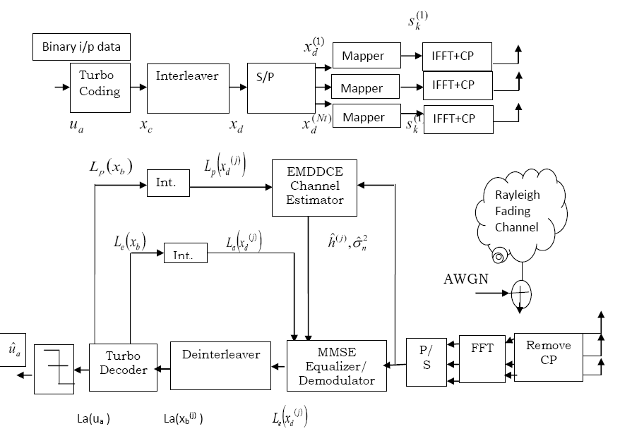

**Fig.1.1.** **Turbo coded MIMO-OFDM transceiver Design**

The received signal vector at the receiver from NR antennas at ith symbol time can be expressed as,

 (1)

Where,



Let ‘D’ be the group of received OFDM symbols at the rth antenna can be written as,

 (2)

* 1. Proposed Optimal EMDDCE channel estimation algorithm

However, classical channel estimation techniques cannot be used in fast time varying multipath channel since the received signal is a superposition of signals transmitted from different antennas for each OFDM subcarrier. The EMDDCE algorithm can convert a multiple-input channel estimation problem into a number of single-input channel estimation problems.

To reduce the computational complexity or to improve the performance of the EM algorithm, a EM decision-directed (EMDDCE) estimation technique has been proposed by combining the EM algorithm with the decision-directed (DD) channel estimation, which presents a reduced computational complexity in slowly time varying channels. To convert biased estimates into unbiased estimates, EMDDCE proposed. Estimate the best channel with the help of LS and MMSE approach separately by utilizing the algorithm CGWO. After this process, with the support of GA, the MMSE and LS techniques are combined for the evaluation of best channel in order to minimize the occurrence of error.

**Step 1**: Apply initial channel estimation algorithm using pilots with LS or MMSE channel estimation techniques.

(3)



**Step 2**: Detect the transmitted signals using MIMO detection techniques. Using LS/MMSE detection techniques can be applied to the signal detection part as,

 (4)

**Step 3**: Update the channel estimate using the conditional probability density function of the received signal given the detected signal vector and initial channel coefficient vector can be given as,

(5)



**Step 4**: Maximize the initial channel estimates and detected signal by using the complete data set as follows.



(6)

**Step 5**: By taking derivative w.r.t. Hr , the channel update equation is given as,

(7)



**Step 6**: The channel estimates are compensated by its bias inverse as,



(8)

where,



**Step 7**: With the support of GA, the MMSE and LS techniques are combined for the evaluation of best channel in order to minimize the occurrence of error.

 (9)

 (10)

 (11)

**Step 8 :** Update the best channel information to the Turbo decoder and repeat the process till it converges.

* 1. Simulation Parameters

The Implementation carried out to dissect the proposed Channel Estimation of a Turbo Coded MIMO-OFDM correspondence framework dependent on Chaotic Gray Wolf Optimization procedure. The test examination is created onto the MATLAB 2015b. The demonstration of the proposed methodology is evaluated based on signal to noise ratio (SNR), mean squared error (MSE) and bit error rate (BER). The performance of the proposed approach analyzed by changing different crossover and mutation rate and the parameter of the proposed system described in Table 1.

**Table 1: Simulation Parameters**

|  |  |
| --- | --- |
| **Parameters** | **Values** |
| Size of FFT/IFFT | 512 |
| Constellation | QPSK,16QAM |
| No. of Tx,Rx antennas | 4,4 |
| Populationsize CGWO,GA) | 50 |
| Iteration | 50,70,100 |
| Mutation probability | 0.01,0.02,0.04 |
| Crossover probability | 0.3,0.4,0.5,0.6,0.7,0.8 |

The performance procured by the usage of CGWO approach regarding LS and MMSE demonstrated below. At first, for every single stage, the best results are resolved concerning 100 cycles of iteration.

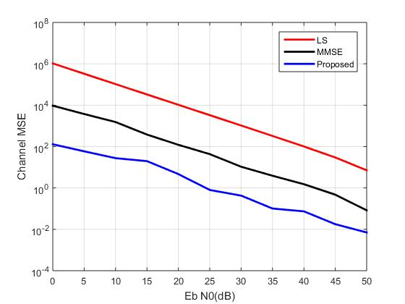

**Fig.1.2.** **MSE Vs SNR during 50th iteration**

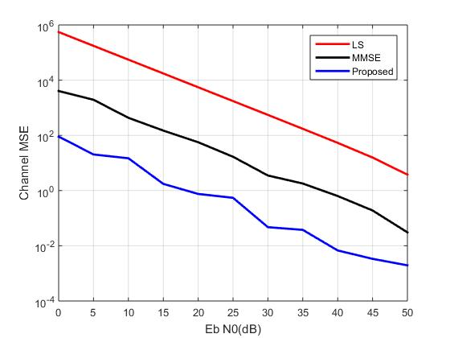

**Fig.1.3.** **MSE Vs SNR during 100th iteration**

The figure 1.2 and 1.3, illustrates the simulation outcome in comparison with LS and MMSE estimation approaches during the 50th and 100th iteration. When comparing the existing approaches the proposed turbo coded system performs better than the existing method of channel estimation. For an increased crossover length the MSE rate of our suggested approach on turbo coded system is decreased simultaneously.



**Fig.1.4.** **BER Comparison of EMDDCE under QPSK modulation**



**Fig.1.5.** **BER Comparison of EMDDCE under 16-QAM modulation**

The figure 1.4 and 1.5, illustrates the BER vs SNR comparison analysis of proposed channel estimation technique under QPSK and QAM modulation schemes. The results validated that the proposed EMDDCE performs better than the existing EM method of channel estimation.

* 1. Conclusion

In this paper we have designed a framework for EMDDCE Channel Estimation of a Turbo Coded MIMO-OFDM communication system based on Chaotic Grey Wolf Optimization (CGWO) and Genetic Algorithm (GA) schemes. The method CGWO in addition to GA, performs better tuning over the channel model which is acquired, in this way the channel model is should be gotten from further relationship with the ideal structure. The result showed the proposed methodology is better when contrasted with the presentation of EM strategy.

References:

1. Samardzija, D., & Mandayam, N. (2003). Pilot-assisted estimation of mimo fading channel response and achievable data rates. IEEE Transactions on Signal Processing, 51(11), 2882–2890. doi:10.1109/tsp.2003.818158
2. Wautelet, X., Herzet, C., Dejonghe, A., Louveaux, J., & Vandendorpe, L. (2007). Comparison of EM-Based Algorithms for MIMO Channel Estimation. IEEE Transactions on Communications, 55(1), 216–226.doi:10.1109/tcomm.2006.887507
3. Oyerinde, O. O., & Mneney, S. H. (2009). Iterative OFDM receiver with Decision Directed Channel Estimation. AFRICON 2009. doi:10.1109/afrcon.2009.5308381
4. Eric Pierre Simon et.al , (2012). Joint Carrier Frequency Offset and Channel Estimation for OFDM Systems via the EM Algorithm in the Presence of Very High Mobility. IEEE Transaction on Signal Processing, Vol.6.No.2, Feb.2012, pp.754-765.
5. Palally, H. R., Chen, S., Yao, W., & Hanzo, L. (2009). Particle swarm optimisation aided semi-blind joint maximum likelihood channel estimation and data detection for MIMO systems. 2009 IEEE/SP 15th Workshop on Statistical Signal Processing. doi:10.1109/ssp.2009.5278578
6. Knievel, C., & Hoeher, P. A. (2012). On Particle Swarm Optimization for MIMO Channel Estimation. Journal of Electrical and Computer Engineering, 2012, 1–10.doi:10.1155/2012/614384
7. Sujitha, J., & Baskaran, K. (2017). Genetic Grey Wolf Optimizer Based Channel Estimation in Wireless Communication System. Wireless Personal Communications, vol.99, issue 2, 965–984. doi:10.1007/s11277-017-5161-8
8. J Zhang, S Chen, L Hanzo, X Mu (2014). Evolutionary-Algorithm-Assisted Joint Channel Estimation and Turbo Multiuser Detection/Decoding for OFDM/SDMA. IEEE Transactions on Vehicular Technology, vol. 63, issue 3, pp. 1204 – 1222.
9. Muhammet Nuri Seyman, et.al,(2011). Partcile Swarm Optimization for Pilot Tones design in MIMO-OFDM Systems. Eurasip Journal on Advances in Signal Processing 2011.
10. K.Vidhya K.R.Shankar Kumar (2011). Enhanced Channel Estimation Technique for MIMO-OFDM Systems with the aid of EP Techniques. European Journal of Scientific Research .Vol.67,No.1,2011 pp. 140- 156.
11. G. Gui, W. Peng and F. Adachi, "High-resolution compressive channel estimation for broadband wireless communication systems", International Journal of Communication Systems, vol. 27, no. 10, pp. 2396-2407, 2012.
12. Prasanta Kumar Pradhan, Oliver Faust, Sarat Kumar Patra and Beng Koon Chua,"Channel Estimation Algorithms for OFDM Systems",pp.1-5,2012
13. H. Zamiri-Jafarian and S. Pasupathy, “MIMO-OFDM channel estimation using improved LS algorithm,” in Proc. IEEE Vehicular Technology Conf.,(Montreal, Canada), Sept. 2006.
14. Sang, T., Lam, W. H., & Zeng, Y. (2006). Semiblind channel estimation and equlization for MIMO space–time coded OFDM.IEEE Transactions on Circuits and Systems, Vol.53, No. 2, 463–474.
15. Z. Luo and D. Huang, “General MMSE channel estimation for MIMOOFDM systems,” in Proc. IEEE Vehicular Technology Conf., (Calgary,Canada), Sept. 2008.