Analysis of X2-handover Techniques for dense LTE Network

|  |  |
| --- | --- |
| Mrs. Swapna Tangelapalli | Dr. P.Pardha Saradhi |
| *Research Scholar, department of ECE* | *Professor, department of ECE* |
| *K.L.University,Vaddeshwaram,*  *Andhra Pradesh, India.* | *K.L.University,Vaddeshwaram,*  *Andhra Pradesh, India.* |
| [Swapna.tangelapalli@gmail.com](mailto:Swapna.tangelapalli@gmail.com) | [pspokkunuri@gmail.com](mailto:pspokkunuri@gmail.com) |
|  |  |

***Abstract*—In order to face the increasing demand for bandwidth caused by mobile data applications and value-added mobile services, 4G/LTE network deployments are Based on the emerging paradigm of networks, Among the various factors that are affecting factors of wireless cellular technology such as delay, throughput, latency etc ,the most effective one is Inter cell Interference(ICI). There are many methods for reducing this ICI, two of them are Frequency Reuse(FR) techniques and Handover techniques. In the dense LTE environment, the deployment of small cells, also called microcells or femto cells are very near in order to provide high data rates and improved quality of services. Different handover algorithms are used and are compared for the good quality of communications. LTE network topology is constructed and simulated done using Ns3 tool. RSRP and RSRQ values are used to calculate the performance of the system. NS-3 is used to simulate this environment and calculate different parameters for different cells like macrocell, microcell, etc using different handover techniques like A3 RSRP handover algorithm and A2A4 RSRQ handover algorithm.**

***Keywords*–*LTE; handover; NS-3; RSRP; RSRQ; microcell; macrocell.***

**I INTRODUCTION**

There has been major pattern shifts or changes in terms of technologies and architecture in mobile networks during the technological growth from 1st generation(1G) from 1980s towards 5th generation(5G) by 2020. There has been a drastic change in technology in mobile networks from 1G to 4G.Using advance digital signal processing and modulations techniques the thirst of system is towards high speed with great capacity. The simplification of the [network architecture](https://en.wikipedia.org/wiki/Network_architecture) to an [IP](https://en.wikipedia.org/wiki/Internet_Protocol)-based system and to reduce the transfer latency were the next goals. Only [packet switching](https://en.wikipedia.org/wiki/Packet_switching) is supported by LTE standards using Internet Protocol (IP) network Technology.

This project mainly focuses on the comparison study between different cell sizes with user equipments travelling in different speeds and different handover techniques used. This study is used in determining which handover technique to be used in different scenarios. Handover is the most important feature of a network which greatly impacts the performance of a system. There are many types of handover algorithms like A2A4 handover, A3 handover, no operation handover. When these parameters (RSRP, RSRQ) fall below threshold value handover procedure takes place. Handover is a process where one user equipment connected to one enodeB, which is called source enodeB is then connected to another enodeB, which is called neighbouring enodeB. The control transfer takes place considering RSRP (Reference signal Received power), RSRQ(Reference signal received quality), SINR(signal to interference noise ratio) etc. depending upon the handover algorithm. The main objective of this project is to simulate LTE environment, move the user equipment from one eNodeB to another eNodeB which are located at different distances for different cells where the speed of the user equipment also varies and then tabulate RSRP and RSRQ value at the time of handover. The results have been recorded by differing values of distance between enodeB’s and speed of user equipment. The performance decreases when the handover time is more. Therefore, rate of call drops will increase leading to poor QOS( Quality of Service). The mobility management becomes difficult to achieve when the distance between eNodeB’s is more. The increasing speed of the user equipment decreases the SINR ratio when the handover does not take place at the cell boundaries. The Paper is organized as, in chapter II explains about Handoff in Cellular network. Chapter III describes LTE handover measurement events, Chapter IV includes simulation procedure and Methodology following with results in chapter V along with future work and conclusion in chapter VI.

**II. Handoff in cellular network**

In cellular communications, the handoff is the way toward exchanging a functioning call or an information session from one cell in a phone arrange or starting with one channel then onto the next cell or another channel. Handoff is vital for counteracting loss of interference of administration to a guest or an information session client. Handoff is also called handover.The 3 different handover procedures are based on three different phases. These includes Handover information gathering,Handover decisioon policies and Handover Execution.

**Cases of Handoff:**

Handoffs are triggered in many cases . Some of them are of the following situations:

* Every cell has a pre-characterized limit,for example, it can deal with just a particular number of users. On the Off chance that the
* quality of clients utilizing a specific cell achieves its greatest limit at the point of handoff happens. A portion of calls are exchanged to bordering cells. gave that the supporter is in the covering inclusion zone of both of the phones
* Cells are regularly subdivided into microcells. A handoff may happen where there is exchange of obligations from the expansive cell to the smaller cell and the other way around. For instance, there is a voyaging client moving inside the ward of big cell. On the Off chance that the explorer stops, at the point locale is exchanged to microcell to alleviate the heap on the huge cell.
* Handoff may likewise happen when there is an impedance of call utilizing a similar recurrence for correspondence.

**Type of Handoffs: There are two types of handoffs.**

* HARD HANDOFF: In the hard handoff, a real break in the association happens while changing starting with one cell then onto the next. The radio connection from the portable station to the current cell is first break before building up the connection with the following cell. It is commonly between recurrence handoff. It is ‘break before make’ policy.

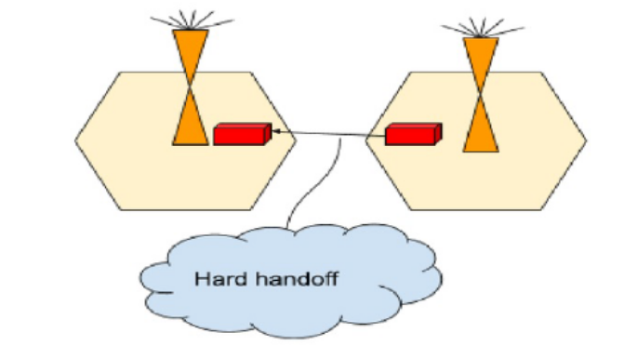

Figure1 Hard handoff

* SOFT HANDOFF: In the soft handoff, no less than one of the connections are added and evacuated to the portable station. This guarantees amid the handoff, no break happens. This is commonly embraced in co-found locales. It is ‘make before break’ policy.

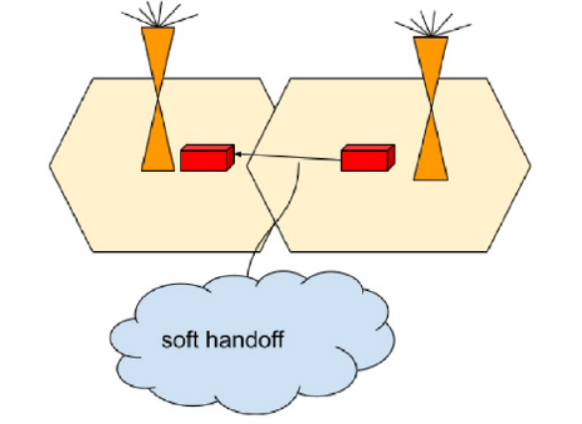

Figure 2: Soft handoff

**III. LTE Handover measurement events**

In this paper, the handover is basically taking place based on the measured parameters such as RSRP(Reference Signal Received Power) and RSRQ(Reference Signal Received Quality). RSRP can also be defined as the average power in dBm of the resource element carrying cell specific reference signals within the considerable bandwidth. RSRQ is measured in dB which usually helps in providing the ranking between different neighbouring cells in reference with their signal quality.

After calculating these RSRP and RSRQ values by the UE, the five different types of predefined events are examined. These five different reporting events which depends on values of RSRP and RSRQ are represented by A1,A2,A3,A4 and A5. The figure below shows the description of all differebt types of events occuring during the UE moves from one cell to another cell.

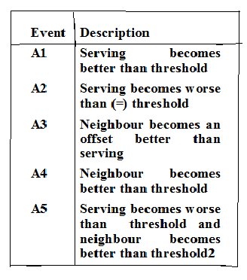

In A2-A4 Event based algorithm, event A2 indicating the UE receiving very low signal quality and can be benefited by hand overing to the new cell, whereas event A4 is used to detect neighbouring cells by considering RSRQ of that cell from UE entering to new cell.

The A3-RSRP algorithm is also called Power budget Algorithm. The stronger RSRP is detected by the UE and the triggering of handover is done to the best cell with highest RSRP values. This handover is based on hysteresis and time to trigger parameter.

The flowcharts given below shows the procedure followed during A-A4 RSRQ and A3 RSRP algorithm for handover

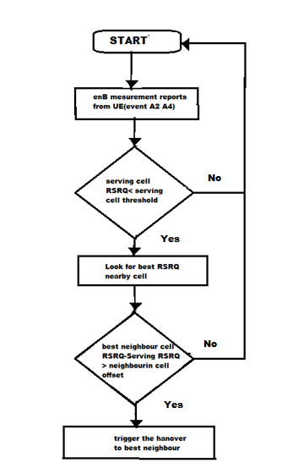

Figure 3: Flowchart for RSRQ based A2-A4 algorithm

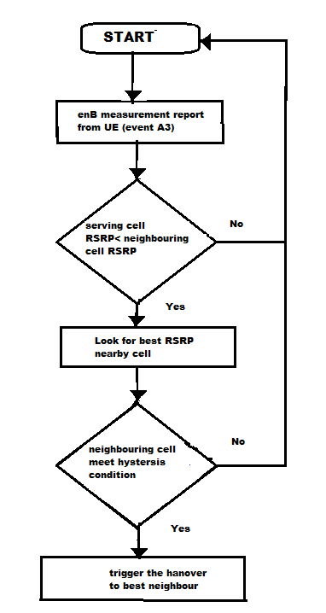

Figure 4: Flowchart for RSRP based A3 algorithm

**IV. SIMULATION PROCEDURES AND METHODOLOGY**

*A. Test Scenarios and Simulation Parameters*

The scenario was simulated with the help of a modified version of lena-x2-handover-measures.cc. It is included in the LTE module of NS-3.

Table I Simulation parameters

|  |  |
| --- | --- |
| Parameter | Value |
| Number of UE’s | 1 |
| Number of eNB’s | 2 |
| Number of bearers per UE | 0 |
| Transmitted power of eNB(dbm) | 46 |
| Udp client interval | 10 |
| Udp client max packets | 1000000 |

*B. Tools and Software*

The simulation was carried on Ubuntu 12.04 LTS operating system on a core i5 Dell laptop out using ns-3.27 version installed.

**V.RESULTS AND ANALYSES**

The results and analyses of the simulations are presented in the following subsections.

1. *Animation of Network Topology*

A snapshot of the topology is shown in Figure 1. The first node is the SGW/PGW, the next node is the remote host and the third node is the serving eNodeB. The other node is the target eNodeB while the last node is the user equipment. It also gives the information about the time of handover

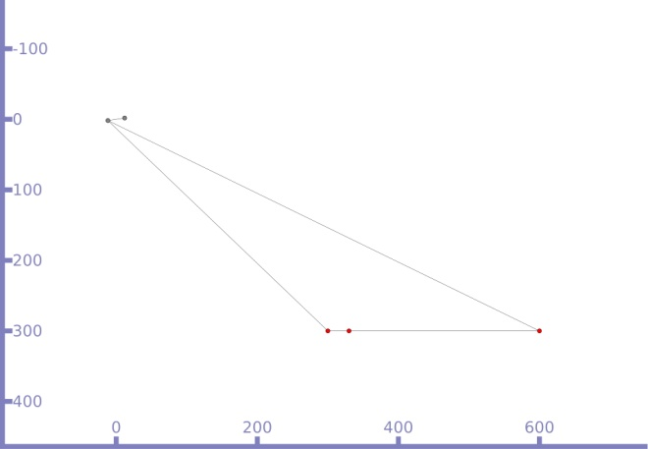

Figure 3. Animation of handover

*B. Simulation Results*

From the RSRP/RSRQ traces obtained from the simulations, their reported values and actual values are obtained at the points of handover for both the serving and target cells. They are presented in Tables II and III, for the A2A4RSRQ handover algorithm and A3RSRP handover algorithm respectively for both microcell and macro cell.

Table II results for A2A4 RSRQ handover algorithm

|  |  |  |  |  |  |  |  |  |  |
| --- | --- | --- | --- | --- | --- | --- | --- | --- | --- |
| DISTANCE (m) | SPEED  (m/s) | CELLID 1 |  |  |  | CELLID 2 |  |  |  |
| Microcell |  | RSRQ | RSRP | RSRQ(db) | RSRP(dbm) | RSRQ | RSRP | RSRQ(db) | RSRP(dbm) |
| 500 | 100 | 26 | 74 | -7 to -6.5 | -65 to -66 | 30 | 76 | -5 to -4.5 | -63 to -64 |
|  | 250 | 19 | 73 | -10.5 to -10 | -66 to -67 | 32 | 82 | -4 to -3.5 | -57 to -58 |
|  | 310 | 16 | 73 | -12 to -11.5 | -66 to -67 | 32 | 86 | -4 to -3.5 | -53 to -54 |
| 1000 | 150 | 26 | 65 | -7 to -6.5 | -74 to -75 | 29 | 67 | -5.5 to -5 | -72 to -73 |
|  | 350 | 26 | 65 | -7 to -6.5 | -74 to -75 | 30 | 68 | -5 to -4.5 | -71 to -72 |
|  | 700 | 25 | 65 | -7.5 to -7 | -74 to -75 | 30 | 68 | -5 to -4.5 | -71 to -72 |
| Marco cell  5000 | 700 | 27 | 48 | -6.5 to -6 | -91 to -92 | 28 | 49 | -6 to -5.5 | -90 to -91 |
|  | 2500 | 26 | 48 | -7 to -6.5 | -91 to -92 | 29 | 49 | -5.5 to -5 | -90 to -91 |
|  | 3500 | 26 | 48 | -7 to -6.5 | -91 to -92 | 29 | 49 | -5.5 to -5 | -90 to -91 |
| 3000 | 700 | 27 | 53 | -6.5 to -6 | -6.5 to -6 | 28 | 54 | -6 to -5.5 | -85 to -86 |
|  | 2500 | 26 | 53 | -7 to -6.5 | -7 to -6.5 | 29 | 54 | -5.5 to -5 | -85 to -86 |
|  | 2900m/s | 24 | 52 | -8 to -7.5 | -8 to -7.5 | 30 | 54 | -5 to -4.5 | -85 to -86 |

Table III Results for A3 RSRP handover algorithm

|  |  |  |  |  |  |  |  |  |  |
| --- | --- | --- | --- | --- | --- | --- | --- | --- | --- |
| DISTANCE  (m) | SPEED (m/s) | CELLID 1 |  |  |  | CELLID 2 |  |  |  |
| Microcell |  | RSRQ | RSRP | RSRQ(db) | RSRP (dbm) | RSRQ | RSRP | RSRQ  (db) | RSRP(dbm) |
| 500 | 100 | 20 | 73 | -10 to -9.5 | -66 to -67 | 33 | 82 | -3.5 to -3 | -57 to -58 |
|  | 150 | 20 | 73 | -10 to -9.5 | -66 to -67 | 33 | 80 | -3.5 to -3 | -59 to -60 |
|  | 250 | 11 | 72 | -14.5 to -14 | -67 to -68 | 33 | 82 | -3.5 to -3 | -57 to -58 |
| 1000 | 100 | 23 | 64 | -8.5 to 8 | -75 to -76 | 30 | 68 | -5 to -4.5 | -71 to -72 |
|  | 150 | 23 | 64 | -8.5 to -8 | -75 to -76 | 31 | 68 | -4.5 to -4 | -71 to -72 |
|  | 200 | 23 | 64 | -8.5 to 8 | -75 to -76 | 31 | 68 | -4.5 to -4 | -71 to -72 |
| Marco cell  5000 | 100 | 24 | 47 | -8 to -7.5 | -92 to -93 | 28 | 50 | -6 to -5.5 | -89 to -90 |
|  | 1000 | 24 | 47 | -8 to -7.5 | -92 to -93 | 31 | 50 | -4.5 to -4 | -89 to -90 |
|  | 5000 | 22 | 45 | -9 to -8.5 | -94 to -95 | 31 | 48 | -4.5 to -4 | -91 to -92 |
| 3000 | 200 | 24 | 52 | -8 to -7.5 | -87 to -88 | 30 | 55 | -5 to -4.5 | -84 to -85 |
|  | 2500 | 23 | 51 | -8.5 to -8 | -88 to -89 | 31 | 55 | -4.5 to -4 | -84 to -85 |

Formula for calculating actual RSRP from reported RSRP (n) in dbm is

n-139 < RSRP(dbm) < n-140 (1)

*C. Analysis and Discussion*

From the above results the following analysis have been made.

1. Performance is better in microcell than macro cell in A2A4 RSRQ handover algorithm.
2. There is similar performance in macro cell for both the handover algorithms
3. There is similar performance in microcell for both the handover algorithms
4. As speed increases in microcell RSRQ values decrease thus decreasing call quality in both the handover algorithms.
5. The difference in performance between the serving and the target cells at the point of handover was higher in microcells than macro cells. This shows that the macro cells are more stable in handling control signaling than small cells.

**VI. CONCLUSIONS AND FUTURE WORK**

In the project we have seen the performances of different handover techniques (A2A4 RSRQ Handover algorithms, A3 RSRP Handover algorithm) in different cells at handover. This kind of study helps us in research and attempt to enhance the functioning of LTE. It also lays bricks to the development of future generations of the technology. In the future we can include real time data transmission between these nodes thus developing the idea of compact small cells where virtual nodes act as base stations and thus we help in the development of 5G.

REFERENCES

1. Sherif Adeshina Busari, Shahid Mumtaz, Kazi Mohammed Saidul Huq and Jonathan Rodriguez “X2-Based Handover Performance in LTE Ultra-Dense Networks using NS-3”, in proceedings of the Seventh International Conference on Advances in Cognitive Radio IARIA, 2017, pp 31-36
2. Tangelapalli Swapna, Dr.P.Pardha saradhi, “Survey with Analytical results on ultra dense 5G”,Internatitonal journal of pure and Applied Mathematics, Volume 117,Issue 18,special Issue,2017,pages1-6
3. Swapna Tangelapalli1 , Dr.P.Pardha Saradhi2 , , Overview of Interference Management in Ultra Dense Networks for future wireless, IJETAE,Volume 8, Issue 4,April 2018.
4. B. Herman, D. Petrov, J. Puttonen and J. Kurjenniemi, “A3-Based Measurement and Handover Model for NS-3 LTE”, in proceedings

of the 3rd International Conference on Mobile services, resources and users (MOBILITY 2013). IARIA, 2013, pp. 20-23.

1. José Bruno Iñiguez Chavarría “LTE Handover Performance Evaluation Based on Power Budget Handover Algorithm” Master’s thesis, Universitat Politècnica de Catalunya February 2014
2. The LENA ns-3 LTE Module Documentation, Release ,2014, <http://networks.cttc.es/wpcontent/uploads/sites/2/2014/01/lena-lte-module-doc.pdf>
3. N. Baldo, M. Requena-Esteso, M. Miozzo, and R. Kwan, “An Open Source Model for the Simulation of LTE Handover Scenarios and Algorithms in Ns-3,” in Proceedings of the 16th ACM International Conference on Modeling, Analysis & Simulation of Wireless and Mobile Systems (MSWiM ’13), Barcelona, Spain. ACM, 2013, pp. 289–298.
4. G. Piro, N. Baldo, and M. Miozzo, “An LTE Module for the Ns-3Network Simulator,” in Proceedings of the 4th International Conference on Simulation Tools and Techniques, (SIMUTools ’11), 2011. ACM, pp. 415–422.
5. A. Helenius, “Performance of handover in Long Term Evolution,” Master’s thesis, Aalto University, Finland, 2011, http://lib.tkk.ﬁ/Dipl/ 2012/urn100708.pdf.

[9] M. Assyadzily, A. Suhartomo, and A. Silitonga, “Evaluation of

X2-handover performance based on RSRP measurement with

Friis path loss using network simulator version 3 (NS-3),” in

Proceedings of the 2nd International Conference on

[10] Namrata Katti, Seema Shivapur, Vijayalakshmi M.," Optimization of QoS in 4G Networks UsingHandover Management", International Journal of Emerging Technology in Computer Science & Electronics (IJETCSE), ISSN: 0976-1353Volume 14 Issue 2 –APRIL 2015,pp-398-402