[Name of the proceedings]

Residual stress measurement of Inconel 600 on different welding techniques by using conventional and XRD methods

P.V Chandra Sekhara Rao1, Aluri Manoj2, B. Renuka Swathi2*

1,2,2*Department of Mechanical engineering, RGUKT-Basar, Telangana- 504107

Abstract

Residual stress is a type of secondary stress which exits even after eliminating all the loads. Components which are fabricated through welding will contain both residual stresses, either compressive or tensile. Estimation of residual stress is vital for analyzing distortion, service life prediction and to determine the failure reasons. Inconel 600 is widely used in applications such as gas turbine components, heat treating industry and aerospace which require good weldability at different temperatures, high strength and also for its excellent mechanical properties. The main motto of this research is to compare the residual stresses for Inconel 600 plates which are welded using different welding techniques by experimental and X-Ray diffraction analytical methods.

[copyright information to be updated in production process]

*Keywords: Inconel 600, residual stresses, TIG, resistance strain gauge*

1. Introduction

Here Over the past decades residual stresses have been discussed widely in scientific literature. Brinksmeier et al. [1] in their systematic study stated that in case with the mechanical strength and distortion along with the electrical or chemical performance, residual stress plays an important role.M.A. Balbaa and Mohamed N.A. Nasr has used finite element modelling to investigate on the residual stress on Inconel 718 of Laser Assisted Machining (LAM). The method of Smoothed- particles Hydrodynamics (SPH) has been used for modelling cutting process at first, then relaxation process has been simulated using Lagrangial model. As compared to conventional machining the results were predicted to Laser Assisted Machining [2]. R. L. Peng et al. has worked on the residual stresses induced from machining of Inconel 718 fabricated at the condition of dry cut within high speed turning. The cutting fluid usage and cutting tool wear influence has been studied. Distribution of the residual stresses characteristics along with the bottom layer compressive stress and top layer tensile stress were also investigated [3]. Investigation of explosion welded joint fabricated from sheets of carbon steel and Inconel 625. Due to welding high residual stress were noticed and attained stress relaxation through application of heat treatment which was proposed by R. Varavallo et al. [4]. Kortabarria, Aitor, et al. has studies the residual stresses induced through machining with the help of 2D finite element model of orthogonal cutting and residual stress were predicted from the sensitivity analysis in an attempt to determine the model input data impact [5]. Kirubaharan, A.m. Kamalan, et al. ha used the technique of electron beam evaporation technique to deposit c-YSZ films on substrate of Inconel 690 to 973K from 673K. GIXRD (grazing incidence x-ray diffraction) method has been used to measure the residual stresses on the film interface and in the film at different angles of incidence. When the temperature of the substrate was raised to 973K from 673K the residual stresses at the interface region has undergone changes to compressive from tensile during the process of deposition [6]. Girinon, Mathieu, et al. has analyzed the states of the residual stresses at the hole after the process of drilling of Nickel alloy of Inconel 718, 316L austenitic stainless steel and 15-5PH martensitic stainless steel with the three modes of lubrication and noticed varying of the residual stress along the hole [7].

**Nomenclature**

V = Output voltage

BV = Bridge excitation voltage (Input voltage)

GF = Gauge factor

$ε$ = Strain

$σ$ = Stress

E = Youngs modulus

$$σ_{φ} =Stress at an angle 'φ'$$

$$ϑ =Poissons ratio$$

$$d_{ϕψ}=Inter planar spacing at an angle 'ψ'$$

Ψ = Angle between “normal of sample” and normal of “normal of diffracting plane”

do = Strain free interplanar spacing

$ϕ =Angle between fixed plane of sample and$ projection in that plane of normal diffracting plane

Telang, Abhishek, et al. has studied on [Ultrasonic](https://www.sciencedirect.com/topics/physics-and-astronomy/ultrasonics) Nanocrystalline Surface Modification (UNSM), [Cavitation](https://www.sciencedirect.com/topics/physics-and-astronomy/cavitation-flow) Shotless Peening (CSP), [Laser](https://www.sciencedirect.com/topics/materials-science/laser-technique) Shock [Peening](https://www.sciencedirect.com/topics/physics-and-astronomy/peening) (LSP) treated Inconel 718 samples and at different time periods they were introduced to temperature ranging 550oC – 650oC. Behavior of the thermal relaxation was compared from the residual stress obtained from XRD [8]. Ahmad, Bilal, et al. has investigated on the 3D printed Inconel 718 and Ti6Al4V using SLM (Selective Laser Melting). The distributions were found using the approach of numerical simulation and contour method and noticed that near and at the Inconel and titanium surfaces tensile residual stress were high and at the region of center compressive residual stresses were found [9]. Pei-Zhuo, Wang, et al. has worked on the residual stresses of the Inconel 718 during the process of grinding utilizing COMSOL Multiphysics 5.0 in both the cases of adding and not adding heat source. Along with this, the impact of distance and height between grinding zone and heat source, heat source length, heat source density were also studied [10]. Vemanaboina, Harinadh, et al. has worked on the residual stresses during the multipass palates fabricated utilizing PCGTAW (Pulsed current Gas Tungsten Arc Welding) of SS316L to IN600 using ERNiCrMo-3 wire as a filler and the resulted residual stresses were measured using XRD [11]. Singh, R., et al. has utilized nitrogen gas to cold-spray IN 718 composition of chemical on substrates of IN 718 for a tool used to repair components of aerospace. Bending methods and hole drilling was utilized to measure the residual stresses magnitude along the thickness and also using parameters of physical process residual stresses were estimated [12].Amudha, A., et al. has studied the minimum residual stresses combinations of duble and single layer deposited Inconel 625 and SS-309Mo on base metal of low carbon steel IS-2062 Grade-B were simulated using ANSYS Finite Element Analysis and base metal preheating and deposition of alternate skip weld are the techniques utilized [13].Xu, Xiao-Yan, et al. has fabricated the forged compressor disc using Inconel 718 and their residual stress were measured using neutron diffraction and XRD methods [14].

1. RS measurement using conventional strain gauges

When the foil gets deformed due to the deformation of the object which alters the electric resistance of the object which is experiencing strain and that strain is measured using a device called strain gauge. Resistance change will be measured by using Wheatstone bridge.

Strain gauges can be used by applying them to the parts which are yet to be welded, in order to estimate the stress during the process. As during the process of welding the temperature is distributed non-uniformly resulting the small-scale plastic deformation. Gauge Factor (GF) in strain gauges is defines as the proportionality between the mechanical strain and the electrical resistance change of the sensor.

As the GF value is recorded estimation of electric resistance is done with the help of the Wheatstone bridge sensors. Strain gauges are provided in certain zones and minor deformations are produced in these zones. The values of electric voltage which are recorded by the strain gauges measurements, can be translated legitimately by the client in stress values (MPa) by methods for required formulae.

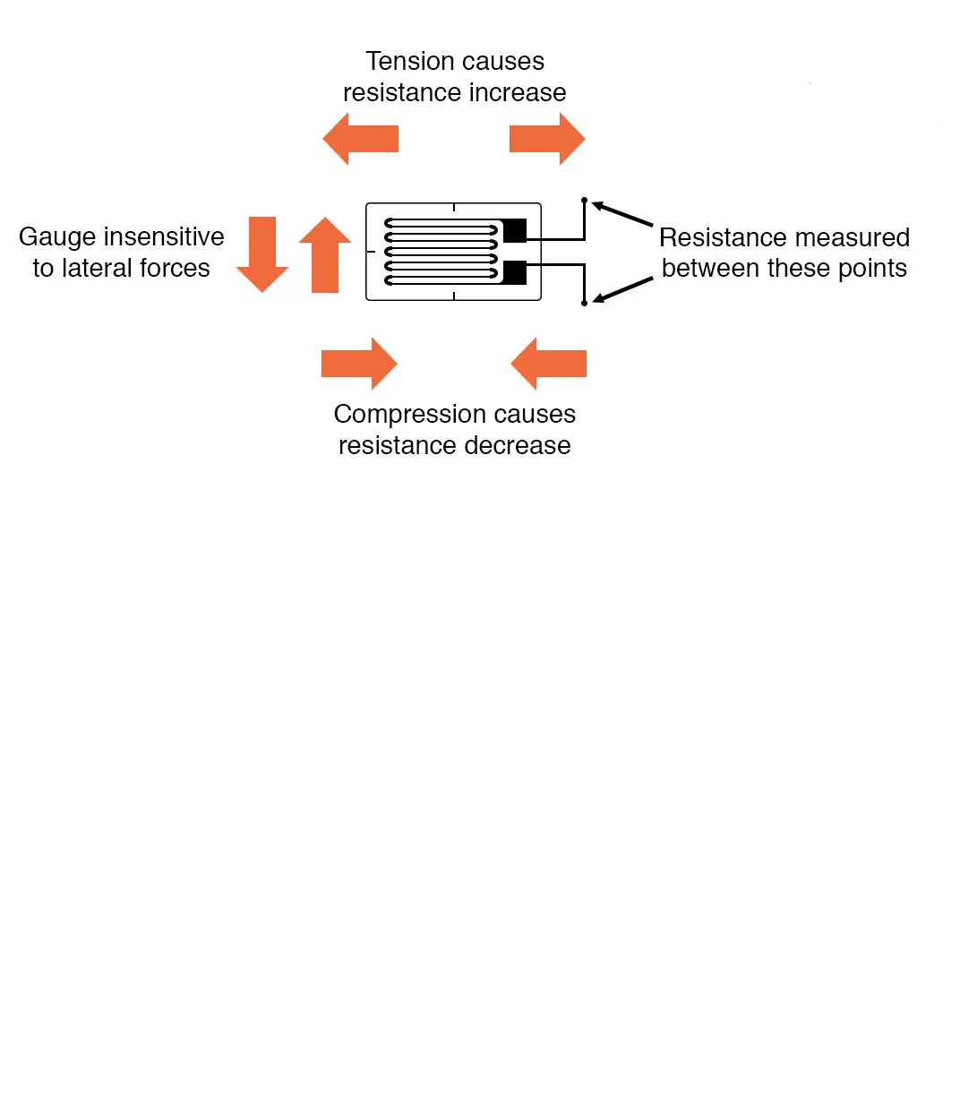Fig. 1. Strain gauge working principle.

* 1. Strain measuring using Wheatstone bridge

Strain is measured by using wheatstone bridge. Variable resistance is replaced with the strain gauges with a motto to measure the strain. Strain gauges of the electrical resistance differs with increment or abatement in the strain of the gadget. The arrangement is exceptionally useful with regards to quantifying the part of changes in resistance with high exactness.

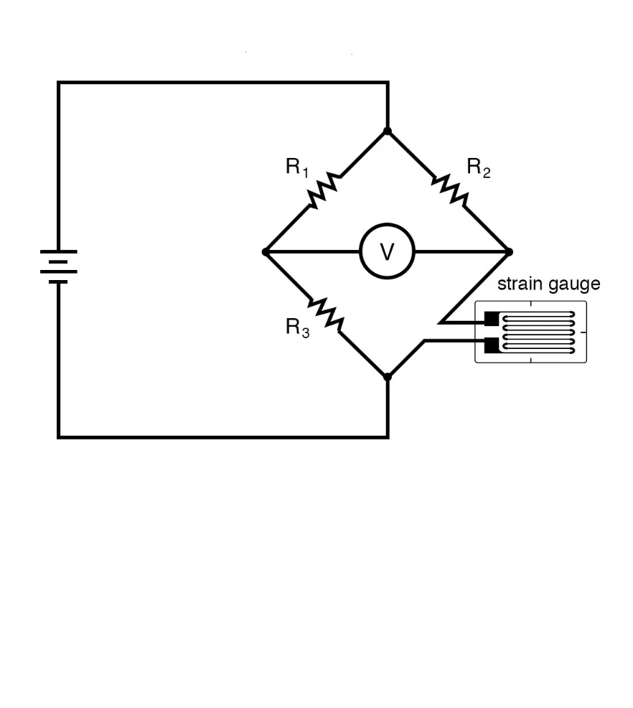

Fig. 2. Strain gauge as variable resistance

1. Experimentation and Methodology
   1. Experiment Description

Please In the experiment, Inconel 600 plates with dimensions of 50 x 100 x 6 mm are welded by TIG welding. Both plates were previously clamped. A single butt weld position with partial penetration was used in the experiments because the easy accessibility of the operator with no risk of losing the experiment due to nonconformity during welding. The parts dimensions to be welded are defined based on the experiments performed. The welding procedure has been defined based on the requirements of TIG process and the geometric characteristics of the joint according to dimensions of joint.

For the signal conditioning, Wheatstone bridge is constructed. In addition, some procedures were rigorously followed for bonding the strain gauges in the parts, which follow standard steps. It was observed that bonding and positioning of strain gauges in the part are the most important steps due to sensors misalignment occurrence and risk of bubbles between sensors and the surface of the parts, thus compromising the process of measurement. In the experiments, unidirectional strain gauges were used with GF = 2.11, electrical resistance of350 ohms and wired copper welded terminals. The zone in the plates in which the strain gauges were positioned as closer to the weld bead as possible was considered critical as a result of the sensors failure possibility depending on the temperature peaks imposed by the heat source, thus compromising the tests.

Fig. 3. Experimental setup

To avoid this drawback, previous studies of the strain gauges location and by the help of temperature gun practical temperatures at certain locations were observed. It was known the residual stresses measurement is complex even in materials free from external forces. It is also known that residual stresses are not directly measured, but the elastic deformation caused by it. These deformations, present at the end of welding processes, were measured in the development of experiments that comprise this project. After plates reach the room temperature, stress values were collected.

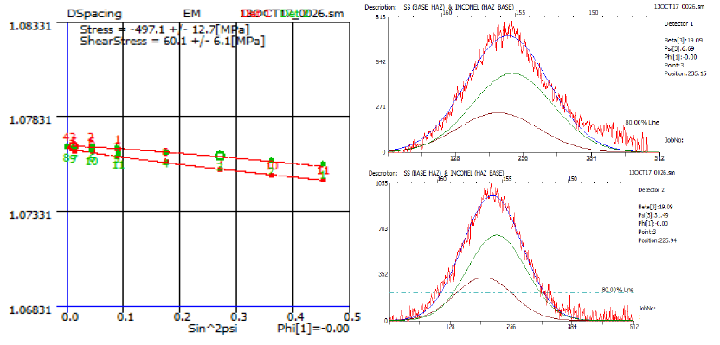Residual stress of TIG welded Inconel 600 specimen is measured with the help of the XRD at Heat Affected Zone (HAZ).

Fig. 4. XRD graphs of stress in TIG welded Inconel 600 specimen at HAZ

The stresses resulted in the TIG welded Inconel 600 specimen in HAZ is -497±12.7 MPa

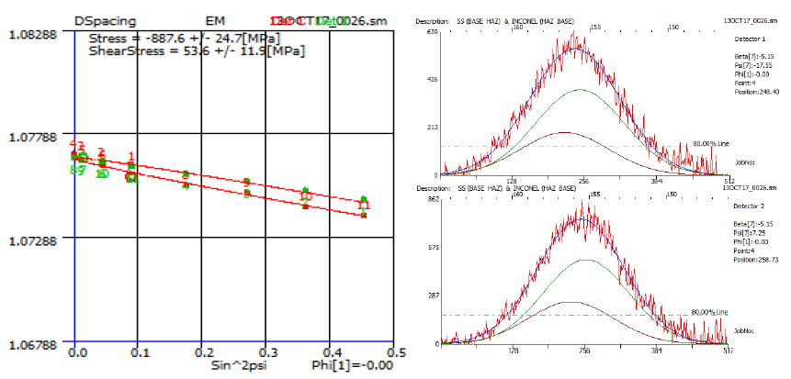Residual stress of TIG welded Inconel 600 specimen is measured with the help of the XRD at Base.

Fig. 5. XRD graphs of stress in TIG welded Inconel 600 specimen at Base

The stresses resulted in the TIG welded Inconel 600 specimen in Base is -887.6±24.7 MPa

* 1. Theoretical calculation of residual stress

*Inconel 600*

E= 207 GPa

µ=0.29

*Inconel Base*

D(spa Cin9)do=1.0766866

Slope from dφψ Vs sin2ψ

Slope =-5.2044763×10-13

$$σ_{φ}=\left(\frac{E}{1+ϑ}\right)\frac{1}{d_{0}}\left[\frac{∂d_{ϕψ}}{∂\sin^{2}ϕ}\right]$$

$$σ_{φ}=-775.654582 MPa$$

*Inconel HAZ*

* 1. Calculation of residual stress from strain gauges

*Inconel base*

$$V=\frac{BV×GF×ε}{4}$$

$$ε=\frac{4V}{BV×GF}$$

GF = 2.11

BV = 10V

E = 207 GPa

V = 20.17 mV

$$ε=3.×{10}^{-3}$$

$$σ=Eε$$

$$σ=772.22 MPa$$

*Inconel HAZ*

$$V=\frac{BV×GF×ε}{4}$$

$$ε=\frac{4V}{BV×GF}$$

GF = 2.11

BV = 10V

E = 207 GPa

V = 12.50 mV

$$ε=2.36×{10}^{-3}$$

$$σ=Eε$$

$$σ=490.52 MPa$$

Table 1. RS values in various methods

|  |  |  |
| --- | --- | --- |
| Method chosen | In HAZ | In Base |
| Theoretical calculation | 496.923 MPa | 775.65 MPa |
| XRD | 490.52 MPa | 772.22 MPa |
| Strain gauge | 497 MPa | 887 MPa |

1. Conclusion

The main motto of this paper is to compare the residual stress values of the TIG welded Inconel 600 specimen through experimentally with the use of conventional strain gauges and XRD methods. The suitable and comparable results were obtained from the analytical method and experimental method which concludes that conventional strain gauge measurement technique can be used in welding where the effect of temperature does not affect sensors operation. The method is not applied for measurements in regions where the temperature of the weld exceeds the value set by the manufacturer of strain gauges. In this case, the use of special sensors is suggested.

References

1. Brinksmeier, E., et al. “Residual Stresses — Measurement and Causes in Machining Processes.” *CIRP Annals*, vol. 31, no. 2, 1982, pp. 491–510., doi:10.1016/s0007-8506(07)60172-3.
2. Balbaa, M.a., and Mohamed N.a. Nasr. “Prediction of Residual Stresses after Laser-Assisted Machining of Inconel 718 Using SPH.” *Procedia CIRP*, vol. 31, 2015, pp. 19–23., doi:10.1016/j.procir.2015.03.034
3. R. L. Peng et al., "Influence of Dry Cut and Tool Wear on Residual Stresses in High Speed Machining of Nickel-Based Superalloy", Materials Science Forum, Vols. 768-769, pp. 470-477, 2014
4. R. Varavallo et al., "Microstructure and Residual Stress Analysis of Explosion Cladded Inconel 625 and ASME SA516-70 Carbon Steel Bimetal Plates", Advanced Materials Research, Vol. 996, pp. 494-499, 2014
5. Kortabarria, Aitor, et al. “Sensitivity Analysis of Material Input Data Influence on Machining Induced Residual Stress Prediction in Inconel 718.” *Simulation Modelling Practice and Theory*, vol. 63, 2016, pp. 47–57., doi:10.1016/j.simpat.2016.02.005.
6. Kirubaharan, A.m. Kamalan, et al. “Thermal Expansion and Residual Stress Behaviour of Electron Beam Evaporated Yttria Stabilized Zirconia Films on Inconel-690 Substrates.” *Journal of Alloys and Compounds*, vol. 722, 2017, pp. 585–592., doi:10.1016/j.jallcom.2017.06.063.
7. Girinon, Mathieu, et al. “Influence of Lubrication Modes on Residual Stresses Generation in Drilling of 316L, 15-5PH and Inconel 718 Alloys.” *Procedia CIRP*, vol. 71, 2018, pp. 41–46., doi:10.1016/j.procir.2018.05.020.
8. Telang, Abhishek, et al. “Effect of Temperature on Microstructure and Residual Stresses Induced by Surface Treatments in Inconel 718 SPF.” *Surface and Coatings Technology*, vol. 344, 2018, pp. 93–101., doi:10.1016/j.surfcoat.2018.02.094.
9. Ahmad, Bilal, et al. “Residual Stress Evaluation in Selective-Laser-Melting Additively Manufactured Titanium (Ti-6Al-4V) and Inconel 718 Using the Contour Method and Numerical Simulation.” *Additive Manufacturing*, vol. 22, 2018, pp. 571–582., doi:10.1016/j.addma.2018.06.002.
10. Pei-Zhuo, Wang, et al. “Control of Grinding Surface Residual Stress of Inconel 718.” *Procedia Engineering*, vol. 174, 2017, pp. 504–511., doi:10.1016/j.proeng.2017.01.174.
11. Vemanaboina, Harinadh, et al. “Evaluation of Residual Stress in Multipass Dissimilar Butt Joints Using X-Ray Diffraction.” *Materials Today: Proceedings*, 2019, doi:10.1016/j.matpr.2019.07.210.
12. Singh, R., et al. “Influence of Coating Thickness on Residual Stress and Adhesion-Strength of Cold-Sprayed Inconel 718 Coatings.” *Surface and Coatings Technology*, vol. 350, 2018, pp. 64–73., doi:10.1016/j.surfcoat.2018.06.080.
13. Amudha, A., et al. “Finite Element Analysis of Thermal Residual Stresses in SS-309Mo and Inconel-625 Multilayer Weld Deposition on Low Carbon Steel.” *International Journal of Fatigue*, vol. 127, 2019, pp. 338–344., doi:10.1016/j.ijfatigue.2019.06.014.
14. Xu, Xiao-Yan, et al. “Characterization of Residual Stresses and Microstructural Features in an Inconel 718 Forged Compressor Disc.” *Transactions of Nonferrous Metals Society of China*, vol. 29, no. 3, 2019, pp. 569–578., doi:10.1016/s1003-6326(19)64965-4.