**Effect of manganese bands on austenite formation of low carbon steels in dual phase steel manufacture.**

**Bharath Bandi1**

Warwick Manufacturing Group (WMG), University of Warwick, Coventry, CV4 7AL, UK

*B.Bandi@warwick.ac.uk*

**Joost van Krevel2, Sukalpan Nandi3, Zulfiqar Husain4, Prakash Srirangam1.**

1Warwick Manufacturing Group (WMG), University of Warwick, Coventry, CV4 7AL, UK.

2Tata Steel, Research and Development, 3H36, PO box 10000, 1970 CA, IJmuiden, The Netherlands.

3Vellore Institute of Technology, Gorbachev Rd, Vellore, Tamil Nadu 632014, India.

4Tata Steel, Research and Development, Voyager Building, 9 Sir William Lyons Road, Coventry, CV4 7EZ, UK.

**ABSTRACT**

A model has been developed to predict the heating rates required to obtain a specific amount of overlap between ferrite recrystallization and austenite formation in the heating step of dual phase steel manufacture. The predicted heating rates of 0.2, 7, 50.5 and 511 0C/s were employed to heat the initial hot rolled steels to inter-critical temperature of 750 0C for 60 sec followed by quenching to room temperature. The effect of manganese bands on the variation of through thickness austenite formation was systematically evaluated in this study. The Mn band spacing of the initial hot rolled samples was found to be 18.5 µm. Thermo-Calc simulations showed that the equilibrium austenite start temperature of the Mn enriched region is at least 70 0C lesser than the average composition. This variation in the composition and its corresponding austenite start temperature led to the formation of significant band structure of martensite at centre and random distribution at surface for all the heat-treated samples. Due to this, the micro-Vickers hardness values show significant through thickness anisotropy in all the samples. Moreover, with the increase in heating rates the potential nucleating sites of austenite decreased which led to the formation of thicker bands in the samples heat-treated at higher heating rates.

*Keywords: Dual Phase steels; heating rate, Austenite formation, Manganese bands, Morphology.*

# 1. Introduction

Extensive use of advanced high strength steel (AHSS) components enable modern day automotive industries to reduce the overall weight of their vehicles [1] without compromising the safety of the passengers [2,3]. This weight reduction not only decreased the vehicle fuel emissions, which in turn reduced the rise in global warming, but also increased their structural crash-worthiness [4]. However, with the continuous increase in the global norms for the passenger safety and the introduction of stricter government regulations on fuel emissions, the demand for materials with enhanced mechanical properties is consistently increasing [5]. Addition of diverse range of alloying elements in the existing AHSS grade steels is an effective way to improve their respective mechanical properties [6].

The choice of an alloying element depends upon its cost, its influence on castability and various processing steps, and eventually its effect on the final mechanical properties. For instance, dual phase (DP) steel, the most commercially successful AHSS steel grade, should ideally have a soft ferrite matrix and hard martensite in its microstructure with negligible amount of pearlite or bainite [7]. The alloy composition of a commercially produced DP steel contains carbon, silicon, aluminum, chromium, manganese and other precipitate forming elements in it. Addition of carbide inhibitors such as Si and Al restricts the formation of pearlite; the former contributing to the solid solution strengthening as well [8,9]. Cr is another common alloying element added to avoid the formation of pearlite and bainite in the final microstructure [10]. Mn acts as a solid solution strengthener in ferrite and stabilizes the austenite phase, which in turn promote the formation of martensite [2]. Increase in the amount of these substitutional alloying elements along with other precipitate forming elements enables the AHSS steel grades to enhance their mechanical properties [11]. However, due to the limited solubility of alloying elements in solid steel, the solute elements gets continuously rejected into the remaining liquid during solidification causing a significant solute segregation across the cast thickness [12,13]. To decrease the amount of this segregation and homogenize the steel composition, a heating and holding step at higher temperature (>1200 0C) is generally employed to allow the diffusion process to take place [14]. However, due to the low diffusion coefficients of substitutional elements, especially Mn (~10-26 m2/s), the centre-line segregation exists throughout the downstream processes and eventually effects the final DP steel manufacture [15]. Several studies have been done to decrease the amount of Mn segregation in steels and thereby its influence on the final microstructure [16,17]. The effect of these Mn bands on microstructural evolution and the consequential mechanical properties of AHSS steels is also one of the prime focus in the AHSS research [18].

Manufacturing of most AHSS steels, including DP steel, consists of a heating step, where the initial microstructure is heated to an inter-critical temperature region such that partial re-austenization occurs [19]. It is well established in the DP steel research, that during this step, the presence of Mn bands lead to a banded morphology of martensite in the final microstructure [20]. However, there is no published literature on the influence of heating rate on the formation of banded microstructure due to the presence of Mn bands. Therefore, in this work, the effect of Mn bands on microstructure evolution of DP steels is systematically evaluated with respect to the heating rates employed during the heating step.

# 2. Experimental Procedure

## 2.1. Material

Low carbon steel with a typical DP steel composition (Fe-0.14C- 2.1Mn-0.37Si-0.06V) was used for this study. The initial cast material was hot rolled (HR) to 2 mm thickness to produce a ferrite-pearlite-bainite microstructure.

## 2.2. Heat treatments

The HR steel was cut into several rectangular specimens of 10x4 mm dimensions such that the transverse direction of the rolling and the longitudinal dimension of the specimen are matched. Four different heating rates of 0.2, 7, 50.5 and 511 0C/s were employed in this study to reach an inter-critical temperature of 750 0C. A holding time of 60 seconds was employed at this temperature before helium gas quenching. These specific heating rates are obtained from a model developed by these authors, which predicts the heating rates required for a cold-rolled (CR) steel to achieve a specific amount of overlap between ferrite recrystallization and austenite formation processes in DP steel manufacture [3]. The main aim of this study is to evaluate the effect of Mn bands and heating rates on anisotropy of HR steel, however, these heating rates were specifically employed in order to maintain consistency between both HR and CR steels. Heat treatments with heating rates of 0.2, 7, 50.5 0C/s were done using Bähr Dilatometer 805 A/D and the ones with 511 0C/s were done using Gleeble 3800-GTC.

## 2.3. Optical microscopy and hardness

The heat-treated samples were cut and mounted along the RD-ND plane. For optical microscopy, the samples were polished and etched using 2 % Nital solution. Micro-Vicker’s hardness values were measured using a load of 500 grams and dwell time of 10 seconds.

## 2.4. SEM analysis

Samples were analyzed for through thickness concentration gradients using energy dispersive X-ray spectrometry (EDX) on a FEG-JEOL 7800F-SEM machine. Thermo-Calc software (Royal Institute of Technology, Stockholm, Sweden [21]) was used to calculate the austenite start temperatures at banded and non-banded regions. Electron back scattered diffraction (EBSD) analysis was done on the samples to reveal their microstructural anisotropy.

# 3. Results and Discussion

**Figure 1 (a) and (b)** represents the optical micrographs of HR steel located at specimen’s surface and centre respectively. The microstructure at both the locations was found to be ferrite-pearlite-bainite; however, the spatial distribution of the phases was found to be completely different from each other. From **Figure 1 (b)**, the presence of pearlite bands can be clearly seen at the centre. An average band spacing of 18.5 µm was found. This occurrence of pearlite bands at centre of a rolled steel happens because of a large difference in solubility of the alloying elements in liquid and solid steel [22]. Due to this, a continuous rejection of solute elements takes place from solid to the remaining liquid during the solidification of cast. This leads to a concentration gradient of solute elements across the cast thickness. Even after homogenization of steel, generally at 1200 0C and long dwell time, the substitutional solute elements tend to be segregated because of their sluggish diffusion rates [23]. Therefore, this segregation effects the complete downstream processes leading to pearlite bands at the centre.

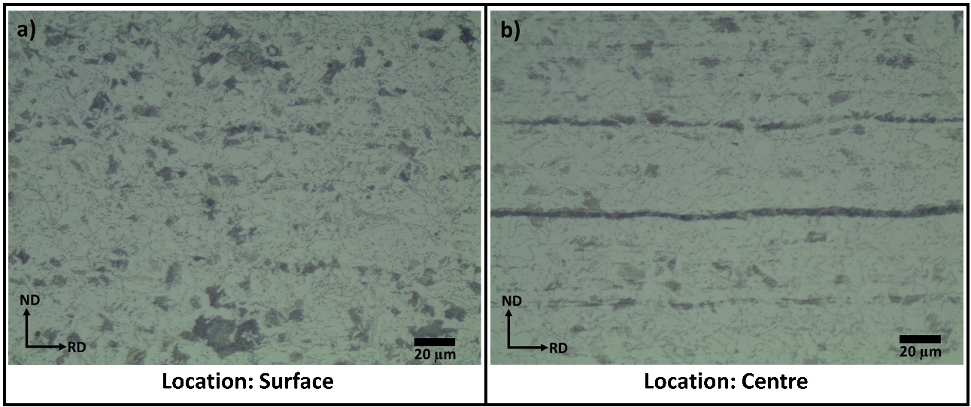

**Figure 1:** *Optical micrographs of HR steel located at* **(a)** *surface, and* **(b)** *centre of the specimen.*

To find the substitutional solute elements responsible for the pearlite banding, EDX line scans were done across the bands. **Figure 2 (a)** shows an EDX line scan with Mn concentration profile across the bands. It can be clearly seen that the weight % of Mn is 3 times higher on the banded region when compared to the non-banded one. Even though the partition coefficient (according to Scheil-Gulliver equation) for Mn was reported to be as high as 0.71 in the literature, severe segregation of it is generally seen in the industrial routes. This is because of the use of higher concentration Mn in commercial alloys, making its segregation more severe. Along with the enriched regions, a slightly Mn depleted region was also found adjacent to these bands. In other words, it can be said that the HR steel had developed three different compositional regions in it. To find the effect of this on the re-austenization process of DP steel manufacture, Thermo-Calc simulations were done on these three different compositions. **Figure 2 (b)** compares the equilibrium temperature range of austenite phase for low, medium, and high Mn regions of the steel. It can be clearly seen that the equilibrium austenite start temperature (Ac1) of Mn enriched region is 70 0C higher than that of normal region.

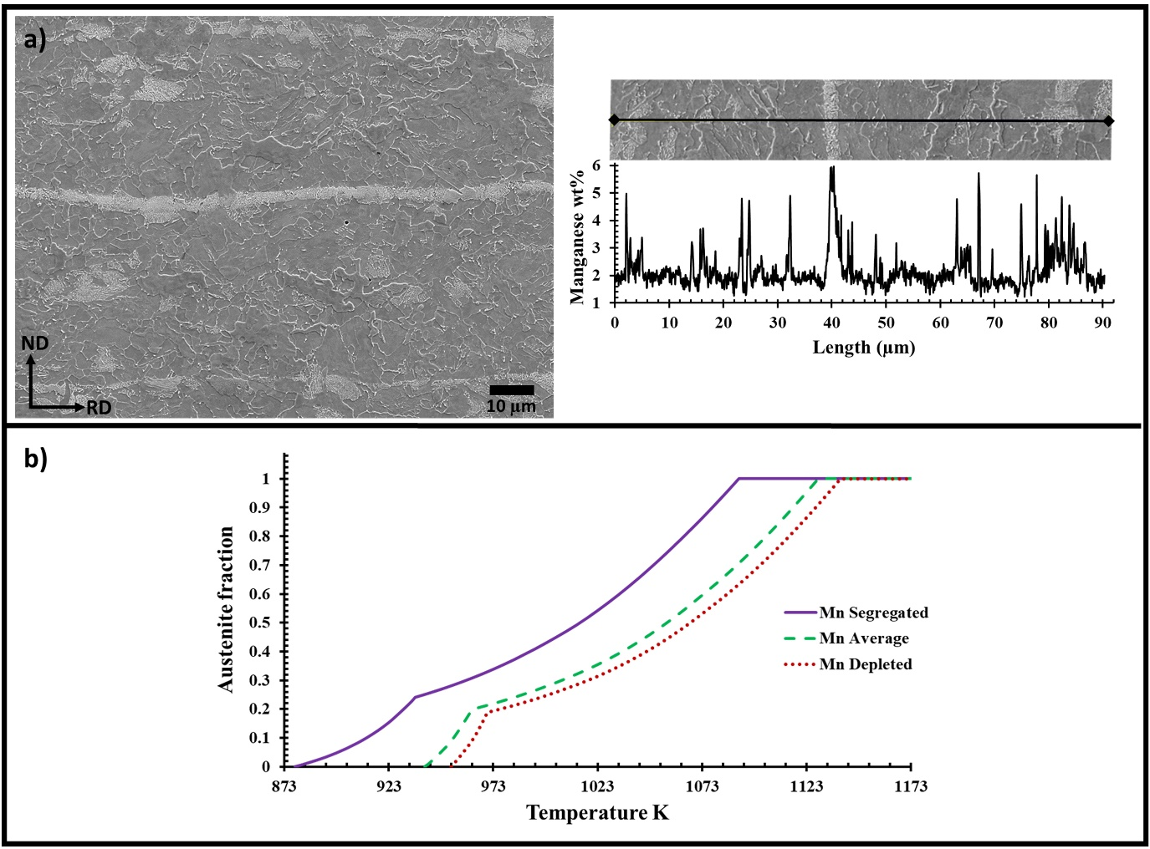

**Figure 2:** **(a)** *EDX line scan showing Mn wt% profile across a pearlite band in HR steel and* **(b)** *Comparison of austenite fraction predicted by Thermo-Calc for three different Mn percentages from the EDX line scan.*

**Figure 3 (a-d)** showsthe SEM micrographs of centre and surface of the specimens heated at specific heating rates of 0.2, 7, 50.5, and 511 0C/s to a temperature of 750 0C and holding time of 60 seconds before quenching. **Figure 3** clearly shows a significant difference in the spatial distribution of martensite for all the samples along their through thickness positions. The centres of all the samples reveal significant banding of martensite phase, however, the surface martensite of all the samples was randomly distributed on ferrite grain boundaries. This phenomenon happens because of lower Ac1 temperatures at Mn enriched pearlite bands, making these regions preferentially transform into austenite. Moreover, the Mn present at these regions acts as significant austenite stabilizer thereby enhancing its growth. It should also be noted that the thickness of martensite bands increased with the increase in heating rates employed. This could have happened because of decrease in potential nucleating sites with increasing in heating rates, thereby enhancing a rapid growth of austenite at the pearlite bands leading to thicker bands of martensite. Due to this variation in martensite morphology, the hardness measurements show significant anisotropy. A difference of at least 20 HV0.5 between surface and centre was found in all the heat-treated samples in this study.

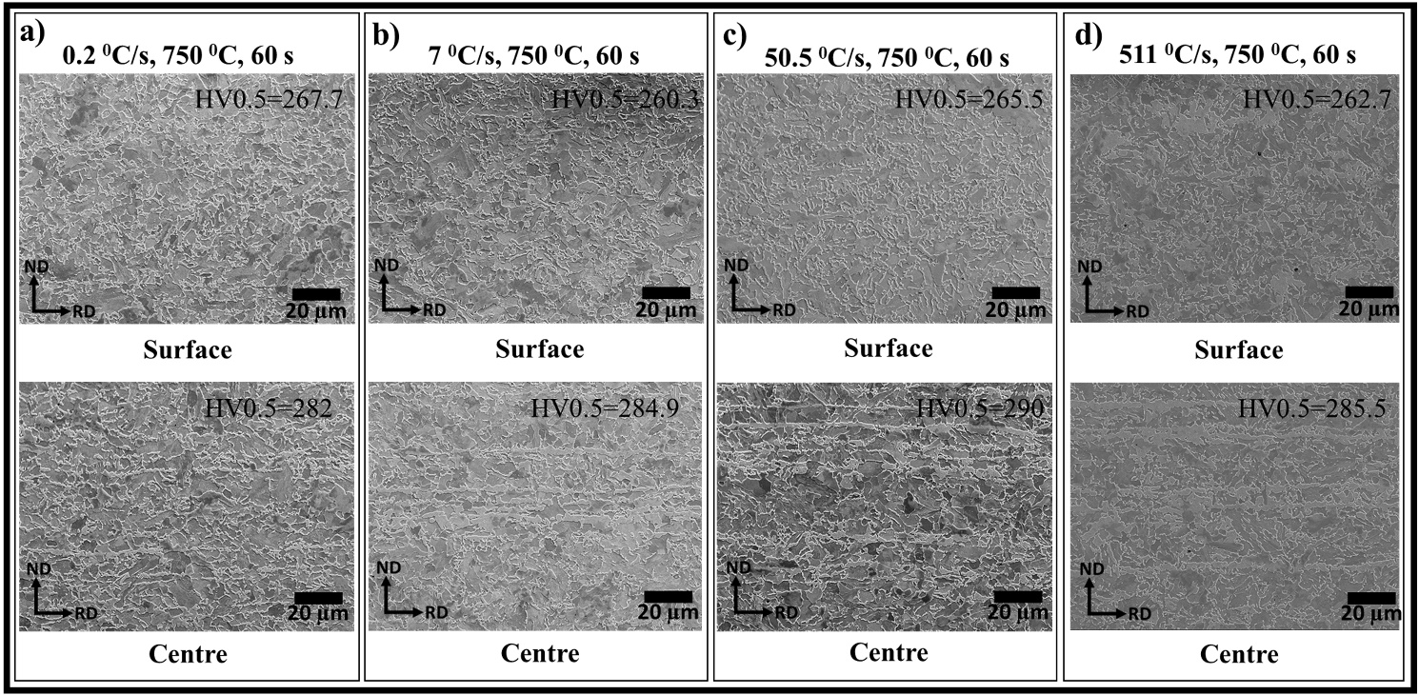

**Figure 3:** *SEM micrographs of surface and centre of samples heat-treated at heating rate of* **(a)** *0.2,* **(b)** *7,* **(c)** *50.5, and* **(d)** *511 0C/s to a temperature of 750 0C and held for 60 sec.*

**Figure 4 (a)** shows the EDX line scan of martensite bands in the sample heat-treated at 7 0C/s to 750 0C for 60 sec. It can be clearly seen that the Mn bands exactly match with the Martensite bands. This therefore proves that during the heating step of DP steel manufacture, the presence of Mn bands in initial steel will lead to a banded martensite microstructure (centre). **Figure 4 (b)** shows the inverse pole figures (IPF) of surface and centre of the sample. Along with the morphological difference, a clear variation in the texture dependence is also observed between the surface and centre of the steel sample.

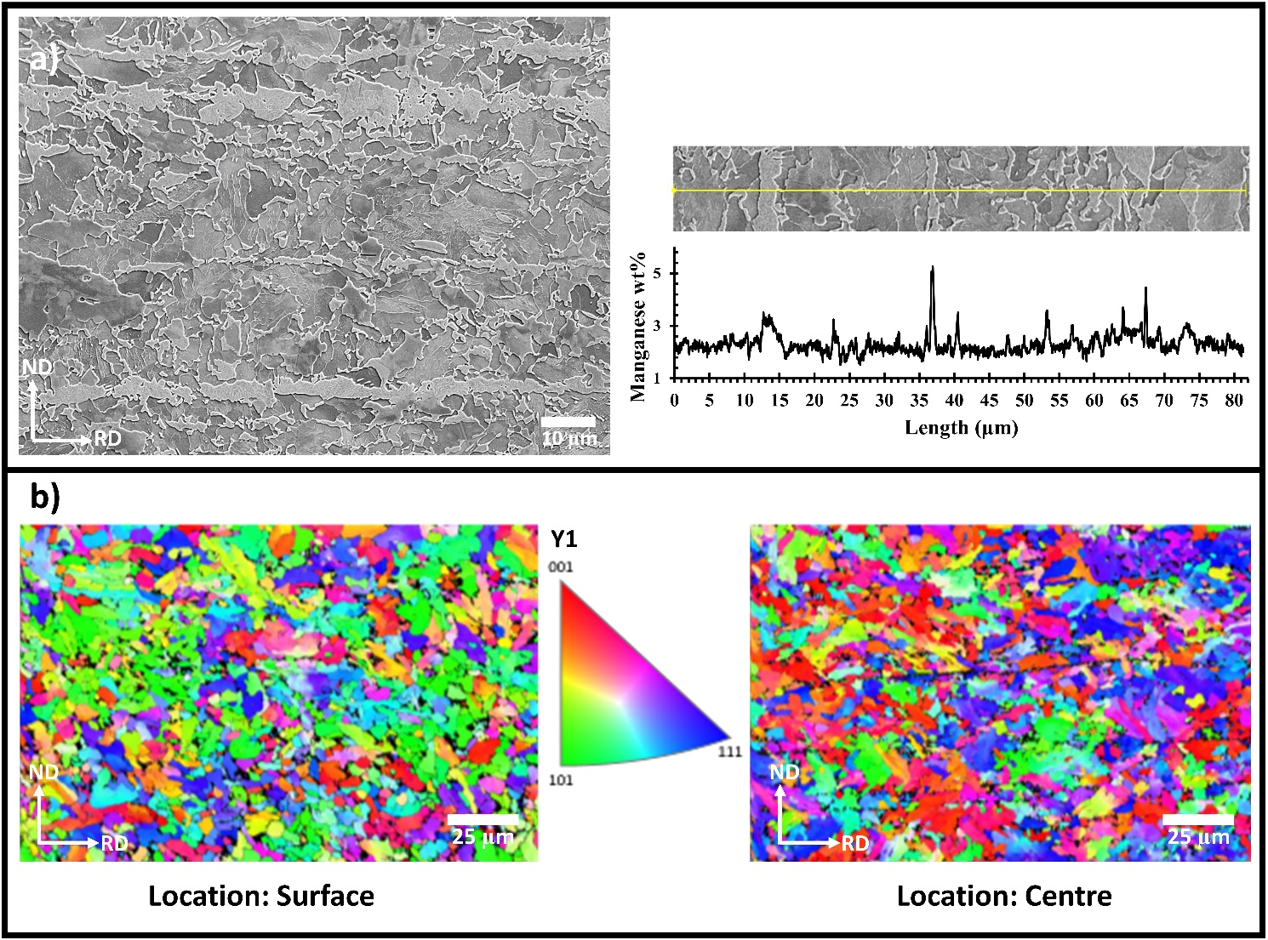

**Figure 4: (a)** *EDX line scan showing Mn wt% profile across a martensite band, and* **(b)** *EBSD IPF images of surface and centre of a sample heat-treated at 7 0C/s to 750 0C and held for 60 sec.*

# 4. Conclusions

The effect of Mn bands on the microstructural evolution of DP steels was studied with respect to the heating rates employed (0.2, 7, 50.5 and 511 0C/s) during the heating step of DP steel manufacture. A pearlite band spacing of 18.5 µm was found in the initial HR steel. It was found that the band regions were significantly enriched with Mn concentration leading to a significant decrease in austenite start temperature. This led to the formation of martensite bands at the centre and random morphology at the surface of all the heat-treated samples. Hardness measurements showed significant anisotropy along the thickness of all the heat-treated samples. EDX line scans at the martensite bands showed high concentration of Mn, therefore, establishing a direct correlation between the initial Mn bands in HR steel and the final martensite bands in DP steel.

# 5. References

1. J. R. Fekete and J. N. Hall, in *Automot. Steels Des. Metall. Process. Appl.* (2016), pp. 1–18.

2. C. C. Tasan, M. Diehl, D. Yan, M. Bechtold, F. Roters, L. Schemmann, C. Zheng, N. Peranio, D. Ponge, M. Koyama, K. Tsuzaki, and D. Raabe, Annu. Rev. Mater. Res. **45**, 391 (2015).

3. B. Bandi, J. van Krevel, N. Aslam, and P. Srirangam, Jom **71**, 1386 (2019).

4. R. Kuziak, R. Kawalla, and S. Waengler, Arch. Civ. Mech. Eng. **8**, 103 (2008).

5. C. A. Horowitz, Int. Leg. Mater. **55**, 740 (2016).

6. F. Perrard and C. Scott, ISIJ Int. **47**, 1168 (2007).

7. S. Oliver, T. B. Jones, and G. Fourlaris, Mater. Charact. **58**, 390 (2007).

8. D. S. Martín, Y. Palizdar, C. García-Mateo, R. C. Cochrane, R. Brydson, and A. J. Scott, Metall. Mater. Trans. A Phys. Metall. Mater. Sci. **42**, 2591 (2011).

9. J. Y. Kang, H. C. Lee, and S. H. Han, Mater. Sci. Eng. A **530**, 183 (2011).

10. S. J. Kim, C. G. Lee, T. H. Lee, and C. S. Oh, Scr. Mater. **48**, 539 (2003).

11. G. hui Zhu, X. hui Zhang, and W. min Mao, Front. Mater. Sci. China **3**, 442 (2009).

12. W. Wang, P. D. Lee, and M. McLean, Acta Mater. **51**, 2971 (2003).

13. C. Slater, A. Mandal, and C. Davis, Metall. Mater. Trans. B Process Metall. Mater. Process. Sci. **50**, 1627 (2019).

14. G. Krauss, Metall. Mater. Trans. B Process Metall. Mater. Process. Sci. **34**, 781 (2003).

15. T. F. Majka, D. K. Matlock, and G. Krauss, Metall. Mater. Trans. A Phys. Metall. Mater. Sci. **33**, 1627 (2002).

16. S. W. Thompson and P. R. Howell, Mater. Sci. Technol. (United Kingdom) **8**, 777 (1992).

17. W. J. Boettinger, S. R. Coriell, A. L. Greer, A. Karma, W. Kurz, M. Rappaz, and R. Trivedi, Acta Mater. **48**, 43 (2000).

18. B. L. Ennis, E. Jimenez-Melero, R. Mostert, B. Santillana, and P. D. Lee, Acta Mater. **115**, 132 (2016).

19. J. Huang, W. J. Poole, and M. Militzer, Metall. Mater. Trans. A Phys. Metall. Mater. Sci. **35 A**, 3363 (2004).

20. B. L. Ennis, C. Bos, M. P. Aarnts, P. D. Lee, and E. Jimenez-Melero, Mater. Sci. Eng. A **713**, 278 (2018).

21. J. O. Andersson, T. Helander, L. Höglund, P. Shi, and B. Sundman, Calphad Comput. Coupling Phase Diagrams Thermochem. **26**, 273 (2002).

22. A. Ghosh, in *Sadhana - Acad. Proc. Eng. Sci.* (2001), pp. 5–24.

23. R. A. Grange, Metall. Trans. **2**, 417 (1971).