**Chemical Mechanical Planarization of Tantalum and Copper in Sodium Carbonate Based Alumina Slurry**

**Arpita Shukla**

Department of Chemical Engineering, National Institute of Technology, Raipur, India

[*arpitachem1790@gmail.com*](mailto:arpitachem1790@gmail.com)

**Noyel Victoria Selvam, Manivannan Ramachandran\***

Department of Chemical Engineering, National Institute of Technology, Raipur, India

[*snvictoria.che@nitrr.ac.in*](mailto:snvictoria.che@nitrr.ac.in)*,* [*rmani.che@nitrr.ac.in*](mailto:rmani.che@nitrr.ac.in)*\**

**ABSTRACT**

Chemical mechanical planarization (CMP) is found to be an effective and reliable technique for eliminating surplus unwanted metal and to give the surface a globally smooth finish [1]. Tantalum (Ta) is used as a barrier layer material while Copper (Cu) is employed as an interconnect material in chip fabrication industries [1]. The effect of slurry comprising alumina and sodium carbonate on the removal rate of tantalum and copper is studied. Alumina in the slurry works as abrasive while sodium carbonate serves as an oxidizer for metal removal. The oxidizer present in slurry oxidizes Ta surface to form tantalum pentoxide. The tantalum pentoxide layer is quite challenging to polish [2]. The experiments were performed by varying different parameters such as concentrations of oxidizer, pH of the slurry and pressure. Effect of pH was observed on the removal rate of both Ta and Cu and the results are shown in Fig. 1. Ta removal rate is increasing with increase in pH and is found to be maximum at pH 11. Cu removal rate decreases from pH 3 till pH 7 and then increases with pH and reported highest at pH 11 in slurry comprising 2 wt % alumina and 3 wt% sodium carbonate. Electrochemical measurements such as open circuit potential, tafel and electrochemical impedance spectroscopy have been applied to investigate the passivation and dissolution performance of Ta and Cu. Fig. 2. shows the effect of pH on corrosion current density (Icorr) for both Ta and Cu which follows same trend as Ta and Cu removal rate.

*Keywords: Tantalum; Copper; Chemical mechanical planarization; Alumina; Sodium carbonate*

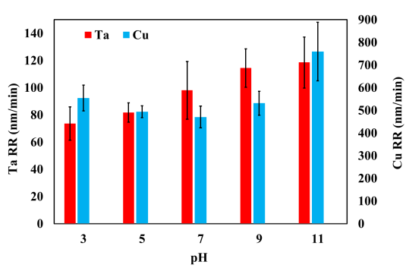 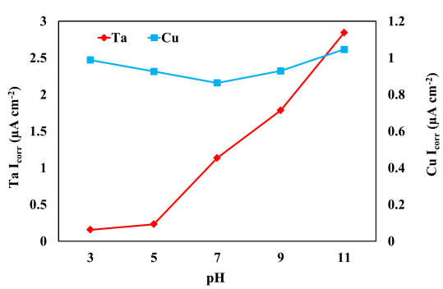

Fig. 1 Effect of pH on Ta and Cu removal rate Fig. 2 Effect of pH on Icorr for Ta and Cu

**REFERENCE**

1. J.C. Chen, W.T. Tsai, Chemical mechanical polishing behavior of tantalum in slurries containing citric acid and alumina, *Surface & Coatings Technology* 185 (2004) 50–57.
2. Y.H. Chen, T.H. Tsai, S.C. Yen, Acetic acid and phosphoric acid adding to improve tantalum chemical mechanical polishing in hydrogen peroxide-based slurry, *Microelectronic Engineering* 87 (2010) 174–179.