***International Conference on Advances in Minerals, Metals, Materials, Manufacturing and Modelling***

***(ICAM5) @ NIT Warangal***

**Energy Materials/ Bio-Materials**

**Utilizing currency notes and banana pulp wastage utilization as bio materials resources inventory**

**Dr. A. G. Matani,**Professor- Mechanical Engineering, Government College of Engineering, Amravati – 444604 [M.S.] India Email: [dragmatani@gmail.com](mailto:dragmatani@gmail.com), [ashokgm333@rediffmail.com](mailto:ashokgm333@rediffmail.com)

**Premesh P. Bhatkar** , 1st Year Ph.D. [AICTE - NDF- 2019] Mechanical Engineering, Government

College of Engineering, Amravati–444604 [M.S.],India

**Abstract**

Western India Plywood’s Limited (WIPL) at Valappttanam found that when 7% of shredded currency was mixed with wood pulp and pressed together, it made excellent boards, without compromising the strength, density or quality of the boards. And, it was cost effective as well. RBI sold the shredded currency at the rate of Rs 250 per ton to WIPL and absorbed the cost of transportation. That made good commercial sense for WIPL as well. A total of 12 currency notes were randomly collected from people like butchers, food sellers, bank, hospital and municipal corporation workers. This paper explores the potential of currency notes and banana pulp waste utilization towards environmental protection in India.

**Keywords**: Utilization of biotechnology in processing of shredded currency waste, global warming and solid waste disposal, thermal modification, optimal pulping conditions.

**INTRODUCTION**

Much of the old currency notes will be now used to make plywood, and soft and hardboards. Plywood, hard board and soft board go into making all kinds of furniture and partitions. Normally, plywood and similar board manufacturing uses wood pulp as a major ingredient to make hard board, press board and soft boards. Western India Plywoods Limited (WIPL) based in Valpattanam in Kerala found that when 7% of shredded currency was mixed with wood pulp and pressed together, it made excellent boards without compromising the strength, density or quality of the boards. And, it was cost effective as well. RBI sold the shredded currency at the rate of Rs 250 per ton to Western India Plywoods Limited (WIPL) based in Valpattanam in Kerala.

**NAVSARI AGRICULTURE UNIVERSITY (NAU) MAKING LONG LASTING CURRENCY NOTES**

The Navsari Agriculture University (NAU) in Gujarat has standardized a process of manufacturing high value paper from Banana fiber, which it claims has the property of making currency notes lasting for about a Century. The paper has been tested in the Central Institute for Research on Cotton Technology. During the research, it was found that paper made out of this fiber has shelf life of over 100 years as it is the strongest of the long fibers ever found amidst natural fibers. It can be folded for as many as 3,000 times. This fiber has the potential to find application in making of the paper required for the printing of currency notes and other valuable documents. At present Japan uses Banana fiber to manufacture the paper required to print its currency Yen.

**MATERIALS AND METHODS**

## 

The raw material used for this research was whole length banana fiber. Banana stem was collected from a common species in Gujarat. This type of banana plant is generally grown all over the country. The stem was cut from plant and chopped in small pieces (2–3 inch) and allowed to sun dry for about 3*/*4 days in the open air. After sun drying, oven dry (OD) measurement was done and the banana fiber was then prepared for cooking. The sheet density increases with increased beating and wet pressing (Figure 1-A). The more flexible beaten fibers adjust themselves easily to other fibers. This leads to increased bonded area and more densely packed fibers in the sheet. The effect of different beatings on roughness was shown in (Figure: 1-B). Roughness decreases with the increase of beating. The roughness of the top side of hand sheet is slightly more than that of the bottom side.

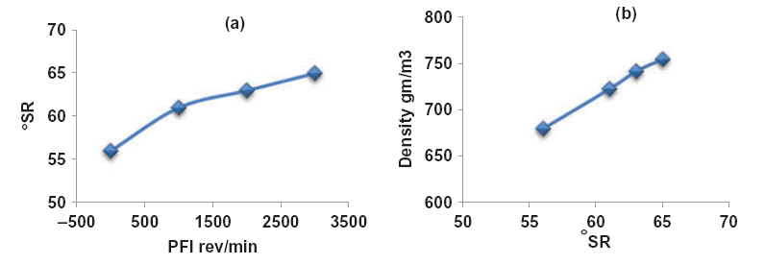

**Design**

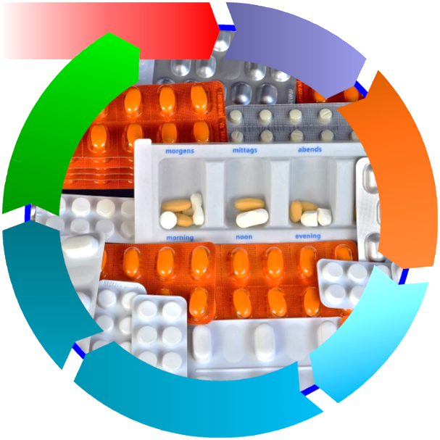

**Distribution**

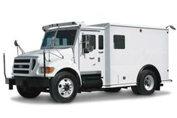



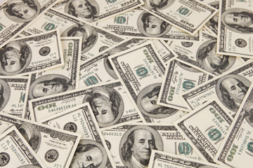

Cellulose nanocrystals

**Remanufacturing**

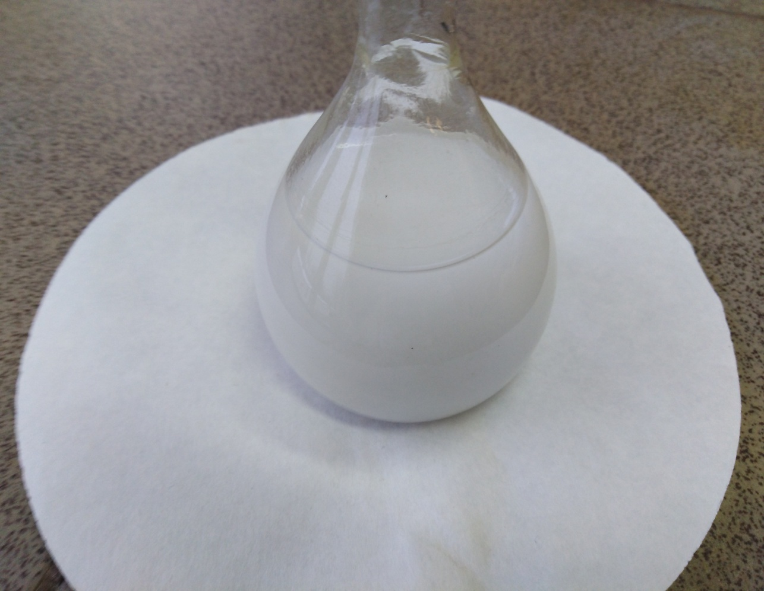

Consumption use and reuse

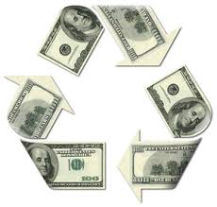

**Recycling**

**Raw material**

**Collection**



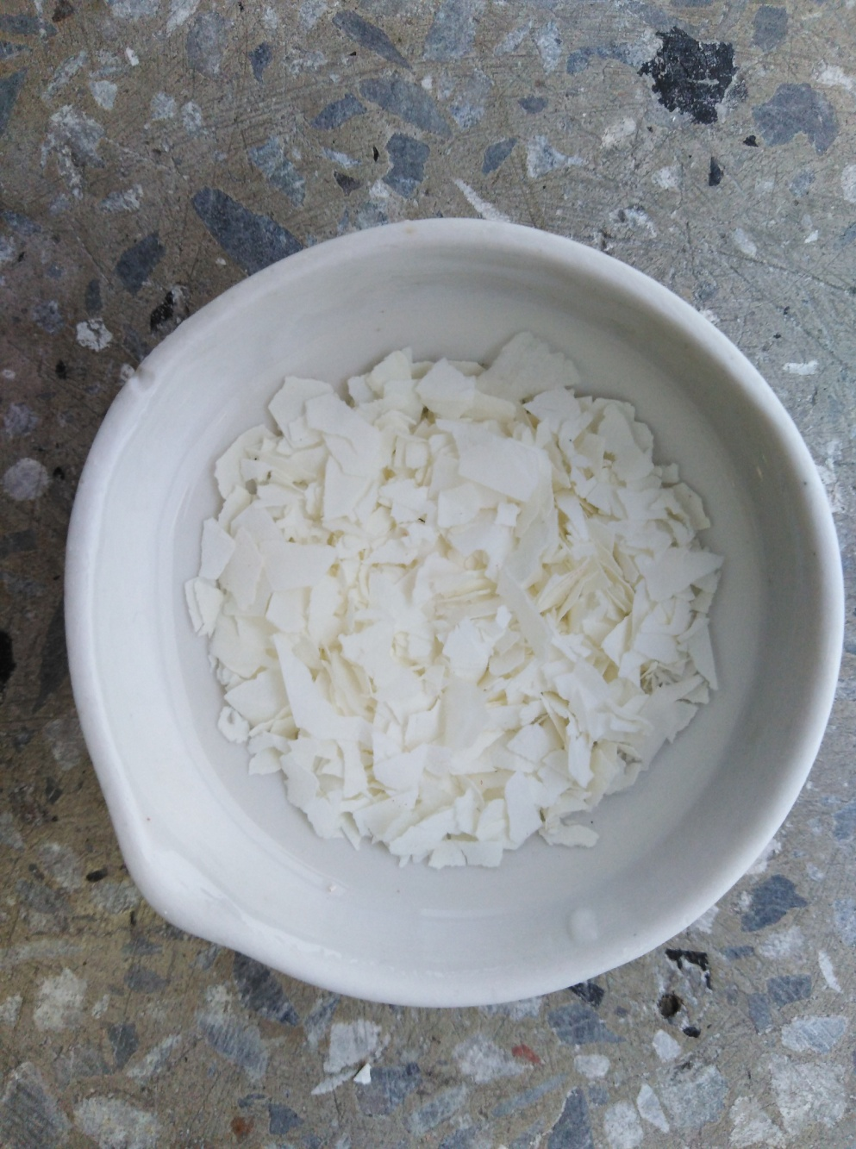

# CONCLUSIONS

The plywood industry can also claim a bright future. At this present time the industry is producing more plywood than they have in the last 20 years. Application where plywood has resurged includes flooring and wall lining, as plywood gives a more nature look and finish. Also plywood is the only non-cement wood composite that can be fully utilized in external and marine conditions. The veneer industry has a bright outlook mainly due to the decreasing availability of native raw material from forests. This industry can produce one hundred veneer layons from a log, in comparison to one table being produced from conventional conversion methods. This means that prime logs can be utilized to their full extent, with up to 95 percent of that log being utilized. New technology has enabled the industry to utilize re-growth and plantation timber which was previously thought to be to small in diameter.

# References

1. Ahmed Yehia, Khaled E. Yassin, Alaa Eid 2017. ” Recycling of shredded currency waste Egyptian Central Bank for making good-quality papers”, *Journal of Separation Science & Technology,* 53(3), 544-550.

2. Chauhan, S., Khan, M.E., Sharma, A.K., and Jain, R.K. 2008. “Enzymatic pulping of shredded currency waste : A potential fiber resources for handmade paper industry , Proceedings of National Conference on Application of Biotechnology in Sustaining the Environment”, *Proceedings of Indian Science Congress Association Jaipur,*  5-6th Feb. 2008, 1--16.

3. Dr. Ashok G. Matani , Dr. S.K. Doifode 2015. ”Effective industrial waste utilization technologies towards cleaner environment”, *International Journal of Chemical and Physical Sciences*, 4(2), 536-540.

4. Ratnaprasad AV, Rao K.M., Nagasrinivasulu G 2009. “Mechanical properties of banana empty fruit bunch fibre reinforced polyester composites” *Indian Journal of Fiber and Textile Research* 34: 162-167.

5. S.M. Sapuan, A. Leenie, M. Harimi, Y.K. Beng. 2006, “Mechanical properties of woven banana fibre reinforced epoxy composites” , *Materials & Design,*  27(8), 689-693.

6. Samrat Mukhopadhyay, Raul Fangueiro, Yusuf Arpaç. 2012 ”Banana Fibers – Variability and Fracture Behaviour”, *Journal of Engineered Fibers and Fabrics,*  3(2) 39- 45.

7. V. Arumuga Prabu, M. Uthayakumar, V. Manikandan, N. Rajini, P. Jeyaraj. 2014, “ Influence of red mud on the mechanical, damping and chemical” *International Journal of Scientific & Engineering Research*, 6(5), 270-279.

8. N. Venkateshwaran and A. Elayaperumal.2010, “Banana Fiber Reinforced Polymer Composites _ A Review” *Journal of Reinforced Plastics and Composites*, 29 (15) . .2387-2396.

9. Boonstra, M. J., Van Acker, J., Tjeerdsma, B., and Kegel, E. 2007. “Strength properties of thermally modified softwoods and its relation to polymeric structural wood constituents,” *Annals of Forest Science* , 64(7), 679-690.

10. Del Menezzi, C. H. S., Tomaselli, I., Okino, E. Y. A., Teixeira, D. E., and Santana, M. A. E. 2009. “Thermal modification of consolidated oriented strand boards: Effects on dimensional stability, mechanical properties, chemical composition and surface color,” *European Journal of Wood and Wood Products,*  67(4), 383-396.

11. Schnabel, T., Zimmer, B., Petutschnigg, A. J., and Schonberger, S. 2007. “An approach to classify thermally modified hardwoods by color,” *Forest Products Journal*, 57(9), 105-110.

12. Poncsak, S., Kocaefe, D., and Younsi, R. 2011. “Improvement of the heat treatment of Jack pine (Pinus banksiana) using ThermoWood technology,” *European Journal of Wood and Wood Products*, 69(2), 281-286.

13. Poncsak, S., Kocaefe, D., Bouazara, M., and Pichette, A. 2006. “Effect of high temperature treatment on the mechanical properties of birch (Betula papyrifera),” *Wood Science and Technology* 40(8), 647-663.

14. Ohnesorge, D., Tausch, A., Krowas, I., Huber, C., Becker, G., and Fink, S. 2009. “Laboratory tests on the natural durability of six different wood species after hygrothermal treatment,” in: *Proceedings of 4th European Conference on Wood Modification,* Stockholm, Sweden, 159-164.

15. Ohnesorge, D., Tausch, A., Krowas, I., Huber, C., Becker, G., and Fink, S. 2009. “Laboratory tests on the natural durability of six different wood species after hygrothermal treatment,” in: *Proceedings of 4th European Conference on Wood Modification*, Stockholm, Sweden, 159-164.

16. Icel, B., Guler, G., Isleyen, O., Beram, A., and Mutlubas, M. 2015. “Effects of industrial heat treatment on the properties of spruce and pine woods,” *BioResources* , 10(3), 5159-5173.

17. N. Tugov 2015, “Experience of using municipal solid waste in the energy industry (An Overview)”, *Energy Conservation, New and Renewable Energy Sources, Thermal Engineering*, 62(2), 853-861.