**EVALUATION OF MECHANICAL PROPERTIES OF AGAVE AMERICANA AND OKRA HYBRID POLYPROPYLENE COMPOSITES**

**N. Ravi Kumar a, Y. Mounika b*, B. Raghava Rao a**

*a Department of Mechanical Engineering, VR Siddhartha Engineering college, Vijayawada-520007, AP, India*

*b Department of Mechanical Engineering, Shri Vishnu Engineering College for Women, Bhimavaram-534202, AP, India*

*Corresponding author Email: **yaragarlamounika@outlook.com**

------------------------------------------------------------------------------------------------------------------

**Abstract**:

In the present work, agave americana and okra hybrid polypropylene composites are fabricated and the mechanical properties of these composites are evaluated. Fibers are chemically treated with Sodium hydroxide (NaOH) and the effect of fiber treatment is investigated. The mechanical properties of chemically treated fiber composite exhibited better strength than that of untreated fiber composite. Experimental results are analysed using statistical techniques like Degree of experiments (DOE) and Analysis of Variance (ANOVA). Multiple regression analysis technique is applied to obtain the mathematical model for tensile, flexural and impact strengths.

***Keywords*:** Natural fibers, Polypropylene composites, chemical treatment (NaOH), Statistical analysis

1. **Introduction**

Hybrid composites have more than one type of fiber in a single matrix material. More studies have developed a logical sequel to conventional composites containing one fiber. Hybrids have a unique feature that can be used to meet various design requirements. These engineered bio composites are opening new markets in the field of commercial construction, automotive, aerospace and also shown reduced effects on the environment such as energy, air, water, and waste [1]. Natural fibers have many distinctive advantages over other fillers with its limitless application areas [2]. Composites are widely used but the mechanical properties of polymers are inadequate for many structural purpose [3]. Development in textile technologies such as weaving, knitting and braiding have resulted in the formation of textile composites that have superior mechanical properties.

The natural fibers such as banana, ramie, sisal and pineapple leaf have the potential to be used as a replacement for glass or other synthetic, inorganic traditional reinforcement materials in composites. Polypropylene is lightweight, durable, moderately inexpensive, and chemical resistant [4]. The natural fibers present many advantages as compared to synthetic fibers which make them attractive as reinforcement in composite materials, also affirmed that okra fiber composites are useful for the preparation of doors for house hold purposes with light weight. The S/N ratios, which are log functions of desired output, serve as the objective functions for optimization, help in data analysis and the prediction of the optimum results. A better result for the relative effect of the different factors is obtained by the decomposition of variance, which is commonly known as analysis of variance [5].

Multiple regression analysis suggests how a dependent variable is related to two or more independent variables. Statistical software packages are the only realistic means of performing the numerous computations required in multiple regression analysis [6]. The multiple coefficient of determination was presented as approximate result of the estimated regression equation.

The main objective of this work is to determine the suitability of agave americana, okra fibers reinforcement in the polypropylene matrix. The effect of the fiber content and the interfacial adhesion on mechanical properties of agave americana, okra hybrid polypropylene composites prepared by injection moulding process was investigated. Experimental results are statistically analysed.

**2.0. Experimental Procedure**

**2.1. Processing, Specimen Fabrication & Testing**

The agave Americana and okra fibers are collected from the local resources and the extracted fiber was then chopped in to short fiber. Polypropylene is used as matrix material. The composite specimens are prepared with proper proportions of fibers A.V - Okra (0% - 100%), A.V - OKRA (25% - 75%), A.V - Okra (50% - 50%), A.V - Okra (75% - 25%), and A.V - Okra (100% - 0%). Fibers are Chemically treated with 10% NaOH and composite specimens are prepared as per ASTM standards. Tensile, Flexural and Impact tests are conducted according to ASTM standards.

**3.0. Results and Discussion**

**3.1. Tensile, Flexural and Impact strength results**

The tensile, flexural and impact specimens are prepared with five different fiber weight percentages as described in previous section. The variations of tensile, flexural and impact strength with weight fraction of fiber are observed from the results that all the composites have shown a moderate increase in tensile, flexural and impact strengths with chemical treatment of fibers. A maximum tensile strength of 25.74 MPa was recorded for A.V-OKRA (75% - 25%) composite and the minimum value of 19.89 MPa was recorded for A.V-OKRA (0% - 100%) composite. a maximum flexural strength of 43.2 MPa for A.V - OKRA (25% - 75%) composite and a minimum value of 38.2 MPa for A.V - OKRA (0% - 100%) composite. The maximum impact strength of 38.12 J/m in A.V - OKRA (25% - 75%) and the minimum value of 31.12 J/m in A.V - OKRA (100% - 0%) was observed. Tensile Modulus variation with weight fraction of A.V - Okra hybrid polypropylene composites is plotted in Fig. 1.(a). Maximum tensile modulus of 187.2 MPa and 199.2 MPa are observed for A.V-OKRA composite (0% - 100%) untreated and treated fibers. Flexural Modulus variation with different weight fraction of A.V-Okra hybrid polypropylene composites is shown in Figure 1. (b). A maximum flexural modulus value of 1044.14 MPa and 1074.23 MPa are observed for A.V - OKRA (100% - 0%) untreated and treated hybrid composites.

**Fig 1.a. Variation of Tensile Modulus**

**Fig 2.b. Variation of Flexural Modulus**

**3.2. Statistical analysis for Tensile, Flexural and Impact strength**

Statistical analysis techniques such as Design of Experiments (DOE), Analysis of Variance (ANOVA), regression for predicted mathematical equation are applied. The S/N ratio and predicted S/N ratio for each combination parameters is calculated. The main effects plots for S/N ratio and predicted S/N ratio are very much close to the calculated S/N ratio values. The larger value of S/N ratios corresponds to better quality and optimal combination of design parameters can be obtained. The main effect plots for S/N ratio are presented figure.2 (a), 2(b), and 2(c) respectively.

The analysis of variance is carried out for the level of significance of 10% (level of confidence 90%). It can be concluded that weight fraction of fiber (X) is more significant and treatment (Y) is significant for tensile strength, flexural and impact strength since corresponding F values are higher than F-crit. The results are listed in figure 3(a), 3(b), and 3(c) respectively.

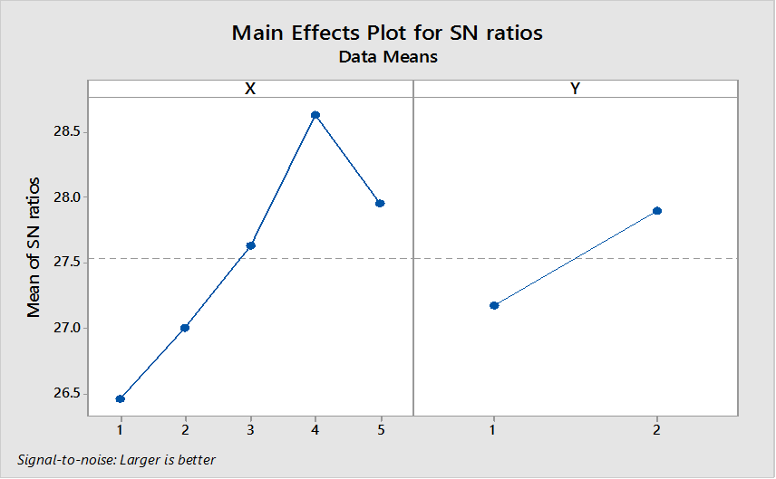 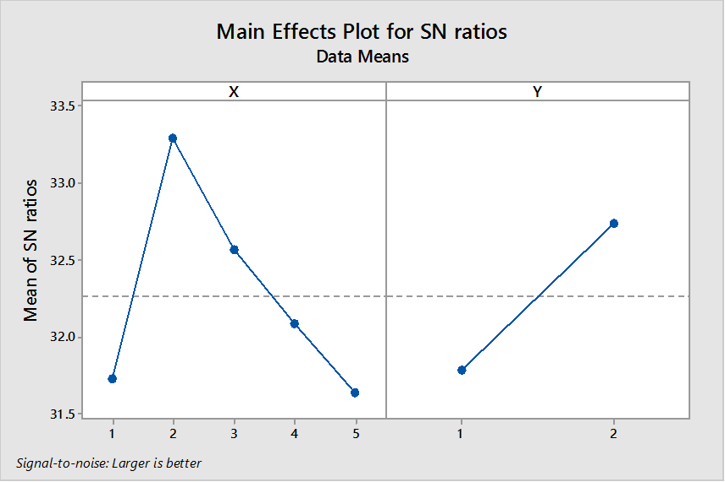

**Fig.2. a. Tensile DOE Fig.2. b. Flexural DOE**

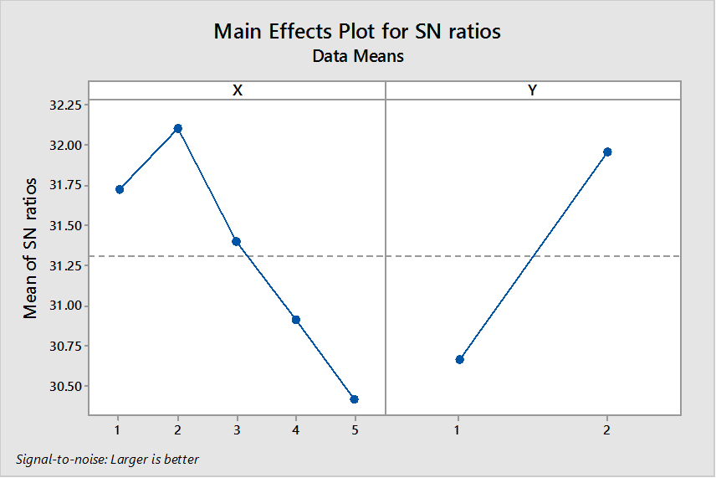

**Fig. 2. c. Impact DOE**

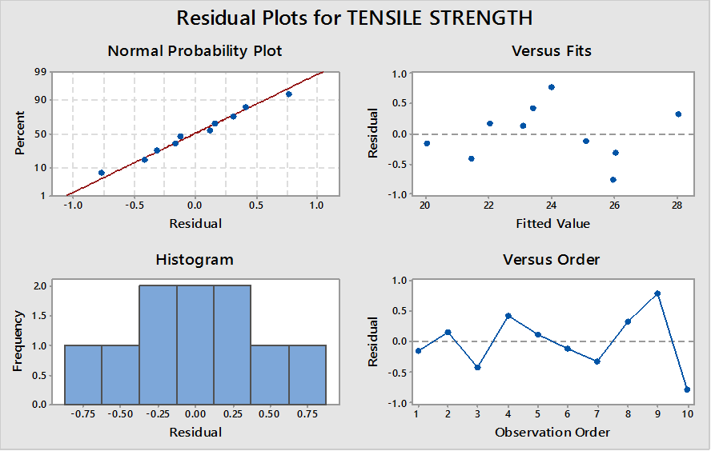 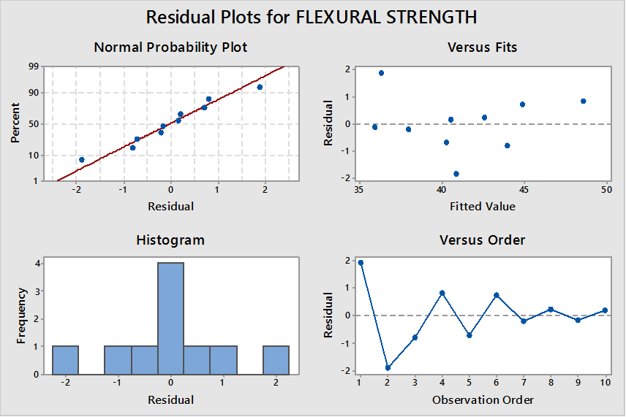

**Fig.3. a. Tensile ANOVA Fig.3. b. Flexural ANOVA**

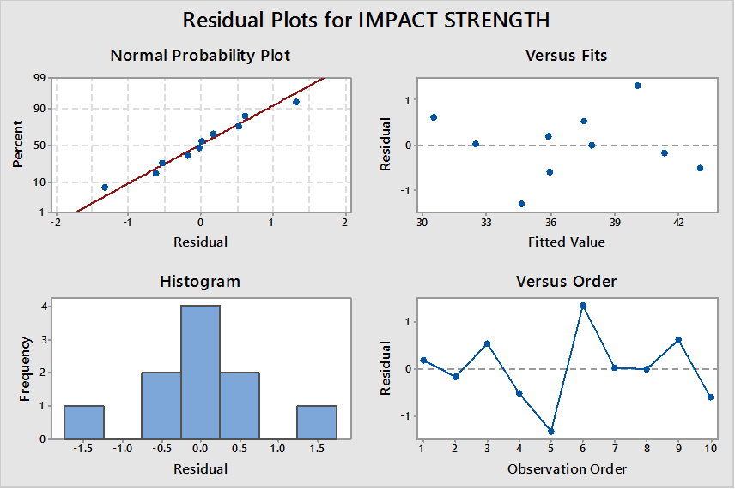

**Fig.3. c. Impact ANOVA**

**3.3. Mathematical model using multiple regression analysis:**

To evaluate the relationship between input and output parameters, the output values of tensile, flexural and impact strength have been used to construct the mathematical models. The functional relationship between dependent output parameter with the input parameters could be postulated using the following equation

Z = A * (X)a * (Y)b  ( 1 )

Where z is dependent output variable like tensile, flexural and impact strength. X and Y are independent input variables such as weight fraction of the fiber and treatment respectively; a, b are the exponents of input parameters. The above nonlinear equation is converted into linear form by logarithmic transformation and can be written as equation

Log (Z) = log (A) + a * log (X) + b *log ( Y ) (2)

The data regression constants are calculated by performing multi parameter linear regression analysis for tensile, flexural and impact.

The predicted values of the tensile flexural and impact strengths are 29.05 MPa, 39.50 MPa and 37.58 J/m respectively.

Error (%) = ($\frac{Experimental value – Predicted value}{Experimental value}$)*100 (3)

The error (%) is below 10% for tensile, flexural, and impact values and hence the experiments conducted meet the specified standards.

**4.0 Conclusion:**

Tensile strength of Agave Americana composite has increased due to the addition of Okra fiber at (75 – 25) % weight fraction. The Flexural and Impact strengths have also shown an improvement when the hybridisation of A.V fiber is done at (25 – 75) % weight fraction with Okra Fiber. However, the hybridization has not shown any improvement in the moduli values. Statistical Analysis shows that the error (%) is below the 10% for tensile, flexural, and impact values and so the experiments conducted is concluded to be optimum.

**5.0 References:**

**1.** Y. Li, Y.W Mai, and L Ye. Sisal fiber and its composites: a review of recent developments. Composite Science and Technology. 60, 2037-2055 (2000)

**2.** R. Karnani, M. Krishnan, and R. Narayan. Bio fiber-reinforced polypropylene composites. Polym. Eng. Sci, 37, 476–483. (1997)

**3.** Gunti Rajesh and Atluri V. Ratna Prasad. Effect of Fiber Loading and Successive Alkali Treatments on Tensile Properties of Short Jute Fiber Reinforced Polypropylene Composites, 26, 63-69. (2013)

**4.** J. Biagiotti, S. Fiori, L.Torre, M.A. Lopez-Manchado, and J.M Kenny. Mechanical properties of polypropylene matrix composites reinforced with natural fibers: A statistical approach*.* Polymer Composites. 25(1), 26-36. (2004)

**5.** R. David, Anderson, J. Dennis, Sweeney, and A Thomas, Williams. Statistics for Business and Economics. WEST Publication, 06 (1996)

**6.** Amirhossein and Esfandiari. Mechanical properties of PP/Jute and Glass Fibers Composites: The statistical Investigation. Journal of Applied Sciences. 7 (24), 3943-3950 (2007)