**CFD ANALYSIS OF CRYOGENIC HELICAL COILED SHELL AND TUBE HEAT EXCHANGER**

S. JaiKumara, A. Umesh Anirudhb, K. Janardhan Saic

*aMechanical Engineering, GITAM (Deemed to be University), Visakhapatnam 530045, India.*

*bMechanical Engineering, GITAM (Deemed to be University), Visakhapatnam 530045, India.*

*cMechanical Engineering, GITAM (Deemed to be University), Visakhapatnam 530045, India.*

Corresponding author’s E-mail: [andaluriumeshanirudh@gmail.com](mailto:andaluriumeshanirudh@gmail.com)

The present study resides the CFD (computational fluid dynamics) analysis of helical coil- shell and tube heat exchanger which is due in cryogenic applications owing its compact construction and larger heat transfer area. The counter flow analysis is carried with two different fluids namely gaseous hydrogen and liquid nitrogen respectively. The analysis was carried out in ANSYS FLUENT 15.0 to get the static temperature, pressure, and velocity. Copper was chosen as a fabrication material for both shell and tube. The results revealed that for a given geometry of heat exchanger, there is an improvement in heat transfer and decrease in velocity was also observed. Also, better and more quantitative insight into the heat transfer process that occurred when a fluid flows in a helically coiled tube.

**1. Introduction**

Shell and tube (or) Tube in tube heat exchanger plays key role in the improvement of heat transfer rates when operating with different heat transfer fluids. The flow of fluid could be parallel or counter flow type in the heat exchanger configuration. The arrangement can be in series or parallel directional configurations to convene the diverse heat transfer requirements. The helical coil heat exchangers having curvature and thus it creates a secondary flow normal to the axial primary flow of fluid and hence the heat transfer increases between the fluid and wall. Further, it put forward more heat transfer area surrounded by little space and thus the overall heat transfer coefficient increases. The constant heat flux and constant wall temperature boundary conditions are used in the heat exchanger design applications. However the helical coiled having disadvantages with these boundary conditions, different studies have suggested to use the constant heat flux and constant wall temperature boundary conditions were preferred because of deficient experimental data available concerning the action of the fluid flow in coil heat exchangers. Thus, *CFD analysis* is the suitable approach to determine the heat transfer characteristics for tube in tube helical coil heat exchanger and for fluid flow pattern.

**2. Design methodology**

The shell and tube helical coil heat exchanger was modelled and analysed using CFD in ANSYS WORKBENCH15.0design module. The following steps are taken for the analysis.

***2.1. Geometry***

The fluid flow (fluent) module from the workbench is selected. The design modeller opens as a new window as the geometry is double clicked.

***2.2. Sketching***

Among three planes (XY-plane, YZ-plane and ZX-plane), the YZ-plane is selected for the first sketch. A 50 mm line for the height of the helical structure is made. A new plane is created in reference with the YZ-plane and new sketchers are added under this plane. A circle of diameter 14 mm is drawn at a distance of 50 mm from the origin. Similarly, two circles of diameters 14 mm and 16 mm are made concentric to previous circle. Yet again two circles of diameters 16 mm and 20 mm are made concentric to previous circles. Finally, two more circles of diameters 20 mm and 22 mm are made concentric to previous circles. All the circles are swept along the line in first sketch using” add frozen” operation to construct the 3D model with different parts. The helical sweep is of two turns is used because the twist specification is defined in number of turns. After the sweep operation, it has shown different parts. These parts are merged using merge operation to make all the parts put together. The modelled geometry (heat exchanger) is depicted in Fig.1.

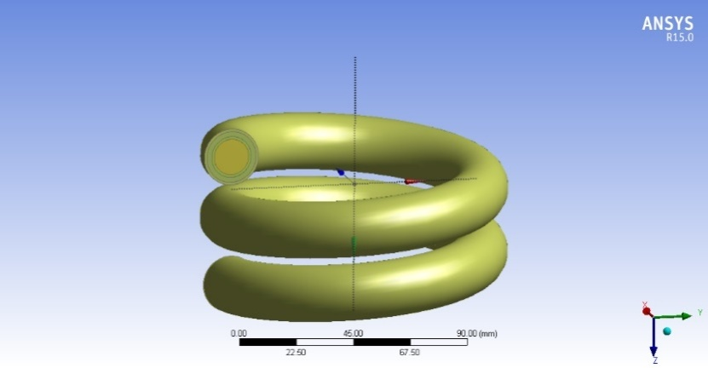

Fig.1. Pictorial view of original geometry

***2.3. Meshing***

The modelled geometry was allowed for meshing. In this analysis, both coarse and fine mesh is used on account of mixed cells. Initially the coarse mesh with tetrahedral cells is used to lessen numerical diffusion structuring the mesh in a fine approach close to the wall area. Further, a fine mesh is generated at the edges and regions of high temperature and pressure gradients. The pictorial view of meshed geometry is shown in Fig.2 and the Table 2 represents the mesh details. The naming at each section is given Table 2 and its pictorial view is depicted in Fig.3. Finally, the mesh quality is checked.

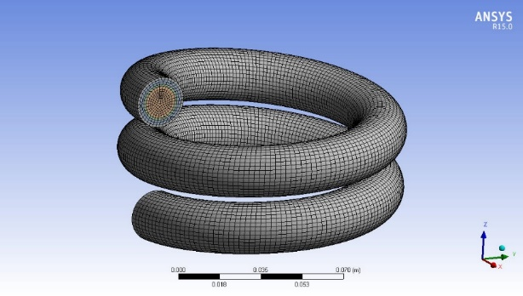

Fig. 2. Pictorial view of a mesh

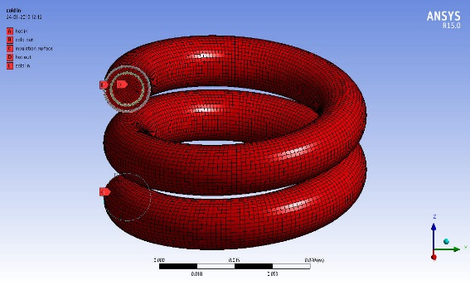

Fig. 3. Pictorial view of named selections

Table 1. Mesh Details

|  |  |
| --- | --- |
| **Parameters** | **Value** |
| Advanced Size Function | Curvature |
| Relevance Centre | Coarse |
| Smoothing | Medium |
| Transition | Slow |
| Curvature Normal Angle | 12.0° |
| Minimum Size | 0.000058423 m |
| Maximum Size | 0.011685 m |
| Maximum Face Size | 0.0058423 m |
| Nodes | 109782 |
| Elements | 103323 |
| Mesh Metric:  a) Skewness  b) Orthogonal Quality | Average - 0.22  Average - 0.92 |

Table 2. Named Selections

|  |  |  |  |
| --- | --- | --- | --- |
| **Part No.** | **Part of the Model** | **State** | **Material** |
| 1 | Inner Fluid | Liquid | Hydrogen |
| 2 | Inner Pipe | Solid | Copper |
| 3 | Outer Fluid | Liquid | Nitrogen |
| 4 | Outer Pipe | Solid | Copper |
| 5 | Insulation Surface | Solid | Copper |

***2.4. Solution setup***

The analysis type is changed to pressure-based type. The velocity formulation is changed to absolute and time to steady state. Gravity is defined as y = -9.81 m/s2. The inlet temperature of gaseous hydrogen is 300K and the inlet temperature of the liquid nitrogen is 77K.

***Models***

Energy is set in ON position. Viscous model is selected as “k-ε model   
(2nd equation). Radiation model is changed to discrete ordinates.

***Materials***

The create option is clicked to add gaseous hydrogen-liquid nitrogen and copper from the list of fluid and solid database.

***Cell Zone Conditions***

The parts are assigned as gaseous hydrogen, liquid nitrogen and Copper as per fluid/solid parts.

***Boundary conditions***

Boundary conditions are used according to the need of the model. The inlet and outlet conditions are selected as velocity inlet and pressure outlet. The walls are separately specified with respective boundary conditions. No slip condition is considered for each wall other than tube walls and each wall is set to zero heat flux condition.

***Solution Methods***

The solution methods used for this analysis are presented in Table 3.

Table 3. Solution Methods

|  |  |
| --- | --- |
| **Parameter** | **Method** |
| Scheme | Simple |
| Gradient | Least Square Cell Based |
| Pressure | Standard |
| Momentum | Second Order Upwind |
| Turbulent Kinetic Energy | Second Order Upwind |
| Turbulent Dissipation Rate | Second Order Upwind |

***Solution Control and Initialization***

The solution initialization method is set to standard initialization while the reference frame is positioned to relative cell zone and the solution is initialized.

***Measure of Convergence***

The number of time steps taken was 300 and the time step size was 1. The maximum iterations per time step are 50. It had a good convergence throughout the simulation.

**RESULTS AND DISCUSSION**

The temperature, pressure, and velocity contours along the heat exchanger can be seen from the Figs.4-7.

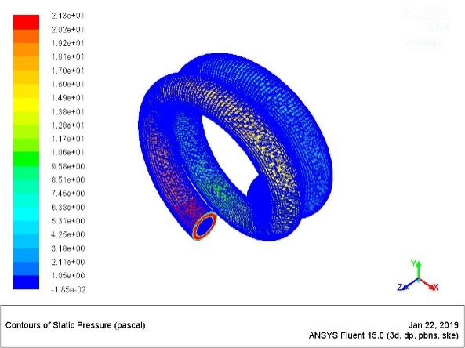 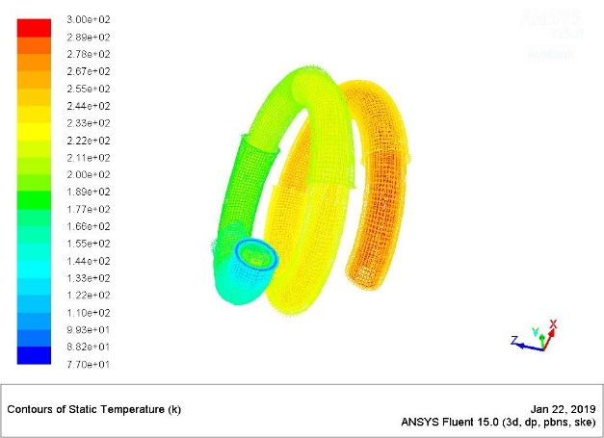

Fig. 4. Contours of static pressure Fig. 5. Contours of static temperature

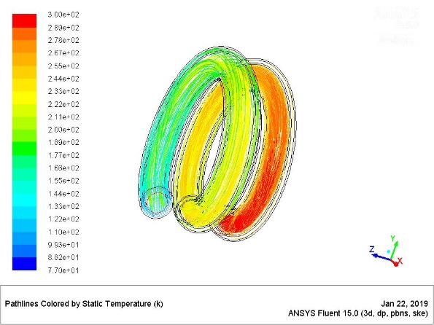 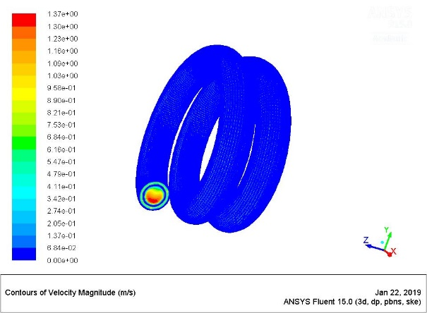

Fig. 6. Path lines of static temperature Fig. 7. Contours of velocity magnitude

**CONCLUSIONS**

The following conclusions were taken from this study:

1. The CFD analysis suits for the heat exchanger applications.
2. Better heat transfer was observed with the two fluids. It can be observed that the inlet temperature of the gaseous hydrogen was dropped from 300K to 246 K while the liquid nitrogen temperature increased from 77K to 134 K. Hence, the heat transfer is perfect with the geometry used in this study and with operating conditions.

**REFERENCES**

[1] D.Pramod , D.P. Vikram, D.Baviskar. “CFD analysis of heat transfer in helical coil tube in tube heat exchangers. IJIERT, Vol.3, 2016.

[2] K.K Sahu, N. K. Saikhedkar. “Computational Fluid Dynamic analysis for optimization of helical coil heat exchanger. IJERT, Vol.5,2016.