**DESIGN AND FABRICATION OF ICE PATTERN FOR CASTING PROCESS:**

**A PRELIMINARY STUDY**

Bharath T, Venkataramanan R, Gautham R, Sarathkumar Sebastin.J

Kalasalingam Academy of Research and Education, Tamilnadu, India

E-mail: [sebastinaero@gmail.com](mailto:sebastinaero@gmail.com)

**Abstract**

The casting process has come to wide range of use in manufacturing process. Wooden, aluminum and wax patterns are widely used in the casting. However, there exist some problems and technical difficulties such as wax pattern expanding, ceramic shell cracking in investment casting, complexity limitation in wooden pattern etc., one of the most promising application of rapid freeze prototyping (RFP) is making metal parts by casting process with the built ice parts. The integration of RFP with sublimated ice and casting process allows the fast creation of complex net – safe metal parts with directly from their CAD model. The advantages of no parts geometric complexity limitation, No experience of parting line design and assembling needed clean and low cost of process operation, and good performance. In this paper we will present our creation study on sublimation of ice pattern for mold making and casting results of the metal parts.

***Keywords*:** Solid freeform fabrication, Rapid tooling, Rapid freeze prototyping ice pattern, sublimation of ice, casting process

**1. INTRODUCTION**

Rapid Freeze Prototyping (RFP) is a Solid freeform fabrication process that builds three dimensional ice parts directly from the CAD models. To make a functional parts (metal or plastic), some traditional shape duplication processes are needed which is similar to some other SFF processes in the late 1940s the mercast process used frozen mercury to make a net – shape parts. The mercury pattern was first formed in the special aluminum molds and was then invested in alcohol/silica slurry, which eventually formed the mold cavity for casting. Mercast was the successful process yielded excellent quality casting. But the molds were expansive and mercury is hazardous to health, eventually the process of forced into disuse. Dry ice was also used as frozen pattern in the casting process developed later. It starts with the building of solid master and silicon mold. Then ice patterns are made with the mold and dipped into the refrigerated ethyl silicate slurry and stuccoed. After the repeating dipping and drying process, a ceramic shell is made and then it is put in a room temperature and allow the ice pattern to melt, drain and dry. One major concern in FCP process is ice pattern making it frozen. Some major issue is in the method include air bubble removal, ice pattern de -moulding and part complexity limitation. With sublimation of ice pattern from RFP possible to make accurate casting with short time. This is especially valuable in case small amount of complex metal parts and for accurate casting.

Though FCP has demonstrated the success of using ice patterns to make metal parts by investment casting, there is no detailed information reported yet. Our study is aimed to find the result of the casting where the mold is made by using ice pattern and then sublimated.

**2. MATERIALS AND METHODOLOGY**

**2.1. Material for low temperature investment casting**

The slurry used for casting process with ice patterns (operating at a low temperature) should have different features from slurry used for regular casting process. For example, the slurry for low-temperature casting process should contain no water, not freeze at sub-zero temperatures, and has medium drying speed.

**2.1.1. Binder**

Silica gel is made with water glass and contains 40-50% water. It will freeze once it is put in low-temperature environment. So it is not possible to use silica gel as the binder. ethyl silicate satisfies the requirements and it can be used as an binder. Since ethyl silicate is not soluble with water, the reaction only occurs on the contacting surfaces and is thus slow. Alcohol is soluble with both ethyl silicate and water. By adding alcohol, the reaction speed can be substantially increased.

**Table 1: Binder composition**

|  |  |  |  |
| --- | --- | --- | --- |
| Distilled water | 40# ethyl silicate | Alcohol | Hydrochloric acid |
| 12ml | 200g | 232g | 3.2ml |

**2.1.2. Separating Agent**

Separating agent is needed for investment casting with ice patterns. The reason is that the slurry contains alcohol and water. The alcohol and water will interact with the ice pattern surface. The decomposition process releases heat which causes more decomposition. As a result, the ice pattern surface will be seriously damaged. The separating agent material must satisfy the following requirements:

* Not soluble with water or alcohol.
* Not reacts with water or alcohol.
* Not freeze at sub-zero temperatures.
* Have good coating property on ice surface at low temperatures.
* Non-toxic and no pollution.

Silicate oil and kerosene can be used as a separator (1:1 ratio). Before coating the separator it cooled to pattern temperature

**2.2. SUBLIMATION OF ICE PATTERN**

Sublimation is the process of changing the ice (solid) phase to vapour (gas) phase. In (FCP) process ice pattern is melted by keeping it in the room temperature. But in the study we sublimated the ice to create the mold cavity. For the sublimation of ice the atmosphere should be maintained in vacuum at 0.degree Celsius .this point is called triple point of water.  The single combination of pressure and temperature at which pure water, pure ice, and pure water vapour can coexist in a stable equilibrium occurs at exactly 273.16 Kelvin (0.01 °C) and a pressure of 611.73Pa (0.0060373057 atm).Simply put, the triple point of water is the only temperature at which water can exist in all three states of matter; solid (ice), liquid (water), and gas (water vapour). This temperature is 0.01°C.At that point, it is possible to change all of the substance to ice, water, or vapour by making infinitesimally small changes in pressure and temperature.

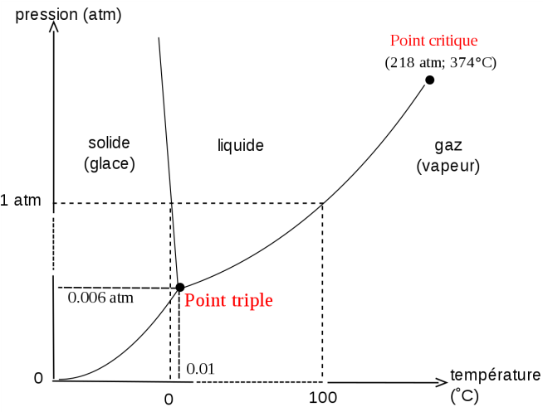

**Figure 1: Triple point of ice**

` Since the following study is focused on the process of casting with sublimation of ice patterns, the ice patterns can be built either by rapid freeze prototyping or by traditional molding method. In order to evaluate the casting accuracy, the ice pattern should be simple and easy to measure.

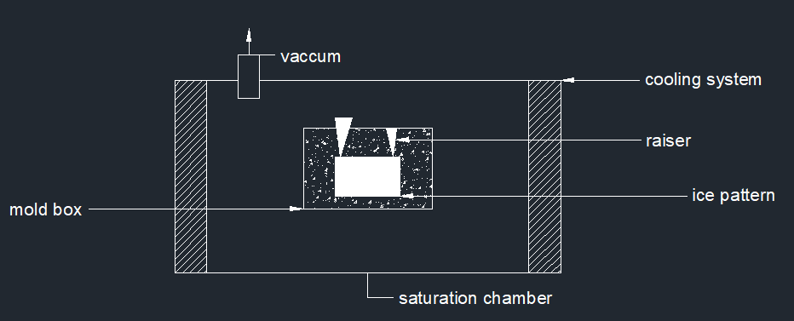

**Figure 2: CAD model**

**Steps involved in this work:**

1. Ice pattern is created using traditional molding method
2. Then the mold material is prepared using the above specification
3. Mold material is cooled to the subzero temperature
4. And then the pattern is used to create the mold cavity
5. Then the ice is removed from the mold by sublimation (ice to vapour) in sublimation chamber, and then pouring and knockout is done.

**3. RESULTS & DISCUSSIONS**

Mold making experiments with ice pattern and then sublimating the ice pattern to create the mold cavity as shown that the time taken for sublimation of ice pattern in the mold differs from the volume of the ice pattern. Our study is taken for simple cube ice for different volume, time taken for sublimation of ice cube for small volume is less compare to sublimation of higher volume. Sublimation condition was 625 Pascal and -2degree Celsius.

Casting process with ice patterns has some different requirements from regular casting both in the materials and the operating process. It requires the binder not to freeze at sub-zero temperatures and not to react with ice. Making mold from ice patterns needs low temperature to avoid ice pattern melting. The study has demonstrated the feasibility of making metal parts by casting with ice parts made by ice mold.

The present work is a preliminary study regarding the sublimation of ice pattern for casting process. A detailed experimental analysis, along with the results and discussion will be provided in the revised paper.

**References**

1. A.S. Sabau and S. Viswanathan, “Material properties for predicting wax pattern dimensions in investment casting”, *Material Science and Engineering A*, vol. 362, 2003, pp 125–134.
2. V.F. Okhuysen, K. Padmanabhan, and R.C. Voigt, “Tooling allowance practices in investment casting industry”, *Proceedings of the 46th Annual Technical Meeting of the Investment Casting Institute*, Orlando, USA, 1998, Paper no. 1.
3. J.C. Gebelin and M.R. Jolly, “Modeling of the investment casting process”, *Journal of Material Processing Technology*, vol. 135, 2003, pp 291 – 300.
4. W. Bonilla, S. H. Masood and P. Iovenitti, “An investigation of wax patterns for accuracy improvement in investment casting parts”, *Bulletin of Industrial Research Institute of Swineburne*, Melbourne, Australia, vol. 18, 2001, pp 348 – 356.
5. B. Singh, P. Kumar, and B.K. Mishra, “Optimization of injection parameters for making wax patterns to be used in ceramic shell investment casting”, *Proceedings of Asian Symposium on Materials and Processing,* 2006, Thailand.
6. Q. Liu, G. Sui and M.C. Leu, “Experimental Study on the ice pattern fabrication for the investment casting by rapid freeze prototyping (RFP)”, *Computers in Industry*, vol. 48, 2002, pp 181 – 197.
7. Q. Liu, V.L. Richards, M.C. Leu, and S.M. Schmitt, “Dimensional accuracy and surface roughness of rapid freeze prototyping ice patterns and investment casting metal parts”, *International Journal of Advanced Manufacturing Technology*, vol. 24, 2004, pp 485–495.