Alternate Heating process in ESP Hoppers of Thermal Power plant – an Experimental pilot Investigation

Dr.R.Saravanana*, Dr.M.Ramaktaiahb,

*aProfessor of Mechanical Engineering and Dean Academics, Ellenki College of Engineering and Technology, Hyderabad -502319, Telangana State, India.*

*bAssistant Professor of Mechanical Engineering, Ellenki College of Engineering and Technology, Hyderabad -502319, Telangana State, India.*

*Corresponding author Email: dr.sarravanan@gmail.com

------------------------------------------------------------------------------------------------------------------

The researchers focus on eco friendly and economy of power generation in the thermal power plants. The system wise analysis will helps to find the way to economic power generation. This research focuses the hopper heating concern. Usually the electric heating is employed to maintaining the hopper as warm to avoid distraction in the flow of ash. The research argues the feasibility of steam heating in the view of waste heat recovery. A new kind of hopper designed and its prototype was fabricated, tested and analysed. The qualitative and quantitative benefits of proposed system were discussed. The proposed system irrespective of climatic changes, and works well.

***Keywords*:** ESP hopper, Steam Heating, energy, pilot investigation

1. **Introduction**

In thermal power plant the hopper heating is done by electric heater for avoiding the condensation fly ash. The condensed fly ash causes the big trouble in the ash collecting system [1]. Even though the ESP is wonderful methods to collecting the fly ash [2], [3] insisted that the need for improving system with economic and environmental pollution concern. Hence different aspects of improving ESP have been reported in the literature. [4] characterize the fly ash collected in the hopper based on the combustion of various coal grades. [5] discussed the guidelines for making appropriate choice of material used for duct like stainless steel, aluminium and copper for ESP hopper. [6] validated the ESP performances with the emission norm of the Tamil Nadu state government, [7] reported that the use of alkali content coals as well as non-coking low sulphur coal increase feed of the fuel as far as rapid loading of ash on ESP. [8] discussed the density of fly ash with respect to climate changes and prerequisites for avoiding those issues. But in this paper focuses the alternate hopper heating system based on waste heat recovery strategy.

1. **Materials and Methods**

In general the net power output can be increased by reduction consumption of power by its own accessories such as Boilers Feed Pump, Forced draught fan, Induced draught fan, D.M. water pump, A.P.H drive motor, Soot blower motor, pulveriser drive motor, Emitting electrode, P.A. fan motor and ESP Hopper coil. According to the observed statistics, the ESP hopper coil consumes high energy. So this research focuses on energy conservation on ESP hopper heating. At present electric heating is employed for heating the hoppers. This paper addresses the feasibility of adopting the steam heating for the same. The source of such steam was identified. The option 1 (refer Figure 1) is by tapping hot air from wind box section in the boiler. That is such hot air Air Pre Heater (APH). The option 2 (Refer Figure 2) is by taking the flash steam which is sent to the atmosphere after condensing the boiler feed water. This high pressure and high temperature water gets vaporized due to sudden expansion if it is released to the atmosphere. Hence that source can be used for ESP hopper Coil.

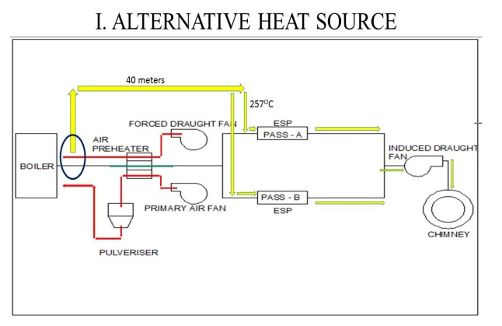

Fig.1 Proposed heat sources: before air pre heater 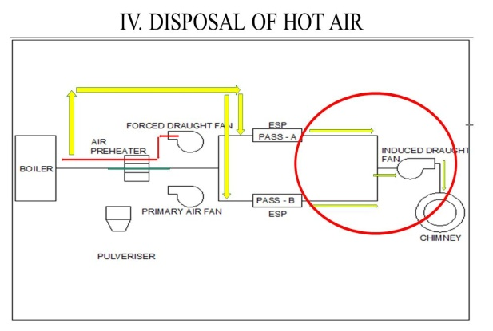

Fig.2 Proposed heat source at disposal of Hot Air

The conventional hopper and its principal parts are depicted in the Figure 3. Averagely the ESP hopper coils consume 6 kW of energy. The methodology is, primarily the some feasibility studies to be carried out such as like mass flow rate /volume flow rate required to replace those heating coils. Heat transfer and heat loss estimation from wind box to hopper (30m to 35m apart but for design purpose 40m). The fabrication of the model, testing and analysis are to be carried out. The theoretical and actual performances are to be compared.



Fig.3 Conventional ESP Hopper (Left) and components of ESP Hopper (Right) (1)

* 1. **Design**

The heating chamber is to be designed to replace the hopper coil. which has to provide power source to maintain fly ash at a temperature range by which the fly ash particles will not stick to the hopper surface while collection. The estimation of total mass flow rate required for specified power, and velocity of hot air can be estimated by fusing following data. The minimum relative temperature required is 120 oC to 130oC. The ambient air temperature or heating chamber temperature (Ts) without heater is 350C. The available heat source i.e., hot air temperature is 300oC. The measured mass flow rate in the duct is 4.688T/hr. the required power (Q) is 6 kW. The specific heat of air (Cp) at 300oC is 1.049 KJ/Kg K. the required mass flow rate (m) out of 464 t/hr is Q/(Cp∆T). That is 0.0390kg/sec. per hopper. There are 24 hoppers are connected hence over all mass flow rate is 0.936 kg/sec or 3.32 tonne per hr. The available square duct is 0.1m long side. The leaving air temperature at the distance of 30m is 257.7oC or 496 F (in let temperature of the hopper heating (Ti). The density of the air ≈257.7oC is 0.616 kg/m3. Hence Volume flow rate is 1.51 m3/sec. The area of cross section is 0.01 m2 , and then flow velocity is 151m/s. The usual notations were used for properties of air for calculated temperature. The hydraulic diameter (Dh) is the cross sectional area (Ac) in which the entry of air is made. Dh = (4Ac2/4Ac) = Ac = 0.0125m. The velocity of air flows through the cross sectional area or Velocity of the medium (vm) is equal to (V/Ac) = (0.052/0.0125) =4.16m/s. The Reynolds number (Re) is equal to [(vm*Dh)/v] = (4.16*0.0125)/30.09*10-6 =1395.08 < 2300 i.e. the flow is laminar. For laminar flow Pr is 0.682. Hence the Nusselt number Nu=0.023Re0.8 pr0.3 = 6.722. The Thermal conductivity (k) is 0.03469. Therefore the convective heat transfer coefficient (h) can be calculated from the relation of Nu= (h*Dh)/k as 19.5748W/m2 K. The exit temperature (Te) of hot air from the hopper heating system can be computed by using the mathematical relation of Te = Ts-(Ts-Ti)*e-h.Ac/(mCp)  and equal to 152.13oC. The Logarithmic Mean Temperature Difference (LMTD) can be computed as 137.0180 C = Tln. Hence the overall Heat transfer coefficient (Q) = hATln = 6.2 kW. The requited heating is 6 kW. Hence the design is safe.

* 1. **Prototyping**

As the hopper is tapper, the heating system to be fabricated as shown in the proposed model. The serpentine tubes fixed by welding on outside surfaces of the inner shell of hopper. That is the steam should passes through a continuous small tube and spread the tube on the surface as shown in left in the Figure 4, at the same time it must be ensured that all the four sides of heating chamber are maintaining at same temperature. Probably the steam inlet is to be at bottom where more heating is required. The fabricated model is shown in the middle of Figure 4 . The hopper heat testing setup is shown in the right side of the Figure 4. The exhaust of Kirloskar four stoke twin cylinder Diesel Engine is employed as heat source. The exhaust passes in the hopper prototype and evaluated the heating performance. The K Type thermo couple thermometers were used for Temperature measurement. The observations obtained at various temperatures with respect to time for evaluating the workability of proposed hopper heating and heating response time. The heating performances were observed by passing the exhaust into the inlet of the hopper prototype at side 1 as inlet and the side 4 as outlet. The observations were obtained five different places of the sides their rounded off average value is recorded and furnished in table 1. The procedure repeated until all four sides as input as their neighbour side as outlet. Those observations furnished in Table 2, Table 3 and Table 4 for side 2 as inlet side 1 as outlet case, side 3 as inlet side 2 as outlet case and side 4 as inlet side 1 as outlet case respectively.

 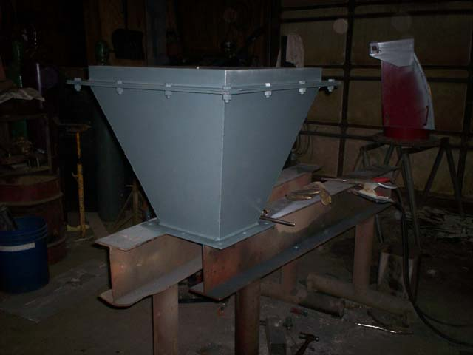 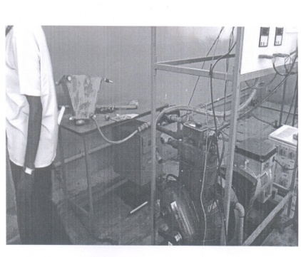

Fig.4. The fabricated Prototype (left) and testing setup (right)

Table 1: Results of Case I (Side 1 as Inlet and Side 4 as Outlet)

|  |  |  |  |  |  |
| --- | --- | --- | --- | --- | --- |
| Sl.No | Time (In  Minutes) | Temperature (Degree Centigrade) | | | |
| Side 1 | Side 2 | Side 3 | Side 4 |
| 1 | 0 to 5 | 35 | 33 | 30 | 31 |
| 2 | 5 to 15 | 46 | 45 | 41 | 40 |
| 3 | 15 to 25 | 55 | 55 | 50 | 53 |
| 4 | 25 to 35 | 59 | 58 | 54 | 57 |
| 5 | 35 to 45 | 61 | 61 | 57 | 60 |
| 6 | 45 to 55 | 62 | 62 | 59 | 61 |

Table 2: Results of Case II (Side 2 as Inlet and Side 1 as Outlet)

|  |  |  |  |  |  |
| --- | --- | --- | --- | --- | --- |
| Sl.No | Time (In  Minutes) | Temperature (Degree Centigrade) | | | |
| Side 1 | Side 2 | Side 3 | Side 4 |
| 1 | 0 to 5 | 32 | 34 | 31 | 31 |
| 2 | 5 to 15 | 44 | 46 | 42 | 43 |
| 3 | 15 to 25 | 54 | 55 | 52 | 54 |
| 4 | 25 to 35 | 58 | 58 | 54 | 56 |
| 5 | 35 to 45 | 61 | 61 | 58 | 60 |
| 6 | 45 to 55 | 62 | 62 | 59 | 61 |

Table 3: Results of Case III (Side 3 as Inlet and Side 2 as Outlet)

|  |  |  |  |  |  |
| --- | --- | --- | --- | --- | --- |
| Sl.No | Time (In  Minutes) | Temperature (Degree Centigrade) | | | |
| Side 1 | Side 2 | Side 3 | Side 4 |
| 1 | 0 to 5 | 33 | 33 | 31 | 34 |
| 2 | 5 to 15 | 45 | 45 | 42 | 45 |
| 3 | 15 to 25 | 54 | 53 | 49 | 53 |
| 4 | 25 to 35 | 59 | 58 | 54 | 58 |
| 5 | 35 to 45 | 60 | 60 | 57 | 61 |
| 6 | 45 to 55 | 61 | 61 | 59 | 62 |

Table 1: Results of Case IV (Side 4 as Inlet and Side 3 as Outlet)

|  |  |  |  |  |  |
| --- | --- | --- | --- | --- | --- |
| Sl.No | Time (In  Minutes) | Temperature (Degree Centigrade) | | | |
| Side 1 | Side 2 | Side 3 | Side 4 |
| 1 | 0 to 5 | 35 | 36 | 32 | 36 |
| 2 | 5 to 15 | 49 | 49 | 45 | 49 |
| 3 | 15 to 25 | 56 | 55 | 52 | 59 |
| 4 | 25 to 35 | 59 | 59 | 55 | 60 |
| 5 | 35 to 45 | 61 | 60 | 57 | 61 |
| 6 | 45 to 55 | 63 | 62 | 59 | 63 |

1. **Result and Discussions**

The design and fabricate a prototype hot gas / steam heating hopper model and tested with exhaust of IC engine for replacing the conventional electric heating. The prototype test results are shown in the graphical form in Figure 3 and Figure 4. The Figure 3 illustrates case wise comparison on each side. The Figure 4 depicts the side wise comparison with respect the cases considered. From the Figure 3 it is understood that rise of temperature in each side found almost uniform with respect to case. The negligence variation observed. From the figure 4 it is clear that with respect to input side the variation of temperature raise with respect time is not significant. Only the side 3 pick up the temperature little slow and the side 4 get little fast due to some fabrication finish issues. Hence it is suggested that the thermal insulation to be provided with external surfaces and any side can be preferred for inlet and its previous will be exit of hot steam.

Side 1 Side 2

Side 3 Side 4

Fig. 5 Case wise comparison on each side.

Case –I Case -II

Case –III Case –IV

Fig. 6 Side wise comparison for each case

The cost of power supply for industry is varies globally based on many factors. The average group of thermal power plants near coal mine 100 to 150 hoppers. The cost of heating is almost free by use of proposed system. If the thermal power plant operates 24 hrs per day for a month. The power required varies 600 kW to 900 kW per hour and for a month , 32000 kWh per month to 6,48,000 kWh per month. The reader may be calculating the exact savings based on exact numbers of hopper available and hours of plant running.

1. **Conclusion**

The alternate heating system for ash collecting hopper for thermal power plant discussed in this paper. The designed and fabricated a prototype for hot gas / steam heating system in hopper and tested. This proposal based on recovery of waste heat from the boiler. As it is continuous operation at stated operating pressure the supply of steam for the hopper heating system will not affect. Hence the operating cost is absolutely free. In the proposed system the steam passes through the small tubes, so noncorrosive tube material is recommended. The proposed system may be used as primary heating of the ash collecting hoppers for higher savings from 4,32000 kWh per month to 6,48,000 kWh per month for the thermal plants having hoppers from 100 to 150 nos. According poke yoke concept, as the thermal power plant operating continuously, it is suggested that the electric heating source as secondary for ensuring mistake proof operation. So the propose system to be implemented on the existing hopper setup.

**References**

1. R.Saravanan, Dr.R.Raju, Proceeding of Emerging Challenges in Design and Manufacturing Technologies, 2007, Sathyabama University, Chennai, and COMBAT Vehicles Research and Development Estabilishment, DRDO, Chennai.( 2007) Vol.1. pp.1-10,.
2. Gupta, T.N. (2003): “Holistic Performance of Fly Ash in Construction Technologies” in 3rd International Conference of Fly Ash Utilization and Disposal (19-21 Feb, at New Delhi pp.27-34 (2003).
3. K. Parker, Applied Electrostatic Precipitation. 10.1007/978-94-009-1553-4. (1997)
4. B.Valentine, A. Guedes, D.Flores, C.R.Ward, J.C. Hower, Coal combustion and gasification products, vol 1, pp.14-24(2009)
5. John H. Stratton, ASHRAE Journal, vol. 42, no. 6, pp24-29, ( 2000)
6. Sindhuja. S, Journal of Pure and Applied Mathematics, Volume 118 No. 20, pp.785-789 (2018)
7. Pradip Kumar Mandal and Tanuj Kumar, ICESP X, Paper 3A1, pp.1-13, (2006).
8. Dr.S.K.Chaudhary, Journal of Environmental Science and Sustainability, vol. 2 (1) pp. 31 – 35, (2014).