**Dynamic Performance Analysis of a Four Ton Automobile Chassis.**

**P.Sowmya1a, K.Karthik RajaShekar2b, M.Madhavi3c*, P.A.Sastry4d**

*a,b,c,dMechanical Engineering, MVSR Engineering college, Hyderabad 501510, Telangana, India.*

*Corresponding author Email: madhavimatlapudi72@gmail.com

------------------------------------------------------------------------------------------------------------------**ABSTRACT**

In the present work an effort is made to investigate the dynamic response of a four Ton truck Chassis due to road undulations. The effects of forcing frequencies due to engine as well as road condition are significant at high speeds of an engine. Numerical analysis is employed on the original dimensions of the Chassis of heavy truck made of structural steel. The analysis is extended to fiber reinforced composites and a combination of structural steel and composite. A new mathematical model is proposed as a 2D beam element with consistent mass matrix solved for mode shapes using determinant based method. However the natural frequencies for composites are obtained from the effective stiffness value derived from Lamination theory. The study involves the change in dimensions, addition of cross members to the chassis at maximum deflection, change of materials of the chassis.Further,under the conditions of base excitation, applying engine harmonic load on the cross members, rolling and pitching conditions, the dynamic response of the chassis are determined. The results show that Fiber reinforced composites have low natural frequencies with 80% weight reduction in comparison to structural steel resulting in increase in pay load ,life of wheels and other mounting elements on chassis.

***Keywords*:** Chassis, Layered Beam Element, Base Excitation, Harmonic Engine load.

-----------------------------------------------------------------------------------------------------------------

1. **Introduction**

The chassis of an automobile acts as a skeleton on which the engine, wheels, axle assemblies, brakes, suspensions etc. are mounted. The chassis receives the reaction forces of the wheels during acceleration and braking and absorbs aerodynamic wind forces and road shocks through suspension. All real physical structures, when subjected to loads or displacements, behave dynamically. The additional inertia forces, according to Newton’s Second law, are equal to the mass times the acceleration. If the loads and displacements are applied very slowly, then the inertia forces can be neglected, and a static load analysis can be justified. However dynamic loads due to high speeds of engine can also be significant. It is also important to study the effects of forcing frequencies due to engine as well as road condition. Hence, an effort is made to investigate the dynamic response of truck chassis due to road undulations.

--------------------------------------------------------------------------------------------------------------

**2. Theoretical background**

Chassis is an important part of automobile. The chassis serves as a frame for supporting the body and different units of automobile like engine, suspension, gearbox, braking system, steering, propeller shaft, differential, axle assemblies, etc. are welded or bolted as shown in figure1.Ladder Chassis or Body on frame are the terms used when the body of a vehicle is mounted to a separate frame or chassis. This frame is like a ladder in design as two long pieces of steel (approximately the length of the vehicle) are held parallel to each other by shorter pieces running across. This type of chassis is better suited for commercial and heavy-duty work.

**2.1 Layout of Chassis**: In the present work a four ton heavy loaded structural steel ladder type chassis as shown in the figure.2 is modeled and analysed for dynamic performance. The frame considered has ‘C’- type cross section for both long and cross members with the specifications mentioned in Table.1

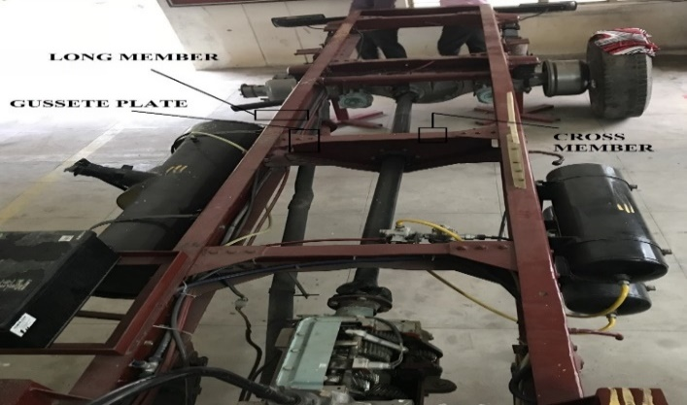 The analysis involves different cross sections and different materials of long and short members of chassis.

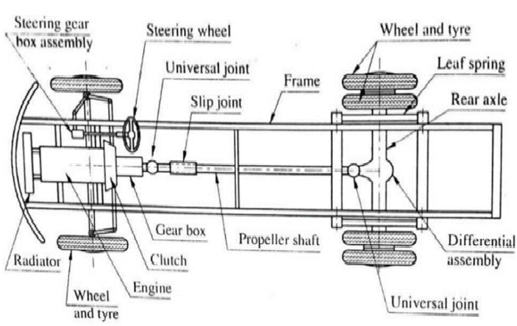

Figure.1 Layout of chassis Figure.2 Structural steel Chassis of Four

Ton Heavy loaded Automobile.

Table: 1 Specification of 4-Ton Heavy Vehicle Truck Chassis frame

|  |  |  |  |  |  |  |
| --- | --- | --- | --- | --- | --- | --- |
| **S. No.** | **Parameters** | **Value** | **S No.** |  | **Parameters** | **Value** |
| **1** | Total length of the chassis | 6775 mm | **9** |  | Load acting on single frame | 34335 N/beam |
| **2** | Width of the chassis | 860 mm | **10** |  | Uniformly Distributed Load | 5.08 N/mm |
| **3** | Wheel Base | 6405 mm | **11** |  | Reaction at point C Rc | 16954.221 N |
| **4** | Front Overhang | 90 mm | **12** |  | Reaction at point D Rd | 17462.779 N |
| **5** | Rear Overhang | 280 mm | **13** |  | Moment of inertia about x-x axis Ixx | 21979040.25 mm4 |
| **6** | Capacity | 4 ton | **14** |  | Deflection of chassis | 4.96mm |
| **7** | Capacity of Truck | 39240 N | **15** |  | Load acting on single frame | 34335 N/beam |
| **8** | Load acting on the chassis | 68670 N |  |  |  |  |

Table 2: Material specifications for the analysis

|  |  |  |  |  |  |
| --- | --- | --- | --- | --- | --- |
| **S No.** | **Material** | **Young’s Modulus(N/mm2)** | **Poison’s ratio** | **Density(kg/m3)** | **Shear modulus(N/mm2)** |
| 1 | Structural Steel | E = 2.1 X 105 | 0.3 | 7798 | G=79.3x 103 |
| 2 | Carbon/epoxy | Ex = 1.21 X 105  Ey = 8.6 X 103  Ez = 8.6 X 103 | υxy = 0.27  υyz = 0.4  υzx = 0.4 | 1600 | Gxy = 4.7 X 103  Gyz = 3.1 X 103  Gzx = 4.7 X 103 |



Figure.3 Line diagram of the chassis and suspension system of the truck considered

The chassis is considered as beam element on which a uniformly distributed load is acting. This load is distributed on the front and rear suspension shock absorbers as well as tyres along with unsprung mass. Unsprung mass is the mass of the suspension, wheels or tracks and other components directly connected to them, rather than supported by the suspension.

**2.1.1 Basic Calculation for Chassis Frame**

According to loading condition of the beam, a beam has a support by two-wheel axles i.e. at C, D. Total load generated on the beam is shown in the figure 4.

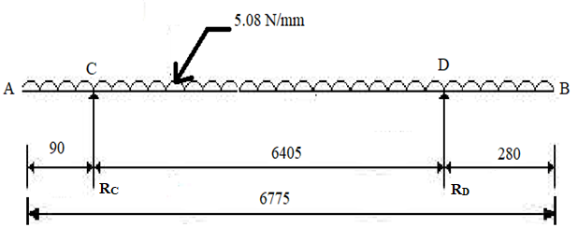

Figure.4 Total body load generated on the beam (All dimensions in mm)

Table.3 Forces acting on the frame

**2.2 Mathematical Modeling of Composite Layered Beam Element**

The closed form solutions to determine eigen values and eigenvectors are used for problems with simple material geometry, loading and boundary conditions. The analysis of fiber reinforced composite structures requires a specialized tool to predict the natural frequencies and mode shapes. In reality fiber reinforced composite beam structure is a beam comprising of different layers with varying thickness and fiber orientations. There are no solutions to this practical beam structure either in Closed form or in Numerical technique. In the current study **a** **layered beam element** (LBE), theoretical model **is** developedbased on Classical Lamination theory. The 2D beam with two noded elements consists of two degrees of freedom at each node viz., one translation and one rotation along with options to number of layers, thicknesses and fiber orientations at each layer.

**2.2.1 Finit*e* Element Formulation of Beam Element**

Stiffness matrix relation for 2D beam element with two degrees of freedom at each node is derived using potential energy. The total strain energy in the beam is given by

(1)

The potential energy of the beam is given by

(2) Where p is the distributed load per unit length, is the point load at point is the moment of couple applied at point k, is the deflection at point m, and is the slope at point k.The degree of freedom is transverse displacement and is slope or rotation. The vector

Hermite shape functions, which satisfy nodal value and slope continuity requirements. Each of the shape functions is of cubic order represented by

The Hermite shape functions can be used to write in the form

(3) Where

In the potential energy of the system, we consider the integrals as summations over the integrals over the elements. The element strain energy is given by

The element strain energy is given by

(4)

where the element stiffness matrix is

Classical theory of Mechanics of laminated composites deals with the response of the system to the applied forces. It tries to analyze the stresses, strains and deformations within the layered structure, predicts structure property relations and helps to understand the fracture and failure mechanisms. In case of composite beams the young’s modulus is dependent on direction of lamina and Effective Young’s modulus is determined in terms of the flexural compliances.The stresses vary within each lamina as well from lamina to lamina. The laminated plate geometry is shown in figure.5.

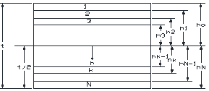

Figure.5 Laminated Plate geometry and ply numbering system.

An extensional force results is not only extensional deformations, but bending and /or twisting of the laminates. (5)

=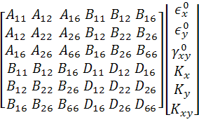 =

=

Extensional Stiffness Matrix:

(6) Aij =

Bending – Extension Coupling Stiffness Matrix:

(7) Bij =

Bending Stiffness matrix:

(8) Dij= 

Extensional stiffness matrix [A] relates the in-plane forces(N) to the midplane strain( εo).The bending stiffness matrix [D] relates the moments { M} to the Curvature {K}.The coupling stiffness matrix [B] couples the in-plane forces[N] with the curvature {k}and the moments{M} with the midplane strains(εo).

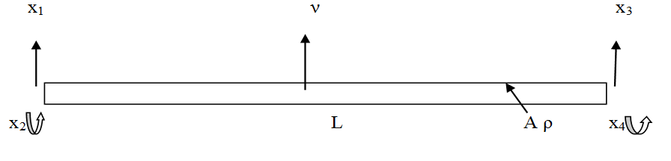

Figure 6. Finite element of beam

The beam 2D is a simple line element with two nodal d.o.f. per node,viz., rotation and translation. The stiffness matrix for the beam element is K=bB = Strain displacement matrix

( 9) =

The inverted form of above equation (10) =

Where M= bending moment, K = bending curvatures = bending stiffness matrix. When the laminate is subjected to a pure bending moment per unit length *Mx=Mxy*=0 ,the resulting curvature is  Where M=total bending moment, which is *Mx*b. I = moment of inertia of beam about neutral axis. Flexural young’s modulus for composite beam should be considered in x and y directions. Flexural modulus in x- direction Efx = 12/t3DI11

Flexural modulus in y- direction Efy = 12/t3DI22,DI11= Inverse of D11,  DI22= Inverse of D22.

**Mass Matrix of a 2D beam element:**

We define the Lagrange by (11)

Hamilton’s principle For an arbitrary time interval from to , the state of motion of a body extremizes the functional

If can be expressed in terms of the generalized variables where , then the equations of motion are given by

(12)

Where the bracketed expression is the element mass matrix

=

This mass matrix is consistent with the shape functions chosen and is called the consistent mass matrix and on summing over all the elements, we get

The potential energy is given by

∏

Using the Lagrangean ∏, we obtain the equation of motion

(13)

For free vibrations the force F is zero. thus ,

(14) For steady state condition, starting from the equilibrium state,

(15)

Where is the vector of nodal amplitudes of vibration and (rad/s) is the circular frequency

( cycles /s or Hz).

(16)

This the generalized eigen value problem

For the beam element hermite shape functions

On integrating , we get

(17)

**Eigen values using Determinant Method**

The governing equation of motion for a free vibration

M+K=0

The governing equation of motion is solved expressing displacement vector as

= eiωt  = (cosωt + isinωt) , Where = Modal vector , ω = natural frequency

= -ω2 X eiωt

In a generalized form (K –λM)=0 , Where λ = ω2

when equation is solved by using the standard Eigen values solution , after imposition of boundary conditions, the Natural frequency Eigen values (λ) ,Corresponding Eigen vectors, mode shapes are obtained.

-----------------------------------------------------------------------------------------------------------------

**3. Simulation study**

The chassis frame is modeled in high end analysis software for the given dimensions and discretized with 2D beam elements with two nodes, having two degree of freedom at each node. The necessary boundary and loading conditions are imposed on the model to obtain the static and dynamic performance of the four ton automobile chassis. Considering the limitations of the utility of 2D beam element on Fiber reinforced composites, algorithms are developed for free vibrations in MAT lab for the theoretical model of layered beam model. The long and short members are considered to be analogues to beam structures and are discretized into number of beam elements. Under the given loading and boundary conditions, static and dynamic parameters are derived. The study is performed under five cases viz.,analysis on original dimensions of C-type section of long member of Structural Steel material, analysis on reduced dimensions of C-type section of long member of Structural Steel material, analysis on additional cross-member at maximum deflecting area on reduced dimensions of C-type section of long member of Structural Steel material, analysis on original dimensions of C-type section of long member of Carbon/epoxy material, analysis on original dimensions of C-type section of long member of Structural Steel material for long members and Carbon/Epoxy material for cross members.

Static analysis is performed to derive maximum deformation and Von Mises stresses on the chassis and dynamic analysis includes modal and harmonic analysis. Modal analysis helps us to find the natural frequencies and the nature of mode for the behaviour of the chassis under different conditions.In Harmonic analysis four other conditions are included which are as follows:

Condition 1: In Base excitation, the four base points are given amplitude of 100mm each and a uniformly distributed load of 5.08N/mm is applied on the chassis frame as shown in figure.7

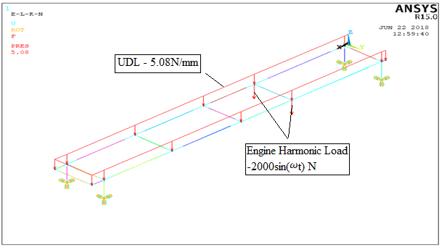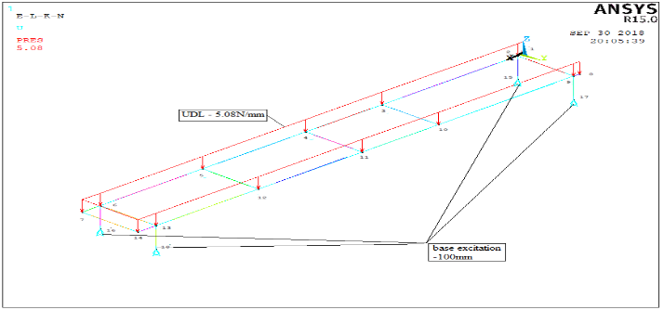

Figure 7.Base excitation condition Figure 8. Engine Harmonic load condition

Condition 2: Engine Harmonic load, an engine harmonic load of 2000 sin(ωt) ,N on second cross member, uniformly distributed load of 5.08N/mm along the chassis frame and the base key points are fixed as shown in figure.8.

Condition 3: In Pitch condition, a displacement of 100mm is applied on rear wheels and no displacements on front wheels, an engine harmonic load of 2000sin(ωt) ,N on second cross member, uniformly distributed load of 5.08N/mm along the chassis frame and the base keypoints are fixed as shown in figure.9.The displacements can be approximated to where i= 1,2,3,4

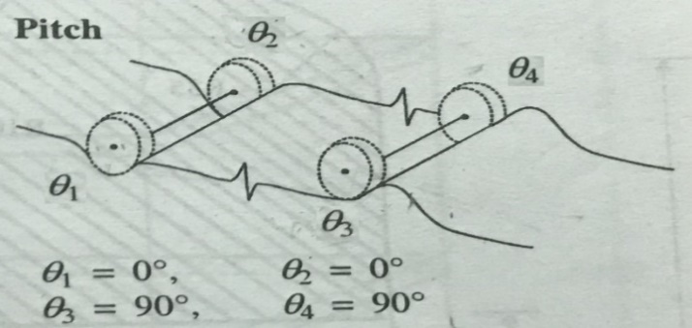

Figure. 9. The pitch condition on the wheels

Condition 4: In Roll condition, a displacement of 100mm is applied on right side of the vehicle and no displacements on the left side of the vehicle, an engine harmonic load of 2000sin(ωt) N on second cross member, uniformly distributed load of 5.08N/mm along the chassis frame and the base keypoints are fixed as shown in figure.10

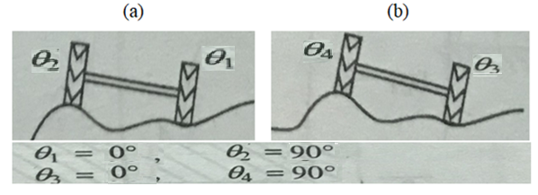

Figure.10 Roll condition on the wheels

**3.1 Results of Structural Steel of ‘C’(230.7mm X 77.5mm X 8mm)**



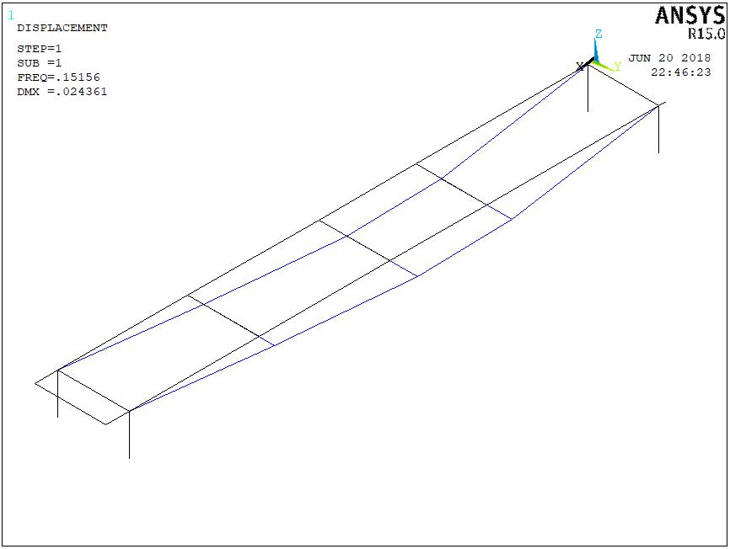 Figure 11. Static Analysis of Structural Steel

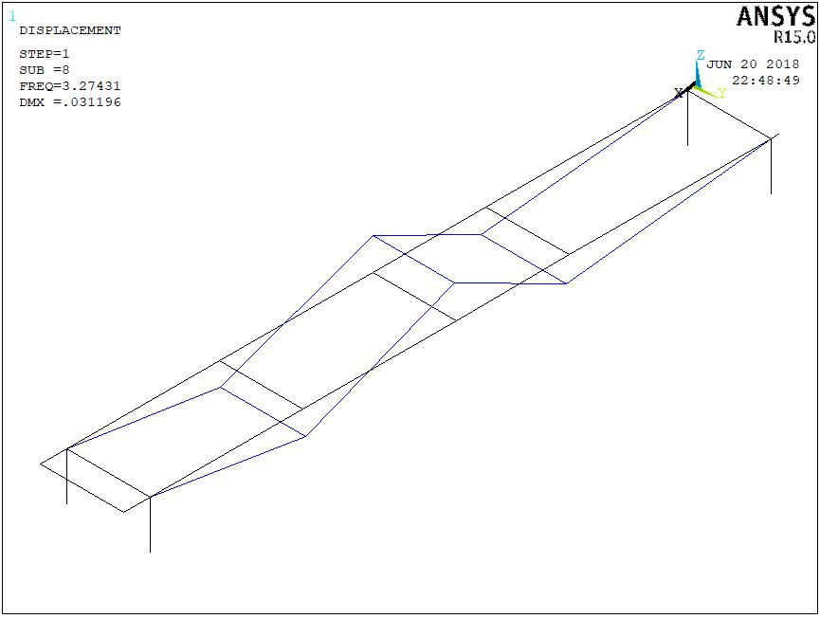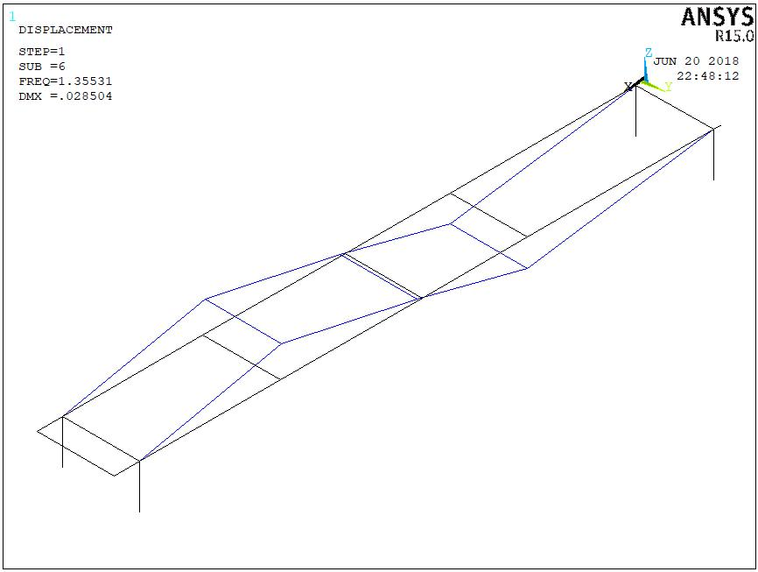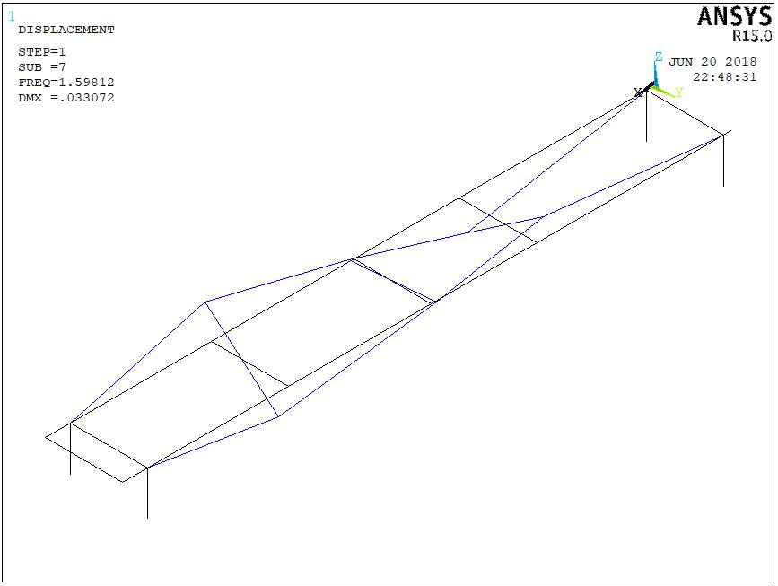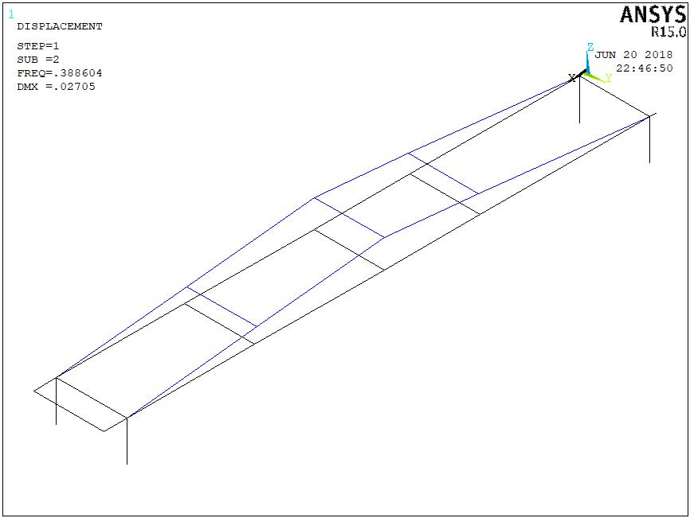

Figure12. Mode shapes of Structural Steel

**Harmonic Analysis:**

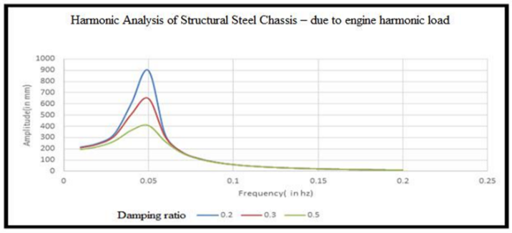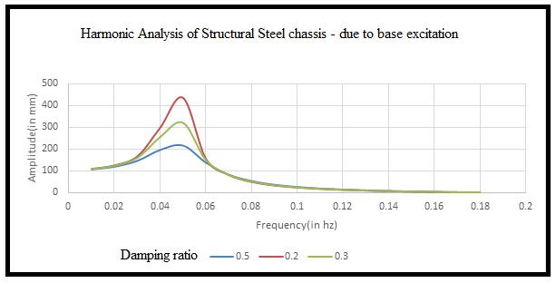

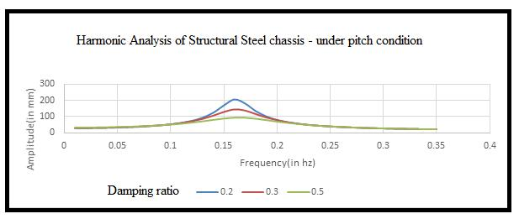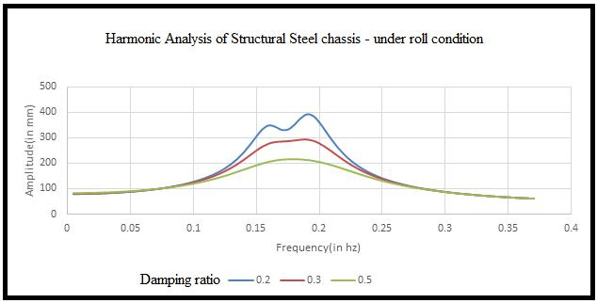

Figure 13 : Harmonic Analysis of Structural Steel Chassis

**Effect on Composite Material of C type Channels (230.7mm x 7.5mm x 8.0mm)**

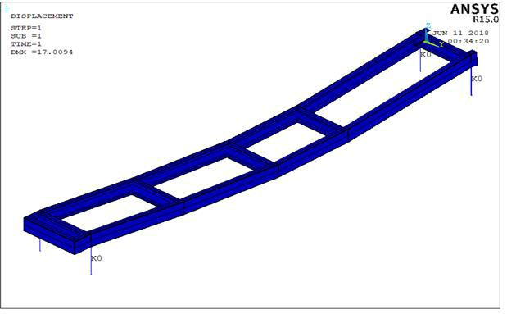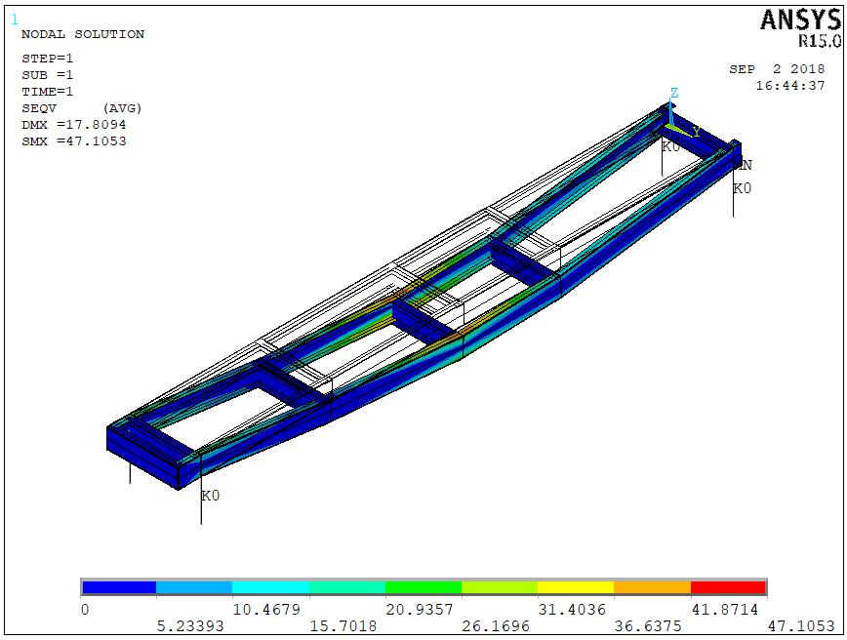

Figure. 14 Static Analysis of Carbon/Epoxy Figure.15 Von Mises Stresses of

Chassis Carbon/epoxy chassis

Mode Shapes

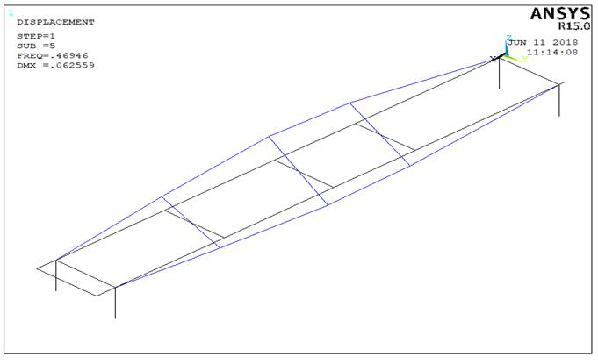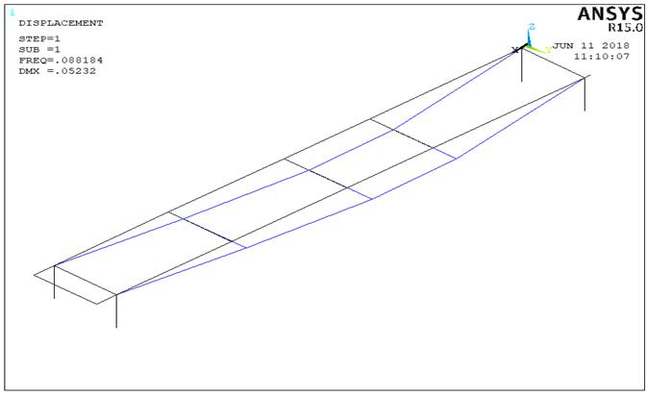

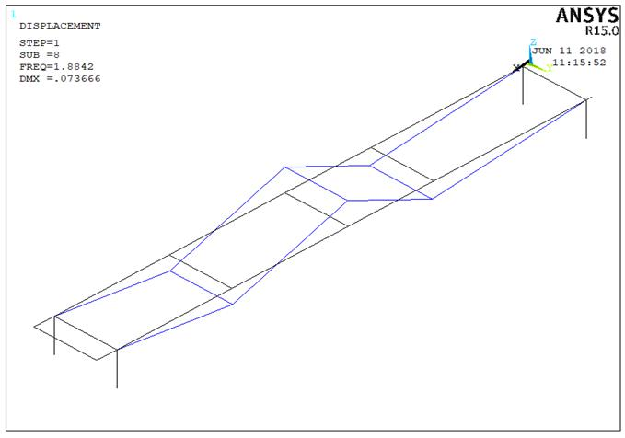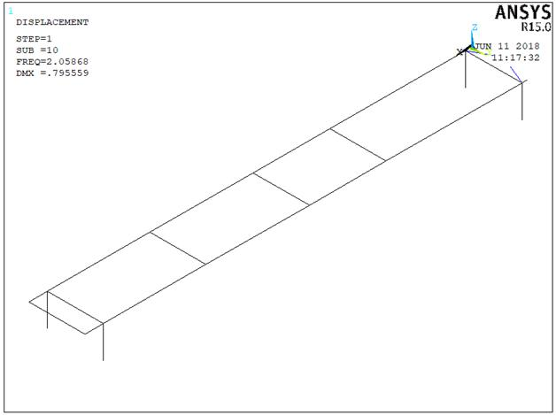

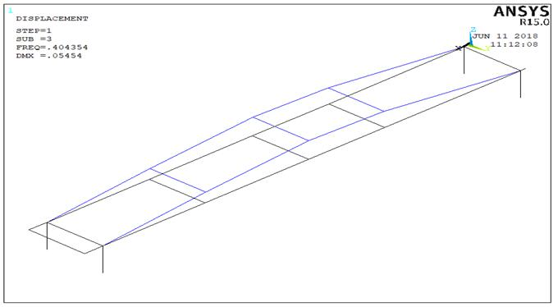

Figure.16 Mode shapes of Carbon/Epoxy

**Harmonic Analysis of Carbon /Epoxy Chassis**

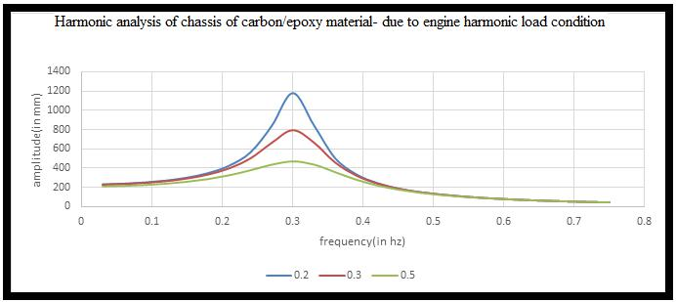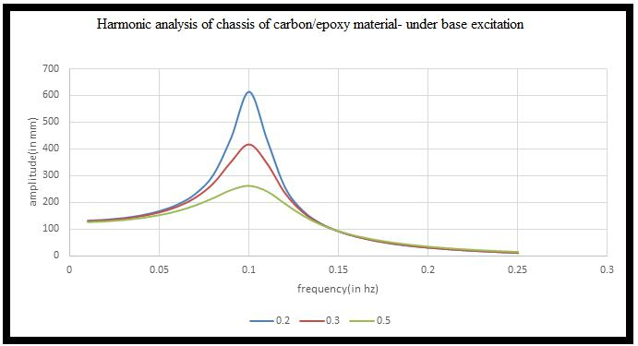

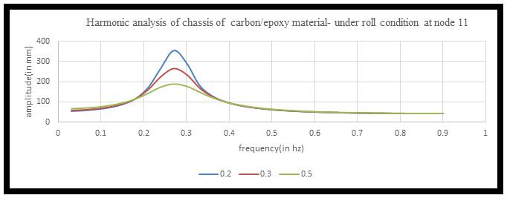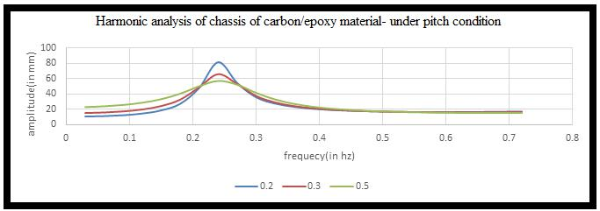

Figure.17 Harmonic analysis of chassis of carbon/epoxy material

**3.2 Results by Layered beam model**

Deformations and natural frequencies of Chassis frame are obtained using layered beam model. The results are compared with numerical technique results developed through ANSYS software. Deformations and natural frequencies of structural steel obtained through Layered beam model are observed to be very close to analysis software. Considering the validation of the procedure, the simulation is preceded for fiber reinforced composites and obtained the corresponding deformations and natural frequencies.

Table 4: Comparison between LBM & ANSYS results.

|  |  |  |  |  |  |  |
| --- | --- | --- | --- | --- | --- | --- |
| **Mode Shape** | Natural Frequencies(Hz)  Structural Steel Chassis | | Nature of mode | Natural Frequencies (Hz) Carbon/Epoxy | | Nature of Mode |
| **LBM** | **ANSYS** | **LBM** | **ANSYS** |
| 1 | **0.082** | 0.151 | Bending | **0.079** | 0.088 | Bending |
| 2 | **0.295** | 0.388 | Bending | **0.205** | 0.221 | Bending |
| 3 | **0.317** | 0.392 | Bending | **0.395** | 0.404 | Bending |
| 4 | **0.399** | 0.452 | Bending | **0.377** | 0.416 | Bending |
| 5 | **0.731** | 0.755 | Bending | **0.401** | 0.469 | Twisting |
| 6 | **1.298** | 1.355 | Bending | **1.051** | 1.002 | Bending |
| 7 | **1.469** | 1.598 | Twisting | **1.093** | 1.179 | Twisting |
| 8 | **3.157** | 3.274 | Bending | **1.802** | 1.884 | Bending |
| 9 | **3.063** | 3.633 | Transverse | **2.011** | 2.059 | Bending |
| 10 | **3.179** | 3.865 | Bending | **2.142** | 2.059 | Bending |

**Results and discussions:**

Static analysis:

|  |  |  |  |  |  |
| --- | --- | --- | --- | --- | --- |
| **Parameters** | **Structural Steel (230.7mmX77.5mm X 8mm)** | **Structural Steel(200mmX 75mm X 6.2mm)** | **Additional Cross-member (200mmX 75mm X 6.2mm)** | **Carbon/ epoxy(230.7mm X77.5 mm X 8mm)** | **Combination(230.7mm X 77.5mm X 8mm)** |
| **Deformation (in mm)** | 4.218 | 7.744 | 7.844 | 17.795 | 4.28 |
| **VonMises Stresses (in N/mm2)** | 46.127 | 72.373 | 75.393 | 47.105 | 46.127 |
| **Weight**  **(in Tonns)** | 3.574 | 2.741 | 2.184 | 0.7427 | 3.2 |

Modal Analysis:

|  |  |  |  |  |  |
| --- | --- | --- | --- | --- | --- |
| **Parameters** | **Structural Steel(230.7mm X 77.5mm X 8mm)** | **Structural Steel(200mmX 75mm X 6.2mm)** | **Additional Cross-member (200mmX 75mmX6.2mm)** | **Carbon/ epoxy (230.7mmX 77.5mmX8mm)** | **Combination (230.7mmX 77.5mmX8mm)** |
| **Natural Frequencies (in Hertz)** | 0.1515 | 0.1593 | 0.1610 | 0.0881 | 0.1161 |
| 0.3886 | 0.3435 | 0.3170 | 0.2214 | 0.3600 |
| 0.3929 | 0.4031 | 0.3821 | 0.4041 | 0.4345 |
| 0.4526 | 0.4133 | 0.4293 | 0.4169 | 0.4748 |
| 0.7552 | 0.7953 | 1.0000 | 0.4692 | 0.8339 |
| 1.3553 | 1.2017 | 1.0397 | 1.0028 | 1.5392 |
| 1.5981 | 1.4285 | 1.2424 | 1.1791 | 1.6874 |
| 3.2743 | 2.9249 | 1.5557 | 1.8843 | 3.8656 |
| 3.6332 | 3.6335 | 2.6278 | 2.0596 | 3.9167 |
| 3.8652 | 3.6359 | 3.2646 | 2.0595 | 4.0535 |

1. Natural frequencies and associated mode shapes are obtained through theoretical approach using Classical Lamination theory and finite element techniques. The beam is discretised with iso-parametric beam elements. Subsequently iterations were carried out using MATLab code to compute the dynamic parameters. The study is carried out for both steel and composite beams.
2. The MAT lab program is verified in order to ensure the subsequent analyses are free of error. The beam is modeled in ANSYS for the same meshing and boundary conditions. The results are compared with theoretical model.
3. For all the five design cases considered, maximum amplitude occurs at the fundamental frequency. This frequency varies from 0.05hz to 0.27hz. Due to engine harmonics, which are 20hz and above, the amplitude of oscillation is negligible. Due to road undulations, at speed in the range of 15 to 40 kmph, and occurring in spacing of 2m to 0.4m, the frequency varies from 1hz to 25hz. In all such cases, the amplitude of vibration of the structure is less than 10mm. Hence the chassis is quite safe
4. The effect of damping ratio considered i.e. 0.2 to 0.5 is found to be negligible at frequencies beyond 0.3hz in all cases of design, and for all dynamic conditions considered.
5. When structural steel chassis is replaced by Carbon/epoxy material, static deflection increased from 4.2mm to 17.795mm which is acceptable, while stress is the same. However, the weight of the chassis is reduced by nearly 80%.
6. Replacing cross members of Steel by Carbon/epoxy has not affected the static or dynamic parameters
7. When the long channel section is reduced from 230.7mmX77.5mmX8mm to 200mmX75mmX6.2mm while the weight of the chassis is reduced by 20% there is a small change in the natural frequencies. The dynamic parameters are not affected much. The static deflection increased from 4.218mm to 7.744mm and stress is increased from 46.127 N/mm2 to 72.373 N/mm2. However, the changes in deflection and stress are both in acceptable limits.
8. Effect of increasing the cross members for the small C section in Steel for long members, resulted in insignificant changes in static and dynamic parameters.

**Conclusion**

The aim is to obtain dynamic characteristics of chassis, through a model which considers the constituent layers and their directional properties; to compare the characteristics with those of a steel chassis. The layered beam model developed in this work can be used to find the natural frequencies**.**

Considering the above analysis of the results, it may be concluded that the existing steel chassis may be fully replaced by carbon/epoxy composite, as the weight is reduced substantially. The long members of the chassis can be replaced by a smaller section retaining the design safety.

Harmonic Analysis:

|  |  |  |  |  |  |  |  |  |  |  |  |  |  |  |  |
| --- | --- | --- | --- | --- | --- | --- | --- | --- | --- | --- | --- | --- | --- | --- | --- |
| Parameters | Structural Steel (230.7mm X 77.5mm X 8mm) | | | Structural Steel (200mm X 75mm X 6.2mm) | | | Additional Cross-member (200mm X 75mm X 6.2mm) | | | Carbon/ epoxy (230.7mm X 77.5mm X 8mm) | | | Combination (230.7mm X 77.5mm X 8mm) | | |
| Damping ratio | 0.2 | 0.3 | 0.5 | 0.2 | 0.3 | 0.5 | 0.2 | 0.3 | 0.5 | 0.2 | 0.3 | 0.5 | 0.2 | 0.3 | 0.5 |
| Base excitation | 435.7  mm  at  0.05 hz | 322.3  mm  at  0.05 hz | 217.1  mm  at  0.05 hz | 448.9 mm  at  0.05 hz | 347.5 mm  at  0.05 hz | 239.1 mm  at 0.05 hz | 498.2mm  at  (0.05 hz) | 367 mm  at  (0.05 hz) | 243.7mm  at  (0.05 hz) | 613.4 mm  at  0.1 hz | 416.8 mm  at  0.1 hz | 262.9 mm  at  0.05 hz | 473.5 mm  at  0.05 hz | 337.2 mm  at  0.05 hz | 221.8 mm  at  0.05 hz |
| Engine harmonic  load  (2000sin(ωt) N) | 896.9  mm  at  0.05 hz | 648.3  mm  at  0.05 hz | 408.2  mm  at  0.05 hz | 873.3 mm  at  0.05 hz | 664.1 mm  at  0.05 hz | 433.5 mm  at  0.05 hz | 968.1mm  at (0.05hz) | 700.6mm  at  (0.05hz) | 441.3mm  at  (0.05hz) | 1180.1 mm  at  0.1 hz | 789.4 mm  at  0.1 hz | 474.7 mm  at  0.1 hz | 967.1 mm  at  0.05 hz | 673.2 mm  at  0.05 hz | 414.1 mm  at  0.05 hz |
| Pitch  condition | 206.7  mm  at  0.16 hz | 142.9  mm  at  0.16 hz | 94.9 mm  at  0.16 hz | 118.6 mm  at  0.14 hz | 85.9 mm  at  0.14 hz | 66.9 mm  at  0.15 hz | 104.3mm  at  (0.14hz) | 80mm  at  (0.14hz) | 60.5 mm  at  (0.14hz) | 81.2 mm  at  0.24 hz | 66.1 mm  at  0.24 hz | 56.7 mm  at  0.24 hz | 211.3 mm  at  0.18 hz | 146.1 mm  at  0.18 hz | 96.7 mm  at  0.18 hz |
| Roll  condition | 348  mm  at  0.16 hz | 294.2 mm  at  0.19 hz | 215.1 mm  at  0.18 hz | 316.4 mm at  0.18 hz | 250.3 mm at  0.18 hz | 189.3 mm at  0.15 hz | 340.7mm  (0.16hz) | 253.5mm  at  (0.16hz) | 183.3mm  at  (0.16hz) | 353.8 mm  at  0.27 hz | 265.4 mm  at  0.27 hz | 188 mm  at  0.27 hz | 447.5 mm  at  0.2 hz | 334 mm  at  0.2 hz | 230.2 mm  at  0.2 hz |

**References**

1. Mr. Rahul L. Patel, Mr. Divyesh B. Morabiya and Mr. Anil N. Rathour “Weight optimization of chassis frame using Pro-Mechanica” ISSN: 2348-8360, SSRG *International Journal of Mechanical Engineering* *(SSRG-IJME)* - vol. 1 Issue 8, pp.4-9, December 2014.
2. Goolla Murali, Subramanyam B and Dulam Naveen “Design Improvement of a Truck Chassis based on Thickness *“Altair Technology Conference, Sigma Consultancy Service India* pp1-6, 2013.
3. “Automobile Mechanics”, Dr. N K Giri, eighth edition, Khanna publishers, New Delhi.
4. Vijaykumar V Patel and R I Patel, “Structural Analysis of Ladder Chassis Frame”, ISSN 2231-2581, April 2012, Mechanical Department, Government Engineering College, Gujarat.
5. Dr. Ajay Bhattu and Shrinidhi rao, “Dynamic Analysis and Design Modification of a Ladder Chassis Frame using Finite Element Method”, Amity journal of Computational Sciences (AJCS), Vol 1, Issue 2, ISSN: 2456-6616.,2004
6. A Hari Kumar and A Deepanjali, “Design and Analysis of Automobile Chassis”, International Journal of Engineering Sciences and Innovative Technology (IJESIT), Vol. 5, Issue 1, Jan 2016, ISSN: 2319-5967.
7. Patel Vijaykumar, et al, “Structural Analysis of Ladder Chassis Frame and Design Modification for Weight reduction”, International Journal of Engineering Research and Technology, ISSN:2278-0181, Vol 1, Issue 3, May 2012.
8. Monika S Agarwal, et al, “Finite Element Analysis of Truck Chassis”, International Journal of Engineering Sciences and Research, ISSN:2277-9655, Dec 2013.
9. Avinash V Gaikwade and Pravin S Ghawade, “Finite Element Analysis of Ladder Chassis Frame”, International Journal of Engineering Technology, management and Applied Sciences, Vol. 2 Issue 6, ISSN 2349-4476, Nov 2014.
10. “Fundamentals of Vehicle Dynamics”, Thomas D Gillespie, Society of Automotive Engieers, Inc. 400 Commonwealth Drive, Warrendale, PA.,2001.