**Optimization of Link Lengths of 2R Manipulator Used for 3D Printing**

K Navaneethaa, A Sai Kumarb*, PVS Subhashinic

*aDepartment of Mechanical Engineering, JNTUH College of Engineering, Hyderabad-500085,Telangana,India*

*bDepartment of Mechanical Engineering, CMR College of Engineering & Technology-501401,Telangana,India.*

*cDepartment of Mechanical Engineering, Vasavi College of Engineering, Hyderabad-500031,Telangana,India.*

*Corresponding author Email: kasanavaneetha@yahoo.in

------------------------------------------------------------------------------------------------------------------

Fused deposition Modelling is one of the rapid prototyping technique using three linear axes for fabricating components. The aim of this paper is to modify and analyse three mutually perpendicular axes of FDM with two revolute (2R) joints. In the present work an existing FDM is considered, the dimensional data along with maximum size of manufacturing component and work volume is also considered from the existing FDM. The proposed 3D printing is with two revolute joints which is modelled in CAD software. Mass data is analysed from CAD software by considering the material as Aluminium 6061, which is used as input mass data for theoretical analysis. Link length optimization of two link manipulator has been carried in the MATLAB.A rectangular work piece is considered for this work. The movement of rectangular work piece has to be completed in 10 seconds with 8 points on it. For this, the equations which are derived by kinematics and dynamics are used as input to MATLAB. A sophisticated program is developed in MATLAB which will result the power Equations and also the actual power values at joint1 and joint2 of 2R manipulator. All the data is exported to Ms- Excel and the minimum power of joint1 and 2 were calculated. Finally, the optimized link lengths for minimum power are presented in graphical form.

***Keywords*:** 3D printing, 2R manipulator, CAD software, MATLAB.

1. **Introduction**

3D printing is also known as additive manufacturing. It is a latest and interesting technology used for developing a 3- dimensional solid object from a digital model. It consists of three phases – Modelling, printing & finishing the product. 3D printing uses a layering technique in which objects are created by continuous layers of materials. The application of 3D printing is growing exponentially and it impacts not only how buildings are modelled but their looks and better surrounding. The applications of 3D printing are in the various sectors like research, education, construction, fashion & many others. With the increase of 3D printing technology, the cost of getting 3D printers has been reducing with the expansion of technology.

A 2R manipulator consists of two joints separated in space by the links. It consists of a base, two revolute joints and end effectors can be programmed to follow a planned trajectory, provided relationships between joint variables and position and the orientation of the end effectors are formulated. The total energy which is the sum of kinetic energy and potential energy of the two link system are defined and used to form Lagrangian equations. Finally to define the torque applied on each link equations are used from the literature [1] [2] [3] (Pawan Singh Yadav and Narinder Singh, 2015, Mahmoud Gouasmi, 2012, Jolly shah 2015).

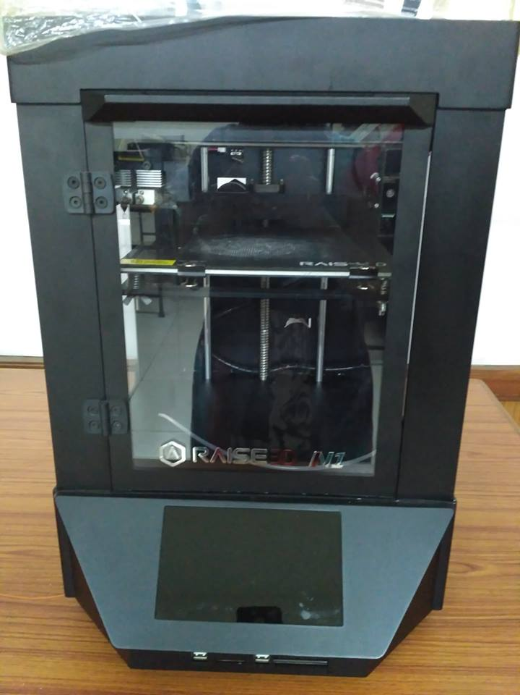

Fig 1: 3D printer used for reference (Courtesy: Vasavi College of Engineering, Hyderabad)

In the present work optimization of the link lengths for a specific rectangular path on a component with a specified placement position from the robot, base is carried out to obtain the minimum power needed for the 3D printing operation among all the link length sets.

**2. CAD model of the 2R manipulator for 3D printing**

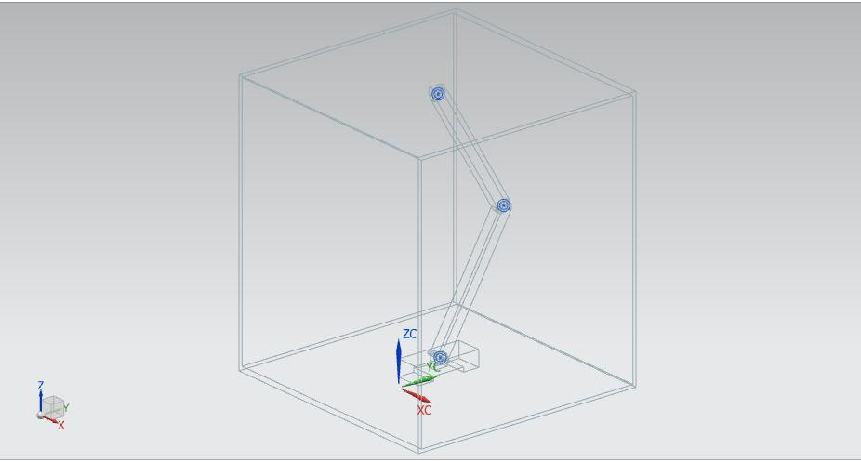

Fig 2: CAD model of 2 link manipulator in 3D printing

**3. Summary of Mathematical equations used in the analyses**

The following are the kinematic and dynamic equations available in literature [2] used for the analysis in MATLAB.

Torques $τ_{1}, τ_{2}:$

$τ_{1}=[\left(\frac{m_{1}}{3}+m_{2}\right)L_{1}^{2}+\frac{m_{2}L_{2}^{2}}{3}+m_{2}L_{1}L_{2}C_{2}\ddot{{]θ}_{1}}+[m_{2}\left(\frac{L_{2}^{2}}{3}+\frac{L_{1}L_{2}C_{2}}{2}\right)]\ddot{θ_{2}}+-m_{2}L_{1}L_{2}S_{2}\dot{θ_{1}}\dot{θ_{2}}-\frac{m_{2}L_{1}L_{2}S_{2}\dot{θ_{2}^{2}}}{2}+\left[\left(\frac{m_{1}}{2}+m_{2}\right)L_{1}C_{1}+\frac{m_{2}L_{2}C_{12}}{2}\right]g+C_{1}\dot{θ_{1}}-C_{2}\left(\dot{θ_{2}}-\dot{θ_{1}}\right)$ (1)

$τ_{2}=[m_{2}\left(\frac{L_{2}^{2}}{3}+\frac{L_{1}L_{2}C_{2}}{2}\right)]\ddot{θ_{1}}+\frac{m_{2}L_{2}^{2}}{3}\ddot{θ_{2}}+\frac{m_{2}L_{1}L_{2}S_{2}\dot{θ_{1}^{2}}}{2}+\frac{m_{2}L_{2}C_{12}g}{2}+C_{2}(\dot{θ_{2}}-\dot{θ_{1}})$ (2)

Power P1, P2: P1= ∗𝜃1 (3)

P2= ∗𝜃2 (4)

**4. Problem formulation**

The following assumptions are considered to optimize the link lengths for minimum power at two joints of 2R link manipulator used for 3D printing.

The length and width of the rectangular path are 0.255m and 0.235m respectively.

The time required to complete one cycle is 10 sec,

Steps taken to complete one cycle is 8 points,

Masses of link-1 and link-2 are 0.16955kg and 0.1671474kg respectively.

The Objective function to minimize the power subjected to constraints is

0.226 ≤ 𝑙1 ≤ 0.350

0.100 ≤ 𝑙2 ≤ 0.224

𝑙1 + 𝑙2 = 0.450

**4.1 The steps adopted in the analyses are as follows**

For the completion of the rectangular path, the path is divided into 8 points. For the given constraints of 𝑙1 + 𝑙2 = 0.450 at every point of Po, P1, so on up to P8, 84 set of data will be generated as shown in table.2 for every 0.001m increase in link length. To decide the motor torque required, it is necessary to find the maximum power generated among the 8 points and also minimum power for each of these 84 variants required among the given constraints of increase of 0.001m in link length.

Table 1 presents the input data used for computing power data at two joints.

|  |  |  |  |  |  |  |  |
| --- | --- | --- | --- | --- | --- | --- | --- |
| **S No.** | **t(sec)** | **Px(m)** | **Py(m)** | **Vx(m/s)** | **Vy(m/s)** | **ax(m/s2)** | **ay(m/s2)** |
| 1 | 0 | 0 | 0 | 0 | 0 | 0 | 0 |
| 2 | 1.3 | 0.1275 | 0 | 0.098077 | 0 | 0.075444 | 0 |
| 3 | 1.3 | 0.255 | 0 | 0.098077 | 0 | 0.075444 | 0 |
| 4 | 1.2 | 0.255 | 0.1175 | 0 | 0.097917 | 0 | 0.081597 |
| 5 | 1.2 | 0.255 | 0.235 | 0 | 0.097917 | 0 | 0.081597 |
| 6 | 1.3 | 0.1275 | 0.235 | -0.09808 | 0 | -0.07544 | 0 |
| 7 | 1.3 | 0 | 0.235 | -0.09808 | 0 | -0.07544 | 0 |
| 8 | 1.2 | 0 | 0.1175 | 0 | -0.09792 | 0 | -0.0816 |
| 9 | 1.2 | 0 | 0 | 0 | -0.09792 | 0 | -0.0816 |

Table 2presents the data for link length combination

|  |  |  |  |  |  |  |  |  |  |  |  |
| --- | --- | --- | --- | --- | --- | --- | --- | --- | --- | --- | --- |
| **S.No.** | **L1(m)** | **L2(m)** | **S.No.** | **L1(m)** | **L2(m)** | **S.No.** | **L1(m)** | **L2(m)** | **S.No.** | **L1(m)** | **L2(m)** |
| **1** | 0.226 | 0.224 | **22** | 0.257 | 0.193 | **43** | 0.299 | 0.151 | **64** | 0.320 | 0.130 |
| **2** | 0.227 | 0.223 | **23** | 0.258 | 0.192 | **44** | 0.3 | 0.15 | **65** | 0.321 | 0.129 |
| **3** | 0.228 | 0.222 | **24** | 0.259 | 0.191 | **45** | 0.301 | 0.149 | **66** | 0.322 | 0.128 |
| **4** | 0.229 | 0.221 | **25** | 0.260 | 0.190 | **46** | 0.302 | 0.148 | **67** | 0.323 | 0.127 |
| **5** | 0.230 | 0.220 | **26** | 0.261 | 0.189 | **47** | 0.303 | 0.147 | **68** | 0.324 | 0.126 |
| **6** | 0.241 | 0.209 | **27** | 0.262 | 0.188 | **48** | 0.304 | 0.146 | **69** | 0.325 | 0.125 |
| **7** | 0.242 | 0.208 | **28** | 0.263 | 0.187 | **49** | 0.305 | 0.145 | **70** | 0.326 | 0.124 |
| **8** | 0.243 | 0.207 | **29** | 0.264 | 0.186 | **50** | 0.306 | 0.144 | **71** | 0.327 | 0.123 |
| **9** | 0.244 | 0.206 | **30** | 0.265 | 0.185 | **51** | 0.307 | 0.143 | **72** | 0.328 | 0.122 |
| **10** | 0.245 | 0.205 | **31** | 0.266 | 0.184 | **52** | 0.308 | 0.142 | **73** | 0.329 | 0.121 |
| **11** | 0.246 | 0.204 | **32** | 0.267 | 0.183 | **53** | 0.309 | 0.141 | **74** | 0.330 | 0.120 |
| **12** | 0.247 | 0.203 | **33** | 0.268 | 0.182 | **54** | 0.310 | 0.140 | **75** | 0.331 | 0.119 |
| **13** | 0.248 | 0.202 | **34** | 0.269 | 0.181 | **55** | 0.311 | 0.139 | **76** | 0.332 | 0.118 |
| **14** | 0.249 | 0.201 | **35** | 0.270 | 0.180 | **56** | 0.312 | 0.138 | **77** | 0.333 | 0.117 |
| **15** | 0.250 | 0.200 | **36** | 0.271 | 0.179 | **57** | 0.313 | 0.137 | **78** | 0.334 | 0.116 |
| **16** | 0.251 | 0.199 | **37** | 0.272 | 0.178 | **58** | 0.314 | 0.136 | **79** | 0.335 | 0.115 |
| **17** | 0.252 | 0.198 | **38** | 0.273 | 0.177 | **59** | 0.315 | 0.135 | **80** | 0.336 | 0.114 |
| **18** | 0.253 | 0.197 | **39** | 0.274 | 0.176 | **60** | 0.316 | 0.134 | **81** | 0.337 | 0.113 |
| **19** | 0.254 | 0.196 | **40** | 0.275 | 0.175 | **61** | 0.317 | 0.133 | **82** | 0.338 | 0.112 |
| **20** | 0.255 | 0.195 | **41** | 0.276 | 0.174 | **62** | 0.318 | 0.132 | **83** | 0.339 | 0.111 |
| **21** | 0.256 | 0.194 | **42** | 0.277 | 0.173 | **63** | 0.319 | 0.131 | **84** | 0.340 | 0.110 |

To complete a rectangular path it has to undergo through points p0 to p8.In order to optimize power values first of all it is mandatory to know the maximum power required to complete a rectangular path and then to find the best combination of link length for minimum power.

Fig 3 Power values for joint1

Fig 4 Power values for joint2

From figure3 and figure 4 it was observed that the minimum power is at link length combination of 51. From table 2 combination 51represents Link1 length is 0.307m and link2 length as 0.143m.

From the observed link length combination it was noticed that optimized link length combination is 51 which represents link1 length as 0.307m and link2 length as 0.143m

**5. CONCLUSION**

The proposed 3D printing is with two revolute joints which is modeled in CAD software. Mass data is analyzed from CAD software by considering the material as Aluminum 6061which used as input mass data for theoretical analysis. A rectangular work piece is considered for this work. In the present work the movement of rectangular path has to be completed in 10 seconds with 8 points on it. For this the equations were derived by kinematics and dynamics are used as input to MATLAB. A program is developed in MATLAB which results of data power at joint1 and joint2 of 2R manipulator. All the data is exported in Ms- Excel and calculated the minimum power of joint1 and 2. It was observed that optimized link length combination is 51 which represent link1 length as 0.307m and link2 length as 0.143m. Further this work has to be checked by varying the points on the rectangular path. And also to be extended by applying forces at the end effector and has to do velocity, acceleration and jerk analysis.

**REFERENCES**

1. Pawan Singh Yadav., and Narinder Singh., 2015, “Robust Control of Two-Link Rigid Manipulator”, International Journal of Information and Electronics Engineering, 5(3).

2. Mahmoud Gouasmi., Mohammed Ouali., BrahimFernini. and M’hamedMeghatria.,2012, “Kinematic Modelling and Simulation of a 2-R Robot Using SolidWorks and Verification by MATLAB/Simulink”, International Journal of Advanced Robotic Systems, Vol. 9, DOI: 10.5772/50203.

3. JollyShah, Prof.S.S.Rattan., Prof.B.C.Nakra.,2105, “Dynamic Analysis of two link robot manipulator for control design using computed torque control”, International Journal of research in computer applications and Robotics, 3(1)

4. Gouasmi, M., Ouali, M., Fernini, B., & Meghatria, M., 2012, “Kinematic Modelling and Simulation of a 2-R Robot Using SolidWorks and Verification by MATLAB/Simulink”, International Journal of Advanced Robotic Systems, 1. DOI:10.5772/50203.

5. Aalim M. Mustafa & A AL-SAIF., 2014, “Modeling, Simulation and Control of 2-R Robot”, Global Journal of Researches in Engineering Robotics & Nano-Tech, 14(1).

6. Tarun Pratap Singh., Dr P. Suresh., Dr. SwetChandan., 2017, “Forward and Inverse Kinematic Analysis of Robotic Manipulators”, International Research Journal of Engineering and Technology(IRJET), 4(2).

7. JabbarQasim Al-Maliki., AlaaJabbarQasimAl-Maliki.,2015, “The Processes and Technologies of 3D Printing”, International Journal of Advance in Computer Science and Technology, 4 (10).

8. T.Prabhu., 2016, “Modern Rapid 3D printer- A Design Review, International Journal of Mechanical Engineering and Technology, pp. 29–37.