DESIGN IMPROVEMENTS IN BOWL MILLS

N.MK Sarath Kumara, A. Vamsi Krishnab*, A. Sandeep Reddyc

*a,b,cDepartment of Mechanical Engineering, Vignan’s Lara Institute of Technology & Science, Vadlamudi, Guntur 522 213 Andhra Pradesh, India*

*Corresponding author Email: vamsikrishnavk09@gmail.com

------------------------------------------------------------------------------------------------------------------

Pulverisers are one of the major auxiliaries in a coal fired thermal power station. These are used for grinding the raw coal, so that the pulverised product at the desired fineness can be fed to and directly fired in the furnace of the steam generator. The following literature gives general idea about different types of pulverisers used in power station and in particular the Pulverisers Manufactured by BHEL, Hyderabad. In addition to it the major assemblies that are associated with the Bowl Mill. In depth explanation of design improvements of Bowl Mill is drawn and portrayed.

***Keywords*:** Pulverisers, Bowl Mill, Design Improvements

1. **Introduction**

Coal is the most dominating energy source with abundant coal reserves throughout the world. It is cheap and transportable. Pulverized form of coal has made modern steam generating units highly thermal efficient, reliable, and safe. Pulverized form of coal has also made efficient use of low-grade coals. Pulverized coal provides coal-air fuel control, flame stability, effective utilization of carbon. It provides reduction in cost and flexibility of operation.

1. **Pulverisers**

Pulverizer is a mechanical device which converts larger coal particles into smaller or fine particles. A pulverizer accepts a volume of material to be pulverized which is dependent on the physical dimensions of the mill and the ability of coal to pass through the coal pulverizing system [1]. The further classification of pulverizers is based on:

1. Low Speed: Ball and Tube Mills
2. Medium Speed: Bowl Mills
3. High Speed: Attrition Mill [2]

Also taking into account of the different types of pulverizing forces, they are classified into 3 types:

1. Impact Force
2. Attrition Force
3. Crushing Force
4. **1. Bowl Mills**

Bowl Mill is one of the high-speed coal pulverizers. It is one of the most advanced designs of coal pulverizer presently manufactured by BHEL; it is used to obtain coal which is used as a fuel for the working of the steam engine. The bowl mill is considered by many to be the finest machine available for pulverizing coal and pet coke as primary fuel for firing kilns, air heaters and other process equipment. It provides a safe, efficient means of uniformly pulverizing and drying these fuels. The HP mill, the latest in the series, continues to redefine the standards of coal grinding [3].

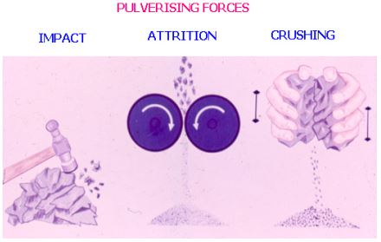

Fig.1. Different types of Pulverizing Forces

**2. 2. Bowl Mill designation**

Suction type mills are designated as XRS whereas pressurized mills as XRP and HP. The nomenclature of each letter is as follows

X - Frequency of power supply (50 cycles /sec)

R - Raymond, the inventor of bowl mills

S - Suction type with exhauster coming after the mill

P - Pressurized type, with primary air fan coming before the mill

H - High Performance mills.

The size of the mill is designated by the three numerical that follow the above. For example, XRP 803 means, it is a Raymond Pressurized Bowl Mill having the nominal bowl diameter of 80 inches with three numbers of rollers grinding assemblies [4]. BHEL supplied mills are all shallow bowl type only.

**2. 3. Major assemblies of Bowl Mills**

**A) Mill drive and Bowl assembly**

The Mill drive and the Bowl assembly consist of the main vertical shaft assembly with bearings, worm gear, worm shaft, worm shaft bearing etc. Lubricant is maintained to the level of the centre line of the worm gear in the Mill base. This lubricates the bearings and Worm Gear- Worm shaft in the Mill Base, when the Mill is in operation. The Bowl Assembly consists of Bull Ring Assembly (Mounted on the Bowl), Skirt Scrapper Assembly and vane wheel assembly (attached to the bowl). In conventional design mills the fixed air guide vanes are provided in place of rotating vane wheel assembly.

**B) Mill Side and Liner Assembly**

The Hot Primary Air required for drying and carrying pulverized coal enters the Mill, in the Mill side and air inlet housing. The Mill side and Liner Assembly are insulated to prevent heat loss from primary air to the atmosphere.

**C) Separator Body Assembly**

The Separator body assembly consists of Journal Pressure Spring Assemblies. Classifier Assembly and Deflector, Intermediate and Journal Frame Liner Assemblies of Vane Wheel Assembly or Separator body liner separator bottom liners and air guide vanes of the conventional design.

**D) Roller Journal Assembly**

The Roller Assembly consists of Journal Shaft, Journal Bearings, Journal Housings, Grinding Roll and Journal Head and Trunnion Shaft Assembly and Vane Wheel Liners for Journal Head and Upper Journal Housing. Three roller assemblies are there in a mill. Lube oil in the Journal Assembly provides Stand Oil Lubrication for the bearings.

**E) Mill Discharge Valve Assembly**

The Mill Discharge Valve Assemblies consists of four Multiport Outlet and Mill Discharge Valves mounted on the multiple port outlet plate. Air Cylinders operate the flaps in the Mill Discharge Valves. Solenoid Valves and Limit Switches are provided to effect and indicate the open or close position of the flap.

**F) Tramp Iron Spout Assembly**

The Tramp Iron Spout Assembly consists of Tramp Iron Spout Body. Tramp Iron Spout Adapter and Valve Gate. This assembly is mounted on Mill base to guide the rejects from the Mill side and Liner Assembly to pyrite Hopper assembly.

**G) Pyrite Hopper Assembly**

The Pyrite Hopper Assembly consists of Pyrite Hopper Body and an outlet valve, which is manually operated. The Pyrite Hopper Body will be mounted with Tramp Iron spout Assembly. Using the outlet valve, the rejects can be removed from Pyrite Hopper through a conveyor or wheel barrow for every half an hour of mill operation. In a pressurized mill before opening the Flap valve of Pyrite Hopper, the Tramp Iron Valve should be closed to prevent hot primary air leaking into the atmosphere.

**2. 4. Design Improvements in Bowl Mills**

The design of CE Raymond Bowl mills, when put into service in Indian Conditions, to grind highly abrasive coals, many problems were faced and reported by the users. Based on the feedback information improvements, design modifications were implemented in a phased manner, with an aim to better the mill performance. The same is detailed below:

**A) Vane Wheel Assembly to Enable Higher Rejects**

A vane wheel assembly fixed to and rotating with the bowl ensures better circulation of the air fuel mixture in the above- bowl area. This reduces localized erosion of the above bowl components and ensures an even mixture. Since the vane wheel mill has more open area around the bowl, it has a better ability to reject unwanted foreign matter. This will improve the life of the mill components and also boiler internals like super heaters, re-heaters, water walls etc. Reduced Velocities also aid in reducing rate of wear and increase primary classification. This action along with modified venturi design has given a better Pulverized fuel fineness at the mill outlet.

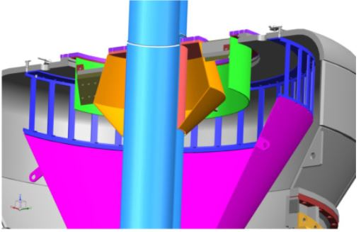

Fig. 2. : Change in Vane Wheel Assembly

**B) Modified Venturi Design**

The Venturi Design has been modified so as to reduce the turbulence in the discharge valve area, which reduces the erosion of the discharge valve assembly. The venturi is itself lined with silicon carbide liners to protect itself from erosion. The multiple port outlets and the valve bodies are lined with suitable liners to enable them combat the erosive pulverized fuel atmosphere.

**C) Contamination of Gear Case Oil**

This is a major problem since replacement of gear case oil is very expensive. The main reason for contamination is Dust Guard seal failure. If the mill is run with excessively worn-out dust guard seal, then chances of primary air entering the gear case are more. If the mill, runs with high spillage the damage can be even worse, since, apart from the ash in the air (assuming poor filtering efficiency of the air filter), coal and other dust can also enter the gear case along with primary air, resulting in oil contamination. To prevent the problem of oil contamination, a mechanical face seal design was introduced in place of dust guard seal design, which prevents dust entry into the gear case and an external lube oil system, which filters out continuously the dust entrapped in the oil. Improved design filters were introduced in the seal air system.

**D) Wear of Mill Internals**

By its very nature, the abrasive coal makes mill internals wear faster. To combat the high abrasive nature of Indian coal with a view to improve the wear life, the material of Classifier vane is changed from Nodular Iron to Ni hard. The separator top, MPO and Journal opening frame are lined with Ni hard liners. The Inner cone is lined with Ceramic tiles. The outlet Venturi and the valve body are also lined with silicon carbide/ ceramic liners. In order to reduce the wear life of the valve disc periphery, a flap type design of MDV assembly is introduced. This design allows the valve disc to be totally removed away from the PF flow path and to be housed in the valve body cover when the valve is kept open.

**E) Failure of Main Vertical Shaft**

This problem was fairly predominant in the case of XRS 603/ XRP 623 mills which was having double taper and was a major issue to be sorted out. The cause of this problem was found to be unequal spring compression or non-operation of one or more springs resulting in unequal loading of MV shaft leading to unbalanced bending moment on the shaft and ultimately breaking it due to fatigue. In order to overcome this failure, a cylindrical shaft was designed and installed which proved successful. The same is now being provided in the gearbox of higher size mills (upto XRP 1003 size).

**F) Oversize Classifier**

The oversize classifier or the tall top classifier mills, design has been introduced in the XRP mills, taking it from the HP series mills, so as to get improved fineness of the pulverized fuel, thereby reducing the carbon loss in the furnace bottom ash and fly ash.

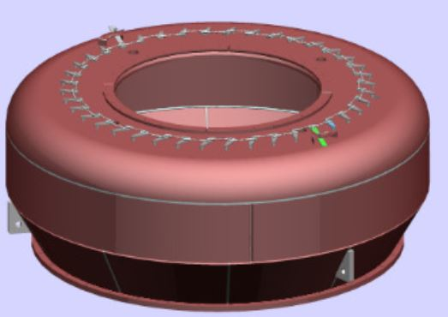

Fig. 3. : Oversize Classifier

1. **Conclusion**

In this work, the types of pulverisers used for the grinding of coal into fine particles are discussed. Bowl Mills are discussed in particular as they are manufactured at BHEL, Hyderabad. The design improvements which should be used to improve the efficiency of the mill is discussed with necessary arrangements and improvements.

**Acknowledgements**

I would like to thank BHEL, Hyderabad, especially Mr. Eswar Prasad, Sr. Engineer Spares Planning. for their unconditional support for completing this project.

**References**

1. PMV Subbarao, Professor, Mechanical Engineering, IITD, web.iitd.ac.in/~pmvs/courses/mel725/mel725-40.ppt
2. https://en.wikipedia.org/wiki/Pulverizer
3. Arvos group, <http://www.arvos-group.com/media/1214/raymond-hp-bowl-mill.pdf>
4. BHEL Maintenance Book