**Numerical analysis of heat transfer and pressure drop characteristics for the plate-fin and tube heat exchanger**

**P.V.Durga Prasad1a*, R.Venkateswar Rao2b, M.Sreeramul3c**

*aMechanical Engineering, M.V.S.R.Engineering College, Hyderabad 501510, Telangana, India*

*b Mechanical Engineering, Vignana Bharathi Engineering College, Hyderabad 501510, Telangana, India*

*cMechanical Engineering, Hyderabad Institute of Science &Technology, Hyderabad 510510, India*

*Corresponding author Email: [_pvdurgap@gmail.com](mailto:_pvdurgap@gmail.com)

ABSTRACT

The heat transfer and pressure drop characteristics of plate-fin and tube heat exchanger are analyzed by using numerical simulation. The parameters that are considered in the analysis, which uses the commercially available computational fluid dynamics (CFD) software FLUENT, are the space between two fins, length of the fin and tube ellipticity. Seven different cases are studied. The main findings are related to the spacing between the fins, which is critical in terms of pressure drop, and the tube ellipticity – its increase enhances the heat transfer and reduces the pressure drop.

***Keywords*:** plate-fin and tube exchanger, numerical analysis, tube ellipticity, pressure drop.

1. **Introduction**

Plate fin and tube heat exchanger is a cross-flow heat exchanger that uses plates as fins is shown in Fig.1; therefore, the flow external to the tubes is unmixed. Often, it is categorized as a compact heat exchanger to emphasize its relatively high heat transfer surface area to volume ratio. The plate fin and tube heat exchanger is widely used in many industries, including the aerospace industry, for its compactness and low weight. Different types of fin patterns, in addition to the plate, exist, such as louver, convex-louver, and wavy; however, in general, the plate fin tends to be the best in terms of performance and of constructional effectiveness. The tube geometry used in plate fin and tube heat exchangers is either circular or elliptical. The majority of the studies dealing with plate fin and tube heat exchangers have been conducted resorting to experiments.

Shepherd [1] analyzed early experimental data for heat transfer of plate fin and circular tube heat exchanger. Later on, Schulemberg [2] extended the analysis to plate fin and elliptical tubes. Kayansayan [3] investigated experimentally the effects of the outer surface geometry on the performance of flat plain fin and circular tube heat exchangers with four-row coils. Jang et al. [4] studied fluid flow and heat transfer over a multi-row (1–6 rows) plate-fin and tube heat exchanger both numerically and experimentally. They considered effects of different geometrical parameters such as tube arrangement, tube row numbers and fin pitch (8–12 fins per inch) for the Reynolds number (based on the fin spacing and the frontal velocity) ranging from 60 to 900 and observed an average heat transfer coefficient of staggered arrangement is 15%–27% higher than that of in-lined arrangement, while the pressure drop of staggered configuration is 20%–25% higher than that of in-lined configuration. Wang et al. [5] investigated experimentally heat transfer and pressure drop for plate fin and tube heat exchanger. Beecher and Fagan [6] reported heat transfer data for twenty wavy geometries. Kays and London [7] analyzed heat transfer and pressure drop of heat exchanger with louvered fins. Achaichia and Cowell [8] experimentally studied the heat transfer and pressure drop of tube and louvered fin surfaces; later on the same authors [9] conducted a numerical study for flow in the laminar regime. Webb and Trauger [10] performed a flow visualization study of the louvered fin geometry with a flat tube. Sahnoun and Webb [11] developed an analytical model for predicting air-side heat exchanger performance of louvered fin geometry. Rocha et al. [12] experimentally estimated the overall heat transfer coefficient of plate fin heat exchangers by considering circular and elliptical tubes. Kundu and Das [13] conducted a dimensional optimization for plate fin and tube heat exchangers with equilateral staggered triangular and rectangular pitch. Romero-Mendez et al.[14] used numerical techniques to estimate the effect of spacing between fins on heat transfer and pressure drop for single row fin and tube heat exchanger. Wang and Chi [15] experimentally analyzed the effect of tube rows, fin pitch, and tube diameter on heat transfer and pressure drop for plate fin and tube heat exchanger. Wang et al. [16] presented correlations of the Colburn and friction factors for plate fin and tube heat exchangers. Saboya and Saboya [17] determined the average heat transfer coefficient for plate fin and elliptic tube heat exchangers using the naphthalene sublimation technique. Torikoshi et al. [18] numerically investigated a plain fin and tube heat exchanger. Erek et al. [19] numerically investigated the effect of fin geometry on heat transfer and pressure drop for plate fin and tube heat exchangers, but they used one particular mass flow rate of the flue gas. Abu Madi et al. [20] determined the effect of geometrical parameters of flat and corrugated fins and the results are presented in terms of Colburn and friction factors.

The present work is focused on the numerical investigation estimation of heat flow, pressure drop, temperature and velocity fields for the plate fin and tube heat exchanger with one row tube configuration; the analysis will be focused on the effect of fin spacing, ellipticity and fin height on the numerically predicted parameters.

1. **Numerical Simulation**
   1. Physical Model

The numerical solutions were carried out using the Computational Fluid Dynamics software package FLUINT 6.0 that uses the finite-volume method to solve the governing equation. The plate-fin and tube heat exchanger, which is the object of the present study, is schematically depicted in Fig.1.The various fin geometries and its dimensions used in this analysis are shown in Table 1. The computational flue gas flow passage is determined by the spacing of the fins and the distance between the centers of the tube for each consecutive pass. The fins are equidistant and the flow area shown in Fig. 2 is assumed to be representative of the overall flow passage. The GAMBIT software is used to model the computational domain and its meshed view is shown in Fig. 3. The inlet boundary condition for the flue gas is given by the velocity (0.5, 0.75 and 1.0 m/s) and temperature (1000 K), and the outlet boundary condition is the pressure and no variation of the temperature in the stream wise direction. The flue gas is assumed to have the properties of air. The cooling fluid circulating in the tube is water and it is considered to be fully developed turbulent flow. The convective heat transfer between the tube and fin is calculated using Gnielinski equation [21], which is given as:

$Nu=\frac{\left(\frac{f}{2}\right)\left(R-1000\right)Pr}{1+12.7{\left(\frac{f}{2}\right)}^{\frac{1}{2}}\left({Pr}^{\frac{2}{3}}-1\right)}$ (1)

$f={\left(1.58ln\left(Re\right)-{3.82}\right)}^{-2}$, 2300 < Re106, 0.5 < Pr < 2000

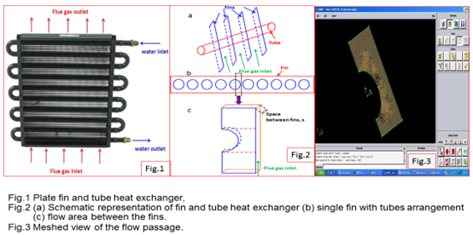

The no-slip boundary condition is applied to the tube and the plate fins. The remaining computational boundaries take a symmetry condition. The materials of the tube and plate fins are copper.

2.2 Numerical Method

The process is assumed to be in steady state and the governing equations describing conservation of mass, momentum and energy are expressed in vector form as follows [22]:

Continuity equation:

$\frac{∂p}{∂t}=∇.\left(ρU\right)=0$ (2)

where ρ is the fluid density, t is the time and U is the flow velocity vector field.

Momentum equation:

$\frac{∂\left(∂\overset{⃑}{U}U\right)}{∂t}+∇\left(ρ\overset{⃑}{U}U\right)=-∇P+∇τ+B$ (3)

Where P, τ and B are pressure, stress term, and the sum of the body forces, respectively.

Energy equation:

$\frac{∂\left(∂h\right)}{∂t}+∇\left(ρUC_{p}T\right)=∇.\left(k∇T\right)$ (4)

Where ρ is the density, h is the enthalpy and k is the effective thermal conductivity.

K–ε model:

The standard k–ε model [23] was used to describe the turbulence. The transport equations for the turbulent kinetic energy and turbulent kinetic energy dissipation are given as follows:

$\frac{∂\left(ρkU_{j}\right)}{∂x_{j}}=\frac{∂}{∂x_{j}}\left[(μ+\frac{μ_{t}}{σ_{k}})\frac{∂k}{∂x_{j}}\right]+μ_{t}\left(\frac{∂u_{i}}{∂u_{j}}+\frac{∂u_{j}}{∂x_{i}}\right)\frac{∂u_{j}}{∂x_{i}}-ρε$ (5)

$\frac{∂}{∂x_{j}}\left(ρεU_{j}\right)=\frac{∂}{∂x_{j}}\left[(μ+\frac{μ_{t}}{σ_{ε}})\frac{∂ε}{∂x_{j}}\right]-ρC_{2}\frac{ε^{2}}{K+\sqrt{ϑε}}$ (6) Where, σ k and σ ε are the turbulent Prandtl numbers for the turbulent kinetic energy and its

dissipation. Turbulent kinetic energy (k) and its dissipation rate (ε) are coupled to the $\left(μ_{t}=ρC_{μ}\frac{k^{2}}{ε}\right)$ value as in the standard k –ε model. The empirical constants, C2, σ k and σ ε are equal to 1.9, 1.0 and 1.3, respectively [24].

The transport equations (5) and Eq. (6), after their discretization are solved sequentially along with the discretized conservation equations. The discretization of the transport equations and conservation equations is conducted using the finite volume method [23] along with a second-order upwind scheme. The continuity equation and momentum equation are solved through an iterative scheme by using the coupling between pressure and velocity is employed through the Semi-Implicit Method for Pressure-Linked Equations (SIMPLE) algorithm [25].

1. **Results and Discussion**
   1. Static temperature: Simulations were conducted for different parameters to determine the static temperature and total pressure fields. Three different velocities of flue gas (0.5 m/s, 0.75 m/s, 1.0 m/s) for all cases studied. The static temperature field for the three velocities for fin spacing is 0.5 mm and tube ellipticity of 1 is reported in Fig. 4 (a-c). It is observed that the velocity of flue gas increases, the outlet temperature of flue gas also increases; the outlet temperatures are 341 K, 362 K and 380 K respectively. The effect of fin spacing is also analyzed with three fin spacing of 0.5 mm, 0.6 mm and 0.7 mm. The static temperature field for each of the three tested flue gas inlet velocities (0.5 m/s, 0.75 m/s and 1.0 m/s) is reported in Fig. 4 (d-f) for a fin spacing, s, 0.6 mm and tube ellipticity, a/b, equal to 1. The outlet temperatures are 343 K, 362 K and 381 K for the inlet velocities of 0.5 m/s, 0.75 m/s and 1.0 m/s, respectively; these results are equal or slightly higher than those for the fin spacing of 5 mm, a finding, which is physically consistent, considering the slight reduction in mixing and consequent reduction in turbulence. The static temperature field for the three inlet velocities with a fin spacing, s, of 0.7 mm and tube ellipticity, a/b, equal to 1, presents a similar trend, namely, 346 K, 367 K, and 386 K for the inlet velocities of 0.5 m/s, 0.75 m/s and 1.0 m/s, respectively; the results are presented in Fig. 4 (g-i). Therefore, it can be said that an increase in grid spacing will lead to a decrease of the difference between the inlet and outlet temperature.

**Table 1** Different fin cases used in this study

|  |  |  |  |  |  |  |  |
| --- | --- | --- | --- | --- | --- | --- | --- |
| **Cases** | **No** | **Velocity, (m/s)** | **L** | **L1** | **L2** | **Spacing (s)** | **Ellipticity, b/a** |
| **Effect of fin spacing, different flow rates at ellipticity, b/a = 1** | | | | | | | |
| Case – 1 | 1 | 0.5 | 35 | 17 | 15.1 | 0.5 | 1 |
| 2 | 0.75 | 35 | 17 | 15.1 | 0.5 | 1 |
| 3 | 1.0 | 35 | 17 | 15.1 | 0.5 | 1 |
| Case – 2 | 1 | 0.5 | 35 | 17 | 15.1 | 0.6 | 1 |
|  | 2 | 0.75 | 35 | 17 | 15.1 | 0.6 | 1 |
|  | 3 | 1.0 | 35 | 17 | 15.1 | 0.6 | 1 |
| Case – 3 | 1 | 0.5 | 35 | 17 | 15.1 | 0.7 | 1 |
|  | 2 |  |  | 17 | 15.1 | 0.7 | 1 |
|  | 3 | 1.0 | 35 | 17 | 15.1 | 0.7 | 1 |
| **Effect of ellipticity (b/a), different flow rates at fin spacing, s = 0.5** | | | | | | | |
| Case – 4 | 1 | 0.5 | 35 | 17 | 15.1 | 0.5 | 0.75 |
|  | 2 | 0.75 | 35 | 17 | 15.1 | 0.5 | 0.75 |
|  | 3 | 1.0 | 35 | 17 | 15.1 | 0.5 | 0.75 |
| Case – 5 | 1 | 0.5 | 35 | 17 | 15.1 | 0.5 | 0.5 |
|  | 2 | 0.75 | 35 | 17 | 15.1 | 0.5 | 0.5 |
|  | 3 | 1.0 | 35 | 17 | 15.1 | 0.5 | 0.5 |
| Case – 6 | 1 | 0.5 | 35 | 17 | 15.1 | 0.5 | 1.25 |
|  | 2 | 0.75 | 35 | 17 | 15.1 | 0.5 | 1.25 |
|  | 3 | 1.0 | 35 | 17 | 15.1 | 0.5 | 1.25 |
| **Effect of L2, different flow rates at fin spacing, s = 0.5** | | | | | | | |
| Case – 7 | 1 | 0.5 | 35 | 17 | 18.1 | 0.5 | 1 |
|  | 2 | 0.75 | 35 | 17 | 18.1 | 0.5 | 1 |
|  | 3 | 1.0 | 35 | 17 | 18.1 | 0.5 | 1 |

Based on the temperature profiles, the amount of heat flow through the fin is calculated from the below equation and the values are presented in Table 2.

Q= kA (∆ T) (7)

From the Table 2, the ellipticity of the tube b/a = 1 and at flow rate of 0.5 m/s, the highest heat flow through fin is achieved. Whereas the ellipticity of the tube b/a = 0.5 and at flow rate of 1.0 m/s, the lowest heat flow through fin is achieved.

**Table 2** Heat flow through the fin at various fin geometry

|  |  |  |  |  |  |  |  |  |
| --- | --- | --- | --- | --- | --- | --- | --- | --- |
| Case | No. | Velocity, (m/s) | L | L1 | L2 | Spacing (s) | Ellipticity, b/a | Heat flow, Q (W) |
| Effect of fin spacing, different flow rates at ellipticity, b/a = 1 | | | | | | | | | |
| Case – 1 | 1 | 0.5 | 35 | 17 | 15.1 | 0.5 | 1 | 33.49 |
| 2 | 0.75 | 35 | 17 | 15.1 | 0.5 | 1 | 32.67 |
| 3 | 1.0 | 35 | 17 | 15.1 | 0.5 | 1 | 31.91 |
| Case – 2 | 1 | 0.5 | 35 | 17 | 15.1 | 0.6 | 1 | 41.04 |
|  | 2 | 0.75 | 35 | 17 | 15.1 | 0.6 | 1 | 40.05 |
|  | 3 | 1.0 | 35 | 17 | 15.1 | 0.6 | 1 | 39.00 |
| Case – 3 | 1 | 0.5 | 35 | 17 | 15.1 | 0.7 | 1 | 47.72 |
|  | 2 | 0.75 | 35 | 17 | 15.1 | 0.7 | 1 | 46.40 |
|  | 3 | 1.0 | 35 | 17 | 15.1 | 0.7 | 1 | 45.17 |

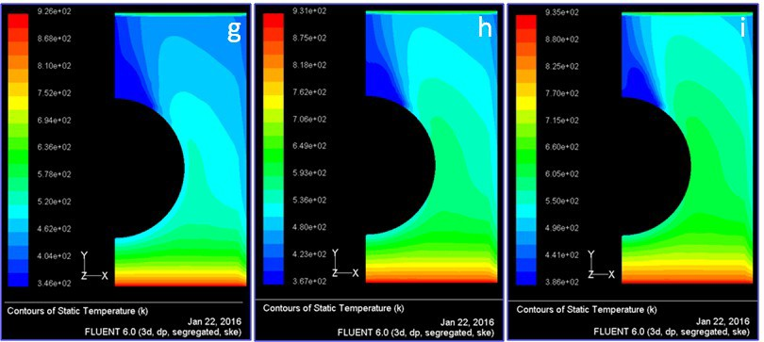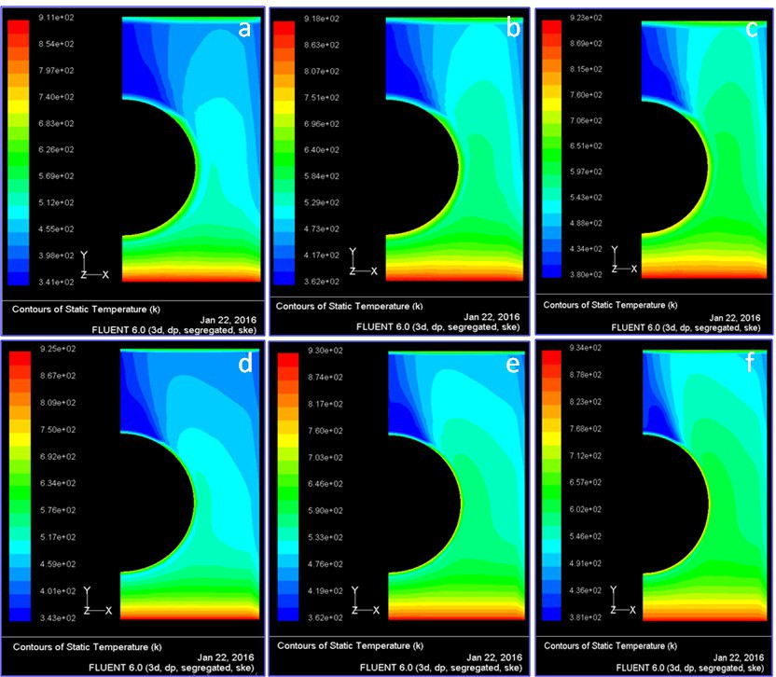

**Fig. 4** Static temperature contours when the tube ellipticity, a/b = 1 with effect of space between the fins (a) s = 0.5, v = 0.5 m/s (b) s = 0.5, v = 0.75 m/s (c) s = 0.5, v = 1.0 m/s (d) s = 0.6, v = 0.5 m/s (e) s = 0.6, v = 0.75 m/s (f) s = 0.6, v = 1.0 m/s (g) s = 0.7, v = 0.5 m/s (h) s = 0.7, v = 0.75 m/s (i) s = 0.7, v = 1.0 m/s

3.2 Total pressure contours: The total pressure is the pressure measured by bringing the flow to rest isentropically (without loss). The total pressure contours (Pa) at velocity of flue gases 0.5 m/s, 0.75 m/s and 1.0 m/s at fin spacing, s = 0.5 mm and at tube ellipticity, a/b = 1 were shown in Fig. 7 (a-c). It is observed from the figure, with the increase of velocity of flue gases increases,

The total pressure drop across the flow area for all the cases are summarized in Table. 3.

**Table 3** Pressure drop through the fin at various fin geometry

|  |  |  |  |  |  |  |  |  |
| --- | --- | --- | --- | --- | --- | --- | --- | --- |
| Case | No. | Velocity,  (m/s) | L | L1 | L2 | Spacin  g (s) | Ellipticity,  b/a | Total pressure  drop (Pa) |
| Effect of fin spacing, different flow rates at ellipticity, b/a = 1 | | | | | | | | |
| Case – 1 | 1 | 0.5 | 35 | 17 | 15.1 | 0.5 | 1 | 0.872 |
| 2 | 0.75 | 35 | 17 | 15.1 | 0.5 | 1 | 1.700 |
| 3 | 1.0 | 35 | 17 | 15.1 | 0.5 | 1 | 2.932 |
| Case – 2 | 1 | 0.5 | 35 | 17 | 15.1 | 0.6 | 1 | 0.725 |
|  | 2 | 0.75 | 35 | 17 | 15.1 | 0.6 | 1 | 1.301 |
|  | 3 | 1.0 | 35 | 17 | 15.1 | 0.6 | 1 | 2.26 |
| Case – 3 | 1 | 0.5 | 35 | 17 | 15.1 | 0.7 | 1 | 0.702 |
|  | 2 | 0.75 | 35 | 17 | 15.1 | 0.7 | 1 | 1.349 |
|  | 3 | 1.0 | 35 | 17 | 15.1 | 0.7 | 1 | 2.323 |

1. **Conclusions**

The study consists of several cases of fin geometry such as fin tube center, fin height; fin spacing and tube ellipticity are investigated, numerically. The following conclusions are drawn from the analysis. The distance between fins has an important effect on pressure drop. For the fin geometry with ellipticity value of 0.75 has the smallest static and total pressure drops. Since flue gas velocity is decreased, the lower pressure drop value is obtained. The ellipticity of the tube b/a = 1.25 and at flow rate of 1.0 m/s, the highest pressure drop across the fin is achieved. The ellipticity of the tube b/a = 1 and at flow rate of 0.5 m/s, the highest heat flow through fin is achieved. Whereas the ellipticity of the tube b/a = 0.5 and at flow rate of 1.0 m/s, the lowest heat flow through fin is achieved. Greater heat transfer and pressure drop values are obtained as the fin height is increased, due to the increased heat transfer surface area. The decrease in tube spacing causes the increase in heat transfer and decrease in pressure drop. As ellipticity increases in a tube, the heat transferred across a heat exchanger increases.

**REFERENCES**

**1. Journal article**

[1] D.G. Shepherd, Performance of one-row tube coils with thin-plate fins, low velocity forced convection, Heating, Piping Air Cond. 28 (1956) 137-144.

[2] F. Schulemberg, Finned elliptical tubes and their applications in air-cooled heat exchangers, J. Eng. Ind. 88 (1966) 179-190.

[3] N. Kayansayan, Heat transfer characterization of flat plain fins and round tube heat exchangers, Exp. Thermal Fluid Science 6 (1993) 263-272.

[4] J.Y. Jang, M.C. Wu, W.J. Chang, Numerical and experimental studies of three- dimensional plate fin and tube heat exchangers, Int. J. Heat Mass Transfer 39 (1996) 3057-3066.

[5] C.C. Wang, Y.J. Chang, Y.C. Hsieh, Y.T. Lin, Sensible heat and friction characteristics of plate fin-and-tube heat exchangers having plate fins, Int. J. Refrigeration 19 (1996) 223-230.

[8] A. Achaichia, T.A. Cowell, Heat transfer and pressure characteristics of flat tube and louvered plate fin surfaces, Exp. Thermal Fluid Science 1 (1988) 147-157.

[10] R.L. Webb, P. Trauger, Flow structure in the louvered fin heat exchanger geometry, Exp. Thermal Fluid Science 4 (1991) 205-217.

[11] A. Sahnoun, R.L. Webb, Prediction of heat transfer and friction for the louver fin geometry, J. Heat Transfer 114 (1992) 893-900.

[12] L.A.O. Rocha, F.E.M. Saboya, J.V.C. Vargas, A comparative study of elliptical and circular sections in one and two row tubes and plate fin heat exchangers, Int. J. Heat Fluid Flow 18 (1997) 247-252.

[13] B. Kundu, P.K. Das, Optimum dimensions of plate fins for fin-tube heat exchangers, Int. J. Heat Fluid Flow 18 (1997) 530-537.

[14] R. Romero-Mendez, M. Sen, K.T. Yang, R. McClain, Effect of fin spacing on convection in a plate fin and tube heat exchanger, Int. J. Heat Mass Transfer 43 (2000) 39-51.

[15] C.C. Wang, K.Y. Chi, Heat transfer and friction characteristics of plain fin-and-tube heat exchangers, part I: new experimental data, Int. J. Heat Mass Transfer 43 (2000) 2681-2691.

[16] C.C. Wang, K.Y. Chi, C.J. Chang, Heat transfer and friction characteristics of plain fin-and-tube heat exchangers, part II: Correlation, Int. J. Heat Mass Transfer 43 (2000) 2693-2700.

[17] S.M. Saboya, F.E.M. Saboya, Experiments on elliptic sections in one and two row arrangements of plate fin and tube heat exchangers, Exp. Thermal and Fluid Science 24 (2001) 67-75.

[19] A. Erek, B. Ozerdem, L. Bilir, Z. Ilken, Effect of geometrical parameters on heat transfer and pressure drop characteristics of plate fin and tube heat exchangers, Applied Thermal Engineering 25 (2005) 2421-2431.

[20] M. Abu Madi, R.A. Johns, M.R. Heikal, Performance characteristics correlation for round tube and plate finned heat exchangers, Int. J. Refrigeration 21 (1998) 507-517.

[21] V. Gnielinski, New equations for heat and mass transfer in turbulent pipe and channel flow, International Chemical Engineering 16 (1976) 359-368.

[22] H.K. Versteeg, W. Malalasekera, An introduction to computational fluid dynamics: The Finite Volume Method, John Wiley & Sons Inc., New York, 1995.

[23] T. Shih, W.W. Liou, A. Shabbir, Z. Yang, J. Zhu, A new k-ε eddy viscosity model for high Reynolds number turbulent flows, Computational Fluids 24 (1995) 227-238.

[24] B.E. Launder, B.I. Sharma, Application of the energy-dissipation model of turbulence to the calculation of flow near a spinning disc, Letters in Heat Mass Transfer 1 (1974) 131–138.

**2. Books**

[6] D.T. Beecher, T.J. Fagan, Effects of fin pattern on the air-side heat transfer coefficient in plate finned-tube heat exchangers, ASHRAE Transactions 93 (1987) 1961-1984.

[7] W.M. Kays, A.L. London, Compact Heat Exchangers, 3rd Eds., McGraw-Hill, New York, 1984.

[25] S.V. Patankar, Numerical heat transfer and fluid flow, Hemisphere Publishing Corporation, USA, 1980.

**3. Conference Proceedings**

[9] A. Achaichia, T.A. Cowell A finite difference analysis of fully developed periodic laminar flow in inclined louver arrays. In: Proceedings of the 2nd U.K. National Heat Transfer Conference, Glasgow, UK 2 (1988) 883-888.

**4. Conference Paper**

[18] K. Torikoshi, G. Xi, Y. Nakazawa, H. Asano, Flow and heat transfer performance of a plate fin and tube heat exchanger (1st report: effect of fin pitch), in: 10th Int. Heat Transfer Conference (1994) 411-416.