Simulation Study on Influence of Blank Alignment in Deep Drawing of Circular Cups

A C Sekhara Reddya,1,*, S Rajeshamb,*, PRavinder Reddyc,C Bhaskara Reddyd

*aResearc Scholer, Dept. Of Mechanical Engineering, Osmania University,Hyderabad,Telangana*

*1Dept. of Mechanical Engg, Sreyas Institute of Engineering and Technoloy. Hydeerabad, 500013, India*

*bDept. of Mechanical Engineering, RGUKT-Basar, Telangana, India*

*cMechanical Engineering, CBIT, Hyderabad, India*

*dMechanical Engineering, SKIET, Tirupati, Andhra Pradesh, India*

*Corresponding author Email: acsreddy64@gmail.com

------------------------------------------------------------------------------------------------------------------

The blank alignment in deep drawing process is very much essential for the draw of quality parts. The Finite Element Analysis (FEA) can be used to predict the forming quality of various sheet metal forming processes such as deep drawing. FEA also helps to enhance the efficiency of the forming process, lowers the development time and the cost. The deep drawing tests through numerical simulation were conducted to determine the effect of blank alignment error with the center of the die and punch tool assembly. The deep drawing tests were conducted on AA6111 aluminum alloy with 2.5 mm, 5 mm, 7.5 mm and 10 mm alignment error. The deep drawing process was simulated using the FE code PAM-STAMP. Having knowledge on error tests helps to take preventive measures for proper alignment in drawing of defect-free parts.

***Keywords*:** Deep drawing, Blank alignment error, FE simulation, PAM-STAMP

1. **Introduction**

The deep-drawing process is extensively used in various industrial applications such as beverages, automobile, and household applications. The experience gained in past years is being used in present days for the design of new and complex parts. The optimization process with a good understanding of the process and the parameters involved using finite element methods lead to the considerable saving of time and money at initial stages of the design. The deep drawing has been studied for a betterunderstanding of experimental tests as well as numerical simulation tests [1,2].

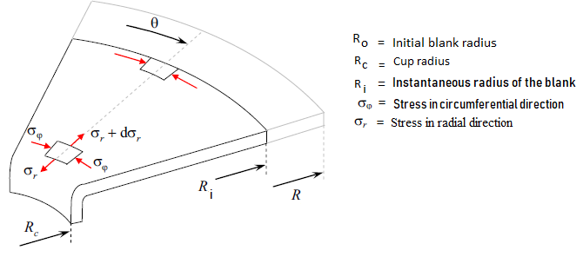

Fig. 1. Stress state in flange portion during deep drawing

The stresses and strains induced in different zones of the blank during the forming are the main reasons for the failure of the component. The stress state in deep drawing process is really a complex phenomenon, involving compression in the circumferential direction and tensile stresses in the longitudinal direction as shown in Fig. 1. The wrong design results in defective parts and deflections of the toolset. A procedure was discussed how to include deformations of toolsets in standard forming simulation at low additional computational cost, using PAM-STAMP by Mark Vrolijk et al[3].

1. **Modeling of Tool Setup**

In the present days, the use of 3D modelingsoftware such as inventor, solid works, Pro-engineer and CATIA has been increased drastically in the design of the tool and die set. The modeling of deep drawing process setup was done with the use of computer-aided design tool, CATIA V5.The functional surfaces of the tool were created and saved in *.igs format and it was imported into PAM-STAMP 2G software for numerical simulation. The material considered wasAA6111 aluminum alloy with 0.9 mm of thickness. The tool setup modeled was as shown in Figure.1 and tool measurements considered for design are shown in Table.1. The mesh was created by choosing the proper size of the element that mainly influences on time of computation and quality[4]. The size of the blank considered in the study was 120 mm. The tests were conducted with intentional misalignment of blank with toolset by 0 mm, 2.5 mm, 5 mm, 7.5 mm and 10 mm to know the effect of alignment error on physical and mechanical properties of the component generated.

Table.1: Tool parameters used for modeling and simulation

|  |  |  |
| --- | --- | --- |
| Tool | Parameter | Qty |
| Punch | Diameter | 80.0 mm |
| Nose radius | 5.5 mm |
| Die | Diameter | 81.5 mm |
| Shoulder radius | 5.50 mm |
| Blankholder | Inner diameter | 85.0 mm |
| Outer diameter | 250.0 mm |
| Blank | Diameter | 120 mm |
| Thickness | 0.9 mm |
| Young’s modulus | 70Gpa |
| Poison’s ratio | 0.3 |
| Plasticity law | Hill |
| Material type | isotropic |
| Hardening law | Holloman |

1. **Simulation Tests**

The simulation process consists of pre-processing, analysis/simulation and post-processing. The pre-processing consists of designing the model of the physical problem. The simulation, which normally is run as a background process, is the stage in which PAM-STAMP solves the numerical problem. Depending on the complexity of the problem and the configuration of the computer, the simulation may take a few seconds to days. In post-processing, one can evaluate the results of the simulation, such as stresses and strains contours, animation of the forming process and the deformed shape of the blanks etc.

The size and type of element to be used in the analysis influence the results and 5 mm mesh size was used for reasonable accuracy. The degree of freedom in all Cartesian coordinates for die and in X and Y coordinates for punch were locked. Applying constraints for tool movements is locking the degree of freedom in some directions, i.e., movement of the punch restricted to z direction. The tools i.e. punch, die and blank holder, in finite element simulation are considered as rigid bodies because they are of extrete stiff compared to the sheet. For this reason the tool can be presented as a surface only [5, 6, 7].The blank holder force depends on the material properties, drawing ratio and the geometry of the cup to be drawn. The excessive blankholder force leads to thinning and low value leads to wrinkling. A constant blankholder force of 50N and a constant punch force of 3000 N is applied. The figure 2 shows the CAD model used for simulation tests.In post processing the various characteristics were investigated from the results obtained from simulation. Figures3 to 7shows the FLD plots showing the wrinkling tendency.

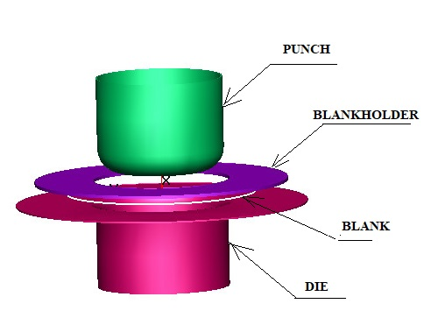

Fig.2. Modelled tool setup for deep drawing

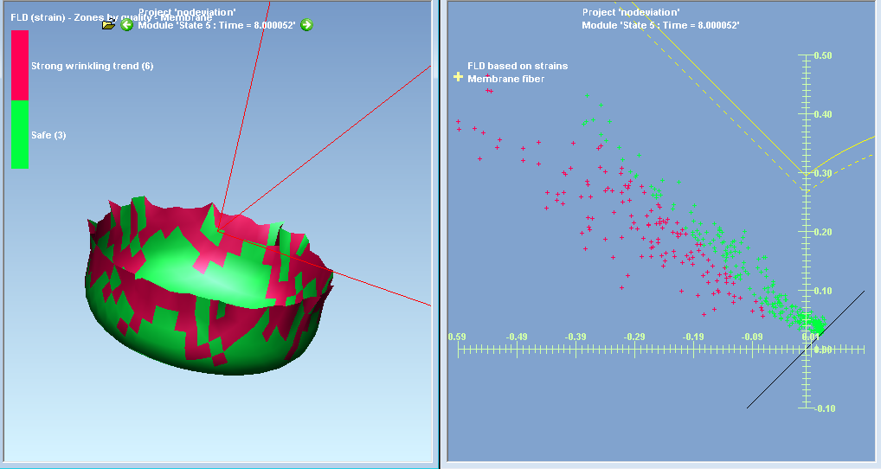

Fig. 3. FLD based strain diagram and the zones of wrinkling tendency with zero alignment error

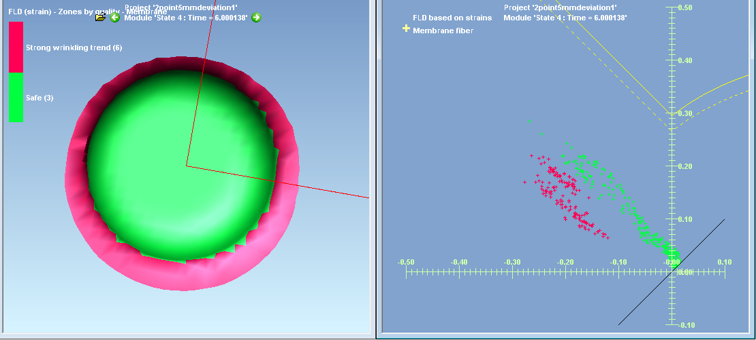

Fig. 4. FLD based strain diagram and the zones of wrinkling tendency in 2.5 mm error test

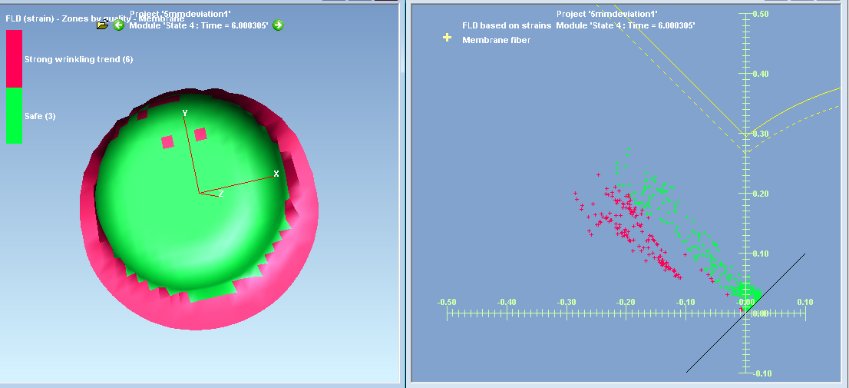

Fig. 5. FLD based strain diagram and the zones of wrinkling tendency in 5 mm error test

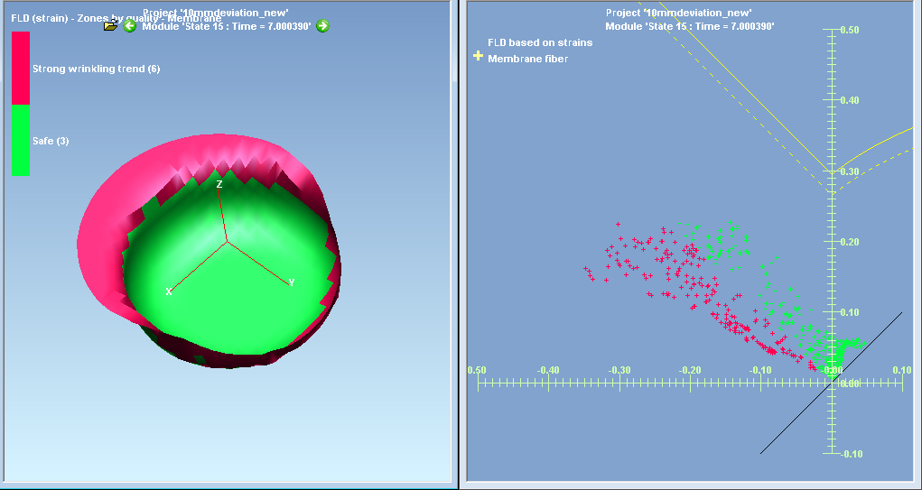

Fig. 6. FLD based strain diagram and the zones of wrinkling tendency in 7.5 mm error test

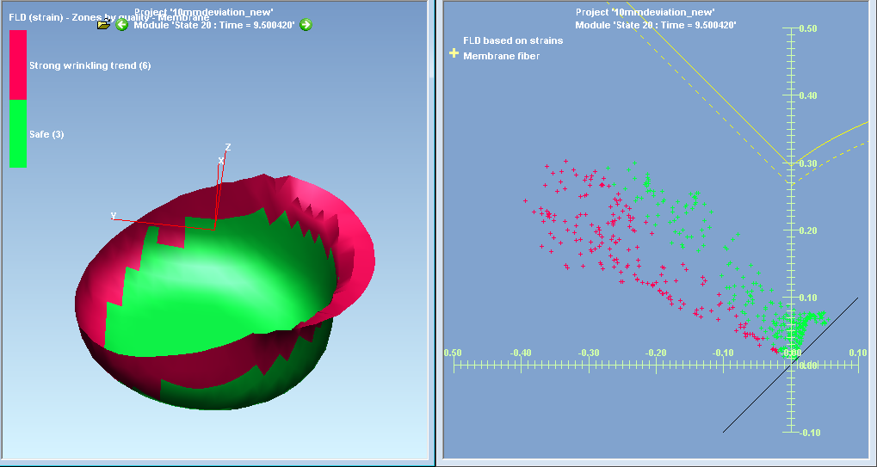

Fig. 7. FLD based strain diagram and the zones of wrinkling tendency in 10 mm error test

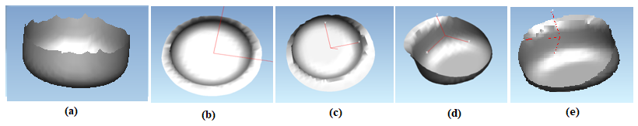

Fig.8. Simulated cups in deep drawing with different alignment errors

Table 2. Maximum and minimum stress and strain values recorded from simulation tests

|  |  |  |  |  |  |  |
| --- | --- | --- | --- | --- | --- | --- |
| Blank deviation | | Zero deviation | 2.5 mm deviation | 5.0 mm deviation | 7.5 mm deviation | 10.0 mm deviation |
| Minor stress GPa | Min. | 0.240665 | 0.143634 | 0.085612 | -0.20112 | -0.47858 |
| Max. | 0.195565 | 0.188317 | 0.210781 | 0.352071 | 0.45099 |
| Major stressGPa | Min. | -0.03934 | -0.0275 | -0.02085 | -0.18434 | -0.33226 |
| Max. | 0.311012 | 0.314864 | 0.367124 | 0.469813 | 0.724431 |
| Vonmises stress  GPa | Min | 0.001934 | 0.004875 | 0.036241 | 0.03288 | 0.060316 |
| Max. | 0.377717 | 0.36475 | 0.354328 | 0.382752 | 0.423107 |
| Equivalent strain | Min. | 0.44315 | 0.138741 | 0.028431 | -0.05121 | -0.42552 |
| Max. | 0.849318 | 0.721351 | 0.67721 | 0.657873 | 0.605192 |

The thickness is not uniformly distributed in the part produced in deep drawing. It was uniform at the bottom, least at the wall and thicker at flange area. But, due to the incorporation of alignment error in the process, the thickness was unevenly distributed throughout the cup irrespective of bottom, wall and flange part [8,9,10]. It was observed that the cup formed is not uniform and the strain diagram shows that the strain at bottom of the cup is less than at the top of the cup in comparison to the punch nose region. The cup has tendency to fail in further deformation at punch nose region. As the cup is fully drawn in this case, and found that the strains at the top of the cup is comparatively less than at the punch nose region. The FLD diagram shows that, the top region of the cup was subjected to more negative strain i.e., compressive strain. At the bottom region the minor and major strains are equal as the blank at the canter can be subjected to biaxial strains. Figure 8 shows the simulated cups produced in different error tests. The Table 2 and fig. 9 to 12 gives the various forming properties found from the simulation tests.

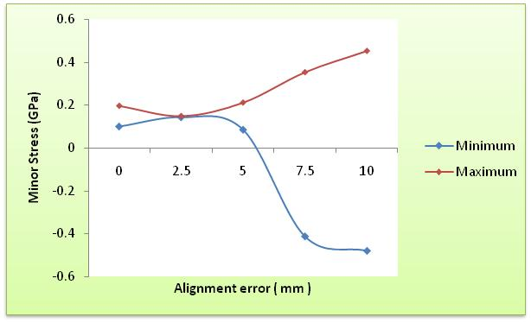

Fig. 9. Minor stresses with alignment error of nil, 2.5 mm, 5 mm, 7.5 mm and 10 mm

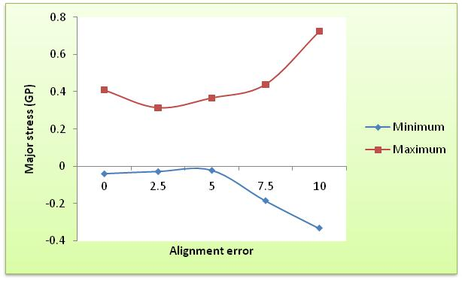

Fig. 10. Major stresses with alignment error of nil, 2.5 mm, 5 mm, 7.5 mm and 10

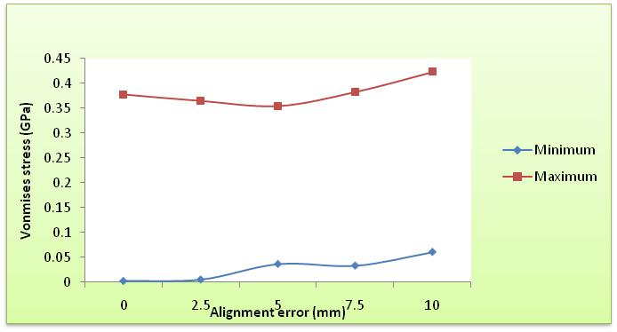

Fig. 11. Vonmises stresses with alignment error of nil, 2.5 mm, 5 mm, 7.5 mm and 10 mm

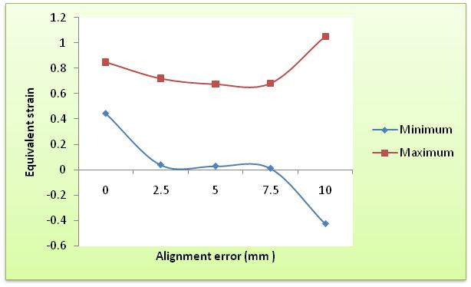

Fig. 12. Equivalent strains for alignment error of nil, 2.5 mm, 5 mm, 7.5 mm and 10 mm

1. **Conclusion**

Using the numerical simulation, it was pointed out that the variation in the centre of blank to the centre of the tool setup has a significant influence on quality of the drawn part. It was observed that the minor stress, major stress and equivalent strain values changes drastically for the errors 5 mm and above. So, it is very much essential to take proper care during blank placing in the deep draw tool setup for having uniform quality characteristics for 80 mm size cup production.

**References**

1.Ngoc-Trung Nguyen, Oh Suk Seo, Chung An Lee, Myoung-Gyu Lee, Ji-hoon Kim, and Heon Young Kim. Mechanical behaviour of az31b mg alloy sheets under monotonic and cyclic loadings at room and moderately elevated temperatures. Materials, 7(2), 1271–1295 (2014)

2. Young Moo Heo, Sung Ho Wang, Heon Young Kim and Dae Gyo Seo. The effect of the drawbead dimensions on the weld line movements in the deep drawing of tailor –welded blanks, Journal of material processing Technology, 113, 686-691 (2001)

3. Mark Vrolijk, Takayuki Ogawa, Arthur Camanho, Manfredi Biasutti, and David Lorenz. A study with ESI PAM-STAMP on the influence of tool deformation on final part quality during a forming process. Proceedings of the 21st International ESAFORM Conference on Material Forming, 1600291-1600296 (2018)

5. Lin, Bor-Tsuen, and Cheng-Yu Yang. Applying the Taguchi method to determine the influences of a microridge punch design on the deep drawing. The International Journal of Advanced Manufacturing Technology 88, no. 5-8 (2017): 2109-2119.

6. Shukla, Anoop Kumar, T. Raghu, S. Rajesham, and I. Balasundar. Analysis of significant parameters influencing formability of titanium alloy by using over all evaluation criteria and new matrix model based on Taguchi method. Transactions of the Indian Institute of Metals 67(5), 721-730 (2014)

6. Shukla, Anoop Kumar, T. Raghu, S. Rajesham, and I. Balasunder. Optimization of formability parameters of alpha–beta-processed titanium alloy at elevated temperature. Proceedings of the Institution of Mechanical Engineers, Part L: Journal of Materials: Design and Applications 228(3), 231-240 (2014)

7. Reddy, A. C. S., S. Rajesham, and P. R. Reddy. Experimental and simulation study on the warm deep drawing of AZ31 alloy. Advances in Production Engineering & Management 10(3),153-161 (2015)

8. Kumar, Anoop, T. Raghu, and S. Rajesham. Influences of Temperature of Thermo Mechanical Working on Hardness of Titanium Alloy. In Advanced Materials Research, 585, 381-386 (2012)

9. Reddy, AC Sekhara, and S. Rajesham. Determination of LDR in deep drawing using reduced number of blanks. Materials Today: Proceedings 5(13), 27136-27141 (2018)

10. Kandasamy, J., M. Manzoor Hussain, and S. Rajesham. Computational Analysis And Experimental Investigations On The Influence Of The Fsw Tool Pin Profiles Towards Superior Imc In Aluminum Alloys. i-Manager's Journal on Mechanical Engineering 2(2),7-12 (2012)

|  |  |  |  |  |
| --- | --- | --- | --- | --- |
|  |  |  |  |  |
|  |  |  |  |  |
|  |  |  |  |  |
|  |  |  |  |  |
|  |  |  |  |  |
|  |  |  |  |  |
|  |  |  |  |  |
|  |  |  |  |  |