Analytical and Finite Element Post buckling analysis of isotropic steel plate subjected to the in-plane loading

**Prashant Sunagar1, Aravind Bhashyam,2 Vishnu Dev Kr 3, Abhishek Chaurasiya 4**

*1,3,4 Department of Civil Engineering, Ramaiah Institute of Technology, Bengaluru-54,Karnataka,Indi*

*2 Department of Civil Engineering, Christ University, Bengaluru, India*

*Corresponding author Email: prashant.sjce@gmail.com

------------------------------------------------------------------------------------------------------------------

***Abstract:***

Disturbance to stability of a member occurs with presence of any external force of different nature than that of the pre-applied load in action or through presence of any eccentric loading. These disturbances includes effects such as buckling in columns and plates which happens when action due to applied load is lesser than the moment due to disturbing agent. This paper investigates the buckling strength of steel plates subjected to loads widthwise, with varying support conditions lengthwise and an effort to trace the load deformation characteristics during post buckling stages, where the transverse strips of plates try to resist the buckling phenomena of longitudinal strips using finite element modeling tool. Hence, resulting in failure of a member at a load greater than that observed during initial buckling stages.

***Keywords*:** Plate Buckling, Buckling Coefficient, Pre-buckling Phenomena, Post-buckling Phenomena

1. **Introduction**

Beams and columns are modelled linearly comparing the considerable difference between the length and width of the member. The members with no much difference between in plane dimensions are termed plate and are modelled as 2D plane members. As discussed about cases of buckling in columns, the same is found to be an intriguing topic when plates are called upon. The difference which makes engineers to broaden their study towards buckling phenomena of plate is its’ capacity to substantially resist higher magnitude of loads than its’ buckling strength. Efforts have been made to develop analytical solutions for the values of buckling strength for different support conditions and modes. In addition, the ultimate strength of the plate incorporating the effects of transverse restraints have been brought out into picture using concepts of effective width.

The expression for buckling strength for flat plates simply supported on all four sides and subjected to uniform compressive force Nx per unit length in x direction has been made by solving equilibrium equation of plates given as,

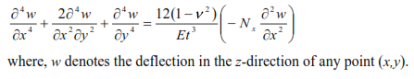

The buckling strength for plates for the condition mentioned above has been determined as,



Where,

k = Buckling coefficient B & t are width and thickness of plate

E = Modulus of Elasticity *v* = Poisson’s ratio

The value of k depends upon the support conditions, aspect ratio and number of half sine waves formed in the buckled mode. The values of which are presented in the table below.

**Table 1 Values of k for Different Load and Support Conditions**

|  |  |  |
| --- | --- | --- |
| **Load Condition** | **Support Condition** | **Buckling Coefficient, *k*** |
| Uniaxial Compressive  Stress (σ*x)* | Hinged-hinged | 4.00 |
| Fixed-fixed | 6.97 |
| Hinged-free | 1.27 |
| Fixed free | 0.43 |
| Shear Stress (τ*xy*) | Hinged-hinged | 5.35 |
| Fixed-fixed | 8.99 |

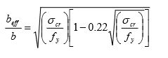The ultimate strength is linked to the effective width and is given by,

Where, *fy* is the yield stress and other terms are as defined earlier. The ultimate strength is the product of effective width and the yield stress. In this study, the buckling coefficients have been determined using *Ansys R19.0* for different support conditions for a steel plate and post buckling analysis has been carried out to determine the ultimate strength.

**2. Specifications:**

The steel plate used in the study was fixed to have following specifications:

**Table 2 Specifications**

|  |  |
| --- | --- |
| **CONSTANTS** | **Values** |
| E | 2.X105 N/mm2 |
| *v* | 0.3 |
| B | 1000 mm |
| T | 10 mm |
| L | 5000 mm |

**3. Results**

The analysis for pre-buckling and post-buckling was carried out using finite element modelling tool as specified above. The results for specific loading stage and support conditions have been grouped below.

**3.1 Pre- Buckling**

The pre-buckling analysis for support conditions as mentioned below has been carried out and grouped:

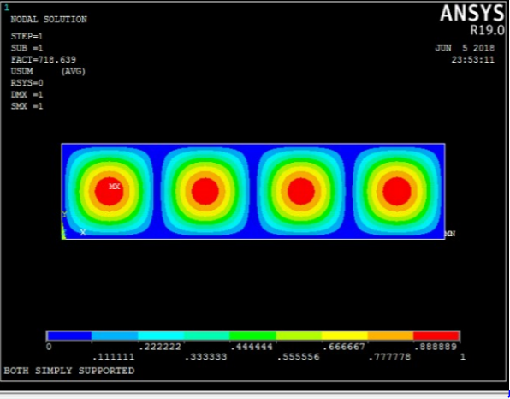

Fig 1 Ansys Environment

|  |  |  |
| --- | --- | --- |
| Support Condition | Value of k from Ansys | Value of k from eqn. |
| Both loaded edges simply supported and unloaded edges both simply supported. | 3.97 | 4 |
| Both loaded edges simply supported and unloaded edges both fixed. | 6.95 | 6.97 |
| Both loaded edges simply supported and unloaded edges one fixed one free. | 0.48 | 0.43 |

**3.2 Post Buckling**

When the compressive stress equals the critical buckling stress σcr, the central part of the plate, such as the strip AB, buckles. But the edges parallel to the x-axis cannot deflect in the z-direction and so the strips closer to these edges continue to carry the load without any instability. Therefore, the stress distribution across the width of the plate in the post-buckling range becomes non-uniform with the outer strips carrying more stress than the inner strips as shown in Fig

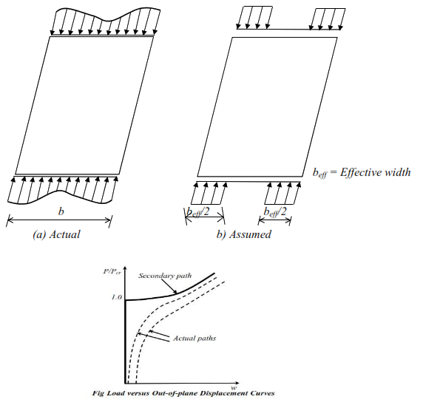

The post-buckling analysis for support conditions as mentioned below has been carried out and grouped:

**3.2.1 Both loaded edges simply supported and unloaded edges both simply supported.**

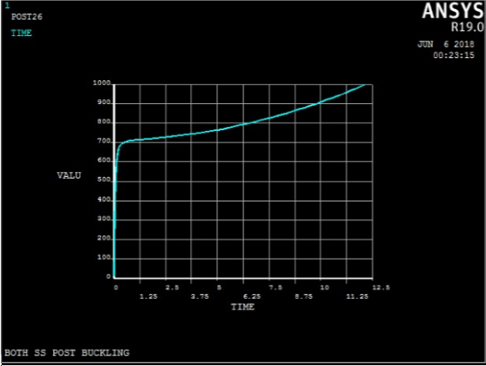

**3.2.2 Both loaded edges simply supported and unloaded edges both fixed.**

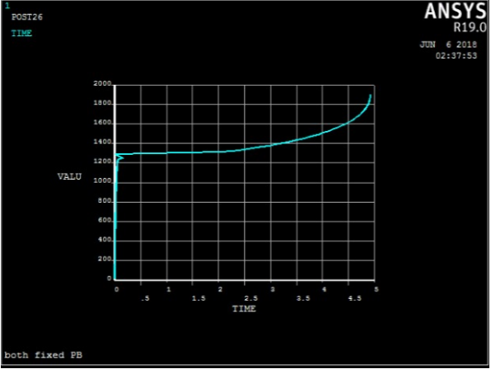

**3.2.3 Both loaded edges simply supported and unloaded edges one fixed one free.**

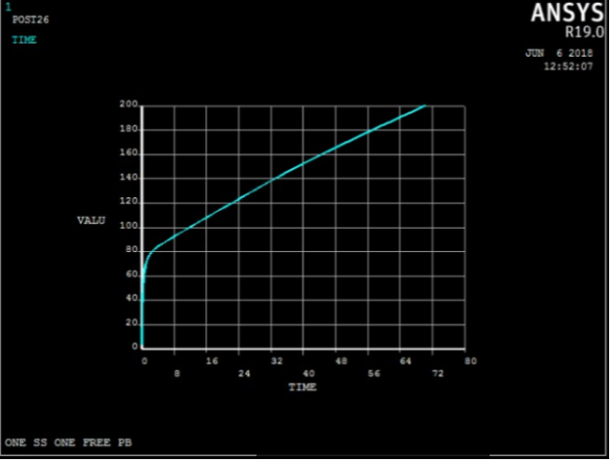

**4. Conclusions:**

1. The collapse of metal plate structures generally involve either fracture or stability limit states. Stability limit states, such as inelastic local plate buckling are typically preferred over fracture limit states, because they provide some post-buckling resistance, and hence greater ductility and the potential for energy dissipation.
2. For seismic design energy dissipation is a fundamental need for most structures, rather than rely on inherent or assumed energy dissipation. Modern design often attempt to explicitly use specific elements for energy dissipation. Properly designed and detailed a thin plate undergoing post-buckling may provide reliable energy dissipation.
3. Steel plate shear walls are an important example of the application of metal plate structures for the purposes of energy dissipation. Utilizing the post buckling response of plates.

**5. References:**

[1]. Mimura H, Akiyama H (1977), Load- Deflection Relationship of Earthquake Resistant Steel Shear Walls with a Developed Diagonal Tension Field, Transactions of the Architectural Institute of Japan, Vol.260, 109-114.

[2]. Thorburn, L J Kulak, G L Montgomery,C J, (1983), Analysis of Steel Plate Shear Walls; Department of Civil Engineering , University of Alberta, Edmonton ,Alberta, Canada. Structural Engineering Report No 107.

[3]. Elgaaly M, Caccese V, Du C, (1993), Post- buckling Behaviour Steel Plate Shear Walls under cyclic loads, ASCE, Journal of Structural Engineering,Vol.119(2), pp. 588-

[4]. Xue M, Lu LW (1994), Interaction of Infilled Steel Shear Wall Panels with surrounding Frame Members, Proceedings of the Structural Stability Research Council Annual Technical Session, Bethlehem, PA, pp.339-354.

[5]. Elgaaly,M, (1998). Thin Steel Plate Shear Walls Behaviour and Analysis. Thin Walled structures, Vol.32, pp.151-180.