Low Cost Test Rig for Demonstrating Single Plane Balancing Using Vibrations

N V S Shankara,*, K. V. Jitendraa, Dr. H Ravi Sankarb, M. Manikumara

*a Department of Mechanical Engineering, Swarnandhra College of Engineering and Technology, Seetharampuram, AP, India*

*b Department of Mechanical Engineering, GIT, GITAM University, Seetharampuram, AP, India*

*Corresponding author Email: [shankar.publications@gmail.com](mailto:shankar.publications@gmail.com)

------------------------------------------------------------------------------------------------------------------

Vibration suppression is a main problem in rotating machinery. In-situ unbalance, as done in case of high-speed machinery, is measured using vibrations that are generated. Thus, a test rig is required for training personnel relating to this area is required. The existing balancing test rigs are costly. Availability of low-cost sensors and development boards like Arduino Uno help in fabricating the test rigs at low cost. In this work, a low-cost test rig demonstrating the vibration measurement and unbalance estimation is discussed. This project is aimed at fabricating motorized setup for demonstrating balancing of rotating masses. As a part of this work, 4 rotary masses are balanced. These four masses are mounted on a disc such that the radial position of the weights can be varied. Vibrations are measured when the disc is rotating. For measuring vibrations, pre-calibrated ADXL335 accelerometer which is available off-the-shelf, is used. This is interfaced to PC using Arduino. The measured unbalance is found to be in good agreement with that of theoretically calculated value. This test rig helps in bringing an insight to students as to how unbalance can be estimated and corrected as well as use of various commercially available vibration measurement sensors.

***Keywords*:** Rotary Mass Balancing, Accelerometer, Arduino, Vibration

1. **Introduction**

Unbalance existing in rotary masses leads to vibrations due to unbalanced centrifugal force (Figure 1). These vibrations lead to failure of machinery. Thus, it is important to balance the unbalance existing in rotary masses of machinery. A lot of work happened in this field. A detailed literature survey regarding field balancing is presented in [1,2]. The terminology involved and overview field balancing is given in detail in [3,4]. The mathematical background relating to static and dynamic balancing as well as field balancing is given in [5–8]. Vibrations are the primary effects of unbalance in rotors. Use of vibrations during field balancing of wind turbines is discussed in [9]. These vibrations can thus be used in estimating unbalance. This is illustrated in [10–16]. For example, Ehrich [12] discussed the experimental in situ balancing of high speed machinery. The use of vibrations for field balancing is also discussed in [17]. [18] summarized the field balancing of steam engines. Shannon [19] causes and identification of imbalance, as well as compensating the same. Various instruments for vibration measurement during field balancing are done in [20–22]. In-Situ balancing is generally done for high speed machinery. Multi-plane balancing of various turbines are summarized in [23,24]. Precautions to be followed during this process of in situ balancing are described in [25].

1. **Laboratory Equipment**

Practical teaching of balancing of rotary masses is very much necessary because balancing finds a lot of applications in daily life. Nisbett [30] summarized an experimental setup for the same. Basic schematic of experimental setup for studying balancing is given in [31]. Multi-resonance TQ Educational and Training Division [32] detailed their equipment demonstrating multi-plane balancing. Mechatronic Laboratory Setup (MMLS) by measuring vibrations for experimentally studying the balancing of rotating masses is described in [33]. Laboratory experimental procedure of two plane balancing is given in [34].

|  |  |
| --- | --- |
|  |  |
| Figure 1: Unbalance in Rotary Mass | Figure 2: Masses rotating in the same plane |

1. **Motivation**

Most of the test rigs used for demonstrating balancing of masses are quite costly [26]. Low cost instrumentation is now available online which helps instrumenting the test rigs in such a way that they can be interfaced with a computer. This motivated the fabrication of this low-cost test rig which costed around Rs.5000/- with all the instrumentation.

1. **Balancing Rotating Masses**

Consider ***n*** masses connected at same point to a shaft rotating at angular velocity ***ω*** and are in a single plane as shown in figure 2 such that ***ith*** mass is connected at ***ri*** radius and at ***θi***angle. Each mass is subjected to centrifugal force acting outwards. The magnitude of these forces is given by equation (1). The resultant unbalance is the vectorial sum of these forces. This unbalance results in vibrations whose frequency is equal to the angular velocity of the shaft.

 (1)

 (2)

1. **Test Rig**

The above principle is demonstrated using a test rig comprising of a disc with four weights attached to it. This rig is sown in figure 3. The position of the weights can be adjusted radially along the slots on the disc. The disc with weights are attached to the disc and the disc is rotated at a predefined rpm. The vibrations that resulting from unbalance are measured using accelerometer which is interfaced to computer using Arduino Uno. Instrumentation is shown in figure 4. The accelerometer that is used is ADXL335 which can measure g-force of ±3.5g with an accuracy of ±0.1g. Accelerometer is mounted in such a way that the Z-Axis is along the shaft axis. It can be noted here that each mass added is 1.12kgs and mass of total rig is 12kg. Fabrication of rig costed Rs.5000.00 onlyConsider ***n*** masses connected at same point to a shaft rotating at angular velocity ***ω*** and are in a single plane as shown in figure 2 such that ***ith*** mass is connected at ***ri*** radius and at ***θi***angle. Each mass is subjected to centrifugal force acting outwards. The magnitude of these forces is given by equation (1). The resultant unbalance is the vectorial sum of these forces. This unbalance results in vibrations whose frequency is equal to the angular velocity of the shaft.

|  |  |
| --- | --- |
|  |  |
| Figure 3: Test rig for simulating rotary mass balancing | Figure 4: Accelerometer and Arduino Mounted |

1. **Experimentation**

Experimentation is done in two steps:

1. Measuring vibrations under no load.
2. Measuring vibrations under load.
   1. **MEASRUING VIBRAITONS UNDER LOAD**

Initially all the loads are dismounted and the disc is rotated at full speed. The angular velocity in this case was found to be 247rpm. Once the speed of the disc is stabilized, vibrations for 30sec are recorded using accelerometer and data is transferred to excel for further analysis. Figure 5 shows the g-force variations in x, y and z directions for two revolutions in this case. Based on the plot, a clear periodicity can be observed along z-axis. This indicates that there is a wobbling in the disc.

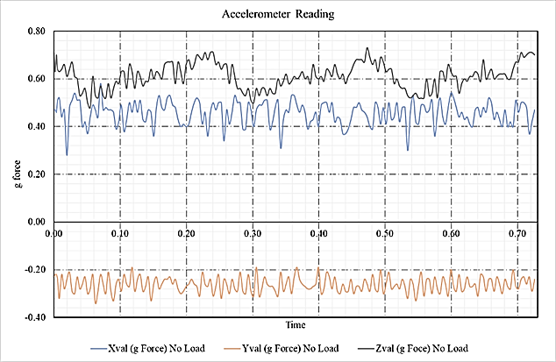

Figure 5: Accelerometer Reading with No-Load

* 1. **MEASRUING VIBRAITONS UNDER LOAD**

In the second step, loads are added to the disc and disc is rotated at 244rpm. The response recorded using accelerometer for 30sec. Plot in figure 6 shows this response. As indicated earlier, periodicity in *z-axis* is due to wobbling. The difference in max and min of g force reading either in *x* or *y* axis. The g force multiplied by weight of the rig will give the unbalance. This unbalance is in complete agreement with those computed theoretically. Theoretical calculations are presented in table 1. The results and computations show that the predicted unbalance is in good agreement with that of measured unbalance.

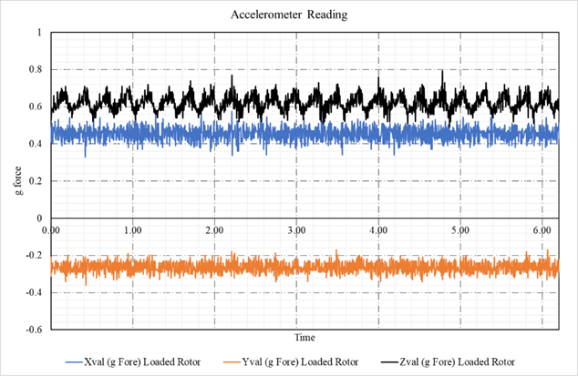

Figure 6: Accelerometer Reading with Load

Table 1: Calculation in Excel

|  |  |  |  |  |  |
| --- | --- | --- | --- | --- | --- |
| **i** | **mi (kg)** | **ri (cm)** | **θi** | **mi*ri*cos(θi)** | **mi*ri*sin(θi)** |
| 1 | 1.12 | 12 | 0 | 0.134 | 0.000 |
| 2 | 1.12 | 12 | 90 | 0.000 | 0.134 |
| 3 | 1.12 | 12 | 180 | -0.134 | 0.000 |
| 4 | 1.12 | 16 | 270 | 0.000 | -0.179 |
|  |  |  |  | **0.000** | **-0.045** |
| **Angular Velocity (rpm)** | | | | | **242.000** |
| **Angular Velocity (rad/sec)** | | | | | **25.342** |
| **Net Unbalance force (N)** | | | | | **28.772** |
| **Net X g-force** | | | | | **0.260** |
| **Net Unbalance measured (N)** | | | | | **30.607**  **= (0.26*9.81*12)** |

1. **Conclusion**

The Balancing of rotating bodies is important to avoid vibration. In heavy industrial machines such as gas turbines and other high-speed rotary machinery, vibration can cause failure of machines, as well as noise and discomfort. Rotary mass balancing is thus an important concept which must be give a practical exposure. In this work, a test rig which gives insight into balancing of forces, as well as filed balancing has been fabricated. The unbalance is measured using accelerometer. The measured value is in good agreement with that of theoretically computed.

**References**

1. Shiyu Zhou and Jianjun Shi, Shock Vib. Dig. **33**, 361 (2001).

2. W. Foiles, P. Allaire, and E. Gunter, Shock Vib. **5**, 325 (1998).

3. R. D. Kelm, in *Vib. Inst. Annu. Train. Semin.* (Kelm Engineering, LLC, Houston, 2008).

4. W. T. Pryor, in *Piedmont Chapter Vib. Inst. Train. Symp.* (2012).

5. J. Antoni, J. Daniere, and F. Guillet, J. Sound Vib. **257**, 815 (2002).

6. J. Antoni, J. Daniere, and F. Guillet, J. Sound Vib. **257**, 839 (2002).

7. D. Temple, in *Facil. Instr. Stand. Tech. Vol. 2-2* (1998).

8. Prüftechnik, *An Engineer’s Guide to Shaft Alignment, Vibration Analysis, Dynamic Balancing & Wear Debris Analysis* (Pruftechnik Ltd, 2010).

9. E. Becker, Telediagnose.Com 1 (n.d.).

10. Dr. Rajiv Tiwari, in *Anal. Identif. Rotor Bear. Syst.* (2010), pp. 1007–1053.

11. E. L. Thearle and N. Y. Schenectady, Trans. Am. Soc. Mech. Eng. J. Appl. Mech. **56**, 745 (1934).

12. R. Ehrich, in *Proc. 9th Turbomach. Symp.* (Texas, 1980), pp. 25–32.

13. J. Fang, Y. Wang, B. Han, and S. Zheng, Sensors (Switzerland) **13**, 16000 (2013).

14. X. Xu and S. Chen, Sensors (Switzerland) **15**, 21876 (2015).

15. R. L. Fox, in *Proc. 10th Turbomach. Symp.* (Texas, 1981), pp. 113–130.

16. D. R. Gruwell and F. Y. Zeidan, in *Proc. 27th Turbomach. Symp.* (Texas, 1980), pp. 85–92.

17. X. Q. Chen, Y. J. Jia, and G. Z. Cheng, Appl. Mech. Mater. **201**–**202**, 83 (2012).

18. B. Howes and B. Long, Beta Mach. Anal. Ltd. 1 (n.d.).

19. R. A. Shannon, in *AMCA Int. Eng. Conf.* (Las Vegas, NV, USA, 2008).

20. Prod. Appl. Guid. Greenheck Fan Corp (2001).

21. P. M. Kumar, J. Kumar, R. Tamilarasan, S. Sendhilnathan, and S. Suresh, Eng. J. **19**, 67 (2015).

22. Http://Www.Smartbalancer.Com/Fileadmin/Smartbalancer/Downloads/Smartbalancer-E-26.4.16.Rz-WEB.Pdf (n.d.).

23. E. J. Gunter, in *Int. Conf. Rotordynamics* (Tokyo, 1986), pp. 135–143.

24. E. J. Gunter and R. R. Humphris, (1985).

25. Https://Www.Mainttech.Se/Wp-Content/Uploads/KNOWLEDGE-OF-BALANCING-AND-VIBRATION-MEASUREMENT.Pdf .

26. Https://Dir.Indiamart.Com/Search.Mp?Ss=static+and+dynamic+balancing&src=as-Rcnt .