Synthesis and Characterization of treated banana fibres and Selected Jute fibre Based Hybrid Composites

T.Malyadria, Dr.R.Saravananb,*, Bellam Venkateshc, Suleyman Cinar CAGANd

*aAssistant Professors of Mech. Engineering, VNR Vignana Jyothi Institute of Engg. and Tech., Hyderabad* *500090, Telangana State, India*

*bProfessor of Mechanical Engineering and Dean Academics, Ellenki College of Engineering and Technology, Hyderabad -502319, Telangana State, India.*

*cAssistant Professor, CMR Institute of Technology, Hyderabad- 501401, Telangana State, India*

*d Faculty, Mechanical Engineering, Mersin University, Ciftlikkoy campus, Mersi- 33343, Turkey*

*Corresponding author Email: [dr.sarravanan@gmail.com](mailto:dr.sarravanan@gmail.com)

------------------------------------------------------------------------------------------------------------------

The hybrid composite is obtained by compounding the natural fibre with artificial or synthetic fibres in the reinforcement phase. For the current work the NaOH treated banana fibres of selected length of 15 mm and selected length of 30 mm jute fibres are combined with glass fibres for various weight fractions. The specimens of treated banana/ glass fibre with epoxy hybrid composites synthesized by hand layup method with reinforcement of treated banana fibres Wt% of 30%, 40%, and 50%. Similarly jute/ glass fibre with epoxy hybrid composites synthesized by hand layup method with Jute reinforcement Wt% of 30%, 40%, and 50%. The synthesized composites characterized by tensile behaviours with help of computerized tensile tester. The interesting results were reported.

***Keywords*:** Hybrid Composite, Treated banana Fibre, Selected Jute Fibre, Tensile Behaviour

1. **Introduction**

The natural fiber composites plays vital role in all fields. Some of the interesting results are motivates this research. The 20% banana fiber of 10 mm with polyester exhibited good harness property the same proportion was obtaining for jute fiber of 20% with Polyester [1]. [2] recommends the length of 30 mm length of banana fiber with 16% content with epoxy yield better mechanical properties. [3] reported that the Alkali treated banana fiber gives improved mechanical properties and less water absorption. [4] recommend the glass woven fiber with jute fiber gives cost and weight reduction of 20% and 23% respectively for fiber weight fraction of 42%. [5] recommends 15% of glass and 15% jute with polyester gives high flexural strength but less than the pure glass fiber composite. [6] reported that 50% weight fraction of jute with epoxy improved desirable properties in mechanical aspects. In this research explore the tensile behavior of the jute epoxy composite with different weight fraction and treated banana epoxy composites. The tensile behavioral study helps to suite the composite to desired application.

1. **Material and Methods**
   1. **Hybrid composite matrix materials**

It is planned to synthesize two kinds of hybrid composites with use of treated banana fibers and jute fibers. Both the natural fibers are strong enough individually. With consideration of desirable properties like: best control over thickness, good weight to strength ratio, and other mechanical properties, electrical insulation capacity etc., the high dense (600 gsm) glass (woven fiber) fiber (refer figure 1(a)) is proposed to make strong composites. The banana fibers collected with care (Refer Figure 1(b)) and tore them to minimal width (refer figure 1(c)). Those fibers are cut in 15 mm long (length of 10 to 15 mm long banana fibers already proved best strength in many banana based composites) and washed well. The washed fibers allowed to dry 2 to 3 hours. The NaoH solution prepared with distilled water with ratio of 6:80 in volume percentage. The well dried banana fibers soaked into the solution for three hours. The hours of chocking are proportional to improving its strength. After 3 hours the fibers took out form the NaoH solution and washed well with water again allow to dry for 3 to 4 hours. Hence the treated banana fibers prepared. The eco friendly, affordable golden fiber i.e., Jute (refer figure 1(d)) was preferred to make another kind of hybrid fiber composites with selected length of 30 mm. The Epoxy and hardener (refer Figure 1 (e) and Figure 1(f) respectively) employed with 10:1 ratio by weight fraction in the composite matrix. The weight fraction of the natural fibers varied in three levels as 30%, 40% and 50% and hence six different hybrid composites planned to synthesize for characterization.

**a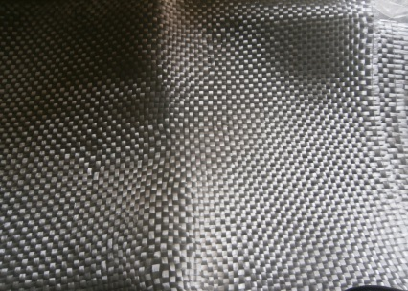 b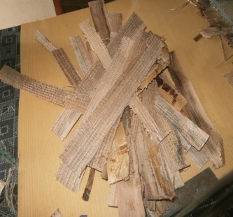 c**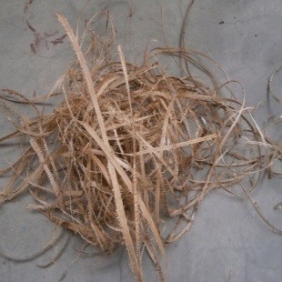

d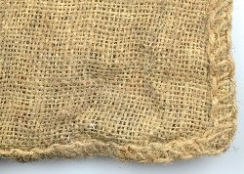 e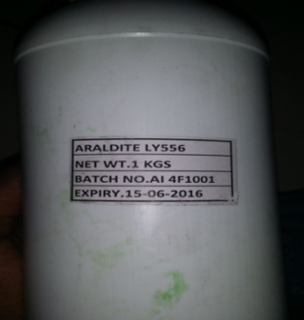 f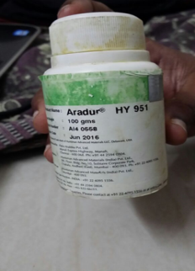

Fig. 1. Hybrid Composite Matrix materials: a) Glass fibre b) Raw banana fibre

c) Treated Banana fibres d) Jute fibre e) epoxy f) Hardener

* 1. **Synthesize of Hybrid Composites**

**a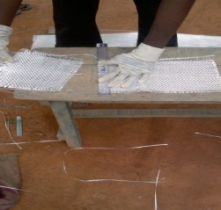 b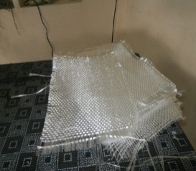 c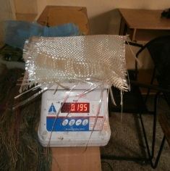 d**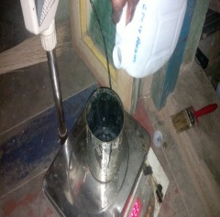

**e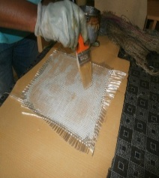 f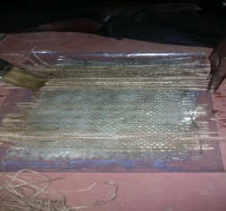 g**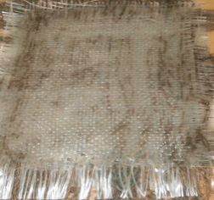

Fig. 2 Synthesize of Hybrid Composite: a) cut of glass fibre to size b) prepared glass fibre c) weighing glass fibre to desired weight fraction d) weighing the epoxy and hardener e) first layer of composite f) second set of layer of composite g) prepared composite sample

The sequential procedure of synthesizing hybrid composites, are depicted in figure 2. The hand layup method was preferred to fabricate the composites. The long Glass fiber sheets cut in to equal size of 30X20 cm2 (Refer figure 2(a), Figure 2 (b)) so that weight fraction can be made easily. The natural fibres weight proportions used as 30%, 40% and 50% . The composite matrix materials weighed as per plan (Refer Figure 2 (c) and Figure 2 (d). The end layers are must be glass fibre, accordingly the weight of natural fibres were weighed and used. Hence the fabrication start glass fibre layer. The hardener mixed with epoxy with weight proportion of 1:10 and apply over the glass layer and filled with treated banana or Jute layer and covered the with glass layer. The natural and artificial fibres added in alternate fashion (Refer Figure 2 (e) to Figure 2 (g)).

* 1. **Characterization of Composites**

Table 1. Tensile properties, packing density and Classification of Hybrid Composites

|  |  |  |  |  |
| --- | --- | --- | --- | --- |
| **Wt% of Fiber Type Content** | **Composite Type** | **Packed Density of natural Fiber** | **Tensile Properties** | |
| **Ultimate Stress (kN/mm2)** | **Yield Stress (kN/mm2)** |
| 30% Jute Fiber | C1 | 1.46 | 0.105 | 0.046 |
| 40% Jute Fiber | C2 | 1.46 | 0.113 | 0.105 |
| 50% Jute Fiber | C3 | 1.46 | 0.139 | 0.036 |
| 30% Banana Fiber | C4 | 1.426 | 0.139 | 0.139 |
| 40% Banana Fiber | C5 | 1.426 | 0.163 | 0.169 |
| 50% Banana Fiber | C6 | 1.426 | 0.204 | 0.204 |

**a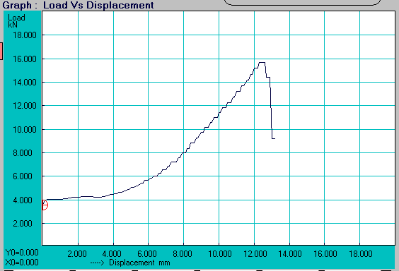 b**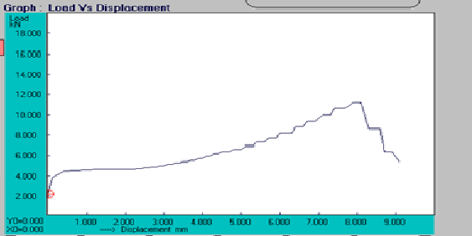

Fig. 3a. Tensile Behavior of Hybrid Composites a) C1 and b) C2

**c 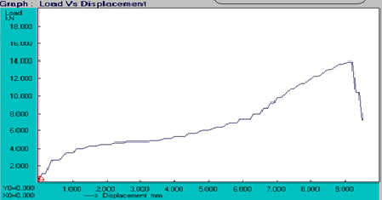 d** 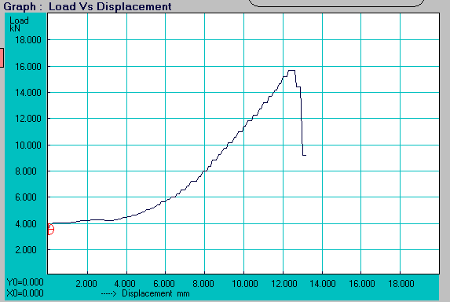

Fig. 3b. Tensile Behavior of Hybrid Composites c) C3 and d) C4

The prepared composites were characterized by tensile properties. The ASTM D-3039 standard followed to prepare specimens and testing procedures. The sample size is 250 X 2 X 2.5 mm. the tensile properties like ultimate tensile stress and yield stress were observed and consolidated in Table 1 for both kinds of hybrid composites. The tensile behaviours exhibit in Figure 3(a). Figure 3(b) and Figure 3(c) for Jute fiber based hybrid composites of 30%, 40% and 50% natural fibres category respectively. Similarly the Figure 3(d) Figure 3(e) and Figure 3(f) exhibit the tensile behaviour of treated banana fibre based hybrid composites for the natural fibre composition of 30%, 40% and 50% respectively.

**e  f** 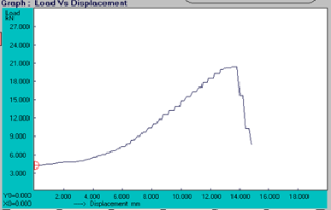

Fig.3c. Tensile behaviour of Hybrid composites e) C1 and f) C6

Fig. 4 Tensile strength of Hybrid composites a) Ultimate Tensile strength b) Yield strength

1. **Conclusion**

The synthesize of hybrid composite with treated banana fibre of length 15 mm and selected jute fibre length of 30 mm with epoxy at different weight fraction were discussed in detail. The choice of characterization here is tensile behaviour and its maximum values, which depicted in the figure 3. The graph ‘a’ depicts the tensile behaviour of composite type C1, similarly the graphs of ‘b’, ‘c’, ‘d’, ‘e’, and ‘f’ revel the composite samples of C2,C3,C4,C5 AND C6 respectively. Hence the tensile behaviour revels that increase of jute fibre composition increases the high displacement with respect to tensile load refer b and c graphs in the Figure 3. The same pattern was found for 405 weight fraction composite of treated Banana fibre hybrid composite. The 30% weight fraction of hybrid composites in both banana and jute fibre cases gives same pattern of tensile behaviour. The figure 4 shows that weight fraction of the selected length treated banana fibre increases, improves the tensile properties. Hence the user can select the appropriate choice of hybrid composite for their desired application.

**References**

1. B.E.Megha, B.S.Keerthi Gowda, G.L.Easwara Prasad, International Journal of Engineering Research in Mechanical and Civil Engineering, vol 2(4), pp 172-176, ( 2017).
2. Venkateshwaran N, ElayaPerumal, Journal of Reinforced Plastics and Composites, vol. 29(15), pp.2387–96 (2010).
3. Satish Pujari, A. Ramakrishna and M. Suresh Kumar, International Journal of Current Engineering and Technology, Special Issue-2, pp.121-126, (2014).
4. M. Muthuvel, G. Ranganath , K. Janarthananand K.Srinivasan, International Journal of Engineering Research & Technology, vol. 2(4), pp335-344, ( 2013).
5. Urmilkumar Chaudhari, Prof. Kundan Patel, Prof. Mayank Madia, International Journal of Advance Research and Innovative Ideas in Education, Vol-2 (3), pp. 2598 -2604 (2016).
6. M. Boopalan, M. Niranjana, M.J. Umapathy, Composites: Part B 51. pp54–57 (2013)