Base transesterification of ineffectual soybean oil using lab scale synthesized CaO catalyst

**Ningthoujam Rakesh Singh a, Naorem Ronaldo Singh a, Langpokpam Denin Singh a, Thokchom Subhaschandra Singh a, *, Tikendra Nath Verma a**

*a Department of Mechanical Engineering, National Institute of Technology Manipur, Langol, Imphal - 795004, India*

*Corresponding author Email: [th.subhas143@gmail.com](mailto:th.subhas143@gmail.com), [th.s.singh@nitmanipur.ac.in](mailto:th.s.singh@nitmanipur.ac.in)

------------------------------------------------------------------------------------------------------------------

The present study involves transesterification of ineffectual soybean oil using synthesized duck egg shell calcinated calcium oxide (CaO) as heterogeneous base catalyst. The catalyst was first prepared by exposing at a muffle furnace for about 180 mins 800 °C and then characterized using X-ray diffraction (XRD), Fourier transform infrared spectrometry (FT-IR), Scanning electron microscopy (SEM) and Energy dispersive x-ray spectroscopy (EDX). There is characterization of uncooked, ineffectual and transesterified ineffectual soybean oil using FT-IR spectrometry. The yield was obtained to be 94.55% when transesterified at 3% (wt.%) catalyst loading, 10:1 alcohol to oil ratio, reaction temperature of 70°C and reaction time of 60 mins. The methyl ester underwent Gas chromatography-Mass spectrometer (GC-MS) test to check the contents of the yield oil. The cheap and ready to be thrown ineffectual soybean oil can be effectively used for producing biodiesel.

***Keywords*:** *Base transesterification, soybean oil, duck egg shells, calcium oxide*

1. **Introduction**

With advancements in production of biofuel from various sources, such as edible, non-edible oils, animal fats, microalgae, tire pyrolysis oil, waste plastic oil, waste cooking oil, etc. [1-7], the researchers have been working round the clock in search of optimal parameters in utilizing less resources and obtaining optimum results. This is primarily due to ever increasing pollution from commercial diesel engines [8]. It has been reported by many researchers that biodiesel/biofuels can provide lesser emissions without much compromise in performance and combustion characteristics. At present there has been much literature which reports the use of various feed materials for production of biodiesel. Although NaOH and KOH were opted by many for performing acid based transesterification, it was evident from many studies that the cost involvement is very high. Hence, researchers are now opting for organic based catalyst for performing the transesterification process. Kamila C. et al. (2017) developed a bench-scale transesterification reactor having capacity to give output of 3L Biodiesel. To optimize the set operating parameters viz. methanol to oil molar ratio, catalyst concentration and reaction time, they used a full 23 factorial. Then, the reactor is used for the transesterification process as well as the recovery of methanol present in excess. Characterization of the product was done using gas chromatography. To determine the ester and calcium concentrations liquid analysis has been used. A maximum yield of almost 100% was obtained at 3 wt. % of the catalyst, reaction time is 75 mins and methanol: oil molar ratio is 6:1 [9].

Rui Shan et al. (2018) have stated that a dual role is played by heterogeneous catalyst. They have reviewed that catalyst made from renewable resources such as shells, ashes from plants and trees, natural sources, large scale wastes generated in industries, etc. are more advantageous as they do not harm the environment and are the most cost effective. [10]. Kenneth R. Szulczyk et al. (2018) have performed a research work in the context of Malaysia. In the study, the researchers have stated that the reason of the cost of biodiesel being higher than normal diesel was the high cost of feed materials [11]. Alan Try Putra Samad et al.(2018) have converted 92.8% of free fatty acids (FFA) into fatty acid methyl esters (FAME) using sulfuric acid as catalyst with 10% w/w of the said FFA in the esterification process[12]. H.M. Mahmudul et al. (2017) have performed a research on the negative impact that is caused by fossil fuels to the environment and the development of renewable sources of energy. They found that biofuels are a very good alternative to normal diesel owing to it being biodegradable and renewable as well as having similar fuel properties [13].

M.M. Hasan et al. (2017) have researched on the performance of CI engines using the blend mixture of biodiesel and diesel. They also gave many advantages of using blend mixture like shorter ignition delay and lesser emission of HC, CO and PM [14]. Jibril Goli et al. (2018) produced biodiesel at which the catalyst was derived from waste chicken eggshell. The characterization of the catalyst was done by XRD, FT-IR, X-ray fluorescence (XRF), Thermogravimetric analysis (TGA/DTA) and SEM. They could produce 93% of biodiesel with an expectation of 92.32% at a reaction time of 3h, temperature of reaction 57*.*5 ᵒC molar ratio of methanol to oil 10:1 and concentration of catalyst of 7 wt% [15]. Yie Hua Tan et al. (2015) studied biodiesel production using waste cooking oil (WCO) using ostrich egg shells as the catalyst. They have concluded that 12:1 methanol to oil ratio, 65 °C reaction temperature, 1.5 wt% catalysts, 2 hours reaction time with a speed of 250 rpm gave the most desired results [16]. Suchada Sirisomboonchai et al. (2015) have performed a research work on the transesterification process of WCO with methanol by utilizing calcined scallop shell (CSS). According to their research, CSS showed higher catalytic activity as compared to commercial CaO [17]. Muhammad Farooq et al. (2015) have discussed about the depleting condition of fossil fuels and performed transesterification of used cooking oil for producing biodiesel using waste chicken bones as a source of catalyst [18].

Xiulian Yin et al. (2016) produced biodiesel using duck eggshell as source of catalyst by heating the sample at higher temperature of about 800 °C to 900 °C. At reaction time of 120 mins, concentration of sulfuric acid as 1.5%, molar ratio 12:1 and reaction temperature of 60 °C with 10 wt. % catalyst, the yield of biodiesel was 94.6%. Re-usability of the catalyst was tested and it was found that catalyst could be used at least 5 times [19]. N. Viriya-empikul et al. (2010) have used egg shell and *meretrix* (*L.*) for biodiesel production using palm oil. They calcined the shells at 800ᵒC at 2 to 4 hours and found that all catalysts exhibit high yield activity (90%) of fatty acid methyl ester (FAME) in reaction time of 2 hours [20]. Dalibor M. Marinkovi et al. (2016) have reported that the CaO based catalysts are the best for biodiesel production [21].

Therefore, in light of the above findings of the researchers in the past, the authors believed that one such commonly available feed material is the used/ineffectual soybean oil. Duck egg shells were also obtained and calcined at 800°C for 80 mins. The catalyst and feed materials were characterized using XRD, FT-IR, SEM, EDX and GC-MS.

1. **Materials and method**

**2. 1. Material collection and preparation**

The materials used for feed has been collected from the Canteen and Hostel Mess of National Institute of Technology Manipur, Langol, Imphal- 795001, India ( 24.83°N latitude, 93.91°E longitude, 756m elevation above sea level). Fig. 1 shows the raw materials which have been used for the present study. Another sample of unused soybean oil is also taken for the present study to compare the characteristics between used and unused feed materials. In the study, 5 litres of the ineffectual soybean oil and 300 g of duck egg shells were used. The ineffectual soybean oil has been preheated to an elevated temperature of about 110-120 °C for removing any moisture from the sample [1]. The duck egg shells were also pre-treated using a hot air oven *(Make: Kelsons Testing Equiptment)*. An electric muffle furnace is used for calcinations of the duck egg shell sample. Fig. 2 shows the process of calcination of the duck egg shells at 800 °C for 180 mins.

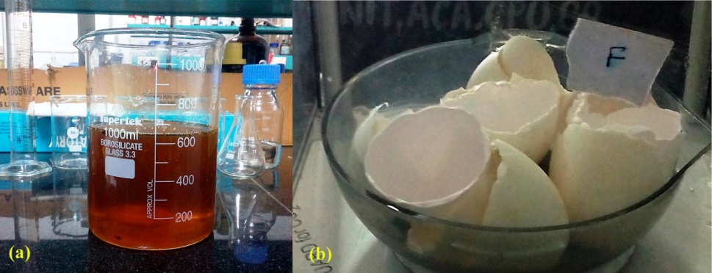

Fig. 1. Feed materials for the present study (a) ineffectual soybean oil (b) duck egg shells

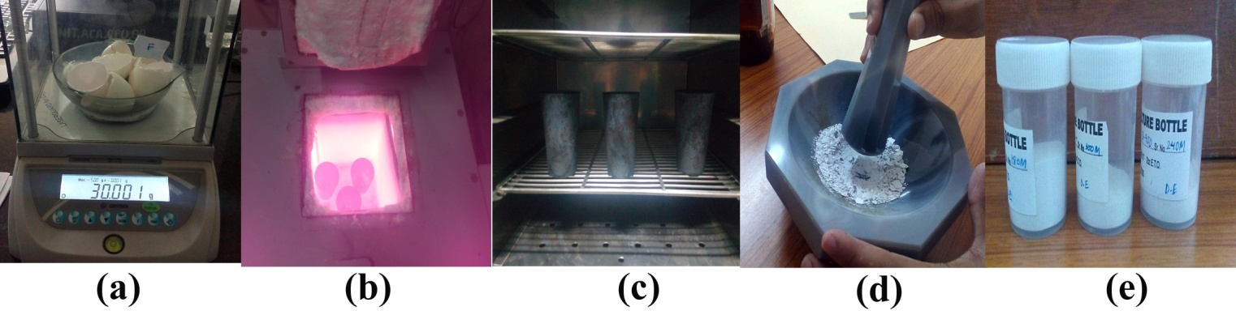

Fig. 2. Calcination of the duck egg shells (a) weighing of the samples (b) calcination at muffle furnace (c) Cooling down at oven (d) grinding of sample (e) bottling of samples

**2. 2. Transesterification**

Fig. 3 shows the process of transesterification of the samples. The transesterification started with filtration of the feed oil. About 100ml of feed oil is taken for each process and the experiment was performed for three times to ensure correctness of the result. The alcohol to oil ratio is taken to be 10:1 and the catalyst loading rate is 3% (wt%). The beaker is kept above the hot plate magnetic stirrer at a temperature of about 70 °C. A thermometer is dipped into the beaker to check the temperature of the reaction. The reaction took place for about 60 mins and finally kept in a separating funnel. The transesrtification reaction is shown in equation (1). After the glycerol is separated, the alcohol and catalyst were recovered. Then the methyl esters underwent a washing process with warm water by vigorous shaking the mixture. After settling the mixture for about 3 days, the methyl esters were collected and measured to determine the yield, using the equation (2).

Fig 3 (a) shows preliminary filtration using a fine cloth [7], (b) alcohol measurement (c) glycerol formation during reaction (d) separation using funnel (e) washing of methyl esters and (f) filtered, washed and dried methyl esters.

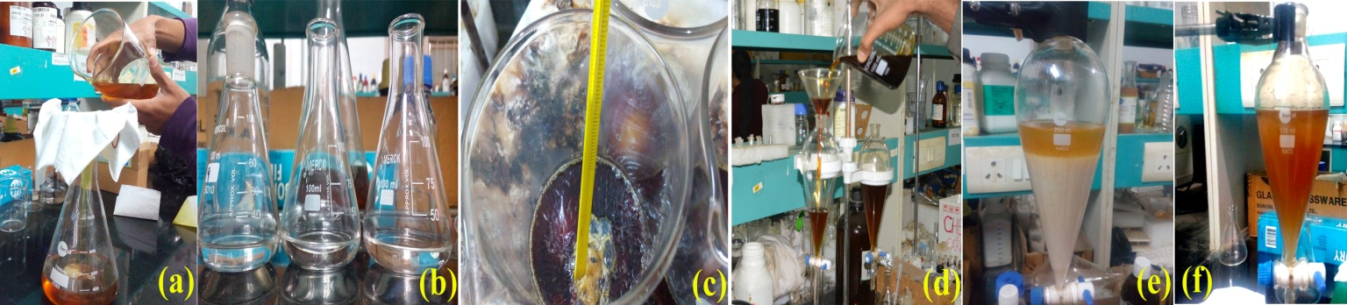

Fig. 3. Transesterification process of the sample

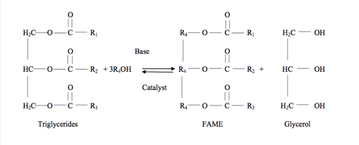 (1)

 (2)

1. **Results and discussion**

During the process of transesterification, it was found that the yield of the present study was obtained to be 94.55%. The GC-MS result yield 9.6% of α-linolenic acid (C-18:3), 51% of linolenic acid (C-18:2), 22.8% of oleic acid (C-18:1) and 16.6% of stearic (C-18:0) & palmitic acids (C-16:0).

**3. 1. Characterization of catalyst**

The calcinated CaO from duck egg shells have been characterized using XRD, FT-IR, SEM and EDX. The corresponding results are shown in Fig. 4 (a), (b), (c) and (d) respectively. The diffraction peaks of 29.68°, 33.42°and 47.72° from Fig 4 (a) corresponds to (111), (200) and (220) of the face centered cubic phase. From Fig. 4 (b), it is evident that the displayed bands of 1411 and 875 cm-1 corresponds to the asymmetric stretching of C=O. The extra stretch at 412 cm-1 displayed the formation of CaO from the duck egg shell samples. Fig 4 (c) and (d) shows the morphology of synthesized CaO. The EDX result shows the elemental composition of the sample, which was found to be 66.75 wt % & 42.01 atomic % (for Ca) and 22.58 wt % and 35.60 atomic % (for O). The findings are coherent to findings of other researchers. [1, 9, 10, 15-18, 19]

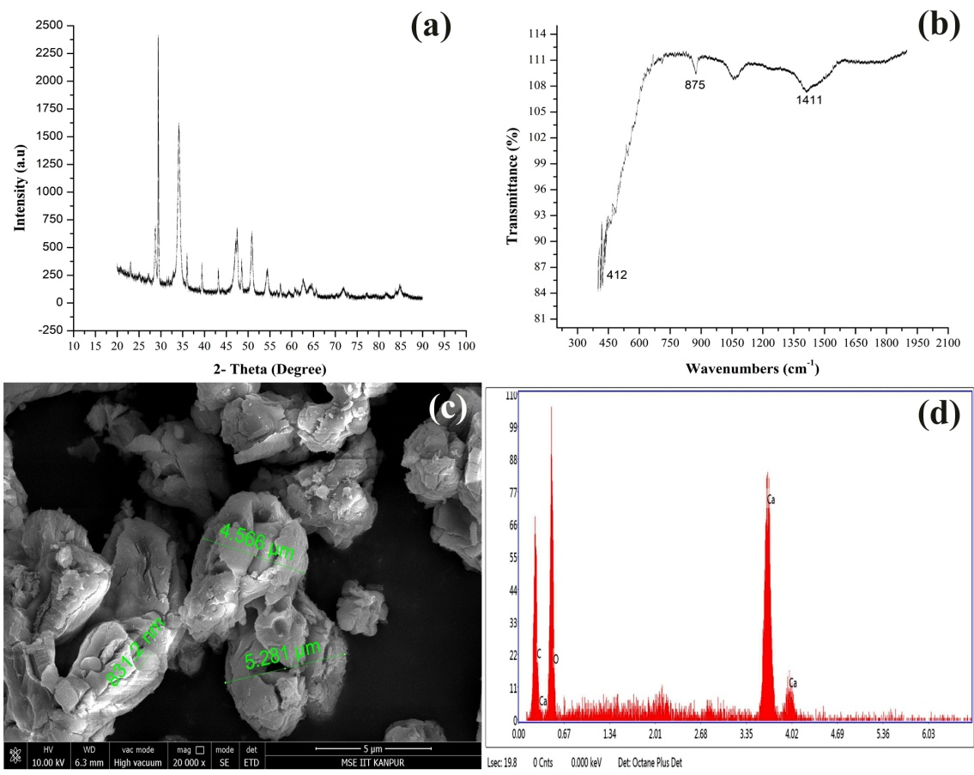

Fig. 4. Characterization of duck egg shells CaO catalyst

**3. 2. Characterization of ineffectual soybean oil and methyl esters**

The ineffectual soybean oil along with the uncooked soybean oil were also characterised using FT-IR alongside the transesterified ineffectual soybean. The corresponding graphs which have been plotted are shown in Fig. 5. The stretching of bonds for the various types of oil is tabulated in Table 1. The present findings were in good relation to those of the results obtained by other researchers [1, 9-10, 16, 19, 21]

Table. 1. Stretching of bonds for various types of oil sample

|  |  |  |  |
| --- | --- | --- | --- |
| **Wavenumber (cm-1)** | | | **Remark [1, 9, 10, 15-22]** |
| **Raw soybean oil** | **Ineffectual soybean oil** | **Transesterified Ineffectual soybean oil** |
| 3009.12 | 3009.10 | 3008.68 | C-H stretch |
| 2923.16 | 2923.16 | 2924.23 | CH2 presence |
| 2853.64 | 2853.64 | 2854.54 | CH2 presence |
| 1743.55 | 1743.52 | 1737.72 | C=O |
| 1464.61 | 1464.58 | 1463.97 | CH2 bending vibrations |
| 1160.24 | 1160.36 | 1179.93 | C-O ester |
| 722.24 | 722.24 | 722.33 | CH2 rocking |

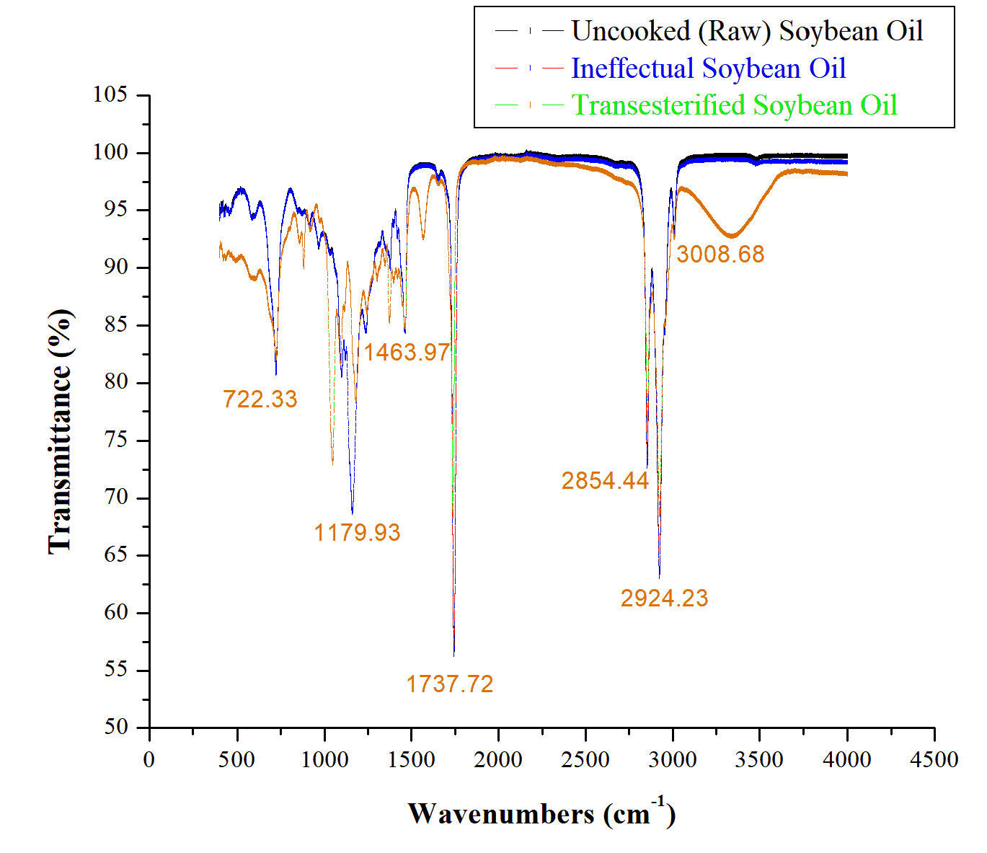

Fig. 5. FT-IR spectroscopy of uncooked, ineffectual and transesterified soybean oil

1. **Conclusion**

Transesterification reaction was performed using ineffectual soybean oil through the application of duck egg shell derived CaO as heterogeneous base catalyst.

During the calcination of CaO at 800 °C for 180 mins, the synthesized CaO showed good morphology and in good relation with those of other researchers.

At 3% (wt.%) catalyst loading rate, 10:1 alcohol to oil ratio, 70 °C reaction temperature and 60 min reaction time, the final methyl ester yield was found to be 94.55%.

Hence, the authors conclude that waste and ready to be thrown soybean cooking oil from various sources, can be effectively used for producing biodiesel. Also substitution of acid base catalyst can be made by readily available and easy to produce CaO from sources like duck egg shells.

**Acknowledgements**

The authors acknowledge the support provided by Department of Chemistry NIT Manipur throughout the course of the project. The authors also thank IIT Kanpur & IIT Guwahati for extensive support in providing results of various tests.

**References**

[1] T. S. Singh and T. N. Verma, “Taguchi design approach for extraction of methyl ester from waste cooking oil using synthesized CaO as heterogeneous catalyst: Response surface methodology optimization,” Energy Convers. Manag., vol. 182, no. October 2018, pp. 383–397, 2019.

[2] U. Rajak, P. Nashine, T. S. Singh, and T. N. Verma, “Numerical investigation of performance, combustion and emission characteristics of various biofuels,” Energy Convers. Manag., vol. 156, 2018.

[3] U. Rajak and T. N. Verma, “Effect of emission from ethylic biodiesel of edible and non-edible vegetable oil , animal fats , waste oil and alcohol in CI engine,” Energy Convers. Manag., vol. 166, no. X, pp. 704–718, 2018.

[4] U. Rajak and T. N. Verma, “Spirulina microalgae biodiesel – A novel renewable alternative energy source for compression ignition engine,” J. Clean. Prod., vol. 201, pp. 343–357, 2018.

[5] U. Rajak, P. Nashine, and T. N. Verma, “Assessment of diesel engine performance using spirulina microalgae biodiesel,” Energy, vol. 166, pp. 1025–1036, 2018.

[6] S. Salam and T. N. Verma, “Appending empirical modelling to numerical solution for behaviour characterisation of microalgae biodiesel,” Energy Convers. Manag., vol. 180, no. August 2018, pp. 496–510, 2019.

[7] Subhaschandra Singh T., Verma T.N. (2019) Impact of Tri-Fuel on Compression Ignition Engine Emissions: Blends of Waste Frying Oil–Alcohol–Diesel. In: Agarwal A., Gautam A., Sharma N., Singh A. (eds) Methanol and the Alternate Fuel Economy. Energy, Environment, and Sustainability. Springer, Singapore

[8] Singh T.S., Verma T.N., Nashine P., Shijagurumayum C. (2018) BS-III Diesel Vehicles in Imphal, India: An Emission Perspective. In: Sharma N., Agarwal A., Eastwood P., Gupta T., Singh A. (eds) Air Pollution and Control. Energy, Environment, and Sustainability. Springer, Singapore

[9 ] K. Colombo, L. Ender, and A. A. C. Barros, “The study of biodiesel production using cao as a heterogeneous catalytic reaction,” *Egyptian journal of petroleum*, vol. 26, no. 2, pp. 341–349, 2017.

[10] R. Shan, L. Lu, Y. Shi, H. Yuan, and J. Shi, “Catalysts from renewable resources for biodiesel production,” *Energy Conversion and Management*, vol. 178, pp. 277–289, 2018.

[11] K. R. Szulczyk and M. A. R. Khan, “The potential and environmental ramifications of palm biodiesel: Evidence from malaysia,” *Journal of Cleaner Production*, vol. 203, pp. 260–272, 2018.

[12] A. T. P. Samad, D. N. Putri, M. S. Perdani, T. S. Utami, R. Arbianti, and H. Hermansyah, “Design of portable biodiesel plant from waste cooking oil,” *Energy Procedia*, vol. 153, pp. 263–268, 2018.

[13] H. Mahmudul, F. Hagos, R. Mamat, A. A. Adam, W. Ishak, and R. Alenezi, “Production, characterization and performance of biodiesel as an alternative fuel in diesel engines–a review,” *Renewable and Sustainable Energy Reviews*, vol. 72, pp. 497–509, 2017.

[14] M. Hasan and M. Rahman, “Performance and emission characteristics of biodiesel– diesel blend and environmental and economic impacts of biodiesel production: a review,” *Renewable and Sustainable Energy Reviews*, vol. 74, pp. 938–948, 2017.

[15] J. Goli and O. Sahu, “Development of heterogeneous alkali catalyst from waste chicken eggshell for biodiesel production,” *Renewable Energy*, vol. 128, pp. 142–154, 2018.

[16] Y. H. Tan, M. O. Abdullah, C. Nolasco-Hipolito, and Y. H. Taufiq-Yap, “Waste ostrich-and chicken-eggshells as heterogeneous base catalyst for biodiesel production from used cooking oil: Catalyst characterization and biodiesel yield performance,” *Applied Energy*, vol. 160, pp. 58–70, 2015.

[17] S. Sirisomboonchai, M. Abuduwayiti, G. Guan, C. Samart, S. Abliz, X. Hao, K. Kusakabe, and A. Abudula, “Biodiesel production from waste cooking oil using calcined scallop shell as catalyst,” *Energy Conversion and Management*, vol. 95, pp. 242–247, 2015.

[18] M. Farooq, A. Ramli, and A. Naeem, “Biodiesel production from low FFA waste cooking oil using heterogeneous catalyst derived from chicken bones,” *Renewable Energy*, vol. 76, pp. 362–368, 2015.

[19] X. Yin, X. Duan, Q. You, C. Dai, Z. Tan, and X. Zhu, “Biodiesel production from soybean oil deodorizer distillate using calcined duck eggshell as catalyst,” Energy Conversion and Management, vol. 112, pp. 199–207, 2016

[20] N. Viriya-Empikul, P. Krasae, B. Puttasawat, B. Yoosuk, N. Chollacoop, and K. Faungnawakij, “Waste shells of mollusk and egg as biodiesel production catalysts,” Bioresource technology, vol. 101, no. 10, pp. 3765–3767, 2010.

[21] D. M. Marinkovi´c, M. V. Stankovi´c, A. V. Veliˇckovi´c, J. M. Avramovi´c, M. R. Miladinovi´c, O. O. Stamenkovi´c, V. B. Veljkovi´c, and D. M. Jovanovi´c, “Calcium oxide as a promising heterogeneous catalyst for biodiesel production: current state and perspectives,” *Renewable and Sustainable Energy Reviews*, vol. 56, pp. 1387– 1408, 2016.

[22] A. Buasri, P. Worawanitchaphong, and S. Trongyong. Utilization of Scallop Waste Shell for Biodiesel Production from Palm Oil - Optimization Using Taguchi Method.*Procedia - Soc. Behav. Sci.* 2014, 8:216–221 [doi: 10.1016/j.apcbee.2014.03.030](https://doi.org/10.1016/j.apcbee.2014.03.030)