**Pressure drop in vertical pneumatic conveying: Comparison between numerical predictions with existing correlations**

Pandaba Patroa,*, Debasis Mishrab

*aMechanical Engineering,VSSUT, Burla 768018, Odisha, India*

*bMechanical Engineering,VSSUT, Burla 768018, Odisha, India*

*Corresponding author Email: ppatro_me@vssut.ac.in

------------------------------------------------------------------------------------------------------------------

CFD simulations using Eulerian modeling (two fluid model incorporating four way coupling) was used to investigate the pressure drop characteristics of gas-solid flows in vertical pipes. Standard  model with standard wall function was used to close gas phase stresses. Kinetic theory of granular flows (KTGF) was used for solid phase stresses, which arise due to inter-particle collisions. The model was validated by comparison with the available experimental data and good agreement was found for pressure drop prediction. It was observed that pressured drop increased with gas velocity and solid loading ratio. Finally, computed results for pressure drop are compared with the existing correlations in vertical flows. Numerical predictions are in good agreement with the correlation of Reddy and Pei (1969) and Capes and Nakamura (1973) data.

***Keywords*:** Gas-solid flow, Pressure drop, Eulerian modeling, Solids loading ratio

1. **Introduction**

Pneumatic conveying of solid particles or gas-solid flow is found in many industrial applications, such as pneumatic transporters, pulverized coal combustion, spray drying, spray cooling, jet impingement cooling etc. These types of flows are complicated due to the presence of solids in gas flow which arises the interaction terms between the two phases and also between the particles and modeling of these interactions. There are two approaches in the numerical modeling of gas-solid flows i.e. Lagrangian and Eulerian models. Lagrangian model tracks individual particles in the flow field, which imposes a restriction on the number of particles that can be tracked. So, this model is unfeasible for many industrial-size problems. However, the Eulerian model treats the solid-phase as a continuum and hence, the motion of individual particles are averaged such that mean equations are solved for both gas and solid. Hence, this model has been used by many researchers1-3 to investigate the gas-solid flows.

For the design of pneumatic conveying piping layout, it is very important to predict pressure drop to find the pumping power requirement for solids transportation. A number of researchers4-7 predicted pressure drop in pneumatic conveying experimentally. It is very much complicated to get the pressure drop data under various operating conditions experimentally. With the development of high speed computers, researchers in industries have extensively been using commercial computer codes to solve two-phase flow problems. But, unfortunately, only very few research publications are available in open literature, which investigated the capabilities of commercially available CFD codes (like Ansys Fluent) as pressure drop prediction tools in relatively high solids loading (volume fraction in the range 0.01 to 0.1). Patro and Dash8-9 investigated gas-solid flows in horizontal and vertical pipes and predicted pressure drop numerically using Ansys Fluent. It was clear that the commercial CFD computer code Ansys Fluent can be used successfully to calculate the pressure drop in gas-solid flow with a considerable degree of accuracy.

In the present study, numerical simulation was done using the Eulerian approach for gas-solid flow in vertical pipes. An extensive study was performed to see the effect of gas Reynolds number, solid loading ratio and particle density on pressure. The predicted data for pressure drop are also compared with the existing correlations developed from experimental data by many researchers.

1. **Numerical Procedure**

In Euler-Euler model, both phases are treated as inter-penetrating continua. So, continuity and momentum equations are solved for both the phases. The Reynolds stress for gas phase employs the Boussinesq hypothesis to relate it to the mean velocity gradients. The kinetic turbulent energy (k) and dissipation energy () employ the standard  model. Inter-particle collisions give rise to solids pressure and stresses, which are closed by incorporating kinetic theory of granular flows (KTGF). Detail mathematical modeling and closure equations are described by Patro and Dash8-9.Space limitation did not permit us to explain these details in the present paper.

The discretized equations, along with the initial condition and boundary conditions, were solved using the segregated solution method to obtain a numerical solution. The phase-coupled SIMPLE algorithm is used to couple the pressure and velocity. The standard *k–ε* epsilon turbulence model with standard wall function was used for gas phase and kinetic theory of granular flow (KTGF) is used to close the momentum equation in solid phase. Fig.1 shows the computational domain and the cross sectional meshing. The computational domain is 30 mm in diameter and length equal to 100 times the diameter. Three grids of mesh sizes 21800, 32700 and 70600 cells respectively are used for grid independence study. The solution has been verified to be grid independent by checking that an increase in the number of grid points had a negligible effect on the computed profiles.

Velocity inlet boundary conditions are used at the inlet of the pipe. Fully developed velocity profiles are defined for both phases at inlet along with the volume fraction of the solid phase.



Where  is the centre line velocity and R is the radius of the pipe.

The turbulence intensity () at the inlet boundary is calculated from the empirical correlation for fully-developed duct flows.



At the outlet, fully developed flow conditions are used where the diffusion fluxes for all flow variables in the direction of the exit are zero. No-slip condition is used for gas phase at the wall. For the solid phase, no-slip boundary condition is not valid as the particles collide with the wall and get rebounded. A value of 0.9 is set for coefficient of restitution for particle-particle collision and particle-wall collisions.

**4. Results and Discussion**

Experimental findings for pressure drop of Tsuji et al.10 are used for comparing our numerical results and validating the numerical model for the prediction of pressure drop. The experiments are carried out at particle diameter of 200 micron and density 1020 kg/m3. The mean velocity of gas was varied from 6 to 20 m/s.

The numerical parameter known as specularity coefficient plays important role in pressure drop prediction while other parameters such as restitution coefficients and drag and lift coefficient are insensitive. When the numerical results are compared with experimental data, satisfactory agreements were reported for specularity coefficient equal to 0.1 for vertical flows (Fig.1). So, this value was used for the rest of the simulations.



Fig.1. Comparison of pressure drop predictions in vertical flow with the experimental data at SLR=1, dp =200 micron

A quantitative comparison is made against the work of other authors in the field; the results of this show good agreement at low loading ratios although the scope of the current work is much wider and operating parameters are comparable to industrial applications. The most notable deficiency of the existing correlations is the inability to accurately predict the pressure drop for gas-solids flows with relatively high solids loading. There are many correlations11-15 available in literature for the pressure drop in pneumatic conveying in vertical flows. The present computations for two-phase pressure drop are compared with the existing correlations (Fig. 2-4).

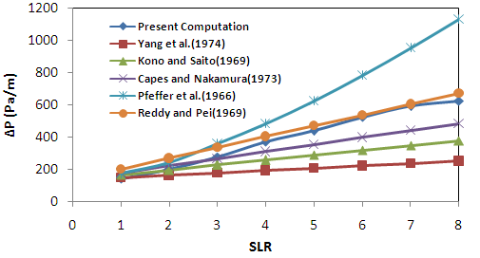

Fig.2. Pressure drop comparison at different loading ratios for D = 30 mm, dp=200 micron, Ug=15 m/s, particle density = 2500 kg/m3

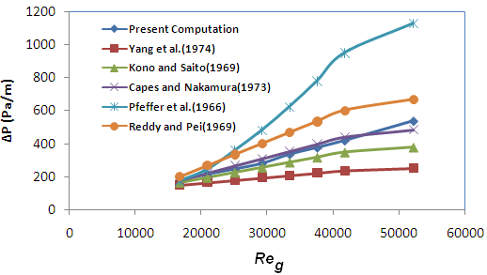

Fig.3 Pressure drop comparison at different gas Reynolds number for D = 30 mm, dp=100 micron, SLR=5, particle density = 1500 kg/m3

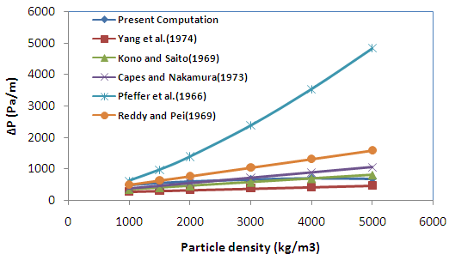

Fig.4 Pressure drop comparison at different particle densities for D = 30 mm, dp=150 micron, SLR=8, Ug=20 m/s

We observed that solids loading ratio and gas velocity are the dominant factors for pressure drop in pneumatic conveying. Pressure drop increases sharply with increase in loading ratio and gas velocity. There is some disagreement in the pressure drop prediction between the existing correlations. The data from Pfeffer et al.12 over predicts all the data. Our numerical predictions are in good agreement with the Reddy and Pei14 and Capes and Nakamura15 data.

**5. Conclusion**

CFD simulations using Euler-Euler approach for gas-solid flows were performed in vertical pipes to study the effect of gas inlet velocity, solids loading ratio and particle density on pressure drop predictions. It was found that pressure drop increases with increase in solids loading ratio (linear variation for vertical flows) and gas phase Reynolds number. There is no significant rise of pressure drop with increase in particle density in the range 1000 to 2500 kg/m. Computed results for pressure drop are also compared with the existing correlations in vertical flow. The correlations by Reddy and Pei14 and Capes and Nakamura15 show better agreement with our numerical data.

**References**

1. C.K.K. Lun and H.S. Liu, Int. J. of Multiphase Flow. 23(3), 575–605 (1997).
2. C. Masson and B.R. Baliga, Int. J. Num. Methods in Fluids. 28, 1441 (1998).
3. R.I. Issa and P.J. Oliveira, Int. J. Num. Methods in Fluids. 43, 1177 (2003).
4. H.E. Rose and R.A. Duckworth, Engineer. 227, 478 (1969).
5. W.C. Yang, Journal of Powder and Bulk Solids Technology. 1, 89 (1977).
6. W.C. Yang, AIChE Journal. 20 (3), 605 (1974)*.*
7. G.E. Klinzing, N.D. Rohatgi, A. Zaltash and C.A. Myler, Powder Technology. 51(2), 135 (1987).
8. P. Patro and S. K. Dash, Particulate Science and Technology. 32 (1), 94 (2014).
9. P. Patro and S. K. Dash, Powder Technology. 264, 320 (2014).
10. Y. Tsuji, Y. Morikawa, and H. Shiomi, J. Fluid Mech. 139, 417 (1984).
11. W.C. Yang, *AICM J*. 24, 548 (1978).
12. R. Pfeffer, S. Rosettti, and S. Licklein, Report NASA,TN-D 360 (1966).
13. H. Konno, and S. Saito, J*.* Chem*.* Eng*.* Jpn*.* 2(2), 211 (1969).
14. K.V.S. Reddy, and D.C.T. Pei, Ind. Eng. Chem. Fundam. 8, 490 (1969).
15. C.E. Capes, and K. Nakamura, Can*.* J*.* Chem. Eng*.* 51, 31 (1973).