**WEAR CHARACTERISTICS OF AL 6061 ALLOY REINFORCED WITH COCONUT SHELL ASH USING STIR CASTING**

**K Varalakshmia**\***, K Ch Kishor Kumar b**

*aMechanical Engineering, Gudlavalleru Engineering College, Gudlavalleru-521356, A.P., India.*

*bMechanical Engineering, Gudlavalleru Engineering College, Gudlavalleru-521356,A.P., India.*

*Email:* *[*varalakshmi.mech@gmail.com*](mailto:varalakshmi.mech@gmail.com)*,*[*kchkishorekumar2k@gmail.com*](mailto:kchkishorekumar2k@gmail.com)*.*

-------------------------------------------------------------------------------------------------------------------------------

**Abstract**

The distinctive characteristics of the composite materials for the particular needs makes these materials additional in style during a kind of applications like automotive bearings, automotive cylinder liners, structural parts, pistons, and aerospace leading to savings of energy and material. In this paper aluminium alloy Al 6061 with Coconut shell ash as reinforcement, at numerous proportions of 1%, 3% and 5% synthesized with Stir Casting method is taken into account. Metal matrix composites made by stir casting method have additional benefits compare with alternative ways. Mechanical properties of mmcs like micro hardness, density, porosity, tensile strength and wear characteristics as completely different variables like load, speed and track diameter are determined.

***Keywords*:** Al 6061, coconut shell ash (CSA), Wear characteristics, Stir Casting.

1. **Introduction**

A Composite material can be formed by at least two unique materials together. The mechanical characteristics of the composites will be better than the individual constituents. The composite materials will be comprises of more than two stages. They are matrix and reinforcement phases.

The current state, demands towards development of engineering material to various specific problems in an exertion to overcome the challenge in manufacturing via tools and materials. Composites (MMCs) bring significant profit due to attainable properties are prominent for the components concerned. The number of metallic alloys employed industrially is very high and new composition is being tested for employed to meet the new diversify demands of many industries. Moreover, the innumerable alloys, aluminium alloy find the wide application in industrial and technology due to as high strength - weight ratio, specific modulus, and high wear resis­tance. Precisely, Al MMCs are effectively implemented in few industrial applications like aerospace, automotive, defence, and electronic packing.

**Selection of Materials**

Base Material - Aluminium-6061 Reinforcement – Coconut shell Ash(CSA)

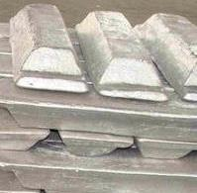 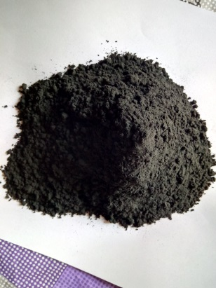

Fig.1. Al 6061 ingots Fig.2. Coconut shell ash

**2. Experimental Work**

**2.1Sieved analysis**

100 g of the reinforcing particulate samples was charged into a set of sieve mesh arranged in descending order of fineness. The samples were shaken for 15 min which is the recommended time to achieve complete classification in accordance with BS 1377:1990. The weight that was retained on each set of sieve mesh was taken and expressed as percentages of the total sample weight. From the weight retained, the grain fineness number (GFN) was computed from the expression

Grain fineness number (GFN) = $\frac{Total product}{Total sum of percentage collected in each sieve}$

A charge of 1.5 kg of Al6061 alloy was placed in stir casting machine to heat up to 7500C, along with 1.0 wt. % preheated flux, and wt.% reinforcement at 3000C in an oven. Argon gas was allowed to pass during melting of alloy to avoid oxidation. The furnace temperature was raised to 7500C. Preheated flux was added to the melt and allowed for homogenization for 5–6 min by agitating of stirrer in the melt. After cleaning the surface of the melt, preheated (up to 3000C) CSA particles were added into the vortex of the melt during stirring. The composite melt was stirred with stainless steel impeller at 600 rpm for 10 min. Then the melt is allowed into the die of 270mm length and 22mm diameter of 2 fingers while stirrer is rotating. The same process is repeated for pure Al6061 alloy and also for reinforcement Coconut Shell Ash (CSA) 1%, 3% and 5%. The ingots of the composites and unreinforced Al6061 alloy were subjected to a heat treatment for 24 hrs at 1100C in muffle furnace.

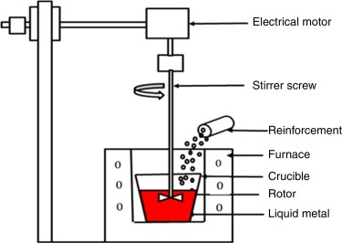

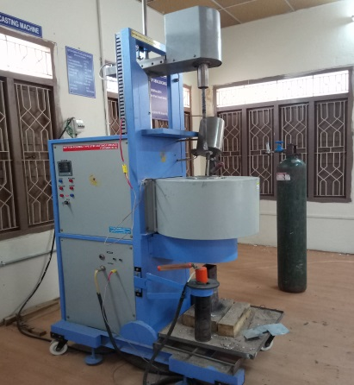

Fig.3. Stir Casting Methodology Fig.4. Stir Casting Machine

**2.2.Micro HardnessTest**

The hardness of the composites was evaluated using Viker’s Micro Hardness Tester (LECO AT 700 Micro hardness Tester).operated on Vickers hardness scale. The samples for hardness test were prepared and tested in accordance with ASTM standard. Basically, specimens cut for the test were representative of the bulk composite compositions and polished to achieve smooth plane surfaces for accurate hardness readings. A precision diamond indenter is impressed on the material at a load of 100 gf for 10 s. In order to avoid segregation effect of the particles, several hardness indents (a minimum of three indentation) are made on the specimens, and average hardness values determined.

**2.3. Tensile strength**

The tensile tests were conducted on the test specimens according to ASTM E08 standards. The universal testing machine (UTM-STAR SYSTEMS 9036TD) loaded with 9.1 kN load cell was used to conduct the tensile test. The tensile strength was evaluated at the cross head speed of 0.2 mm/min.

**2.4. Wear Test**

In a pin-on-disc wear tester, a pin is loaded against a flat rotating disc specimen such that a circular wear path is described by the machine. The machine can be used to evaluate wear and friction properties of materials subjected to loading under pure sliding conditions. The size of the Pin may vary from 6mm to 10 mm of either square or circular cross section. A convenient way is to use ball of commercially available materials such as bearing steel, tungsten carbide or alumina as counter face, so that the name of ball-on-disc is used which is as shown in fig7.

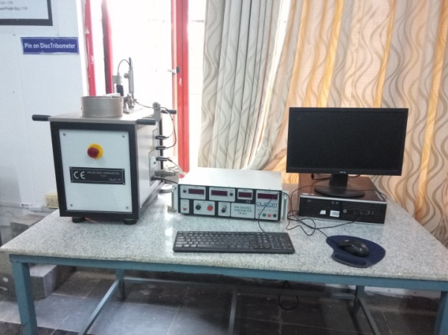

Fig.5. Wear Testing Machine

Wear tests were carried out under dry sliding conditions under the loads of 15, 25 and 35 N which rotated at 410 rev/min. A fixed track diameter of 70mm was used in all tests.

**3. Results and Discussion**

3.1 Micro Vickers Hardness

Fig.6. Shows the Vicker’s micro hardness plot of specimens

In the composite with 150 μm CSA, there was an increase in hardness at 1wt% filler addition followed by continuous increase in hardness at 5wt% in composite, the composite 5%exhibited improvement in hardness over that of the alloy.

**3.2 Tensile Test**

Tensile test helped to determine the tensile strengths of different composite it was found that there was a remarkable increase in tensile strength with a increase in addition of reinforcement.

Fig.7 Graph of Metal Matrix Composites v/s Ultimate Tensile Stress(MPa)

Maximum tensile stress obtained was 143.66MPa for Al 6061 + 5% CSA reinforced aluminum composites.

**3.4. Wear Test Analysis**

3.4.1. Wear rate vs Load

Wear rate has significantly reduced for composite with the addition of reinforcing phase (%) for both varying RPM and varying load. From obtained results from wear testing, it was noticed, a considerable decrease in wear rate with increasing load and speed.

**Speed = 1.5 m/s, Composition-1%CSA+ Al 6061 Speed = 1.5 m/s, Composition-3%CSA+ Al 6061**

**Speed = 1.5 m/s,Composition-5%CSA+ Al 6061Speed = 1.0 m/s, Composition-1%CSA+ Al 6061**

**Speed = 1.0 m/s, Composition-3%CSA+ Al 6061Speed = 1.0 m/s, Composition-5%CSA+ Al 6061**

**Speed = 0.5 m/s, Composition-1%CSA+ Al 6061 Speed = 0.5 m/s, Composition-3%CSA+ Al 6061**

**Speed = 0.5 m/s, Composition-5%CSA+ Al 6061**

4. Conclusion

The following conclusions have been drawn:

1. Al 6061 alloy MMCs reinforced with different sizes and weight percentages of CSA particles (up to 5 wt. %) have been successfully fabricated by the Stir Casting method.
2. The optimum conditions of the production process were that the pouring temperature was 700ºC, preheated mold temperature was 350ºC, the stirring speed was 600 rev/min, the stirring time after the completion of particle feeding was 5 min, the particle addition rate was 5g/min.
3. The tensile strength and hardness of MMCs increased.
4. The Wear rate of the MMCs increased with the addition of reinforcement.
5. The hardness of the metal matrix composites increased with addition of reinforcement.

**References**

[1] R. S. Sankara Raju, M. K. Panigrahi, R. I. Ganguly, and G. SrinivasaRao, “Tribological behaviour of al-1100-coconut shell ash (CSA) composite at elevated temperature,” *Tribol. Int.*, vol. 129, pp. 55–66, 2019.

[2] L. Natrayan, “Investigation on Microstructure and Mechanical behaviour of AA6061 Reinforced SiC and various Leaf Ashes using Stir Casting Technique,” vol. 4, no. 10, pp. 107–112, 2018.

[3] K. Ravi Kumar, T. Pridhar, and V. S. SreeBalaji, “Mechanical properties and characterization of zirconium oxide (ZrO2) and coconut shell ash(CSA) reinforced aluminium (Al 6082) matrix hybrid composite,” *J. Alloys Compd.*, vol. 765, no. Al 6082, pp. 171–179, 2018.

[4] P. V Rajesh, M. S. Prasanth, V. S. Daniel, and C. M. Saravanan, “Evaluation of Mechanical Properties and Machinability Analysis of A l 6061 Hybrid Composite,” vol. 6, no. April, pp. 250–255, 2018.

[5] S. Jain, V. Aggarwal, R. S. W. ,MohitTyagi, and R. Rana, “Development of Aluminium Matrix Composite Using Coconut Husk Ash Reinforcement,” *Int. Conf. Latest Dev. Mater. Manuf. Qual. Control*, pp. 352–359, 2018.

[6] K. N. Niranjan, B. N. Shivaraj, M. Sunil, and A. R. Deepak, “Study of Mechanical Properties on Al 6061 Hybrid Composite By Stir Casting Method,” *Int. Res. J. Eng. Technol.*, vol. 4, no. 1, pp. 1036–1040, 2017.

[7] T. Nithyanandhan, K. Rohith, C. G. Sidharath, C. Sachin, and S. Jagadesh, “Investigation of Mechanical Properties on Aluminium Based Hybrid Composites,” pp. 118–126, 2017.

[8] M. Poornesh, J. X. Saldanha, J. Singh, and G. M. Pinto, “Effect of Coconut Shell Ash and SiC Particles on Mechanical Properties of Aluminium Based Composites,” vol. 7, no. 4, pp. 112–115, 2017.

[9] J. W. Pinto, G. Sujaykumar, and R. M. Sushiledra, “Effect of Heat Treatment on Mechanical and Wear Characterization of Coconut Shell Ash and E-glass Fiber Reinforced Aluminum Hybrid Composites,” vol. 6, pp. 15–19, 2016.

[10] P. Lakshmikanthan and B. Prabu, “Mechanical and tribological beheaviour of aluminium Al6061-coconut shell ash composite using stir casting pellet method,” *J. Balk.Tribol.Assoc.*, vol. 22, no. 4–I, pp. 4008–4018, 2016.

[11] C. Saravanan, K. Subramanian, V. A. Krishnan, and R. S. Narayanan, “Effect of Particulate Reinforced Aluminium Metal Matrix Composite –A Review,” *Mech. Mech. Eng.*, vol. 19, no. 1, pp. 23–30, 2015.

[12] W. A. Ajibola, A. Dada, F. P. Ilaro, and O. State, “Microstructural and Mechanical Characterization of Reinforced Aluminum Composite ( MMC ),” *Int. J. Sci. Eng. Appl. Sci.*, vol. 1, no. 7, pp. 86–97, 2015.

[13] O. O. Daramola, A. A. Adediran, and A. T. Fadumiye, “Evaluation of the mechanical properties and corrosion behaviour of coconut shell ash reinforced aluminium (6063) alloy composites,” *Leonardo Electron. J. Pract. Technol.*, vol. 14, no. 27, pp. 107–119, 2015.

[14] D. S. King, W. G. Fahrenholtz, and G. E. Hilmas, “Silicon carbide-titanium diboride ceramic composites,” *J. Eur. Ceram. Soc.*, vol. 33, no. 15–16, pp. 2943–2951, 2013.

[15] H. R. Ezatpour, M. Torabi-Parizi, and S. A. Sajjadi, “Microstructure and mechanical properties of extruded Al/Al 2O3 composites fabricated by stir-casting process,” *Trans. Nonferrous Met. Soc. China (English Ed.*, vol. 23, no. 5, pp. 1262–1268, 2013.

[16] H. Su, W. Gao, Z. Feng, and Z. Lu, “Processing, microstructure and tensile properties of nano-sized Al2O3particle reinforced aluminum matrix composites,” *Mater. Des.*, vol. 36, pp. 590–596, 2012.

[17] H. N. Reddappa, K. R. Suresh, H. B. Niranjan, and K. G. Satyanarayana, “Effect of Rolling on Microstructure and Wear Behavior of Hot Rolled Al6061-Beryl Composites,” *Adv. Mater. Res.*, vol. 463–464, pp. 444–448, 2012.

[18] K. K. Alaneme, A. O. Aluko, K. K. AlanemeAψ, and A. O. Aluko, “Production and Age-Hardening Behaviour of Borax Premixed SiC reinforced Al-Mg-Si alloy Composites developed by Double Stir-Casting Technique,” *West Indian J. Eng.*, vol. 34, no. 2, pp. 80–85, 2012.

[19] E. Sandeep, K. Ravesh, and T. K. Garg, “Prepration& Analysis For Some Mechanical Property Of Aluminium Based Metal Matrix Composite Reinforced With,” *Int. J. Eng. Res. Appl.*, vol. 2, no. 6, pp. 727–731, 2012.