**EXPERIMENTAL INVESTIGATION ON STRENGTH OF ABS SPECIMENS BY OPTIMIZING THE FDM PROCESS PARAMETERS**

Chetty Nagaraja, Debashis Mishrab,*, T. Tirupatic

*a,b,c Department of Mechanical Engineering, CMR Technical Campus, Hyderabad-501401, Telangana, India*

*Corresponding author Email: debashis171@gmail.com

------------------------------------------------------------------------------------------------------------------

The recent most admired additive manufacturing (AM) technique is the fused deposition method (FDM) because of its low cost and ease of operation. The FDM printed parts often suffered with lack of global or average strength, because of more strength in printed direction and leads to anisotropic mechanical properties. The most effective methods to obtain high tensile strength are the optimization of process parameters of FDM process to manufacture high strength ABS samples. The present research paper objective is to analyze the process parameters effect on tensile strength of FDM printed specimen with Acrylonitrile Butadiene Styrene (ABS). The specimen is prepared as per the ASTM D 638 standards. The specimens are printed in accordance with L9 matrix a Taguchi method. The chosen FDM process parameters are fill density with 40, 60 and 80(%), print speed with values of 60, 80 and 100(mm/min), and layer thickness 100, 200 and 300(microns). From the tensile strength investigation of ABS samples, the maximum tensile strength of 24.866 MPa is obtained with specimen build with the parameters, infill-80%, speed- 100mm/min and layer thickness 0.2mm.

***Keywords*:** Additive Manufacturing; Acrylonitrile Butadiene Styrene; Fused Deposition Modelling; Taguchi L9 approach

1. **Introduction**

The FDM technique becomes popular in very short span due to its ease in operation, short production cycle and low production cost. This technology made easy in rapid prototyping of functional objects, structures suitable for thermal resistance such as for aerospace application and electrical conductive parts for prosthesis application by using different materials. Intricate parts are produced at lower cost in comparison to conventional production process as this process does not require excess tooling. The process involves deposition of melted thermoplastic through heated nozzle layer by layer manner on a build platform in the type of a prearranged two dimensional (x-y) layer platform (1). The deposited material solidifies and a desired shaped part is produced. The table on which the build sheets are located lies on the x-y plane. Layer is deposited according to the cross section of geometry to be printed from a CAD file. The fig. 1 represents the working process of FDM technique. The density of ABS is 1.06g/cm3, tensile strength 42MPa and produces excellent impact and heat resistance, exhibits good strength and machinability, provides fine corrosion and scratch resistance. The present research paper objective is to present the effect of process parameters of fused deposition method on mechanical properties of ABS material specimens.

Godfrey et al. 1 investigated FDM process parameters influence on mechanical strength of printed specimen with ABS material by employing design of experiments. Zero part orientation and increased raster angle also resulted the gain in tensile strength is reported. Tontowi et al. 2 analysed FDM process parameters to enhance the quality i.e. dimensional accuracy and strength of printed specimens with poly-lactic materials using Taguchi method and Response Surface Method to optimize the process parameters. Enhanced quality of prints with optimised parameters obtained with RSM in comparison to Taguchi method is concluded. Adrian Rodriguez et al. 3 studied the influences of process parameters on strength of polylactide (PLA) and acrylonitrile butadiene styrene (ABS) pieces manufactured by FDM.

Process parameter infill density is having major effect on strength is stated. PLA specimens are more rigid and having greater strength than ABS is concluded. Ahn et al. 4 carried out experiments to study the effects of FDM parameters and build orientation on the tensile and compressive strength of the ABS parts fabricated by FDM. The parameters considered are air gap, road width, model temperature, material colour and build orientation Ang et al. 5 concluded that process parameter build orientation is critically affects the mechanical properties and porosity of ABS fabricated parts. Wang et al. 6 tested the specimens printed with different deposition orientations and found that Z direction resulted in maximum tensile strength of FDM part and vertical direction to the layer results the minimum tensile strength. Sood et al. 7 built a mathematical model by using CCD and ANOVA techniques to obtain the desired properties of FDM processed parts. It is noticed that the overall increase in strength by reducing the amount of layers and by increasing the layer thickness. Percoco et al. 8 conducted experiments to find the strength under compression of chemically treated and untreated ABS samples printed by FDM process. The results obtained as maximum strength of untreated sample is 44.01 MPa and treated sample is 44.66 MPa. Raster angle 30 and 60 degrees is having more impact on the strength is reported. Farzad Rayegani et al. 9 printed ABS samples using FDM process and optimized the different factors to obtain the desired strength. The group modelling for data handling method is used to create a functional network to relate the input factors and output response. The maximum strength is reported as 38.9 Mpa. I. Flores et al. 10 reported a robust experimental design to analyse the impact of process parameters by following the optimum guidelines. The design is reported as simplex form of process parameters selection by reducing the noise factors to improve the rate of production.

1. **Experimental details**

The ABS material specimens are printed as per ASTM standard D 638 by using the 3D printer Fracktal works Julia and the set up and printed ABS specimens are shown in fig. 1. The input process parameters are print speed, fill density, layer thickness and their working ranges are given in table 1. The Taguchi L9 approach experimental conditions are given in the table 2. Statistical software named as Minitab is used to draw a valid and meaningful conclusion by optimizing the FS welding process parameters. The analysis of variance technique (ANOVA) is used to find the significance of the achieved relationship. In this technique F ratio called fishers test is used to measure the fitment of the experimental data to the 95% confidence interval statistically. The signal-to-noise ratio (S/N) used to determines the robustness by removing the noise factors to improve the quality of the product. Minitab analyzes the S/N ratio for each group of control factor and their levels available in the experimental design. For static experimental design there are different S/N ratio which termed as; larger is better, smaller is better, nominal is best. The formula for the larger is better S/N ratio using base 10 log is: S/N = ­10×log (Σ (1/Y2)/n) (1)

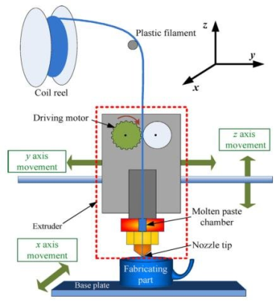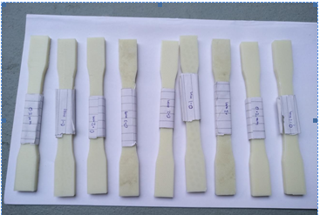

Fig. 1. Schematic FDM process, FDM machine setup, Printed ABS samples

Table. 1. Input parameters and their working ranges

|  |  |  |  |
| --- | --- | --- | --- |
| 3D printing input process parameters | Working levels | | |
| 1 | 2 | 3 |
| Print speed(mm/min) | 60 | 80 | 100 |
| Fill density (%) | 40 | 60 | 80 |
| Layer thickness (microns) | 100 | 200 | 300 |

Table. 2. Taguchi 09 experimental conditions

|  |  |  |  |  |
| --- | --- | --- | --- | --- |
| Row No. | Print speed (mm/min) | Fill density (%) | Layer thickness (microns) | Ultimate tensile strength (MPa) |
| 1 | 60 | 40 | 100 | 12.369 |
| 2 | 60 | 60 | 200 | 14.164 |
| 3 | 60 | 80 | 300 | 21.337 |
| 4 | 80 | 40 | 200 | 10.720 |
| 5 | 80 | 60 | 300 | 22.620 |
| 6 | 80 | 80 | 100 | 12.265 |
| 7 | 100 | 40 | 300 | 20.974 |
| 8 | 100 | 60 | 100 | 13.064 |
| 9 | 100 | 80 | 200 | 24.866 |

1. **Result and discussion**

The observations made from the experiment, tabulated in the table 2, are when print speed is kept constant at 60 rpm, fill density is changed as 40, 60, 80 (%) and layer thickness is varied as 100, 200, 300 microns, the strength of 3D printed ABS specimens are obtained as 12.369, 14.164 and 21.337 MPa. When the print speed increased to 80 rpm and kept constant with varying the fill density and layer thickness the tensile strength of the ABS samples are obtained as 10.72, 22.62, 12.265 MPa. Further increase in print speed to 100 rpm and with the change in fill density and layer thickness the strength of the ABS samples is obtained as 20.974, 13.064, 24.866 MPa. Particularly the strength of ABS samples is obtained to be higher such as 21.337, 22.62 and 24.866 MPa when the layer thickness is maintained at 200 and 300 microns. S/N ratio for each process parameters is calculated using the condition larger is better and the mean value of obtained tensile strength is tabulated in the table 3. Delta is the variability between the maximum and minimum average response (signal to noise ratio and mean) for the individual factors. Ranking of each delta value is defined in terms of, largest delta value (layer thickness) is rank 1 and smallest delta value (print speed) is rank 3.

From the table 4, the regression optimization is carried to found a relationship between the chosen process parameters and response values to analysing their individual as well as combined impact. F value explains the significance of the process parameters on the tensile strength such as layer thickness (0.02) represents to be more significant than print speed (0.237) and fill density (0.14). 'P' value (0.05) describes the regression coefficient is in the chosen range of controlled FDM factors. The contour plots shown in fig. 2 are the two dimensional representations of obtained strength under tension of the ABS samples presented as a surface with respect to the process parameters.

In the contour images the red colour areas describes the ranges of the low strength from 12 to 18 MPa and green colour areas are the ranges of maximum strength from 18 to 24 MPa. The regression expression is shown in equation 2 can be successful applied to assume the strength (TS) of ABS samples printed by FDM process considering the chosen ranges of the process parameters tabulated in table 1.

Table. 3. Process parameters and their S/N ratio, Mean values

|  |  |  |  |  |  |  |
| --- | --- | --- | --- | --- | --- | --- |
| Level | Print speed  (mm/min) | | Fill density  (%) | | Layer thickness (microns) | |
| S/N  ratio | Mean  values | S/N  ratio | Mean values | S/N ratio | Mean values |
| 1 | 23.82 | 15.96 | 22.96 | 14.69 | 21.98 | 12.57 |
| 2 | 23.16 | 15.20 | 24.15 | 16.62 | 23.85 | 16.58 |
| 3 | 25.56 | 19.63 | 25.42 | 14.49 | 26.70 | 21.64 |
| Delta | 2.40 | 4.43 | 2.46 | 4.80 | 4.72 | 9.80 |
| Rank | 3 | | 2 | | 1 | |

Table. 4. Regression Analysis: tensile strength versus rotational speed, tilt angle, feed

|  |  |  |  |  |  |
| --- | --- | --- | --- | --- | --- |
| Sources | Degrees of freedom | Adjusted Sum of Square | Adjusted Mean Square | F-Value | P-Value |
| Regression | 3 | 178.48 | 59.49 | 5.28 | 0.05 |
| Print speed  (mm/min) | 1 | 20.29 | 20.29 | 1.80 | 0.237 |
| Fill density  (%) | 1 | 34.58 | 34.58 | 3.07 | 0.14 |
| Layer thickness (microns) | 1 | 123.61 | 123.61 | 10.96 | 0.02 |
| Error | 5 | 56.38 | 11.28 |  |  |
| Total | 8 | 234.86 |  |  |  |

Regression Equation:

TS = - 6.71 + 0.0920 × Rotational speed + 0.1200 × Tilt angle – 0.0454 × Feed (2)

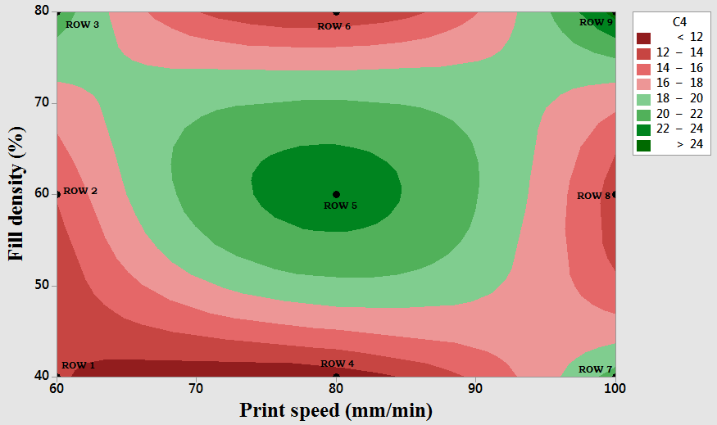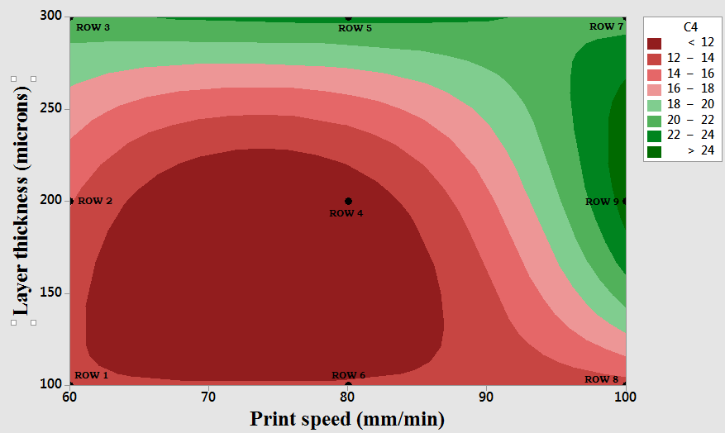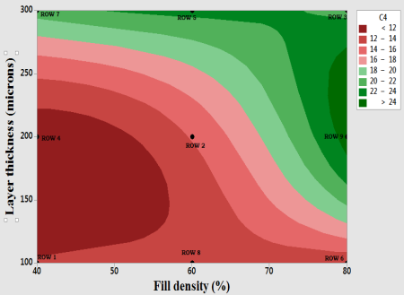

Fig. 2. Counter plots between tensile strength (C4) and FDM process parameters

1. **Conclusion**

The FDM process parameters is optimized using Taguchi L9 approach and the regression expression is generated which can be employed to get 95% confidence. The maximum tensile strength is obtained as 24.86MPa with the process parameters print speed 100 mm/min, fill density 80% and layer thickness 200microns. The layer thickness is having more effect on the tensile strength of ABS samples printed by the FDM process than fill density and print speed. But the combination of the all three process parameters is also observed when print speed 80 rpm, fill density 60% and layer thickness 300microns at which the tensile strength obtained as 22.620 MPa.

**References**

**1.** C. Godfrey, Onwubolu, Rayegani Farzad, Characterization and Optimization of Mechanical Properties of ABS Parts Manufactured by the Fused Deposition Modelling Process, International Journal of Manufacturing Engineering, Hindawi Publishing Corporation, Article ID 598531 (2014).

**2.** A.E Tontowi, L. Ramdani, R.V. Erdizon, D.K. Baroroh, Optimization of 3D-printer Process Parameters for Improving Quality of Polylactic Acid Printed Part, International Journal of Engineering and Technology (IJET), Vol. 9 No 2 Apr-May (2017).

**3.** Adrian Rodriguez-panes, Juan Claver and Ana Maria Camacho, The Influence of Manufacturing Parameters on the Mechanical Behaviour of PLA and ABS Pieces Manufactured by FDM: A Comparative Analysis, Materials, MDPI, (2018).

**4.** SH. Ahn, M. Montero, D. Odell, Anisotropic Material Properties of Fused Deposition Modelling ABS, Rapid Prototype Journal 8(4):248–257, (2002).

**5.** KC. Ang, KF Leong, CK Chua, Investigation of the Mechanical Properties and Porosity Relationships in Fused Deposition Modelling-Fabricated Porous Structures, Rapid Prototype Journal 12(2):100–105, (2006).

**6.** AK Sood, RK Ohdar, SS Mahapatra, Parametric Appraisal of Mechanical Property of Fused Deposition Modelling Processed Parts, Materials Design 31(1):287–295, (2010).

7**.** CC Wang, TW Lin, SS Hu, Optimizing the Rapid Prototyping Process by Integrating the Taguchi Method with the Gray Relational Analysis, Rapid Prototype Journal 13(5):304–315, (2007).

**8.** G Percoco, F Lavecchia, LM Galantucci, Compressive Properties of FDM Rapid Prototypes Treated with a Low Cost Chemical Finishing, Research Journal Applied Science Engineering Technology 4(19):3838–3842, (2012).

**9.** F Rayegani, GC Onwubolu, Fused Deposition Modelling (FDM) Process Parameter Prediction and Optimization Using Group Method for Data Handling (GMDH) and Differential Evolution (DE), International Journal Advance Manufacturing Technology 73(1–4):509–519, (2014).

**10.** I. Flores, E. Coatanea, M. Salmi J. Tuomi, Proceedings of the International Symposium on Robust Design – IsoRD14 Denmark, pp. 135-145, Robust Design Principles to Evaluate Additive Manufacturing Capabilities (2014).