**Experimental and Microstructural Analysis of TIG and MIG Welding on Dissimilar Steels**

Amaram Aravind Reddya, Abu Sufyan Malikb,

*aMechanical Engineering, Vasavi College of Engineering, Hyderabad 500031,TS, India*

*bMechanical Engineering, Mahaveer Institute of Science and Technology, Hyderabad 500005,TS, India*

*Corresponding author Email: [amaramaravindreddy8@gmail.com](mailto:amaramaravindreddy8@gmail.com), [malikabusufyan@gmail.com](mailto:malikabusufyan@gmail.com),

------------------------------------------------------------------------------------------------------------------

Mild steel and Stainless steel are the two most used steels in the automotive industries and in various constructional and industrial applications. Welding of these steels with lesser defects and higher strengths is the most important need of the current industries. In this paper, TIG and MIG welding is preformed between these two dissimilar steels. Due to welding, changes takes place in physical and microstructural properties, so in this paper an experimental and microstructural analysis is made to determine the properties like hardness, impact strength, tensile strength and microstructure of the weld zone*.*

***Keywords*:** Stainless Steel, Mild Steel, Tig Welding, Mig Welding.

1. **INTRODUCTION**

The modern age demands light weight, high strength structures with desired product properties which leads to the joining of dissimilar materials. Many industries relay on metals for manufacturing of desired products and joining of dissimilar metals is an important application in industries.

So coming to metal joining processes welding is an efficient process for joining dissimilar metals and to achieve a high strength and permanent joint. The joining of dissimilar metals with welding will only work if both the metals to be weld are mutually soluble with each other or else as an alternative a third metal which is soluble with both the metals is used to get a joint.

**1.1 WELDING**

In TIG welding tungsten electrode is placed centrally in the torch. The inert gas is supplied through the annular space between torch and electrode. Filler material is supplied using and separate rod. Shielding is achieved by covering the weld zone with a blanket of gases (Argon, Helium) which prevent the exposure of weld metal to oxygen and hydrogen of the air.

Small torches for welding thin sections are air cooled but large torches designed for heavy duty. Depending on the weld material, standard AC or DC machines may be used to maintain electric arc.

It is used for welding all metals and alloys having various thickness. It is extensively used for welding Aluminium, Stainless steel and titanium.

In MIG welding, the arc is struck between the work piece and the wire, which act as electrode and filler material, the arc and weld pool are shielded by inert gas. Depending upon the work material, the shielding gas may be argon, helium and carbon dioxide.

In this case, the bare metal electrode (consumable electrode) in the form of continuous wire is fed through welding torch with the help of electrical motor and feed rolls. The electrode and work piece are connected to electrical supply. The gas from the cylinder is supplied through nozzle to form a protection shield around the weld area.

It is mainly important in welding of carbon and low alloys steels, stainless steels, magnesium alloys, copper and aluminium alloys.

**1.3 STEELS**

Mild Steels are the high carbon steels. These generally contain less than about 0.60-1.4% wt of Carbon. The alloy of Mild Steel with Chromium, Magnesium, Vanadium, tungsten and Molybdenum are used as Knives, Razors, Cutting tool and dies, hacksaw blades and crankshaft. They typically have a yield strength of 430–585MPa (62–85 Ksi), tensile strengths 605-780 MPa (88–113 Ksi), and a ductility of 33–19%EL.

The stainless steelsare highly resistant to corrosion in a variety of environments, especially ambient atmosphere. Their predominant alloying element is chromium; a concentration of at least 11 wt% Cr is required. They typically have a yield strength of 205 MPa( 30ksi) to 1650Mpa (240 Ksi), tensile strengths between 380 and 1790 MPa (55to26Ksi) and a ductility of 20 to 40%EL. Due to its wide range in mechanical properties stainless steel is the backbone of all the industries. A wide range of mechanical properties combined with excellent resistance to corrosion make stainless steels very versatile in their applicability. Equipment employing these steels includes gas turbines, high-temperature steam boilers, heat-treating furnaces, aircraft, missiles, and nuclear power–generating units.

**2. EXPERIMENTAL PROCESS**

**2.1 MATERIAL AND FILLER ROD SELECTION**

**2.1.1 MILD STEEL (MS1040)**

AISI 1040 carbon steel has high carbon content and can be hardened by heat treatment followed by quenching and tempering to achieve 150 to 250ksi tensile strength.

Table -1**:** Chemical Composition

|  |  |  |  |  |  |
| --- | --- | --- | --- | --- | --- |
| **Element** | Iron (Fe) | Manganese (Mn) | Carbon (C) | Sulfur (S) | Phosphorous(P) |
| **Content(%)** | 98.6-99 | 0.60-0.440 | 0.370-0.440 | <0.050 | <0.040 |

Table -2**:** Mechanical Properties

|  |  |  |  |  |  |  |  |  |
| --- | --- | --- | --- | --- | --- | --- | --- | --- |
| **Properties** | Tensile Strength | Yield Strength | Bulk Modulus | Shear Modulus | Elastic Modulus | Elongation at Break | Hardness (Brinell) | Impact |
| **Values** | 620 MPa | 415 MPa | 140 GPa | 80 GPa | 190-210 GPa | 25% | 93 | 45 J |

**2.1.2 STAINLESS STEEL (304L)**

304L stainless steel is a sought after material for use in severely corrosive conditions. Weld annealing is only necessary in applications where stress loads are excessive. This steel Grade is found in a variety of commercial sectors, particularly in the chemical industry.

Table -3**:** Chemical Composition

|  |  |  |  |  |  |  |  |  |
| --- | --- | --- | --- | --- | --- | --- | --- | --- |
| **Element** | Iron (Fe) | Chromium (Cr) | Nickel (Ni) | Manganese (Mn) | Silicon (Si) | Carbon (C) | Sulfur (S) | Phosphorous (P) |
| **Content(%)** | 60-65 | 18-20 | 8-12 | <2 | 1 | 0.03 | 0.03 | 0.045 |

Table -4**:** Mechanical Properties

|  |  |  |  |  |  |  |
| --- | --- | --- | --- | --- | --- | --- |
| **Properties** | Tensile Strength | Yield Strength | Elastic Modulus | Elongation at Break | Hardness (Brinell) | Impact |
| **Values** | 564 MPa | 210 MPa | 193-200 GPa | 58% | 82 | 78 J |

**2.1.3 Filler Rod for TIG Welding (SS304L)**

This **SS 304L Welding Electrode**is a heat resistant, titanium stabilized, austenitic alloy that’s commonly used for service in the 1000˚F – 1600˚F temperature range. It is the grade of choice for applications combining high strength, resistance to scaling and phase stability with resistance to subsequent aqueous corrosion.

Table -5**:** Chemical Composition

|  |  |  |  |  |  |  |  |  |
| --- | --- | --- | --- | --- | --- | --- | --- | --- |
| **Element** | Iron (Fe) | Chromium (Cr) | Nickel (Ni) | Manganese (Mn) | Silicon (Si) | Carbon (C) | Sulfur (S) | Phosphorous (P) |
| **Content(%)** | 60-65 | 18-20 | 8-12 | <2 | 1 | 0.03 | 0.03 | 0.045 |

**2.1.4 Filler Rod for MIG Welding (ER70S-6)**

Type ER70S-6 is a wire with higher levels of Deoxidizers welding of steels with moderate amounts of scale or rust. (Mn & Si) compared to other carbon steel wires. This wire is suitable for welding of steels with moderate amounts of scale or rust.

Table -6**:** Chemical Composition

|  |  |  |  |  |  |
| --- | --- | --- | --- | --- | --- |
| **Element** | Iron (Fe) | Manganese (Mn) | Silicon (Si) | Copper (Cu) | Molybdenum (Mo) |
| **Content(%)** | 95 | 1.4-1.85 | 0.80-1.15 | 0.50 | 0.15 |

|  |  |  |  |  |  |  |
| --- | --- | --- | --- | --- | --- | --- |
| **Element** | Nickel (Ni) | Chromium (Cr) | Carbon (C) | Sulfur (S) | Vanadium (V) | Phosphorous (P) |
| **Content(%)** | 0.15 | 0.15 | 0.06-0.15 | 0.035 | 0.03 | 0.025 |

**2.2 WELDING PROCEDURE**

**2.2.1 Metal Cutting**

The Specimen is made according to the dimension provided in the Table-7 by the Grinder Cutting Machine.

Table -7**:** Specimen Dimensions

|  |  |  |  |
| --- | --- | --- | --- |
| **Material** | **Length** | **Width** | **Thickness** |
| **Mild steel** | 150 mm | 100 mm | 13 mm |
| **Stainless steel** | 150 mm | 80 mm | 9 mm |

**2.2.2 Edge Preparation**

Edge preparation is required for a work piece which has more than 5mm thickness. The plate we used for welding is 13mm (Mild Steel) and 9mm (Stainless Steel) thick. So, for edge preparation we used bench grinding machine to prepare a **“V Groove”** at an angle of 60˚ which means each workpiece possess 30˚ angle. The root gap maintained is 3 mm, with the provision of root gap, if complete thickness of plate is not melting at least the molten metal of electrode or filler rod can flow up to the bottom of joint and produces the joint. Root Face is maintained as 2mm, the root face is provided to avoid the burning through of edges or plate.

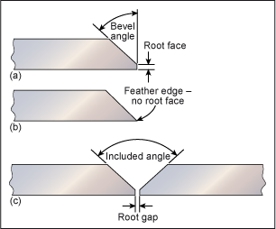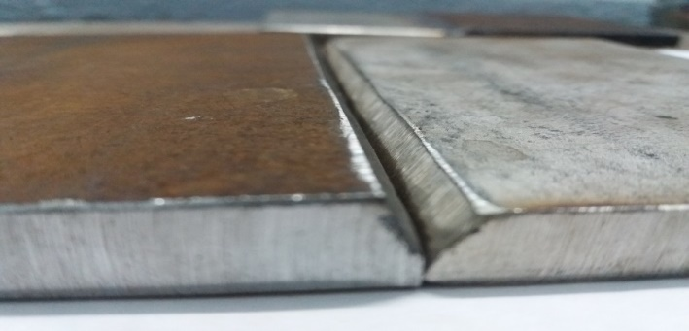

Fig_3 Edge Preparation

**2.2.3 Parameter Considered for TIG and MIG Welding**

TIG welding can be performed either by AC or DC current, here welding is performed on DC current, the selected range of DC current and voltage to perform welding is 160Amp and 24Volts and the shielding gas used is Argon. The shielding gas used is Argon. The non-consumable electrode used is made up of 98% Tungsten and 2% Thoriated. The preferred size for non-consumable electrode is 3mm. The polarity used for electrode is Negative. The flow rate of consumable electrode is 10lit/min and size is 3mm.

MIG welding is an arc welding and it can be performed either by AC or DC current. We performed the operation by using DC current of 150 Amps and 20 volts and the electrode used have Positive polarity. The shielding gas used is CO2. Electrode is made up of Copper coated MS wire which has a thickness of 1.2mm. The flow rate for consumption of electrode is 10lit/min.

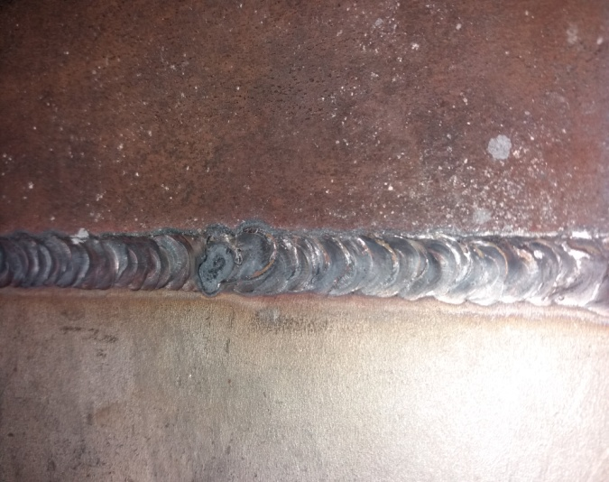 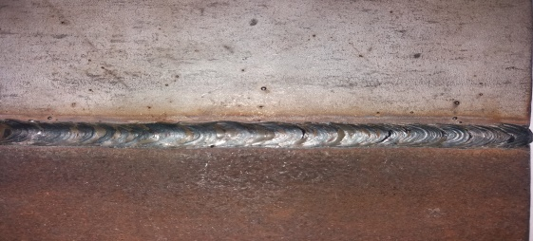

Fig_4 TIG Welding Fig_5 MIG Welding

**3. VISUAL INSPECTION OF WELDED JOINT**

External features of a welded joint can be inspected through visual inspection like weld bead profile which indicates weld width, bead angle and external defects.

Table -8**:** TIG Welded Part Table -9**:** MIG Welded Part

|  |  |
| --- | --- |
| Filler used | **SS304L** |
| Weld bead width | **8 mm** |
| Weld bead height | **6.2 mm** |
| Penetration | **4mm** |
| Reinforcement | **2 mm** |
| Weld quality | **High** |
| Surface defects | **Moderate** |

|  |  |
| --- | --- |
| Filler used | **MS ER70S6** |
| Weld bead width | **9.5 mm** |
| Weld bead height | **6.2 mm** |
| Penetration | **11 mm** |
| Reinforcement | **3 mm** |
| Weld quality | **High** |
| Surface defects | **Moderate** |

**4. DESTRUCTIVE TEST RESULT AND ANALYSIS**

The welding procedure, specification and assessing the suitability of a welded joint is usually done by Destructive Testing such as Tensile Test, Impact Test and Rockwell hardness Test.

**4.1 TENSILE TEST**

A tensile test measures the response of a material to the stress by applying a pulling force. The specimen is prepared according to ASME SEC-IX: 2015 standard. The universal testing machine of model TUE-C-600 is used to conduct this test. The method used is ASTM A370-2015.

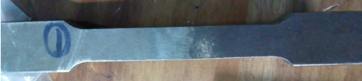

Fig_6 Tensile Test Specimen (ASME SEC-IX: 2015)

Table -10**:** Tensile Test Report (TIG Welding)

|  |  |  |  |
| --- | --- | --- | --- |
| **INPUT DATA** | | **OUTPUT DATA** | |
| **Specimen Shape** | Flat | **Load at Yield** | 28.8 KN |
| **Material Type** | Steel | **Yield Stress** | 230.631 N/mm² |
| **Specimen Description** | TIG Welding (MS+SS) | **Load at Peak** | 32.250 N/mm² |
| **Specimen Width** | 12.5 mm | **Tensile Strength** | 258.258 N/mm² |
| **Specimen Thickness** | 9.99 mm | **% Elongation** | 0.80 |
| **Initial Gauge Length** | 50 mm |  | |
| **Pre Load Value** | 0 KN |
| **Max. Load** | 600 KN |
| **Specimen Gauge Length** | 50.4 mm |

Table -11**:** Tensile Test Report (MIG Welding)

|  |  |  |  |
| --- | --- | --- | --- |
| **INPUT DATA** | | **OUTPUT DATA** | |
| **Specimen Shape** | Flat | **Load at Yield** | 21.57 KN |
| **Material Type** | Steel | **Yield Stress** | 173.183 N/mm² |
| **Specimen Description** | MIG Welding (MS+SS) | **Load at Peak** | 21.720 N/mm² |
| **Specimen Width** | 12.48 mm | **Tensile Strength** | 174.387 N/mm² |
| **Specimen Thickness** | 9.98 mm | **% Elongation** | 0.90 |
| **Initial Gauge Length** | 50 mm |  | |
| **Pre Load Value** | 0 KN |
| **Max. Load** | 600 KN |
| **Specimen Gauge Length** | 50.45 mm |

The above results indicate that a satisfactory weld joint, when welding mild steel with stainless steel can be achieved with both TIG and MIG welding process. So overall tensile test results indicate that the best tensile strength can be achieved with TIG welding process using ER304L filler when compare to other.

Fig_7 Tensile Test Results

**4.2 IMPACT TEST**

Impact test is the method of evaluating the toughness and sensitivity of a material. The specimen was made according to ASTM A 370-2015 as shown in the fig-8. The notch created has depth of 2mm and test is conducted on machine model FIT 300(EN).

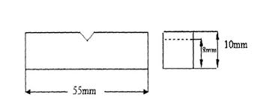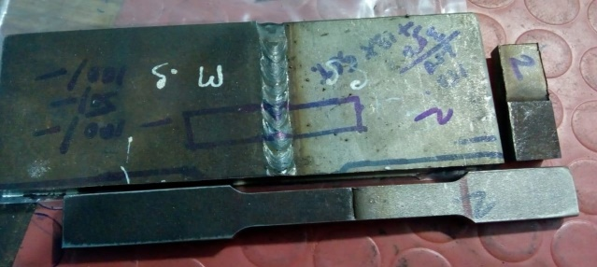

Fig_8 Specimen for Impact Test

Table -12**:** Impact Test Result

|  |  |
| --- | --- |
| **Type of Welding & Filler rod** | **Impact strength Joules** |
| **TIG Welding (SS 304 L FILLER ROD )** | 22 |
| **MIG Welding (ER70S6 FILLER WIRE)** | 26 |

The overall data indicates that MIG welded joint can bear high impact load. But TIG welded joint has less impact load bearing capacity.

**4.3 HARDNESS TEST**

In this experiment the Rockwell hardness test using C scale was carried out at the weld zone, heat affected zones and at other parts of mild steel and stainless steel. The specimen for the micro hardness was prepared according to standards. A diamond indenter was used for the test and the test was carried out with minor load 10Kg and major 140 kg load.

Table -13**:** Hardness Test Result

|  |  |
| --- | --- |
| **Type of Welding & Filler rod** | **Hardness on weld bead** |
| **TIG Welding**  **(SS 304 L FILLER ROD )** | 80 |
| **MIG Welding**  **(ER70S6 FILLER WIRE)** | 62 |

Fig_9 Hardness test Result

The above results indicate that the hardness of TIG weld bead more than MIG, hence TIG welding can be preferred if hardness is a criteria. Due to unequal heating and cooling of base metals different hardness are found at different parts.

**5. MICROSTRUCTURAL ANALYSIS**

The microstructural analysis is carried out by optical microscope (MET SCOPE-1) and the method used is ASTM E 407-07 and ASTM E 3-11. The microstructure is taken on magnification of 200X. The etching agent used is Aquaregia and Nital.

**5.1 TIG WELDING MICROSTRUCTURE**



Fig_10 Microstructure of TIG Welding

Microstructure consists of grain structure of Austenite, Pearlite and Ferrite matrix. Microstructures consist of fine austenite and pearlite ferrites grains are uniformly distributed weld zone to base material. No cracks observed at HAZs.

As the microstructure indicates distribution of phases like fine austenite and pearlite with uniform distribution of ferrite grains. It implies that the weld bead has both strength and ductility. Hence optimum mechanical properties are obtained can be further improved by heat treatment.

In TIG Welding it has dense distribution of Pearlite as compare to MIG welding which indicates it has more hardness.

**5.2 MIG WELDING MICROSTRUCTURE**



Fig_11 Microstructure of MIG Welding

Microstructure consists of grain structure of Austenite, Pearlite and Ferrite matrix. Microstructures consist of fine austenite and pearlite ferrites grains are uniformly distributed weld zone to base material. No cracks observed at HAZs.

As the microstructure indicates distribution of phases like fine austenite and pearlite with uniform distribution of ferrite grains. It implies that the weld bead has both strength and ductility. Hence optimum mechanical properties are obtained can be further improved by heat treatment.

**6. CONCLUSIONS**

In this paper we discussed about the effect of Tig and Mig welding while welding between two dissimilar steels. The overall result of Tig and Mig welding can concluded in these following points.

1. Tig welding with filler rod SS304L has more tensile strength and yield stress as compared to Mig welding with filler rod ER70S6.
2. Mig welding has higher percentage of elongation as compared to Tig welding.
3. Mig welding has higher toughness.
4. The hardness of TIG welding is high as compared to MIG welding so we can choose TIG welding when hardness is the criteria for manufacturing.
5. The weld quality is superior for TIG welding.
6. The microstructure of both TIG and MIG Welding indicates that they have uniform strength and ductility.

**References**

**1. Journal article**

1. Md. Gaffar, Mudavath Shankar, Pampana Sampath Kumar and V.V.Satyanarayana. Experimental Investigation on Welded Joints of Dissimilar SteelsInternational Journal of Current Engineering and Technology, vol-7 No.3,E-ISSN 2277 – 4106, P-ISSN 2347 – 5161 (2017)
2. Kumar Rahul Anand, Vijay Mittal. Parametric optimization of Tig welding on joint of SS and MS using Taguchi Technique. International Research journal of Engineering and Technology, vol-4 No-5, e-ISSN: 2395 -0056 p-ISSN: 2395-0072 (2017)
3. *Idris Kaynak,* The Welding Of Dissimilar Materials With Copper Based Consumables. Usak University Journal of Material Sciences, December (2016)
4. S.Giridharan, TTM.Kannan, K.Balamurugan, Arun Kumar, Vignesh, Experimental Investigation and Analysis of Dissimilar welding of AISI 316 L and IS 2062 using GTAW, International Journal of Innovative Research in Science, Engineering and Technology Vol. 5(6),(2016)

**2. Book**

* William D. Callister, Jr. David G. Rethwisch , Material Science and Engineering an Introduction, 8th Edition, John Wiley and Sons, Inc. (2010)