Numerical investigations of Photovoltaic phase change materials system with different inclination angles

Tushar Sathe1a,*, A.S.Dhoble2b, Devidas Yadav3c

*a.b,cDepartment of Mechanical Engineering, VNIT, Nagpur 440010, Maharashtra, India*

*Corresponding author Email: tusharsathe90@gmail.com ________________________________

------------------------------------------------------------------------------------------------------------------

Excess unused solar radiations falling on the PV system raises its temperature and decreases the electrical conversion efficiency. Phase change materials can be effectively used for the thermal management of PV systems due to its high latent heat. In the current research work effect of inclination angle on the thermal performance of PV PCM system is investigated. The inclination angle is increased from 150 to 900 with constant PCM thickness of 30mm at 1000W/m2 of incoming solar radiation. It is observed that the PCMs can be effectively reduce the PV surface temperature. The increase in inclination angle of PV PCM system reduces the time required for melting PCM and increases the PV surface temperature.

***Keywords*:** Photovoltaic, Phase change materials, Boussinesq approximation.

1. **Introduction**

The natural resources for fulfilling ever increasing demand of heat and electricity across the globe are on the verge of extinctions. Solar energy has been considered one of the prominent alternative for the natural resources due to its abundant availability, free of cost and probability to efficiently replace the use of natural fuels for the production of heat or electricity. Solar energy can be converted into electricity with photovoltaic (PV) solar cells. PV solar cell is very mature technology now; however, it has serious issue of decreasing its efficiency with the increase in its surface temperature. Solar PV panels generally converts 16-20% of the incoming solar radiation into electricity and most of the excess unused solar radiations causes to increases the temperature of PV cells; which affects its performance[1]. The solar PV cells efficiency is measured at the standard test conditions of 250C, AM1.5 and the incoming solar radiations of 1000W/m2. The increase of 10C in the surface temperature of PV solar cells above 250C causes to decrease the efficiency of PV solar cells around 0.45-0.6% and thus, the thermal management of PV systems is considered to be one of major challenge across the globe especially, in the country like India with very hot climate in most of the time around the year.

During last 2-3 decades various active and passive thermal management systems has been investigated by various researchers; though, the best possible thermal regulation systems is still not available. The PCMs may be organic or inorganic and have common tendency to absorb heat during charging and releasing the absorbed heat during discharging period [2]. Phase change materials (PCMs) has been used as a thermal energy storage systems in the past but, due to its property of high latent heat and maintaining constant temperature during phase change; it can be efficiently combined with the PV systems [3,4]. Choubineh et al. [5] performed experimental investigations of PV systems with salt hydrates as a PCM for the applications in the building storage systems. They found 3.7-4.30C reduction in the surface temperature of the PV panel. Karthick et al. [6] experimentally investigated the effect of inorganic glauber salt as a PCM on the performance of building integrated photovoltaic phase change material system. The results estimated 12% reduction in PV cell temperature compared to conventional PV system. The CO2 mitigation over the lifetime of the developed PV PCM system was observed to be 1.74 tCO2e. Su et al. [7] performed on site experimental analysis of concentrated PV systems and compared the performance of water cooling and PCM cooling system. They concluded that the PCM cooling was more effective way for the performance improvement of CPV-T systems. Ma et al. [8] performed mathematical modelling and sensitivity analysis of PV system integrated with PCM. They developed 1D resistance model and observed that with every 100W/m2 increase in solar radiations causes 50C increase in the peak PV temperature however, they suggested that the PCM melting temperature should be slightly higher than the ambient temperature. Lu et al. [9] investigated the performance of building integrated concentrated PV systems with the fins and PCMs. 12% improvement in PV efficiency were observed with the developed fin based PV PCM system. It is observed from the previous literature that the PCM can be effectively utilized for the thermal regulation of PV systems and huge research work has already been carried out to analyse the performance of PV system with PCM; however, it is noticed that the numerical analysis of PV system integrated with PCM need to be performed more effectively as most of the previous literature based on vertical building integrated PV system and very few studies are available with inclined PV systems. It is well known that the PV systems are mounted with different inclination angles depending on the geographical location on the earth.

In the present work numerical investigations is carried out with PV PCM system with different inclination angle. The numerical model is first validated with past experimental results available in the literature. The effect of temperature on the specific heat and thermal conductivity is considered during the analysis. Natural convection plays a major role during inclined PV PCM system; thus, the effect of natural convection is also considered during numerical analysis using Boussinesq approximations. The inclination angle of the PV PCM system is varied from 150 to 900 and the effect of inclination angle on the different performance parameters are analysed.

1. **Methodology**

In the current research work polycrystalline PV panel integrated with the PCM is considered for the numerical analysis as shown in fig. 1. The PV panel is made up of five layers and at the back of the PV panel, PCM container is attached with the aluminium metal plate as a top side. For the numerical analysis few assumption were considered: heat loss is neglected from the bottom and the side wall, solar flux is distributed uniformly and the PV panel contact resistance is neglected during the

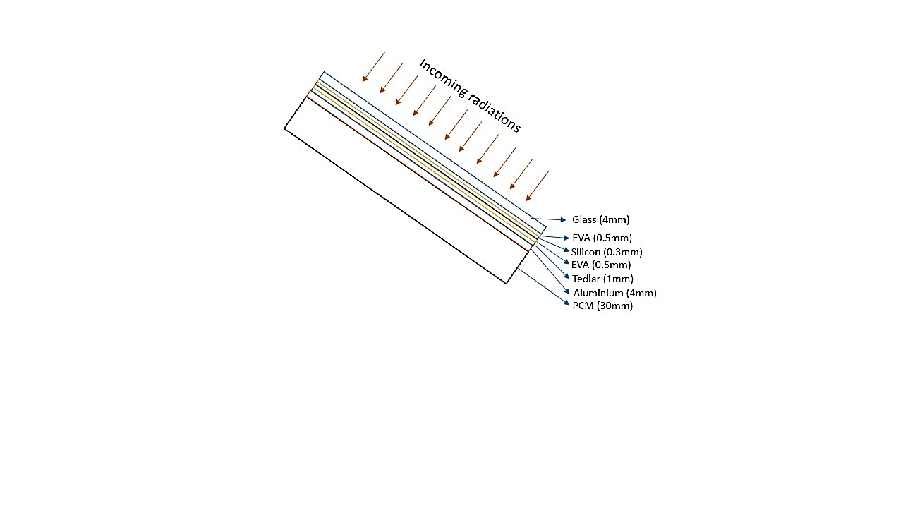 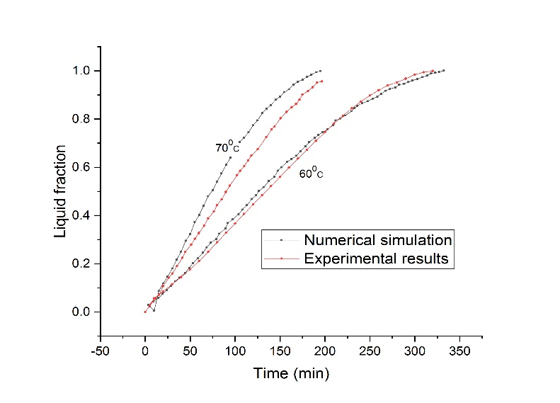

Fig. 1. Numerical model of the system Fig. 2. Validation of numerical model

The melting process of PCM inside the PCM container is modelled using enthalpy-porosity technique suggested by voller and Prakash [10]. The density variations during the phase change process can be incorporated in the numerical analysis using Boussinesq approximation to observed natural convection effect:

 (1)

Where, ρ is the density of liquid PCM and  is the thermal expansion coefficient. The governing equations for the 2D, laminar and Newtonian flow are given as follows [11,12]

Continuity equation,

 (2)

Momentum equation,

 (3)

Energy equation,

 (4)

Where, is the density,  is the velocity vector, is the enthalpy, is the pressure,  is the dynamic viscosity, is the thermal conductivity and is the acceleration due to gravity. The source term in the momentum equation can be given as:

 (5)

Where, is the mushy zone constant; measures the amplitude of the damping.  Indicates the liquid fraction,

 (6)

The numerical model is first validated with the experimental results obtained by Kamkari et al. [13] with different input temperature of 600 and 700C applied to the vertical PCM container as shown in fig. 2. The grid independence study and time independent study has also been carried to analyse the effect of changing grid size and time step size on the numerical results. Three different time step size with different number of nodes is investigated and finally, 18620 number of nodes is selected for the analysis with 0.1s of time step size.

1. **Results and discussion**

The temperature variations of the PV surface, PCM inside PCM container and velocity of PCM during phase transition is investigated at different tilt angle of the system with 1000W/m2 of incoming heat flux. ANSYS Fluent 16 is used for the numerical analysis. SIMPLEC scheme is selected for the pressure velocity coupling and PRESTO is used for the pressure spatial discretization. Energy, velocity and continuity residuals were selected to be 10-8, 10-4 and 10-4 respectively. Piecewise linear changes is used to accommodate change in specific heat as suggested by Biwole et al. [14]. RT25 is selected for the analysis with the melting point of 26.60C. The ambient temperature is selected to be 200C. All the other system parameters are selected as available in the literature [15]

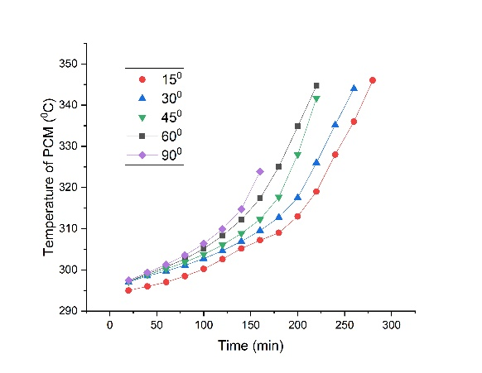 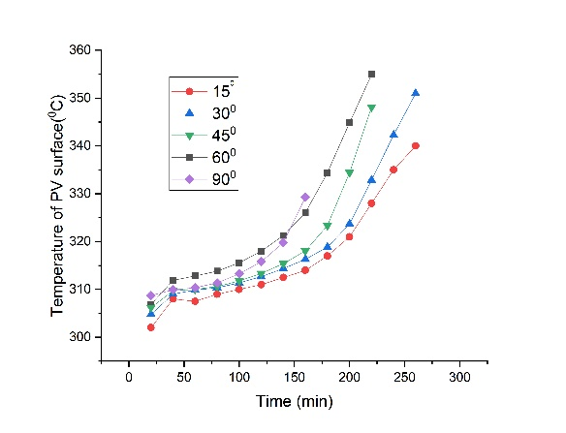

(a) (b)

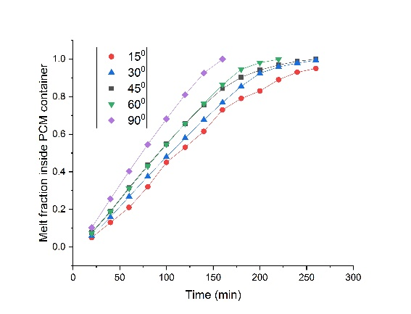 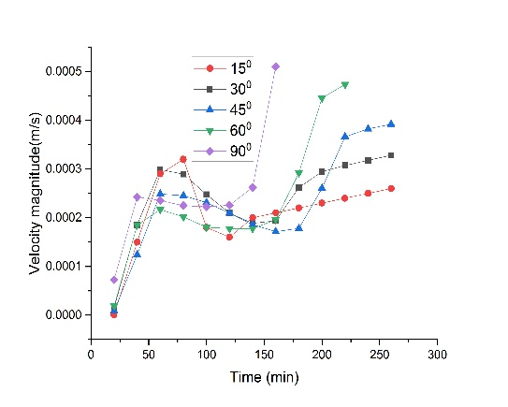

(c) (d)

Fig. 3. (a)Temperature of PCM with time (b) Temperature of PV surface with time

(c) Melt fraction of PCM with time (d) Velocity magnitude of PCM with time

Inclination angle of PCM system plays a major role for the selection of performance parameters. Fig. 3 shows the variation of different parameters of PV PCM systems with respect to time. Fig 3(a) exhibits the changes in the PCM temperature inside the PCM container. It can be observed that the temperature of PCM increases with the increase in the inclination angle. For the smaller inclination angle the heat transfer from the aluminium surface to the PCM is mainly with conduction; however, the natural convection current are quite low due to smaller velocity magnitude as shown in fig. 3(d). As the inclination angle increases the natural convection dominates the conduction heat transfer and it increases the heat transfer to the PCM from aluminium plate. Fig 3 (b) shows the PV surface temperature with respect to time. It can be seen that, as the inclination angle increases the PV surface temperature is also increases. As, at lower inclination angle, the heat transfer is quite low, the time required to melt the PCM is also more and thus it takes more time to convert in to liquid Fig 3(c). PV PCM system with 900 inclination angle takes around 180 min for complete melting however, 150 inclined PV PCM system consumes around 300s for the complete melting. The velocity magnitude of PCM inside the PCM container are more in 900 system and it decreases with the decrease in the inclination angle.

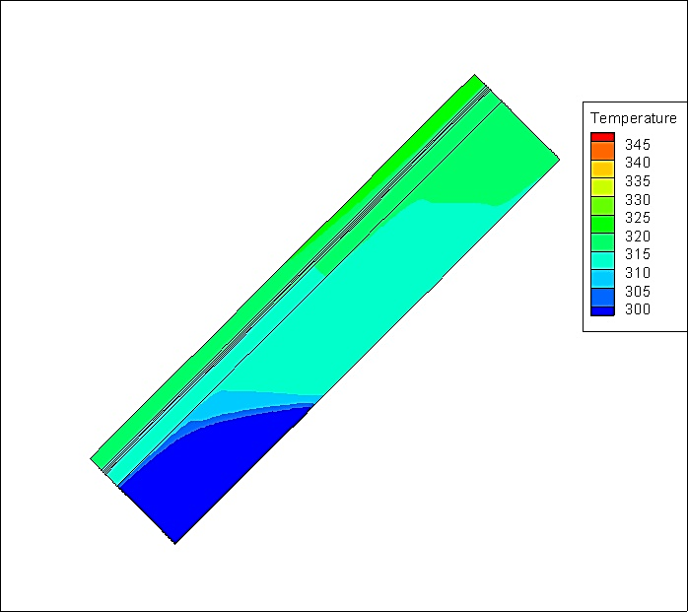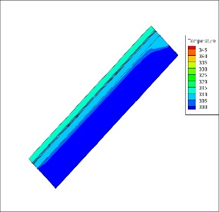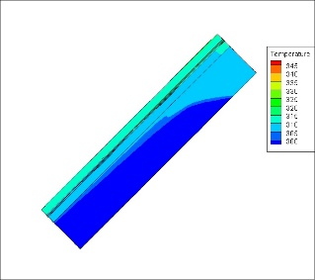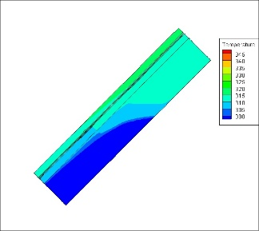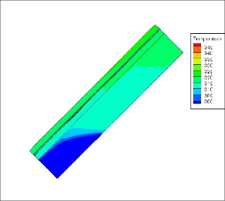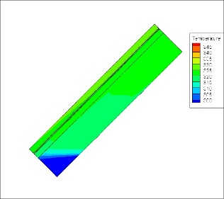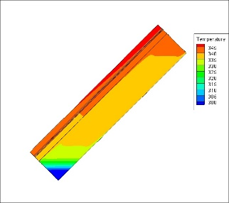

t = 40min t=80min t=120min t=160min t=200min t=240min

Fig. 4. Temperature variations in PV PCM system with respect to time

Fig. 4 shows the contours of temperature variation with respect to time at 450 of inclination angle.

**4. Conclusions**

Inclination angle plays a major role for the design of PV PCM system. In the current research work effect of inclination angle on the thermal performance of PV PCM systems is investigated. It is observed that, as the inclination angle increases the time required to melt the PCM decreases and PV surface temperature increases. It can be concluded that, optimum PCM thickness need to be selected for the required inclination angle of PV panel during the design of PV PCM system.

**References**

[1] Browne MC, Norton B, Mccormack SJ. Phase change materials for photovoltaic thermal management. Renew Sustain Energy Rev 2015;47:762–82. doi:10.1016/j.rser.2015.03.050.

[2] Barnes FS, Levine JG. Large Energy Storage Systems Handbook. CRC Press; 2011.

[3] Nazir H, Batool M, Bolivar Osorio FJ, Isaza-Ruiz M, Xu X, Vignarooban K, et al. Recent developments in phase change materials for energy storage applications: A review. Int J Heat Mass Transf 2019;129:491–523. doi:10.1016/j.ijheatmasstransfer.2018.09.126.

[4] Abu-Hamdeh NH, Alnefaie KA. Assessment of thermal performance of PCM in latent heat storage system for different applications. Sol Energy 2019;177:317–23. doi:https://doi.org/10.1016/j.solener.2018.11.035.

[5] Choubineh N, Jannesari H, Kasaeian A. Experimental study of the effect of using phase change materials on the performance of an air-cooled photovoltaic system. Renew Sustain Energy Rev 2019;101:103–11. doi:https://doi.org/10.1016/j.rser.2018.11.001.

[6] Karthick A, Murugavel KK, Ramanan P. Performance enhancement of a building-integrated photovoltaic module using phase change material. Energy 2018;142:803–12. doi:10.1016/j.energy.2017.10.090.

[7] Su Y, Zhang Y, Shu L. Experimental study of using phase change material cooling in a solar tracking concentrated photovoltaic-thermal system. Sol Energy 2018;159:777–85. doi:10.1016/j.solener.2017.11.045.

[8] Ma T, Zhao J, Li Z. Mathematical modelling and sensitivity analysis of solar photovoltaic panel integrated with phase change material. Appl Energy 2018;228:1147–58. doi:https://doi.org/10.1016/j.apenergy.2018.06.145.

[9] Lu W, Liu Z, Flor JF, Wu Y, Yang M. Investigation on designed fins-enhanced phase change materials system for thermal management of a novel building integrated concentrating PV. Appl Energy 2018;225:696–709. doi:10.1016/j.apenergy.2018.05.030.

[10] Voller VR, Prakash C. A fixed grid numerical modelling methodology for convection-diffusion mushy region phase-change problems. Int J Heat Mass Transf 1987;30:1709–19. doi:https://doi.org/10.1016/0017-9310(87)90317-6.

[11] Kamkari B, Amlashi HJ. Numerical simulation and experimental verification of constrained melting of phase change material in inclined rectangular enclosures. Int Commun Heat Mass Transf 2017;88:211–9. doi:10.1016/j.icheatmasstransfer.2017.07.023.

[12] Ji C, Qin Z, Low Z, Dubey S, Choo FH, Duan F. Non-uniform heat transfer suppression to enhance PCM melting by angled fins. Appl Therm Eng 2018;129:269–79. doi:10.1016/j.applthermaleng.2017.10.030.

[13] Kamkari B, Shokouhmand H, Bruno F. Experimental investigation of the effect of inclination angle on convection-driven melting of phase change material in a rectangular enclosure. Int J Heat Mass Transf 2014;72:186–200. doi:10.1016/j.ijheatmasstransfer.2014.01.014.

[14] Biwole PH, Eclache P, Kuznik F. Phase-change materials to improve solar panel’s performance. Energy Build 2013;62:59–67. doi:10.1016/j.enbuild.2013.02.059.

[15] Khanna S, Reddy KS, Mallick TK. Performance analysis of tilted photovoltaic system integrated with phase change material under varying operating conditions. Energy 2017;133:887–99. doi:10.1016/j.energy.2017.05.150.