Aerodynamic flow field measurements of Horn ice accreted NACA0015 airfoil- An Experimental Study

Aakhash Sundaresana, S. Arunvinthanb and S. Nadaraja Pillaic*

*a,b,cTurbulence & Flow Control Lab, School of Mechanical Engineering*

*SASTRA Deemed University, Thirumalaisamudram, Thanjavur, India-613401*

*Corresponding author Email: nadarajapillai@mech.sastra.edu

------------------------------------------------------------------------------------------------------------------

The formation of ice is inevitable when the airfoil is subjected to a lower critical icing temperature; due to which, the aerodynamic performance could deteriorate to a significant amount. There are basically four different types of ice shapes that could form on the airfoil surface namely rime ice, glaze ice, mixed ice and runback ice. In this research, efforts have been made to study the effects of horn ice on the leading edge of the NACA0015 airfoil. To mimic the horn ice shape, 3D printed mathematical model of the ice shape was engineered and employed on the leading edge of the airfoil. It was found out that the horn shaped ice accretion induced earlier flow separation due to the presence of horn when compared to the baseline (Clean wing). This flow separation is due to an adverse pressure gradient which results in a decrease in the aerodynamic performance of the airfoil.

***Keywords*:**  Horn ice, Flow separation, Aerodynamic performance, Geometric mathematical model.

1. **Introduction**

Accretion of ice on the surface of the airfoil could be disastrous, as it could completely deteriorate the aerodynamic performance of the airfoil. Many other researchers have carried out experiments and computer simulations to identify key phenomenon behind the icing problem and its effects1,2. But, as a matter of fact; simulations can only complement the experimental work but cannot completely replace the experimental results. In this research work, flow field measurements of the horn ice accreted airfoil were investigated experimentally, and a brief overview of the flow physics is explained to understand the effects of horn ice on the airfoil. Mathematically modelled and 3D printed horn ice shape was used to serve as an approximate ice template in reference to the numerical works conducted by many other researchers3.

1. **Experimental Methodology**

The experiment was conducted in a low speed subsonic wind tunnel situated at SASTRA Deemed University. The test section measures a dimension of 1.5 m × 0.3 m × 0.3 m and the turbulence intensity inside the test section was kept below 0.51%. The experiment was conducted at a velocity of 30 m/s and the angle of attack was varied from 0◦ to 24◦ with an increment of 3◦. In order to mimic the horn ice accreted shape, 3D printed template was designed using mathematical modelling and was employed on the leading edge of the NACA0015 airfoil as shown in figure 1. Pressure measurement system including the SCANIVALVE Pressure Scanner was utilized to obtain the pressure distribution on the surface of the airfoil. The scan rate of the pressure scanner was set to 700Hz and 10000 samples of pressure data were acquired at a single port.

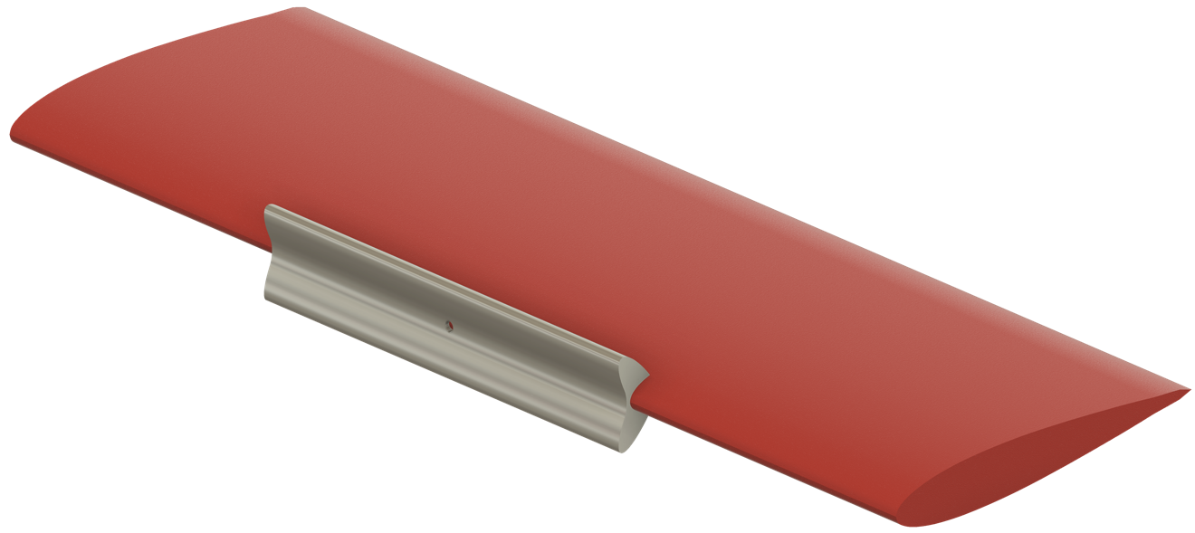

Fig. 1. Schematic of the Horn ice mounted on the Leading edge of the airfoil.

**3. Results and Discussions**

By analyzing the pressure distribution on the surface of the airfoil, it could serve as a fundamental criterion for understanding the flow physics behind the horn ice accretion phenomenon. From figure 2, it is evident that the coefficient of lift decreases when compared to the baseline airfoil. When there is a formation of horn ice on the leading edge of the airfoil, it could possibly lead to a laminar separation bubble in the downstream of the airfoil. Considering the CL plot, for the baseline model the airfoil stalls at α = 6◦, whereas for the horn ice accreted airfoil, it stalls at α = 3◦. There is a significant decrease in the coefficient of lift as well as the stall angle of attack. Having a glance at the pressure distribution plot, it could be understood that because of the presence of the horn; earlier flow separation occurs and there is a formation of a laminar separation bubble on both sides of the airfoil at approximately 0.25c. Also, the CP plot intersects at a single point at all the three angles of attack, possibly due to a moment about the leading edge of the airfoil. Further investigation of the moment on the horn ice accreted airfoil needs to be conducted in order to lay down the reason for the intersection of the pressure distribution curve.



Fig. 2. CL vs Angle of Attack (α)



Fig. 2. Coefficient of Pressure (CP) at AOA = 3◦



Fig. 2. Coefficient of Pressure (CP) at AOA = 3◦



Fig. 3. Coefficient of Pressure (CP) at AOA = 6◦



Fig. 4. Coefficient of Pressure (CP) at AOA = 15◦

**Conclusion**

Following conclusions can be made from the results and discussions section as follows:

**1.** The formation of horn ice on the leading edge of the airfoil deteriorates the aerodynamic performance.

**2.** Due to the horn ice accretion, the moment about the leading edge is created as it is evident from the pressure distribution plot.

**Acknowledgements**

Funding: This work was supported by “Research and Modernization fund, SASTRA Deemed to be University” grant number R&M/0035/SoME-008/2015-16. The authors thank SASTRA(deemed to be University) for their financial assistance.

**References**

1. M.B. Bragg, A.P. Broeren and L.A. Blumenthal, Iced-airfoil aerodynamics, Progress in Aerospace Sciences, 41 (2005) 323-362.
2. Jen-Ching Tsao and David N. Anderson, Additional Study of water droplet Median Volume Diameter (MVD) Effects on Ice shapes, NASA/CR-2005-213853.
3. L. Prince Raj, J.W. Lee and R.S. Myong