**PEDAL POWERED WATER PURIFICATION**

**T. Venkata Sai Kaartheeka, M. Manikantab , S. Prudhvi Tejac, K. I. Vishnu Vandanad**

a,b,cUG Student , dAsst. Professor, Dept. of Mechanical Engineering, PVP Siddhartha Institute of Technology, 520007,Vijayawada, AP. INDIA

Corresponding author Email: [kodeyvandana@gmail.com](mailto:kodeyvandana@gmail.com) ; [tkaartheek.378@gmail.com](mailto:tkaartheek.378@gmail.com) ;

**Abstract -** *Most of the earth is covered by Water, but it needs to be purified before it can be consumed. Generally water**purification needs electricity along with large systems, making purified water more costly. But there are several mechanical water purification methods with low processing cost. One such purification method is**pedal powered water purification (PPWF). Many people worked on this type of water purification system and came up with different designs. In the present work we are proposing a pedal based water purification system which works as a renewable water purifier. It mainly uses pedal power to purify water and makes water potable. This system uses a basic principle of thermodynamic concepts. The entire design was in three stages. These stages are Dynamo, Heating zone and Condenser. Here we constructed a prototype of Pedal Powered Water Purification System and obtained purified water by operating in the three different stages.*

***Keywords*: *Water Purification, Pedal Power, Purifying Chamber, Purified Water.***

**1. Introduction**

The Earth is covered by 75% water, yet one of the world’s greatest issues is a lack of drinking water. Water is vital element on earth and is very essential to sustain life, and a satisfactory and safe supply must be available to all. But nowadays, the water is getting contaminated due to industrialization, which produce large amount of wastes which contains toxic chemicals and pollutants which leads to many diseases. They contain pollutants such as sulphur, asbestos, nitrates and harmful chemicals. In many developing countries, people walk many miles to reach a source of water that is not necessarily potable. Water contains many chemicals and contaminants which also include microscopic organisms and bacteria. These chemicals and contaminants can endanger health, and can cause serious illness. Humans can live for weeks without food, but only a few days without water (Water.org Inc., 2009). Many people in developing countries barely have access to good water source. Many water sources are completely filthy and disease-ridden too. To decrease the contamination of water, we can use different processes such as boiling, distillation, water chlorination, sedimentation, reverse osmosis, solid block activated carbon, granular activated carbon, water softeners, sediment filters, boiling, bottled water, ozonation, ion exchange and filtration. Among all the above process mentioned Reverse Osmosis is best suited for issues which were originally designed for mainly two things, they are: Desalination and reduction of specific chemical contaminants. Reverse Osmosis is needed to remove fluoride, sodium, total dissolved salts, or chemicals like arsenic, radium and nitrates. The water purification system can be operated by means of different types of energy like electrical energy, solar energy, thermal energy, gravitational potential energy, magnetic energy etc making the process costlier. But there are newer methods like pedal powered water purification (PPWF) which makes process less costly and several authors worked on it. This attachment, though not a permanent solution, would be a contribution to the improvement of their quality of life.

Pedal Powered Water Purification is simplest form of water purification and it is an eco-friendly system. The PPWF works on mechanical energy and with no electricity. Drinking water and irrigation in remote areas can be had by PPWF where no electricity is available. PPWF also provides healthy exercise besides free from pollution. Our motivation is to aid those less fortunate areas, which run into contamination problems within their local water resources.

**2. LITERATURE REVIEW**

Dhoble Shubham, Gautam Harinarayan Et al 2018[1] made the pedal powered water purifier and discusses the variation of discharge with rotor shaft and done the experiment arround the required rpm and plot their power transmission losses and the discharge variation.V.Sridhar , G.Vinay Et al 2018[2] made the fabricaion of pedal powered water purifier, in this setup they made to purify the water using different process and the final purified water will be useful to various household purposes. Dustin Drake, Michael Solley Et al 2011 [3] studied regarding the possibilities of human powered reverse osmosis for producing potable water for developing countries. Anyanwu, S. Ikechukwu Et al 2016 [4] focused on the design and fabrication of a pedal operated power generator. It is intended for burning fats while yet generating electricity with a simple and cheap design. The inverter converts the direct current (DC) into alternating current (AC) which is needed to charge low voltage devices like mobile phones, laptops etc. Peramanan et. al 2014 [5] has studied the fabrication of Human Power Reverse Osmosis Water Purification Process. The project has been carried out to make an impressing task in the field of water purification method. Betzabe Gonzalez et. al 2014 [6] has analyzed and studied on the design and he used peristaltic pump with silicone tubing. This tubing was visually better suited for our project having no kinds to reduce flow, easy to clean and flexible enough to create suction between rollers. Filtered water we get through this design. M venkata praveen kumar et al 2017 [7], worked on purification of water by using bicycle. It converts human motion into usable power to run a reverse osmosis filtration system. The flow rate was determined according to given information from the reverse osmosis manufacturer. Anusha Pikle, Yash Siriah et al 2017 [8], presented a paper analysing the design of a pedal operated water filtration system. It is mainly used by local dwellers. It works on the principle of compression and sudden release of a tube. This creates negative pressure in the tube which in turn creates the vaccum and draws water from the sump into the pump. At the same time rollers push the water through to the filter where adsorption takes place to purify the water. Anand and ramprasad et al 2017 [9], reviewed the literature regarding a variety of portable water purification techniques like boiling, solar water disinfection, sedimentation and ceramic filters coagulation, adsorption (activated carbon), chlorination, uv irradiation, ultra filtration, reverse osmosis and other combined methods that have been predominantly used at the household level. Jayant Gidwani et al 2016 [10], In this paper author mentioned about fan pump (ppwp) which purifies the water and can be used for both drinking water and garden irrigation. PPWP will consist of a centrifugal pump operated by pedal power. PPWP provides drinking water lubrication of ppwp.

**3. METHODOLOGY:**

The water purification system can be operated by means many types of energies like electrical energy, solar energy, thermal energy, gravitational potential energy magnetic energy etc but in the present work we proposed and built a prototype of water purification system which works on the basis of mechanical energy without external electricity and filters. In our prototype, a bicycle attachment is used to purify and transport water from a contaminated source while the rider is pedalling. This attachment, though not a permanent solution, would contribute to the improvement of the quality of life of rural people with poor water facility. A healthy adult is can give a maximum output of about 900 watts (W) ,but can only be sustained for a few second . This ideal output required for pumping is 60W of Pedalling at 50 revolutions per minute. A healthy human an easily generate it through steady continuous pedalling. So we have chosen the pedal power system here for purification of water. In this purification process the entire design is divided into three different stages and in these stages water is purified. The stages are Generator, Boiler and Condenser. Initially the water which is contaminated is pumped with the help of chain drive. The chain drive is used to transmit mechanical energy from driver shaft to driven shaft. Chain drivers are used to maintain velocity ratio constant. Chain drives efficiency is more as compared to belts drives. Also it can suits for a distance of 3 to 8 mts. So here we preferred a chain drive as a transmission system. The contaminated water is drawn to Boiler with the help of pump. The generator is used to convert the mechanical energy in to electrical power so that the contaminated water is heated in the boiling chamber. It is essentially a closed vessel inside which water is stored. As the generator gives the input to the boiler, it heats the pollutant water. After water gets heated it turns in to vapour and then it goes to condenser. The condenser is used to cool and condense the water which comes from the boiler. Hence the clean water is condensed and stored in a container.

**4. WORKING PROCESS:**

The entire process of the design begins by adding contaminated water into the tank. All the heavy sediments are immediately removed as the water passes through several layered mesh micron layer. The initial filtering step is crucial because the mesh would quickly clog if it has to filter heavier sediments. The tank lid must then be sealed securely so that pressure can be built in the tank. We segregated our entire setup into two parts. The first one is concerned with the generation of electric power. The process starts with pedaling where one end of the chain sprocket is connected to the dynamo with the help of a belt. As long as we pedal, it drives the dynamo which is connected through the belt and it is used for the generation of electricity. The electricity generated by pedaling is stored in batteries for continuous supply of electricity for further use. Here batteries are used because we cannot ensure that the pedaling will be uniform. The second one is all about the usage of the generated electricity for Purification of Water. Here, we used a nichrome wire which has high thermal conductivity and medium resistance level so that water can be boiled at a faster rate from the power which we generated earlier. We are using the nichrome wire of specific diameter so that it can with stand the electrical resistance up to the mark. The nichrome wire is dipped into the water which has to be purified and then electric current is allowed to pass through the nichrome wire so that the wire heats up the water. As the melting point of nichrome is higher than the boiling point of water, it can with stand higher temperatures. Once the water gets boiled it converts into steam or water vapour and which it passes through cooling pipes and gets cooled. Finally, the purified water is collected in a vessel. Although the process is a slower one, we can ensure that it can last for a long time. Also the output water can be used for drinking and household purposes. Further purification tests are to be conducted.

1. **FLOW CHART & PARTS OF PPWP:**

In this mechanism rare wheel of the bicycle is rotated with the help of driver and driven gear of the bicycle. This generates the pedal power and is converted in to mechanical energy. The chain drive is connected to dynamo and the rare wheel hub of the bicycle. Dynamo also rotates when the rare wheel of the bicycle is rotated with the help of the rotation system. The shaft of the dynamo rotates up to its rpm. With the rotation of the great speed the electric power is created in the dynamo and this power goes in this heating chamber. The contaminated water suck into the water from the water tank and it discharge the water into the heating chamber.

**Chart-1: Layout of PPWP**

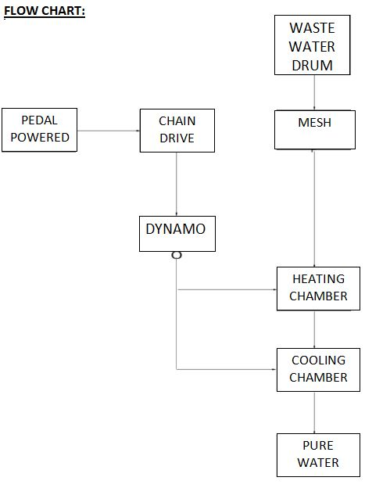

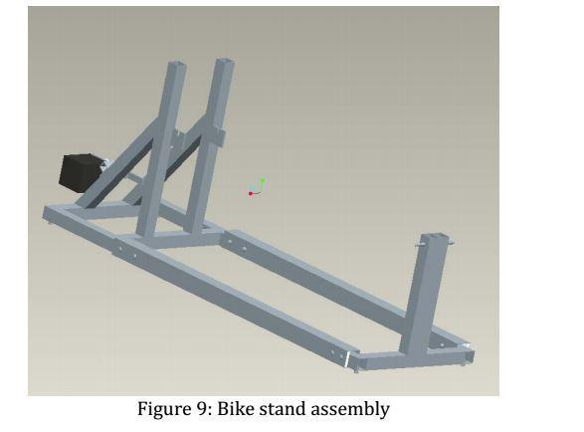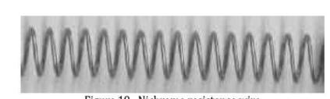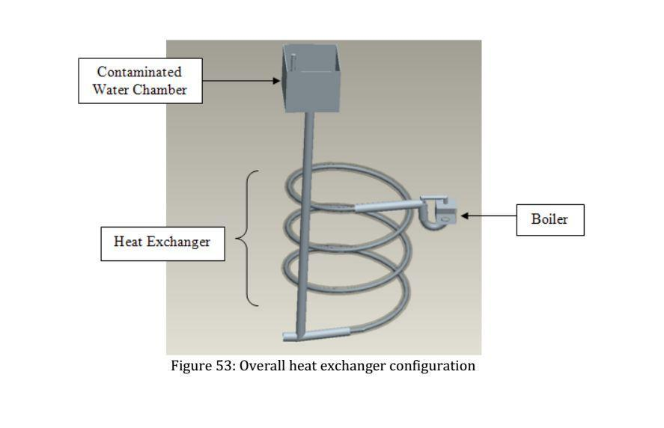

**Fig -1**: Bike stand assembly **Fig -2**: Nichrome wire **Fig -3**: **Heat Exchanger**

The assembly design Fig-1 was made in Pro-E software. The sprockets and chain drive will be mounted and are made with mild steel. Nichrome resistance wire in the Fig-2 is used as the heating element inside of the boiler and heat x system. The resistance wire receives the electricity produced by the windmill and converts it into heat. To improve efficiency, various resistance Nichrome wires are tested. The overall heat ex-changer configuration is shown in the above Fig-3. The dirty water chamber and the heating zone are kept at a height difference which allows gravity to carry the contaminated water up through the heat ex-changer.

**6. Fabrication**

In the fabrication process welding is done to get a weld joint that is a continuity of material between two parts, on a well-defined area of contact, to generate an assembly. As Arc welding has distinct advantage over gas welding in the concentration of heat, in the present fabrication the frame was welded by the arc welding process.

**Table-1: Component specification**

|  |  |  |
| --- | --- | --- |
| SNO | SPECIFICATION | SIZE |
| 1 | Driven diameter of sprocket | 0.168m |
| 2 | Driver diameter of sprocket | 0.065m |
| 3 | Center distance between driver and driven | 0.48m |
| 4 | No. of teeth of driver | 40 |
| 5 | No. of teeth on driven | 18m |
| 6 | Suction diameter | 0.025m |

**Fig-4: Fabrication of pedal stand assembly**

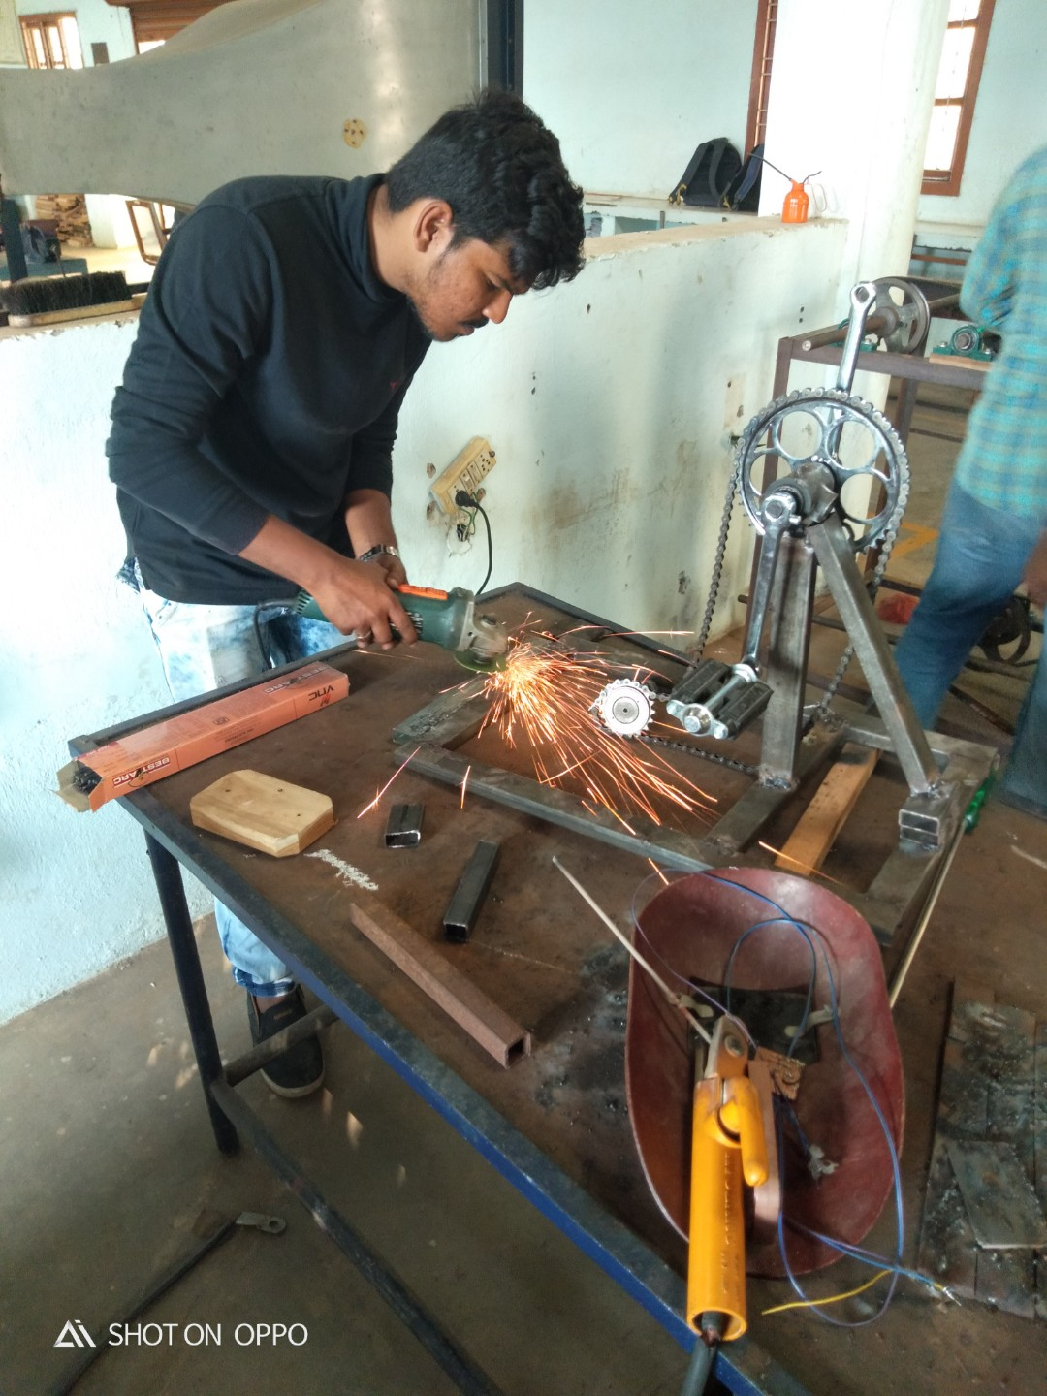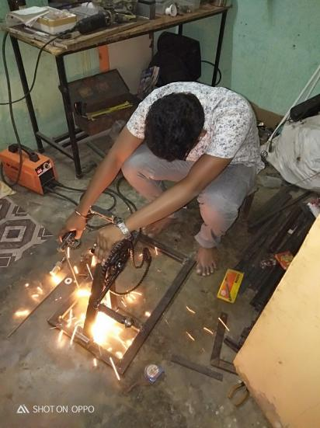

**7. Conclusion:**

Pedal Powered Water Purification can be used to generate pure drinking water in remote areas. PPWP system provides healthy exercise besides no pollution. It is economical. The design is a portable and can be used for irrigation in various places. The proposed prototype of PPWF is used to carry experiments at different pollutant water and observed that it is giving good results. Finally it is concluded that it is a new invention that utilizes simple equipment and puts them all together to help villages in developing countries to have daily access to safe drinking water all by harnessing the energy of pedal power. At the same time more laboratory tests are to be performed to ensure the safety of water generated from this process.

**8. References:**

1. Dhoble Shubham p.1 Gautam Harinarayan p.2 Gavali Pankaj v.3 Kharpade Prashant n.4 Prof. P. S. Baravkar5, “The Pedal Operated Water Purifier”Ijsrd Vol. 6, Issue 02, 2018.
2. V.Sridhar1, g.Vinay2, k.Sai Ram3, b.Ajay Ram4,“Fabrication Of Pedal Powered Water Purifier”Jetir September 2018, Volume 5, Issue 9.
3. Dustin Drake, Michael Solley “Human Powered Reverse Osmosis For Producing Potable Water For Developing Countries” *(Laccei’2011) August 3-5, 2011 , Medellín, Colombia.*
4. Anyanwu, s. Ikechukwu Ashinze e. Anthony “Design And Fabrication Of a Pedal Operated Power Generator” Issn 2222-1727 (Paper) Issn 2222-2871 (Online) Vol.7, No.3, 2016.
5. A.Peramanan, a.Anto Willy Bald, p.Arunkumar, g.Naveen Kumar, a.Veera Sekar, “Fabrication Of Human Powered Reverse Osmosis Water Purification Process” Vol.2 Issue.3,2014.
6. Betzabe Gonzalez, Sandra Lazte, Justin Cromartie, Kenneth Hernandez (2014) From Florida International University “Bicycle Powered Water Filtration System“ November 26, 2014.
7. V k Ravi, Sushmitha v, m Venkata Praveen Kumar, Amal Thomas, “Reverse Osmosis Water Purification By Cycling Action” (*Ijlera) Issn: 2455-7137 Volume – 02, Issue – 05, May – 2017.*
8. Anusha Pikle, Altaf Somani, Sanjay n.Havaldar , Yash Siriah And Samiksha Patil, *“*Pedal Operated Water Filtration System (Mobifilt)” Ijcet Special Issue-4 (March 2016).
9. Anand b. Rao And Ramprasad v, Seminar Report On Portable Water Purifiers, Centre For Technology Alternatives For Rural Areas (Ctara), Indian Institute Of Technology Bombay, Powai, Mumbai, November, 2014, 36-37.
10. Jayant Gidwani, Amit Kesheorey, Ratnesh Mishra, Rahul Lowanshi, Nitesh Lowanshi, “Pedal Powered Water Pumping And Purification” Ijsart - *Volume 2 Issue 5 –May 2016.*