**EXPERIMENTAL INVESTIGATION OF FOUR STROKE SINGLE CYLINDER DIESEL ENGINE WITH OXYGENATED FUEL ADDITIVES**

1Maloth Mohan Kumar 2Vasmate Shiva Kumar

*1Assistant Professor Department of Mechanical Engineering Anurag Group of Institutions Hyd India 500088*

*2Assistant Professor Department of Mechanical Engineering Anurag Group of Institutions Hyd India 500088*

Email: **maloth.mohankumar@gmail.com**

--------------------------------------------------------------------------------------------------------------------------------------------

Abstract— The objective of this investigation was to improve the performance of a diesel engine by adding oxygenated fuel additive of known percentages. The effect of fuel additive was to control the emission from diesel engine and to improve its performance. The fuel additive dim ethyl carbonate was mixed with diesel fuel in concentrations of 1%, 3%, 5% and 7% used. The experimental study was carried out in a single-cylinder diesel engine. The result showed an appreciable reduction of emissions such as hydrocarbon, carbon monoxide, smoke density and considerable improvement in performance parameters of engine.

**Keywords**— Diesel engine, Oxygenated fuel additive, Dimethyl carbonate, Carbon monoxide.

1. **Introduction**

As evidenced by recent lawsuits brought against operators of large diesel truck fleets and by the Consent Decree brought against the heavy-duty diesel manufacturers, the environmental and health effects of diesel engine emissions continue to be a significant concern. Reduction of diesel engine emissions has traditionally been achieved through a combination of fuel system, combustion chamber, and engine control modifications. Catalytic after treatment has become common on modern diesel vehicles, with the predominant device being the diesel oxidation catalytic converter. To enable advanced after-treatment devices and to directly reduce emissions, significant recent interest has focused on reformulation of diesel fuel, particularly the reduction of sulfur content. The EPA has man-dated that diesel fuel will have only 15 ppm sulfur, with current diesel specifications requiring around 300 ppm. Reduction of sulfur will permit sulfur-sensitive after treatment devices, continuously regenerating particulate traps, NOx control catalysts, and plasma assisted catalysts to be implemented on diesel vehicles. Another method of reformulating diesel fuel to reduce emissions is to incorporate oxygen in the fuel, as was done in the reformulation of diesel. The experiment carried out by J. Wang, J. Xiao and S. Shuai explores the possibility to significantly reduce the particulate matter (PM) emissions by new fuel design. Several oxygenated blends were obtained by mixing the biodiesel, ethanol, and dimethyl carbonate (DMC), and diesel fuels. The tests were conducted on two heavy-duty diesel engines, both with a high-pressure injection system and a turbocharger. The total PM and its dry soot (DS) and soluble organic fraction (SOF) constituents were analyzed corresponding to their specific fuel physiochemical properties. A blended fuel that contains biodiesel, DMC, and high cetane number diesel fuels was chosen eventually to enable the diesel engines to meet the Euro IV emission regulation. Based on the test results, the basic design principles were derived for the oxygenated blends that not only need the high oxygen content, but also the high cetane number and the low sulfur and low aromatic contents. The fuels used in this study include a baseline diesel fuel, three types of biodiesels, and their blends with ethanol, DMC, DMM, and straight-run (or directly distilled) diesel fuel. Ethanol, DMC, and DMM are used as oxygenates to raise the oxygen content, while the straight-run diesel fuel is used to improve the auto-ignition capability of the blended fuel. When fueling oxygenated blends, the direct soot constituent in PM emissions decreases significantly as the fuel oxygen content increases. However, when the oxygen content reaches 15% or higher, reduction rate becomes slow. Combustion and emission characteristics of a direct-injection diesel engine fueled with diesel-diglyme blends were investigated by Yi Ren, Ke Zeng and Bing liu. The results show that the ignition delay and the amount of heat release in the premixed combustion phase decrease with the increase of the oxygen mass fraction in the blends. The diffusive combustion duration and the total combustion duration decrease, while the amount of heat release in the diffusive combustion phase increases with the increase of the oxygen mass fraction in the blends. The maximum mean gas temperature in the cylinder increases and the duration of the high gas temperature decreases with the increase of the oxygen mass fraction in the blends. The center of the heat-release curve moves close to the top dead center and the effective thermal efficiency increases with the increase of the oxygen mass fraction in the blends. Moreover, the smoke concentration decreases with the increase of the oxygen mass fraction in the blends. Under the high engine load, smoke decreases by 3.7% for a 1 wt % increase of the oxygen mass fraction in the blends. The NOx concentration shows a slight decrease or remains unchanged with the increase of the oxygen mass fraction in the blends. The experiment was carried out by Zuohua Huang, Ke Zeng, Bing Liu and Xibin Wang on single cylinder diesel engine. Oxygenated blends were prepared by adding methanol and solvent to diesel fuel, and engine performance and emissions of the oxygenated blends under various fuel delivery advance angles were conducted in a compression ignition engine. The results showed that the engine thermal efficiency increased and the dieselequivalent brake specific fuel consumption decreased as the fuel delivery advance angle for the oxygenated blends increased, and the behavior had a tendency to be more obvious at high engine speed. The NOx concentration in the oxygenated blends increased as the fuel delivery advance angle increased. For a specific fuel delivery advance angle, the NOx concentration increased as the oxygenate mass fraction in the fuel blends increased, whereas a large addition of oxygenates in the diesel fuel reduced the NOx concentration. The addition of oxygenate in the diesel fuel had a strong influence on the NOx concentration at high engine load, whereas it had little influence at low engine load. The CO content decreased as the fuel delivery advance angle at high engine load became retarded, whereas at middle and low loads, the CO concentration varied little with variation of the fuel delivery advance angle but presented a low value for the diesel/oxygenate blends. The fuel delivery advance angle had little influence on the exhaust hydrocarbon (HC) content for the diesel/oxygenates blends. The amount of smoke can be decreased remarkably by the addition of oxygenate in diesel fuel at the setting of various fuel delivery advance angles. The amount of smoke decreased as the fuel delivery advance angles for both diesel fuel and diesel/oxygenate blends increased; this phenomenon would be due to the increase in the fraction of fuel burned in the premixed burning phase and the decrease in the fraction of fuel burned in diffusive combustion phase, as well as the improvement of the diffusive combustion in the presence of oxygenated blends. The study also showed that a flat NOx/smoke tradeoff curve existed when the oxygenated blends were used. The experiment was carried out by Juhun Song, Vince Zello and Andre Boehman on single cylinder turbo diesel engine. The experiment was carried out to check the effect of oxygen enrichment of air and oxygen enrichment of fuel on the emission characteristics of engine. Test was performed at 75% load and 1900 rpm because the effect of oxygen enrichment is considerable at full load than no load condition. For oxygen enrichment of fuel a mixture of glycol ether and diglyme with a cetane number 100 was used. The other fuel additive used was 1, 3-dioxolane.They concluded that oxygen enrichment of intake air reduces diesel PM significantly more than fuel oxygenation, fuel oxygenation can provide PM reduction with only a modest affect on NOx emissions. With their linear structure, the glycol ethers that comprise CETANER were shown to be far more effective for soot reduction than equivalent oxygen addition via Dioxolane with its ring structure. The investigation was carried out by T. Nibin, A. Sathiyagnanam and S. Shivprakasam to improve the performance of a diesel engine by adding oxygenated fuel additive of known percentages. The effect of fuel additive was to control the emission from diesel engine and to improve its performance. The fuel additive dimethyl carbonate was mixed with diesel fuel in concentrations of 5%, 10% and 15% and used. The experimental study was carried out in a multi-cylinder diesel engine. The result showed an appreciable reduction of emissions such as particulate matter, oxides of nitrogen, smoke density and marginal increase in the performance when compared with normal diesel engine. The experiment was carried out on a Matador, four cylinders, four strokes, diesel engine which was loaded by a hydraulic dynamometer. They concluded that Smoke level and PM decreases with 5% DMC addition with the neat diesel fuel. The NOx level decreases with 5% DMC addition with the neat diesel fuel. The soot level decreases with addition of additives to the neat diesel fuel. There is a marginal increase in brake thermal efficiency with 5% DMC addition with the neat diesel fuel. The 5% DMC addition to the neat diesel fuel gives the best results. This result is optimum for the performance and emission characteristics of the diesel engine.

1. **Experimental Set-Up**

Fig. 1 Experimental Set-Up

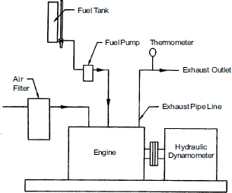

A stationary, 5 hp direct injection diesel engine was used to conduct experiments. In all cases it is necessary to ensure that throughout the speed range and engine torque output cannot exceed the capacity of dynamometer to with it coupled. If this condition does occur, the engine speed will increases uncontrollably until a point is reached where the falling torque value again comes within the capacity of the brake. Under such condition test work would be impossible and the engine might be dangerously over speed. A dynamometer is a device for measuring force, moment of force (torque), or power. The power produced by an engine, motor or other rotating prime mover can be calculated by simultaneously measuring torque and rotational speed (RPM). Several different types of dynamometer are used in engine test work but we are using rope brake dynamometer is couple to engine. For testing variable speed either fluid friction dynamometer or electrical dynamometer are essential. In both these types, other factors remains unaltered the revisiting torque automatically increases with increase of speed and vice versa so that steady speed conditions are more easily achieved. A simple and accurate flow measuring device utilizes a pipette of 100 ml capacity for engine of small and medium size.

The constricted end of the pipette is cut off and the vessel is re- calibrated to contain the rated volume between two mark made on the lower and upper glass stems respectively. The pipette is then supported vertically in a suitable holder at height considerable above that of inlet of the fuel pump. The lower outlet of pipette, the main fuel supply pipe and the pipe to pump are all connected to union of three way cock. Exhaust Gas Analyzer is used to measure the level of pollutants in the exhaust of the engine. The instrument is used for measuring HC: CO. Probe of it was fitted in the engine exhaust pipe. Exhaust of the engine passes in to the instrument probe and sensor of instrument sense the quantity of CO and HC contained in exhaust gas and result revel on the panel board. Smoke meter is used to measure the smoke density of the exhaust. As the visibility is the main criteria in evaluating the intensity of smoke, principle of the smoke meter depends on the light obstruction by the smoke.

1. **Result & Discussion**

**A . Brake Thermal Efficiency**

Fig 2 shows the variation in brake thermal efficiency with load for various concentration of oxygenated fuel additive. With increase in load the brake thermal efficiency increases up to 13 Kg load then again it decreases at overload condition. Graph also states that with increase in concentration of DMC in diesel the brake thermal efficiency increases. The maximum efficiency is achieved at 5% DMC concentration at full load and it is 35.0484%. It is due to more complete combustion of fuel due to more oxygen content in DMC. It is also seen that the increment in brake thermal efficiency with additive concentration is more at full load compared to part load and no load condition. At 7% DMC concentration brake thermal efficiency again decreases.

Fig 2. Load vs. Brake thermal efficiency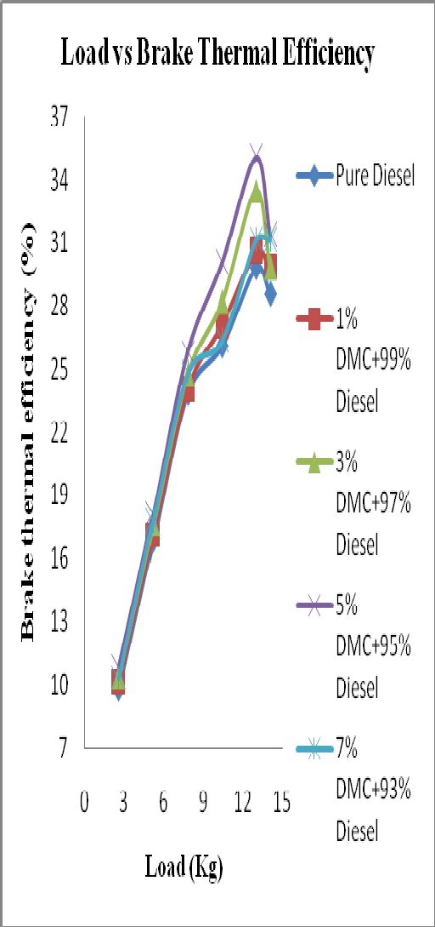

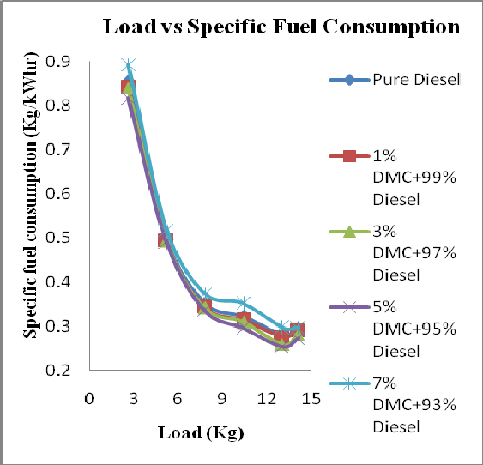**B. Brake Specific Fuel Consumption**:

Fig. 3 Load vs. Brake specific fuel consumption

It is seen from the graph that with increase in load the specific fuel consumption decreases and at overload condition it again increases. It is also noted that with increase in concentration of DMC the specific fuel consumption decreases. The minimum fuel consumption is achieved at 5% DMC (vol by vol) at full load and it is 0.2536 Kg/kWhr. The decrease in specific fuel consumption is due to the more oxygen content in DMC causes complete combustion of fuel and reduces its consumption for same power production. At 7% DMC the specific fuel consumption is again increases because DMC is having calorific value which is much lower than that of Diesel and causes increase in fuel consumption

**C. Exhaust gas Temperature:**

The graph shows that exhaust gas temperature increases with increase in load. With increase in concentration of DMC in diesel the exhaust gas temperature increase.

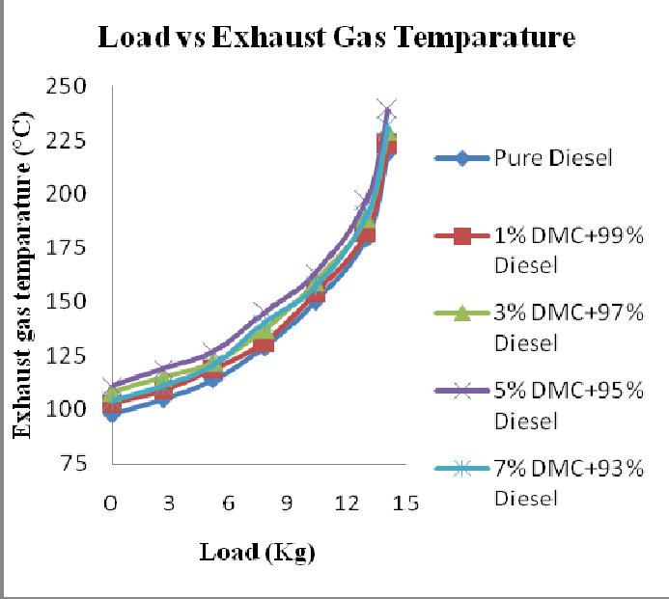

Fig. 4 Load vs. Exhaust gas temperature

This is due to the oxygen enrichment of fuel by addition of DMC. The maximum exhaust gas temperature is achieved at 5% DMC concentration. With further increase in DMC concentration the exhaust gas temperature decrease due to the delusion of combustion due to additional oxygen and lower calorific value of DMC. At 7% of DMC concentration exhaust gas temperature decreases due to large decrease in calorific value of mixture. The calorific value of DMC is one third of the calorific value of diesel

## HC Emission:

The hydrocarbon emission increases with increase in load. From the graph it is clear that with increase in concentration of the DMC the HC emission considerably reduces. The minimum HC emission is achieved at 7% DMC concentration for all loads. The variation of HC emission at part load with concentration of DMC is less as compared to full load variation.

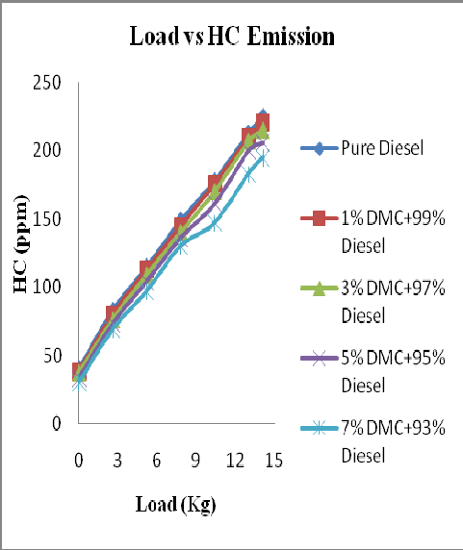

Fig. 5 Load Vs HC Emission

## COE Emission

The generation of carbon monoxide is due to the lack of availability of oxygen. From the graph it is clear that with increment of load the carbon monoxide emission increases. It is also seen that with increase in concentration of DMC the carbon monoxide emission decreases. It is due to more availability of oxygen through the additive. The decrease in carbon monoxide is less with increase in DMC concentration at part load compared to full load.

## 

Fig. 6. Load vs. CO Emission

1. 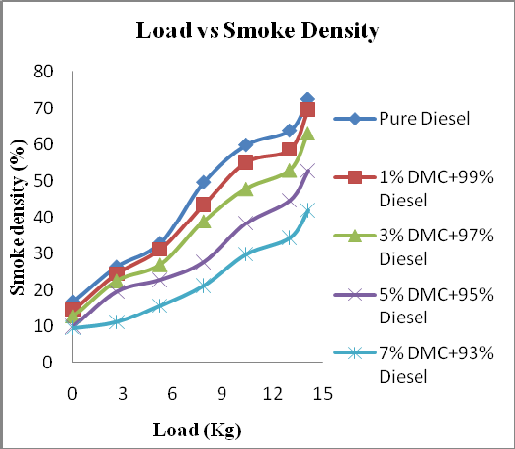**Smoke Density**

Fig. 7 Load vs. Smoke Density

It can be observed from the graph that smoke density increase with increase in load. Maximum smoke emission occurs at maximum load. The smoke density for diesel fuel is 72.4% for maximum load. It is seen from the graph that with increase in concentration of DMC the smoke density decreases. The oxygen enrichment provided by the DMC leads to reduction in smoke density. At maximum load the smoke density is of 41.9% at 7% DMC concentration in fuel.

CONCLUSIONS

## The use of oxygenated fuel additive on diesel engine under different loading conditions was studied using single cylinder four stroke diesel engine to discuss the various engine performance parameters like brake thermal efficiency, brake specific fuel consumption, exhaust gas temperature, exhaust emission and smoke density. The following observations were made after conducting the experiments.

1. Smoke level, HC and CO emission decreases with 7% DMC addition with the neat diesel fuel.
2. There is a marginal increase in brake thermal efficiency with 5% addition of DMC in pure diesel.
3. There is a considerable reduction in brake specific fuel consumption with 5% DMC addition in diesel.
4. The exhaust gas temperature increases considerably with 5% addition of DMC in neat diesel.

## REFERENCES

1. J. Wang, F. Wu, J. Xiao, 2009, “Oxygenated blend design and its effects on reducing diesel particulate emissions”, fuel, Vol 88 (10), 2037-2045.
2. Y. Ren, Z. Huang, D. Jiang, B. Liu, and X. Wang, 2007, “Effect of the addition of diglyme in diesel fuel on combustion and emission in a compression ignition engine”, American chemical society, 2573-2583.
3. Z. Huang, H. Lu, D. Jiang, B. Liu, and X. Wang, 2005, Performance and emission of a compression ignition engine fueled with diesel oxygenate blends for various fuel delivery advance angles”, American chemical society, 403-410.
4. J. Song, V. Zello, and A. Boehman, 2002, “Comparison of impact of intake oxygen enrichment and fuel oxygenation on diesel particulate emission”, Fuel chemistry journal, 778-779.
5. T. Nibin, A. Sathiyagnanam, S. Sivaprakasam, 2003, “Investigation on emission characteristics of a diesel engine using oxygenated fuel additive”.