EPQ model for Non Instantaneous Deteriorating Items.

**1Pankaj S. Ardak**

1Assit. Prof., P.R. Pote College of Engineering and Management ,Amravati. India, 444601.

pankajardak@gmail.com

------------------------------------------------------------------------------------------------------------------

An EPQ models are effectively used in the field of inventory management and production as control tool. In present model attempt has been made to discuss the inventory production model for non instantaneous deteriorating items with time dependent holding cost and inventory dependent demand. It is assumed that there will be no deterioration for certain constant period of time. Inventory dependent demand has been considered for production time and constant during inventory consumption time. Optimum solution has been find out by using differential calculus.Results indicate that inventory consumption parameter has considerable effect on the total inventory.

***Keywords*:** EPQ, Inventory dependent consumption rate, time dependent holding cost.

1. **Introduction**

In recent years, many of the researchers studied the inventory systems with an inventory-level-dependent demand rate. It is observed that large stocks of consumer goods can appeal increase in demand. The items cannot be used for its original purposes if they deteriorate. Thus effect of deterioration attracts the attention of researchers. Consumable item like milk, pack food, meat, flowers and bakery products are items in which rate of deterioration remains higher during the normal storage period of the units. Many of the research developed EPQ models by considering different parameters. Ardak *et. al.* (2017) developed EPQ model by considering mixed demand pattern and also considered time dependent holding cost to develop EPQ model. David et. al considered partial backordering with constant demand to study inventory model. The effect of an imperfect production process, on the optimal cycle time had been studied by Rosenblatt and Lee. Gede (2010) considered price-dependent demand for deteriorating Items. Jinn(2005) analysed and characterize the influences of time varying demand and cost over the length of production run. Setup cost and process quality has been considered by Kuo(2007) as a function of capital expenditure. Disruption often occurs in production system. Liao (2010) developed a model with delay in payment, in which there are two warehouses, one is own, another is rented. T sao (2011) considered an inventory model in supply-chain system for multi item under the policy of trade credit.

As perishable items deteriorates with time. To store such item needs special storing arrangements. This leads to increase in holding cost. In the present model time dependent holding cost is considered. During production demand is assumed to be inventory dependent and constant after maximum inventory . Complete paper is divided into several sections. Research motivation is included into introduction. Notation and assumption used throughout the paper narrated in next section. The third section formulates the model and derives optimal solution. The last section discussed the numerical and sensitivity analysis.

# 2.Assumptions and Notations.

Assumption and notations used to develop the model are as follows:-

Assumptions:-

1. The production rate is constant and greater than the demand.
2. During production demand is assumed to be inventory dependent and constant after maximum inventory.
3. Deterioration is non instantaneous and kept constant.
4. Inventory holding cost is considered as time dependent
5. Shortages not allowed.
6. Inspection of every produced items.

Notations:-

1. I1 – Inventory during non deterioration period.
2. I2 – Inventory during production and deterioration.
3. I3 – Inventory when production stops.
4. T1–No deterioration period
5. T2 –deterioration start period.
6. T3 – No Production time.
7. P – Constant production rate.
8. D –Demand rate.
9. θ – Rate of Deterioration
10. α – Inventory dependent rate parameter.
11. IH – Holding cost per unit, H(t)=a +bt.
12. Ci – Inspection cost per unit
13. T –cycle time. (T =T1 + T2 + T3)
14. TC – Total cost.
15. IC – Total Inspection cost.
16. TCT – Total cost per unit time.
17. A– Set up Cost.

# 3. Model Formulation

Present work developed deteriorating EPQ model for inventory dependent demand and time dependent holding cost. As shown in fig 1, the production will start at t = 0, Up to time T1 the inventory will gradually build up with no deterioration. Deterioration of items present in inventory starts after T1. Later, production stops at t = T2, Demand get satisfied from maximum inventory level. The differential equations described the production system as follows.

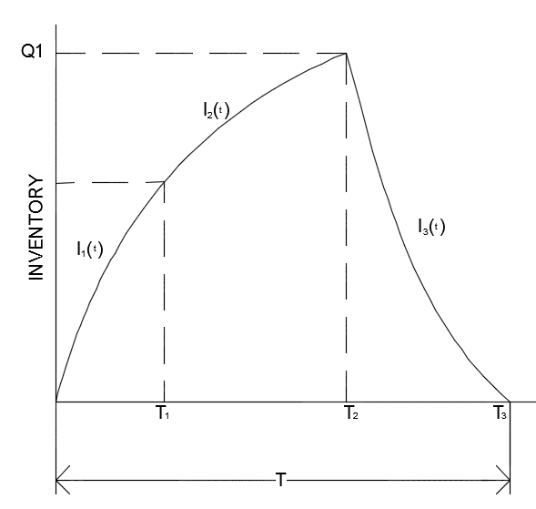

Fig. 1. Inventory Level

Inventory level from t = 0 to t = T1 with no deterioration is represented by differential equation as follows.

 0 ≤ t ≤ T1 1.

The combined effect of inventory dependent demand and deterioration is shown by the following differential equation.

 0 ≤ t ≤ T2 2.

Change in inventory level due to constant demand and deterioration of items is governed by the following differential equation.

 0 ≤ t ≤ T3 3.

Above three equations with initial boundary conditions, at t = 0, I1 (t) = 0 , at t = T2 , I2(T2) = Q1 and at t = T3, I3(T3)=0 are used in the derivation of our model.

 0 ≤ t ≤ T1 4.

 0 ≤ t ≤ T2 5.

 0 ≤ t ≤ T3  6.

Total Inventory holding cost is given by

 7

Inspection cost can be modelled as,

 8.

Total cost = Set up cost + Holding cost + Inspection cost.

 9.

Production cycle time = 

Total cost per unit time



The optimum production up time can be derived by satisfying the equation (10)

 10.

# 4. Numerical and Sensitivity Analysis.

To validate the model numerical example and sensitivity analysis has been carried out. The numerical data is adopted from Ardak *et al*. Let, A= Rs.30 per production cycle, P = 2500 units per unit time, D = 1200 units per unit time, α = 0.5, θ = 0.1,a= 2 b = 1.5.Fig. 2 shows the convexity of total cost with production time T2. The optimum value of total cost per unit time is also represented on fig. 2. Sensitivity analysis is carried out by taking one parameter at a time and keeping others unchanged.

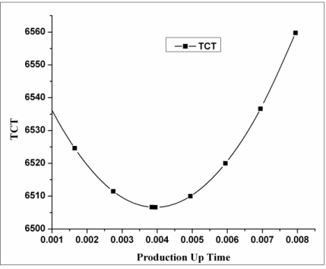 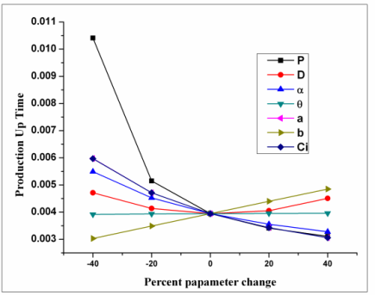

Fig. 2. T2 V/s TCT Fig.3. T2 V/S Parameter Change

|  |  |  |  |  |
| --- | --- | --- | --- | --- |
| **Parameter changes** | | | | |
| **Parameters** | **-40%** | **-20%** | **20%** | **40%** |
| **TCT** | **TCT** | **TCT** | **TCT** |
| P | 1539.823 | 4025.38 | 8983.273 | 11455.954 |
| D | 8815.517 | 7677.21 | 5322.49 | 4132.2157 |
| α | 9056.227 | 7464.50 | 5866.455 | 5408.6997 |
| θ | 6506.865 | 6506.59 | 6506.327 | 6506.2499 |
| a | 5965.56 | 6238.63 | 6771.552 | 7035.1117 |
| b | 4968.609 | 5738.23 | 7273.231 | 8038.639 |
| Ci | 5965.639 | 6238.656 | 6771.539 | 7035.0917 |

Table i sensitivity analysis of t2 Table 2. Sensitivity Analysis of TCT

|  |  |  |  |  |
| --- | --- | --- | --- | --- |
| **Parameter changes** | | | | |
| **Parameters** | **- 40%** | **- 20%** | **20%** | **40%** |
| **T2** | **T2** | **T2** | **T2** |
| P | 0.0104 | 0.0051 | 0.0034 | 0.00311 |
| D | 0.0047 | 0.0041 | 0.0041 | 0.00451 |
| α | 0.0055 | 0.0045 | 0.0036 | 0.00328 |
| θ | 0.0039 | 0.0039 | 0.004 | 0.00396 |
| a | 0.006 | 0.0047 | 0.0034 | 0.00306 |
| b | 0.003 | 0.0035 | 0.0044 | 0.00485 |
| Ci | 0.006 | 0.0047 | 0.0034 | 0.00306 |

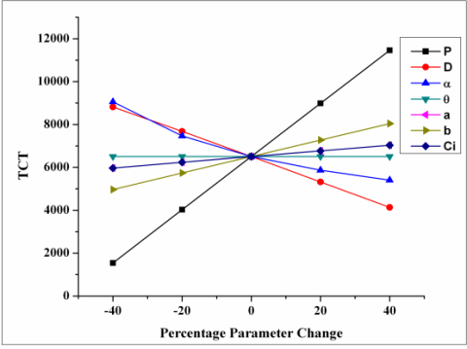 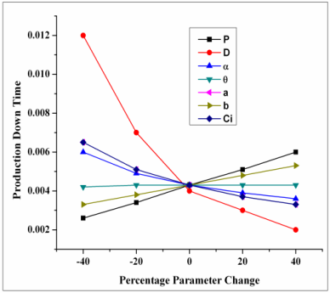

Fig.4 TCT v/s Parameter change Fig.5 T3 v/s Parameter change

From fig.3, it is observed that production rate, demand and inspection costs are highly sensitive to production up time. While inventory dependent consumption rate, holding cost parameter are moderately sensitive to up time. Deterioration rate is slightly sensitive to production time. The first 20% increase in production rate is highly sensitive than the last 20% increase, to production up time. As demand is inventory dependent, due to increase in production rate increases inventory and increase in demand, less change in the time required to build the maximum inventory. Increase in inspection cost decreases the inventory buildup time.

Fig 4 shows, production rate inventory dependent consumption parameter and demand are highly sensitive to total cost per unit time. Inspection cost and holding cost are moderately sensitive while deterioration is slightly sensitive to total cost per unit time.

TABLE II Sensitivity analysis of T3

|  |  |  |  |  |
| --- | --- | --- | --- | --- |
| **Parameter changes** | | | | |
| **Parameters** | **- 40%** | **- 20%** | **20%** | **40%** |
| **T3** | **T3** | **T3** | **T3** |
| P | 0.0026 | 0.0034 | 0.0051 | 0.0060 |
| D | 0.0117 | 0.0066 | 0.0030 | 0.0022 |
| α | 0.0060 | 0.0049 | 0.0039 | 0.0036 |
| Θ | 0.0042 | 0.0043 | 0.0043 | 0.0043 |
| a | 0.0065 | 0.0051 | 0.0037 | 0.0033 |
| b | 0.0033 | 0.0038 | 0.0048 | 0.0053 |
| Ci | 0.0065 | 0.0051 | 0.0037 | 0.0033 |

Demand is highly sensitive to production down time. Production rate, inventory consumption rate and inspection cost are moderately and deterioration, holding cost are slightly sensitive to down time. Increase in demand and inventory consumption rate both decreases the production down time. But increase in holding cost and production rate increases the down time.

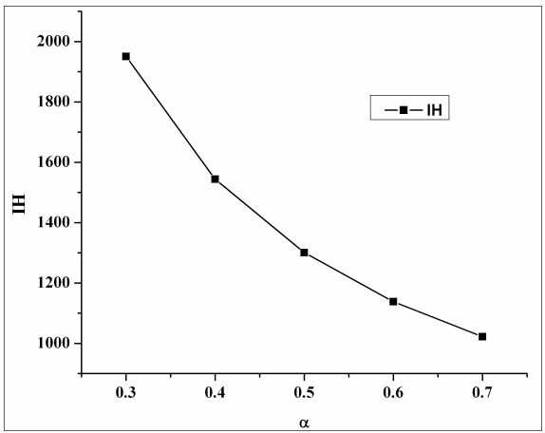

Fig 6. Demand parameter v/s Holding cost.

Fig.6 shows how inventory holding cost change with inventory consumption parameter α. The inventory and holding cost increases with production rate. So TCT is highly sensitive to the production rate. The inventory dependent demand decreases total inventory and therefore decrease in inventory holding cost. This has commented from fig 6. This indicates that inventory dependent consumption rate parameter can control the inventory.

# 5. Conclusion

Theoretical EPQ model has been developed by considering mix demand pattern and time dependent holding cost. Holding cost can be controlled by proper selection of inventory dependent consumption rate parameter. This indicates that buying capacity of customer can be increased. This model can be useful for the inventory managers in decision making especially for the perishable items. The model can be further developed by considering different deterioration rate, production rate, holding cost and demand pattern

# 6. References

*.*

Ardak P. S. Borade A. B.( 2017), ‘An EPQ Model with time dependent holding cost and varying deterioration rate’,*International Journal of Mechanical Engineering and Technology,* Volume 8, Issue 8,August 2017, pp 958-966

Ardak P.S. Borade A.B., Reneta S.B.(2017), ‘An EPQ Model For Deteriorating Items with mix demand pattern’, *International Journal of Mechanical Engineering and Technology*, Volume 8, Issue 6, June 2017, pp. 59–69 .

Ardak P. S., Borade A.B, ‘An EPQ Model with Varying Rate of Deterioration and Mixed Demand Pattern.’, *International Journal of Mechanical and Production Engineering Research and Development*,Vol. 7, Issue 5, Dec 2017, 423-432

Jinn ,T.T., Liang,Y. O., Mei, C. C., (2005) A EOQ model for deteriorating items with power form stock dependent demand, *Information and Management science*, **16**, Number 1 pp 1-16.

Behrouz ,A. N., Babak, A. EPQ model with depreciation cost and process quality cost as continuous functions of time. *International Journal of Industrial Engineering* 5, (8) , 77-89,2009.

DavidW. Pentico, Matthew J. Drake, Carl Toews, The deterministic EPQ with partial backordering:Anewapproach, *International journal of Management Sciences, Omega* 37 ,624 – 636,2009.

Rosenblatt, M., and Lee,H.L., (1986),Economic Production Cycles with Imperfect Production Processes , *IJE Transaction*,.pp 48-55.

Jinn,T. T., Liang, Y.O., Chun,T.C., (2005) , Deterministic economic production quantity models with time varying demand and cost, *Applied Mathematical Modeling*, 26,pp 987-1003. Elsevier.

Gede, A. W., Hui, M. W. Production Inventory Models for Deteriorating Items with Stochastic Machine Unavailability Time, Lost Sales and Price Dependent Demand.” *Jurnal Teknik Industri*, 12, (2), 61-68,2010.

Khedlekar,U.K., A disruption production model with exponential demand”. *International Journal of Industrial Engineering Computations* ,3 , 607–616,2012.

Kuo,L.H. An EPQ model with set up cost and process quality as function of capital expenditure”. *Applied Mathematical Modelling,*31,10 -17,2007.

Jui-Jung Liao, Kuo-Nan Huang, Deterministic inventory model for deteriorating items with trade credit financing and capacity constraints, *Computers & Industrial Engineering*, *vol. 59,* pp. 611-618, 2010.