Significance of Architectural Model Making for Climate Responsive Green Building Design.

Prof. Rupesh Manohar Surwade1a, Prof. Amit Wahurwagh2b,

*aJhulelal Institute of Architecture,Nagpur-441111,Maharashtra,India*

*bDepartment of Architecture and Planning,VNIT Nagpur,Maharashtra,India*

* Email: arupesh11@gmail.com, aramitwagh@gmail.com

------------------------------------------------------------------------------------------------------------------

**Abstract**: This paper focuses on the Architectural model making, an important tool which is very helpful in the designing of the Green Buildings. Architectural model making helps the designers (or students of Architecture) in the designing of their task. Design can be evaluated directly and indirectly in relation to various aspects of designing.

Through models one can study the interaction of volumes, different viewpoints, or concepts during the design process. The research paper considers among others, the important questions: that how efficient is the structure with respect to natural lighting and ventilation, what is the effect of sun pipes, solar panels, and green roof on the composition (or facade aesthetic), and how far the science of sciography deliberately employed in the form of sun shades. Through model making, researcher can do the study of the thermodynamics of the building. The user of the building can experience comfort in a building while using energy in smarter ways within a building. As heating and cooling systems are governed by the laws of thermodynamics, these systems can be experimented or tested on the models. Experiments through an architectural model help in giving the brief idea of the amount of energy consumed in the heating and cooling of a buildings under evaluation.

***Keywords*:** Architectural Model Making, Climate, Green building and thermodynamics.

1. **Introduction**

Architectural model making is a very essential tool while designing a climate responsive green building. Model making further help explores thoughts that are unpremeditated, pre-verbal, and non-linear. The idea evolves in the brain and these ideas can be manifested in the model, while model making set the boundaries and design thus cannot dominate the efficient use of the resources. The crafts of making things whether drawings or models, is the essence of design. Scale models are necessary for obtaining practical information with regard to what the building will look like when finished, how much sunlight will come in the windows and how the building will fit in its surroundings.

The climatic parameters that influence the building fabric are solar radiation, temperature, relative humidity, wind, and precipitation. In the experiments, the model can be used in a generic sense (that is, a block model or study model), representing its system and elements. A green building model can be tested and explored that is environmentally responsible and resources efficient throughout its seasonal cycle. The objectives of model making can be expanded, complementing the desired level of resource optimization. Here, resource optimization refers to concerns of economy, utility, durability, and comfort. Through model making, the design of the building with solar passive techniques in addition to the building shape, size (of the built form), wall, roof, windows, shading devices and pergola can be explored objectively.

1. **1 Types of Architectural Model Making**

**Physical models include:**

Exterior model making of buildings which regularly include some landscaping or public places about the building. Interior models are models showing internal space, finishes, colours, furniture and Aesthetics.

Landscaping models are models of landscape design and expansion representing features such as paving, pathways, roofs, pergolas, vegetation. Landscaping design models usually characterize public spaces and may, in some cases, include buildings as well.

Urban Design models are models in general built at a much smaller scale (starting from 1:500 and less, 1:700, 1:1000, 1:1200, 1:2000, 1:20 000), representing several city blocks, even a whole town or village, large resort, campus, industrial facility, military base and so on. Urban models are a vital tool for town/city planning and development.

**2.2 CAD or Virtual Modelling:**

Buildings are increasingly designed in software with CAD (computer-aided design) systems. Early virtual modelling involved the fixing of arbitrary lines and points in virtual space, mainly to produce technical drawings. Modern packages include advanced features such as databases of components, automated engineering calculations, visual fly-throughs, dynamic reflections, and accurate textures and colours.

As an addition to CAD (computer-aided design) and BIM (building information modelling), virtual reality architectural sessions are also being adopted at gradually more faster rates. As this technology enables participants to be immersed in a 1:1 scale model, essentially experiencing the building before it is even being built.

1. **Solar Radiation**

**Solar radiation is the radiant energy received from the sun.** When the behavior of architectural model is observed in daylight with appropriate cardinal alignments the energy supply mechanisms can be worked out.

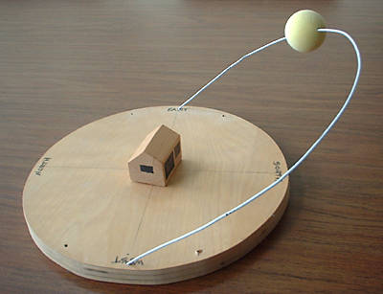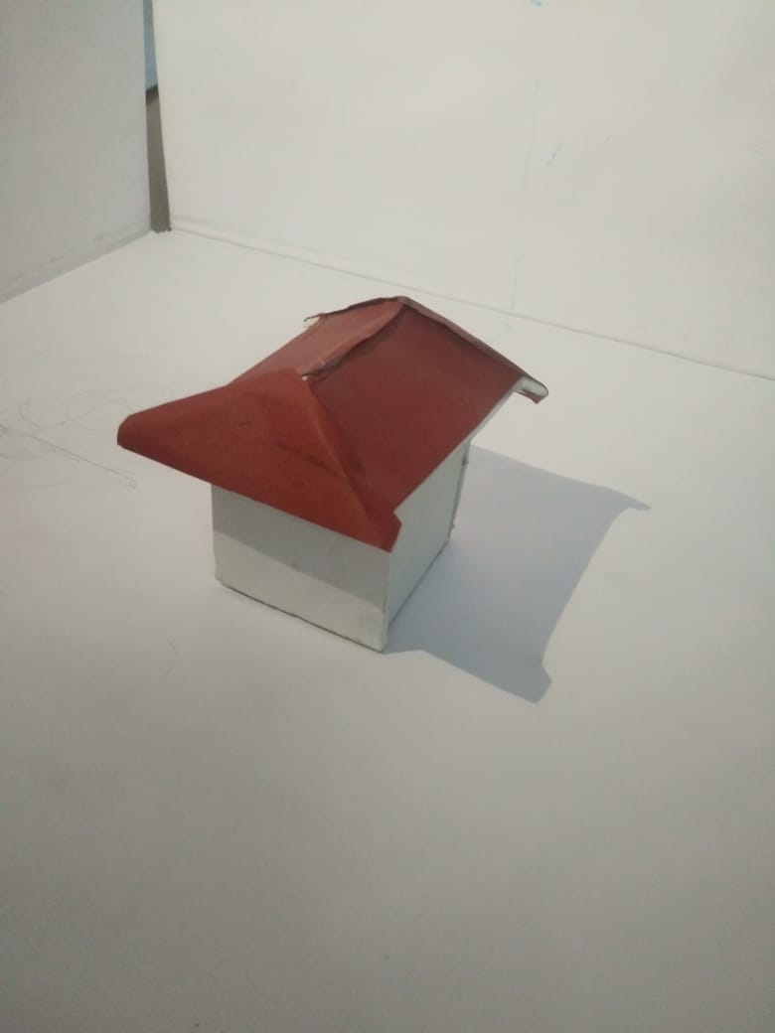Fig. 1. Solar radiation study through model making

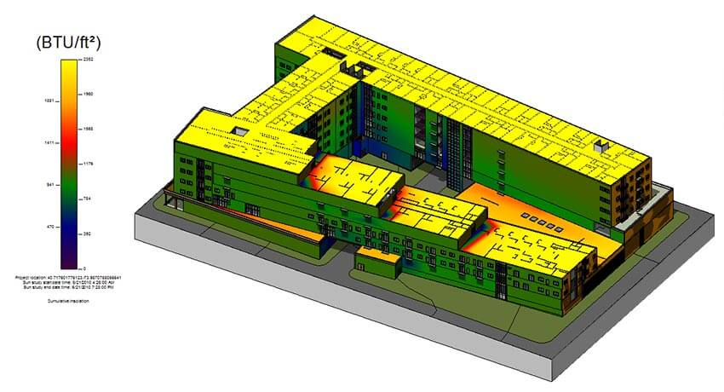

Fig. 2. Solar radiation study through Virtual model making

The solar radiation is the radiant energy received from the sun. The radiation incident on a surface varies from moment to moment depending on its geographic location (latitude and longitude of the place). Orientation, season, time of day and atmospheric conditions.

Solar radiation is the most important weather variable that determines whether a place experience high temperature or is predominantly cold. The instruments used for measuring of solar radiation are the pyranometer. The duration of sunshine is measured using a sunshine recorder.

1. **Materials Used in Green Building Construction**

**Renewable sources:** Forests

**Reuse from waste:** old plumbing, doors etc.

**Wool bricks:** Obtained by adding wool and a natural polymer found in seaweed to the clay of the bricks. 37% more strength than burnt bricks and resistant for cold and wet climate.

**Sustainable concrete:** its crushed glass and wood chips or slag-a by product of steel manufacturing. Reduces the emission of Co2.

**Solar Tiles**: Exist to simply protect a building and they spend a large portion of the day absorbing energy from the sun.

**Paper Insulation**: Made from recycled newspapers and cardboard then filled with chemical form and insect resistant and fire retardant.

**Triple-Glazed windows:** its super- efficient windows and stop heat to enter the building & from direct sunlight.

**Eco Friendly:** using bamboo replacing the steel bars

1. **Literature review of Passive solar Building Techniques**

Literature Review of Passive Solar Building Techniques will cover thermodynamics of the building, direct-gain, indirect gain, shading, day lighting, thermal mass, thermal storage walls, insulation and windows methods of implementing passive solar building techniques. For this review, it is assumed that the buildings are in the northern hemisphere with most of the solar radiation coming from the south.

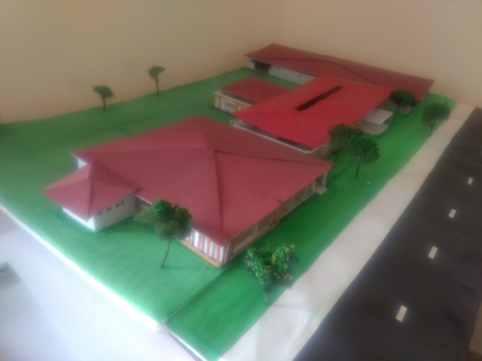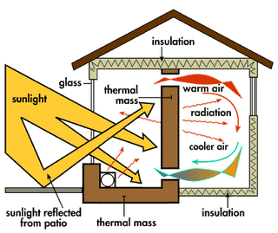

Fig. 2. Passive solar Building Techniques

1. **Climatic Factors & Passive solar effects.**

Heating and cooling effect by the geometry of the architecture. Chajja, overhang and portico are helpful in controlling heating or cooling of the building.  cooling systems and shading devices to retained internal cool air temperature. This flow is responsible for the ventilation of buildings and the quality of the indoor air.  cooling systems and shading devices to retained internal cool air temperature.

1.Roof Form/Materials

2. Orientation

3. Aligning of building

4. Fenestration

5.opening

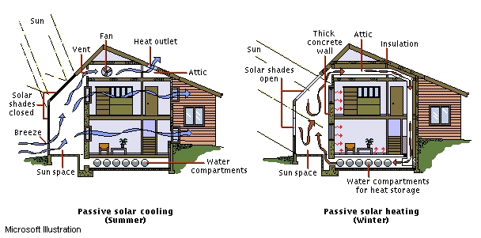

Fig. 3. Passive solar Cooling (summer & winter)

1. **Conclusion**

Architectural model help to evaluate how their buildings will ventilate, how it will affect the local external flow of wind, and what the implications for air quality and energy consumption should be made. Interior design or geometry of the architecture and the position or location and sizes of openings are vital in the functioning of the structure.

This research paper identified the existing development taking place on the Technique front and analyzes the model scale and their implication for green building. The outcome of this research ( Physical model making & Virtual model making) is that the student design process will improve for green building projects.

1. **References**

**1. Journal article**

Rajashree Kotharkar , Pankaj Bahadure ,and Neha Sarda , VNIT Nagpur. Sustainability (2014) ISSN 2071-1050, [www.mdpi.com/journal/sustainability](http://www.mdpi.com/journal/sustainability)

Chetan S. Dhanjode1, R. V. Ralegaonkar2, Vaidehi A. Dakwale 3*International Journal of Sustainable Construction Engineering & Technology (ISSN: 2180-3242) Vol 4, Issue 1, 2013

G. Patle, V. A. Dakwale, R. V. Ralegaonkar, “Design of Green Building: A Case Study for Composite Climate,” International Journal of Engineering Research and Applications, vol. 1(2), pp.388-393, 2011

**2. Book**

Mauhew,A. Koenigsberger, O.H, Szokolay, S. V. and Iggersoll, T. G., ‘Manual Of Tropical Housing & Building’( Longman 1974)

Watson, D, FAIIA and Kenneth Labs, ‘Climatic Building Desig Energy Efficient Building Principle and Practice’

**3. Conference Proceedings**

T.Y. Chen, J. Burnett and C. K Chau, “Analysis of embodied energy use in the residential building of Hong Kong,” Energy, vol. 26, pp. 323–340, 2001

Y. K. Juan and P. Gao, “A hybrid decision support system for sustainable office Building renovation and Energy performance improvement,” Journal of Energy and Buildings, vol. 42, pp. 290–297, 2010

**4. Thesis**

Lentz, Timothy Robert, "Analysis of the passive design and solar collection techniques of the houses in the 2009 U.S. Department of Energy's Solar Decathlon competition" (2010). Graduate Theses and Dissertations. 11361.

**5. Web Links**

1.http://www.napkitores.hu/legjobb.html?a=HKzXY9CZJWo|Solar-Radiation-Analysis-in-Revit-Tutorial

2.<http://designcoalition.org/kids/energyhouse/sunpaths.htm>

3.www.wikipedia.com

4.https://lib.dr.iastate.edu/etd/1136