**Study the Effect of Multi Conventional and Swirl Jet Impingement on Pin fin Heat Sink**

**1KOVVADA LOKNADH,2N.V.S. SHANKAR,3A.DHANUSH BABU,4S. CHANDU PRASAD**

*1Mechanical engineering,Grandhi Varalakshmi Venkatrao Institute of Technology, Bhimavaram-534201,A.P,India*

[*loknadhkovvada337@gmail.com*](mailto:loknadhkovvada337@gmail.com)

*2 Mechanical engineering , Swarnandhra College of Engineering and Technology, Seetharampuram-534275,A.P,India*

[*Shankar.publications@gmail.com*](mailto:Shankar.publications@gmail.com)

*3 Mechanical engineering, Bhimavaram Institute of Engineering and Technology, Bhimavaram-534201,A.P,India*

[*dhanush301@gmail.com*](mailto:dhanush301@gmail.com)

*4 Mechanical engineering, DNR College of Engineering and Technology, Bhimavaram-534201,A.P,India*

[*s.chanduprasad@gmail.com*](mailto:s.chanduprasad@gmail.com)

**ABSTRACT**

Jet impingement is finding a lot of applications in cooling because high localized heat distribution rates are achievable. The uses include cooling of gas turbine nozzles, electronics etc. The impingement cooling can be either with single or multiple jets depending on the application. A lot of work happened in multi-conventional jet impingement (MCJI) and less work in the area of multi-swirl jet impingement (MSJI). The current work investigates into multi-swirl jet cooling on pin fin heat sink with constant wall heat flux (of 8333 W/m2) and compares it with multi-conventional jet impingement. For this purpose, simulations are carried for five different Reynold’s Number values for both types of jets; heat transfer coefficient is computed in each case and compared. The simulated results for MCJI cooling are verified analytically using the expressions from past literature. Cfx has been used for numerical simulations and MathCAD is used for analytical computations.

**Keywords—** MSJI, MCJI, Cfd, constant wall heat flux

1. **Introduction**

Jet Impingement has a lot of utilizations for both cooling and heating. These applications vary from use of impinging hot gases for baking to cooling turbine blades and electronic components. A lot of work happened in the field of jet impingement cooling. Lakshmi Prasad, et al [1] compared the performance of sparse and dense heat sinks during the testing, it is observed that with increase in turbulence there is an increase in cooling while the dense heat sink showed 10K less temperature than sparse design. Chougule, et al [2] studied Single jet impingement and Multi-jet impingement on pin fin heat sink. In both the cases, heat sink geometry is maintained constant. Volumetric flow rate in both the cases is the same. Numerical simulations are executed for investigation purposes. Chougule, et al [3] used cfd simulations to understand the effect of jet impingement distance and turbulence under various cross flow conditions in multi-jet impingement. 3X3 jet impingement on 4X4 pin fin heat sink was considered for the study. During the study variation of 3 parameters, namely, z/d, Re and cross flow are studied. Values of heat transfer coefficient for various values of z/d ratio and Re values are calculated experimentally and compared with those calculated through simulation. Avinash Patil, et al [4] did experimental investigation into variation of heat transfer in square pin fin heat sink. Paisarn Naphon, et al [5] simulated the effect of outlet placement for confined jet impingement of mini rectangular pin fin array when subjected to impinging water jet. Hwa-Chong Tien, et al [6] Study of performance squared pin fin heat sink subjected impinging flow for PC cooling is performed using simulation.

H. A. El-Sheikh, et al [7] experimentally investigated the enhancement of heat transfer from a discrete heat source using multiple jet impingement of air in a confined arrangement. Two jet to jet spacing’s and different types of pin fin heat sinks are investigated. Results for the average heat transfer coefficient were correlated in terms of Reynolds number, fluid properties and geometric parameters of the heat sinks and the orifice plate. Correlation from this work has been used to compute heat transfer coefficient manually. H. A. El-Sheikh, et al [8] performed experimentation on single jet impingement on pin fin heat sink. Correlations relating to heat transfer have been proposed.

**2. PROBLEM STATEMENT**

Based on the literature survey done, it can be understood that there are no mathematical formulations given for Multi-Swirl Jet Impingement (MSJI). Thus it is aimed at investigating MSJI of air on pin fin heat sink. The geometry has a pin fin heat sink with a base of 60mm X 60mm X 10mm. A 4X4 array of pin fins are present on the base with fin length being 40mm and the spacing between pins being 15mm. As a part of this, to study the effect of air-jet impingement on pin fin heat sink simulations are executed. Constant wall heat flux of 8333W/m2 is simulated in both the cases. During simulations, air is treated as incompressible fluid. The model k-ε is used for simulations. 3x3 jet impingement is simulated in all the cases. The Geometry simulated is shown in figure 1. Grid analysis was performed on various mesh densities so as to make sure that the results are independent on grid size. The final grid sizes used are: 3107976 for conventional jet impingement and 2465435 for swirl jet impingement. The following figure 2 represents the Meshed models and boundary conditions.

|  |  |
| --- | --- |
|  |  |
| Geometry for simulating Multi-Conventional Jet Impingement on Pin fin  heat sink | Geometry for simulating Multi-Swirl Jet Impingement on Pin fin heat sink |
|  |  |

Figure 1: CAD Geometry used for Simulation

|  |  |
| --- | --- |
|  |  |
| Meshed model for simulating Conventional jet impingement on pin fin heat sink | Meshed model for simulating Swirl jet impingement on pin fin heat sink |
|  |  |

Figure 2: Grids used for CFD Simulation

1. **CALCULATIONS**

Expression for computing average Nusselt number for pin fin heat sink under conventional multi-jet impingement was derived by El-Sheikh&Garimella [7]. This equation is given below.

(1)

Where – Heat Transfer Surface Area, – Cross section area of the jet, – Equivalent diameter of the square heat sink base, *Dpipe*– Diameter of the orifice, *pjet* – Spacing between the jetsUsing Nusselt number calculated from the above equation, *Wall Heat Transfer Coefficient* is calculated using the expression where k is the thermal conductivity, D is the equivalent diameter of the heat transfer area. A maximum of 10% error existed between calculated and simulated values. Figure 3 shows the comparative plot of calculated and simulated results for MCJI. Comparative plot showing computed and actual values of *h* during MCJI are given in figure 3.

On investigations, it was found that the equation proposed in [1], with a modification in constant, can be used for computing Nusselt number during MSJI on pin fin heat sink. The final equation used for computing *h* in case of MSJI is given below.

(2)

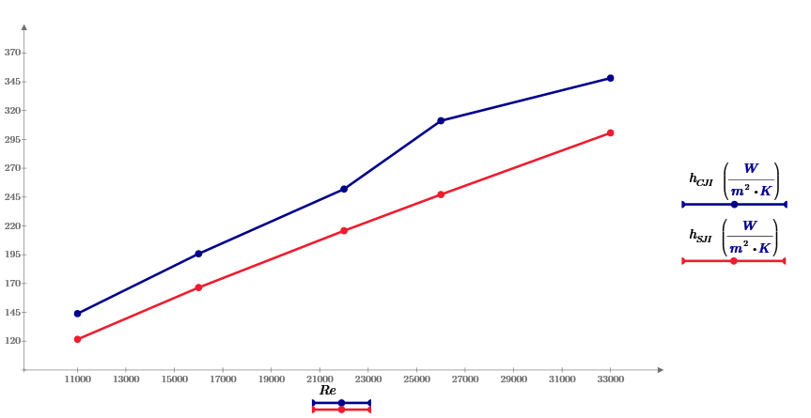

Figure 3: Plot comparing the wall heat transfer coefficient on pin fin heat sink under conventional and swirl jet impingement

*h­­CJI – Wall Heat Transfer Coefficient under conventional jet impingement*

*h­­SJI – Wall Heat Transfer Coefficient under swirl jet impingement*

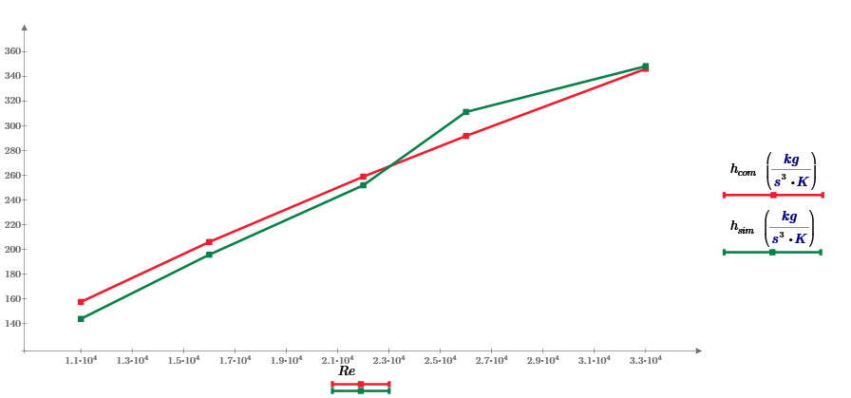

Figure 4: Comparison of Wall Heat Transfer Coefficient obtained from simulation and Numerical computations for Pin Fin Heat Sink with Multi-Conventional Jet Impingement.

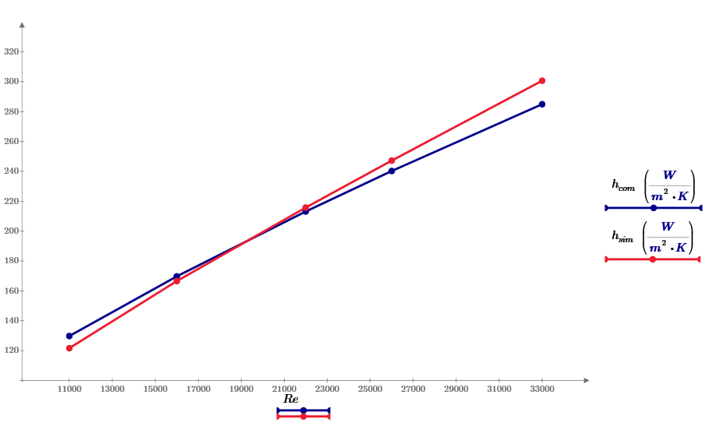

Figure 5: Comparative plot showing computed and simulated heat transfer coefficients during Multi-Swirl Jet Impingement on pin fin heat sink

1. **Interpretation of Results**

Based on the comparative plots of Wall Heat Transfer Coefficients of a pin fin heat sink when subjected to Multi-Conventional Jet Impingement and Multi-Swirl Jet Impingement, it can be observed that the wall heat transfer coefficient is low in latter case. In order to understand the reason, pressure and velocity plots along a plane parallel to the base and at a height of 25mm from the base are compared in both cases. It may be noted that the pressure and velocity plots presented here are for Re=11000 only for the interpretation shall be same for rest of Re values simulated. Pressure distribution plots are presented in figure 5.22 and velocity distribution plots are presented in figure 5.23. Temperature and Wall Heat Transfer coefficient distributions along the surface of the heat sink are presented in figures 5.24 and 5.25 respectively.

|  |  |  |  |
| --- | --- | --- | --- |
| Figure 3 - PINFINCJI/Figure003.jpg | | Figure 4 - PINFINSJI/Figure004.jpg | |
| (a) Pin Fin heat Sink Subjected To Multi – Conventional Jet Impingement | | (b) Pin Fin heat Sink Subjected To Multi – Swirl Jet Impingement | |
| Figure 6: Velocity distribution plots of pin fin heat sink subjected to Multi jet impingement | | | |
|  |  | |
| (a) Pin Fin heat Sink Subjected To Multi – Conventional Jet Impingement | (b) Pin Fin heat Sink Subjected To Multi – Swirl Jet Impingement | |
| Figure 7: Turbulent Kinetic Energy distribution plots of pin fin heat sink subjected to Multi jet impingement | | |
| Figure 2 - PINFINCJI/Figure002.jpg | Figure 1 - PINFINSJI/Figure001.jpg | |
| (a) Pin Fin heat Sink Subjected To Multi – Conventional Jet Impingement | (b) Pin Fin heat Sink Subjected To Multi – Swirl Jet Impingement | |
| Figure 8: Wall Heat Transfer Coefficient distribution on surface of pin fin heat sink | | |

**5. Conclusions**

Numerical simulations for investigating the augmentation of heat transfer using Multi-Swirl Jet Impingement on pin fin heat sink have been performed. Simulations are performed with five different Re values for two cases Multi-Conventional Jet Impingement (MCJI) and Multi-Swirl Jet Impingement (MSJI).During simulations, only Re value is varied for pin fin heat sink. Simulation results for Multi-Conventional jet impingement verified using analytical calculations with the expression given in 1[7] for pin fin. The max error is found to be less than 10%. Based on the results of simulations for both cases, it was observed that:

1. Stagnation region is high for conventional jet impingement
2. Higher vorticity observed in conventional jet impingement and thus has greater turbulence
3. The above reasons lead to higher heat transfer coefficient in conventional jet impingement.

As per the literature survey done, no literature suggesting the equations for multi-swirl jet impingement on pin fin exists. Making a small modification to the equation suggested by El-Sheikh&Garimella [7] by introducing a equation (2), it is found that the analytically computed values and simulated values are in less than 10% difference.

**6. REFERENCES**

1. Lakshmi Prasad K, A. Ramakrishna, N.V.S. Shankar (2013), "Numerical Simulation for Studying Heat Transfer in Multi Jet Impingement on Sparse and Dense Pin Fin Heat Sinks", International Journal of Engineering and Innovative Technology (IJEIT), 2(9), pp.206-210
2. N. K. Chougule, G.V.Parishwad, P. Gore, C.M. Sewatkar (2012), "Numerical analysis of pin fin heat sink with a single and Multi air-jet impingement condition", International Journal of Engineering and Innovative Technology, 1(3), pp.44-50
3. N. K. Chougule, G.V.Parishwad, P. Gore, C.M. Sewatkar and S.Pagnis (2011), "Multi jet impingement on pin fin heat sink with different cross flow schemes", Proceedings of International mechanical engineering congress and exposition, 2011 , USA
4. Prof. AvinashPatil, Mr. Kiran Dhadwe (2011), "Effect of variation of jet impingement distances on cooling of Horizontal Plate with Square Fins", International journal of Mechanical Engineering, 1(2), pp.108-113
5. PaisarnNaphon, SethaKlangchart (2011), "Effects of outlet port positions on the jet impingement heat transfer characteristics in the mini-fin heat sink", International Communications in Heat and Mass Transfer, 38, pp.1400-1405
6. Hwa-Chong Tien, Wei-Dong Huang (2005), "Simulation and Assessment Of Air Impingement Cooling On Squared Pin-Fin Heat Sinks Applied In Personal Computers", Journal of Marine Science and Technology, 13(1), pp.20-27
7. H. A. El-Sheikh, S V. Garimella (2000), "Heat Transfer from Pin-Fin Heat Sinks under Multiple Impinging Jets", IEEE Transactions on Advanced Packaging, 23(1), pp.113-121
8. H. A. El-Sheikh, S V. Garimella (2000), "Enhancement of Air Jet Impingement Heat Transfer using Pin-Fin Heat Sinks", IEEE Transactions on Components and Packaging Technologies, 23(2), pp.300-308