**Design and Fabrication of Die Back Door for Manufacturing**

**of Cylinder Liners**

T Vadivelu a,*, Dr.C.Vijaya Bhaskar Reddyb, Dr.G.Prasanthi c

*aResearch Scholar, JNTUA, Ananthapuramu-515002, A.P, India*

*bMechanical Engineering Department, SVCET, RVS Nagar, Chittoor-517127, A.P, India*

*c* Department of Mechanical Engineering, JNTUA, Ananthapur-515002, A.P, India

*Corresponding author Email: Vadimay28@gmail.com

------------------------------------------------------------------------------------------------------------------

The true centrifugal die casting process was observed at Vijayawada alloy casting private limited, at Vijayawada in India. In the present observation, for the production of cylinder liners, resin sand was used at the front door of the horizontal centrifugal die casting machine and also resin sand was coated or lined at inner surface of the die or mould. However, no resin sand is used at the back door, which results in direct molten metal to metal contact at the back door and which increases the hardness of the cylinder casting (i.e., forms excess than required) due to rapid cooling rate at rear end side of the casting machine, is called chilling, its form at a particular casting zone at back door side range from 6 to 10 mm, which is undesirable. Due to this hot spot defect appear on the back door and it decreases the back door life (i.e., its average life maximum 3 to 4 days). The chilling length is removed by the parting operation, which increases the cost of production. In this research work, to eliminating that hot spot defect, the die back door is design and fabricated to introduce resin sand and also the temperature distribution of the die back door was simulated by using ANSYS 18 software and also carried out FE-SEM, EDX microanalysis for microstructure (i.e. Old and new castings) and presence of variation in chilled casting zone. Result in, no direct metal to metal contact, increasing the life of back door and the hardness of the cylinder casting is limited to as per requirement, parting operation and hot spot defects are eliminated. Instead of parting operation, facing operation is adopted. The time required for facing operation is 1/6th of the parting operation.

***Keywords*:** Die casting, Chilling, Backdoor, Resin sand

1. **Introduction**

Centrifugal casting is one of the superior-quality cylindrical or tubular casting techniques widely used in casting industries, in which melt is poured into a rotating dies or moulds. Due to centrifugal force the die is rotated [1] about its axis at high speed (500 to 1500 rpm), so that the melt to be contributes over the dies surface such that hollow cylindrical castings are produced after complete solidification. These type of castings are very fine grained on the outer diameter, while the inside surface has more inclusions and impurities; these are gathered by centrifugal force towards the centre of the case, that can be machined away. In this type of castings are free from defects when compared to statically [6] casting process, have higher production rate and superior mechanical properties [5]. Centrifugal casting machines are generally three types based on the direction of the mould spinning axis: vertical, horizontal and inclined. The present research work carrying out on horizontal centrifugal casting machine. Horizontal centrifugal casting machines are generally used to cast pieces with a uniform internal diameter or with a high length to diameter ratio components. Products include cylinder sleeves, tubes, pipes and cylindrical or tubular castings [2] that are simple in shape.Mahadevan et al. [3] have been explored the behaviour of the fluid filled partially in a horizontal rotating cylinder die by rotating the cylinder die gradually. Su-Ling Lu et al. [4] has been examined the filling and temperature field of cantilever type horizontal centrifugal casting of wet type cylinder liner were simulated based on the proCAST software, and solidification processes and temperature field were also simulated in the time of cooling process.

However, hot spot defects have not been examined in the horizontal centrifugal die casting process. Hot spot defects are shown in Fig.2; which occur when casting area cools more rapidly than the reaming area and also dies back door, in the time of hot molten metal contact to the dies back door and resulting, excess hardness occurs at rear end side of the casting up to 6 to 10 mm length (Chilling ring & it’s pieces) as shown in Fig.4.

In this study, dies back door is design and fabricated to introduce resin sand instead of graphite/bentonite coating and also the temperature of die back door is simulated through ANSYS 18 software and also hot spot defects were analysed. It expected that result would help to minimize the scraps and improve the quality of cylinder liner manufactured by horizontal centrifugal die casting.

**2. Material for cylinder liner**

Generally ferrous and non-ferrous materials are used for the preparation of the cylinder liners. Based on present work grey cast iron was selected due to its low cost and wide range of properties. Grey iron contains graphite in the form of flakes and it having great lubricating nature due to graphite flakes, excellent machinability, moderate hardenability, toughness, optimum strength and considerable corrosion resistance excellent damping capacity and wear resistance. Grey cast iron have a chemical composition of 2.5-4.0% Carbon,1-2.5% Silicon,.0.6-1% Manganese,0.2-0.4 Cromium,0.3% Posporus,0.05 Sulphur and the remainder iron.

**3. Experimental setup**

To control the excess hardness at the rear end side of the casting and eliminating the hot spot defect on the die back door, the new die backdoor is designed [4] based on old die back door and fabricated as per the drawing is shown in Fig.1(a), with an outer diameter 130 mm and intermediate step diameter 119.5mm. In the fresh die back door additional step is created (i.e., 96 mm diameter) based on the inner diameter of the casting. At the top of the die, an eight mm hole is drilled due to send the sand into the die its drawing is shown in Fig.1 (b).

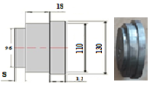 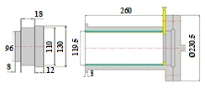 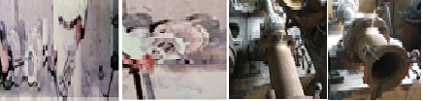

Fig.1 (a) New die backdoor design and fabrication,(b)Sand send through 8mm hole

A suitable supporting door instrument is designed and fabricated is shown in Fig. 3, to support the resin sand until the resin sand solidifies. 8mm bottom diameter 12mm top diameter and 50mm length tapper rod is used for closing the 8mm hole on the die, otherwise, the liquid metal may come outside and affects the worker

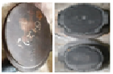 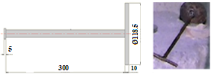 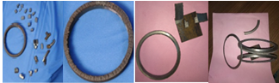

Fig. 2 old die back door, Fig. 3 supporting door instrument, Fig. 4 old & new castings parting rings & its hot spot defect.

The resin sand was sent into the die through a pipe with 2 kg/m2 pressures (To close the 8mm hole with tapper rod), its drawings and fabricated instrument are shown in Figs.1(b).The resultant diagram is shown in Fig.6(a). Due to pressure force, resin sand cannot withstand at the circular portion, that gap also filled with resin with help of funnel (At this particular instant that 8mm hole can be opened). The elliptical portion which is completely filled by the resin sand is shown in Fig. 6(b). Now carefully closed that the 8mm hole with the tapered rod. Now the die back door and die are preheated (i.e.,200 0 C) directly without sand, which helps the resin sand to form adhesive nature on the die back door and also which maintains the pouring temperature constantly. After dressing the die with quartz and resin sands, the molten metal is poured into the die with the help of the spout. After few minutes, the molten metal will solidify, and the casting will be separated from the die for cooling. The new method produces effective castings without chill and hot spot defects. Parting operation is completely eliminated to introduce to new method, and the corresponding visuals are shown in Fig.4, which clears that the white cast iron is completely terminated on the rear end side of the casting and its different sample variations (these rings are not presented white colours) are shown in Fig. 4.The machined casting becomes a liner.

The hardness of the each cast sample was evaluated using a Rockwell’s hardness testing machine in C-Scale (i.e., HRC Series).The excess hardness portion casting samples are taken by a small pieces (Both old & new cast cylinder castings at rear side ring portion can be made small pieces, then hardness can be carried out two opposite pieces from top to bottom and other two opposite pieces left to right at rear end side of the casting is shown in fig. 5), then it can be grinded and polished by grinding machine and CC-22 P800 silicon carbide electro cathode water proof abrasive paper.

The microstructure investigation was performed using field emission scanning electron microscopy (FE-SEM): It is the high-resolution electron imaging, over 1,000,000X (> 10nm at 1kV) can be performed with very low accelerating voltages (50-150 kV are scanned across the specimen). Specimens for microstructural examination were cut from the rear end side of the casting (Old casting 10 mm chilling ring portion was taken and make it a small pieces and also newly cast,10 mm rear side casting portion) samples were grinded and polished by using grinding machine and abrasive paper. The etching of the samples was carried out using 98ml ethanol +2ml nitric acid (HNO3) before the microstructural examination was performed, using field emission scanning electron microscope.

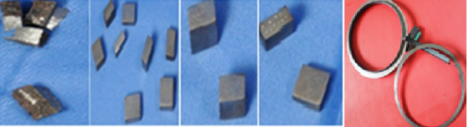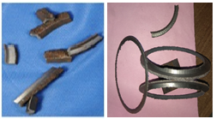 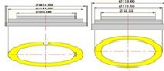

Fig.5 both old & new cast cylinder castings at rear side ring portion can be made small pieces & Hardness tested specimens, microstructure tested specimens. Fig.6 (a) & (b) Elliptical portions.

**4. Heat transfer transient analysis**

The calculation of the temperature distribution for the die back door, based upon unsteady-state heat conduction, was found by solving the governing equation for fluid flow and heat transfer conduction for solid sphere, considering the following equations are employed.

In 0≤x≤x0, & T=T0 at o, where, x=radius of sphere, *k*=Thermal conductivity of sphere material, T=Temperature variation and dr=spherical shell thickness. Heat transfer behaviour during mold filling and solidification are given as follows: Conservation of mass,, the energy equation during mold filling is governed by the equation: *Cp*and *K* are the specific heat and tthermal conductivity of the molten metal. u:velocity component, = densityT is the temperature, and Q is an internal power source. In the inner free surface and outside of mold/die, the radiation effect must be considered in both flow melt and solidified metal. Heat loss due to convection and radiation determined from the equation:-λ. = h.(Tw1-Tw2) +σ.ϵ(Tw1-Tsur1), where λ: thermal conductivity, T:temperature, h:convection heat transfer coefficient, σ:Stefan-Botlzmann’s constant, ϵ:the emissivity

Initial conditions: The initial preheated temperature of 200o C was applied to the mold and resin sand coating. The pouring temperature of the liquid is 1350±50 o C was applied to the casting. The moving fluid flow speed of 1Kg/s was applied to the mold surface and fluid filling time is approximately 30s.

Rotational speed of the die: Using the following formula to calculate the rotational speed of the mold.N=29.9 (G/Ri­­­­­) 0.5 ...…… (i)

­Where, N is the rotational speed of the mold in RPM, Ri is the inner surface radius of the casting in meters and G is the coefficient of gravity. For metal molds (Cast iron, Steel...), G generally adopts range of 40-120.The speed of 1400 RPM was selected after G value was calculated.

Boundary conditions: The mold/die and casting was cooled in atmospheric air and the ambient temperature of outer mold surface is considered as 20 o C.The interface heat transfer coefficient of 25 W/m2 K was applied to the die back door, resin sand and outer surface of the mold.

**5. Result and Discussions**

Result section covers three different sub sections as hardness measurement, microstructure analysis and also the temperature distribution of the die back door was simulated by using ANSYS 18 software.

The value of hardness for each cast samples( based on old method) are measured in Rockwell hard ness in C-Scale series (HRC series).The value of hardness at top, bottom, left and right side (Chill portion ring was taken and make it a small pieces) section of casting samples were polished to obtain a flat and smooth surface finish. Multiple tests were performed on each sample and average hardness values are taken as a consideration, these hardness values are as shown in table 1.

From the figure 7, it can be noted that at chill portion, from 1 to6 mm distance (From rear side of casting to front side) the hardness is found very high (i.e., excess than required), at 7 to 8 mm distance the hardness values are gradually decreased and moderate and 9 to 10 mm it found constant hardness values (i.e., required amount of hardness values). Above similar procedure can be followed for new method castings and its hardness values are shown in table 2 and from the figure 8, it can be seen that all sides of casting sample values are found constant hardness values (i.e., required amount of hardness values).

The micrographs shows that the microstructure of chilled portion of the (Old method producing casting piece at rear end side) casting is characterized with high percentage of cementite and little amount or no graphite flakes as shown in figure 9.Chilling nature is formed due to fast cooling rate at the die and die back door zone (Due to molten metal hits directly to the die back door, result in lower the Si and carbon percentage),result in much of the carbon in a molten cast iron forms iron carbide(Fe3C-in a pearlite matrix) instead of graphite upon solidification. This type of cast iron is also called white cast iron because of the white crystalline appearance of the fracture surface, which is hard and brittle, and almost impossible to machine.

The micrographs shows that the microstructure of rear side portion of the (New method casting piece at rear end side) casting is characterized (Hardness is constant thought out the cylinder casting with required amount) distinct graphite flakes with fine sizes uniformly distributed and randomly oriented. This type of graphite is typical of type-A graphite as shown in figure 10, which is usually preferred for most casting applications.

The EDS/EDX analysis of the chilled surface by SEM/ EDS result (Fe, Si & C element mass %) shown in Fig. 9 and also given in Table 3. SEM/EDS analysis of the newly casted casting pieces at rear end side of the casting were observed (Fe, Si & C element mass %) shown in Fig.10 and also given in table 4.Alloy concentration is expressed in atomic per cent (atom%).It can be seen that chill region contain lower Si and C percentage compared to new casting pieces. 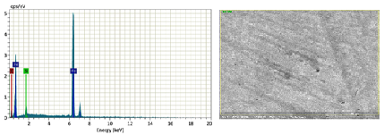 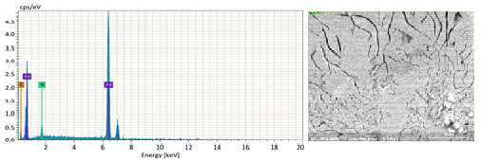 Fig.9. High magnification view (2500x) of the white cast iron specimen & Fig.10.grey cast iron specimen etched with 2% nital (Microstructure and EDS analysis).

Table 3 EDS Analysis for Sample-2(Big size-WCI)

|  |  |  |  |  |  |  |
| --- | --- | --- | --- | --- | --- | --- |
| Element | At.No | Mass [%] | Mass norm [%] | Atom[%] | Abs.error[%]  (1 sigma) | Rel.error[%]  (1 sigma) |
| Fe | 26 | 72.55 | 81.31 | 50.12 | 2.06 | 2.84 |
| C | 6 | 14.67 | 16.44 | 47.12 | 3.76 | 25.66 |
| Si | 14 | 2.25 | 2.25 | 2.76 | 0.15 | 7.46 |
|  |  | 89.23 | 100.00 | 100.00 |  |  |

Table 4 EDS Analysis for Sample -1 (Small size-G.CI)

|  |  |  |  |  |  |  |
| --- | --- | --- | --- | --- | --- | --- |
| Element | At. No | Mass[%] | Mass norm [%] | Atom[%] | Abs.error [%]  (1 sigma) | Rel.error [%]  (1 sigma) |
| Fe | 26 | 84.98 | 87.74 | 62.67 | 2.33 | 2.74 |
| C | 6 | 10.15 | 10.48 | 34.80 | 2.40 | 23.63 |
| Si | 14 | 1.72 | 1.78 | 2.53 | 2.53 | 6.95 |
|  |  | 96.85 | 100.00 | 100.00 |  |  |

Table.1.The hardness values obtained by used in old die back door

|  |  |  |  |  |  |
| --- | --- | --- | --- | --- | --- |
| Samples | Chilling length (mm) | | | | |
|  | 2 | 4 | 6 | 8 | 10 |
| series 1 | 47 | 41 | 36 | 30 | 24 |
| series 2 | 47 | 40 | 35 | 29 | 24 |
| series 3 | 46 | 40 | 34 | 28 | 23 |
| series 4 | 45 | 39 | 33 | 27 | 22 |

Table.2.The hardness values obtained by used in old die back door

|  |  |  |  |  |  |
| --- | --- | --- | --- | --- | --- |
| Samples | Chilling length (mm | | | | |
|  | 2 | 4 | 6 | 8 | 10 |
| series 1 | 24 | 23 | 22 | 22 | 22 |
| series 2 | 24 | 23 | 22 | 22 | 22 |
| series 3 | 24 | 23 | 22 | 22 | 22 |
| series 4 | 24 | 23 | 22 | 22 | 22 |

Fig.7.Casting hardness values (By using old die back door) graph

Fig.8.Casting hardness values (By using new die back door) graph

**6. Simulation results**

C:\Users\Admin\Desktop\DPI\s2.tif C:\Users\Admin\Desktop\DPI\s3.tif 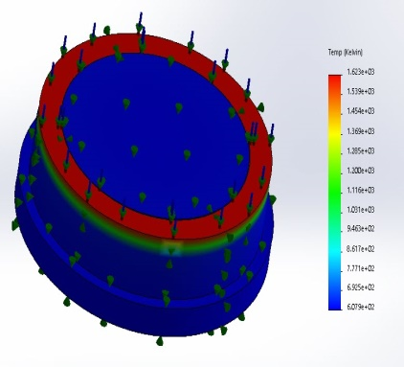

Fig.11.Temperature distribution of die back door with resin sand at different temperatures (1300 0C, 1350 0C & 1400 0C or 1573 0 K, 1623 0K & &1673 0K)

C:\Users\Admin\Desktop\DPI\s4.tif C:\Users\Admin\Desktop\DPI\s5.tif 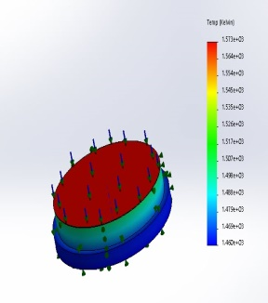 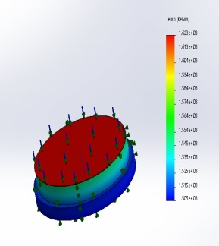

Fig.12 (a & b).Heat flux distribution of die back door at different flow rates (137.9Kw/m2 & 143.4Kw/m2). Fig.12 (c & d).Temperature distribution of die back door with bentonite coating at different temperatures (1300 0C & 1400 0C or 1573 0 K &1673 0K)

Based on the above simulation conditions simulation of die back door is carried out. The aim is to simulate the temperature and heat flux field (Both temperature & heat flux analysis are shown in Fig.11 and 12) of the die back door to increase the life of back door and remove the hot spot defect.

**7. Conclusion**

The new method was observed to be free of cementite as compared to old method and it gives to the required amount of hardness due to slower cooling rate and also promotes hypoeutectic as-cast grey iron with a uniform distribution of randomly oriented finer type -A graphite flakes.

The microstructure of white cast iron is observed after etching, note that the interdendritic cementite (white) appearance. Austenite formed as the proeutectic constituent before the eutectic reaction (liquid transforms to austenite and cementite) and later transforms to pearlite and cementite upon cooling below the eutectoid temperature.

The simulation results show that there is no difference between input temperatures (For old die) and out temperatures, the old die back door faced almost pouring temperature, due to cause its life expired within three days. But new designed die back door facing preheat output temperature, due to cause its life increased life long and eliminate the hot spot defect, all measurements showed in above figures 11 and 12.

**Acknowledgements**

The authors would like to gratefully acknowledge to SVCET for providing financial support during the work and also gratefully acknowledge to M/s VACPL, Vijayawada for allowing carrying out this research work.

**References**

[1] Kim K T, “Fabrication and characterization of BSCCO-2212 tube prepared by Centrifugal

Casting”, Physica C: 460-463 (2007)

[2] Cumberland, “Centrifugal Casting Techniques”, The British Foundry man, 26-46(1963)

[3] Thoroddsen ST, Mahadevan L, “Experimental study of coating flows in a partially-filled

horizontally rotating cylinder”, Experiments in fluids, 23 (1):1-13 (1997)

[4] Su-Ling Lu, Fu-Ren Xiao,Shuang-Jie Zhang, Yong-Wei Mao, Bo Liao, “Simulation study on

the centrifugal Casting wet-type cylinder liner based on ProCAST, Applied thermal

engineering, 73:510-19 (2014)

[5] Paranjpe, D.V, “Centrifugal Casting”Foundry, May/June, 2001

[6] Jones, M.C, “Investigation of Centrifugal Casting Techniques”, Foundry Trade Journal,

1003-1017(1970)