**Effect of Velocity Slip on Two Phase Flow in an Eccentric Annular Region**

**Umadevi B 1 , Dinesh P.A.2 and Vinay. C.V1**

**Abstract**

A mathematical model is developed to study the simultaneous effects of particle drag and slip parameter on the velocity as well as rate of flow in an annular cross sectional region bounded by two eccentric cylinders. In physiological flows this phenomena can be observed in an eccentric catheterized artery with inner cylinder wall is impermeable and outer cylinder wall is permeable. Blood is a heterogeneous fluid having liquid phase consisting of plasma in which a solid phase of suspended cells and proteins. Arterial wall gets damaged due to aging and lipid molecules get deposited between damaged tissue cells. Blood flow increases towards the damaged tissues in the artery. In this investigation blood is modeled as two phase fluid as one is a fluid phase and the other is particulate phase. The velocity of the fluid phase and rate of flow are obtained by transforming eccentric annulus to concentric annulus with the conformal mapping. The formulated governing equations are analytically solved for the velocity and rate of flow. The investigations are carried out by varying eccentricity parameter, slip parameter and drag parameter. Enhancement of slip parameter signifies loss of fluid then the velocity and rate of flow will be decreased. As particulate drag parameter increases then the velocity as well as rate flow decreases. Eccentricity facilitates transport of more fluid then the velocity and rate of flow increases.

**Keywords:** Catheter, Slip parameter, Drag parameter, Eccentricity.

**1. Introduction**

Arterial constriction / stenosis is associated with significant changes in blood flow, pressure distribution and resistance to flow the damage caused to arterial wall due to aging and stenosis increases permeability of solvent at the walls. One of the clinical procedures to treat atherosclerosis balloon angioplasty involves the insertion of a catheter with a tiny balloon at the end. The insertion of catheter will further increase the impedance or frictional resistance to flow and will alter pressure distribution. The insertion of catheter also creates an annular region the rate of flow of blood through an artery is, governed by the need of surrounding tissues for nutrients when the supply of nutrients is not sufficient to meet the needs of the tissue, the artery dilates and the pressure gradient increases to a level to ensure adequate supply of nutrients this process is known as auto regulation. As the dynamics of flow between circular cylinders can be modified appreciable by displacement of axis it is necessary to consider eccentric annular region bounded by two circular cylinders. With all the above said reasons flow of Newtonian fluid between eccentric cylinders with permeable wall involves conformal mapping of doubly connected region bounded by eccentric circles in to concentric circles.

Back [1] and Back et al.[2] studied the important hemo-dynamical characteristics like the wall shear stress, pressure drop and frictional resistance in catheterized coronary arteries under normal as well as pathological situation of a stenosis present. Mac Donald [3] studied the pulsatile blood flow in a catheterized artery and obtained the theoretical estimates for pressure gradient corrections for catheters which are positioned eccentrically. Taking into account the non-Newtonian behavior of blood described by Casson fluid model, Dash et al. [4] studied the changed flow pattern in a narrow artery when catheter is inserted in to it and estimated the increase in the friction in the artery due to catheterization. Sarkar and Jayaraman [5] have studied the pulsatile flow in a catheterized stenosed artery and estimated the correction in the mean pressure drop along the stenosis due to catheterization. Indira et al. [6] have studied the effect of couple stresses on flow in a doubly connected region. Datta et al. [7] have examined the heat transfer to pulsatile flow of a dusty fluid in pipes and channels with a view to their applications in the analysis of blood flow. Ghosh and Sarkar [8] have considered hydro magnetic channel flow of a dusty fluid induced by velocity tooth pulses. Ghosh and Ghosh [9] have solved hydromagnetic flow of two phase fluid near pulsating plate. Most of the methods use integrals of Cauchy type and then use truncation procedures to get numerical results. Daripa and Dash [10] have used Fourier series and numerical methods to study pulsatile flow in eccentric catheterized arteries Shivakumar and Ji[11] have considered transport of Newtonian fluid flowing in an annular domain ‘D’ in the x-y plane bounded by two eccentric circles. The method is to map the eccentric circles in the x-y plane to concentric circles in a $ζ-η$ plane conformally such that the boundary condition on the eccentric annulus is satisfied. In the present study effect of drag of particulate matter on the flow of a Newtonian fluid is studied. A mathematical model has been developed to study the simultaneous effects of particle drag and slip parameters on velocity as well as rate of flow in an eccentric catheterized artery. Blood is modeled as a two phase fluid as liquid phase consisting of plasma in which a solid phase of suspended red cells, white cells, platelets and protein particles. It is necessary to understand the effect of drag exerted by these particles on the flow. In the present study, the effect of drag of particulate matter on the flow of a Newtonian fluid with the Beavers and Joseph boundary slip condition is studied.

**2. Mathematical formulation**

To consider the effect of resistance exerted by the suspended particles on the blood, the velocity of the solid particle on the blood, the velocity of solid particles as well as the fluid and the particulate drag due to suspensions. This drag is similar to the resistance offered by dust on the fluid in a dusty viscous fluid. Saffman[12] has formulated the basic equations for the flow of dusty fluid. Srivastava[13] has used a similar model for blood taking into account the effect of red cell concentration and drag produced by them. The basic governing equations in vector notation for a dusty viscous fluid is given by

$\left[\frac{∂\vec{q}}{∂t} +\left(\vec{q}∙∇\right)\vec{q}\right]=-∇p +μ∇^{2}\vec{q}+NK\left(\vec{V}-\vec{q}\right)$ (1)

$Nm\frac{∂\vec{V}}{∂t}=NK\left(\vec{q}-\vec{V}\right)$ (2)

where $\vec{q }, \vec{v}$ are velocities of fluid phase and particle phase respectively, ρ is the fluid density, µ is the viscosity of the fluid, N is the number of density of particles. K (= 3µπd) is the Stokes resistance co-efficient.  is the pressure, is the mass of the particles, is diameter of the dusty spherical particle,  is the time. Two phase flow of a Newtonian fluid with particulate matter flowing in an eccentric annular domain D, the x-y plane bounded internally by C1 and externally by C2 is considered specified in a schematic diagram shown in figure.1. The initial flow velocity is assumed as (0, 0, *w*(x, y)). The basic governing equations for the specified physical assumptions from the Eqs. (1) and (2) are given by



**Figure 1: Physical Configuration**

 (3)

 (4)

 (5)

where  is velocity of the fluid,  is velocity of the suspended particles.

To solve the above governing equations, we consider the following assumptions for pressure, velocity of fluid and dusty particles in the form of



Implementing the above expressions given in Eqs. (3) and (4) and representing in terms of complex variables with  using variable separable method. The pressure gradient is assumed as constant. Expressing= the boundary conditions can’t be expressed in cylindrical coordinates at a constant value of one independent variable then the set of equations reduces to

 (6)

 (7)

whereis the relaxation time, is the drag parameter,is the non dimensional velocity of the fluid in the direction of the axis of the annulus whose cross section D is bounded by , is non dimensional velocity of the dusty particles, is the rate of flow.

We consider the homogeneous boundary value problem where the bounding curves  expressed for the velocity of the fluid as

 (8)

By solving analytically the Eq.(6) with the technique of series solution in terms of Bessel functions of first and second kinds, according to physical configuration as a cross section of cylindrical annulus for doubly connected region the velocity of the fluid phase is agreed as

 (9)

**3. The eccentric annulus**

The conformal mapping defined as

 (10)

whereandtransform conformally the annular space enclosed by two eccentric circles to a concentric circles annular region bounded by two circles of radius

)  and  with

,  then

 and ,  and  must satisfy ,

where is the radius of the catheter, is the radius of the artery,  is the eccentricity parameter.

The conditions for the boundary value problem as homogeneous no-slip velocity on  and non-homogeneous BJ- slip condition on .

on and  on  (11)

Using the conformal mapping given by the Eq.(10) the above boundary conditions become

at  and  at  (12)

Transforming the expression of the velocity of the fluid phase given in Eq. (9) by using conformal mapping specified in Eq. (10) and applying the boundary conditions given Eq. (12), the velocity of the fluid phase obtained as

 (13)

are specified in the appendix.

**4. Rate of flow**

Using Complex form of green’s theorem,

 (14)

the rate of flow is obtained as

 (15)

Using the conformal transformation specified in Eq. (10) on Eq. (15) and computing the integration as well as simplifying then the rate of flow is agreed as

 (16)

are given in the appendix.

**5. Results**

According to the investigation of fluid flow exerted from the drag particulate in the eccentric annulus circular region. By using conformal transformation the eccentric annulus region transformed into concentric annulus with the assumptions. The results have been obtained solving analytically and computation by using Mathematica software. Velocity and rate flow ruled by three parameters – Drag parameter, Eccentricity parameter and Slip parameter.

The velocity of the fluid phase is specified by the Eq. (13) is computed and graphically depicted shown in figures (2) & (3) for different values of drag parameter**,** eccentricity parameter and slip parameter **.**

The rate of flow is given by the Eq. (16) is computed and graphically depicted in figures (4) & (5) for different values of drag parameter**,** cross-sectional area, eccentricity parameter**** and slip parameter  Also the rate of flow for different values of drag parameter**,** eccentricity parameter  and slip parameter****has been tabulated in the Table.1.

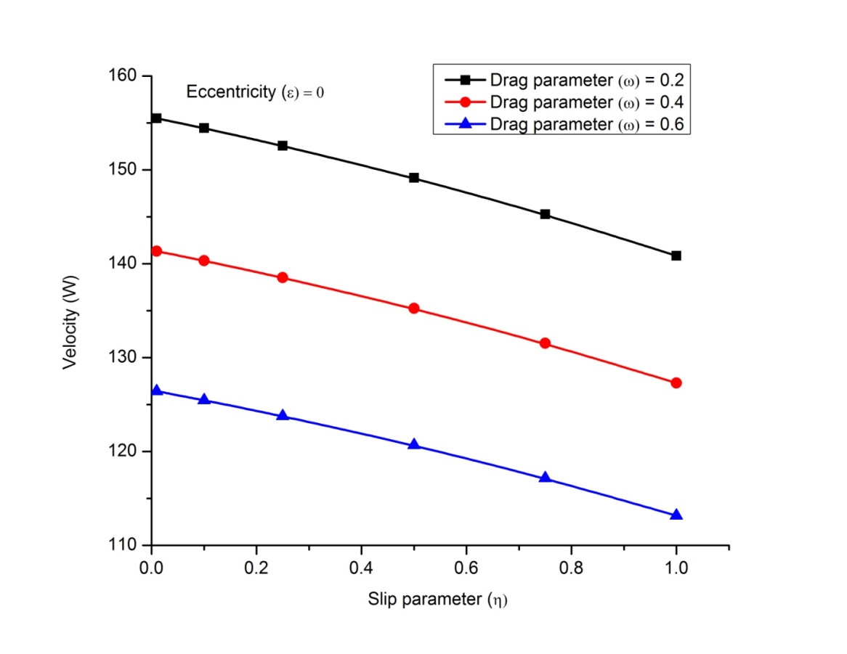

**Figure 2: Velocity profile verses slip parameter for various values of drag parameter, eccentricity parameter  = 0**

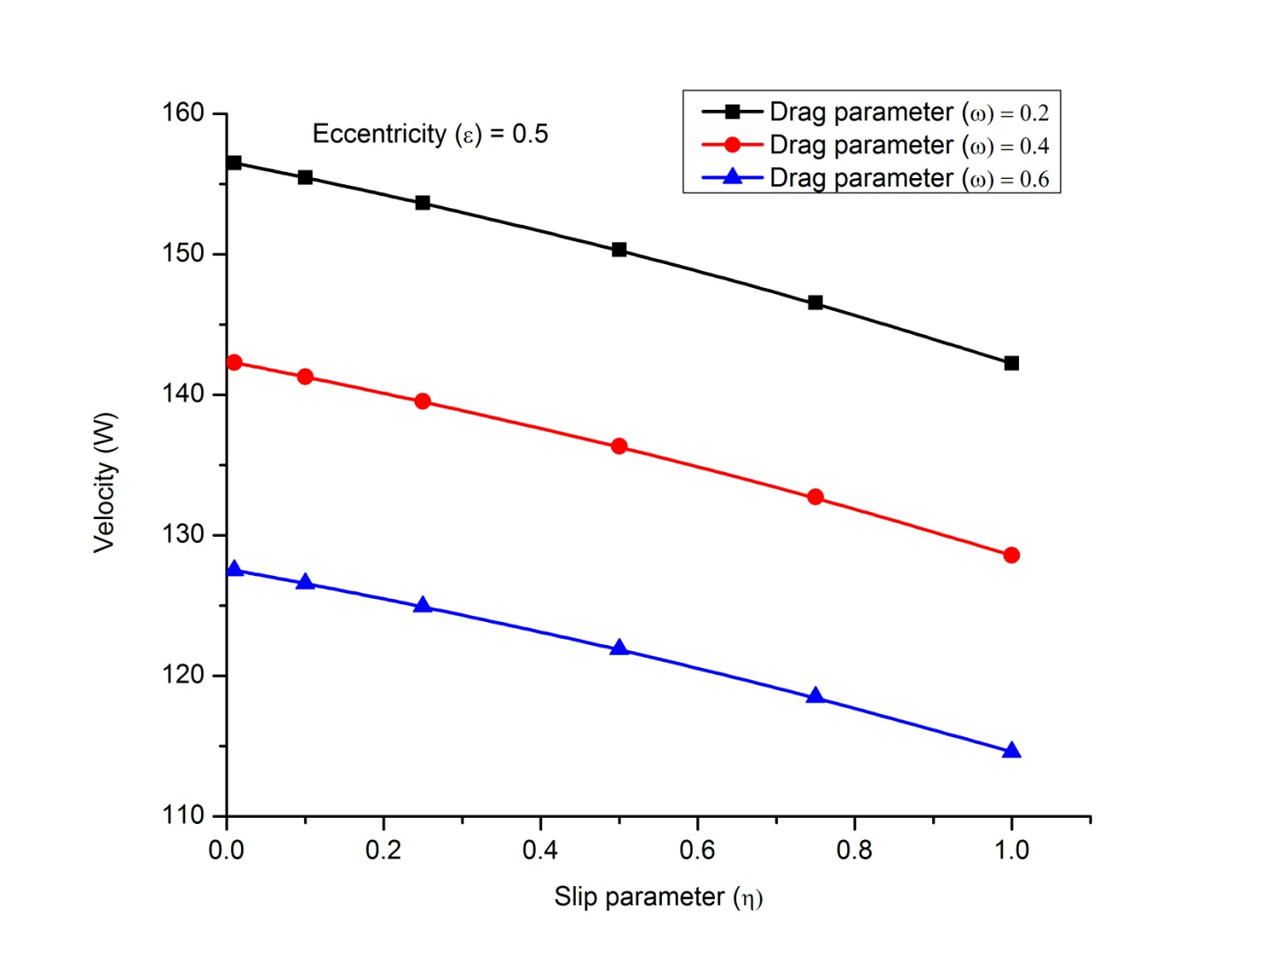

**Figure 3 :Velocity profile verses slip parameter for various values of drag parameter, eccentricity parameter  = 0.5**

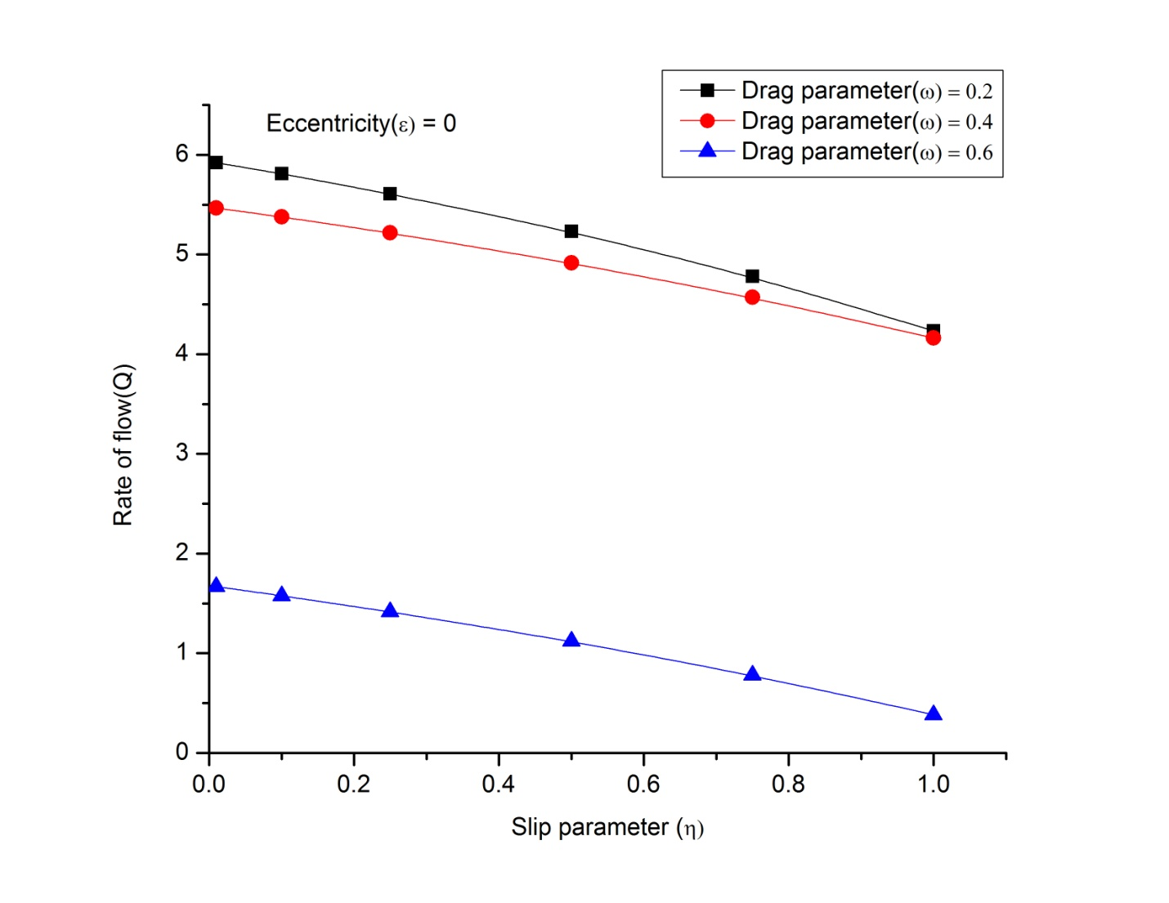

**Figure3: Rate of flow Q verses slip parameter for various values of drag parameter,eccentricity parameter  = 0**

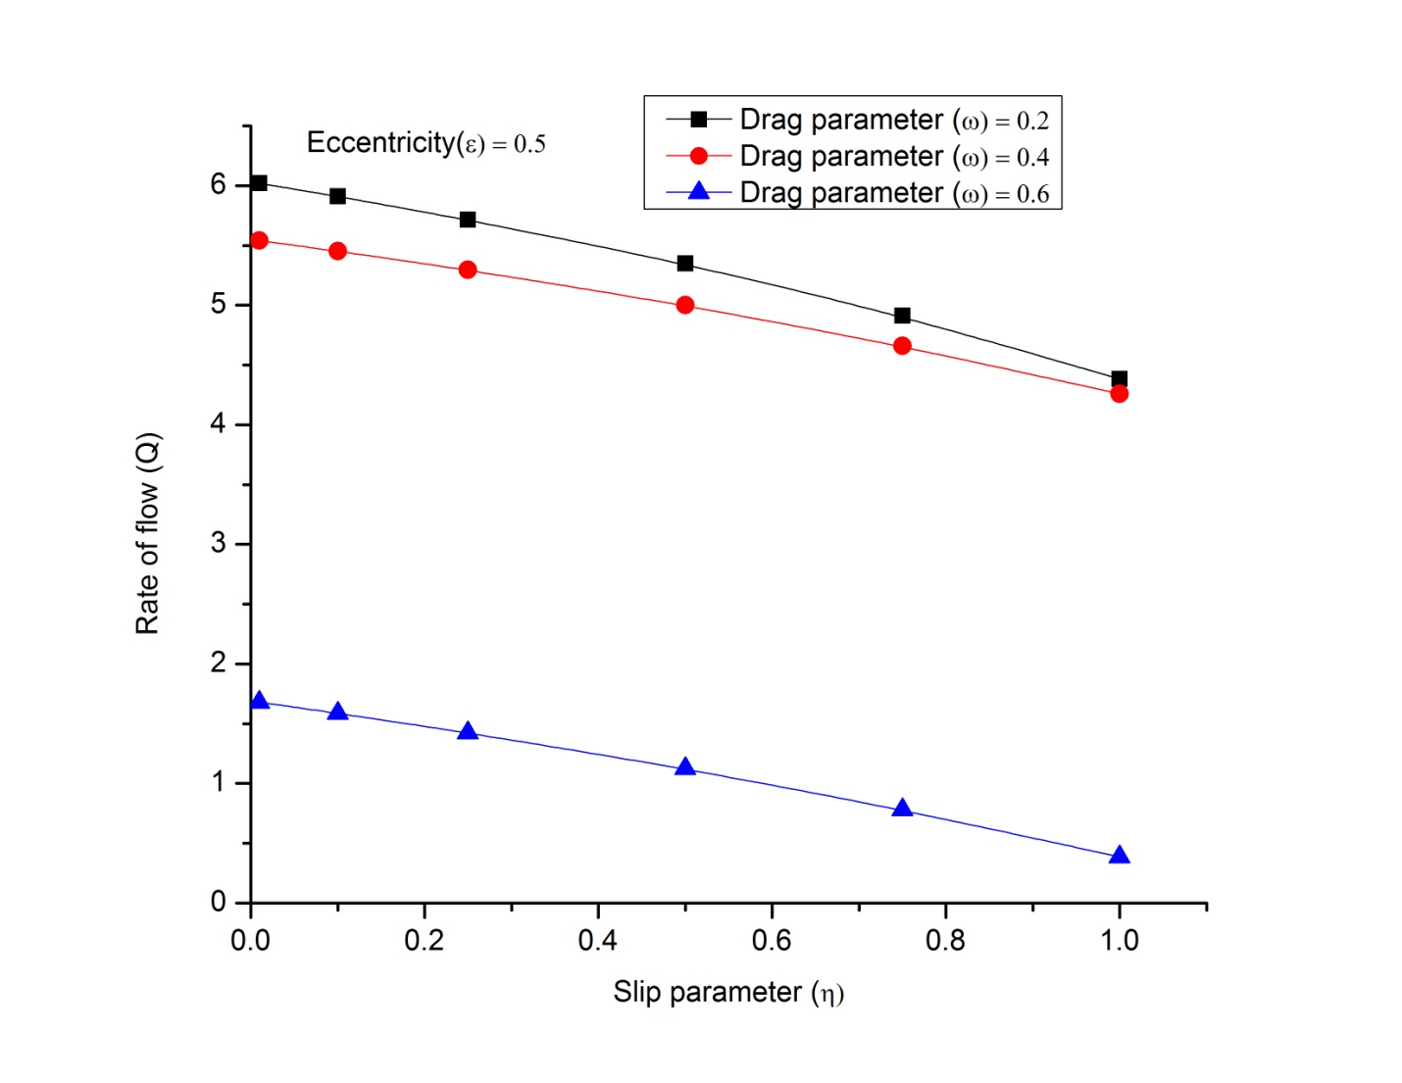

**Figure4: Rate of flow Q verses slip parameter for various values of drag parameter,eccentricity parameter = 0.5**

**Table 1 : Rate of flow Q for Eccentricity, Slip and Drag parameters**

|  |  |  |  |
| --- | --- | --- | --- |
| Slip parameter | Eccentricity | Drag parameter | Q  Rate of flow |
| 0.01 | 0 | 0.2 | 5.92072 |
| 0.5 | 0 | 0.2 | 5.2317 |
| 1 | 0 | 0.2 | 4.23465 |
| 0.01 | 0 | 0.6 | 1.66859 |
| 0.5 | 0 | 0.6 | 1.12225 |
| 1 | 0 | 0.6 | 0.384941 |
| 0.01 | 0.3 | 0.2 | 5.99123 |
| 0.5 | 0.3 | 0.2 | 5.31582 |
| 1 | 0.3 | 0.2 | 4.34065 |
| 0.01 | 0.3 | 0.6 | 1.67638 |
| 0.5 | 0.3 | 0.6 | 1.1252 |
| 1 | 0.3 | 0.6 | 0.385691 |
| 0.01 | 0.5 | 0.2 | 6.01916 |
| 0.5 | 0.5 | 0.2 | 5.34915 |
| 1 | 0.5 | 0.2 | 4.38263 |
| 0.01 | 0.5 | 0.6 | 1.67941 |
| 0.5 | 0.5 | 0.6 | 1.12636 |

**6. Discussion**

The present investigation makes clear that as drag particulate matter is present it influences the flow. The composition of blood varies individually from person to person. If it is more of LDL’s (Low density lipoproteins) and red cells etc than requirement it causes severe problem for blood circulation and for oxygen supply. Gradually it lead to blocks in the arteries and heart problems. To treat this, in many clinical procedures the insertion of catheter in necessary.

Increase in eccentricity results in increase of cross sectional area, there by facilitating flow of more fluid, resulting in increase of velocity. The velocity will be decreased as the drag parameter and slip parameter increased. Enhancement of slip parameter signifies loss of fluid, thereby declining of velocity and rate of flow. Rate of flow increases with enhancement in eccentricity and decreases with the extension of drag parameter and slip parameters.

**7. Conclusions**

The eccentricity of annulus facilitates transport of more fluid than concentric annulus. As eccentricity parameter ****gives the results for concentric cylinders. As drag parameterincreases the velocity and rate of flow will be decreased. The present study gives insight to the variations of pressure gradients in pressure of catheter and also the effects of loss of fluid due to permeability of the wall.

**Acknowledgement**

The encouragement and support from the managements of JSS Academy of Technical Education, Research center M S Ramaiah Institute of Technology acknowledged by the authors.

**Compliance with Ethical Standards:**

Conflict of Interest: All the authors have no conflict of interest.

Ethical approval: This article does not contain any studies with human participants or animals performed by any of the authors.

**References**

**Back, L.H.** (1994): Estimated mean flow resistance increase during coronory artery catheterization. Journal of Biomechanics 27, 169-175.

**Back, L,H., Kwack, E.Y., Back, M.R. (**1996): Flow rate-pressure drop relation in coronary angioplasty : catheter obstruction effect. Journal of Biomechanical Engineering Transactions ASME 118, 83-89.

**Daripa and Dash (**2002):A numerical study of pulsatile blood flow in an eccentric catheterized artery using fast algorithm**,** J. of Engg. Mathematics, 42, 1-22.

**Dash, R.K., Jayaraman,G., Mehta, K.N.(**1996): Estimation of increased flow resistance in a narrow catheterized artery – a theoretical model. Journal of Biomechanics 29, 917-930.

**Datta et.al** (1995): Pulsatile flow and heat transfer transfer of a dusty fluid through an infinitely long annular pipe, Int. Multiphase Flow 21 (3),515.

**Ghosh A. K,& Ghosh** (2005): On Hydromagnetic flow of a two phase fluid near a pulsating plate., Indian J. Pure. Appl. Math.,36(10), 529.

**Ghosh. A. K, & Sarkar .K (**1995): On Hydromagnetic channel flow of a dusty fluid induced by tooth pulses., J.Phys. Soc. Jpn., 64 (3), 3001.

**Indira R, Venkatachalappa M. & P.G. Siddeshwar** (2008): Flow of Couple-Stress fluid Between two eccentric cylinders, International J. of Math. Sci. & Engg. App. (IJMSEA) 2 No. IV , pp. 253 – 261.

**MacDonald (**1986): Pulsatile flow in a Catheterised Artery, Journal of Biomechanics 19, 239-249.

**Saffman P.G.**(1962): On the stability of laminar flow of dusty gas J.Fluid.Mech,13, 120.

**Sarkar A, Jayaraman G** (1998): Correction to Flow Rate – Pressure Drop Relation in Coronary Angioplasty: Steady Streaming Effect. J. Biomechanics 31 ,781 – 791.

**Shivakumar.P.N and Ji** (1993): On the Poisson’s equation for doubly connected regions, Canadian Appl. Mathematics.

**Srivastsava V. P.** (1996):Two phase model of blood flow through stenosed tubes in the presence of a peripheral layer : Applications, J.Bio Mech.29, 1377.

**Appendix**



