**SCRAMJET INLET DESIGN USING TEACHING LEARNING BASED OPTIMIZATION**

Venkat Rao1 M.Kamal1  S. N. Omkar2 Umashankar3

1Assistant Professor, Department of Mechanical Engineering, CMR College of Engineering & Technology, Kandlakoya, Hyderabad- 501401(e-mail: venkatrao2423@cmrcet.org)

2Chief Research Scientist, Department of Aerospace Engineering, Indian Institute of Science Bangalore-560012

3Professor, Department of Mechanical Engineering, Siddaganga Institute of Technology Tumukuru-572103

**Abstract**

*To improve the design level and get better integrated performances of Hypersonic Cruise Vehicle (HCV). Optimization design is the most important key technique of Air-breathing Hypersonic Cruise Vehicle (HCV). The inlet of the HCV is very crucial because it needs to provide a high compression ratio, with minimum total-pressure loss. The flow has to remain supersonic after the shock system. The combustion inlet temperature and pressure should be such that auto ignition of the fuel takes place, i.e. no pilot ignition should be required. The temperature should conform to the material limitations. At the design point operation the shock system should end at the exit of inlet and thereafter no shock reflection should take place.*

*The objective is to find the optimum design for the inlet which minimizes the total pressure loss, while maintaining the combustor inlet conditions required for supersonic combustion and auto ignition. A single ramp, two ramp and three ramp configurations have been investigated. The TLBO routines for optimizing the design have been used in other design optimization efforts. For the designs considered in this investigation, specific Mach number and altitude limits were established and dimensional designs were identified. Utilization of these codes and representative results are documented in the report.*

Key words : **scramjet inlet, TLBO, Design optimization.**

**INTRODUCTION**

Research of hypersonic vehicle starts with the efforts to build a scramjet engine that can accelerate the launch vehicle to hypersonic speeds or that can keep aircraft cruise at a hypersonic speed. Scramjet design, even a model scramjet design, is a complex problem. The process of scramjet design involves simulation of coming air compressed by forebody/inlet, combustion occurring in a combustor, and exhausted gas expanding in the nozzle, and also the evaluation of scramjet performance and the decision or optimization of design parameters**.** . In most cases, designers have tried to take advantage of the vehicle*’*s shock structure in order to increase range and/or payload. This leads to a ‘‘wave rider’’ design. It would also be a significant advantage if the design could fly at or near maximum lift to drag ratio throughout the trajectory .Additionally, it will be required that the scramjet powered missile be launched with an external propulsion source, such as a solid rocket, to some ‘‘take-over’’ Mach number and altitude. At that point, the scramjet engine is started and propels the system until a minimum Mach number and or altitude preclude further operation of the engine. Currently, the success rate for producing thrust in flight conditions using scramjets is unclear. Because of the hypersonic flow regime, it is impossible to separate the external aerodynamics from the internal fluid flow path. Consequently, the system must be designed as a symbiotic collection of interconnected pieces. It is clear, however, that the design must obey the basic laws of conservation of mass, momentum and energy and that the equations of motion applied to the fluid internal to the design must finally result in a positive thrust solution if the system is to experience prolonged powered flight. Air-breathing hypersonic cruise vehicle (HCV) is one of the most important configurations of hypersonic vehicles. This configuration takes scramjet as its power device and can fly in high velocity from 5*Ma* to 10*Ma* for long times and distances. Commonly, its cruise range is over 1000 Km. Because of these advantages, HCV has become the research emphasis all over the world. Optimization design is a key technique of HCV, but due to the mutative flight environment and rigid work condition of scramjet, the optimization design aimed at integrated performances is very difficult.

In the optimization design of HCV, our main work is minimizing the pressure losses across the supersonic inlet. Scramjet inlets are a critical component and their design has important effects on the overall performance of the engine.

**2. THE OPTIMIZATION PROBLEM**

• Cruise conditions:

1. Flight altitude *H* = 30 km

2. Flight mach no. *M* = 6.

3. Range,R=1000km

**2.1. Basic assumptions**

Shock on lip condition.

All assumptions of oblique theory.

The flow is assumed to be One dimensional.

The fluid is assumed to be inviscid hence frictional losses are not considered in calculating total pressure loss. The total pressure loss is only because of the non isentropic behavior across the shock.

The working fluid, air, is modeled as a thermally perfect gas so that the ideal gas equation of state holds.

**2.2. Optimization Of Inlet**

The performance of compression systems can be separated into two key

Parameters:

1. Capability – Extend of compression that can be achieved

2. Efficiency – Accomplishing the compression with minimum losses

Meaningful discussions of inlet performance must include both parameters as, for example, a highly efficient inlet can be very easily designed if it is required to do little compression.

Figure below shows a schematic of the internal flow path of a typical airframe-integrated scramjet with particular reference stations highlighted. Station 0 is in the free-stream flow ahead of the vehicle, and a stream-tube with area A0 captures the airflow processed by the engine. Station 1 is downstream of the vehicle forebody shock and represents the properties of the flow that enters the inlet. Station 2 is at the inlet throat, which is usually the minimum area of the flow path.

Our interest in this project is to find the optimum configuration for the inlet so that the total pressure loss across the shock system is minimum, while maintaining the required combustor inlet conditions. Consequently the flow properties beyond station 3 has not been investigated.

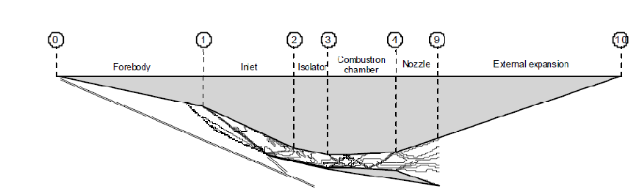



*Flow stations in a SCRAMJET engine*

**2.3 Methodology**

For optimization, ‘TLBO’ (Teaching Learning Based Optimization) function in MATLAB (Global Optimization toolbox) is used. Here the flow turn angle and the turning required in individual ramp is given as input.

Optimization of inlet is a multi objective problem. But in the current case, the objective is only to find the configuration giving minimum total pressure loss.

Hence the objective function is

***f*** = **1 − *Pof***

***Poi***

Where P0f is the final stagnation pressure, and P0i is initial stagnation pressure.

The following constraints has to be satisfied

1. Combustor inlet Mach number is greater than 2

2. Combustor inlet temperature should be higher than 700 K. Because for successful combustion, the inlet temperature to the combustion chamber should be above 700 K for H2 as fuel.

3. The compression ratio is at least 30.

4. The length of the fore body is not prohibitively large, L<3 m.

The input variable to the function is usually the flow turning angle. It was difficult to formulate the constraint in terms of the input variable. Hence for the optimization problem, the strategy was to eliminate all the off design cases and get a solution space in which the minimum can be investigated. A MATLAB program which facilitates this has been developed. Here the logic was to give a random value for the output that would never be the minimum. Though it’s a crude way, it was found to be effective.

Three configurations were investigated and the corresponding optimum geometry in each case is found. The results were compared.

1. Two shock system – Single ramp

2. Three shock system – Two ramps

3. Four shock system – Three ramps

It is expected that the efficiency should increase as the number of ramps are increased. Also, the length of the forebody is expected to increase. To validate the aerodynamics of recommended configuration, wind tunnel test is to be done.

The mass flow rate is arbitrarily taken to be ***ma***= 5 kg/s. The calculationswere done for unit depth. This essentially fixes the overall height, h, of the inlet.All the mass within the stream tube of height ‘h’ and unit depth, is expected toenter the combustor. Under the specified inlet conditions **h=0.587m**. For the designpoint operation, shock on lip condition has to be satisfied. That is the shocksgenerating from the ramps should be concurrent at the lip of the cowl. All nondesign cases were eliminated as mentioned before.

For all the cases ambient conditions were those at altitude of 30 km

Temperature T1 = 231.4 K Pressure P1 =1855 Pa

**3. OPTIMIZATION OF DIFFERENT CONFIGURATIONS OF INLET**

**3.1.Two Shock System**

A single ramp deflects the flow forming the first shock. This shock intersect the lip of the cowl and then reflects forming the second shock.

The objective function for this case has only one input. Consequently, I used the ‘TLBO’ algorithm in MATLAB to get the optimum value for this configuration.

The optimum flow deflection angle was found to be **17.380**

|  |  |
| --- | --- |
| M1 | 6.5 |
| M2 | 3.75 |
| M3 | 2.67 |
| T3 | 763.5 K |
| Pof/Poi | 0.3649 |
| Compression ratio | 30 |

|  |  |
| --- | --- |
| Geometric specifications (all lengths in metres) | |
| Length of wedge, L | 1.575 |
| Length to the cowl lip,l1 | 1.22 |
| Height of inlet, h | 0.587 |
| Height of combustor, D | .08 |

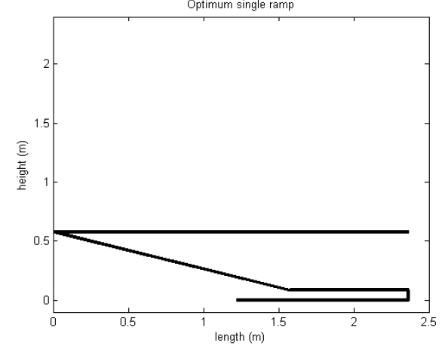

**3.2. Three Shock System**

Two ramps are employed to deflect the flow each of which creates of varying strength.

Both shock intersects at the cowl lip and then reflects to give the third shock. The function takes in two values, total flow deflection required and the fraction by which this flow deflection should takes place between the two wedges. TLBO was employed to get the minimum of the function .The optimum flow deflection angle was found to be 16.20 , which is split between the two wedges angles θ1 = 7.840 and θ2 = θ1 + 8.340

|  |  |
| --- | --- |
| M1 | 6 |
| M2 | 4.93 |
| M3 | 4.11 |
| M4 | 2.9 |
| Tf | 703 |
| Compression Ratio | 30.43 |
| Pof/Poi | 0.615 |

|  |  |
| --- | --- |
| Geometric specifications (all lengths in metres) | |
| Total length of wedges,L | 2.43 |
| Length of wedge 1, L1 | 1.24 |
| Length of wedge 2, L2 | 1.19 |
| Length to lip of cowl, l1 | 2.1 |
| Height of inlet,h | 0.587 |
| Height of combustor,D | .07 |

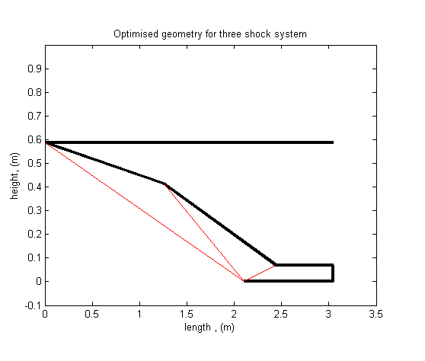

**3.3. Four Shock Systems**

An extenstion to the three shock system this configuration uses 3 wedges to deflect the flow. All three shocks emanating from the wedges meet at the lip and reflect to give the fourth shock. The function used takes in the flow deflection created by each wedge as the input. TLBO is used for optimization. The flow deflection is found to be 16.450

|  |  |
| --- | --- |
| Wedge No. | Flow deflection angle in degrees |
| 1 | 5.21 |
| 2 | 5.43 |
| 3 | 5.81 |

Practically the variation is very negligible, but for design, the configuration ( 5-5-7) is found to give a close enough pressure loss as the above used design. Note that the table gives flow deflection angle, so the wedge angle would be the progressive summation of previous deflection angles for each wedge.

|  |  |
| --- | --- |
| M1 | 6 |
| M2 | 5.29 |
| M3 | 4.68 |
| M4 | 4.15 |
| M5 | 2.91 |
| Tf | 702 |
| Compression Ratio | 32.92 |
| Pof/Poi | 0.6696 |

|  |  |
| --- | --- |
| Geometric specifications (all lengths in metres) | |
| Total length of forebody,L | 2.79 |
| Length of wedge 1, L1 | 1.16 |
| Length of wedge 2, L2 | 0.6 |
| Length of wedge 3, L3 | 1.03 |
| Length to lip of cowl, l1 | 2.48 |
| Total Height | 0.58 |
| Height of inlet to combustor | 0.064 |



**4. RESULTS**

From the optimization procedure followed, it is very evident that to get lesser total pressure loss, i.e. efficient compression, we need use an inlet that uses multiple ramps.

|  |  |  |  |
| --- | --- | --- | --- |
| No. of ramps | Pof/Poi | Length (m) | |
| 1 | 0.3649 | 1.57 | |
| 2 | 0.615 | 2.43 | |
| 3 | 0.6696 | | 2.79 |

The results augur well with the theory. As the flow is turned in steps of smaller angles the total pressure loss decreases. So, infinite steps would give us an isentropic compression as theory predicts. And also the length of forebody required for compression increases as the number of ramps increases.

**5. CONCULSION**

From the optimization procedure followed, it is very evident that to get lesser total pressure loss i.e efficient compression, we need use an inlet that uses multiple ramps. And also the length of forebody required for compression increases as the number of ramps increases.

**REFERENCES:**

1.Supersonic combustion of kerosene/h2-mixtures in a model scramjet combustor C. Gruenig* and F. Mayinger, Institute a for thermodynamics, Technical University Munich, d-85747 Garching / Germany.

2. Scramjet missile design using Genetic algorithms,R.J. Hartfield *, J.E.

Burkhalter, R.M. Jenkins, Aerospace engineering, Auburn university, 211 Aerospace Engineering Building,Auburn, al 36849, United States.

3. Research on integrated optimization design of hypersonic cruise vehicle ✩ Che Jing 􀗛*,*1, Tang Shuo 2, *College of Astronautics, Northwestern Polytechnical*

*University, Xi’an, Shannxi, 710072, P.R. China.*

4. Analysis and design of a hypersonic SCRAMJET engine with a starting Mach

no of 4, Kirsten Robert Nicole, University of Texas, Arlington

5. Hypersonic Airbreathing Propulsion , William H Heiser and David T. Pratt

6.R. Venkata Rao and Vivek Patel, An elitist teaching learning based optimization algorithm for solving complex constrained optimization problem, International Journal of Industrial Engineering Computations 3 (2012) 535-560.