Measurement and Control of Temperature and Speed using LabVIEW

Nilaj Deshmukh 1, Shamim S Pathan 2*, Praseed Kumar 3

1, 2,3 Department of Mechanical Engineering, Fr. C. Rodrigues Institute of Technology,

Vashi, Navi Mumbai , 400 703, Maharashtra, India.

2* Corresponding Author: [shamimspathan@fcrit.ac.in](mailto:shamimspathan@fcrit.ac.in)

**Abstract**

The temperature measurement and its control is important for various industries The automation leads to precise measurement and controlling above parameters. Measurement of temperature and speed can be done using various different techniques. The present study considers the importance of automation This work aims at measuring temperature of water and speed of a DC motor with the desired accuracy using multiple sensors. Along with the evaluation of different sensor performance by measurements, a control system is provided using closed loop control circuit to monitor the temperature and speed at desired value or set reference. An experimental set up is developed for the same using LabVIEW Environment.

Keywords: LabVIEW, temperature control, speed control, LabVIEW, Arduino, DAQ etc.

1. **Introduction**

Temperature and speed is one of the most monitored parameters. The accurate measurement of these parameters is still a difficult task . Considering the need of automation, the present study mainly focus on precise measurement and control of temperature and speed. The present study involves measurement and controlling temperature with different sensors such as thermocouple, RTD, and controlling it. . An accurate determination of temperature, or the measure of hot or cold, is an important factor in many industries such as Food and Beverage Processing, Plastic Production, Metal Processing. If the temperature measurement information is not correct, then it can affect quality of the final product, as well as endanger workplace security. Hence, temperature measurement is important in every domain and its control provides the desired conditions for any processes.

The speed of any system is a key aspect of many industrial systems, and controlling it is of prime important in many industries. Electric motors in any industry consume almost 50% of the world's electricity. With the cost of energy rising steadily, industry is focused on replacing inefficient constant-speed motors and drives with microprocessor-based, variable-speed drives. This new motor-control technology will reduce energy consumption by more than 30% compared to the older drives. While these variable-speed controllers add cost to a motor, the forecasted energy savings and increased motor functionality should easily offset those initial expenses within a few years. Thus the accurate measurement and control of speed becomes an important aspect from point of view of efficiency and energy saving.

**2. Main Text References**

Accurate controlling and measurement is still a major issue in many applications. To understand various approaches in measurement and controlling, an extensive literature survey has been carried out as stated below.

Das, et.al.[2], have carried out an experiment for controlling the temperature of a process operating under high temperature with a help of a servo motor. To achieve this goal Resistance Temperature Detector (RTD) is used as the temperature sensing device and a Servo Motor is used as the final control element of the temperature feeding unit. The open source prototyping platform Arduino is used as the central controller of this system. The control algorithm which is implemented to achieve this is a proportional control algorithm which means, after measuring the temperature and comparing it with the desired set point an error signal will be calculated and accordingly an appropriate control signal will be generated following PID algorithm which in turn will cause the servo to rotate accordingly and control the knob of the feeding device.

Singh, Patel, et.al. [3] , have developed an experimental set-up to control the speed of BLDC motor using PWM control method. The performance of the PMBLDC system is simulated. Simulink is utilized with MATLAB© to get a reliable and flexible simulation. Three phase windings use one Hall Sensors each. They provide three overlapping signals giving a 60° wide position range. Whenever the magnetic poles pass near the sensors, they either give a high or low signal, indicating North or South Pole is passing the pole. A BLDC motor is driven by voltage strokes coupled by rotor position which is measured using Hall sensors. The speed and torque of the motor depend on the strength of the magnetic field generated by the energized windings of the motor, which depend on the current through them. Hence adjusting the rotor voltage and current will change motor speed. The required speed is controlled by a speed controller. This is implemented as a conventional proportional-Integral controller. The difference between the actual and required speeds is given as input to the controller. Based on this data PI controller controls the duty cycle of the PWM pulses which correspond to the voltage amplitude required to maintain the desired speed.

Naik, et.al. [4], have carried out analysis of an accurate Inductive Proximity Sensor that is interfaced to the Arduino and is used to detect metal. A graph of Distance v/s Current is plotted for different metallic materials. The Detection of various metallic materials can be done by using an accurate Inductive Proximity Sensor like the M18DPO. The Arduino interacts with software developed in the PC end through USB architecture and an attractive Graphical User Interface (GUI) based system is developed in the PC end to provide the user with real time, online display of the Inductive Sensor Output.

Esenowo, Jack, et.al.[5], have carried out an experimental analysis on a simple temperature measurement design using thermistor for industrial purposes. This paper establishes the characteristics of the resistance via temperature and it’s constant since it has been difficult to determine if a thermistor has a positive or negative temperature coefficient. The practical approach was adopted to determine its characteristics where it was revealed that all thermistors are nonlinear in nature. In this design, the empirical and the practical design were compared. Its implementation considers the temperature within the ranges of 350C to 600C which is 308K to 333K respectively. The result obtained were analyzed to ascertain the functionality of the experimented design via its performance and suggestions on further improvement were made.

Karhe, et.al.[6], have developed a home automation system that is used to control devices like doors, lights, surveillance systems, and consumer electronics. A smart home automation system has been developed to automatically achieve some activities performed frequently in daily life to obtain more comfortable and easier life environment. LabVIEW is being used in this system to design program codes to read, monitor and display process parameters for real time data acquisition system. In the design of real time data acquisition system, several sensors like LDR, temperature sensor, and humidity sensors are used that will observe the different parameters. ATmega16 microcontroller receives the data from different sensors, placed at specific locations and sends the data to LabVIEW that communicates with the user. The approach combines hardware and software technologies. The goal of this application is to demonstrate the usefulness of multifunction data acquisition boards for monitoring and control. This is achieved by using the LabVIEW environment to acquire and process signals, generating commands and displaying the progress of the process variables to the user.

The literature review shows that various researchers attempted controlling of speed and temperature using different techniques. However, effective and accurate control of speed and temperature has proven to be difficult to achieve. The purpose of present study is to attempt an effective controlling and measurement of speed and temperature.

**3. Design of Experimental Setup for Temperature Control**

A closed loop control system is developed for the experimental set-up to control the temperature. An experimental setup to measure and control temperature is designed and developed using different sensors..

**3.1 Temperature Sensors**

For precise measurement of temperature, multiple sensors have been used to get different readings and to provide a control system to maintain the temperature of boiling water at a defined set temperature. The following temperature sensors are used for temperature measurement and controlling is carried in LabVIEW environment.

**3.1.1 Resistance Temperature Detector**

Resistance Temperature Detectors (RTDs) are temperature sensors that contain a resistor that changes resistance value as its temperature changes. They have been used for many years in laboratory and industrial processes, and have developed a reputation for accuracy, repeatability, and stability. Fig 2.1 depicts the image of three wired RTD PT100 which is used as one of the temperature sensor in the setup which has the temperature range of -50°C to +200°C with an increase of 1.32°C for 0.51ohms of resistance increase. Also it has good accuracy with interchange ability and long term stability.

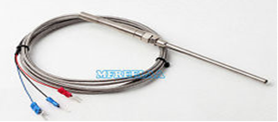

Fig 3.1 Three wired RTD [9]

With a temperature range up to 850°C, RTDs can be used in all but the highest-temperature industrial processes.

**3.1.2 Thermocouple**

For most practical temperature ranges, from cryogenics to jet-engine exhaust, can be served using thermocouples. Depending on the metal wires used, a thermocouple is capable of measuring temperature in the range –200°C to +2500°C. Thermocouples are rugged devices that are immune to shock and vibration and are suitable for use in hazardous environments. Because they are small and have low thermal capacity, thermocouples respond rapidly to temperature changes, especially if the sensing junction is exposed. They can respond to rapidly changing temperatures within a few hundred milliseconds. Because thermocouples require no excitation power, they are not prone to self-heating and are intrinsically safe.

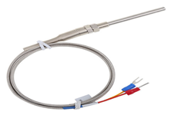

Fig 3.2 Two wired Thermocouple J Type[10]

Fig 2.2 depicts the image of type J thermocouple used in the experimental setup for sensing the temperature of water heating in the kettle. It has a grade C extension wire with sensing range from 0°C to 200°C. For 0.058°C rise in temperature there is an increase in 1mVolts for thermocouple. The LabVIEW and the input module does the signal conditioning for the same voltage to temperature calibration giving the value of temperature in °C ultimately.

**4. Control system for Experimental Setup to Control Temperature**

The measurement has been carried out with RTD and thermocouple and controlling is done using LabVIEW software. NI DAQ Modules 9219 and 9263 are used for this purpose in LabVIEW environment.

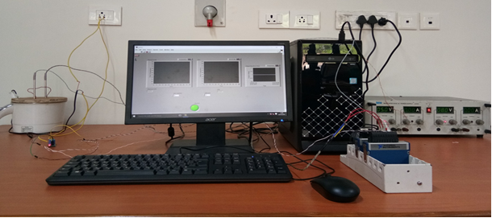

Fig 4.1 Experimental Setup for Temperature Measurement

As shown in the Fig3.1, temperature readings of water initially at room temperature is taken using RTD and thermocouple simultaneously. Then the temperature reading is noted at ten degrees interval up to the boiling temperature of water.

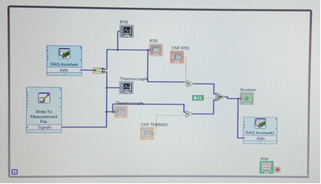

Fig 4.2 Block Diagram for Temperature Measurement and Control using LabVIEW

For controlling part a closed loop system is constructed in LabVIEW . The analog signal of temperature is given to interfacing device. The NI DAQ modules are used for interfacing.

**5. Block Diagram for Temperature Measurement and Control**

. The control system can be designed for temperature control using comparators and gate logic to take into consideration the output from multiple sensors and act according to the set temperature condition so as to maintain the system at the desired temperature. The control system block diagram is as shown in the Fig 4.1, which displays the sensor output temperature in LabVIEW environment and also provides the control signal output for the same from LabVIEW. This is a weak signal and for the signal to actuate a multiplier operator is used in LabVIEW software so that it can activate the 5volts relay module.

 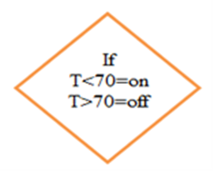

 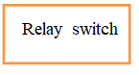 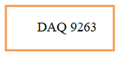

Fig 5.3 Temperature Measurement and Control Block Diagram

6**. Control system for Experimental Setup to Control Speed**

An experimental set- up is designed for measuring and controlling speed . The measurement and controlling has been carried out in LabVIEW environment . The measurement of speed is done by IR proximity sensor.

**6.1 Speed Sensors**

For precise measurement of speed, multiple sensors have been used to get different readings and to provide a control system to maintain desired rpm of a permanent magnet DC Motor. The speed sensors used for the same are as follows.

**6.1.1 IR Proximity Sensor**

This sensor module have great adaptive capability of the ambient light, having a pair of infrared transmitter and the receiver tube, the infrared emitting tube to emit a certain frequency, encounters an obstacle detection direction (reflecting surface), infrared reflected back to the receiver tube receiving, after a comparator circuit processing, the green LED lights up, while the signal output will output digital signal (a low-level signal), through the potentiometer knob to adjust the detection distance, the effective distance range 2 ~ 80cm working voltage of 3.3V-5V. The detection range of the sensor can be adjusted by the potentiometer, with little interference, easy to assemble, easy to use features, can be widely used robot obstacle avoidance, obstacle avoidance car assembly line count and black-and-white line tracking and many other occasions.

When the module detects obstacles in front of the signal, the circuit board green indicator light level, while the OUT port continuous output low-level signals, the module detects a distance of 2 ~ 80cm, detection angle 35 °, the detection distance can be potential adjustment with adjustment potentiometer clockwise, the increase in detection distance; counter clockwise adjustment potentiometer, the detection distance decreased.

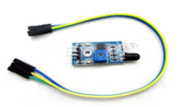

Fig 6.1 IR Proximity Sensor[11]

The sensor active infrared reflection detection, target reflectivity and shape of the detection distance of the key. The black minimum detection range, white maximum; small area object distance is small, a large area from the large.

The sensor module output port OUT can be directly connected with the NI-DAQ 9219 input module, Connection: VCC-VCC; GND-GND; OUT-IO

3-5V DC power supply module can be used. When the power is turned on, the red power LED is lit.

With the screw holes of 3mm, easy to install;

Each module in the delivery has threshold comparator voltage adjustable via potentiometer, special circumstances, please do not adjust the potentiometer

**6.1.2 Hall Effect Sensor**

Hall-Effect Sensors Hall-effect sensing is a sensing technology that detects the presence of a magnetic field. This technology is mainly used to sense position, speed, and acceleration. Hall Effect Sensors are devices which are activated by an external magnetic field. We know that a magnetic field has two important characteristics flux density, (B) and polarity (North and South Poles). The output signal from a Hall effect sensor is the function of magnetic field density around the device. When the magnetic flux density around the sensor exceeds a certain pre-set threshold, the sensor detects it and generates an output voltage called the Hall Voltage, VH. Fig 2.4 depicts the image of hall effect sensor FC-03 which has been used in the experimental setup.

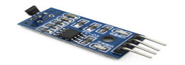

Fig 6.2 Hall Effect Proximity Sensor[12]

**7. Design of Experimental Setup for Speed Control**

A closed loop system is developed for Speed Measurement with control in LabVIEW. The components used are sensors for data acquisition, micro-controller for controlling the servo motor which is used as actuator for motion of knob of speed regulator to maintain a constant speed, IR Proximity Sensor FC-5,Hall Effect Sensor FC-03, 230V DC Motor, Speed Regulator, Arduino UNO Board, Servo Motor and Regulated Power Supply.

As shown in the Fig 6.1 rpm readings of a DC motor are taken using two sensors namely IR proximity FC-51 and Hall Effect Proximity FC-03 simultaneously. Then the speed reading is noted at different intervals of time and controlled the same.

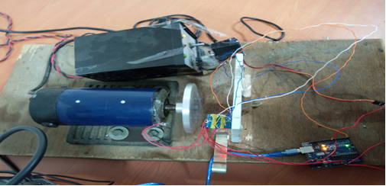

Fig 7.1 Experimental Setup For Speed Measurement And Control

8**. Results and discussion**

The entire temperature measurement and control setup was developed using the Ni-DAQ modules such as 9219 and 9263 as input and output module respectively for temperature measurement. External circuit is developed using various hardware components like wires, relay switches, power supply, sensors, heater, chassis, etc. Also the experimental setup for speed measurement is developed using sensors, Arduino board and a servo motor. The micro controller i.e. Arduino Uno is software programmed for maintaining the desired speed and this is achieved using servo motor attached to the regulator knob.

Graphical results obtained from the experiments performed and readings are plotted on the line graph for both the sensors that is RTD (blue) and Thermocouple (orange) along with the readings measured using Thermometer (green) as shown in the Fig 7.1 below. Thermometer readings are taken as step interval for every one degree Celsius and hence it is not a smooth curve.

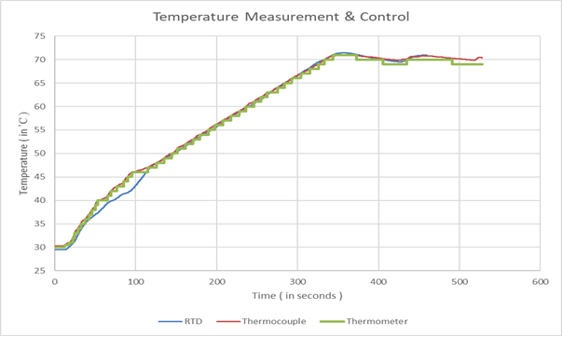

Fig 4.1 Temperature Graph

The following graphs depict the performance variation of speed measured using two different sensors viz. IR proximity sensor (blue), Hall effect sensor (red) and the angle turned by the servo motor for maintaining the set speed is shown in the curve given by green colour. The sequence of the graphs is as follows for the rpm as set in the controller code.

1. Maintain speed at 15rpm

2. Maintain speed at 20rpm

3. Maintain speed at 25rpm

4. Maintain speed at 30rpm

5. Maintain speed at 35rpm

These five plots as stated below actually represents the performance characteristics of IR Proximity sensor FC-51 and Hall Effect sensor FC-03 when working together in the same environment. Along with that the servo motor turning angle is noted so as to control the knob of speed regulator to maintain the desired speed.

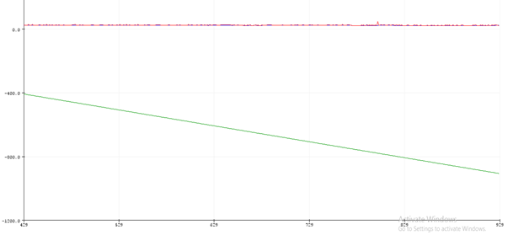

Table 4.2 shows the output we obtained while measuring the temperature of the sensor

.

**References**.

[1] S.Das, S.K.Swar, S. Rudra, A. Mitra, A. Dey, “Design of Industrial Temperature Monitoring System Using RTD and Servo Motor with PID Algorithm”, IJAREEIE, Vol. 5, Issue 4, April 2016

[2] Vinod Kr S.P., A.K.Pandey, “Modeling and Simulation of Brushless DC Motor Using PWM Control Technique”, IJERA, www.ijera.com, Vol. 3, Issue 3, May-Jun 2013, pp.612-620.

[3] Anish A. Naik, Deeksha N., Shruti N., Shubham N., “Inductive Proximity Sensor Interfaced with Arduino”, IJSTE- International Journal of Science Technology & Engineering, Volume 2, Issue 09, March 2016.

[4] K. E. Jack , E. O. Nwangwu, A. Etu, E. Ugwunna, “A Simple Thermistor Design for Industrial Temperature Measurement”, IOSR Journal of Electrical and Electronics Engineering , Volume 11, Issue 5, Sep - Oct 2016, PP 57-66.

[6] R. Karhe, C.S.Patil, M. S. Patil, “Real Time Data Acquisition and Home Parameters Monitoring using LabVIEW”, International Journal of Advanced Research in Computer Engineering & Technology, Volume 2, Issue 3, March 2013.

[7] Honeywell Datasheet, 32312814, Issue A.https://sensing.honeywell.com/honeywell-sensing-bipolar-hall-effect-digital-position-sensor-ic-ss41-l-t2-t3-s-sp-datasheet-32312814-b-en.pdf [8] Three wire RTD PT100 image, three+wire+rtd+pt100&oqhttp://www.thermometricscorp.com/3-wire-rtd.html