Aerodynamic Drag and Aeroacoustic Sound Prediction of Square Cylinder Using CFD

K. Karthika, E. Arunachalamb,*, S. Esakki Ganeshb, P. Lokesh Kumarb

*aDepartment of Aeronautical Engineering, School of Automotive and Mechanical Engineering, Kalasalingam Academy of Research and Education, Anand Nagar, Krishnankoil 626126, India*

*bDepartment of Mechanical Engineering, School of Automotive and Mechanical Engineering, Kalasalingam Academy of Research and Education, Anand Nagar, Krishnankoil 626126, India*

*Corresponding author Email: arunachalam051580@gmail.com

------------------------------------------------------------------------------------------------------------------

This paper presents a numerical methodology for coupled aerodynamic and aeroacoustic calculations for low Mach number air flow past square cylinder. Computations are performed at a subcritical Reynolds number of 54,800 using unsteady Reynolds averaged Navier Stokes technique and Ffowcs Williams-Hawking acoustic analogy. The spectral and aerodynamic results obtained are compared with those found in the literature for similar cases.

***Keywords*:** Aeroacoustics, Aerodynamics, CFD

**1. Introduction**

The interaction of high-speed flow past a solid body generates unsteady fluid dynamic loads, which in turn produces flow-induced noise, also called aeroacoustic sound. Aerodynamic loads and the associated aeroacoustic sound emitted from the bluff bodies are of concern for many engineering applications, such as bullet train, aircraft landing gear, automobiles etc.. As, the requirements for the environmental noise emission levels of aircraft and automobiles, driven by societal demand, are becoming more stringent, it is important to understand and control these flow-induced problems so that engineering design and public comfort can be improved continuously. The aerodynamic drag force exerted on high-speed vehicles is very much associated with the engine power and consequently the fuel expenditure. So, the aerodynamic drag force exerted on the solid body and the sound radiated to the surroundings is of foremost concern in many industrial applications. Therefore, the numerical computation of aerodynamic and aeroacoustic characteristics of rigid bluff bodies have received extensive attention.

The development of aerodynamics led to streamlined structures which have decreased aerodynamic drag and self-induced noise in comparison to bluff bodies. This is attributable to the retarded separation of the boundary layer, decreased wake region and decreased vortex generation. But most structures encountered in the engineering applications are bluff bodies which include bridge piers, buildings, vehicles, chimneys, cooling towers, heat exchanger tubes, flame-holders, aircraft undercarriage during landing, pipelines and re-entry vehicles, to mention a few. Hence studying the aerodynamics and aeroacoustics of bluff bodies, has been the field of interest of several numerical and experimental. From the literature survey, it is observed that most of the analysis is concentrated on circular cylinders and a few reported investigations are found on the study of aerodynamic drag and flow-induced noise on flows over the square cylinder. The air flow over a square cylinder and the associated aerodynamics is significant because the flow separation point is permanent. But, in the case of a circular cylinder, the flow separation point alters periodically around the aft of the cylinder. So, the case study selected for this paper is a square cylinder. Almost all previous studies with attached splitter plates focused at low Re. In most industrial applications, however, the aerodynamic sound becomes more significant only for high Re flows. Hence, in this paper, a high Re (= 54,800) flow is treated.

**2. Geometry and Flow Conditions**

In this work, rigid square cylinder with attached splitter plate of normalized length and thickness of the rear plate are D and 0.02D respectively are considered. All simulations in this paper are carried out at Re = ρUD/μ = 54800, where ρ is the density of air (= 1.225 kg/m3), U is the incoming flow velocity (= 50 m/s), D is the side length of cylinder (= 0.016 m) and μ is the dynamic viscosity of air (= 1.7894 × 10-5 Pa.s). The flow Re and the associated properties in this paper are in consistent with the experimental values (Latorre Iglesias et al., 2016).

**3. Computational Methodology**

The turbulent air flow field over the cylinder is computed by utilizing the two-dimensional unsteady Reynolds averaged Navier Stokes (URANS) technique (Samion et al., 2016), where the numerical model simultaneously solves the mass and momentum conservation equations. Even though the flow field in this problem is three-dimensional in nature, the two-dimensional method can, however, obtain the significant aerodynamic and aeroacoustic characteristics at a cheap computational expense and is a more appropriate technique for a parametric study. The k-ω SST model is employed to provide closure to the system of equations formed by URANS. The finite volume method with the QUICK scheme is utilized for the spatial discretization, while a first-order implicit scheme is used for temporal discretization. The SIMPLE algorithm is utilised for the pressure-velocity coupling. An adaptive time-stepping method is used in the paper, where the time steps are adjusted automatically with respect to the truncation error. The time-step is allowed to change in between 10-8 s and 10-4 s. When the residuals of all variables fall just below 10-5, the solution has been regarded as converged. To compute the aerodynamic drag coefficient and acoustic pressure signals, the unsteady information is collected, once the fluid flow attains the statistically steady-state. The flow-induced sound is calculated using the FW-H acoustic analogy (Williams and Hawkings, 1969) with the two-dimensional URANS results as input by using a “correlation length” method. The “correlation length” technique presumes that the vortex shedding is completely correlated over a certain length of the cylinder in the lengthwise direction. The correlation length that is required in this method can be found experimentally by determining the surface static pressure along the length of the cylinder. In this paper, a correlation length of 6D is adopted based on the previous experimental data. The CFD simulations have been carried out by implementing the cylinder models in the commercial flow solver Ansys Fluent, and a Matlab code was developed for processing the acoustic pressure data.

**4. Results and Discussion**

**4.1 Computational domain, boundary conditions and mesh**

The dimensions of the computational domain around the two-dimensional square cylinder are shown in Fig. 1. The uniform fluid stream is normal to the inlet boundary ‘AB’, i.e. *x*-axis is parallel to the incoming velocity *U*. The origin (0, 0) of the coordinate system is positioned at the midpoint of the cylinder. The boundaries ‘BC’ and ‘AD’ have zero shear stress and normal velocity. The outlet boundary ‘CD’ has a zero value of gauge pressure. The no-slip (wall) condition is assigned on the cylinder (and plate) surface. The computational domain size is chosen as 31.5D × 21D (Samion et al., 2016).

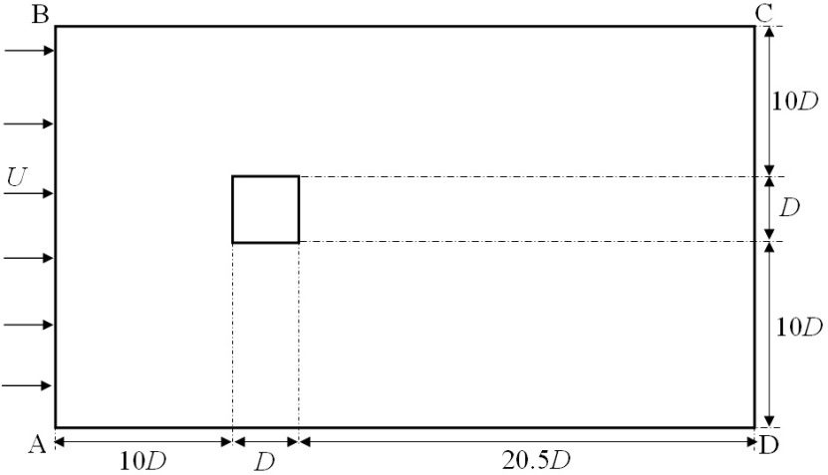

Fig. 1: Schematic diagram of the computational domain

Structured O-grids with circumferential clustering in the vicinity of the square cylinder are provided and the remaining computational domain is meshed with fine unstructured triangular grid system (Fig. 2). A near wall resolution of *y*+ = 1 has been preserved near the cylinder surface for fully resolving the laminar sublayer. The number of O-grids in the radial direction is 20, and the first cell distance from the cylinder surface is 7.1 × 10-6 m with a growth ratio of 1.2. Along the peripheral surface of the cylinder, the cells are being spaced equally at 0.02D (= Δ*s*) apart.

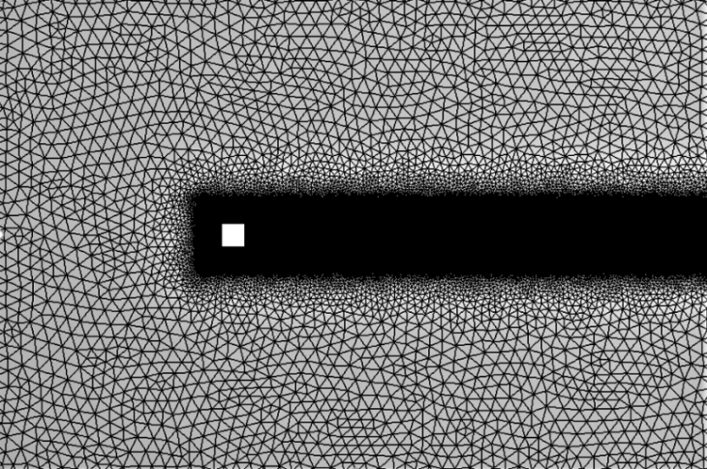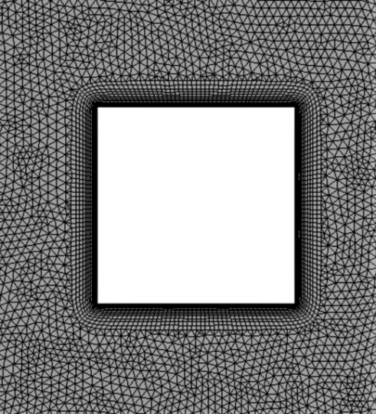

(a) (b)

Fig. 2: Computational mesh. (a) full view (b) near view.

**4.2 Aerodynamic and aeroacoustic results**

For numerical calculations, the turbulent airflow stream should attain a statistically steady state and this takes place at approximately 0.1 s. In all computations, the entire simulation time is 1.1 s and the final 0.9 s (i.e. from 0.2 s to 1.1 s) of time history data is used in calculating the aerodynamic and acoustic results. In other words, flow sampling occurred over a non-dimensional time of *tU*/*D* = 2812, which equates to approximately 331 vortex-shedding cycles. The precision of the SPL calculations primarily relies on the accuracy of the aerodynamic solution. To validate this solution, the mean aerodynamic drag coefficient (*CD,mean*), rms lift coefficient (*CL,rms*) and Strouhal number (*St*) corresponding to the dominant vortex shedding frequency, computed numerically, are compared with previous studies (Table 1). The aerodynamic forces on the cylinder consist of two main parts: pressure and shear force acting in directions normal and tangential to the cylinder surface, respectively. The pressure and shear forces exerting on the cylinder surface are integrated, and resolved in the *x*- and *y*- directions to obtain the drag and lift forces, respectively. The *CD,mean*, *CL,rms* and *St* of the cylinder obtained from simulations are in good agreement with the previous studies. The *St* corresponding to the dominant vortex shedding frequency is computed by fast Fourier transform (FFT) of the lift force time history (Fig. 3).

Table 1: Comparison of the numerical solution with literature.

|  |  |  |  |
| --- | --- | --- | --- |
| **Method (Author)** | ***CD,mean*** | ***CL,rms*** | ***St*** |
| *k*-*ω* SST (*Present*) | 2.151 | 1.446 | 0.118 |
| *k*-*ω* SST (Samion et al., 2016) | 2.1 | 1.43 | 0.126 |

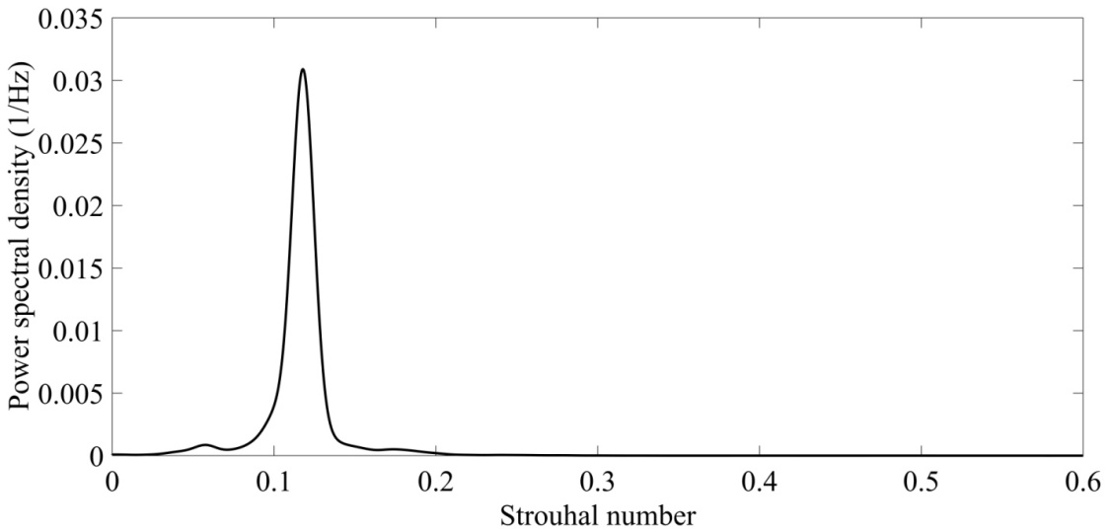

Fig. 3: Power spectral density of the lift coefficient

To evaluate the accuracy of the far-field acoustic analysis, the computed flow-induced sound data are validated using experimental results (Latorre Iglesias et al., 2016) at *Re* = 54,800. The sound measurements were conducted in an open jet anechoic wind tunnel on a square cylinder. The power spectral density (*φpp*) of the calculated sound pressure at the receiver location (0, 87.5*D*, 0) has been obtained using Welch technique adopting Hann window with 50% overlap of 3 data segments. The SPL (dB) is defined as,

$\text{SPL}\left(f\right)=\text{10}\log_{\text{10}}\left(\frac{{}_{pp}\left(f\right)}{p_{ref}^{2}}\right)$ (1)

where *f* is the frequency in Hz and *pref* (= 2×10−5 Pa) is the reference pressure.

Figure 4 displays the comparison of the computed SPL spectrum with experimental data. The computed spectrum agrees with the experimental spectrum at the principal regions and shows an adequate match elsewhere. The most important characteristics of this spectrum, specifically, tonal Strouhal number (i.e. the Strouhal number associated with the peak frequency of the spectrum, represented by *StT*) and the tonal SPL at this frequency (represented by SPLT in dB) match precisely with experimental results as shown in Table 2. This means that the URANS and FW-H method utilized in this study is capable to predict the important features of the flow induced sound, and also has the capability to present additional insight through a parametric study. To make evident the sound reduction levels at the receiver location, the OASPL, which is an estimate of the total sound energy of the SPL spectrum is utilized in this paper. Based on the calculation using Eq. (2), the OASPL is found to be 96.89 dB.

$\text{OASPL=}\text{10}{\text{log}}_{\text{10}}\left(\int{\frac{{}_{pp}\left(f\right)}{p_{ref}^{2}}\text{d}f}\right)$ (2)

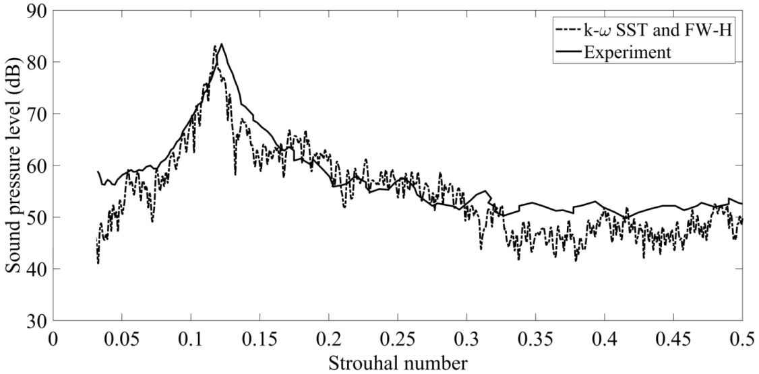

Fig. 4: Comparison of the numerical SPL spectrum with the experimental result.

Table 2: Comparison of the calculated sound parameters with experimental results.

|  |  |  |
| --- | --- | --- |
| Acoustic parameters | Exp. | Num. |
| *StT* | 0.122 | 0.118 |
| SPLT (dB) | 83.48 | 83.06 |

Comparing the *StT* (see Table 2) with the *St* (see Table 1), it is clear that the peak sound frequency takes place at around the dominant vortex shedding frequency, which means the dominant role of vortex shedding on aeroacoustic sound generation.

**5. Conclusion**

A generalized CFD approach is attempted to capture the far-field sound emitted from square cylinders. The incoming flow field has a *Re* = 54,800 and the flow field has been resolved using the URANS technique, and the far-field acoustic results are computed by means of the FW-H acoustic analogy. The considered method shows promising results in predicting the concerned properties. Future work should address the behaviour of cylinders of various cross-sections, with the active flow and noise control.

**References**

Latorre Iglesias, E., Thompson, D.J., Smith, M.G., 2016. Experimental study of the aerodynamic noise radiated by cylinders with different cross-sections and yaw angles. J. Sound Vib. 361, 108–129. https://doi.org/10.1016/j.jsv.2015.09.044

Samion, S.R.L., Ali, M.S.M., Abu, A., Doolan, C.J., Porteous, R.Z.Y., 2016. Aerodynamic sound from a square cylinder with a downstream wedge. Aerosp. Sci. Technol. 53, 85–94. https://doi.org/10.1016/j.ast.2016.03.007

Williams, J.E.F., Hawkings, D.L., 1969. Sound Generation by Turbulence and Surfaces in Arbitrary Motion. Philos. Trans. R. Soc. A Math. Phys. Eng. Sci. https://doi.org/10.1098/rsta.1969.0031