Instability Analysis of Fiberglass reinforced plastic (FRP) subjected to the in-plane loading

**Prashant Sunagar1, Aravind Bhashyam,2 Mahesh Babu 3, Manish Shashikant 4**

*1,3,Department of Civil Engineering, Ramaiah Institute of Technology, Bengaluru-54,Karnataka,Indi*

*2 Department of Civil Engineering, Christ University, Bengaluru, India*

*4 Department of Civil Engineering, BMSIT , Bengaluru, India*

*Corresponding author Email: prashant.sjce@gmail.com

------------------------------------------------------------------------------------------------------------------

***Abstract:***

Fiberglass reinforced plastic (FRP) is a composite material made of fibre reinforcement surrounded by a solid matrix. There have been numerous studies on the composite laminated structures which find many applications in many engineering fields namely aerospace, biomedical, civil, marine and mechanical engineering because of their ease of handling, good mechanical properties and low fabrication cost. They also possess excellent damage tolerance and impact resistance. The objective of the current work is to investigate the buckling of FRP laminated plates using ANSYS. The buckling load of an FRP laminated plate depends on a variety of variables, including aspect ratio, thickness of the laminate, fibre orientation of the laminae that make up the laminate, and the boundary conditions. Among other things, it was found that the buckling load for FRP laminated plates simply supported on all edges the fibre orientation of the mat layers +/- 15 degrees is highest compared to other boundary conditions considered.

***Keywords*:** Plate Buckling, Fiberglass reinforced plastic, orthotopic plate,Post-buckling Phenomena

1. **Introduction**

Composite materials will be materials with at least two constituents consolidated to form a material with different properties than those of the individual constituents. Fibre reinforced plastic (FRP) is a composite material that comprises of two constituents: a series of fibres surrounded by matrix

**Lamina Co-ordinate System.**

A Fibre-strengthened lamina, as appeared in Figure 2.1, is in a state of plane stress if

$$σ_{33}=σ_{23}=σ_{31}=0$$

The stress-strain relationship, in lamina coordinate system, for an orthotropic lamina in a state of plane stress is given as

$\left\{\begin{matrix}σ_{1} \\ σ_{2} \\ τ_{12}\end{matrix}\right\}$ = $\left[\begin{matrix}Q_{11} & Q_{12} & 0 \\ Q_{21} & Q_{22} & 0 \\ 0 & 0 & Q_{66}\end{matrix}\right]\left\{\begin{matrix}ε_{1} \\ ε_{2} \\ γ_{12}\end{matrix}\right\}$

where [Q] is the reduced stiffness matrix. The components of the reduced stiffness

matrix is characterized regarding the in-plane mechanical properties of the lamina and are

$$Q_{11}=\frac{E_{1}}{1-υ_{12}υ_{21}}$$

$$Q_{12}=\frac{υ_{12}E_{2}}{1-υ_{12}υ_{21}}$$

$$Q_{22}=\frac{E_{2}}{1-υ_{12}υ_{21}}$$

$$Q_{66}=G_{2}$$

Theoretical determination of the in-plane mechanical properties of a fibre-reinforced lamina using micromechanics was discussed in previous section. The strain-stress relationship, in lamina coordinate system, for an orthotropic laminated plate in a state of plane stress is given as

$\left\{\begin{matrix}ε_{1} \\ ε_{2} \\ γ_{12}\end{matrix}\right\}$ = $\left[\begin{matrix}S_{11} & S_{12} & 0 \\ S_{21} & S_{22} & 0 \\ 0 & 0 & S_{66}\end{matrix}\right]$ $\left\{\begin{matrix}σ_{1} \\ σ_{2} \\ τ_{12}\end{matrix}\right\}$

where [S] is the consistence matrix. The components of the consistence matrix are

given as

$$S_{11}=\frac{1}{E_{1}}$$

$$S_{12}=-\frac{υ_{12}}{E_{1}}$$

$$S_{22}=\frac{1}{E_{2}}$$

$$S_{66}=\frac{1}{G_{12}}$$

**Global co-ordinate system.**

Many of the lamina that make up a laminate have a coordinate system (1-2-3) that does not coincide with the global coordinate system (x-y- z) of the laminate. An orthotropic lamina whose co-ordinate system doesn’t coincide with the global coordinate system of the laminate is called a generally orthotropic lamina. Due to the presence of generally orthotropic lamina in a laminate, a method of transforming stress-strain relationships from one coordinate system to another is required.



**3.4Lamina 0n-and 0ff-hub C0nfigurati0ns**

The stress-strain relationship for an orthotropic lamina in terms of the global coordinates is

$\left\{\begin{matrix}σ_{x} \\ σ_{y} \\ τ_{xy}\end{matrix}\right\}$ = $\left[\begin{matrix}{\overline{Q}}_{11} & {\overline{Q}}_{12} & 0 \\ {\overline{Q}}_{21} & {\overline{Q}}_{22} & 0 \\ 0 & 0 & {\overline{Q}}_{66}\end{matrix}\right]\left\{\begin{matrix}ε_{x} \\ ε_{y} \\ γ_{xy}\end{matrix}\right\}$

where [ $\overline{Q}$] is the transformed reduced stiffness matrix, using the relation

[$\overline{Q}$] = ${[T ]}^{-1}$ [Q] [T]

where [T] is the transformation matrix, which is

$$\left[T\right]=\left[\begin{matrix}m^{2} & n^{2} & 2mn \\ n^{2} & m^{2} & -2mn \\ -mn & mn & m^{2}-n^{2}\end{matrix}\right]$$

**UNIAXIAL COMPRESSION**

**Critical buckling load for loading edge simply supported and unloaded edge simply supported**

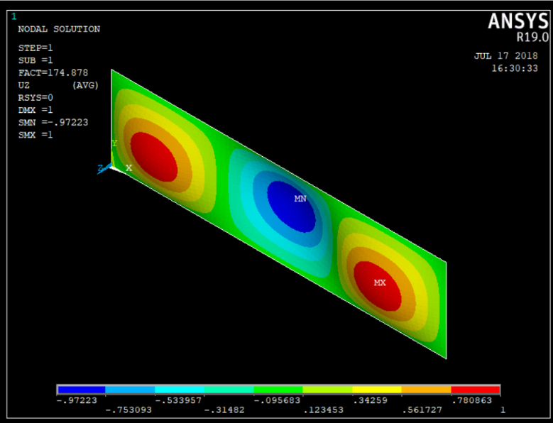

**Properties of laminated plates analysed.** The laminated plates that are

examined in this work using ANSYS19.

**Calculated laminate longitudinal and transverse modulus for different orientation:**

|  |  |  |  |  |
| --- | --- | --- | --- | --- |
|  | **15** | **30** | **45** | **60** |
| **Longitudinal modulus, Ex** | 23594 | 20684.28 | 18036.69 | 16933.52 |
| **Transverse modulus, Ey** | 10901 | 11086.77 | 12341.62 | 14968.52 |
| **Poison’s ratio** | 0.25 | 0.25 | 0.25 | 0.25 |
| **Shear modulus, Gx** | 4140 | 4140 | 4140 | 4140 |
| **Shear modulus, Gy** | 3450 | 3450 | 3450 | 3450 |

**Bending stiffness for (+15/-15/-15/+15) orientation**

|  |  |  |  |  |
| --- | --- | --- | --- | --- |
| **BENDING STIFFNESS MATRIX**  **D Mpa** | | | | |
| **Plates thickness**  **(mm)** | $$D_{11}$$ | $$D_{22}$$ | $$D_{66}$$ | $$D_{12}$$ |
| **8** | 1073796 | 496120.3559 | 147201.15 | 124030.1103 |
| **10** | 2097158 | 968938.7409 | 287488.5 | 242234.7269 |
| **12** | 3624034 | 1674393.12 | 496800 | 418598.352 |

**Critical buckling load for laminated plate (15/-15/-15/15):**

**Simply-Simply-Simply-Simply**

|  |  |  |  |  |  |  |
| --- | --- | --- | --- | --- | --- | --- |
| **A in mm** | **B in mm** | **Aspect ratio**  **(a/b)** | **Plate thickness in mm** | **Calculated critical buckling load in Mpa** | **ANSYS critical buckling load in Mpa** | **Percentage error** |
| 1000 | 1000 | 1 | 8 | 23.74 | 25.20 | 9.14% |
| 1000 | 800 | 1.25 | 8 | 34.512 | 38.25 | 10.83% |
| 1000 | 666.667 | 1.5 | 8 | 53.94 | 58.27 | 10.1% |
| 1000 | 500 | 2 | 8 | **94.512** | **100.51** | 6.21% |
| 1000 | 1000 | 1 | 10 | 46.38 | 49.11 | 7.35% |

**Critical buckling load for laminated plate (15/-15/-15/15):**

**Simply-Simply-Simply-Simply**

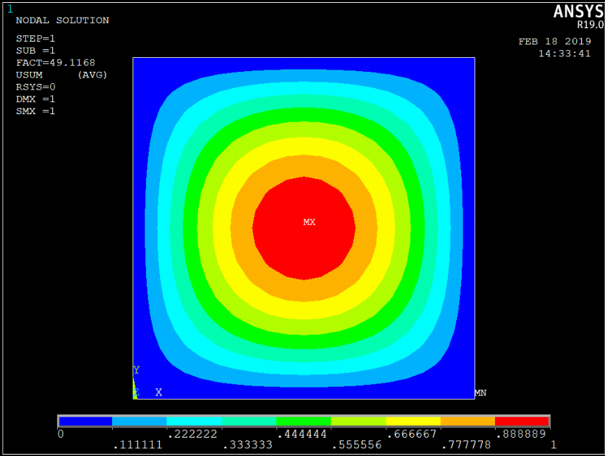

**Aspect ratio a/b = 1, thickness t= 10mm Simply-Simply-Simply-Simply**

**CONCLUSION**

It was noted that different length to breadth ratio affected the critical buckling load. The buckling load increases as the a/b ratio increases. When the aspect ratio changed from 0.5 to 1, the variation in buckling load is almost 24%. The rate of change of buckling load with the aspect ratio is almost uniform.

It is clear from the study that the there is a correspondence between the classical analysis and Finite Element Analysis. Its feature physical significance suggests that the modelling of plates as the cases for laminated plates can be possible in ANSYS.

Theoretical values of buckling load for laminated plates using Classical lamination theory (CLT) are matching with analytical values for all side simply supported condition. The average percentage of error is less 5%.

**REFERENCES**

1. A K Sreevastva, R.K Singh. Effect of aspect ratio on buckling of composite plates-. Journal of Composites Science and Technology 59 (1999) 439-445

2. Buket Okutan Baba and Aysun Baltaci. Buckling characteristics of symmetrically and anti-symmetrically laminated composite plates with central cutout,- Applayed Composite Materials – 14(2007):265–276

3. C.W. Pein and R. Zahari. Experimental investigation of the damage behaviour of woven fabric glass/epoxy laminated plates with circular cut-outs subjected to compressive force,- International Journal of Engineering and Technology, (2007)Vol. 4, No. 2, pp.260-265

4. Chavanan supasak, A comparison of experimental buckling load of rectangular plates determined from various measurement method-.Department of mechanical engineering,Bangok,(2006)18-20,2547

5. Chainarin Pannok and Pairod Singhatanadgid . Buckling analysis of composite laminate rectangular and skew plates with various edge support conditions. - The 20th Conference of Mechanical Engineering Network of Thailand (2006)18-20.

6..David Roylance, Laminated composite plates, Massachusetts Institute of Technology Cambridge, (2000) MA 02139.