**Numerical Analysis of Porous Recto semicircular Enclosures with Non uniform heating of Bottom Wall**

**SHANTANU DUTTA1* ARUP KUMAR BISWAS2** *Department of Mechanical Engineering, Department of Mechanical Engineering,*

*NSHM Knowledge Campus Durgapur National Institute of Technology Durgapur*

*Durgapur-713212, India Durgapur-713214, India*

*Corresponding Email: 1*shantanu.dutta@nshm.com Email: 2arup.biswas10@gmail.com*

------------------------------------------------------------------------------------------------------------------

**ABSTRACT**

In this paper, we analyze numerically the effects of natural convection heat transfer and entropy generation characteristics in a two-dimensional recto semicircular enclosure saturated with a porous medium. It is found that streamline strength increases with increase of Da number and there is a significant alteration in Nusselt number with the increase of Darcy number in the enclosure and also this phenomenon occurs at higher values of Rayleigh number.

***Keywords****:Natural convection; porous ; Nusselt Number*

1. **Introduction**

Natural convection in a porous enclosure plays an important role in numerous applications such as the thermal management of electronics devices, nuclear reactor systems, solar heating, geothermal exploitation, food processing, grain storage, energy-efficient drying processes, atmospheric study, to name a few. An important energy policy involves heat transfer process, where energy efficiency can be improved by optimizing system design along with preventive maintenance to detect energy losses. Since the primary objective is to minimize energy consumption in various processes, natural convection heat transfer is the preferred mode of heat transfer in various industries, as it requires no external energy sources inspite of its limitation of not being able to produce maximum heat transfer. A comprehensive documentation of these applications can be found in Bejan et al.[1], Ingham et al.[2], Pop and Ingham [3], Vafai [4]. Saeid and Pop [5] numerically studied the unsteady natural convection in a two-dimensional square cavity filled with a porous medium and concluded that the time required to reach the steady state is longer for low Rayleigh number and shorter for high Rayleigh number. Basak et al. [6] studied natural convection in a porous square cavity with uniform and non uniform heating from the bottom wall for wide ranges of Rayleigh number (103 ⩽ Ra ⩽ 106), Darcy number(10- 6 ⩽ Da ⩽ 10- 3), and Prandtl number (0.71 ⩽ Pr ⩽ 10). They established that the conduction dominant heat transfer is observed for Ra ⩽ 7 X 104 during uniform heating of the bottom wall whereas the heat transfer is dominated by conduction for Ra ⩽ 3 x 105 for non uniform heating corresponding to Darcy number equal to 10- 4.

Accordingly,the present objective of this study is to analyze the thermal and fluid flow due to natural convection in recto semicircular cavities filled with fluid saturated porous medium with sinusoidal heating of bottom wall in order to meet the requirement of maximum heat transfer for various applications and is not reported in literature yet. The finite element method[7] has been employed to solve the nonlinear equations of fluid flow for a range of parameters, Da=10-5 -10-3 along with Pr=0.71 at different Rayleigh number (Ra=103-106),in order to show the effect of Da. The results are presented in terms of contours of isotherms (θ), streamlines (ψ) and average Nu(Nuavg).

* 1. **Problem specification:**

Consider a two-dimensional recto semicircular enclosure saturated with porous media as shown in Figure 1.

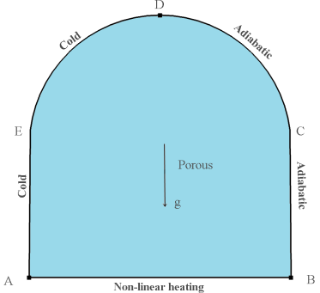

Fig. 1. Schematic of the 2 dimensional enclosure

The enclosure is heated non-uniformly from bottom wall, while the left walls are cooled to a constant temperature. The right walls are maintained adiabatic.

The dimensionless form of the temperature distribution on the heated wall (Eq. (1)) can be referred in [8] as

 (1)

**2.Governing equations and boundary conditions**

The fluid flow obeys Darcy law. The fluid and solid matrix of porous medium are in thermal equilibrium. There is no phase change. The fluid properties are constant except the variation of density with temperature. Furthermore, it is assumed that the temperature of the fluid is equal to the temperature of the solid everywhere in the porous region, and local thermal equilibrium is applicable The heat and fluid flow in porous medium are governed by following non-dimensional form of equations. We model this natural-convection problem by introducing a Boussinesq buoyancy term to the Brinkman’s momentum equation, and then link the resulting fluid velocities to the heat transfer in porous media . The Boussinesq buoyancy term after converting in terms of Rayleigh number that appears on the right-hand-side of the ‘Y’momentum equation accounts for the lifting force due to thermal expansion.

The governing equations pertinent to the present problem can be written in dimensionless form as continuity equation:

 (2)

X-momentum equation:

 (3)

Y-momentum equation:

 (4)

Energy equation:

 (5)

In the above equations, various dimensionless parameters are defined as, , ,,, ,,  where, L is the length of the enclosure, U and V are the dimensionless velocities in x and y directions, respectively, is the thermal diffusivity, P is the dimensionless pressure, ρ is the density of fluid, g is gravitational acceleration, is volumetric thermal expansion coefficient,  is kinematic viscosity, Pr is Prandtl number and Ra is Rayleigh number.

The boundary conditions employed for the solution Eqs. (1)–(4) are as follows:

, (along AB) (6a)

,  (along AE) (6b)

, (along ED) (6c)

,  (along CD, BC) (6d)

**2.1. Nusselt Number**

It is important to recognize that the Nusselt number is a dimensionless measure of the convective heatflux and is evaluated from the solution of the temperature field. The local Nusselt number along any surface can be obtained as follows:

****where n denotes the normal direction on a plane. [7]

The average Nusselt number at the bottom and side walls are given by:

 [8]

**3.Numerical Solution Methodology and Model Validation**

The finite element methodology has been adopted for solving this paper and this description of the methodology can be found in [6]. The Gauss’s quadrature method [6] is used to perform the integration. The Newton-Raphson technique is employed to solve the set of algebraic equations.

Further a grid sensitivity analysis has been performed to confirm that our numerical results presented herein are independent of the grid used. Three different arrangements comprising of 2100, 5672 and 14726 elements have been considered for the analysis. The details of grid independence tests can be referred in literature [7] and can befound in Table 1. We proceed our numerical analysis with 5672 elements to save time and resources,because the change is less than 2% with further increase in finite elements(14726).

Table 1: Grid independency

|  |  |  |  |
| --- | --- | --- | --- |
| Ra | Nuavg 2100 | Nuavg 5672 | Nuavg 14726 |
| 1000000 | 4.3096 | 4.3196 | 4.3462 |
| 100000 | 2.4825 | 2.4836 | 2.4943 |
| 10000 | 0.99985 | 0.9992 | 1.0031 |
| 1000.0 | 0.86167 | 0.8609 | 0.8641 |

In order to test the accuracy of the numerical code employed in the current investigation, results presented have been validated by Lauriat and Prasad [9].The results of average Nusselt number(Nuavg) are found to be good agreement with Lauriat and Prasad [9] for porous vertical cavity with heated left wall, cooled right wall and top and bottom walls adiabatic. The comparisons are presented in Table 2.

Table 2: Comparison of average Nusselt number on the uniformly heated bottom wall from the present work with those reported by Lauriat & Prasad [9]

|  |  |  |  |  |
| --- | --- | --- | --- | --- |
| Da | Ra | Present work | Lauriat & Prasad[9] | Difference |
| 10-2 | 103 | 1.00 | 1.02 | 1.9% |
| 104 | 1.62 | 1.70 | 4.7% |
| 105 | 4.10 | 4.26 | 3.7% |
| 10-4 | 105 | 1.03 | 1.06 | 2.8% |

4. Results and Discussion

The prime focus of the current investigation is to analyze the transport characteristics of thermal energy and entropy generation inside a two-dimensional porous recto semicircular enclosure subjected to non-uniform temperature distribution at the bottom wall. The numerical experiments are presented for Rayleigh number in the range of 103⩽Ra⩽106 and Darcy number 10-4⩽Da⩽10-2.

4.1. Flow and temperature field

In order scrutinize the heat transfer characteristics for Darcy number and Rayleigh number variation, the analysis of the flow and thermal field is of utmost importance. Accordingly, the streamlines and isotherms are illustrated in Figures 2 for one Darcy number ,10-2) and Rayleigh numbers in the range of 104 and .

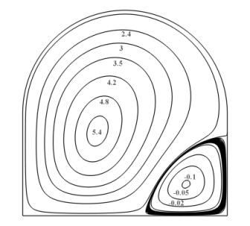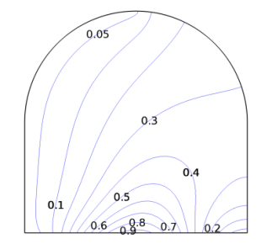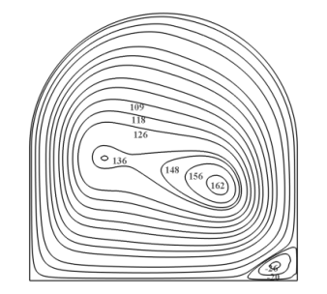 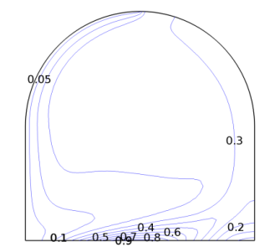

(a) (b)

Fig. 2. Stream lines and isotherms (a) Ra=104 (b) Ra=106, Da=10-2

For all values of Rayleigh number and Darcy number shown, two asymmetric circulating cells, rotating in the opposite directions are observed within the enclosure. It can be perceived, that the two cells are not symmetric and this is for asymmetric boundary condition. At low Ra=104 stream lines are characterised by low cell strength of ψmax=5.4(anticlockwise circulation which increases to ψmax=162 when Ra=106 for dominant convection effects. This is because at lesserRa=104 the buoyancy force isunable to overcome the viscous force for Rayleigh number upto  and accordingly the dominant mode of thermal energy transport is diffusion of heat. Isotherms from Fig 2demonstrate twisting at higher Ra.

4.2 Nusselt Number

In order to analyse the influences of Rayleigh number and Darcy number on the heat transfer characteristics, the variation of local Nusselt number along,bottom heated and cooled vertical walls is plotted for Da=10-2 As can be seen from Figure 5(c) that for Da=10-3 the variation of local Nusselt number at the bottom wall with Rayleigh number is invariant both qualitatively and quantitatively for Rayleigh number up to  owing to the fact that buoyancy force dominates over viscous force although permeability of the medium is relatively high and accordingly the heat transfer is mainly dominated by conduction. For Rayleigh number beyond 104, the local Nusselt number is strongly influenced by Rayleigh number, the boundary condition imposed (Sinusoidal nature) and the enhancement in the Nusselt number is quitesignificant for Ra=106. Local Nu for cold walls are lesser and they demonstrate a local jump at Y=0.2 for lesser Ra values because of presence of isotherm pattern.

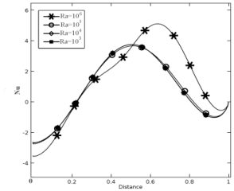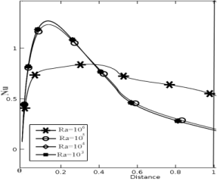

Fig. 3**.** Variation of local Nusselt number on hot and cooled vertical walls for different values of Rayleigh number (a) Da=10-2

4.3 Average Nu

Average Nusselt number is demonstrated in Table 3 and it is found that the values on bottom wall or cold walls are increased with increase in Darcy number and the rate of enhancement is more profound when Darcy number is changed from  to 10-2 with increase in permeability of the fluid.

Table 3: Average Nusselt Number on the bottom and vertical wall for different values of Rayleigh number and Darcy number

|  |  |  |  |  |  |  |
| --- | --- | --- | --- | --- | --- | --- |
| Ra | Average Nusselt number on bottom wall | | | Average Nusselt number on vertical and arched cold wall | | |
| Da=10-4 | Da=10-3 | Da=10-2 | Da=10-4 | Da=10-3 | Da=10-2 |
|  | 0.854 | 0.856 | 0.861 | 0.689 | 0.687 | 0.687 |
|  | 0.856 | 0.872 | 0.999 | 0.689 | 0.691 | 0.690 |
|  | 0.878 | 1.255 | 2.484 | 0.696 | 0.774 | 1.457 |
|  | 1.395 | 3.627 | 4.319 | 0.823 | 2.049 | 2.768 |

**Conclusion**

In the present work, we execute numerical experiments to study the natural convection heat transfer characteristics inside a two-dimensional recto semicircular enclosure filled with a saturated porous medium.

* Average Nusselt number reveals, that for lower values of Darcy number (10-4), the heat transfer in the enclosure is mainly due to conduction and it is not influenced by Rayleigh number. For higher values of Darcy number(Da=10-2, 10-3), the dominant mode of heat transfer is dependent on Rayleigh number.

**Acknowledgements**

The authors acknowledge technical help from IIT Kgp CFD lab. The authors did not receive any financial grants or project for this work.

**References**

[1]A. Bejan, I. Dincer, S. Lorente, A.F. Miguel and A.H. Reis, Porous and Complex Flow Structures in Modern Technologies, Springer, New York, (2004).

[2] D. B. Ingham, A. Bejan, E. Mamut and I. Pop (Eds.), Emerging Technologies and Techniques in Porous Media, Kluwer, Dordrecht, (2004).

[3]I. Pop and D.B. Ingham, Convective Heat Transfer: Mathematical and Computational

Modelling of Viscous Fluids and Porous Media, Pergamon, Oxford, (2001).

[4] K. Vafai, Handbook of Porous Media, Marcel Dekker, New York, (2000).

[5] N. H. Saeid and I. Pop, Transient Free Convection in a Square Cavity Filled with a Porous Medium, Int. J. Heat Mass Transf. 47, 1917–1924, (2004).

[6] T. Basak, S. Roy, T. Paul, and I. Pop, Natural Convection in a Square Cavity Filled with a Porous Medium: Effects of Various Thermal Boundary Conditions, Int. J. Heat Mass Transf. 49, 1430–1441, 2006.

[7]O.C. Zienkiewicz and R.L. Taylor, The finite element Method, 4th ed. McGraw-Hill (1991).

[8]S.Dutta, A.K. Biswas and S.Pati , Natural convection heat transfer and entropy generation inside porous quadrantal enclosure with non-isothermal heating at the bottom wall, Numeric.Heat Transf. 73(4), 222–240 (2018).

[9]G. Lauriat and V. Prasad, Non-Darcian Effects on Natural Convection in a Vertical Porous Enclosure, Int. J. Heat Mass Transf. 32, 2135–2148, (1989).