**Solar hybrid electricity generator and water heater. (SHEGAWH)**

**1Mr. Nishant kshirsagar, 2Mr. Suraj Sandhanshiv, 3Dr. Nihar walimbe**

1 Department of Mechanical Engineering, Dhole Patil College of Engineering, Pune 412207

Email: kshirsagarnishant124@gmail.com

2 Department of Automobile Engineering, Dhole Patil College of Engineering, Pune 412207

Email: [sugosgroup@gmail.com](mailto:sugosgroup@gmail.com)

3 Department of Mechanical Engineering, Dhole Patil College of Engineering, Pune 412207

Email: niharwalimbe@gmail.com

**Abstract**

As the name indicates that it is a portmanteau of solar heating and solar collecting system which brings reflector and collector together in use. Reflectors and collectors are the significant component of a solar hybrid system. Reflectors create a defined diversion angle for the solar rays striking on it. The collectors collect the sun’s energy, transform this radiation into heat, and then transfer this heat into a fluid, water or air, which has much household or industrial application. In this paper we have analyzed the variety of reflectors and examined their efficiency and reflectivity, to create a hybrid solar collector and water heater. Flat plate and parabolic collector are widely used for industrial and domestic purposes. Here we have used a hemispherical shape collector which has a unique characteristic of trapping the solar rays striking on the reflector and concentrating at one point. Reflectors used here are Aluminum food foil, Aluminum paint and Vinyl sheet. Having approximately 87%, 82% and 86% reflectivity respectively. For rotation of pipe according to sun’s direction LDRs and Arduino is used as a sun tracking system.

**Keywords**

Solar collector, Hybrid collector, solar water heater, solar electricity generator, hemispherical collector.

**Problem statement**

As per research we have few abundant resources available on earth which are wind energy, tide energy and solar energy.  Everyone around the globe is well aware about it but only few dare to install it even after having a subsidy on it. Especially in India we are entrusted with such a blessing in disguise and hardly a handful of people have installed it or using it on a daily basis.

Where countries like USA, Japan, and all the European countries don't have sunlight throughout the year still they are making most of whatever is available to them.

The most significant part is subsidizing solar collector seems to be null and void. Indian population is gargantuan and has more number of lower middle class than higher class.

Now what makes the unit more costly, first thing first, one has to buy two units of solar panel.

1. Solar water heater

2. Solar collector

Two units add up to the cost and make the entire arrangement expensive and rambunctious to manage for an average family.

**Literature Survey**

Previous studies have demonstrated that flat plate and parabolic collector are more efficient and economic than hemispherical collector; they are still widely accepted. Whereas this type of collector can manage both water heating and electricity generation. Investing a capital in electric water heater and then connecting it to a solar collector is fatuous, instead merely a single copper pipe or steel can do the same with comparatively lower capital.

**Introduction**

This paper concentrates on the optimization of the electric energy production by PV cells through the development of a sun-tracking system. This solution has many advantages over the similar existing devices, as this system is autonomous regarding the information needed to process the optimal orientation and is brilliant in a way that it executes on-line monitoring of the photovoltaic energy production.

Solar Energy comprises of heat and light and takes nearly 8 minutes 19 seconds to reach EARTH. GLOBAL WARMING is taking on Earth, with the increase in consumption of non-renewable energy sources, pollution and green house gasses and adding to the global warming. COUNTRIES are coming up together to fight global warming and innovate ways to produce clean and green energy. Solar energy is one of the green energy and over the past years its usage has increased tremendously. Let’s explore more facts about solar energy

Solar energy is the cleanest source of energy available to us, with nearly no maintenance and easy installation. This energy is made of radiant heat and light and can be harnessed with technologies like photovoltaic, solar architecture, solar heating, artificial photosynthesis and solar thermal electricity. The amount of solar energy that Earth receives every hour is more than enough to fulfill the needs of entire population for 1 full year. The ideal location receives an average of about 5.5 hours of sunlight per day every year, and a cloudy location receives 2.5 hours of sunlight per day of each year.

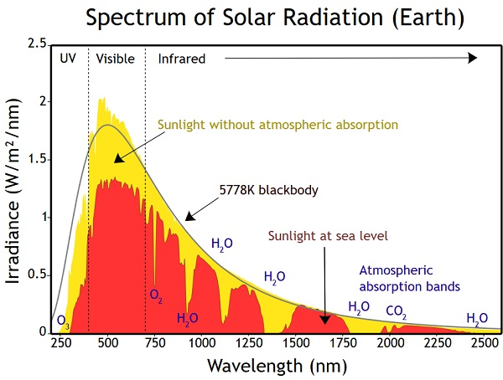

174 petawatts solar radiation is received by the earth in upper atmosphere. Approximately 30% of the radiation is reflected back to space and land, clouds and oceans observe the rest. Water cycle is the result of solar insulation. The oceans, landmasses absorb heat and their temperature increases, the warn air rises high and clouds are created thus causing rain. In 1956 solar panels were first introduced.

In 2015 about 44% of solar power market share was dominated by California. Plants use solar energy to prepare their own food by a process called photosynthesis. Nearly 1366 watts of solar radiation per square meter is received by earth. Green houses are used to convert light into heat and encourage the cultivation of crops throughout the year. Solar panels tend to produce direct current electricity; it flows in 1 direction only.

Solar panel is used to convert solar energy heat into electricity. For multitudinous number of uses, starting from cooking to running the satellites in space. Solar energy is free of pollution and causes no environmental effects like non-renewable energy.

In addition solar panel has a warranty of 25 to 30 years. Compared to rest of the renewable energies, solar energy is the most widely used. Satellites are powered by the solar energy. Solar energy will be more affordable in future with the amendments in the technology.  In 1958 the first solar car was built by International rectifier Company.

There are also incentive programs for solar panel installation, to encourage people to leap on sustainable energy. The largest solar power plant in the worlds located in the Mojave Desert, in California. It covers an area of 1,000 acres and more which generates around 354 MW. As it doesn’t have any moving part it is noise pollution free. A domestic solar panel component consists of solar panels, battery, inverter, charge regulator and wiring. The fastest solar car in the world is built by Japan’s Ashiya University with a top speed of 57 miles per hour in 2014.

**Temperatures in India**

|  |  |  |  |  |
| --- | --- | --- | --- | --- |
| **City** | **Year** | **Date** | **Timing** | **Temperature** |
| **Mumbai** | |  | | --- | | **2016** | | **2017** | | **2018** | | **7th may**  **7th may**  **7th may** | **12-18**  **12-18**  **12-18** | **32**°C  **33**°C  **33**°C |
| **Nagpur** | |  | | --- | | **2016** | | **2017** | | **2018** | | **7th may**  **7th may**  **7th may** | **12-18**  **12-18**  **12-18** | **44**°C  **42**°C  **44**°C |
| **Chennai** | |  | | --- | | **2016** | | **2017** | | **2018** | | **7th may**  **7th may**  **7th may** | **12-18**  **12-18**  **12-18** | **35**°C  **37**°C  **37**°C |
| **Pune** | |  | | --- | | **2016** | | **2017** | | **2018** | | **7th may**  **7th may**  **7th may** | **12-18**  **12-18**  **12-18** | **36**°C  **37**°C  **38**°C |
| **Delhi** | |  | | --- | | **2016** | | **2017** | | **2018** | | **7th may**  **7th may**  **7th may** | **12-18**  **12-18**  **12-18** | **38**°C  **43**°C  **38**°C |

Table no.1.1

The intensity of sunlight can be measured by using a [sunshine recorder](https://en.wikipedia.org/wiki/Sunshine_recorder), [pyranometer](https://en.wikipedia.org/wiki/Pyranometer), or [pyrheliometer](https://en.wikipedia.org/wiki/Pyrheliometer). For calculating the amount of sunlight reaching the ground, both the [eccentricity](https://en.wikipedia.org/wiki/Orbital_eccentricity) of Earth's [elliptic orbit](https://en.wikipedia.org/wiki/Elliptic_orbit) and the attenuation by [Earth's atmosphere](https://en.wikipedia.org/wiki/Earth%27s_atmosphere) have to be taken into account accurately. The extraterrestrial solar illuminance *E*ext, corrected for the elliptic orbit by using the day number of the year ‘dn’, is given for a better approximation.

**{\displaystyle E_{\rm {ext}}=E_{\rm {sc}}\cdot \left(1+0.033412\cdot \cos \left(2\pi {\frac {{\rm {dn}}-3}{365}}\right)\right),}Eext = Esc . (1+ 0.033412. cos (2*3.148dn-3/365))**

Where dn=1 on 1st January; dn=32 on 1st February; dn=59 on 1st March (except on leap years, where dn=60), etc. Here in this formula dn–3 is used, because in modern times [Earth's perihelion](https://en.wikipedia.org/wiki/Apsis#Earth's_perihelion_and_aphelion), the closest approach to the Sun and, therefore, the maximum *E*ext occur around 3rd January each year. The 0.033412 value is determined knowing the ratio between the perihelion (0.98328989) AU squared and the aphelion (1.01671033) AU squared should be around 0.935338.

The illuminance solar constant denoted by (*E*sc), is equal to 128×103 [lux](https://en.wikipedia.org/wiki/Lux). The direct normal illuminance denoted by (*E*dn).

{\displaystyle E_{\rm {dn}}=E_{\rm {ext}}\,e^{-cm},}

Where *c* is the [atmospheric extinction](https://en.wikipedia.org/wiki/Atmospheric_extinction) and *m* is the relative optical [air mass](https://en.wikipedia.org/wiki/Airmass). Atmospheric extinction plummets the number of lux to around 100 000 lux.

|  |  |  |  |
| --- | --- | --- | --- |
|  | Levels | Temperature in °C | Temperature in °F |
| 1 | Sun | 5505°C | 9941°F |
| 2 | Exosphere | 1700 °C | 3600°F |
| 3 | Thermosphere | 500°C | 900°F |
| 4 | Mesosphere | -90°C | -130°F |
| 5 | Stratosphere | -3°C | 26.6°F |
| 6 | Troposphere | 6.5 | 3.6°F |
| 7 | Earth | 14.6°C | 58.3°F |

Table no. 1.2

|  |  |  |
| --- | --- | --- |
|  | Location | Energy in watts/meter2 |
| 1 | Atmosphere | 1366 |
| 2 | Earth’s surface | 1000 |

Table no. 2.1

The time by which sunlight energy reaches the top of earth's atmosphere its intensity will be around 1,366 watts per square. Passing through the atmosphere will lessen that by 18% down to 1,120 watts. Mind you, that's 1,120 watts at noon, at the equator, on a well clear day.

**Design**

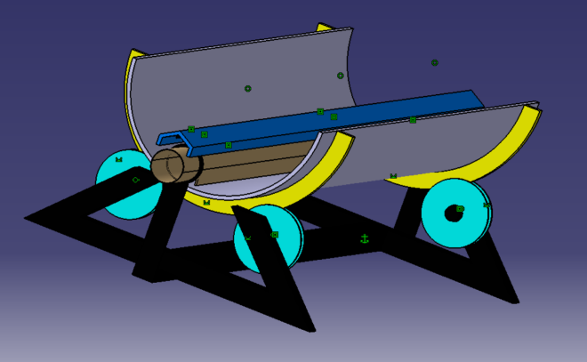

Fig. no. 1.1

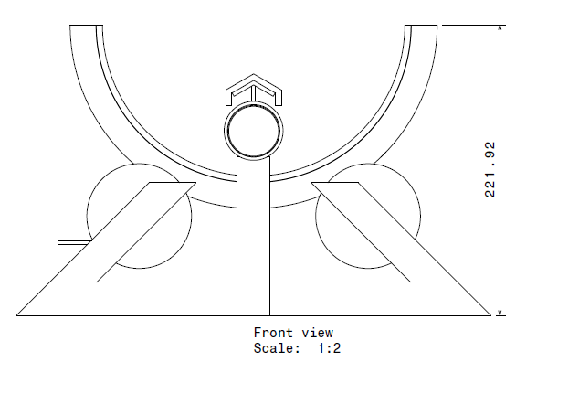

Fig. no. 1.2

**Conclusion**

Hence we have studied multitudinous Reflectors and their reflectivity, Vinyl is what we found flexible and reflective of all. And hemispherical shape is slightly efficient than parabolic and flat plate, which comes with a unique characteristics of tapping solar radiation.

**References**

1. <http://www.iitk.ac.in/olddord/solar%20energy%20proposal%20from%20IIT%20Kanpur.pdf>
2. <https://www.researchgate.net/publication/320226399_A_Review_Paper_on_Electricity_Generation_from_Solar_Energy>
3. <https://www.irjet.net/archives/V4/i7/IRJET-V4I7246.pdf>
4. <https://www.academia.edu/29542375/The_nature_of_hemispheric_specialization_for_prosody_perception>