Service Quality Measurement in healthcare sectors – a Case Study

**P.S.Prema Kumara*, Dr.G.Rambabub**

*aMechanical Engineering, Koneru Lakshmaiah Education Foundation, Vaddeswaram, 522501, AP, India*

*aMechanical Engineering, Andhra University College of Engineering, Visakhapatnam, 530003, , AP, India*

* Email: kumar.mech.me@gmail.com

**Abstract**

Health care is one of the very important sectors in the service industries of any country. This research is based on healthcare service quality as it is a major area within the service sectors where multiple interactions occurring internally. Patient satisfaction is the criterion used to measure the response of the medical centres’ examination and treatment for the patient's expectations. Based on previous literature and research, a study is made to identify the factors that affect the satisfaction of the patient. Six factors namely: Responsiveness, Safety and Security, Assurance, Tangibles, Empathy and Reliability are considered. Furthermore, four sub factors for each factor are considered. Case study of 15 hospitals both public and private hospitals of AP state are considered for measuring the health care service quality performance evaluation. Confirmatory Factor Analysis is implemented, and reliability of the variables checked for the internal consistency and relative weights also determined.

Key words*:* Health services, Patient satisfaction, Relative weight and Confirmatory factor analysis.

1. **INTRODUCTION**

Healthcare is a significant field of study from both technical and organizational perspectives providing specific prior research that may be used as a basis for, and extension into service quality. According to Gill & White [1], there is no proper relation between patients’ satisfaction and their perceived healthcare quality. Parasuraman, A., Zeithaml, V. A., & Berry, L. L.[2] developed a 22- item instrument for assessing perception of customers in service organizations. A survey conducted by [Prasanta Mahapatra](https://www.researchgate.net/profile/Prasanta_Mahapatra2) [3] on patient satisfaction on different aspects of public hospitals where their research was only on patient satisfaction of limited dimensions.

**1.1 Health Care -Service Quality**

The dimension of service quality is still debated among the academic researchers. The purpose of this study is to examine the different dimensions used and applied in the process of evaluating the service quality in the health care sector.

**1.2 Patient’s Satisfaction**

Patient satisfaction is the parameter used to measure the response of heathcare sector examination and treatment for the patient's expectations. Patient satisfaction is an important parameter to certify the service quality and efficiency of health care sector .

**1.3 Identification of Factors and Sub-Factors of Health Care service Quality**

Based on previous literature and research, a study is made to identify the factors that effect the satisfaction of the patient. Six factors namely: Responsiveness (RES), Safety and Security (SAS), Assurance (ASU), Tangibles (TAN), Empathy (EMP) and Reliability (REL) are considered. Furthermore, four sub factors for each factor are considered. Service appropriateness (RES1), Promptness of service delivery (RES2), Service availability (RES3) ,Quick and simple process of admission and Discharge (RES4), Personal privacy (SAS1), Confidentiality of patients’ information (SAS2), Comfortable and safe Hospital Environment (SAS3), Correct Diagnosis (SAS4), Commitment (ASU1), Accountability (ASU2), Confidence in Diagnosis and Treatment (ASU3) and Skill, ability, competency of providers (ASU4), Availability of Advanced Medical Equipment (TAN1), Availability of Advanced Skills and Knowledge Medical Staff (TAN2), Infrastructure Facilities (TAN3), Overall cleanliness of the hospital (TAN4), Polite Attitude of Employees (EMP1), Reasonable cost without compromising on quality (EMP2),Transparency in Billing (EMP3), Emotional Support and Attention (EMP4), Consistent and correct service delivery (REL1), Meeting deadlines for Medical and diagnostic services (REL2), Regular Monitoring of Health status (REL3) and Clear Understanding of Specific patient needs (REL4).

1. **Methodology**

Simon Gyasi Nimako & Foresight Kofi Azumah [4] mentioned that CFA approach used to propose a framework of latent factors that are critical for understanding service quality. The confirmatory factor analysis was done using LISREL 8.8. In the calculation Relative Weight Analysis, for the Relative Importance Index (RII), the formula below was used:

$$\dot{RII}=\frac{∑W}{A*N}$$

where, W—weighting given to each statement by the respondents and ranges from 1 to 5;

A—Higher response integer (5); and N—total number of respondents. Finally the priority of service quality factors are obtained.Fig 2.1 shows the methodology.

**Relative weight Analysis**

**CFA**

**Priority structure of Health Care service quality factors**

**Health Care Service Quality Factors**

**Obtain Data on**

**Health Care Service quality**

`

Fig 2.1 Factor analysis and relative weight analysis

1. **Case Study**

In this study, the patient’s expectations of service quality provided by hospitals were analysed based on the responses received from patients of various government and Corporate hospitals in different parts of the state of Andhra Pradesh in India. A total of 375 patients were administered the questionnaire and 304 useful responses were received, i.e., a response rate of 81%. This research uses the questions and let the patient to answer. It is appropriate to do measurable outcome and save time. The items will be estimated by the 5 - point Likert Scale

1. **Reuslts and Discussion**

Cronbach’s α values obtained are greater than 0.85, which ensures the internal consistency and validity of the constructs (Nunnally, 1978). CFA was used to assess the dimensionality of the scales in the measurement models included in this study.

**4.1 Confirmatory Factor Analysis**

The average variance extracted (AVE) for each of the constructs of RES, SAS, ASU, TAN, EMP and REL are 0.55, 0.56, 054, 0.67, 047 and 0.69 respectively are greater than threshold value of 0.5 indicates latent variables had reliability and convergence validity. The path diagram of the model is shown in fig 4.1

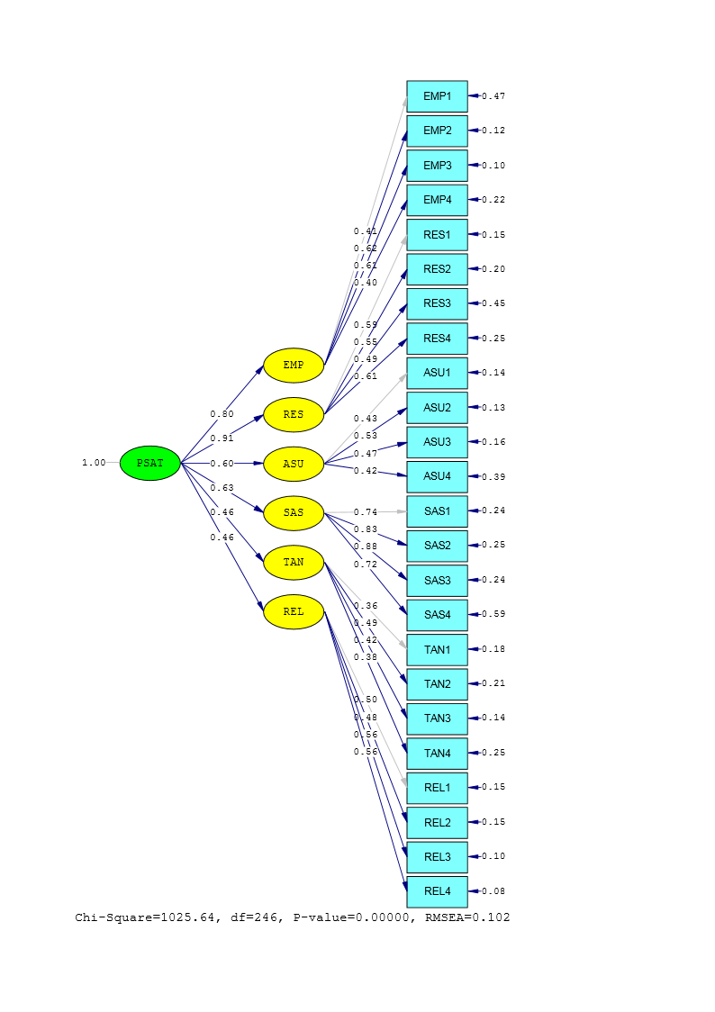

Fig. 4.1 The path diagram of the model

Table 4.1 shows that, research findings are close to ideal figures indicates a good model fit.

Table 4.1: Fit indices of model

|  |  |  |  |
| --- | --- | --- | --- |
| **Indicators** | **Propriety Indicators** | **Ideal Figures** | **Research Findings** |
| Absolute Propriety Indicators | /d.f | 1.0 – 5.0 | 4.1 |
| GFI(Goodness of fit index) | >0.90 | 0.78 |
| AGFI(Adjusted goodness of fit index) | >0.90 | 0.73 |
| SRMR | ≤0.05 | 0.052 |
| RMSEA(Root mean square error of approximation) | ≤0.08 | 0.102 |
| Relative Propriety Indicators | NNFI(Non normed fit index) | ≥0.90 | 0.91 |
| NFI(Normed fit index) | ≥0.90 | 0.89 |
| CFI(Comparative fit index) | ≥0.90 | 0.92 |

**4.2 Relative Weights Analysis**

Highest importance value of (0.1939) is obtained with empathy. Similar importance weight is obtained with responsiveness (0.1712), Assurance(0.1715) and reliability (0.1707). Safety and security obtained importance weight of 0.1604. Relatively low importance is obtained for tangibles. Relative priority of these customer requirements is shown in Figure 3.2.

|  |  |  |  |  |  |  |  |  |  |
| --- | --- | --- | --- | --- | --- | --- | --- | --- | --- |
| |  | | --- | |  | |  |  |  |  |  |  |  |  |
|  |  |  |  |  |  |  |  |  |
|  |  |  |  |  |  |  |  |  |
|  |  |  |  |  |  |  |  |  |
| **Priority** |  |  |  |  |  |  |  |  |
|  |  |  |  |  |  |  |  |
|  |  |  |  |  |  |  |  |
|  |  |  |  |  |  |  |  |
|  |  |  |  |  |  |  |  |

Figure 4.2: Priority of patient requirement factors

1. **Conclusion**

In this research, a six-factor model with 24 items of patient’s requirements on health care service quality sector are suggested through confirmatory factor analysis. The present findings provide evidence to support that this is a valid instrument to determine patient requirements among the organizations where to measure health care service quality. Further, the priority of the factors for service quality of health care is determined. In the study, Empathy is identified as the important factor gives highest value among all the six main factors which improves the service quality based on customer expectation.

**References**

1. Liz Gill and Lesley White A critical review of patient satisfaction: Quality leadership in healthcare services Vol. 22 No. 1,pp. 8-19. (2009)
2. Parasuraman, A., Zeithaml, V. A., & Berry, L. L. SERVQUAL: A Multiple-Item Scale for Measuring Consumer Perceptions of Service Quality. Journal of retailing, 64(1),12-40. (1988).
3. Prasantha Mahapatra, Srilatha P,Sridhar,A patient satisfaction survey in public hospitals Journal of Academy of Hospital Administration (India)) 13(2):11-15(2001).
4. Simon Gyasi Nimako, Foresight Kofi Azumah, Francis Donkor and Veronica Confirmatory factor analysis of service quality dimensions within mobile telephony industry in Ghana, The Electronic Journal Information Systems Evaluation Volume 15 Issue 2, (pp197-215) 2012
5. Gotlieb, Jerry B.,Grewal, Dhruv,Brown, Stephen WConsumer satisfaction and perceived quality: Journal of Applied Psychology Vol 79(6) pp 875-885. (1994)
6. David Ebbevi, Helena Hvitfeldt Forsberg, Anna Essen,& Sofia Ernestam: Value-Based Health Care for Chronic Care:Aligning Outcomes Measurement with the Patient PerspectiveWolters Kluwer Health, Inc Vol. 25, No. 4, pp. 203–212 (2016)
7. Kee-Luen Wong , Seng-Fook Ong & Thiam-Yong Kuek, Constructing a Survey Questionnaire to Collect Data on Service Quality of Business Academics, European Journal of Social Sciences, ISSN 1450-2267 Vol.29 No.2, pp. 209-221 (2012)
8. Si Dung Chu_ Tan Sin Khong Measuring healthcare service quality in a private hospital in a developing country by tools of Victorian patient satisfaction monitor,

Journal of Hospital Administration ISSN 1927-6990 ,Vol. 7, No. 5 (2018)

1. Muhammad Shafiq, Muhammad Azhar Naeem, Zartasha Munawar and Iram FatimaService Quality Assessment of Hospitals in Asian Context: An Empirical Evidence From Pakistan, The Journal of Health Care Volume 54: 1–12 (2017)
2. Dr. Rupa Rathee, Pallavi Rajain, Dr. Isha Confirmatory Factor Analysis of Service Quality Dimensions in Healthcare, International Journal of Science and Research,ISSN (Online): 2319-7064, Volume 5 Issue 5 (2016)
3. Ali Mohammad Mosadeghrad,Factors influencing healthcare service quality, International journal of health policy and management 3(2), 77–89(2014)
4. Don Hee Lee and Kai K. Kim Assessing healthcare service quality: a comparative study of patient treatment Types, International Journal of Quality Innovation 3:1(2017)
5. Faisal Talib and Zillur Rahman Service Quality in Healthcare Establishments: A Literature Review, International Journal of Behavioural and Healthcare Research Vol. 5, Nos. 1/2, 2015
6. Parasuraman, A., Zeithaml, V. A., & Berry, L. L. A conceptual model of service quality and its implications for future research. The Journal of Marketing, 41-50. (1985).
7. Iram Fatima, AyeshaH, Usman Iqbal and Muhammad Shafiq, Dimensions of service quality in healthcare: a systematic review of literature, International Journal for Quality in Health Care, 1–19(2018)
8. Rafael Hod, Oded Maimon and Eyal Zimlichman,The Relationships between Hospital Service Quality and Operational Efficiency: an Alternative Model, Health Economics & Outcome Research, SSN: 2471-268XVolume 2 • Issue 3(2016),
9. Spreng, R. A., MacKenzie, S. B., & Olshavsky, R. W. A reexamination of the determinants of consumer satisfaction. The Journal of Marketing, 15-32. (1996).