**Thermo-physical properties of solar thermic fluids dispersed with carbon nanotubes**

S.Raviteja1a, Dr. V. Srinivas2a , S.Jaikumar3a and Ch.V.K.N.S.N. Moorthy4b

*aDepartment of Mechanical Engineering, GITAM (Deemed to be University),Visakhapatnam-530045 India*

*b Department of Mechanical Engineering,* Institute of Aeronautical Engineering, Hyderabad, INDIA

*Corresponding author Email: [*vsrinivas@gitam.edu*](mailto:vsrinivas@gitam.edu)

------------------------------------------------------------------------------------------------------------------

Abstract: The aim of the paper is to examine the consequence of multi-walled carbon nanotubes on the thermo-physical properties of working fluids used in solar thermal engineering systems. Thermo-physical property evaluation is very essential to regulate the efficiency and performance of solar thermal systems. Ethylene glycol and a commercially accessible thermic fluid therminol 62 are chosen as based fluids. Nanofluids are prepared by dispersing 0.1 %, 0.25 %, 0.5 % and 0.1 % weight fraction of multi walled carbon nanotubes. The nanomaterials are surface modified before dispersion in the thermic fluids and extreme care is taken to prevent property deterioration during surface modification. Thermal conductivity of base fluids and nanofluids is measured in the temperature range of 100 to 300 oC. Physical property of viscosity is evaluated in the temperature range of 50 to 150 oC. It is found that there is a 15 to 20 % increase in the thermal conductivity with the dispersion of carbon nanotubes with slight increase in viscosity.

***Keywords*:** Solar thermic fluids nanofluids, Carbon nanotubes, thermo-physical properties

**Introduction**

The overexploitation of fossil fuel leads to environmental pollution and global warming and thus eco-freedom energy technology needs to be developed. Now a days, solar energy grown to be one of the key source for the sustainable development for the conversion of thermal and electrical energy using solar collectors and solar panels. However, the higher operating cost and high operating cost and lower efficiency involved in solar energy conversion is limiting its utility. The conversion of solar energy into heat energy is possible in solar collectors using a heat exchanging fluid (absorber fluid or thermic fluid). Common thermic fluids are ethylene glycol, ethylene glycol-water mixtures, silicone based fluids, and Hydrocarbon oils etc. One of the current ways of increasing the performance of solar collector is by means of thermic fluid instead of usual fluid. Nanoparticles when dispersed in heat transfer fluids enhance the thermal and optical properties of the conventional fluids thus enhancing the performance by reducing the size. Several studies have been made concerning improvement of thermal conductivity with the use of nanofluids. The present paper studies the effect of Multi walled carbon nanotubes on the thermos-physical properties of solar thermic fluids. In the present study ethylene glycol based solar thermic fluids and commercially available thermic fluid therminol 62 are dispersed with Multiwalled carbon nanotubes and investigated for property enhancement. Artificial neural networks are used to simulate the results in the choicest range.

**2. Experiment and Methodology**

**2.1. Materials**

In this work, the multi walled carbon nano tubes are produced from M/s Cheap Tubes Inc., USA. The MWCNTs is 20-40 nm diameters in size, 25 microns length with the purity of 95 %. The remaining chemicals are used in this study are EP grade and the surfactant used is AR grade which is procured from M/s Sigma Aldrich India Pvt limited. Therminol 62 is selected as hydrocarbon-based thermic fluid and ethylene glycol as polar thermic fluid. Fig.1 shows HRSEM image of pristine long length entangled MWCNTs.

C:\Users\SWATHI\Downloads\15K03.tif

Fig.1 shows HRSEM image of pristine long length entangled MWCNTs.

**2.2. Surface modification of MWCNTs**

In the liquid medium, the Pristine MWCNTs have a tendency to agglomerate and form substantial particle clusters. It is necessary to alter the MWCNTs surface with surfactant to form stearic repulsions between separate nanotubes to disentangle them and make them stable in the liquid. The SPAN 80 (Sorbitaanmonooleate) surfactant that have tendency to adsorb on the MWCNTs surface decreasing its energy on the surface is used in the present study. In case of ethylene glycol-water mixtures, the CTAB (cetrimonium bromide) is used for surface modification. To prepare surface modified MWCNTs, surfactant and Multiwalled carbon nanotubes are taken in the ratio of 2:1 and ultra-sonicated in a solvent for 30 minutes which creates a mechanochemical reaction. This reaction coats the surfactant on to the surface of the MWCNTs.

**3. Evaluation of physicochemical properties**

**3.1. Thermal conductivity**

Thermal conductivity is the property of a material through which the heat conducts. The higher thermal conductivity materials are used in sink applications. Since the thermal conductivity of materials is temperature dependent, measurement of Thermal Conductivity is made using Hot DiskTM Thermal analyzer TPS 500. The thermal conductivity of the thermic fluids dispersed with MWCNTs is measured at various temperatures ranging from 100 to260oC.

**3.2. Dynamic Viscosity**

Viscosity is the resistance to flow of fluid and it describes the inner friction of a moving fluid. A fluid with great viscosity opposes motion as its molecular structure gives more internal friction, whereas a fluid with lower viscosity streams easily on account of its molecular composition which results in very modest friction. Wells-Brookfield Cone & Plate Viscometer is used to measure the absolute viscosity of base fluids and nanofluids. Cone and Plate Viscometer is a precise torque meter which is driven at discrete rotational speeds. The absolute viscosity of thermic fluids dispersed with MWCNTs is measured in the temperature range of 750C and 120 0C to verify whether the fluid, when dispersed with nanomaterials, follows the Newtonian law.

**4. Results and discussion**

**4.1. Thermo—physical property evaluation of nanofluids**

The trends of variation of viscosity with temperature for ethylene glycol-water mixtures are shown in Figs. 2&3. The variation of thermal conductivity for therminol 62 based fluids is shown in Fig 4. It can be seen from the above figures, at lower temperatures, the significant change in viscosity was observed. Conversely, the increase in viscosity was observed marginally at higher temperatures owing to lower mass fraction of CNTs in the nano fluid preparation.

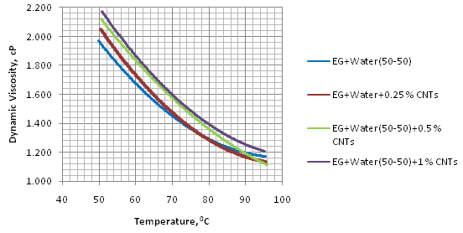

Fig. 2 Variation in dynamic viscosity with temperature

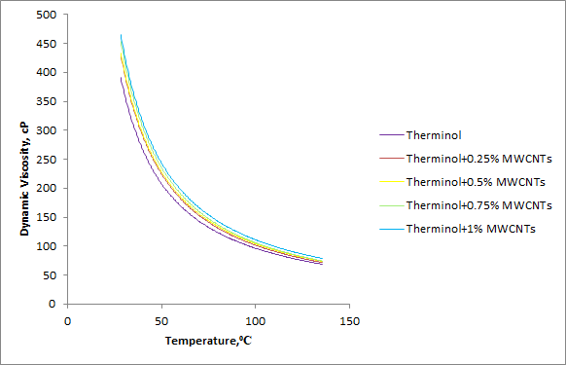

Fig. 3 Variation in dynamic viscosity with temperature

Figs 2 and 3 show variation of thermal conductivity with temperature. It is found that there is a good improvement in thermal conductivity with the dispersion of nanomaterials. The improvement in thermal conductivity is dependent on the base fluids, mass fraction and temperature. Pure Ethylene glycol and therminol dispersed with MWCNTs showed higher improvement in thermal conductivity compared to ethylene glycol-water mixtures.

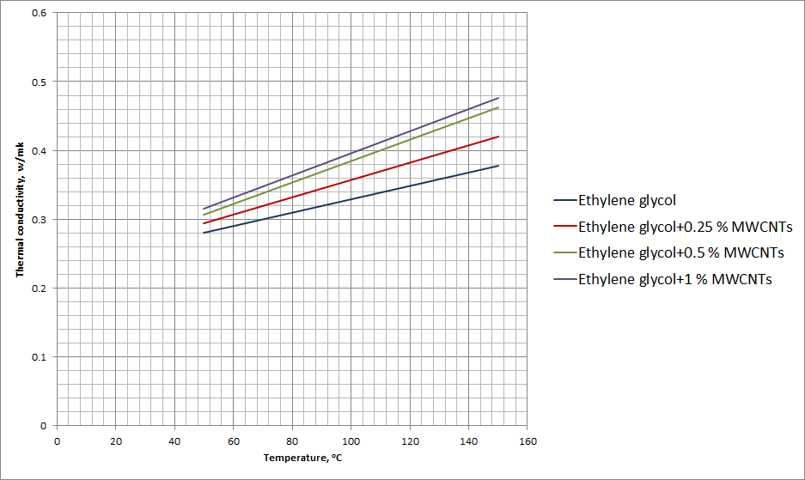

Fig. 4 Variation in thermal conductivity with temperature

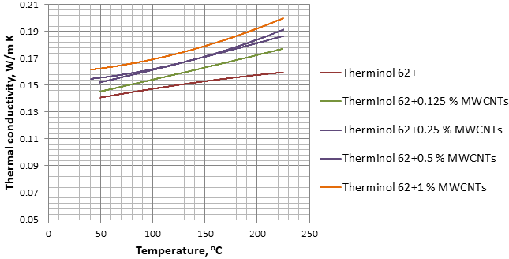

Fig. 5 Variation in thermal conductivity with temperature

**4.3. Analysis of data using artificial neural networks**

Thermal conductivity enhancement is reported in all the experiments conducted by many researchers in the literature. But vast discrepancies are found from the experimental results. Hence there is a need for developing a good mathematical model to describe the thermal conductivity of nanofluids. In this study, backpropagation artificial neural networks are used to calculate the error contribution of each neuron after a batch of data is processed. In this study, the experimental values are trained using MATLAB with a set of input and output values by developing a network to predict the error. The developed network consists of input values as the volume percentage of ethylene glycol, the mass fraction of MWCNTs, temperature and thermal conductivity as output values. The results are shown in the following graphs

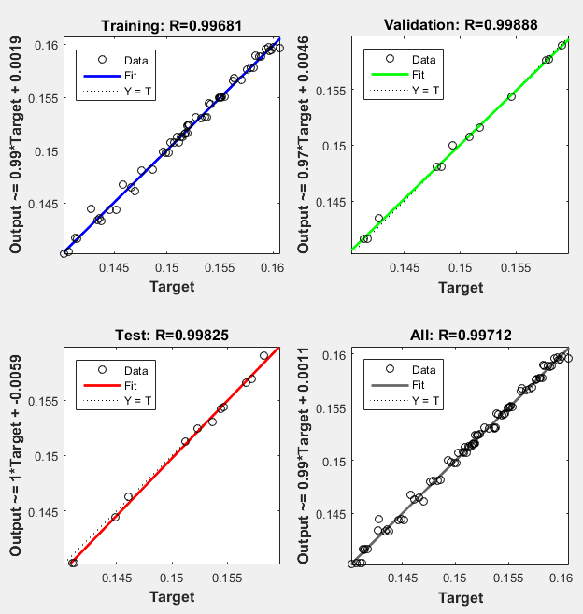

Fig. 6 Validation of data of thermal conductivity of therminol 62 at different mass fractions of MWCNTs and temperatures using artificial neural network

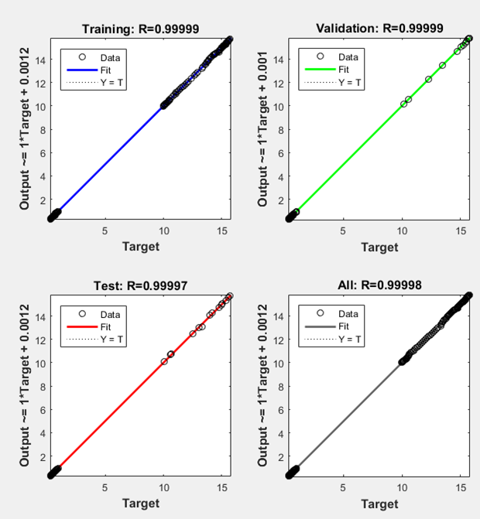

Fig. 7 Validation of data of thermal conductivity of ethylene glycol-water mixtures at different mass fractions of MWCNTs and temperatures using artificial neural network

**5. Conclusions**

1. Dispersion of MWCNTs in thermic fluids improved the thermal properties without compromising viscous properties.
2. The thermal conductivity improved with the increase in mass fraction and the improvement is in the range 5 % to 20 %.
3. There is no deterioration of dynamic viscosity with the dispersion of MWCNTs indicating the pumpability of nanofluids.
4. The data has been validated using artificial neural networks and the ANN is able to predict the thermal conductivity and viscosity at different temperatures, mass fractions for a wide range of data.

**Acknowledgment**

*The authors appreciatively recognize the support received from Hindustan Petroleum Corporation Ltd., India for conducting the tests. The authors also acknowledge the support from IIT Madras, IIT Kharagpur ,and Osmania University, Hyderabad in classification. The authors honestly show gratitude the management of GITAM University, India for the support extended.*

**References**

1. Alim MA, Abdin Z, Saidur R, Hepbasli A, Khairul MA, Rahim NA.: Analyses of entropy generation and pressure drop for a conventional flat plate solar collector using different types of metal oxide nanofluids. Energy Build 66,289–296 (2013).
2. Assael, MJ., Chen, CF., Metaxa, IN., & Wakeham, WA.: The Thermal conductivity of suspensions of carbon nanotubes in water. International Journal of Thermophysics 25 (4), 971-985 (2004).
3. Assael, MJ., Metaxa, IN., Arvanitidis, J., Christofilos, D., & Lioutas, C. Thermal conductivity enhancement in aqueous suspensions of carbon multiwalled and double-walled nanotubes in the presence of two different dispersants. International Journal of Thermophysics 26 (3), 647-664 (2005).
4. Bang, IC., & Chang, SH.: Boiling heat transfer performance and phenomena of Al2O3–water nanofluids from a plain surface in a pool. Proceedings of ICAPP. Pitterburgh, US (2004).
5. Chaji H, Ajabshirchi Y, Esmaeilzadeh E, Heris SZ, Hedayatizadeh M, KahaniM.:Experimental study on the thermal efficiency of flat plate solar collector using TiO2/water nanofluid. Mod ApplSci 7(10),60–69 (2013).
6. Chen, S., Wu, G., Liu, Y., & Long, D.: Preparation of Poly(acrylic acid) Grafted Multiwalled Carbon Nanotubes by a Two-Step Irradiation Technique. Macromolecules 39 (1), 330-334 (2006).
7. He Q, Zeng S, Wang S.: Experimental investigation on the efficiency of flat-platesolar collectors with nanofluids. Applied Thermal Engineering Journal 88,165–71 (2015).
8. Kameya Y, Hanamura K.: Enhancement of solar radiation absorption using nanoparticle suspension. Sol Energy; 85.2,299–307 (2011).
9. Meibodi ME, Sefti MV, Rashidi A, Kalal HS.: The role of different parameters on the stability and thermal conductivity of carbon nanotube/water nanofluids. InfCommun Heat Mass Transfer 37.3,319–323 (2010).
10. Meibodi SS, Kianifar A, Niazmand H, Mahian O, Wongwises S.: Experimental investigation on the thermal efficiency and performance characteristics of a flat plate solar collector using SiO2/EG–water nanofluids. Inf Commun Heat Mass Transfer 65,71–75 (2015)