**Parametric studies on combined conduction and convection heat transfer in perforated fins**

Darawath Srinua, G. Ganesh Kumar,b,*, Dr. K. Sridharc

Kakatiya Institute of Technology and Science, Warangal

*Corresponding Author

**ABSTRACT**

Literature provides numerous analytical, numerical and experimental studies pertaining to heat transfer through perforated fins concerned with different kinds of geometries. Prominent among the latest works is that of Kern and Kraus [1], who gave the concept of usage of fins in various electronic applications to enhance the dissipation of heat. Further Kraus and Bar-Cohen [2] extended their work by optimize the geometry of the fin. The usage of a fin though increases the heat transfer rate leads to increase in weight and cost of a device. But a design engineer is to strive for compact devices to improve the overall efficiency of a device.

The significance of heat transfer by convection can be found in many engineering applications, such as energy transfer in buildings, solar collectors, nuclear reactors and electronic packaging, etc. Prominent results of an experimental probe into the problem of combined conduction- convection from a vertical, thin plate fins with different shaped perforations were presented here. An experimental set up was designed and fabricated to study the effect various parameters like temperature, heat generation, thermal conductivity, overall heat transfer coefficient in the perforated fin. Perforated fins can be used to increase the rate heat transfer coefficient and effective heat transfer area. The change in the magnitude of the surface area depends on the geometry of the perforations [1]. A mathematical analysis was performed to calculate effect of heat transfer parameters. The variation of temperature along the fin is calculated experimentally and compared it with that of theoretical. A study is also been done to compare the heat transfer parameters for various geometric shapes like circle, square, triangle, etc. An experimental set up has been fabricated

1. **SOLUTION METHODOLOGY**

The net rate of heat transfer is obtained from the energy balance which is given as follows:

q heat generated due to electric power = q net, conduction + q net, convection+ q net radiation

where q heat generated due to electric power, represents is electrical heat generated in the primary surface, q net, conduction is the net rate of heat transfer due to conduction, q net, convection net rate of heat transfer due to convection, q net radiation net rate of heat transfer due to radiation.

From the above equation we can get the average heat transfer coefficient as follows:

$\overline{h}= \frac{q_{net convection}}{A_{s}\left[T_{s}-\left[\frac{T_{out}+T_{in}}{2}\right]\right]}$

Nusselt number is obtained by using the heat transfer coefficient obtained from the above equation.

1. **RESULTS AND DISCUSSION**

Exhaustive parametric studies have been done on the effect of perforations on the pin fins. As an example, the temperature profiles along the length for different pin fins were presented. This result is obtained experimentally from the set up fabricated for the study. This study is performed for the fixed input of heat generated of 54 W and velocity of fluid flow (air) at inlet and out let being 13.4 m/s and 5.5 m/s respectively. Here study is performed for three different configurations viz., (1) Vertical solid cylindrical pin fin (2) Vertical cylindrical pin fin with four perforations (3) Vertical cylindrical pin fin with single large perforation. As can be seen from Fig. 2, for a given heat input, the non-dimensional temperature along the fin is found to be increasing as we move from primary surface to the tip of the fin for all the three cases which is obvious. It can also be observed that the heat dissipation is more for the fin with large perforation (whose volume is equivalent to volume of four perforations as in case 2) compared to that with four perforations and the temperature is much less for the case of solid pin fin. The central temperature was found be decreased by 7.14% if we use the fin with large perforation compared to that of pin fin with four perforations. Similarly the temperature the percentage decrease in central temperature is by 17.53 % if we compare with solid fin. Hence the fin with perforations is more efficient compared to solid fin.

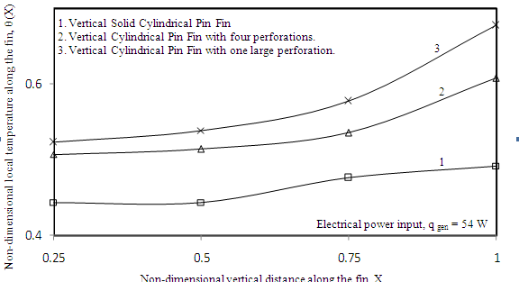

*Key words*: Conduction, Convection, Perforated Fins, Heat Transfer