*International Conference on New Frontiers in Chemical, Energy and Environmental Engineering (INCEEE-2019) 15-16 Feb, 2019, NIT Warangal, India*

**Catalytic Co-pyrolysis of Rice Husk with LDPE Using ZSM-5**

Vinayak Mali1, Sumanth Mogaveera1, Shruthi P K1 Prakash Binnal1*

*1Department of Chemical Engineering, Siddaganga Institute of Technology, Tumakuru-572103,Karnataka,India*

**Abstract**

In the present work, Catalytic Co-pyrolysis of rice husk with LDPE was investigated in batch mode using ZSM-5 (having Si/Al ratio of 6) as catalyst. The purpose was to increase H/C ratio and aromatic fractions in the resulting bio-oil. The reactor was made of SS 304, Design pressure of 3 bar and provided with 4.5 kW electric heater, PID controller to regulate temperature, graphite gasket, safety relief valve, pressure gauge, K-type thermocouple and provision to circulate nitrogen gas to reactor(Fig.1). Copper tube (3/4’’, 15 m long) was used as condenser.

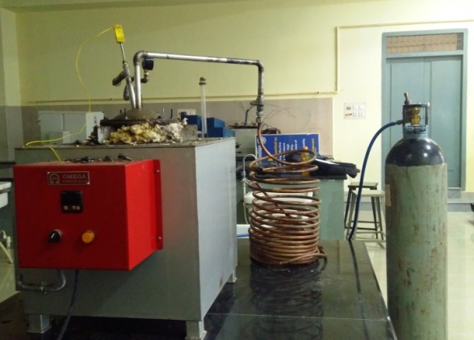

Figure 1: Pyrolysis reactor

In all experiments, the gel fuel obtained after pyrolysis experiments was subjected to simple distillation to obtain gasoline range hydrocarbons (boiling point range: room temperature to 2040C).Various trials were conducted to investigate the effect of temperature, Rice husk:LDPE ratio, Catalyst concentration on yield and composition of bio-oils and also gasoline range fractions.

Characterization of bio-oils and gasoline range fractions was done by CHNSO analysis (FLASH EA 1112 series, Italy (Make: Thermo finnigan) and GC HRMS analysis(GC 7890 (Make: Agilent) with FID detector, along with Mass spectrometer: Jeol (Make: AccuTOF GCV). Surface area and pore size of catalyst was done by BET.

*References*

1. Benjamin Bernard Uzoejinwa, Energy Conversion and Management 163 (2018) 468–492