Application of biocementation for augmentation of mechanical properties of fly ash concrete

Snigdha P. Bhutange1*, M. V. Latkar2

1*Research Scholar, Civil Engineering Department, Visvesvaraya National Institute of Technology (VNIT), Nagpur – 440010, Maharashtra, India. (Corresponding Author) Email address- snigdhabhutange@students.vnit.ac.in

2Associate Professor, Civil Engineering Department, Visvesvaraya National Institute of Technology (VNIT), Nagpur – 440010, Maharashtra, India. Email address – mv.latkar@gmail.

# Introduction

Fine powder that is generated as a byproduct of burning pulverized coal in power plants is known as fly ash. Fly ashes are seen to bear pozzolanic and/or cementitious properties which is why they can be amended with concrete (Fraay A.L.A., J.M. Bijen J.M., 1989). Fly ash is known to have many environmental and health hazards and thus incorporation of fly ash in cement concrete has been proved to be a sustainable solution (Mishra and Siddiqui, 2014). Even though the utilization of fly ash in concrete is a sustainable practice, incorporation of high percentages of fly ash in concrete by replacing cement results in concrete having comparatively lower strength (Berryman *et al.*, 2005). Biocementation has a potential to compensate the compromised strength resulted from the replacement of cement with fly ash (Achal, Pan and Özyurt, 2011).Microbially induced calcium carbonate precipitation (MICCP) is a process that occurs in nature and has moulded the entire globe (Pei *et al.*, 2013). Many natural structures such as ant hills on land and coral reefs in water are best examples of calcification occurring at ambient conditions and providing them stability. Taking note from nature, many researchers have tried to utilize this naturally occurring phenomenon for the betterment of construction materials. According to Tarczewski, (2015), microbially induced calcification is one of the most sustainable construction technologies and has potential to improve properties of construction materials in an eco-friendly way. Urea hydrolysis is the most eminent pathway among the several pathways of microbial calcification due to its easily controllable CaCO3 producing mechanism (Whiffin, 2004). Carbonate ions (CO32−) are produced as a part of metabolism of bacterial mass and their conversion to CaCO3 when provided with Ca2+ is the principle involved in MICCP. The following flow chart (Fig. 1) explains the sequence of processes occurring in MICCP.

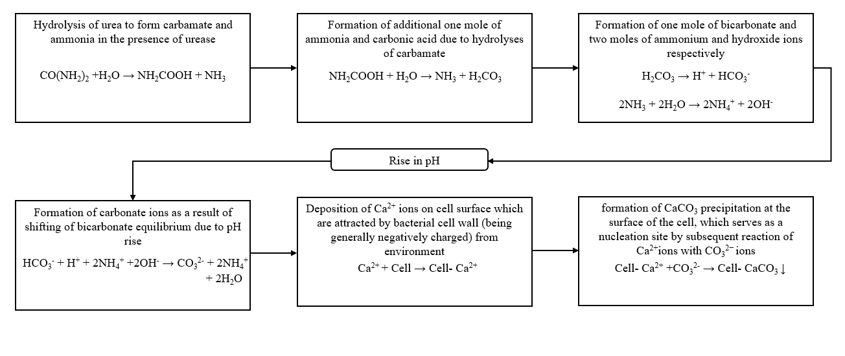

Figure 1. Sequence of processes occurring in MICCP

Incorporation of bacterial mass into the matrix of construction materials is found to improve properties of construction materials. This happens due to coverage of micro voids within the matrix by CaCO3 precipitations formed due to bacterial activity. Some of the soil bacteria are capable of performing the urea hydrolysis reaction with the secretion of urease enzyme as a part of their metabolism. Benefit of this phenomenon has been taken by many researchers for the improvement of construction materials.

# Materials and Methods

In the present study ordinary Portland cement of grade 53, locally available natural river sand (fine aggregate) confirming to IS 383: 1970 of zone II having specific gravity of 2.60 and coarse aggregates having maximum size of 20 mm and below as per IS 383:1970 were used. Locally available tap water confirming to IS 456:2000 was used throughout the study. The fly ash used was class F fly ash obtained from Koradi thermal power plant, Maharashtra, India (ASTMC618-03, 2002). Rhizospheric soil collected from garden was used as a mixed bacterial source. Tap water was used for the preparation of bacterial solution. Low cost ingredients were used to provide nutrients to grow the bacteria. Table 1 shows the composition of growth medium used to grow mixed culture of bacteria. The mix design was done as per IS 10262: 2009 to develop 28 days compressive strength of 30 MPa and slump of 70–100 mm by using tap water, control 1 solution and bacterial solution having a composition as shown in table 1(IS 10262: 2009).

**Table 1.**Constituents of control, control 1 and bacterial solution

|  |  |  |  |  |
| --- | --- | --- | --- | --- |
| **Purpose** | **Constituent**  **(g/l of water)** | **Control Solution/Tap water** | **Control1solution** | **Bacterial solution** |
| Bacterial source | Soil | 0 | 0 | 200 |
| Protein source | Lentil seed powder | 0 | 10 | 10 |
| Vitamin source | Meat extract | 0 | 3 | 3 |
| Carbon source | Sugar | 0 | 0.5 | 0.5 |
| Substrate | Urea | 0 | 5 | 5 |
| Calcium source | Calcium hydroxide | 0 | 5.5 | 5.5 |

All the ingredients shown in Table 1 were added in water. The prepared solution was then kept in incubator at 37o C for 24 hours. The supernatant of the bacterial solution was then separated from the soil and addition of urea as a substrate and calcium hydroxide as calcium source was done to it. 5 g/l of urea and 5.5 gm of calcium hydroxide were added. The proportion of urea and calcium hydroxide was decided according to stoichiometry of the reaction involved. Control 1 solution was prepared in similar manner without adding soil. These solutions were used to prepare specimens of standard sizes for testing.

# Results and Concluding Remarks

Compressive strength test, Water absorption test, Ultrasonic pulse velocity test, Rapid chloride permeability test, Split tensile strength test, flexural strength test, Scanning electron microscopy, Energy dispersive X-ray analysis, X- Ray diffraction analysis, carbonation test and estimation of soluble chlorides and sulphates concentrations were carried out as per respective standards. Results showed around 7%, 11%, 13%, 15% & 16% increment in compressive strength and 7%, 9%, 10%, 14% & 15% reduction in percent water absorption of bacterial specimens as compared to control specimens; for 3, 7, 14, 28 & 90 days of curing respectively. Average split tensile increment values in bacterial specimens were 8.33% & 9.09% and that of flexural strengths were 7.07% & 7.82% respectively for 28 and 90 days. SEM, EDX and XRD analyses showed presence of CaCO3 precipitations in bacterial specimens. Bacterial fly ash concrete was proved to be durable by qualifying all durability tests like UPV, RCPT, carbonation and chloride and sulphate concentrations. Bacterially induced CaCO3 precipitations caused overall improvement of fly ash concrete.

**References**

IS383:1970, (1970) ‘Specification for Coarse and Fine Aggregate From Natural Sources for Concrete’, *IS 383(Second rev.)*, p. New Delhi,India.

Achal, V., Pan, X. and Özyurt, N. (2011) ‘Improved strength and durability of fly ash-amended concrete by microbial calcite precipitation’, *Ecological Engineering*. Elsevier B.V., 37(4), pp. 554–559. doi: 10.1016/j.ecoleng.2010.11.009.

ASTMC618-03 (2002) ‘Standard Specification for Coal Fly Ash and Raw or Calcined Natural Pozzolan for Use’, pp. 1–3.

Berryman, C. *et al.* (2005) ‘High-percentage replacement of cement with fly ash for reinforced concrete pipe’, 35, pp. 1088–1091. doi: 10.1016/j.cemconres.2004.06.040.

Fraay A.L.A., J.M. Bijen J.M., Y. M. de H. Y. M. (1989) ‘The Reaction of Fly Ash in Concrete. A erltieal Examination’, *CEMENT and CONCRETE RESEARCH.*, 19(c), pp. 235–246.

IS10262:2009 (2009) ‘Concrete mix proportioning - Guidelines (First Revision)’. doi: 10.1002/ajpa.22079.

IS456:2000 (2000) ‘Bureau of Indian Standard (BIS). Plain and reinforced concrete- code of practice: IS 456’, (July).

Mishra, S. and Siddiqui, N. A. (2014) ‘A Review On Environmental and Health Impacts Of Cement Manufacturing Emissions’, *International Journal of Geology, Agriculture and Environmental Sciences*, Volume – 2(Issue – 3 June 2014), pp. 26–31.

Pei, R. *et al.* (2013) ‘Use of bacterial cell walls to improve the mechanical performance of concrete’, *Cement and Concrete Composites*. Elsevier Ltd, 39, pp. 122–130. doi: 10.1016/j.cemconcomp.2013.03.024.

Tarczewski, R. (2015) ‘Formation of Sustainable Infrastructure Using Microbial Methods and Humanization of Man-made Environment’, *Procedia Manufacturing*. Elsevier B.V., 3(Ahfe), pp. 1704–1711. doi: 10.1016/j.promfg.2015.07.991.

Whiffin, V. S. (2004) ‘Microbial CaCO3 Precipitation for the Production of Biocement’, *Phd Thesis*, (September), pp. 1–162. doi: http://researchrepository.murdoch.edu.au/399/2/02.